1. **SQL DB Alert**

Login to SQL DB (**fon-dp-dev-std-sql-002.database.windows.net**) and trid to login with wrong credentials couple of times. It should trigger an alert as we tried wrong credentials many times

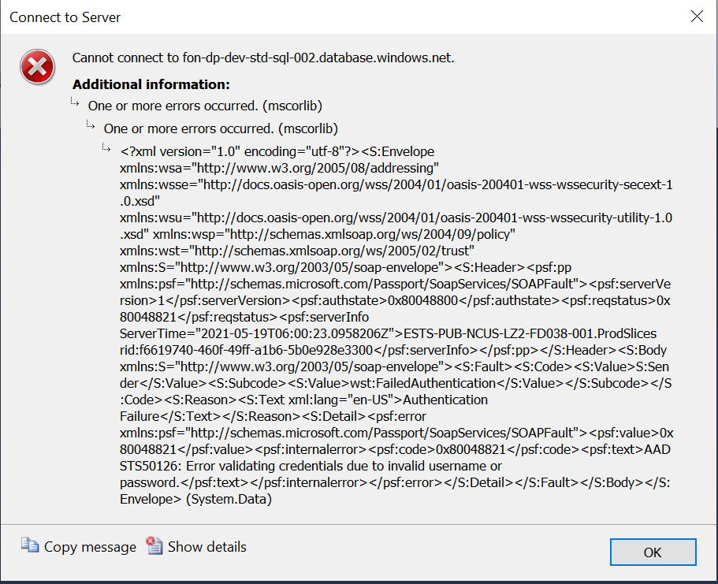

1. **Storage Alert Trigger**

Connected “**fondpdevrawdls001**” and “**fondpdevrawdls002**”

Whitelisted my IP (india) - 103.155.222.137, and tried to open some containers inside this storage

It should trigger an alert because India is not listed in region specific

**Next action**

We will wait for 1 hour to reach these alerts to the log analitics

Login to Log analitcis

1. Query SQL and make sure the alert reached in log analytics
2. Query storage and make sure the alert reached in log analytics
3. **SQL Query**

{"source":"la-draft-clipboard","value":[{"tokenKey":"0A8479F5-9F01-4CEB-9DB7-72CF3CEB4B37","type":"literal","tokenExpression":"DATABASE AUTHENTICATION FAILED"}]}

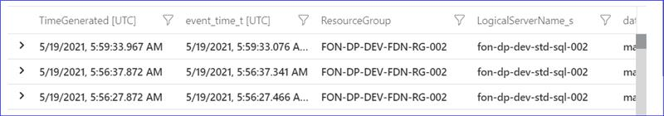

1. **Storage Query**