Que-1- **What are the advantages of Bootstrap?**

ANS -1 bootstrap is save our time and efforts. You have not a write a long cord. Bootstrap offers a verity of elements like a buttons, forms, cards, navbar, and more.

Que-2-**What is a Bootstrap Container, and how does it work?**

**ANS-2 container is a basic layout element in bootstrap. container is used to the contain pad and centre the content within them. It contains the row elements and the row elements are the container of columns.**

**1.container**

**The container class provides a responsive fix width contain**

**2. container fluid**

**The container fluid provide a max width contain.**

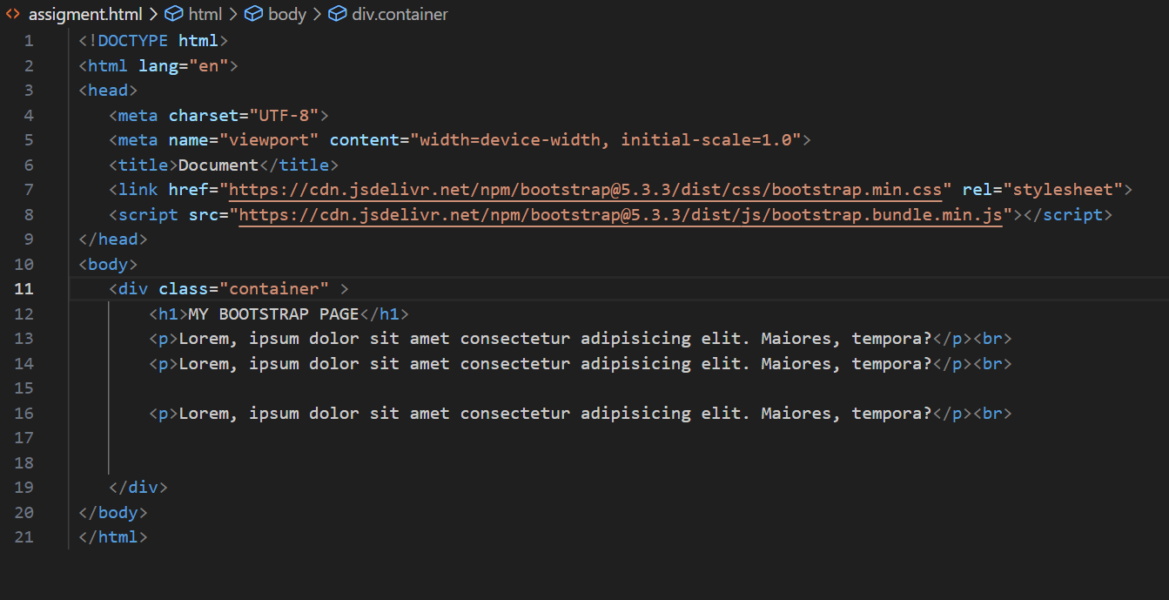

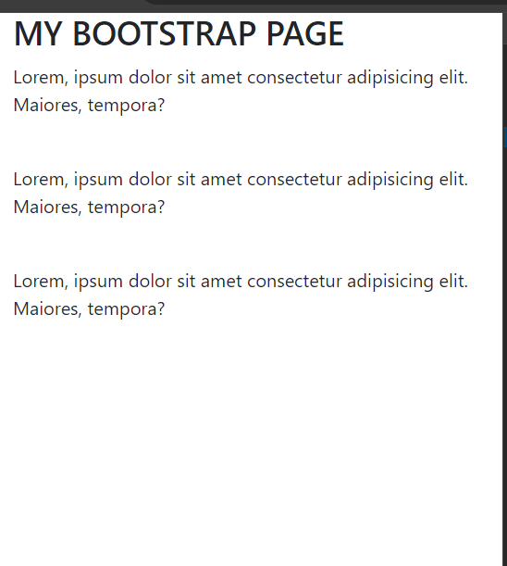

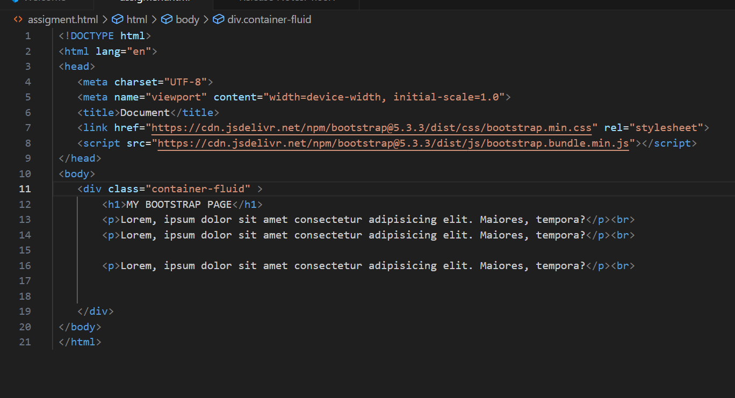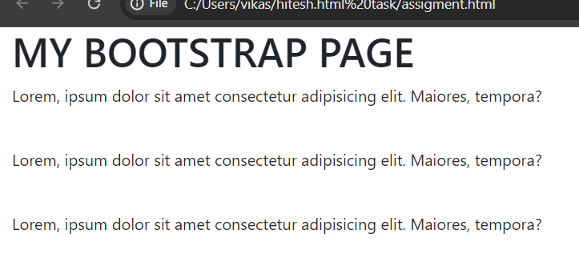

**Que-3-What are the default Bootstrap text settings?**

**Ans-3-**Bootstrap 4 uses a default font-size of 16px, and its line-height is 1.5.

**Que-4-What do you know about the Bootstrap Grid System?**

**Ans-4-**Bootstrap's grid system allows up to 12 columns in the page.

If you not use the 12 column you can group the wider column.

**Que-5-What is the difference between Bootstrap 4 and Bootstrap 5?**

ANS -5 bootstrap 4 is dependent on jQuery. Bootstrap 4 make a css used in any work

Bootstrap 5 is removed the jQuery dependency.

Bootstrap 5 introduces more utility classes, making it easier to apply styles directly in the HTML without the need for custom CSS.

**Que-6-What is a Button Group, and what is the class for a basic Button Group?**

ANS-6 button groups it is used to create a series of a button in groups without space horizontally and vertically.

<div class=button group>

**Que-7-How can you use Bootstrap to make thumbnails?**

**Step 1: include the jQuery and bootstrap link into a head tag.**

**Step 2: create a div tag in our html body**

**Step 3: create a three div section each per image.**

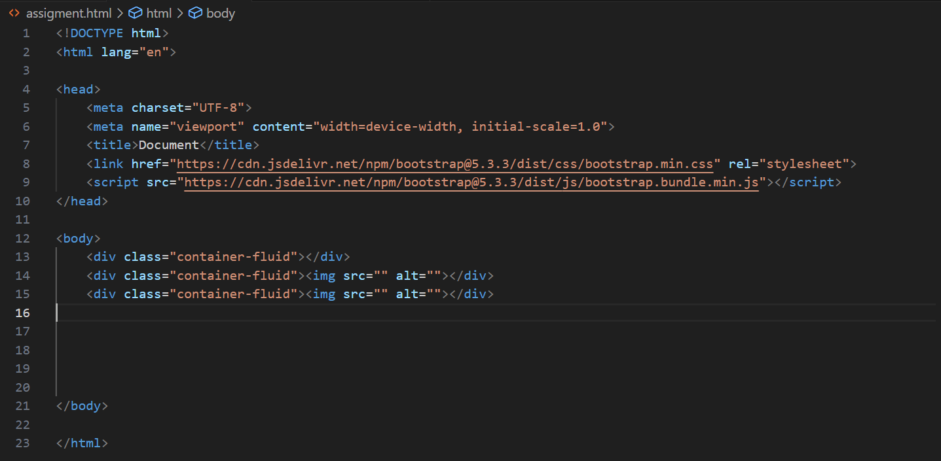

**QUE-8-In Bootstrap 4, what is flexbox?**

ANS-8 bootstrap 4 it is easier to design flexible responsive layout structure without using float or positioning.

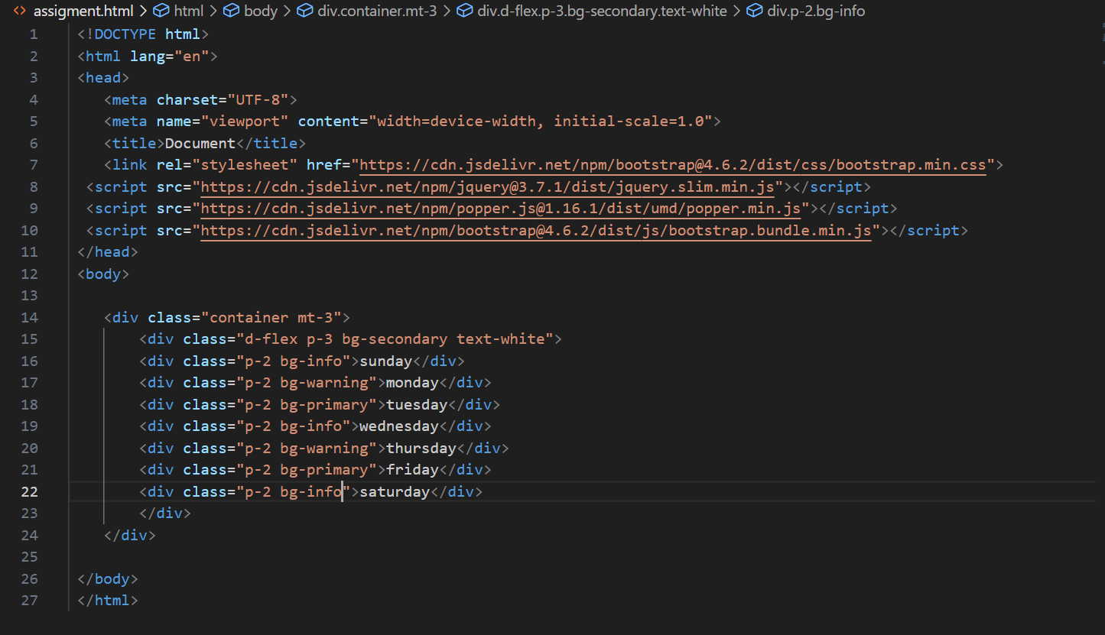



**QUE-9 how can create a alert in bootstrap?**

**Ans-9**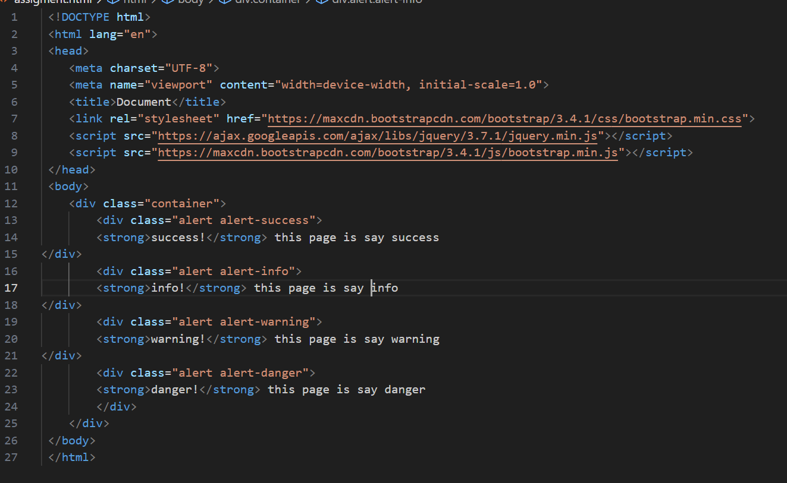

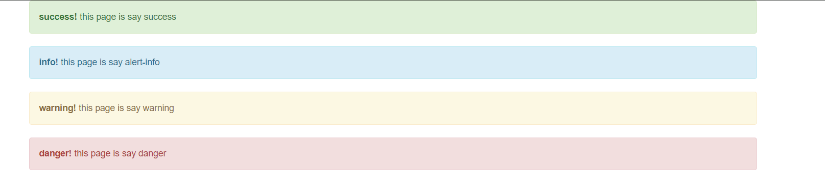

**Que-10 What is a bootstrap card and how would you create one?**

**ANS -10**

