CMSC140 Project 4 Documentation Template

Class: CMSC140 CRN 40020
Program: Project #4
Instructor: Alla Webb
Summary of Description: (Calculating information from an inputFile and sending to outputFile)
Due Date: 07/20/26
Integrity Pledge: I pledge that I have completed the programming assignment independently.
I have not copied the code from a student or any source.
I have not given my code to any student.
Print your Name here: Luis Aguero

Part1: Flowchart and Pseudo Code: Here is Flowchart and pseudo code for Project 4 program:

Part2: Comprehensive Test Plan
A good test plan should be comprehensive. This means you should have a few test cases that test when the input is in and out of range, division by 0, incorrect Data type, etc. (Provide valid and invalid input)
Cases | Input | Expected Output | Actual Output | Did Test Pass?
Case 1 | Input file: Project4_inputCredits.txt  Alex 12 138.25 88.5  Sam 15 138.25 58  Jordan 9 150.00 92 | Valid Students: 3  Invalid Records: 0  Average Grade: 79.50  Min Grade: 58.00  Max Grade: 92.00 | Valid Students: 3  Invalid Records: 0  Average Grade: 79.50  Min Grade: 58.00  Max Grade: 92.00 | Yes
Case 2 | Input file: InvalidGradeTest.txt  Alex 12 138.25 105  Sam 15 138.25 -10  Jordan 9 150.00 92 | Valid Students: 1  Invalid Records: 2  Average Grade: 92.00  Min Grade: 92.00  Max Grade: 92.00 | Valid Students: 1  Invalid Records: 2  Average Grade: 92.00  Min Grade: 92.00  Max Grade: 92.00 | Yes
Case 3 | Input file: InvalidCreditsCost.txt  Alex -5 138.25 88  Sam 15 -50 90  Jordan 9 150.00 92 | Valid Students: 1  Invalid Records: 2  Average Grade: 92.00  Min Grade: 92.00  Max Grade: 92.00 | Valid Students: 1  Invalid Records: 2  Average Grade: 92.00  Min Grade: 92.00  Max Grade: 92.00 | Yes
Case 4 | Input: wrong input filename entered:  wrongfile.txt  Then entered:  Project4_inputCredits.txt | Error Opening Input File. Try again.  Program accepts correct filename and continues. | Error Opening Input File. Try again.  Program accepts correct filename and continues. | Yes

Part3: Screenshots related to the Test Plan:
Case 1
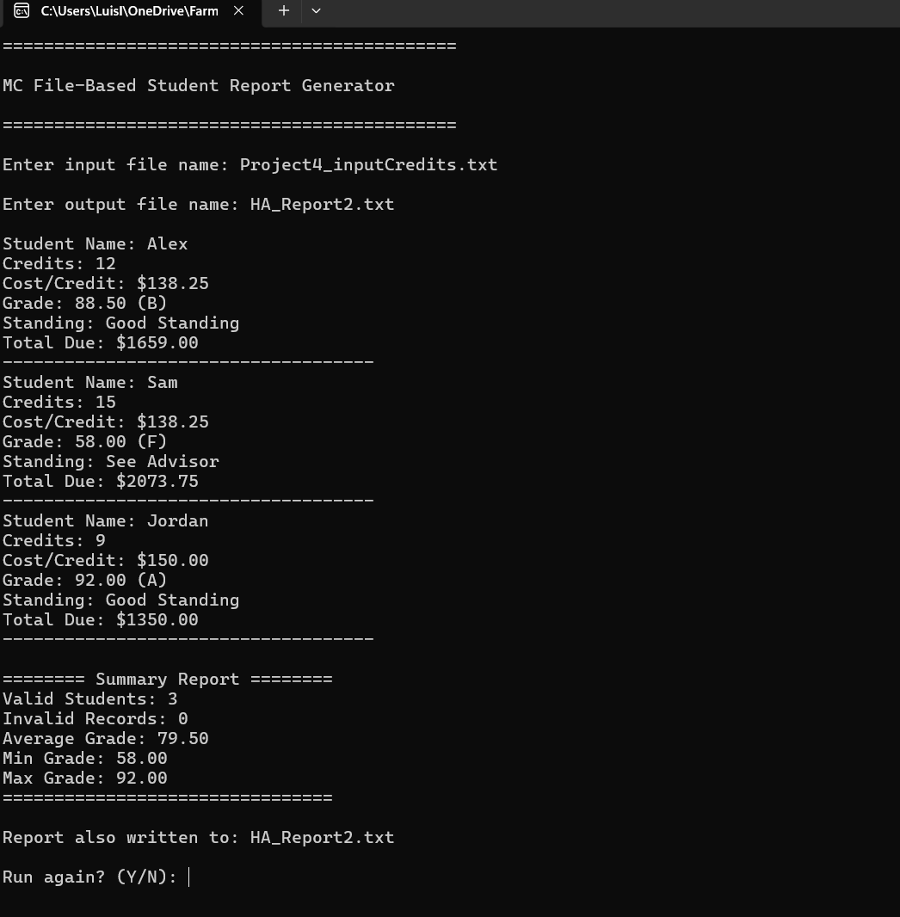
Case 2
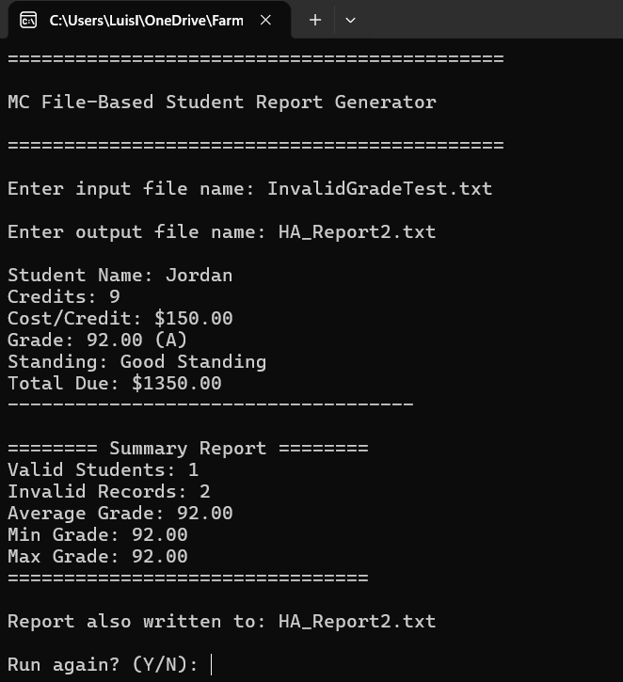
Case 3
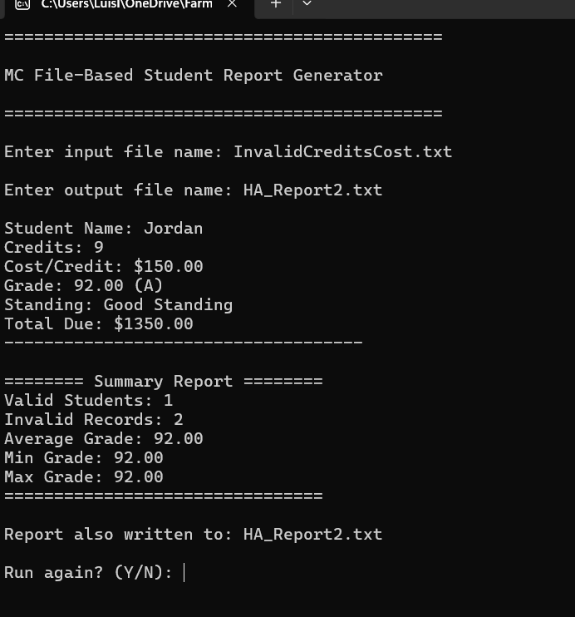
Case 4

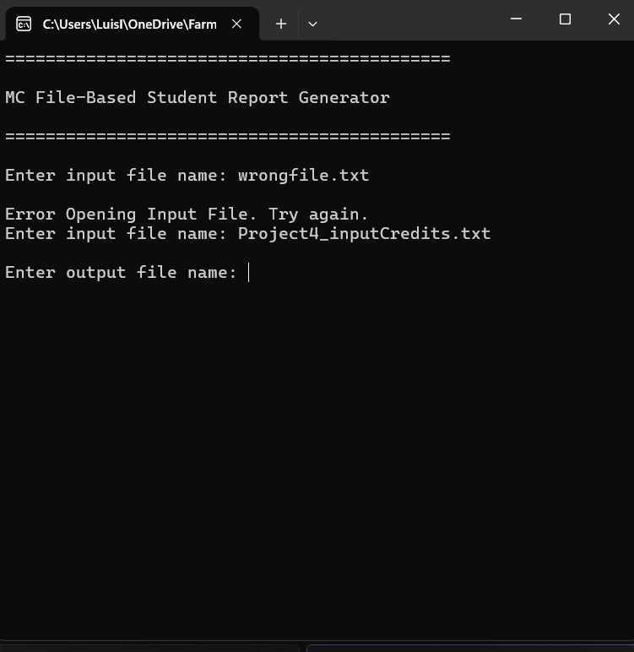

Lessons Learned <Provide answers to the questions listed above>:

Write about your Learning Experience, highlighting your lessons learned and learning experience from working on this project.
Working on this project helped me improve my understanding of C++ programming by applying concepts from previous assignments into a larger program. I learned how to organize a program into multiple functions, work with input and output files, validate data, and use loops and conditional statements to process multiple records. This project also helped me understand how different functions can work together to complete a larger task instead of writing everything inside the main function.

What have you learned?

I learned how to use file input and output with ifstream and ofstream to read information from file and create a formatted report. I also learned how to calculate summary statistics such as the average, minimum, and maximum values while processing data. Another important lesson was learning how to validate input data before performing, passing information between functions, and organizing my code in a more modular way.

What did you struggle with?

Working on this project helped me improve my understanding of C++ programming by applying concepts from previous assignments into a larger program. I learned how to organize a program into multiple functions, work with input and output files, validate data, and use loops and conditional statements to process multiple records. This project also helped me understand how different functions can work together to complete a larger task instead of writing everything inside the main function.

What would you do differently on your next project?

On my next project, I would spend more time testing different situations earlier in the development process. I would create test cases for both valid and invalid data before finishing the program so I can find problems sooner. I would also try to make my code more efficient by reducing repeated sections and looking for opportunities to reuse functions.

What parts of this assignment were you successful with, and what parts (if any) were you not successful with?

I was successful with creating a modular program, reading student records from a file, calculating tuition and grades, generating reports, and displaying summary information. I was also successful with adding validation for incorrect values and handling multiple program runs. One area that required improvement was working with file output formatting because small mistakes could affect the final report. Through testing and debugging, I was able to correct issues and complete the assignment successfully.

Provide any additional resources/links/videos you used to while working on this assignment/project.

Starting Out with C++: From Control Structures to Objects, 10th Edition through Revel

I also reviewed my class notes and previous examples provided during the course to help with functions, file input/output using ifstream and ofstream, loops, conditional statements, and formatting output.

Check List: <Provide answers to the column Y/N or N/A >:

# |  | Y/N | Comments
 | Assignment files:
 | - FirstInitialLastName_ Assignment#.zip | Yes or No | YES
 | - FirstInitialLastName_Assignment#.docx/.pdf | Yes or No | YES
 | Program compiles | Yes or No | YES
 | Program runs with desired outputs related to a Test Plan | Yes or No | YES
 | Documentation file:
 | - Comprehensive Test Plan | Yes or No | YES
 | - Screenshots related to the Test Plan | Yes or No | YES
 | - Algorithms/Pseudocode (if required) | Yes or No or N/A | YES
 | - Flowchart (if required) | Yes or No or N/A | YES
 | - Lessons Learned | Yes or No | YES
 | - Checklist is completed and included in the Documentation | Yes or No | YES

