**Project report—Study of shark attacks**

Zhihao Lin

Sharks are mysterious, dangerous animals that attack human beings. They are deadly and famous. Because of the famous film “White Sharks”, they are well known all over the world. Actually I should say that it is no strange thing that the white sharks are so infamous. Hence when I learned that there will be a project about anything that is interesting, I decided that my project should be about the sharks and study why they are so infamous; if they are really so dangerous. Below is a screen shot of the original data set.



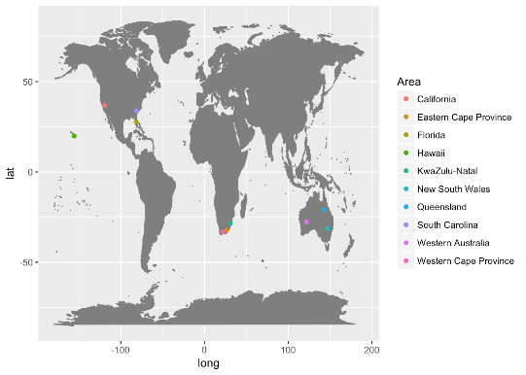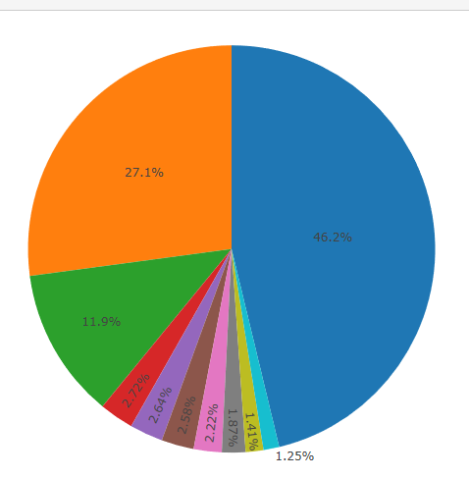

Actually one of the reasons for which sharks are so famous is that it attacks the USA quite often. Actually USA one single country suffered almost the same amount of attacks in the top ten attacked countries. Since the United States has been the hegemony of the world in the past decades, this is quite enough to make sharks famous. And among the top ten most frequently attacked Areas, four were located in the United States, especially Florida suffered almost the sum of 2nd, 3rd, 4th most frequently attacked area. And among those countries, the top three most frequently attacked countries are all countries that speaks English, while English has been the language of world, this also makes sharks very infamous.

After discussing about the reasons for which sharks are so famous, I decided to try to think about which are the most dangerous activities. Since the activity in the original data set is not good, I decided to use the unnest _token to look for it. And the top five most dangerous activities are swimming, surfing, spearfishing, fishing and diving. Although the data set shows that many people were attacked while they went swimming. I shall say that, swimming is still far much safer than the rest of the activities, and it is only because swimming is far much popular and easier to learn than the rest.

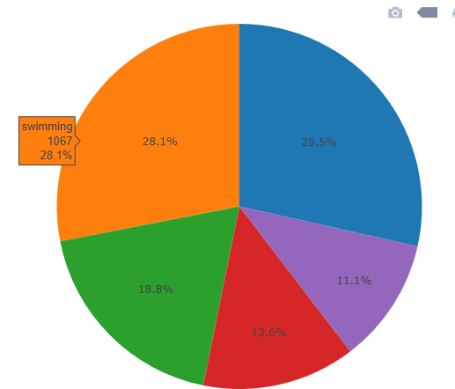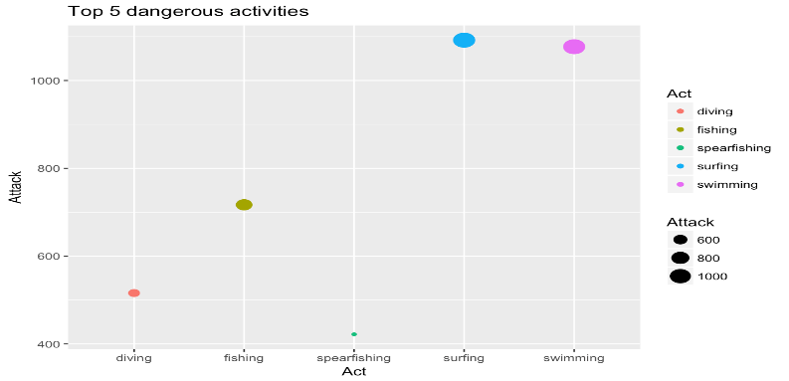

After discussing about the activities of acts people were doing when they were attacked, I decided to discuss the types of attack. There is data about if sharks were provoked and that makes me curious—if sharks are dangerous creatures that attack innocent people and take us as their foods, or are they simply those harmless creatures like those people who claim they love animals? The outcome seemed to support those who claims sharks are dangerous animals. Many of the attacks were reported not the type of provoked, although there are many of them I don’t know how to explain them it is still quite obvious that sharks are dangerous creatures, and attack people even without being provoked.

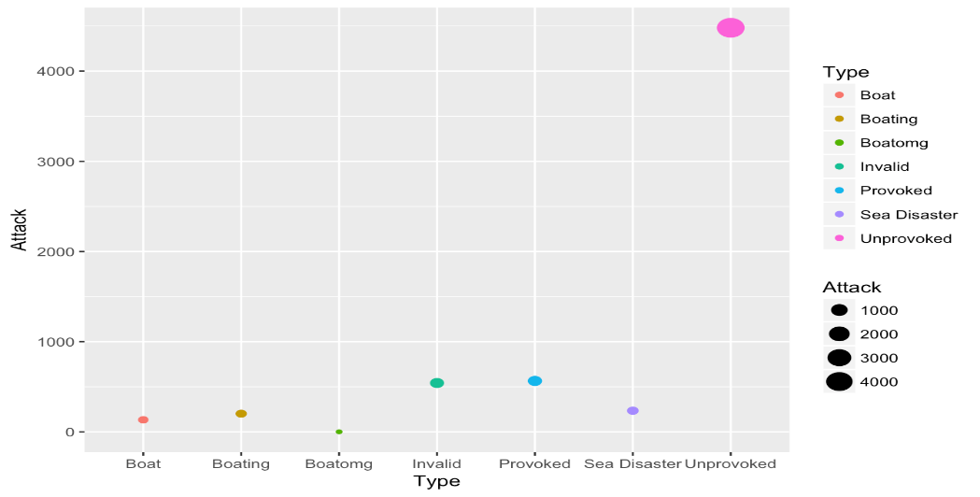

After studying the type of attacks, I think it is time to discuss what make attack more likely. As the plot above, the plot showed the top ten most frequently attacked area, proved that they are sharing one thing in common—the latitude of them are low. Hence it brings me to what makes me interesting—whether sharks only go these places or not , and whether people only go to shorelines when it is extremely hot or not. Therefore I decided to plot it out and combined with the months when people were attacked, I believe I can know the answer. On the left hand side, Australia, right hand side, USA. Seemed people are attacked very frequently during summer. If the plot for South Africa is needed, please see shiny app.

Actually the data set was not formed in a good way. The months were stored in terrible way, there are time labeled to be xxxx year, summer or something else like that. I have no other choice but to use str_extract to extract those formed like Jan, Feb. Although the patterns like summer, winter were also extracted, but there is not much of them so I just extracted those in the top 12 list and joined the new dataset with the original data set.

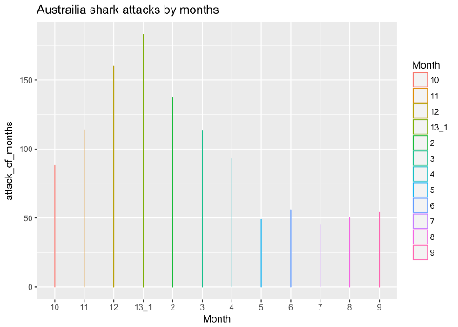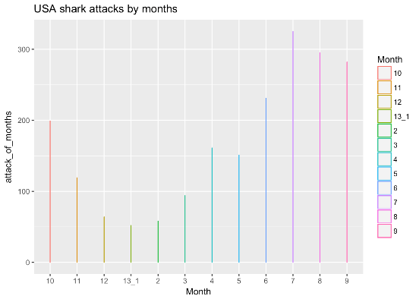

Actually there are also people claiming that sharks are endangered animals. They are always claiming that we shall protect these infamous, hated animals. They have always been saying that if we keep on hunting sharks in the speed we are doing for now, they would distinct within a few months. In my opinion, if this is true, then it would be very likely for the attack to decrease as time goes by. Hence I decided I should be looking at the frequency of attack by countries. Although the shark attacks in Australia, Papua New Guinea has been greatly decreased during the 1970s to 1990s, the attacks in the United States kept growing. It seemed that the sharks are not going to go away from our life, at least in a short period of time.

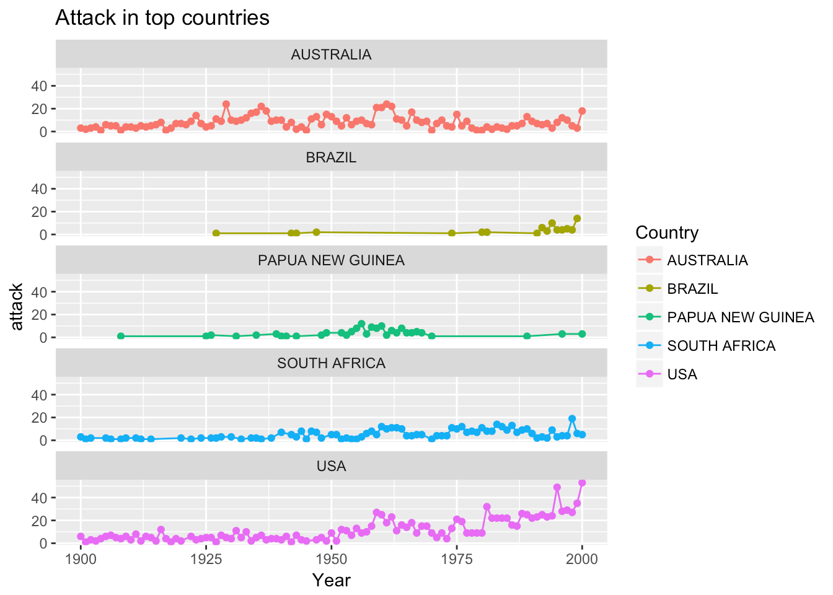

And although the attacks are interesting, I find the death rate also quite an interesting and important thing. We know sharks are well feared, and that is partially because sharks are so big and seemed could kill once they launch their attack on people. So what is the death rate of people who suffered from shark attacks and how it changes as time goes by? I decided to draw a plot to think of it.

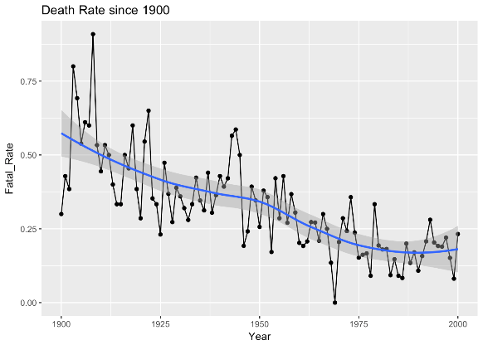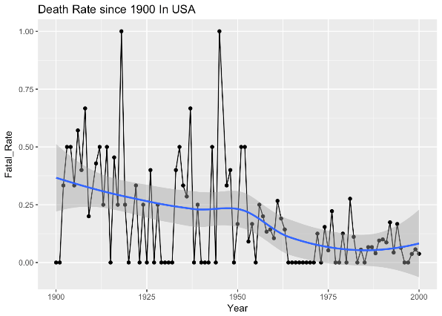

The attack seemed to be decreasing as time goes by, this make sense since the technology have been growing as time goes by. However, the death rate decreased significantly since the 1950s. I would say thank you to penicillin. Penicillin has been proved to be useful maybe since the 19th century but the mass production of it did not success until the 1940s. It is very helpful to cure people who were bitten. Since the time of these things are so close I would like to say this is what I think.

However, people still need to go to the coastline so that they can be attacked. And people are willing to go to the shorelines so that they can have their good vocation. Hence I would like to compare the amount of attacks with the amount of international tourisms comes to this country at that year. Although I know I should try to use the number of tourists go to the shorelines but I failed to find the data set. 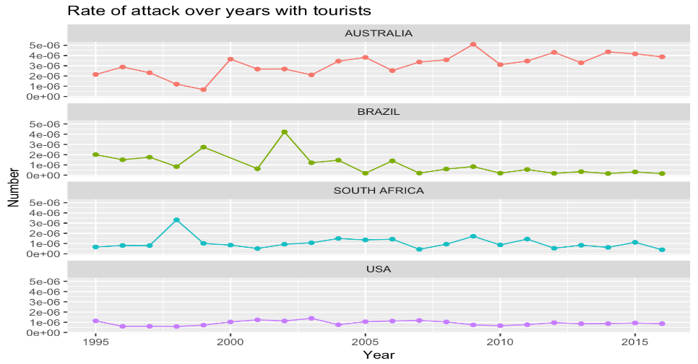

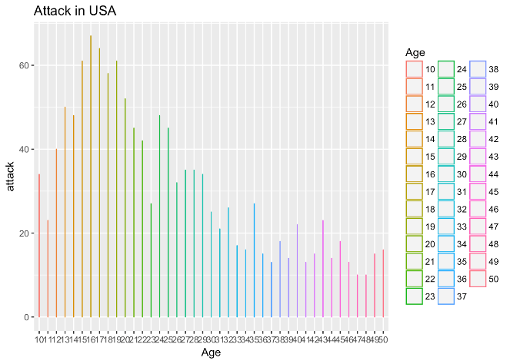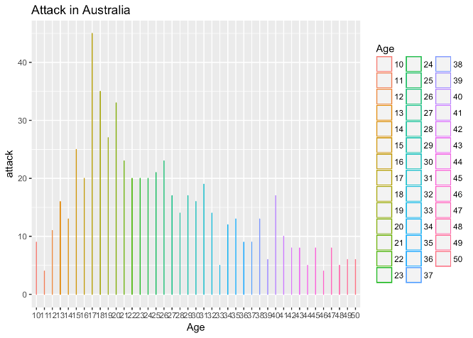

And I also tried to study the component of age of people who was attacked. The two plots above showed the amount of people attacked by their age. It seemed that People in the United States attacked by sharks are younger than those in Australia. And in both countries, teenagers are likely to be attacked. Whatever, I believe that young people are more enthusiastic and they are more likely to ignore the signals which shows the dangerous zones. What’s more, it is no wonder that young people are more likely to go to the coastlines to go surfing and diving. These are all acts that needs to reflect immediately and even the spear fishing needs to do everything quickly.

And it is high time for explaining why sharks are so infamous. It is no strange things that people all know white sharks, since there are so many famous films about the terrifying white sharks, attacking unprepared people. So why white shark? There are numerous of sharks, some are harmless, some are dangerous. And the plot below might be able to show.

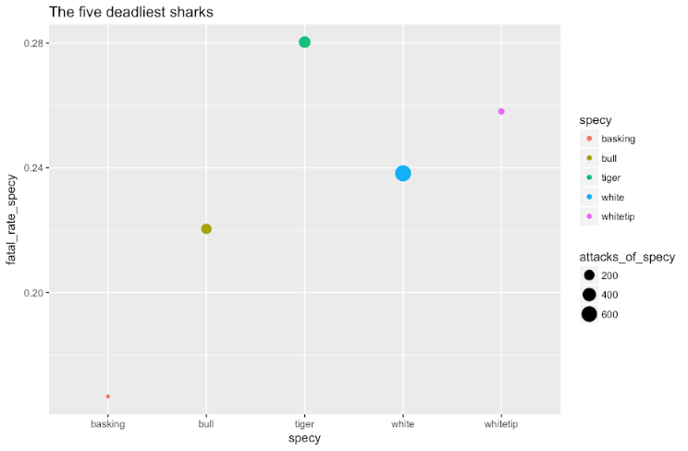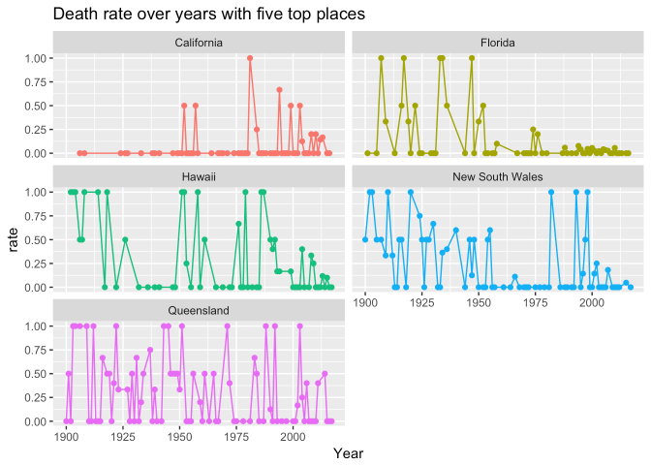

It seems that white sharks are not the deadliest shark at all. However it is almost as deadly as the most dangerous shark, tiger shark. What’s more, the frequency of attacks launched by this kind of shark is also higher than any other sharks. I think I have understood why white sharks are so infamous. Due to the high frequency of attack and deadly attack of white shark, people would always imagine that white sharks are the most deadly shark.

I also plotted the death rate of different areas, and it seems that death rate of Florida has been well controlled, California also. However, the other places do not provide a tend strong enough. I am not sure if the death rate is controlled thanks to the well-developed United States hospital systems. Actually the death rate of other countries can be showed by my shinny apps. Actually the better developed countries has a lower death rate than those undeveloped. 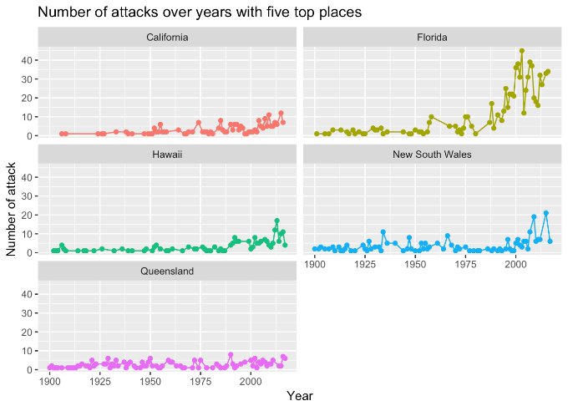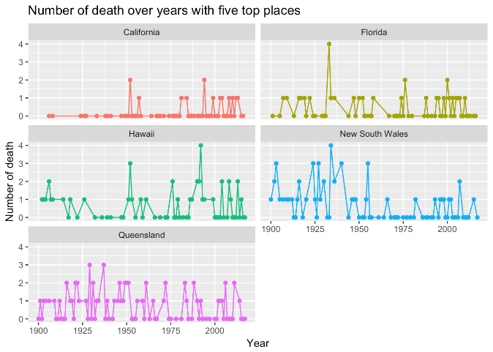

From these plots I shall say that maybe from the aspect of area, the scale of attack is too small to be calculated very sound in a statistical way. The fluctuation might sometimes be caused by luck.

**Conclusion**

In general, sharks are not really harmless creatures that needs protection. Moreover, the death rate is lowered if shark attack in the 1950s from most developed countries shall be considered. In most cases, people attacked by sharks are likely to be young people or even teenagers. The attacks are most likely to take place during summer, which may be contributed by our will to go to the coastlines when it is hot. However, I do suspect it might also because sharks are not able to move that much during the winter since they are unable to keep their body temperature.