**Lab 08 Answers**

**2.**

**a)**

Concentration ratio of four companies = Sum of sales of 4 companies / Total sales

Ex:

Forestry products:

Concentration ratio of four companies = 100* (190 + 167 + 100 + 50) / 565 = 0.8973*100 = 90%

**b)**

Select highest ratio for highest concentration ratio and smallest for smallest concentration ratio

**c)**

**3.**

**4.**

**5.**

**8.**

**a)**

**\**

**b)**

**9.**

**a)**

**b)**

**c)**

**d)**

**b)**

**c)**

**11.**

**Excess capacity = Output of min of LRAC – Output where MR = MC**

**= 39 – 12 = 27**

**12.**

**Profit is maximized where MR and MC curves both intersect each other.**

**MR and MC curve are intersection at 24 units**

**Price is on the demand curve at the profit-maximizing quantity = 64$**

**Average total cost can be calculated from the ATC curve at 24 units = 58$**

**Profit = (Price – ATC) * Quantity**

**= (64 - 58) * 24 = 144$**

**14.**

**15.**

**\**

**16.**

**17.**

**Profit-maximising qty of a firm is where MC = MR**

**18.**

**a)**

**b)**

**c)**

**d)**

**e)**

**f)**

**19.**

**20.**

**21.**

**22.**

**23.**

**24.**

**25.**

**Lowest bidder wins the contract and receives full value of the bid. Can either bet $130 or $140.**

**We want to find cooperative action, so if both firms bid $140 mil, both will retain $70 mil, thus it is the cooperative outcome**

**26.**

**Both A and B bids 30$ cause none of them wants to have profit of 0$**

**27.**

**c and d)**

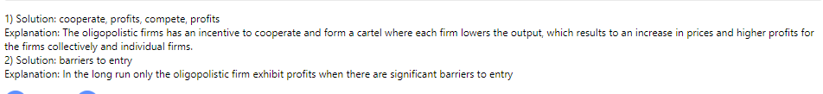

**28.**

