# ABSTRACT

This recommendation report provides an informative overview of three electrically powered lawn tractors offering a comparative analysis of their features, performance, and price. The aim is to assist you in making informed decisions when choosing a lawn tractor.

The first one is the Troy-Bilt XP 42 in 56-Volt MAX 60 Ah Battery Lithium-Ion electric Drive Cordless Riding Lawn Tractor which features a powerful 56-volt maximum lithium-ion battery with three brushless motors. Its cordless design ensures handle-free operation, eliminating the need for gas and minimizes emissions. With its ability to mow up to two acres per charge, it is very efficient and affordable at about $4799.00 with a three-year warranty.

The second one is John Deere’s X350R Lawn Tractor with a 42-inch Rear-Discharge Deck which is designed for efficient grass clipping management. With a 21.5-hp iTorque Power System, it boasts a dependable electric power source, eliminating the need for gasoline and reducing environmental impact. It also offers a large capacity rear happer that is easily emptied from the operator seat. Its price is currently $5999.00 USD with a four-year warranty.

The third one is Cub Cadet’s XT1 LT42E Electric Riding Mower which offers the convenience of electric power that mows up to 3.5 acres or 1.5 hours on a single charge. This electric riding power is designed for quiet operation with no engine maintenance, no oil changes, no bolts, and no gas for an easy-to-use mowing experience. Its price is currently at $6499.00.

Electrically Powered Lawn Tractor Recommendation Report

By

Daniel Lam 40248073

A report submitted in partial fulfilment of the requirements of ENCS 282

Concordia University

August 9th, 2023

# 1. INTRODUCTION

### In recent years, the world has witnessed a paradigm shift towards sustainable practices across various sectors, and landscaping and lawn maintenance are no exception. As concerns about environmental conservation, noise pollution, and greenhouse gas emissions continue to escalate, traditional gas-powered lawn tractors are facing scrutiny for their contributions to these issues. In response, a new generation of electrically powered lawn tractors has emerged, offering a compelling alternative for homeowners and commercial landscapers alike. This recommendation report delves into the benefits and considerations of adopting electrically powered lawn tractors, highlighting their environmental advantages, performance capabilities, and economic feasibility. By exploring the technological advancements, operational efficiencies, and long-term implications of transitioning to electric lawn tractors, this report aims to provide a comprehensive understanding for stakeholders looking to make informed decisions about their lawn maintenance equipment. As we navigate the intersection of sustainable technology and landscaping practices, the insights presented in this report will guide readers in embracing electric lawn tractors as a pivotal step towards achieving both ecologically conscious and aesthetically pleasing outdoor spacing

### 2. PROBLEM

This section describes the issues related to purchasing an electrically powered lawn tractor. As such, the following criteria below are evaluated to ensure the best satisfaction of the buyer. This report aims to provide the best solutions for Mr. Grenier’s shopping.

## 2.1 Price

## Price is a crucial criteria when evaluating electrically powered lawn tractors, as it directly impacts the budget allocation for the purchase. While electric models generally tend to have a higher upfront cost compared to their gas-powered counterparts, it's essential to consider the long-term savings that may arise from reduced fuel consumption and maintenance costs. Evaluating price should involve a comparison of various electric models within the desired budget range.

## 2.2 Performance and Durability

## Performance encompasses multiple aspects, including cutting efficiency, power output, battery capacity, and maneuverability. Examining power specifications, such as motor wattage and torque, will indicate the tractor's capability to handle various terrain types and grass heights. Battery capacity and charging times play a critical role in uninterrupted operation, especially for larger properties. The tractor's maneuverability, turning radius, and ease of handling are also pivotal in ensuring efficient mowing and navigating obstacles.

## 2.3 Additional Features

The availability of additional features can significantly enhance the usability and convenience of an electric lawn tractor. Features such as adjustable cutting heights, mulching and bagging options, LED lights for low-light mowing, and ergonomic seating contribute to a more tailored and user-friendly experience. can be complex and difficult. Safety features like automatic shut-off when obstacles are detected can mitigate accidents during operation.

### 3. SOLUTION ANALYSIS

## 3.1 Troy-Bilt: Troy-Bilt XP 42 in. 56-Volt MAX 60 Ah Battery Lithium-Ion Electric Drive Cordless Riding Lawn Tractor

Home Depot’s selection of lawn tractors is a great place to search. It features a special model from the company Troy-Bilt to solve this problem: the Troy-Bilt XP 42 in. 56-Volt MAX 60 Ah Battery Lithium-Ion Electric Drive Cordless Riding Lawn Tractor.

This recommendation report highlights the merits of the battery-powered Troy-Bilt Super Bronco 46E XP riding mower as an ideal solution for efficient and eco-friendly lawn maintenance. Eliminating the need for gas cans and oil changes, this electrically powered tractor features a robust brushless motor that propels it to mow expansive areas of up to 2 acres with a runtime of approximately 1.5 hours on a single charge. The design encompasses a spacious Step-Thru frame that facilitates effortless ingress and egress, coupled with an adjustable high-back seat for enhanced comfort during operation. Noteworthy is the rear hitch, which enables swift attachment of various tow-behind accessories such as dump carts, spreaders, and aerators (attachments available for separate purchase). A distinctive advantage of this electric tractor is its remarkable noise reduction, rendering it up to 65% quieter than its gas-powered counterparts. With its impressive features and sustainable attributes, the Troy-Bilt XP 42 in. exemplifies a practical and environmentally conscious choice for seamless lawn maintenance operations.

The lawn tractor’s price is $4799.00 with the possibility of monthly payment of $800.00 over 6 months (no interest if paid in full within 6 months) with Home Depot. A purchase with Home Depot will also grant a 5-year limited warranty on all parts except for the battery which only lasts 3 years.

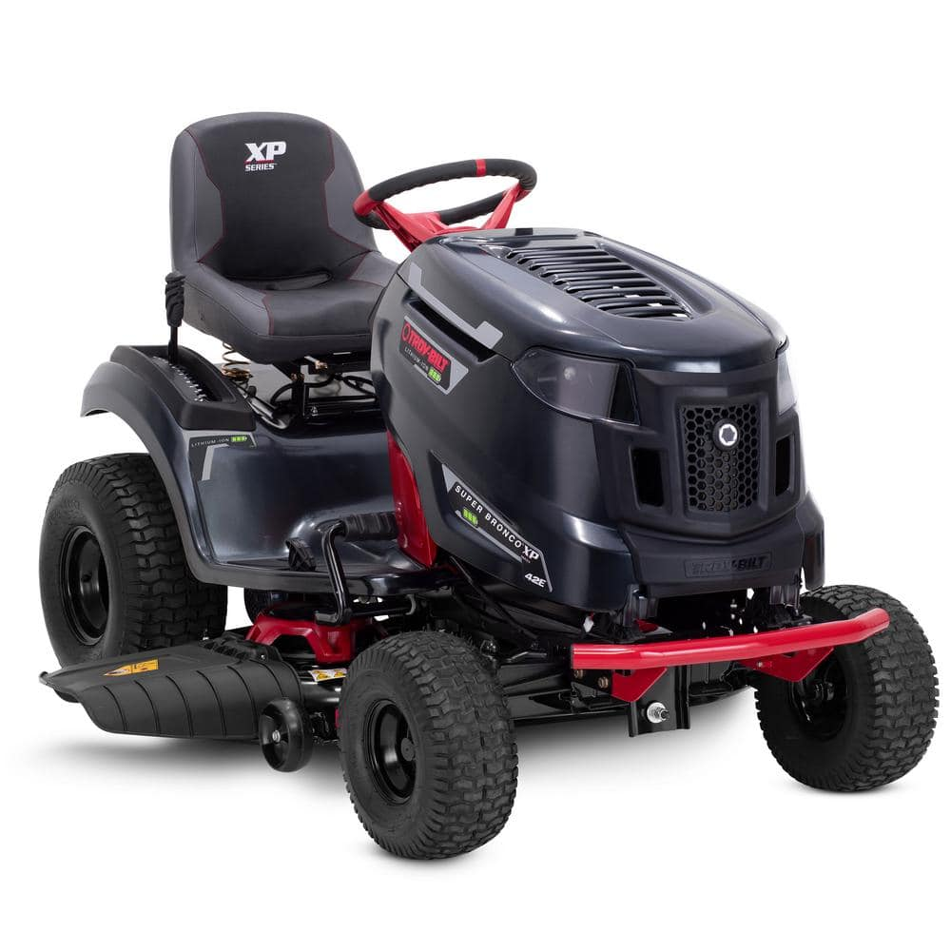

Figure 1: Photograph of the Troy-Bilt Lawn Tractor [1]

Features:

1. Energy Efficient: The mower is equipped with a powerful 56-Volt lithium-ion battery and three efficient brushless motors, ensuring dependable and consistent performance.
2. Extended Battery Life: The mower is capable of mowing expansive lawns of up to 2 acres, delivering up to 1.5 hours of continuous runtime on a single battery charge. The mower can be charged to 85% capacity in less than 4 hours, minimizing downtime and optimizing efficiency.
3. Comfortable Design: The step-through frame design facilitates effortless entry and exit from the mower, enhancing user convenience.
4. Easy Navigation: With a 16-inch turning radius, the tractor offers easy navigation around trees and landscaping, even in confined spaces.
5. Additional features: The 42-inch twin-bladed deck guarantees a precise and uniform cut, while the two anti-scalp deck wheels prevent turf damage.

To conclude, the Troy-Bilt electrically powered lawn tractor is a great choice for criteria regarding cost, performance, and additional features. A realistic picture of the lawn tractor is shown to demonstrate the aesthetic of the structure.

## 3.2 John Deere: X350R Lawn Tractor with 42-inch Rear-Discharge Deck

The X350R Lawn Tractor with a 42-inch Rear-Discharge Deck presents a formidable solution for efficient and versatile lawn maintenance. Powered by a robust 21.5-hp (16.0-kW) iTorque™ Power System, this tractor ensures reliable performance, capable of tackling various mowing tasks with ease. The 42-inch (107 cm) Edge™ Rear-discharge Deck delivers exceptional cutting precision, producing a clean and uniform finish across the lawn. Notably, the large capacity rear hopper facilitates effortless disposal of grass clippings and other debris, all conveniently operated from the comfort of the operator's seat. The inclusion of a 4-year/300-hour bumper-to-bumper warranty further underscores the manufacturer's commitment to quality and durability. With its powerful engine, efficient deck design, ergonomic features, and comprehensive warranty coverage, the X350R Lawn Tractor stands as a dependable choice for maintaining a pristine and well-groomed lawn.

Figure 2: Photograph of John Deere’s X350R Lawn Tractor [2]

Features:

1. Powerful Engine: The tractor is powered by a John Deere iTorque Power System, a combination of engine features and an exclusive hood design that provides superior lugging ability, even cooling, and durability. A large 44.3 cu in. (726-cc), 21.5-hp (16-kW) engine has plenty of power and torque for superior performance. The larger, more powerful engine also allows the engine in the rear-discharge tractor to be operated at a lower 3100-rpm speed for quieter operation.
2. Sharp Mower Deck: The 42-inch Rear-Discharge Rear-Collect Mower Deck is designed to deliver a clean and precise cut across the lawn.
3. Removable Rear Hopper: The rear hopper boasts a generous capacity and can be effortlessly emptied, adding to the convenience of the operation.
4. Snow Removal: Lawn tractor owners can add a John Deere snow blower or front blade to make quick work of moving snow whenever the need arises. Weather enclosure and tire-chain attachments add comfort and performance.

To conclude, the X350R model is an amazing choice if you are looking for a jack-of-all trade. It comes with amazing durability for harsh Canadian weather conditions for a higher price value. Note that the lawn tractor is currently priced at 5,999.00$ and it comes with multiple offers and discounts including a 0% APR fixed rate for 36 months and free delivery if the tractor is bought online. An exclusive 4-year or 300-hour (whichever comes first), single-source, bumper-to-bumper warranty is standard for all John Deere X300 Series Tractors. Please refer to Figure 2 to view the overall appearance of the X350R Lawn Tractor with 42-inch Rear-Discharge Deck.

## 3.3 Cub Cadet: XT1 LT42E

The XT1 LT42E Lawn Tractor represents a stride forward in the realm of modern lawn care technology. Anchored by a commanding 56 Volt MAX, 60Ah, 3000Wh lithium-ion battery, this model introduces a new dimension of eco-consciousness and practicality to yard maintenance. Charging convenience is elevated through compatibility with a standard 110-Volt outlet, ensuring seamless integration into daily operations. Central to the XT1 LT42E's profile is its remarkable capacity to cover substantial areas, capable of mowing up to 3.5 acres or sustaining continuous operation for 1.5 hours on a solitary charge, all without experiencing power fade. A swift recharge cycle, approximately 4 hours, contributes to optimizing operational intervals, a critical factor in maintaining an efficient lawn care routine. Facilitating its performance is a resilient 13-gauge, 42-inch twin blade deck that accommodates side discharge functionalities. This construction guarantees precision and uniformity in grass cutting across various terrains, underscoring its practical versatility. As such, the XT1 LT42E Lawn Tractor effectively redefines lawn care dynamics, presenting an amalgamation of ecological consciousness, operational efficiency, and pragmatic design.

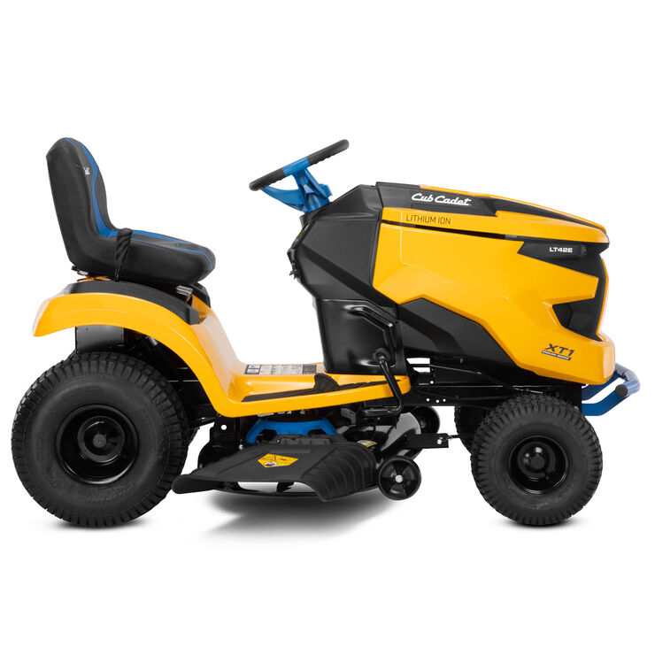

Figure 7: Side View of the XT1 LT42E.

Features:

1. Less Maintenance: No need for gas, oil changes, spark plugs, belts or even pulley maintenance.
2. No Power Fade: The lithium-ion technology allows for full speed and consistent, high-powered performance without fading.
3. Premium Cut: Two brushless motors deliver power to a 13-gauge steel, direct drive, twin blade cutting deck.
4. Comfortable Seating: Premium 15-inch adjustable cut-and-sew seat with 10o incline and slide slope.
5. Easy-to-use Automotive-Inspired Handling : Optimized steering system delivers a one-touch 16-inch turn radius. Additionally, it is very easy to turn on the engine with a single button push powering on and cruise control to maintain a desired speed for consistent mowing.
6. Zero Emissions: No exhaust, carbon monoxide or unburned hydrocarbons from the on-board source of power.
7. Powerful Illumination: LED highlights provide comfortable and precise cutting at dawn or dusk.

To conclude, the XT1 LT42E is a great overall model for buyers that are looking for an environmentally friendly yet powerful lawn tractor. With its comfortable seating and easy handling, it is very beginner friendly for any farmers who are looking for their first lawn tractor purchase. The major downside is that since it is a popular model, it is priced quite high, and it quickly sells out. Currently, the price of the model is listed at $6,299.00. Additionally, it is backed by a 3-year limited residential and 4-year limited battery warranty.

# 4. SOLUTIONS ANALYSIS

In the table below, the rows will represent the evaluation criteria and the columns will represent the options mentioned in section 3. A checkmark is selected for the winner of the criteria. Criterions such as aesthetics are subjective despite all three options being amazing choices.

The criterions selected for the tractor’s purchase are ordered in order of importance:

1. Performance: This criterion is picked first as the main selling factor of the tractor is how performant it is based on its battery duration and how sharp it can mow lawns.
2. Price: The price criterion falls second to durability since cheaper prices do not guarantee a long-lasting investment. However, it is still a very important factor as the buyer will want to save as much money as possible for the best investment.
3. Additional Features: Additional features such as an included rear happer are always nice accessories to include to allow additional usage for the user. Snow resiliency is considered as an additional feature as opposed to performance as it requires additional parts for dealing with snow.
4. Aesthetic: A beautiful and eye-catching lawn tractor may provide further satisfaction to the owner as it is a feature that is strongly associated with the price paid.

Table 1: Criteria Analysis of Each Electrically Powered Lawn Tractor

|  |  |  |  |
| --- | --- | --- | --- |
| Criteria | Troy-Bilt XP 42 in. 56-Volt MAX | John Deere X350R Lawn Tractor | Cub Cadet XT1 LT42E |
| Performance |  |  | ✔ |
| Price | ✔ |  |  |
| Additional Features |  | ✔ |  |
| Aesthetic |  |  | ✔ |

# 5. RECOMMENDATION AND CONCLUSION

Based on the following information, the order of recommendation are ordered as below:

1. Cub Cadet’s XT1 LT42E Lawn Tractor
2. John Deere’s X350R Lawn Tractor with 42-inch Rear-Discharge Deck
3. Troy-Bilt XP 42 in. 56-Volt MAX

Based on your farm’s needs, the number one recommendation for your chosen lawn tractor is the XT1 LT42E by Cub Cadet. This is due to the sheer immense land that you own for your farm, which is over 300 acres large. With the XT1 LT42E’s remarkable ability to mow up to 3.5 acres on a single charge, it proves to be the most performant one out of the three recommended choices. The only downside is the high price range, but the performance and the aesthetic of the lawn mower will be worth it. Since it can cover more land per charge, it will use less electricity overall, thus being the most environmentally friendly.

The X350R Lawn Tractor is the next best choice due to the multiple additional features that it can offer, the main one being the rear happer. While not as performant, the ease of use of the additional features makes it a very reliable choice for any weather condition while you are farming. With a mediocre price range, the tractor’s powerful engine still makes up for it with decent performance.

Finally, the Troy-Bilt XP 42 is the final recommended choice for tractors. Despite being the cheapest out of the three choices, the two other tractors outclass it either in performance or in additional features. It is still a relatively good choice for its price range, however for your huge land area, it requires way too much recharge while you mow your lawn. It also does not come with any extra features so it will only be usable during the summer.

In conclusion, the XT1 LT42E is the best electrically powered lawn tractor out of three choices due to its performance and aesthetic. With that said though, all three choices are still excellent choices while providing their own strengths.

# REFERENCES

[1] Home Depot, Troy-Bilt XP 42 in. 56-Volt MAX 60 Ah Battery Lithium-Ion Electric Drive Cordless Riding Lawn Tractor, <https://www.homedepot.com/p/Troy-Bilt-XP-42-in-56-Volt-MAX-60-Ah-Battery-Lithium-Ion-Electric-Drive-Cordless-Riding-Lawn-Tractor-Super-Bronco-42E-XP/324852011>, August 7, 2023.

[2] John Deere, X350R Lawn Tractor with 42-inch Rear-Discharge Deck, <https://www.deere.com/en/mowers/lawn-tractors/x300-series/x350-lawn-tractor-collect-mower/>, August 7, 2023.

[3] Cub Cadet, XT1 LT42E (2021), <https://www.cubcadet.ca/en/electric-riding-lawn-mowers/xt1-lt42e-2021/33ABA7ES710.html>, August 7, 2023.