**Written Tutorial Assignment 1:**

**Short Technical Description of Corkscrew**

1. Write a Mechanism Description for a Simple Corkscrew

A corkscrew is a manual device designed for the purpose of extracting corks from wine bottles, preserving the integrity of the cork and preventing it from breaking apart. It is a common tool found in households, bars, and restaurants, primarily used by wine enthusiasts and professionals to access the contents of a sealed bottle. The overall size of the corkscrew is typically small and portable, making it easy to store and carry and it is usually made of metal giving off a silverish color. Some of its components include the worm, the handle and may even feature additional components, such as a foil cutter.

The first component consists of a helical or spiral-shaped metal worm. It is a pointed metallic shaft with a threaded, corkscrew-like structure and is the primary component responsible for penetrating and gripping the cork during the extraction process. The metal worm is typically made of stainless steel or other durable metals, ensuring strength and corrosion resistance. Its helical shape allows it to efficiently pierce and engage with the cork.

The second component consists of the handle where the user grips and operates to turn the metal worm into the cork. It provides the necessary torque and leverage to rotate the metal worm, driving it deeper into the cork and facilitating its removal. The handle can vary in size and material, ranging from a simple T-shaped plastic grip to a more elaborate ergonomic design made of wood, metal, or plastic.

Handle

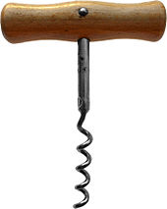

Worm

Figure 1: Anatomy of a Basic Corkscrew

In conclusion, the basic corkscrew is a manual tool designed to effortlessly remove corks from wine bottles. Its main components, the helical metal worm and the handle, work in unison to penetrate and extract the cork effectively.

1. Write one comparison paragraph & compare your mechanism description with the one from Wikipedia

From Wikipedia, this is their description of a simple corkscrew:

*“A corkscrew is a tool for drawing corks from wine bottles and other household bottles that may be sealed with corks. In its traditional form, a corkscrew simply consists of a pointed metallic helix (often called the "worm") attached to a handle, which the user screws into the cork and pulls to extract it. Corkscrews are necessary because corks themselves, being small and smooth, are difficult to grip and remove, particularly when inserted fully into an inflexible glass bottle. More recent styles of corkscrew incorporate various systems of levers that further increase the amount of force that can be applied outwards upon the cork, making the extraction of difficult corks easier.” – Wikipedia [1].*

Comparing both versions, they are both very similar. Both descriptions name and describe the more specific parts of the corkscrew such as the “worm” and explain how to use a corkscrew to its intended effect. The main difference is that in my version, my description focuses more on explaining the main components of the corkscrew while Wikipedia gives a briefer description and focuses more on the various different types of corkscrews.

1. Write a Mechanism Description for Sommelier Knife. (NO WING CORKSCREW).

A sommelier knife, also known as a waiter's friend or wine key, is a multi-functional tool designed for wine professionals and enthusiasts to open wine bottles with ease and finesse. It combines several essential functions, making it a versatile and indispensable tool for anyone involved in wine service or enjoyment. The main purpose of a sommelier knife is to provide a convenient and efficient tool for opening wine bottles. It allows users to remove the cork cleanly and safely, ensuring the wine's integrity remains intact during the opening process. It typically has a slender and elongated shape, resembling a pocketknife and often made of high-quality stainless steel, ensuring durability and resistance to corrosion. The color and finish may vary, with common options being silver, black, or metallic. The components of the object feature a corkscrew, a foil cutter knife, and a bottle opener integrated into a single unit.

The first component is the corkscrew which is a helical or spiral-shaped metal worm attached to the sommelier knife. It is the primary component responsible for penetrating and removing the cork from the wine bottle. Its purpose is to penetrate the cork's center and securely grip it, allowing the user to extract the cork smoothly and without causing damage to the cork or wine and is made of stainless steel and has a spiral-shaped structure that allows it to efficiently penetrate the cork.

The second component is the foil cutter knife, which is a small, sharp blade integrated into the sommelier knife, often hidden within the handle. Its purpose is to cut and remove the foil or seal covering the top of the wine bottle before using the corkscrew and ensures a clean cut and prevents any unwanted debris from falling into the wine The foil cutter knife is usually a small, curved blade concealed within the sommelier knife's body usually made out of metal with a sharp side that allows to cut efficiently.

The third component is the bottle opener which is a flat metal lever or hook located at the opposite end of the corkscrew. Its purpose is to assist in removing the metal caps or closures commonly found on some wine bottles and is typically made out of a flat and sturdy piece of metal, often with a hook-like design, that allows the user to pry off bottle caps with ease.

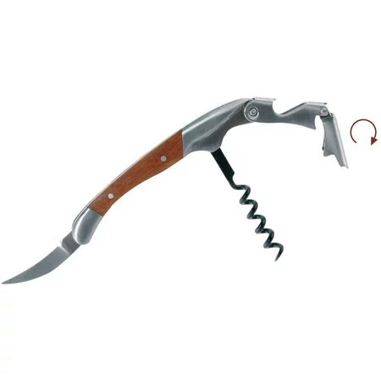

Bottle Opener

Corkscrew

Foil cutter knife

Figure 2: Anatomy of a Sommelier Knife

In conclusion, a sommelier knife is a versatile and practical tool designed to open wine bottles efficiently and professionally. Its main components, including the corkscrew, foil cutter knife, and bottle opener, ensure a seamless and hassle-free wine-opening experience.

# References

Wikipedia. (n.d.). *Corkscrew*. Retrieved from Wikipedia: https://en.wikipedia.org/wiki/Corkscrew