**Written Tutorial Assignment 1:**

**Short Technical Description of Corkscrew**

**Suggested approach:**

1. Show picture of Simple Corkscrew (Below), and get students to write a short description.

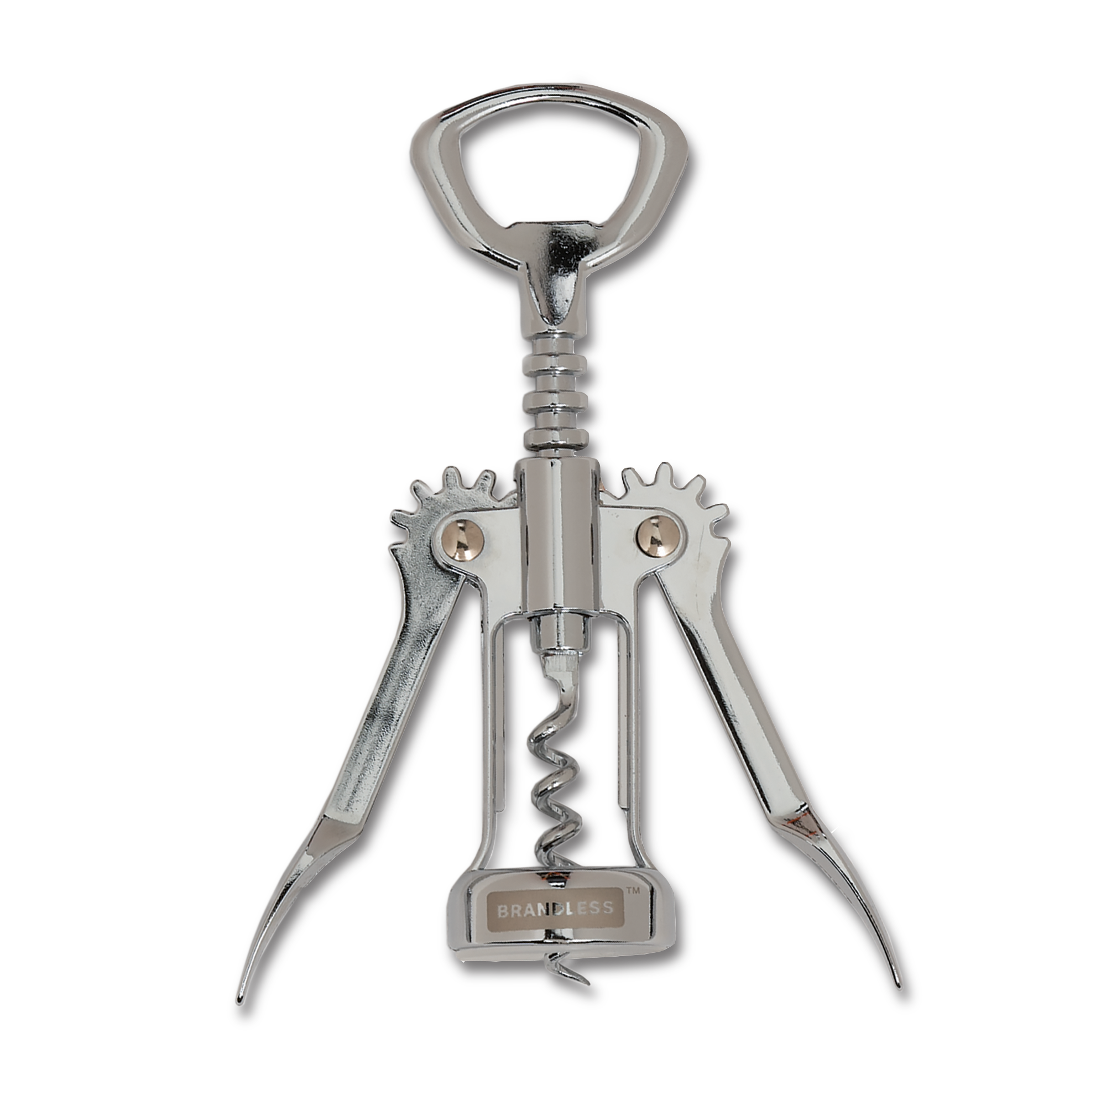

A corkscrew is a handy tool for opening wine bottles. It has a handle, a spiral metal worm, and sometimes a bottle opener or foil cutter. By twisting and pulling, it helps remove the cork effortlessly. Corkscrews come in different styles and materials, making them suitable for various preferences. They make opening wine bottles quick and convenient.

1. Take feedback and write up a ‘merged’ version on board, including different elements to make it as substantial as possible.

A corkscrew is a compact and versatile tool designed specifically for opening wine bottles. It typically consists of a handle, a spiral-shaped metal worm, and sometimes includes additional features such as a bottle opener or foil cutter. The worm is inserted into the cork, and by twisting and pulling, the corkscrew provides leverage to effortlessly extract the cork from the bottle. Corkscrews come in various styles and materials, ranging from classic stainless steel to sleek modern designs, catering to different preferences and aesthetic tastes. With its simple yet effective design, the corkscrew is an essential accessory for wine enthusiasts and professionals alike, making the process of opening a bottle of wine quick and convenient.

1. Show definition/description of Simple Corkscrew from Wikipedia (Below), and get students to compare this with their own version/s.

From Wikipedia, this is their description of a simple corkscrew:

*“A corkscrew is a tool for drawing corks from wine bottles and other household bottles that may be sealed with corks. In its traditional form, a corkscrew simply consists of a pointed metallic helix (often called the "worm") attached to a handle, which the user screws into the cork and pulls to extract it. Corkscrews are necessary because corks themselves, being small and smooth, are difficult to grip and remove, particularly when inserted fully into an inflexible glass bottle. More recent styles of corkscrew incorporate various systems of levers that further increase the amount of force that can be applied outwards upon the cork, making the extraction of difficult corks easier.” – Wikipedia*

Comparing both versions, they are both very similar. Both descriptions name and describe the more specific parts of the corkscrew such as the “worm” and explain how to use a corkscrew to its intended effect. The main difference is that in my version, my description focuses more on how corkscrews are mainly used by wine enthusiasts due to its design while Wikipedia’s version focuses more on the various different types of corkscrews.

1. Show students picture of Wing Corkscrew and/or Sommelier Knife (Below), and instruct students to draft, write and edit their own mechanism description and hand it in at the end of the lesson (100 – 125 Words, 30 – 40 minutes?)

The Sommelier Knife, also known as a waiter's corkscrew, is a versatile tool used by sommeliers and wine enthusiasts for the opening and serving of wine bottles. This compact and ergonomic device incorporates multiple functions into its design. The knife consists of a sturdy handle, typically made of wood or stainless steel, which provides a comfortable grip. It features a sharp, serrated blade at one end, used for cutting the foil or plastic seal that covers the bottle's cork. At the opposite end, a double-hinged fulcrum system with a helical screw allows for effortless cork extraction. Additionally, the Sommelier Knife includes a small, fold-out lever that provides leverage to remove the cork from the bottle with minimal effort. This essential tool combines functionality, ease of use, and portability, making it a must-have for wine professionals and enthusiasts alike.