1.1.4.3

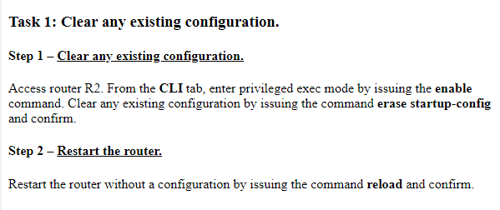

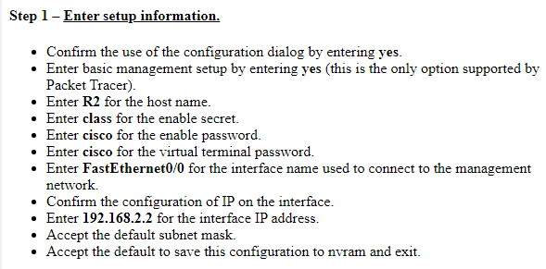

**Enter R2 for the host name**

En

Conf t

Hostname R2

**Enter class for the enable secret**

Enable secret class

**Enter cisco for the enable password.**

Conf t

Line vty 0 4

Password cisco

**Enter FastEthernet0/0 for the interface name used to connect to the management network.**

Show ip interface brief

Conf t

Interface f0/0

**Enter 192.168.2.2 for the interface IP address.**

Ip address 192.168.2.2 255.255.255.0