CÔNG CỤ TCPDUMP

Cài đặt tcpdump bằng lệnh sau:

dnf install -y tcpdump

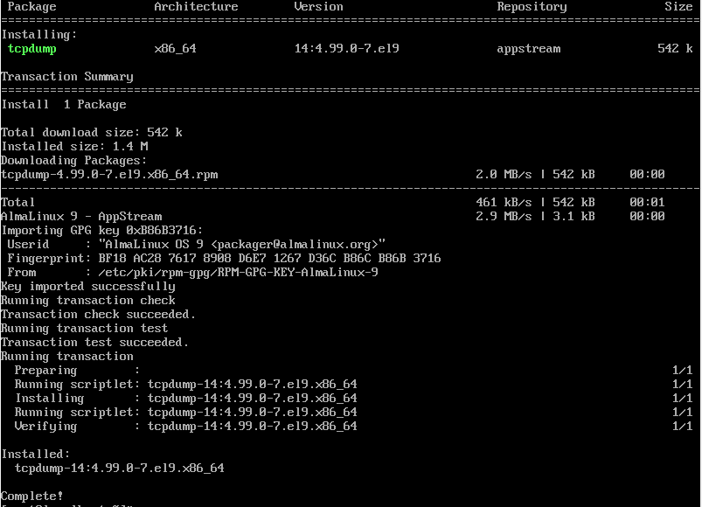

**Tcpdump -c**

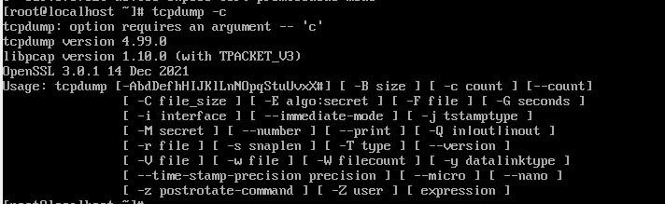

**Tcpdump -D**

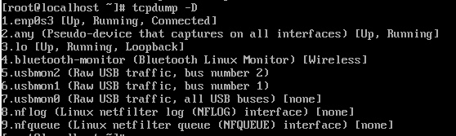

**Tcpdump -H**

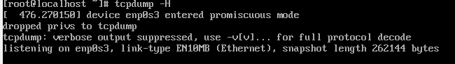

**Tcpdump -i**

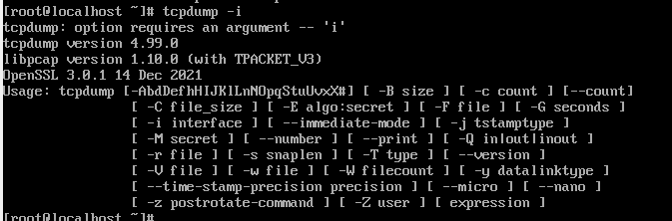

**Tcpdump -P**

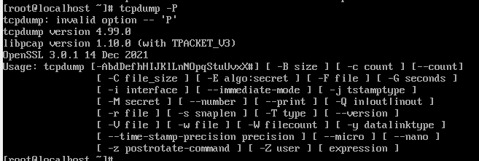

**Tcpdump -r**

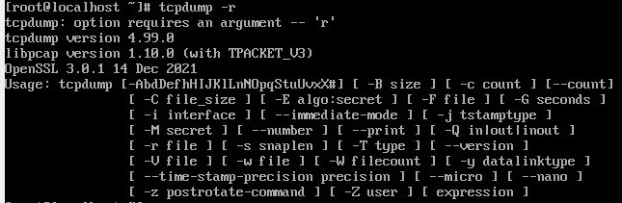

**Tcpdump -S**

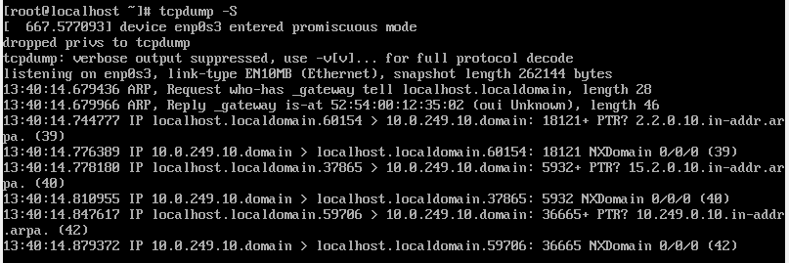

**Tcpdump -T**

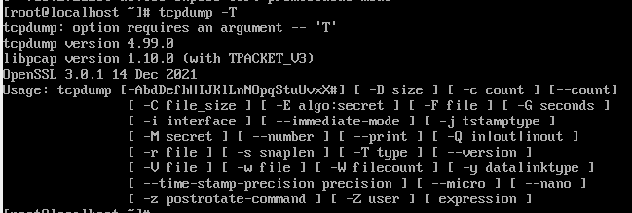

**Tcpdump -w**

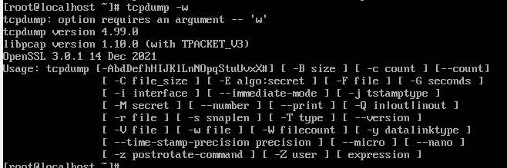

**Tcpdump -x**

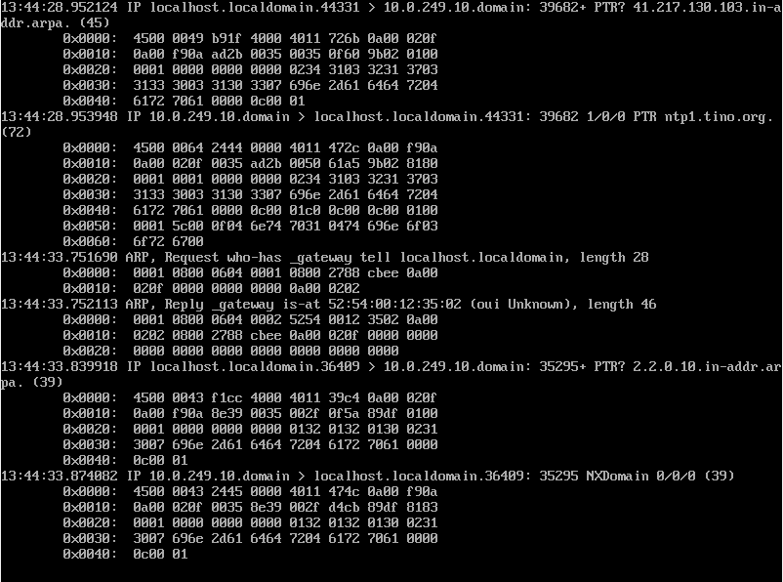

**Tcpdump -X**

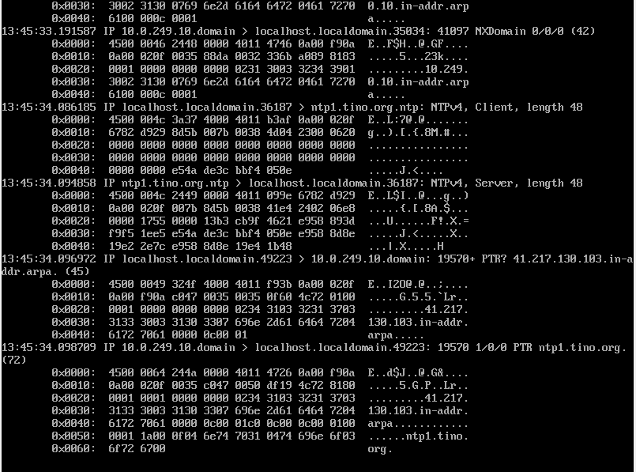

**Tcpdump -port**

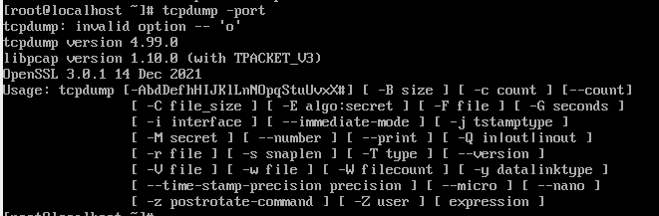

**Tcpdump -src**



**Tcpdump -dst**

