ROAD MAP BACK-END (ENGLISH - VIETNAMESE)

# 1/ Internet.

## 1- How does the internet work?

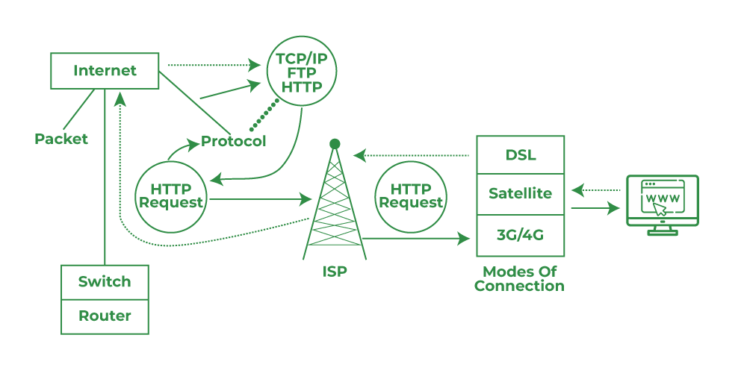

- The Internet is a network of networks. It works by using a technique (công nghệ) called packet switching(chuyển mạch gói), and by relying on standardized(chuẩn hoá) networking protocols(giao thức) that all computers can interpret(thông dịch).There are two main concepts that are fundamental(cơ bản) to the way the Internet functions: *packets* and *protocols*.

### Parkets:

- In networking, a packet is a small segment(bộ phận) of a larger message. Each packet contains(chứa) both data and information about that data. The information about the packet's contents is known as the "header," and it goes at the front of the packet so that the receiving machine knows what to do with the packet. To understand the purpose(mục đích) of a packet header, think of how some consumer products(sản phẩm tiêu dùng) come with assembly instructions(hướng dẫn lắp ráp).

- When data gets sent over(được gửi qua) the Internet, it is first broken up(chia) into smaller packets, which are then translated(biến đổi) into bits. The packets get routed(định tuyến) to their destination(điểm đến) by various networking devices(thiết bị mạng khác nhau) such as routers and switches. When the packets arrive at their destination, the receiving device reassembles(tập hợp) the packets in order(theo thứ) and can then use or display the data.

- Compare(so sánh) this process to the way the United States' Statue of Liberty(tượng nữ thần tự do của Mỹ) was constructed(được xây dựng). The Statue of Liberty was first designed and built in France. However, it was too large to fit onto a ship(phù hợp với con thuyền), so it was shipped(được vận chuyển) to the United States in pieces(mảnh/miếng), along with(cùng với) instructions about where each piece belonged. Workers who received the pieces reassembled them into the statue that stands today in New York.

- While this took a long time for the Statue of Liberty, sending digital information(thông tin số) in smaller pieces is extremely(vô cùng) fast over the Internet. For instance(Ví dụ), a photo of the Statue of Liberty stored(lưu trữ) on a web server can travel across(du lịch quanh) the world one packet at a time and load on someone's computer within milliseconds.

- Packets are sent across the Internet using a technique called packet switching. Intermediary routers and switches(bộ dịnh tuyến và bộ chuyển đổi trung giang) are able to process(xử lý) packets independently(độc lập) from each other, without accounting(tính toán) for their source or destination. This is by design so that no single connection dominates(chiếm ưu thế) the network. If data was sent between computers all at once with no packet switching, a connection between two computers could occupy(chiếm)) multiple(nhiều) cables(dây cáp), routers, and switches for minutes at a time(nhiều lần trên phút). Essentially(thiết yếu), only two people would be able to use the Internet at a time(cùng lúc) — instead of an almost(gần như) unlimited number of people, as is the case(trường hợp) in reality.

### Prorocols(Giao thức):

- Connecting two computers, both of which may use different hardware and run different software, is one of the main challenges that the creators of the Internet had to solve. It requires(yêu cầu/đòi hỏi) the use of communications techniques(kỹ thuật giao tiếp) that are understandable(có thể hiểu được) by all connected computers, just as(giống như) two people who grew up in different parts of the world may need to speak a common(phổ thông/phổ biến) language to understand each other(hiểu nhau).

- This problem is solved with standardized protocols(tiêu giao thức chuẩn hoá). In networking, a protocol is a standardized way of doing certain(chắc chắn) actions and formatting(định dạng) data so that two or more devices are able to communicate with and understand each other.

- There are protocols for sending packets between devices on the same network (Ethernet), for sending packets from network to network ([IP](https://www.cloudflare.com/learning/ddos/glossary/internet-protocol/)), for ensuring(đảm bảo) those packets successfully arrive in order ([TCP](https://www.cloudflare.com/learning/ddos/glossary/tcp-ip/)), and for formatting data for websites and applications ([HTTP](https://www.cloudflare.com/learning/ddos/glossary/hypertext-transfer-protocol-http/)). In addition to these foundational(nền tản) protocols, there are also protocols for routing, testing, and [encryption](https://www.cloudflare.com/learning/ssl/what-is-encryption/)(mã hoá). And there are alternatives(lựa chọn thay thế) to the protocols listed above(được liêt kê ở trên) for different types of content — for instance, streaming video often uses [UDP](https://www.cloudflare.com/learning/ddos/glossary/user-datagram-protocol-udp/) instead of TCP.

- Because all Internet-connected computers and other devices can interpret and understand these protocols, the Internet works no matter who or what connects to it.

## 2- What is HTTP?