Profibus PA
At the beginning you will notice that the Profibus DP cable is changed from a familiar purple cable to a black Profibus PA cable via a DP/PA coupler. So, the only actual Profibus DP device is the Phoenix Contact distributed IO station, the rest of the field devices.
Profibus PA is a Profibus cable which contains the voltage for the device, but the transfer speed of the network will be slower.
The DP/PA couple requires some special Profibus connection settings on your Device/Network Configuration, which will be shown on this document.

Identifying the devices

You should be able to find all the bus devices shown in topology diagram (in files directory).
Use CPU as shown in the picture below (check the actual device from course tutor)
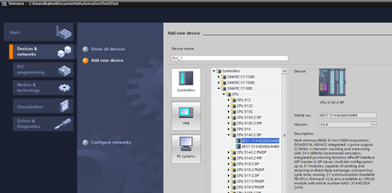

Devices and configuration
Set the DP interrupt mode for all devices to DPV0, as shown in the picture below
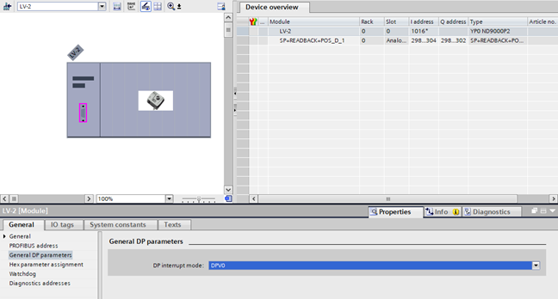

Drive
Drive type is ACS-880 and it is using the Profibus adapter FPBA-01 as used in logical contols – course. It is using also the same PPO –type.

Things the operator needs:
Start/Stop commands
Running/Stopped status
Speed setpoint
Current speed

Check out what kind of interlocks should be for pump and make those interlocks into your program. At least running dry should be prevented.

Distributed IO
The distributed IO controls the parts of the process that are “hardwired” instead of fieldbus connected.
The modules that should be inserted into the device can be seen here. NOTE! The IO addresses are completely random, decide the addresses for you project on your own:

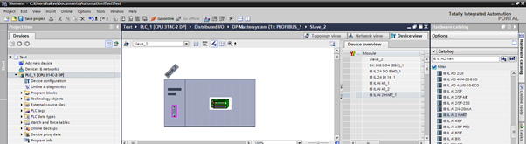

Analog inputs are using something else range than Siemens components, because these cards are made by Phoenix Contact. Study what is the range and use it. Note you have done one scaling block already on previous course. You can use also that. In real life that IO is looking like this:
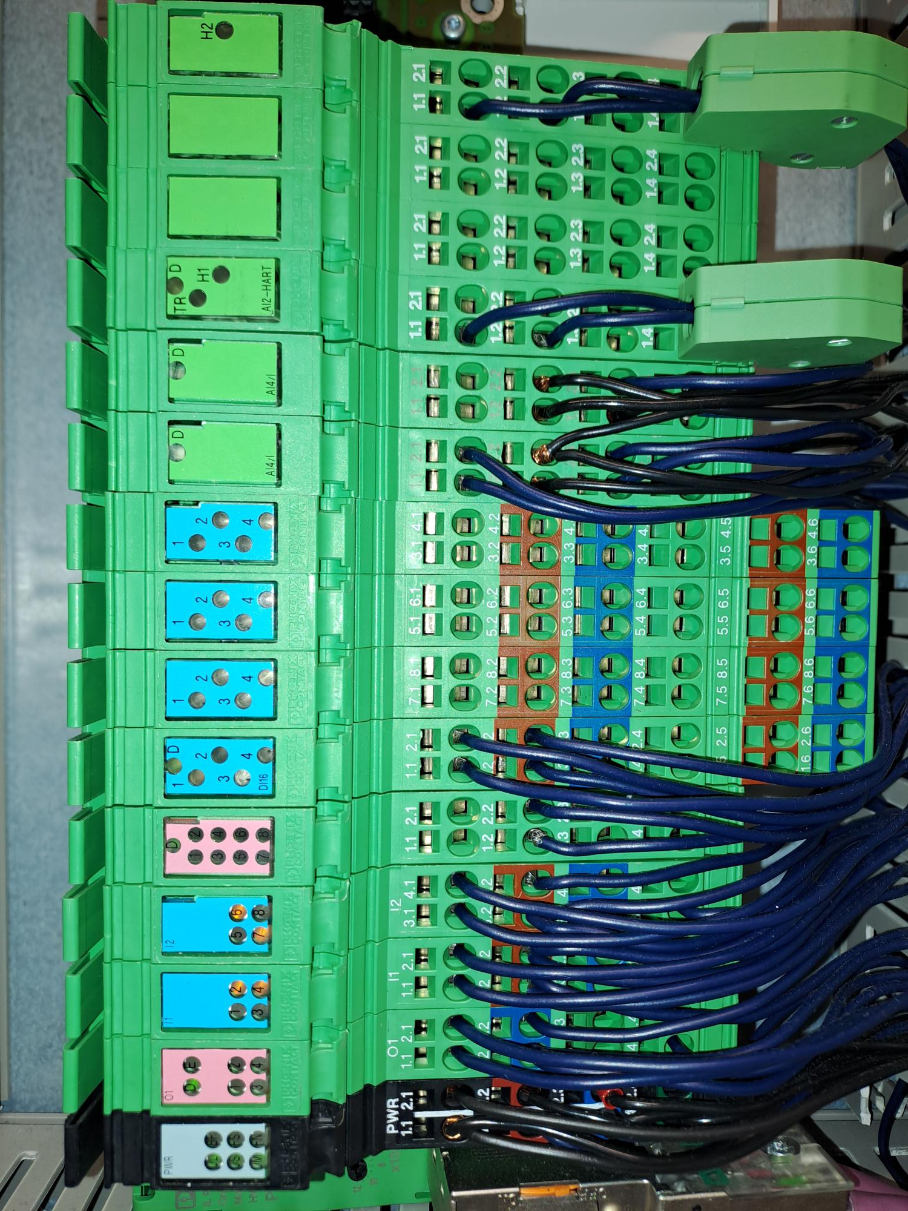

Things the operator needs:
Scaled measurement values
Open/Close command for the On/Off valves, and the status of the command (since there is no feedback from the valve, you must assume that open command = valve open)
Level switch states, should be 1/True when the switch is ok

Control Valves
The modules that should be inserted into the device can be seen here. NOTE! The IO addresses are completely random, decide the addresses for you project on your own:

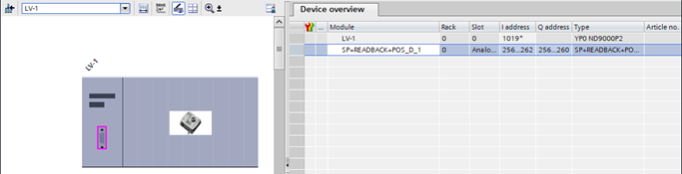

To determine how to control the device and how to read the device data, you must read the manual. Note that the valve controller requires a hexadecimal value (byte) in the Status-byte to allow any actions. Read the manual.

ND9000P (neles.com)

Things the operator needs:
- Position setpoint
- Current position

Profibus settings
To allow the system to use Profibus DP and Profibus PA, you must increase the Watchdog time of the Profibus due to the PA being slower.
To change the settings, go to the network view. You can only do this after you have inserted at least one device to the project and created the Profibus network.
Click the Profibus Network, select the Network Settings menu and change the profile to User-Defined.

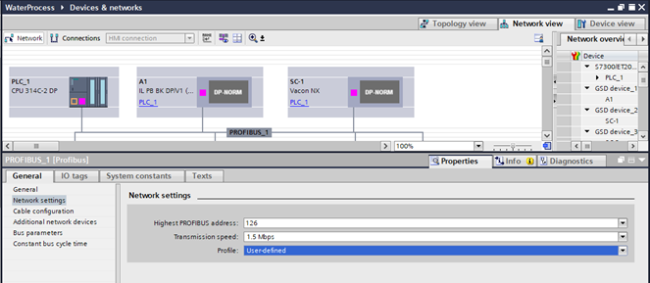

Then change the Bus parameters

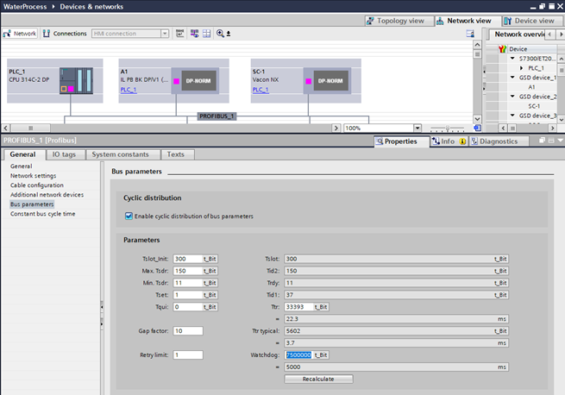
Change the Watchdog to 750 0000 and press enter, so that the time below is 5000ms. This is enough for our application. Nothing else needs to be changed. Do not press the Recalculate button.

Control loop
You also need to create a control loop for the application according to separate assignment (different loops in two modules). You only need to use the P and I terms of the controller, no need to use the Derivation. So, you need to use the Siemens PID-controller block, but only the P and I terms, so it’s actually a PI-controller. READ THE MANUAL OF THE PID CONTROLLER!
While the loop is in automatic mode, all the other devices should be in automatic mode also. The easiest way to create the Auto/Manual mode for the devices is to have a SR-flipflop for each controllable device. When the SR is True, the device is in automatic mode and the operator cannot operate the device. When the device is in manual mode (SR is False), the operator can operate the device from the control room/HMI. The switching between auto and manual should be possible from the HMI and by the PLC program.
For example:
When you set the control loop to automatic mode, the pump should also be set to auto. Some other devices should be set to auto too, to allow the water to flow. Ask for the details from course tutor. Figure out what you need to do to achieve the proper functionalities.
NOTE! When the device is in manual mode, no commands from the PLC program are allowed. The operator must set the device to manual mode before they can command the device.

Sequence

Create a sequence that implements at least the following logic:
- The sequence starts when the operator starts it from the control screen
- Open a route from Tank back to tank (closed loop, pump is returning all the liquid back to original tank)
  - Remember to set all necessary devices to automatic mode (A-mode)
- Use flow control loop (which you build yourself) to hold the water flow in the pipeline at 50% for 15 seconds
  - You’ll have to use some tolerance here, for example +-2%, depending on the tuning of your controller
  - Remember to set manual valves to right positions. It is normal task for operator.
  - If you want/need to, you can use two different paths for flow.
- Shut down pump and close the opened pipeline.

If you want, you can add more steps etc. These will have a positive impact on grading.
You could for example, create an automatic/manual mode for the sequence, and when the sequence is in automatic mode, the whole sequence will loop until manually stopped from the control screen. When in manual mode, the sequence will only execute once when started.

How to get information needed:
There are many documents in Moodle. If there is not all the information you need, try to find it somewhere. If you don’t find, ask.
You have many peer tutors. As in real life project, you must be active and get effect information. Ask from other students.

