**Rana Alshehri -2005625 - B8B - group6**

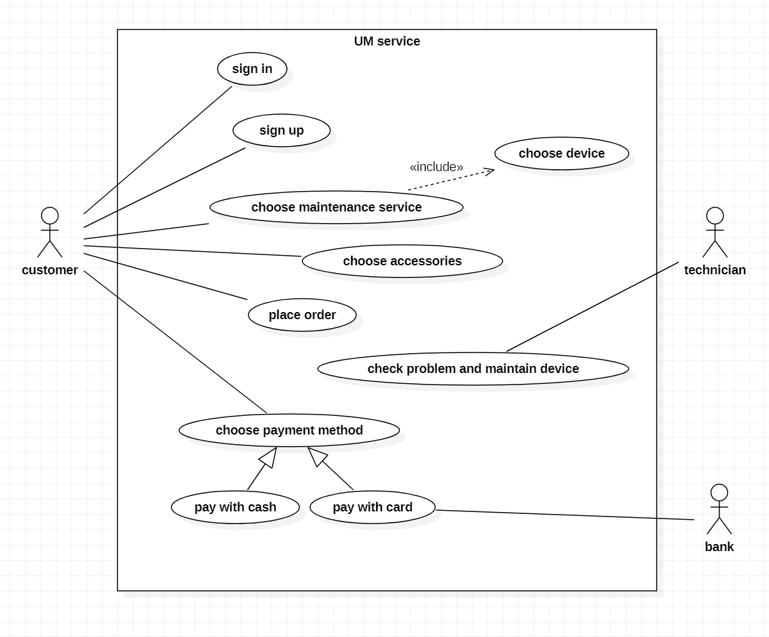

**Tabular description of sign in use case**

|  |  |
| --- | --- |
| UM service: sign in | |
| customer | **Actor** |
| The customer is authenticated, and the system displays a home page after user signed in by entering their phone number and password | **Description** |
| Phone number and password | **Data** |
| The customer choose language before using this function | **Stimulus** |
| The system displays a home page | **Response** |
| The customer sign in must be successful, in order to be able to access the home page | **Comments** |