WVS Tourism National Behavioral Pattern
Phase 1 & Phase 2
From WVS question selection and Hobby scoring to Birth-Country behavioral patterns

Project Overview
The project builds an explainable behavioral prior that can support tourism recommendations when a new user has little or no personal history. The result is intended as a weak cold-start signal, not as a statement that every person from the same country has the same preferences.
Stage | What was done
Phase 1 | Review WVS questions, select tourism-relevant signals, map questions to Survey Q4 Hobbies, and define transparent answer scoring.
Phase 2 | Apply the Phase 1 rules to actual WVS respondents, group results by Q266 Country of Birth, apply W_WEIGHT, and calculate Birth-Country Hobby / Category / Environment patterns.

Key Project Numbers
Metric | Result
WVS respondents | 97,220
Valid Q266 respondents | 93,440
Valid Birth-Country proxies | 152
WVS questions reviewed | 313
Tourism-relevant questions selected | 50
Unique questions used in Hobby mapping | 37
Question × Hobby relationships | 101
Tourism Hobbies | 9
Important: Q266 is Country of Birth. In this project it is treated as a Birth-Country / nationality proxy, not as confirmed legal nationality.

Files Used to Review the Work
The two Excel files below contain the detailed tables behind this document. The document explains the full logic; the Excel files are used when a detailed row-level check is needed.
File | Where to look | Purpose
WVS_Phase1_Question_Hobby_Scoring.xlsx | QUESTION_HOBBY_SCORING | Every Question × Hobby relationship, full WVS wording, Semantic Weight, answer scoring, and rationale.
WVS_Phase1_Question_Hobby_Scoring.xlsx | ALL_50_QUESTIONS | The 50 selected tourism-relevant WVS questions shown once each.
WVS_Phase1_Question_Hobby_Scoring.xlsx | QUESTION_HOBBY_MATRIX | Question × Hobby weight matrix used for the mapping heatmap.
WVS_Phase2_BirthCountry_Pattern_Results.xlsx | HOBBY_RESULTS | Final Birth-Country × Hobby signals, global baseline, relative signal, sample information, and ranking eligibility.
WVS_Phase2_BirthCountry_Pattern_Results.xlsx | CATEGORY_RESULTS / ENVIRONMENT_RESULTS | Category and Indoor / Outdoor / Both results.
WVS_Phase2_BirthCountry_Pattern_Results.xlsx | STATISTICAL_EFFECTS | Eta Squared, Omega Squared, and ICC checks for Hobby-level country-group differences.

Phase 1 — Question Selection and Tourism Mapping
The WVS questionnaire was not treated as a tourism survey. Questions were first audited for behavioral relevance. A question was retained only when its meaning could reasonably support a tourism-related behavioral construct. Politically specific, sensitive, or unsupported relationships were not used as Hobby evidence.
- 313 WVS questions were reviewed.
- 50 questions were retained as tourism-relevant.
- 37 unique questions were used in direct Question × Hobby mappings.
- Those 37 questions produced 101 Question × Hobby relationships because one question can support more than one Hobby.
Detailed data: WVS_Phase1_Question_Hobby_Scoring.xlsx → ALL_50_QUESTIONS — full list of the 50 selected questions without Hobby-level repetition.
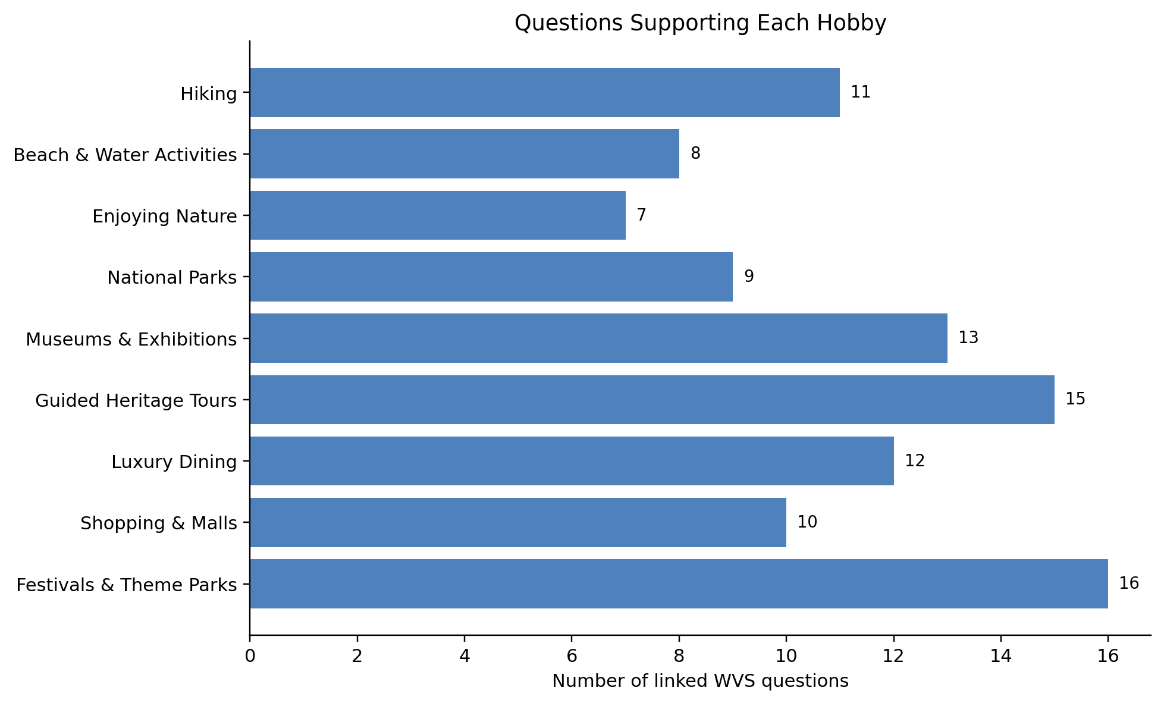
Question counts are based on the audited Phase 1 Question × Hobby mapping.
Important: Question count is coverage, not evidence quality. Semantic Weight and Evidence Tier are also required to understand how strongly each question supports a Hobby.

Question × Hobby Mapping
The main Phase 1 unit is one WVS Question × one Hobby relationship. The same WVS question may appear under several Hobbies, and each relationship can have a different Semantic Weight. This repetition is intentional, not a duplicate-data error.
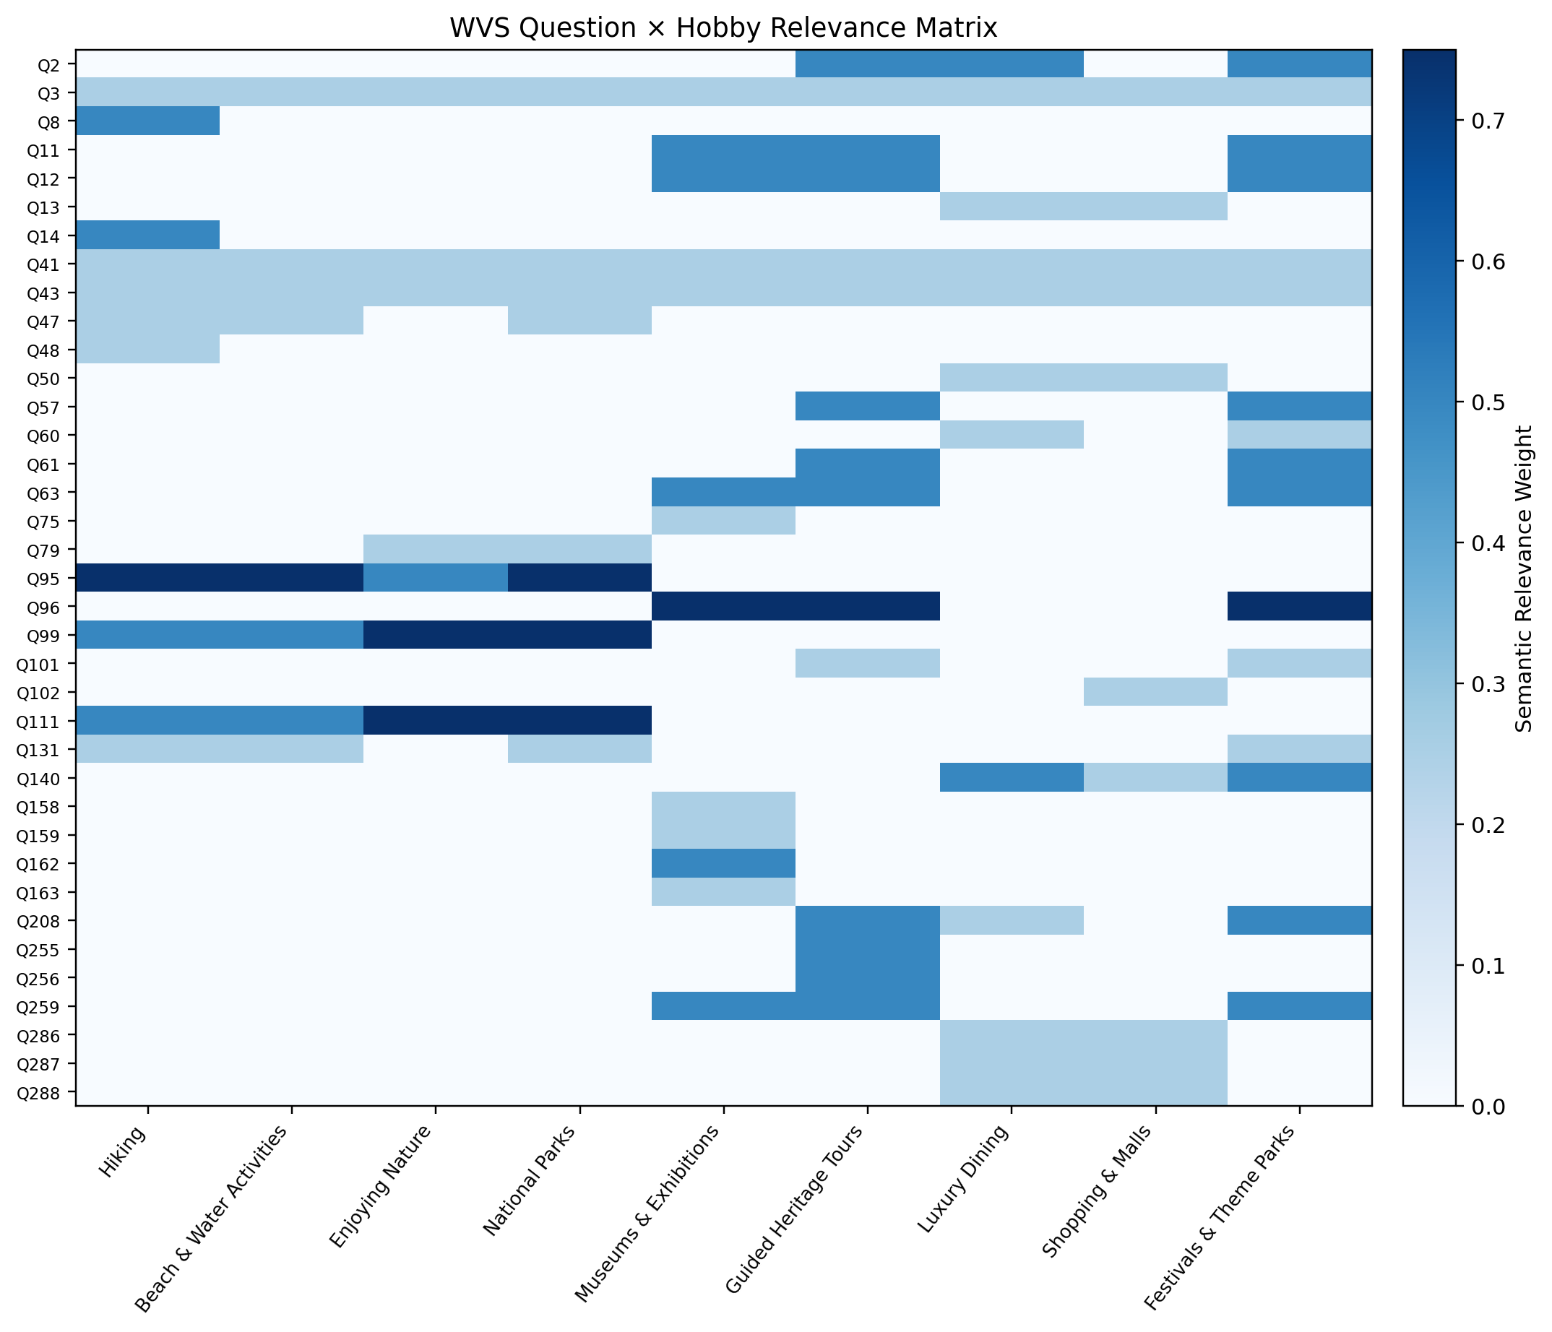
Rows = WVS questions. Columns = Survey Q4 Hobbies. Cell value = Semantic Relevance Weight.
Detailed data: WVS_Phase1_Question_Hobby_Scoring.xlsx → QUESTION_HOBBY_MATRIX — complete numerical matrix used for this heatmap.
Important: This is a mapping heatmap, not a confusion matrix. A confusion matrix requires predicted labels and ground-truth labels.

Example — Q95 Mapping and Answer Scoring
Q95 is a useful example because it shows both parts of the scoring design: the relationship between the question and each Hobby, and the evidence produced by the respondent answer.
Item | Actual value
WVS Question | Q95 — Sport or recreational organization, football/baseball/rugby team membership
Behavioral Construct | Active Recreation Participation
Hiking | Semantic Weight 0.75 — Tier B
Beach & Water Activities | Semantic Weight 0.75 — Tier B
National Parks | Semantic Weight 0.75 — Tier B
Enjoying Nature | Semantic Weight 0.50 — Tier C
The Semantic Weight answers: “How strongly does this question relate to this Hobby?” It is not the respondent score.
Q95 Answer | Response Evidence Score
0 — Don't belong | 0.00
1 — Inactive member | 0.50
2 — Active member | 1.00
Technical missing codes | Excluded / NaN
Detailed data: WVS_Phase1_Question_Hobby_Scoring.xlsx → QUESTION_HOBBY_SCORING — full question wording, weight, tier, response scoring, and mapping rationale for every Hobby relationship.

Scoring Method
The scoring keeps two concepts separate: Question-to-Hobby relevance and respondent answer evidence.

Question Coverage by Hobby
The chart below shows how many WVS questions support each tourism Hobby in the approved Phase 1 mapping. It measures mapping coverage, not the strength of the final Hobby preference.
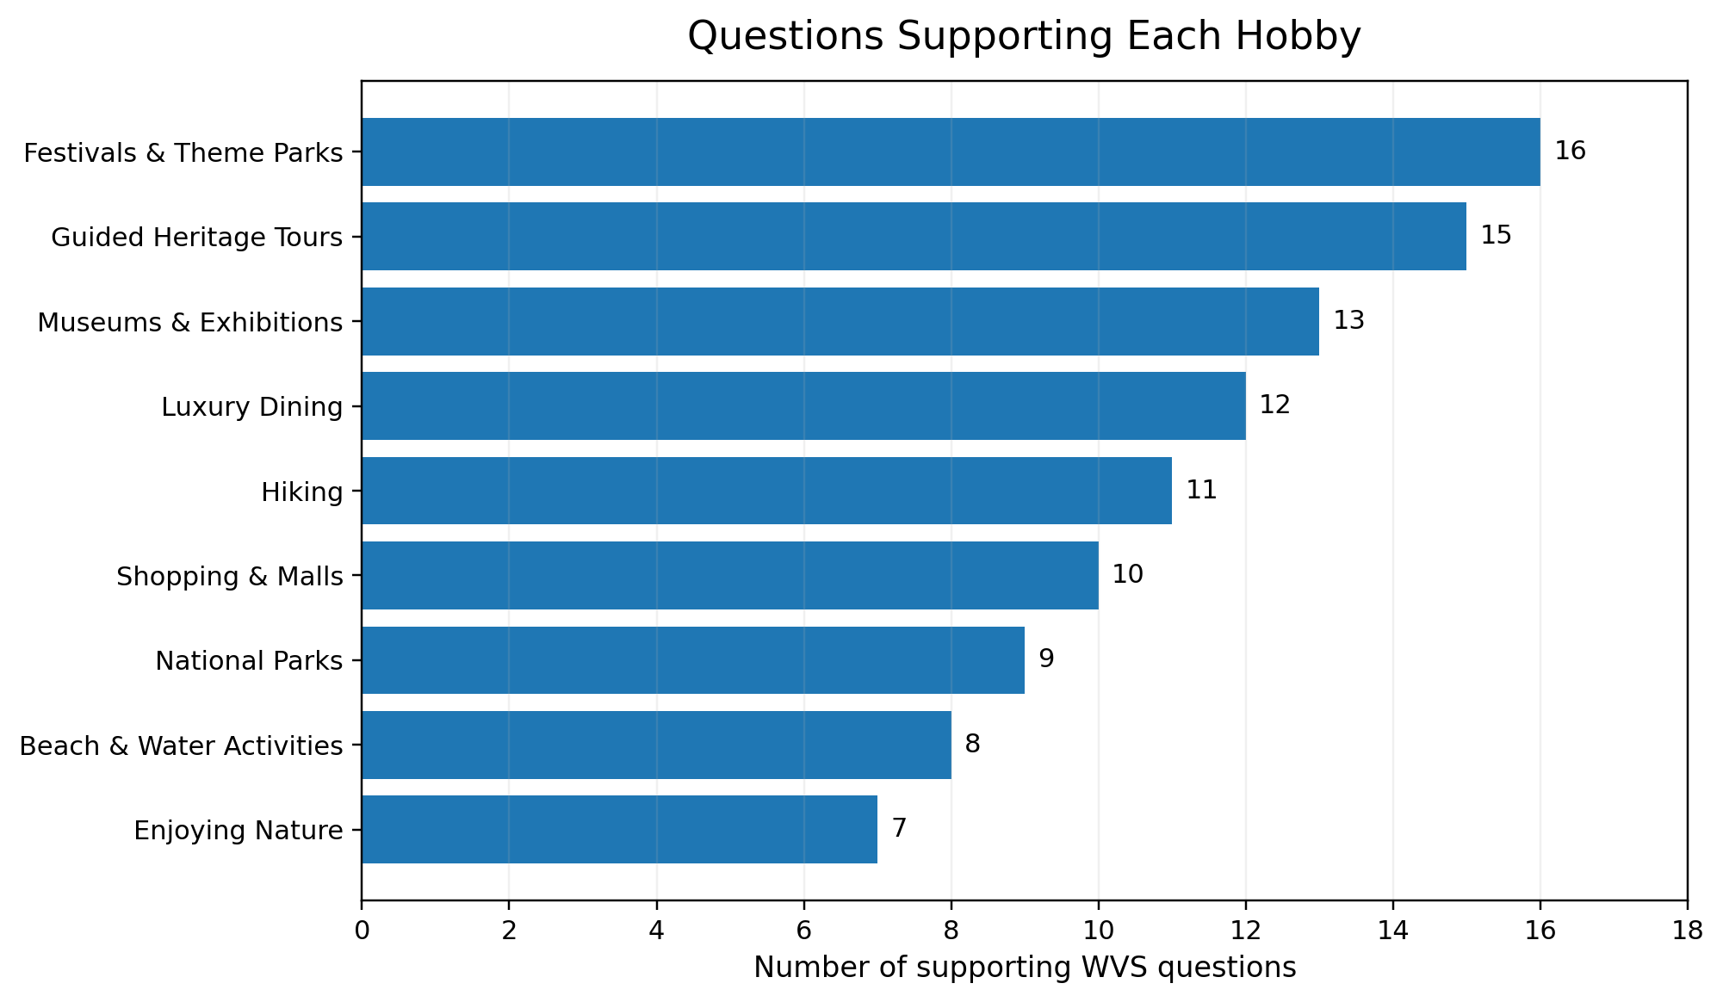
Important: these counts are Question × Hobby relationships. The same WVS question may support more than one Hobby, so the counts across Hobbies should not be interpreted as the number of unique WVS questions.
Concept | Meaning
Semantic Relevance Weight | Strength of the Question → Hobby relationship.
Response Evidence Score | Normalized 0–1 evidence produced by the respondent answer.
Question Contribution | Response Evidence Score × Semantic Relevance Weight.
Question Contribution = Response Evidence Score × Semantic Relevance Weight
Respondent Hobby Score = Σ Valid Question Contributions ÷ Σ Weights of Valid Answered Questions
Important: Missing / refused / not asked responses are excluded from the numerator and denominator. Missing answer does not mean zero preference.

Applying the Rules to WVS Respondents
Step | Action
1 | Calculate Hobby scores for each respondent using the Phase 1 rules.
2 | Read Q266 and map it to canonical Birth Country + ISO2 + ISO3.
3 | Group respondents by Q266 Country of Birth.
4 | Apply W_WEIGHT during aggregation.
5 | Calculate Hobby, Category, and Environment signals.
6 | Compare each Birth-Country score with the global WVS baseline.
Detailed data: WVS_Phase2_BirthCountry_Pattern_Results.xlsx → HOBBY_RESULTS — country-level Hobby outputs with signal, global baseline, relative score, sample size, coverage, and eligibility.

What the Birth-Country Pattern Represents
The final pattern is a vector across the 9 Hobbies rather than one label for a country. The same approach is also calculated for Categories and Indoor / Outdoor / Both.
Measure | Interpretation
WVS-Derived Signal | Absolute 0–100 display of the aggregated Hobby signal.
Global Baseline | Overall WVS weighted baseline for the same Hobby.
Relative vs Global | Country signal − global signal. This is the main measure of what is distinctive.
Quality fields | Raw N, Effective N, Question Coverage, and Ranking Eligibility.

How to Read the Environment Results
Each row in the Environment results represents one Birth Country × Environment result. Birth Country is derived from Q266, while ISO3 provides the standardized country code used for consistent identification across outputs. Environment identifies whether the derived signal relates to Indoor, Outdoor, or Both activities. WVS-Derived Signal (%) is the final weighted environment score for that Birth-Country group, while Global Baseline (%) is the overall weighted WVS reference score for the same environment. Relative vs Global (pp) is calculated as the country signal minus the global baseline, showing how far the group is above or below the overall WVS reference in percentage points. Raw N, Effective N, and Question Coverage (%) describe the amount and quality of evidence supporting the result. Eligible for Ranking indicates whether the row meets the project's defined quality requirements for comparison, and Country Rank shows its position among eligible Birth-Country groups for the same environment.
Detailed data: WVS_Phase2_BirthCountry_Pattern_Results.xlsx → ENVIRONMENT_RESULTS — Birth-Country × Environment signals, global baseline, relative signal, evidence-quality fields, eligibility, and ranking.
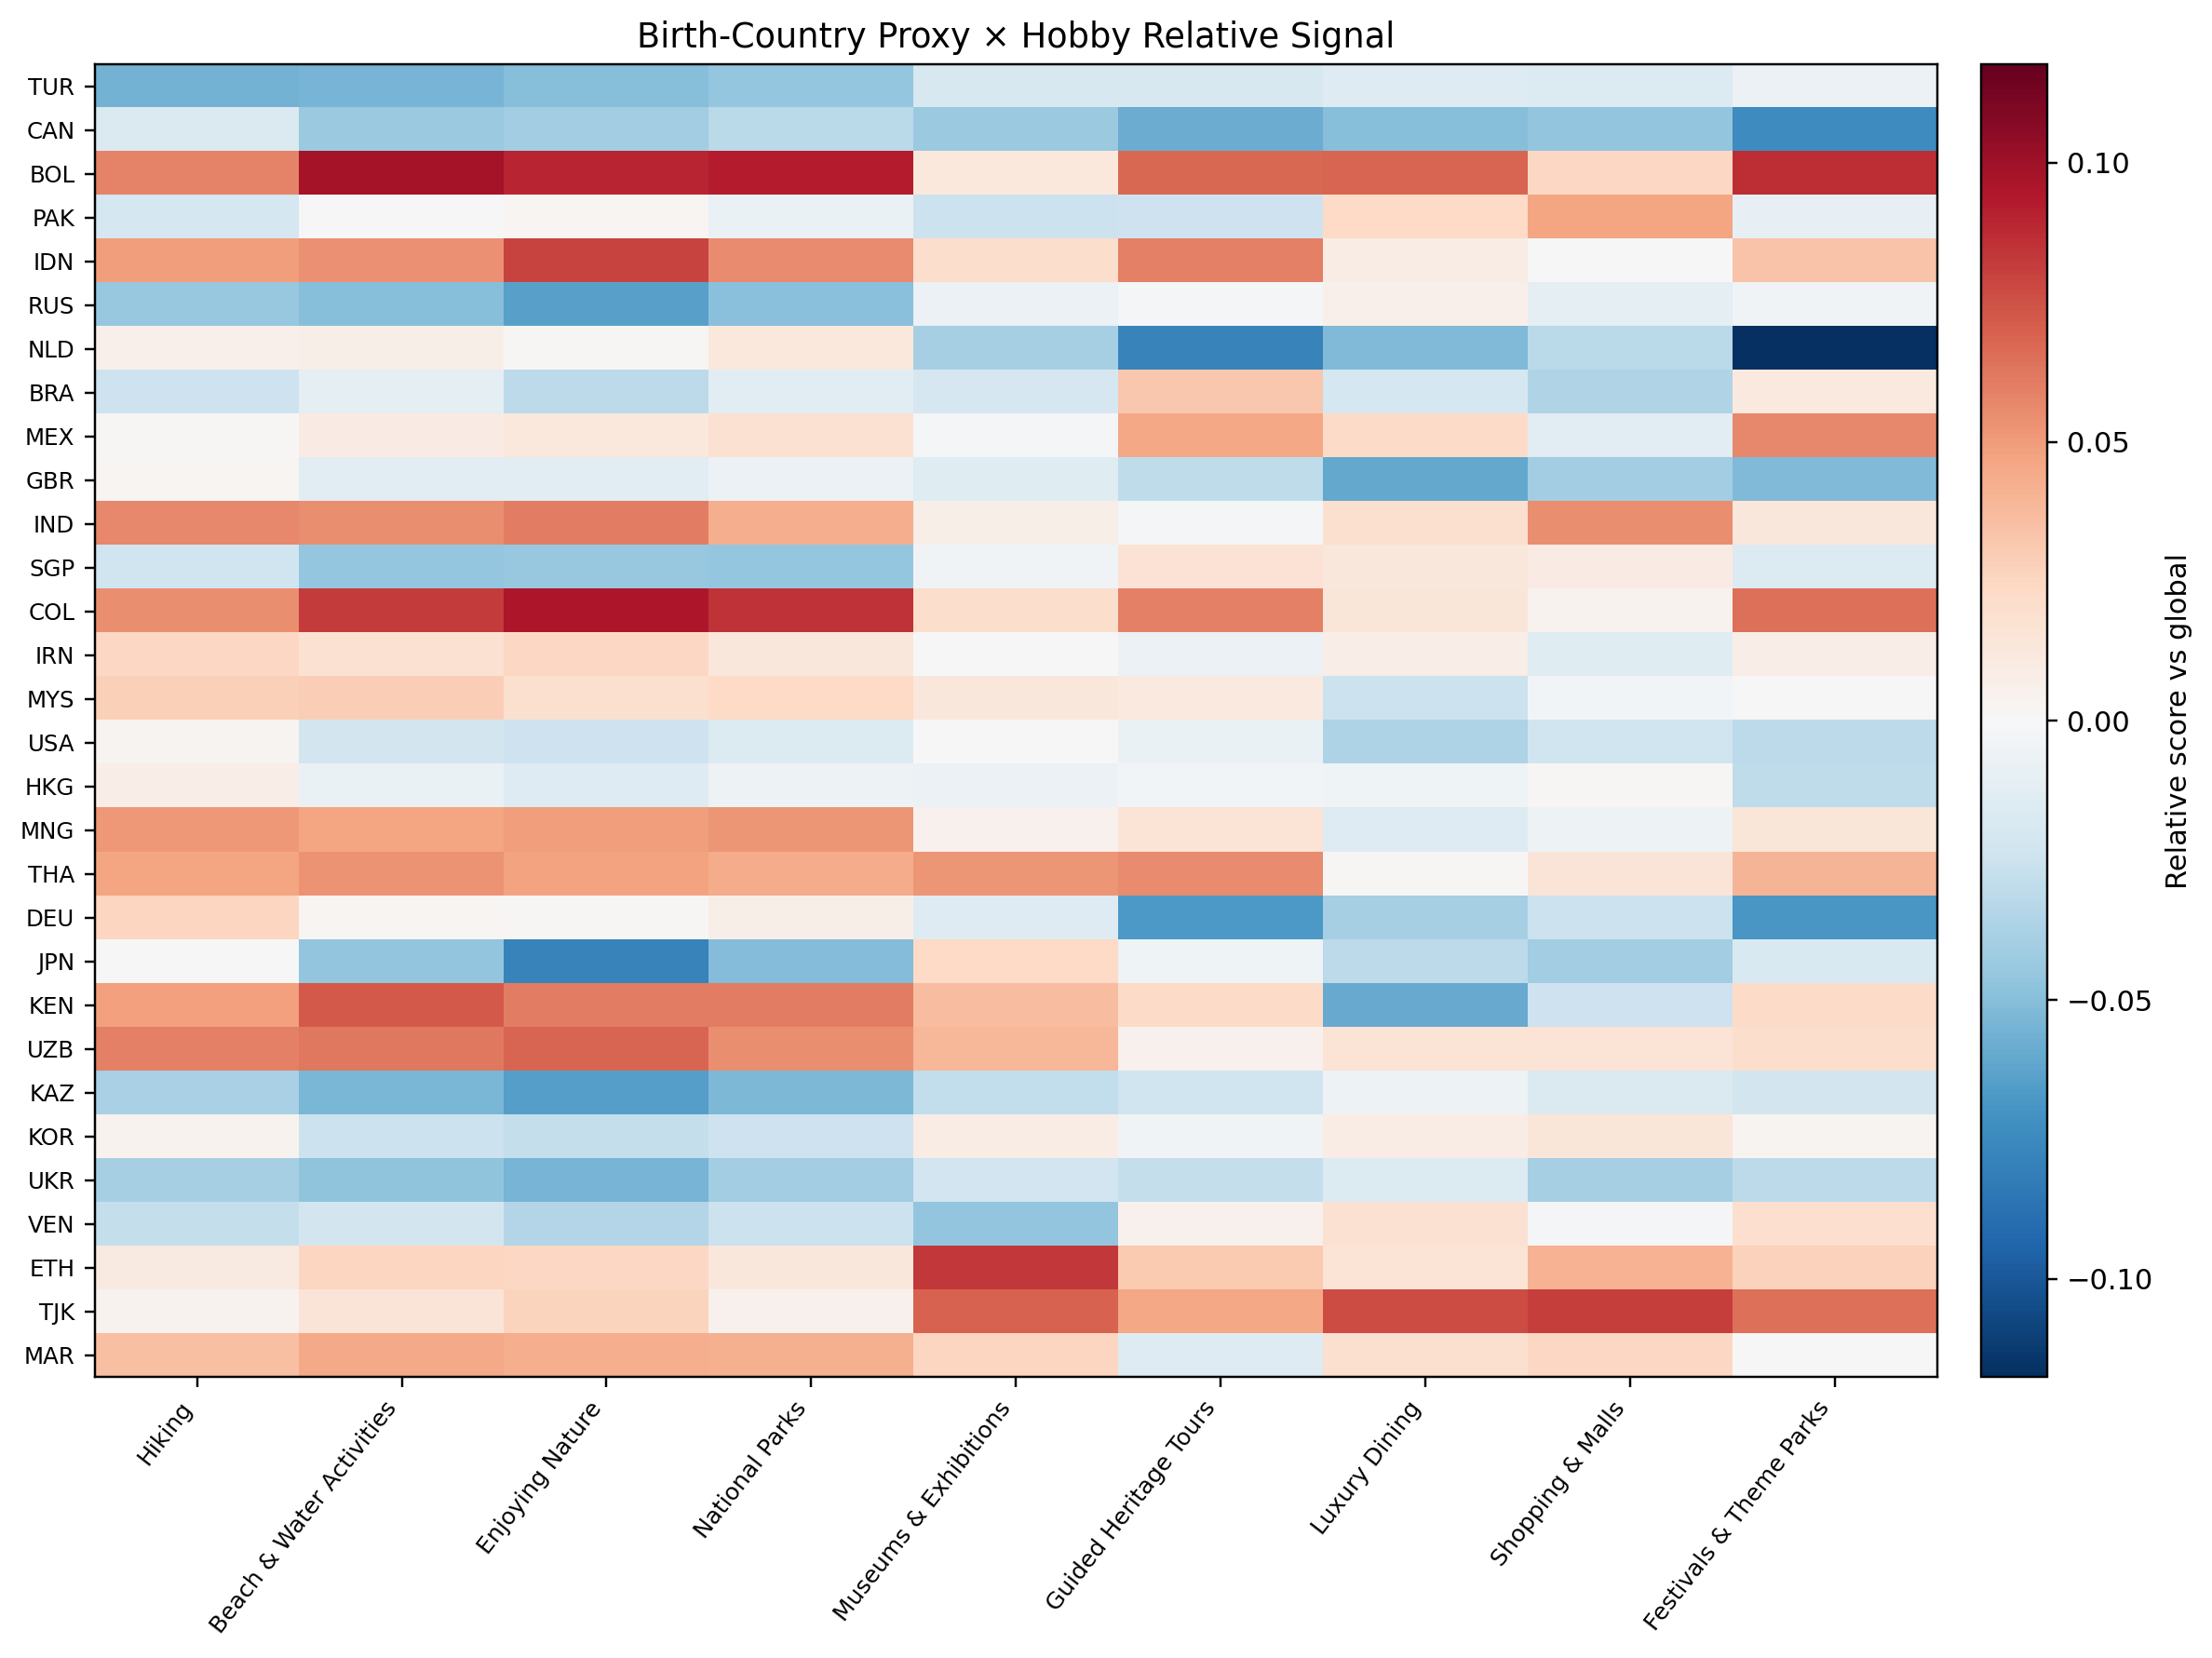
Relative-to-global Hobby pattern for a readable subset of eligible Birth-Country groups. Full results contain all 152 valid Birth-Country proxies.
Important: A score such as 48% is a WVS-derived signal. It does not mean that 48% of people from that country literally prefer the Hobby.

Real Result Example — India
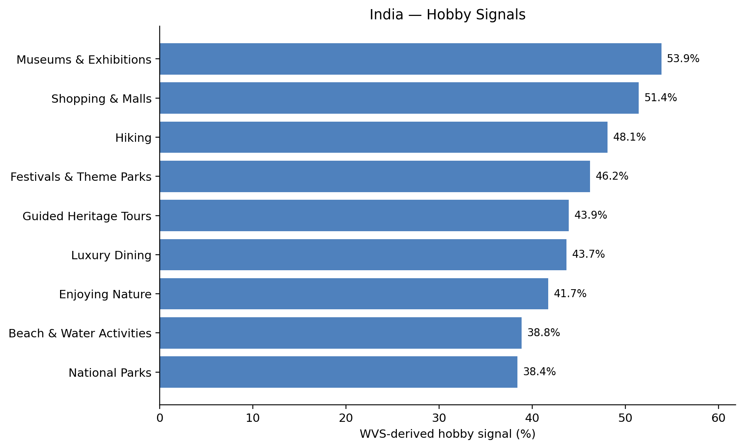
Absolute WVS-derived Hobby signals for Q266 Birth Country = India.
Metric | Actual result
Raw sample size | 1,873
Effective sample size | 1,573
Highest absolute Hobby | Museums & Exhibitions — 53.9%
Most distinctive relative signal | Enjoying Nature — +6.0 pp vs global
Hiking relative signal | +5.7 pp vs global
Hiking question coverage | 87.2%
This example shows why absolute and relative scores should be read together. Museums & Exhibitions is the highest absolute signal, while Enjoying Nature and Hiking are more distinctive relative to their global baselines.
Detailed data: WVS_Phase2_BirthCountry_Pattern_Results.xlsx → HOBBY_RESULTS — filter ISO3 = IND to inspect the exact rows behind this example.

Statistical Check — Are the Group Differences Measurable?
A visible heatmap difference is not enough by itself. Phase 2 also compares between-group and within-group variation. Eta Squared, Omega Squared, and ICC are retained as statistical diagnostics.
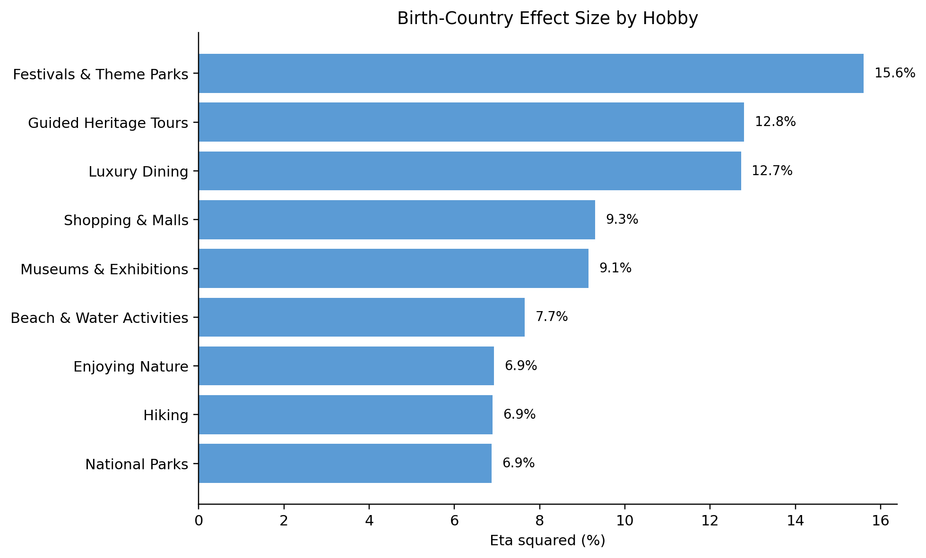
Eta Squared by Hobby. Higher values indicate stronger association between Q266 group membership and variation in that derived Hobby signal.
Hobby | Eta² | Omega² | ICC
Festivals & Theme Parks | 0.156 | 0.155 | 0.157
Guided Heritage Tours | 0.128 | 0.127 | 0.128
Luxury Dining | 0.127 | 0.126 | 0.128
Shopping & Malls | 0.093 | 0.092 | 0.093
Museums & Exhibitions | 0.091 | 0.090 | 0.091
Important: Effect size shows association with Birth-Country grouping. It does not show that Country of Birth causes the preference.
Detailed data: WVS_Phase2_BirthCountry_Pattern_Results.xlsx → STATISTICAL_EFFECTS — complete Hobby-level Eta², Omega², and ICC values.

Important Limitations
Limitation | What it means
Q266 | Country of Birth, not confirmed legal nationality.
WVS | A behavioral/value survey, not a direct tourism-preference survey.
Hobby signal | An inferred behavioral score, not a literal population percentage.
Semantic weights | Transparent and auditable, but not yet calibrated against real Survey ground truth.
Individual variation | People within the same Birth-Country group can differ substantially.

Next Step
The next step is validation against real Survey responses. The WVS-derived Hobby / Category / Environment signals can then be compared with explicit user choices, the semantic weights can be calibrated, and the appropriate cold-start weight can be determined empirically before recommendation-system integration.
Current stage | Status
Question selection and Question → Hobby mapping | Complete
Respondent scoring and Birth-Country pattern calculation | Complete
Survey validation | Next
Weight calibration | Future after validation
Recommendation-system integration | Future

