Spencer Pease

AMATH 481

Final – Option 5

**Background**

A Bose-Einstein Condensate (BEC) is one of the five states of matter. Created when a dilute gas of bosons is cooled to within a fraction of absolute zero, what distinguishes a BEC from other states of matter is that at these low temperatures, bosons will collapse into the same quantum energy state, acting indistinguishably from one another. Groups of particles will act as one “super particle”.

In a simplified model of BEC systems, the state of condensed particles is described by the Gross-Pitaevskii (GP) equations, listed below:

$$iψ_{t} + \frac{1}{2}∇^{2}ψ-{\left|ψ\right|}^{2}ψ +\left[{A }_{1 }\sin^{2}\left(x\right)+ {B }_{1}\right]\left[{A }_{2}\sin^{2}\left(y\right)+{B }_{2}\right]\left[{A }_{3 }\sin^{2}\left(z\right)+ {B }_{3}\right]ψ = 0$$

This system can be solved using numerical methods.

**Numerical Approach**

The first thing to notice about the GP equations is that, given a grid X, Y, Z, and parameters A, B, the only variable left unaccounted for is $ψ$. Moreover, this system is set up so that $ψ_{t}$ can be determined by $ψ$, meaning $ψ$ at a point in time can be calculated from $ψ$ the previous point in time. This is the perfect setup for iterative (time-stepping) methods like Runge-Kutta 4th order. To get $ψ_{t}$ on its own, we rewrite the GP equations as:

$$ψ_{t} = i\left(\frac{1}{2}∇^{2}ψ-{\left|ψ\right|}^{2}ψ +\left[{A }_{1 }\sin^{2}\left(x\right)+ {B }_{1}\right]\left[{A }_{2}\sin^{2}\left(y\right)+{B }_{2}\right]\left[{A }_{3 }\sin^{2}\left(z\right)+ {B }_{3}\right]ψ\right)$$

Ignoring the $i$ term for now, we see that the right-hand-side of this equation can be separated into linear and nonlinear terms, $L$ and $N$:

$$ψ_{t} = i\left(L + U\right)$$

$$L = \frac{1}{2}∇^{2}ψ \\ N = -{\left|ψ\right|}^{2}ψ +\left[{A }_{1 }\sin^{2}\left(x\right)+ {B }_{1}\right]\left[{A }_{2}\sin^{2}\left(y\right)+{B }_{2}\right]\left[{A }_{3 }\sin^{2}\left(z\right)+ {B }_{3}\right]ψ$$

Given that our problem has periodic boundaries, an efficient way to solve this problem is by using a semi-spectral approach in the Fourier basis. This method is asymptotically more efficient than either matrix division or LU-decomposition four this problem, running in $O(n log(n))$. We will solve the linear part of our system in Fourier space and the nonlinear part in the problem space. Even with needed conversions in and out of Fourier space, this method will still run efficiently.

**Implementation**

Let’s implement this problem in MatLab. We start with our problem parameters:

%%% Define problem parameters

n = 16;

L = 2*pi;

tspan = 0:0.5:4;

A = [-1 -1 -1];

B = -A;

%%% Define problem space %%%

xyz = linspace(-L/2, L/2, n+1);

[X, Y, Z] = meshgrid(xyz(1:n), xyz(1:n), xyz(1:n));

x_vec = reshape(X, n^3, 1);

y_vec = reshape(Y, n^3, 1);

z_vec = reshape(Z, n^3, 1);

%%% Define fourier space %%%

kxyz = (2*pi/L)*[0:(n/2-1) (-n/2):-1]; kxyz(1) = 10^-6;

[KX, KY, KZ] = meshgrid(kxyz, kxyz, kxyz);

%%% Define Laplacian %%%

K = KX.^2 + KY.^2 + KZ.^2;

Lap = -K;

And the initial conditions of either:

psi0 = cos(X).*cos(Y).*cos(Z);

psi0f = fftn(psi0);

psi0f_vec = reshape(psi0f, n^3, 1);

Or:

psi0 = sin(X).*sin(Y).*sin(Z);

psi0f = fftn(psi0);

psi0f_vec = reshape(psi0f, n^3, 1);

Now we need to define the function we will solve using our iterative ODE solver, ODE45:

function psift_vec = rhs(t, psif_vec, Lap, A, B, x_vec, y_vec, z_vec, n)

psif = reshape(psif_vec, n, n, n);

psi = ifftn(psif);

psi_vec = reshape(psi, n^3, 1);

spatialPart_vec = ...

(A(1).*sin(x_vec).^2 + B(1)) .* ...

(A(2).*sin(y_vec).^2 + B(2)) .* ...

(A(3).*sin(z_vec).^2 + B(3));

nlPart_vec = (-psi_vec.*conj(psi_vec) + spatialPart_vec).*psi_vec;

nlPart = reshape(nlPart_vec, n, n, n);

nlPartf = fftn(nlPart);

lPartf = (1/2).*Lap.*psif;

psift = 1i*(lPartf + nlPartf);

psift_vec = reshape(psift, n^3, 1);

end

Finally, we plug everything int to ODE45 to get a solution:

[t, psifSol_vec] = ode45(...

@(t, psif_vec) rhs(t, psif_vec, Lap, A, B, x_vec, y_vec, z_vec, n), ...

tspan, psi0f_vec);

**Investigation**

For our cosine initial conditions, the probability density of our solution looks like this:

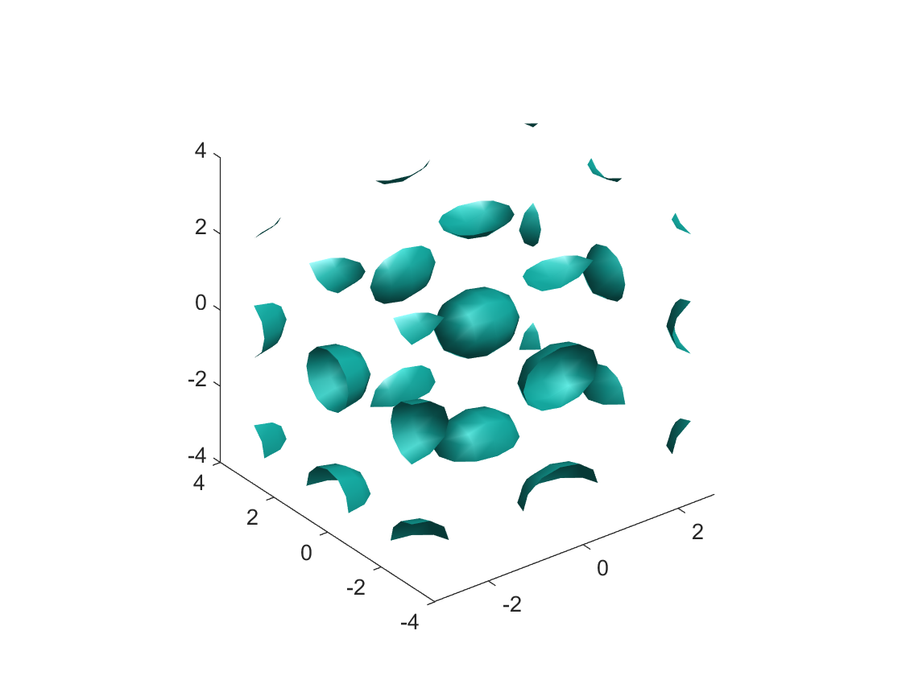

And the sine initial conditions give us a solution:

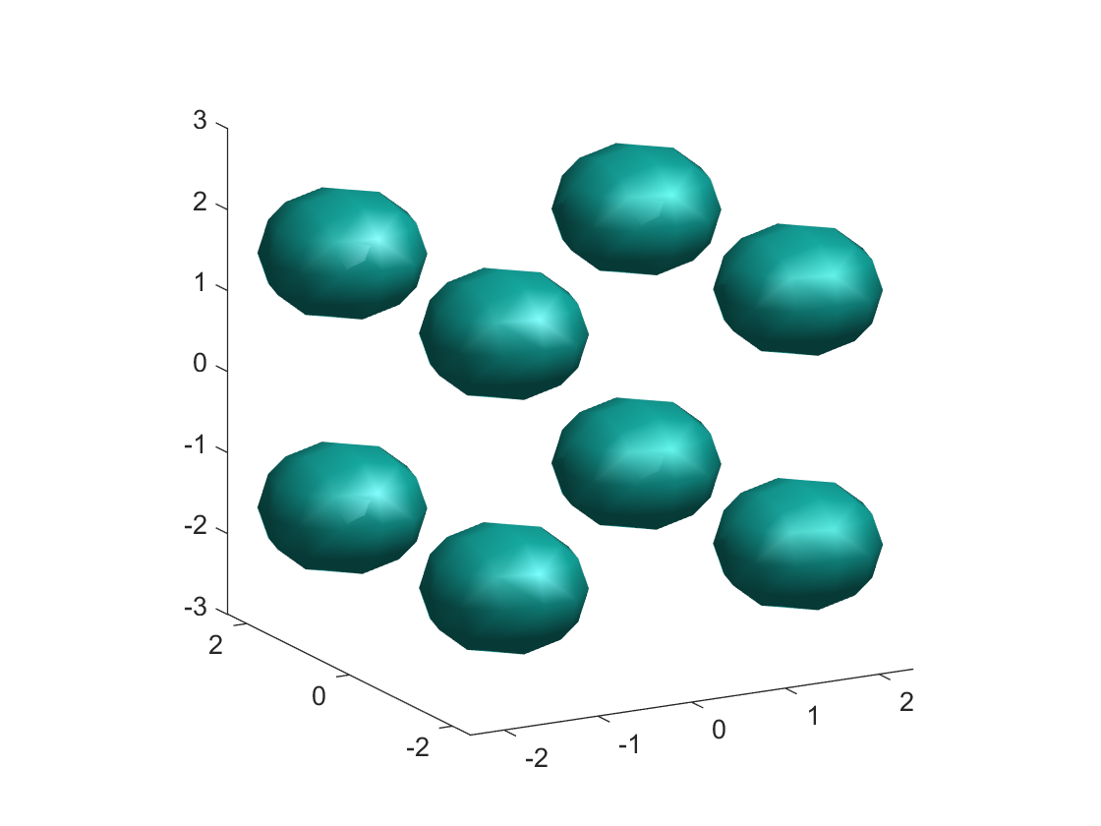

The symmetric nature of these solutions matches up with what we already know about BEC. The system of bosons has collapsed to form groups of “super” particles indistinguishable from one another. This condensation also leads to stability. Plotting the solution at each time step shows little change, meaning that the system is already settled into its low energy state. The difference between the two initial conditions makes sense when you consider that sine and cosine are equivalent to each other when shifted by pi radians. This is why the solutions “fill the gaps” between each other, the solutions are simply translated in space.