This lab session covers Django Contrib Package (admin, sessions and messages). By the end of this session, students should have a very good understanding of how to use these packages.

Pre-lab Preparation:
- Pages of the previous lab.
- Add the necessary contrib packages in settings.py

Lab Activities:

Task 1: Create a register page with a URL '/users/register' with any necessary HTML files and view functions.
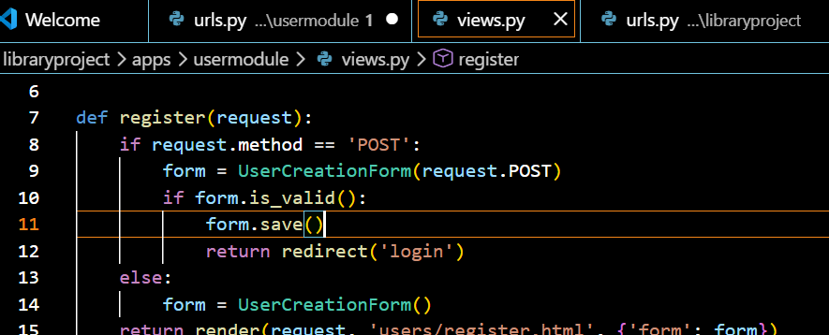
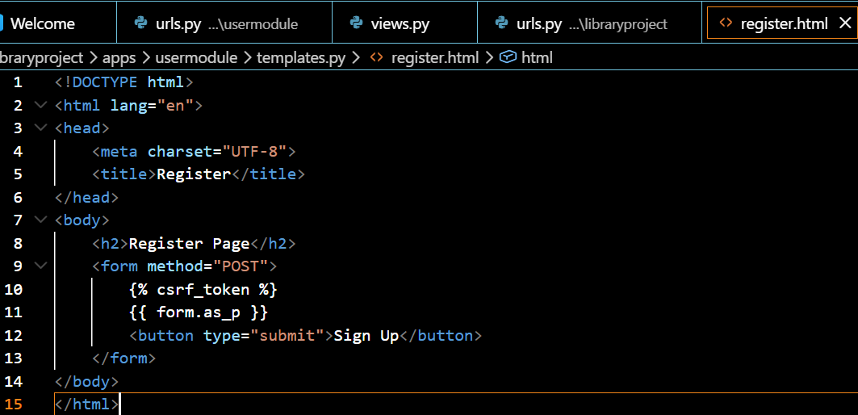

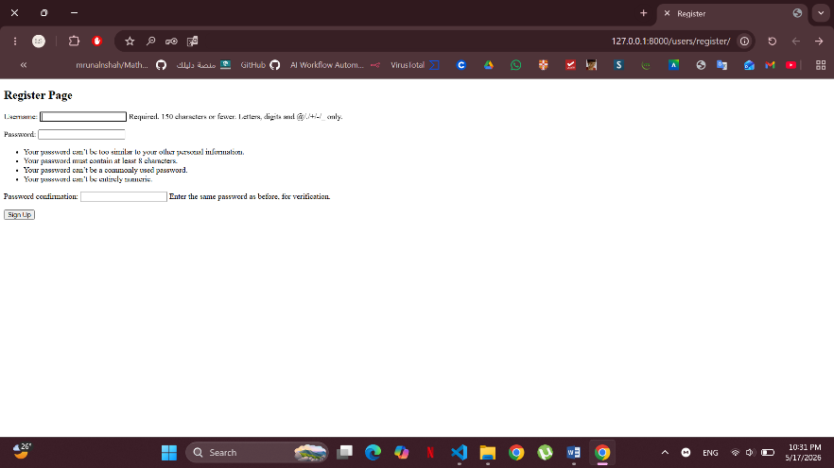

Task 2: Create a login page with a URL '/users/login' with any necessary HTML files and view functions.
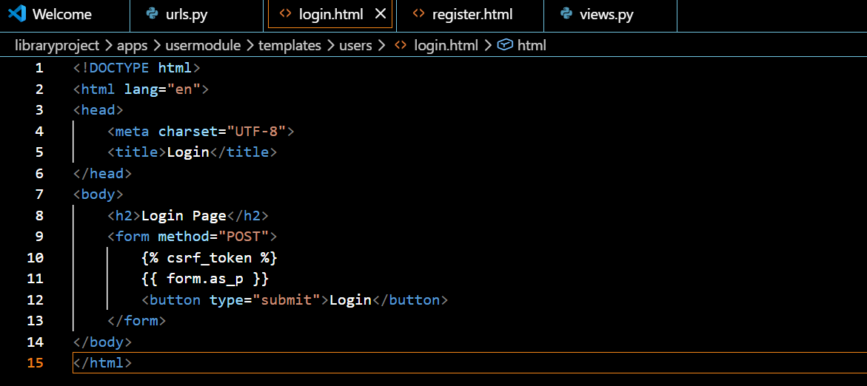
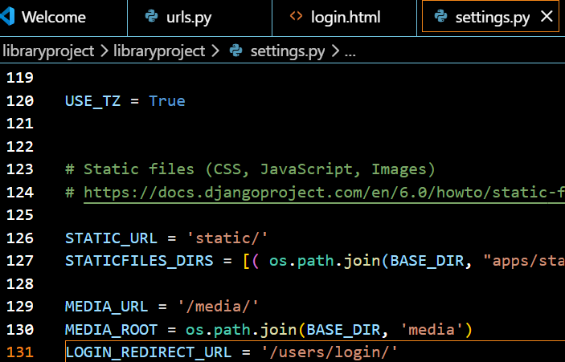
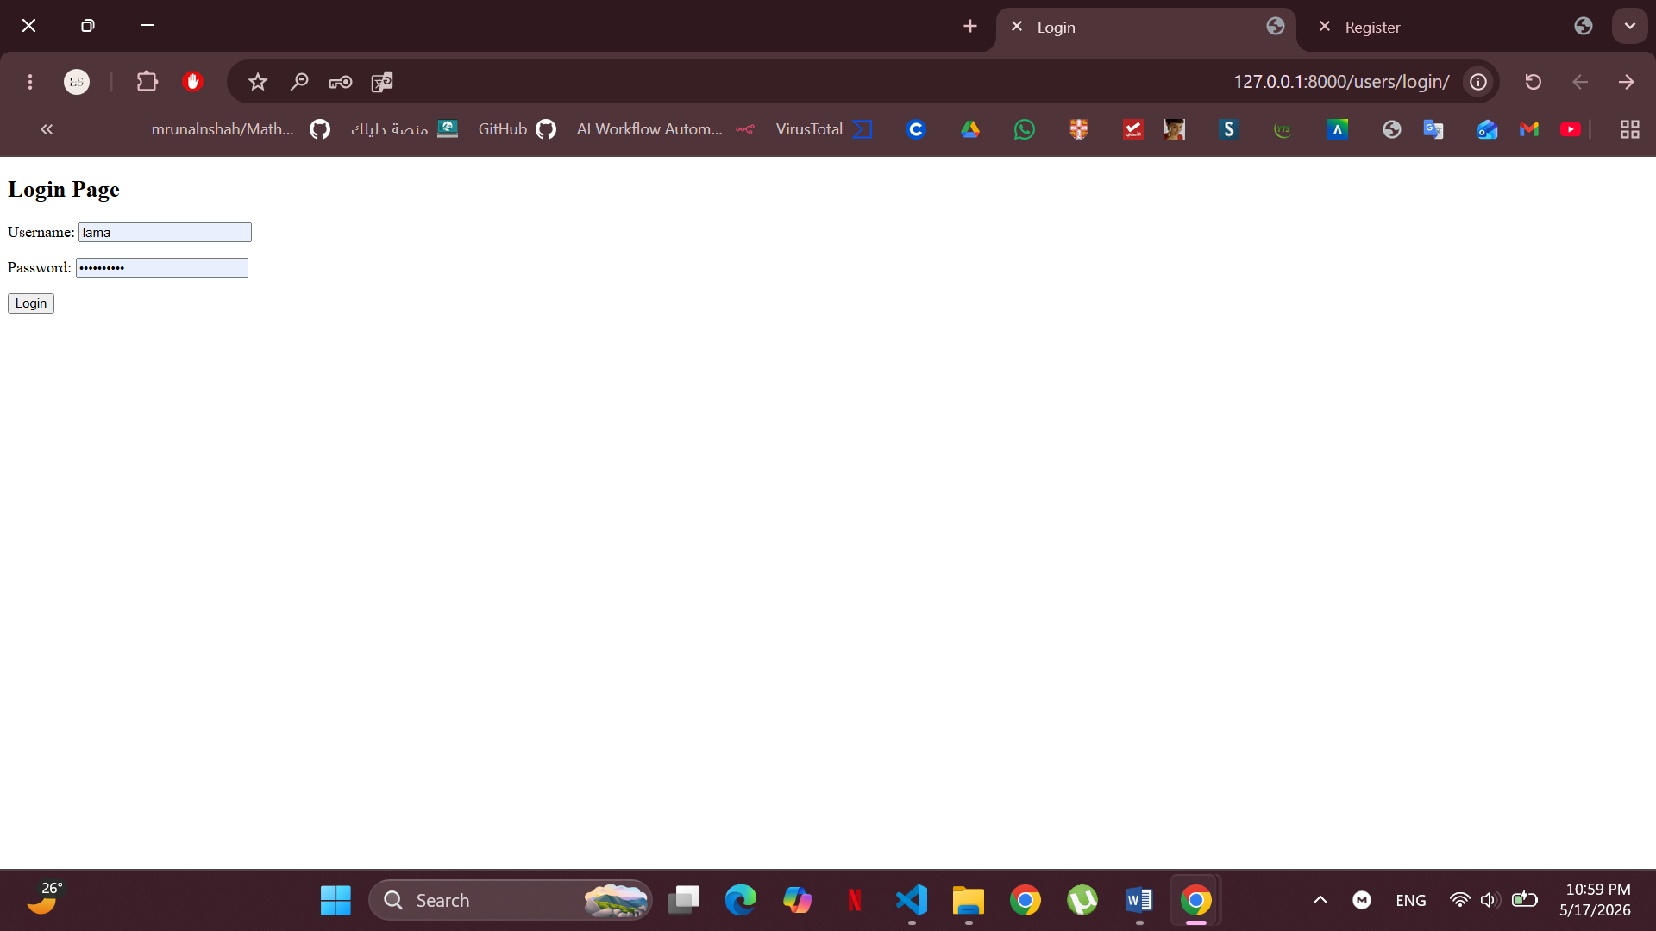
Task 3: Apply login permission to the previous lab. If the user is not logged in, redirect the user to the login page.
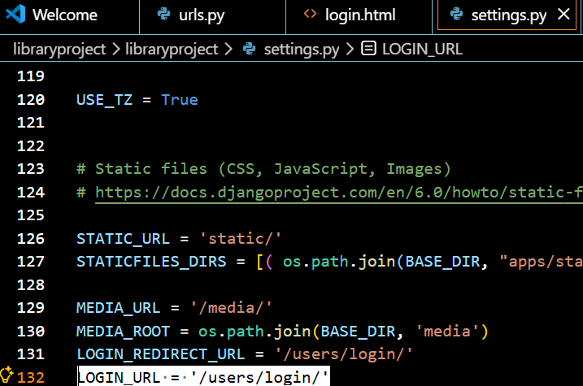
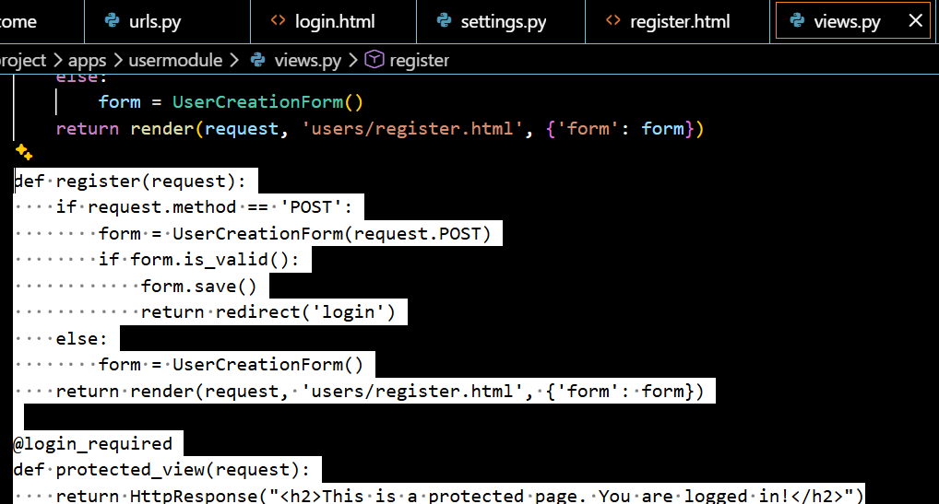
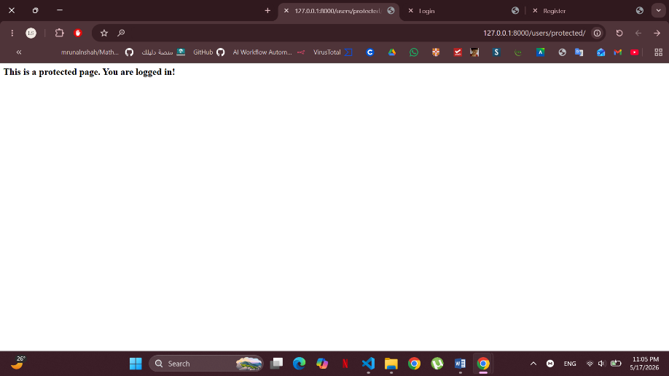
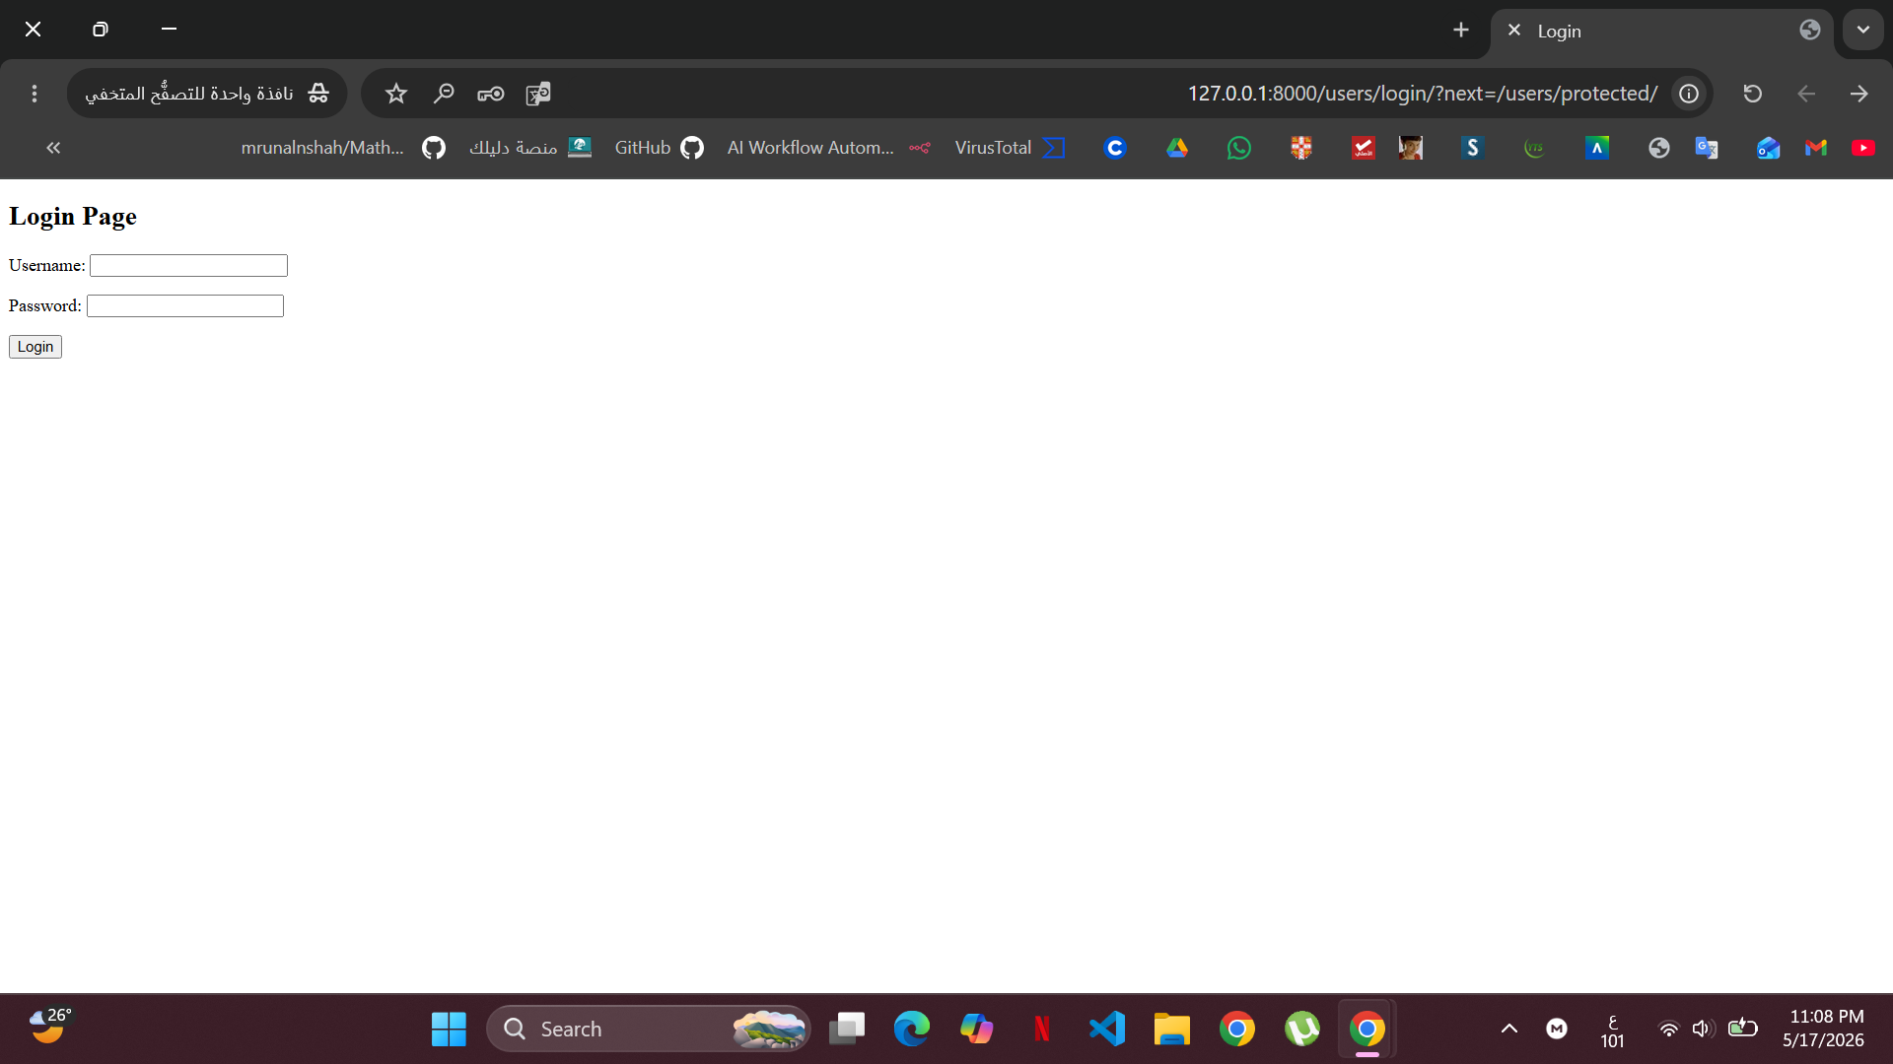

Task 4: Add a link '/users/logout' to sign out users to all pages where the user is logged in.

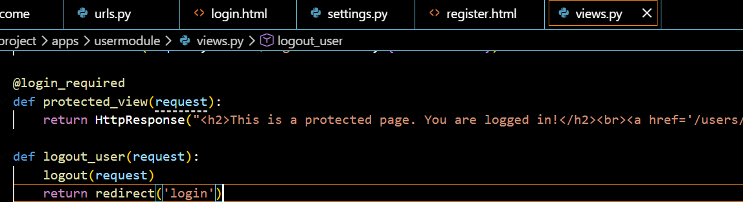
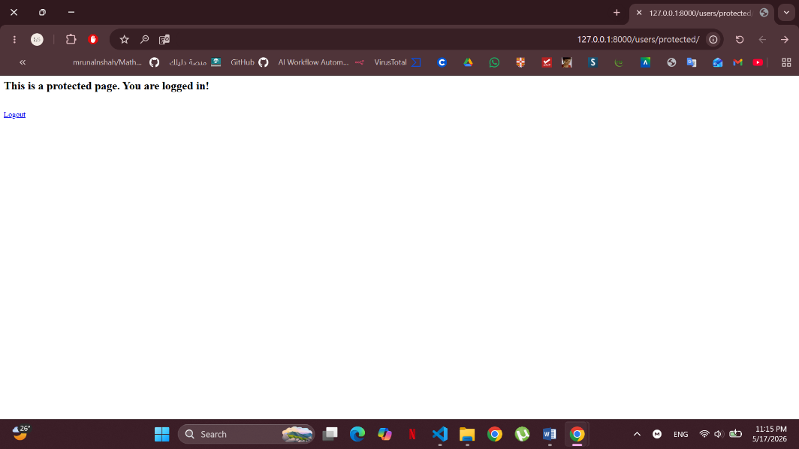
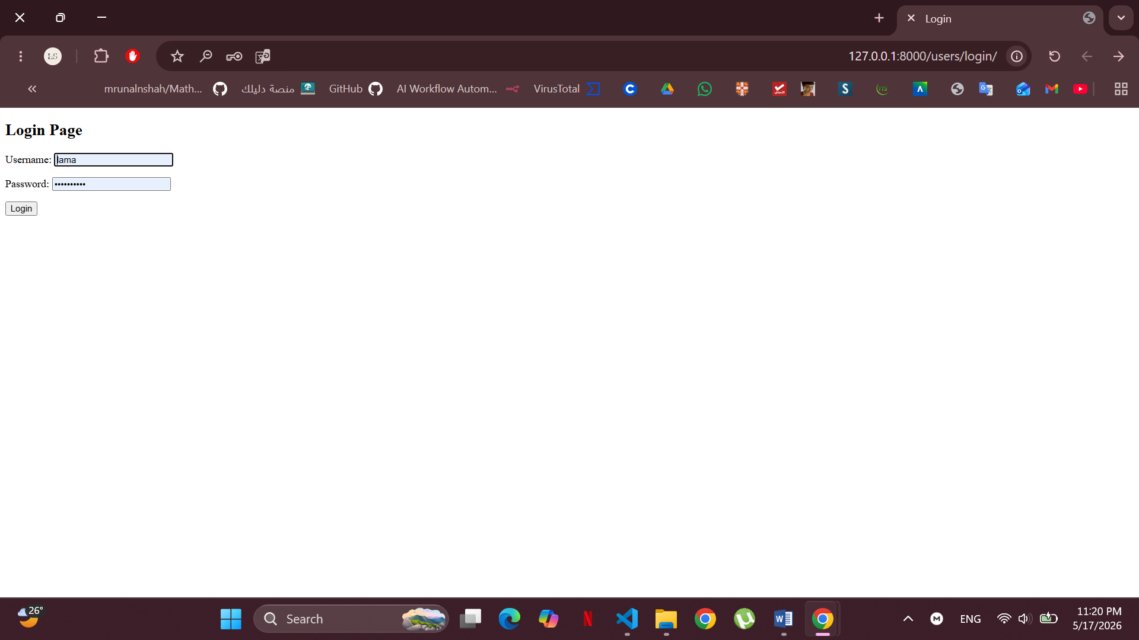

Task 5: Provide messages to users, like, 'you have successfully registered', 'login successfully', or 'error message.'

