CHAPTER 1: INTRODUCTION
1.1 Background and Motivation
Cross-sectional return prediction asks whether information available at a given date can separate securities that will subsequently perform relatively better from those that will perform relatively worse. Machine learning methods have attracted growing attention for this task because flexible models can capture non-linear relationships and interactions that linear specifications may not adequately represent (Gu, Kelly and Xiu, 2020; Fieberg et al., 2023). Extreme Gradient Boosting (XGBoost) provides a flexible tree-based modelling framework capable of representing non-linear relationships and interactions among predictors (Chen and Guestrin, 2016). Greater flexibility does not, however, guarantee better out-of-sample performance. Its usefulness depends on the information contained in the predictors, the breadth of the cross-section and the reliability of the evaluation and validation process (Arnott, Harvey and Markowitz, 2019; Martin and Nagel, 2022).
This study compares Pooled Cross-Sectional Ordinary Least Squares (OLS) and XGBoost in predicting the relative one trading day ahead performance of securities in a dynamically constructed, liquid Johannesburg Stock Exchange (JSE) universe of approximately 40 stocks. Both models receive the same target, predictors and chronological training information. The study is a statistical forecasting and ranking experiment. It does not estimate trading profitability, transaction costs or portfolio weights.
1.2 Research Problem, Question and Hypotheses
Much of the empirical evidence on machine-learning return prediction is based on broad international or developed-market datasets (Gu, Kelly and Xiu, 2020; Fieberg et al., 2023). A relatively small emerging-market cross-section represents a different empirical environment: a flexible model has fewer securities per date from which to learn conditional relationships, so whether it outperforms a transparent linear benchmark is an empirical question. Hanauer and Kalsbach (2023), for example, examine machine learning in the cross-section of emerging market stock returns, providing evidence that the market environment remains relevant when evaluating predictive models.
The gap addressed here is the limited evidence on whether XGBoost adds statistically significant cross-sectional ranking information over Pooled OLS in a small emerging market universe. The research question is:
Does XGBoost produce statistically superior out-of-sample cross-sectional ranking performance relative to Pooled OLS when both are evaluated under the same expanding-window walk-forward framework on the JSE?
The one day ahead horizon is the primary analysis. The null hypothesis is that the mean daily difference in Information Coefficient (XGBoost minus OLS) is zero. The one-sided alternative is that it is positive. A two-sided test is also reported.
1.3 Objectives and Scope
The study has four objectives:
- Data and universe construction: To construct a point-in-time liquid JSE universe with data-quality checks and OHLC consistency checks.
- Predictor construction: To construct nine momentum, volatility, relative-strength, trend and trading-activity predictors using only information available before each prediction date.
- Model comparison: To compare Pooled Cross-Sectional OLS and XGBoost under identical chronological out-of-sample conditions using cross-sectional ranking and prediction-error measures.
- Statistical inference: To determine whether the observed difference in model performance provides sufficient statistical evidence of a systematic difference between the two approaches, accounting for temporal dependence in the daily performance series.
The target is the cross-sectional percentile rank of the next-day return. Models are evaluated with chronological expanding window validation, preserving the temporal ordering of the forecasting problem and reserving subsequent observations for out-of-sample evaluation (Tashman, 2000). XGBoost hyperparameters are chosen by nested chronological validation rather than from the test periods, so that the final evaluation periods do not influence model selection decisions.
The study includes no portfolio optimisation, position sizing, transaction cost modelling or economic back test. Its conclusions therefore concern statistical ranking performance rather than direct investment profitability.
1.4 Contribution and Structure
The study contributes (i) evidence from the JSE rather than from large developed-market databases, (ii) a controlled comparison in which both models share the target, predictors, training information and evaluation sample, and (iii) strict walk-forward and nested validation that limits look-ahead bias. Its aim is not to show that either approach is universally superior but to establish whether non-linear flexibility adds measurable value in this setting.
Chapter 2 reviews the literature. Chapter 3 describes the data, universe, target and predictors. Chapter 4 sets out the methodology. Chapter 5 reports the results. Chapter 6 discusses the findings, limitations and conclusions.
CHAPTER 2: LITERATURE REVIEW
2.1 Introduction
Cross-sectional equity return prediction has moved from predominantly linear econometric approaches toward flexible machine-learning methods, reflecting the possibility that relationships between security characteristics and subsequent returns involve nonlinearities, interactions and conditional effects. Greater flexibility does not necessarily imply better out-of-sample performance, however, so flexible models must be assessed against transparent benchmarks and under validation procedures that respect the temporal structure of financial data.
This chapter reviews the literature relevant to comparing Pooled Cross-Sectional Ordinary Least Squares (Pooled OLS) and Extreme Gradient Boosting (XGBoost) for one day ahead cross-sectional ranking on the Johannesburg Stock Exchange (JSE). It is organised thematically: cross-sectional prediction and linear benchmarks, machine learning and XGBoost, the predictors used, emerging-market and JSE evidence, data quality, chronological validation and forecast evaluation. It closes by synthesising these strands and identifying the research gap.
2.2 Cross-Sectional Return Prediction and the Linear Benchmark
A central problem in empirical asset pricing is whether observable characteristics of securities contain information about subsequent returns. Cross-sectional prediction differs from time-series forecasting because the aim is to distinguish, at a given date, securities expected to perform relatively better or worse, not to forecast the aggregate direction of the market. The present study therefore estimates a common predictive relationship that distinguishes securities by subsequent relative performance, evaluated cross-sectionally on each trading date.
The literature has identified many characteristics that may carry such information, including momentum, volatility, valuation, liquidity and trading activity. Jegadeesh (1990) documented short-term return reversals, and Jegadeesh and Titman (1993) provided influential evidence of intermediate-horizon momentum. Together these studies show that past price behaviour relates to subsequent cross-sectional performance, although the direction and persistence of the relationship depend on the horizon and market. Characteristics should also be considered jointly, because a variable that appears informative alone may add little once correlated characteristics are included. Gu, Kelly and Xiu (2020) show how machine learning can combine a large set of characteristics while allowing for nonlinearities and interactions. Their evidence comes from a large developed-market dataset, whereas the present study examines a concentrated South African universe at a one-day horizon, so it cannot establish that the same characteristics or methods will be equally effective on the JSE.
A credible evaluation of machine learning requires an appropriate benchmark, since performance cannot be interpreted without knowing how much information a simpler specification already captures. This study uses Pooled OLS, which models the subsequent cross-sectional outcome as a linear combination of the predictors with a common intercept and common coefficients across all securities and dates, rather than estimating a separate regression for each security. Fieberg et al. (2023) provide a direct precedent: they examine machine-learning techniques for cross-sectional equity-return prediction and use pooled OLS as the linear benchmark.
The benchmark is valuable because its additive structure is interpretable. If XGBoost performs better out of sample, the difference can be attributed to additional functional flexibility for this predictor set and market. If the difference is small or statistically indistinguishable from zero, the flexibility adds little under this design. Complexity should not be assumed to be superior. Arnott, Harvey and Markowitz (2019) stress the risks of overfitting in financial back testing, and Martin and Nagel (2022) treat financial prediction as a high-dimensional problem in which out-of-sample behaviour is central. The relevant question is therefore not whether XGBoost can represent a more complicated function than Pooled OLS, but whether that flexibility yields statistically meaningful and persistent gains on observations unavailable during estimation and model selection.
2.3 Machine Learning, Nonlinearity and XGBoost
Machine learning has been adopted in empirical asset pricing partly because relationships between characteristics and future returns may be nonlinear and involve interactions. A linear model represents each predictor through a single coefficient, conditional on the other variables, whereas flexible methods allow the relationship to vary across regions of the predictor space. Gu et al. (2020) provide influential evidence that this flexibility can be useful, particularly when many characteristics are available.
The selected technical and trading-activity variables may plausibly interact. The meaning of recent momentum may depend on volatility or trading activity, and a moving-average signal may behave differently for securities with unusually high or low volume. A linear additive model represents such effects only through its specified coefficients, whereas a tree-based model can identify conditional structure without each interaction being specified in advance. XGBoost, introduced by Chen and Guestrin (2016), builds an ensemble of decision trees sequentially, each improving on the predictions of earlier trees, with regularisation and shrinkage to control complexity. Krauss, Do and Huck (2017) apply gradient boosting and other tree-based methods to statistical arbitrage, showing that such methods can be applied to complex financial data.
The existence of nonlinear structure does not imply that nonlinear models always outperform linear ones. Financial data are noisy, the effective signal is limited, market conditions change and relationships found historically may not persist. Flexibility is therefore both an opportunity to capture genuine structure and a risk of fitting unstable relationships. The risk is greater when hyperparameters are chosen from historical data, because repeated experimentation can adapt the specification to the validation results. Cawley and Talbot (2010) show that model-selection procedures can themselves overfit, and Arnott et al. (2019) and Martin and Nagel (2022) emphasise disciplined out-of-sample evaluation. XGBoost is accordingly used here to test whether nonlinearities and interactions yield incremental ranking information beyond the linear benchmark, not on the assumption that they must.
The prediction problem is also one of relative performance. Relative ordering can remain informative even when exact return magnitudes are hard to estimate, so each date's one-day-ahead returns are transformed into a cross-sectional percentile target bounded between zero and one. This places observations on a common scale and gives both models the same response variable, so performance differences can be attributed more directly to model form. Ranking the outcome does not make prediction easy, however. Characteristics that are informative for medium-term returns need not be informative for the next day's ordering, and individually informative characteristics may add little when correlated.
2.4 Predictors
The nine predictors capture different dimensions of price behaviour, volatility and trading activity. They also overlap in the information they contain, which makes the set a realistic setting for testing whether a nonlinear model can identify conditional relationships that an additive linear model cannot.
2.4.1 Momentum and Moving-Average Measures
Jegadeesh and Titman (1993) documented momentum over intermediate horizons. Much of the established evidence concerns medium-term holding periods, whereas this study predicts the next trading day, so evidence of momentum over several months cannot be treated as evidence of next-day predictability. Momentum is measured over several windows because recent price information may carry different signals depending on window length, and its contribution is treated as an empirical question. Moving-average rules have a long history in technical analysis. Brock, Lakonishok and LeBaron (1992) found that moving-average signals contained predictive information in historical US data, and Lo, Mamaysky and Wang (2000) developed a systematic statistical treatment of technical patterns. Moving-average ratios measure the current price relative to trend, but they are closely related to momentum, so their joint use creates substantial overlap. Pooled OLS estimates conditional additive effects for such variables, while XGBoost can partition the predictor space through sequential splits.
2.4.2 Relative Strength and Volatility
The Relative Strength Index (Wilder, 1978) is a bounded oscillator of the strength of recent upward and downward price movements. It offers a transformed representation of recent gains and losses and not an independent characteristic, so the relevant question is whether it adds information when combined with the other predictors. Ang et al. (2006) document a relationship between idiosyncratic volatility and subsequent cross-sectional returns. Recent volatility captures price instability that may distinguish securities with similar cumulative returns, but its relationship with future returns need not be constant or linear and may depend on the market environment, momentum and trading activity. Both predictors are therefore natural candidates for conditional relationships.
2.4.3 Trading Activity and Liquidity
Trading activity provides information that differs from purely price-based characteristics. Lee and Swaminathan (2000) show that trading volume is relevant to interpreting return continuation, and Amihud (2002) documents the importance of liquidity and price impact. The study uses abnormal volume and abnormal value traded, which capture deviations from recent activity and not absolute participation. Unusual activity often accompanies large price moves, volatility changes or shifts in investor attention, so trading activity may modify the predictive value of momentum or volatility. A tree-based model can represent such conditional effects without every interaction being specified manually.
2.4.4 Cross-Sectional Standardisation
The predictors are measured on different scales (returns, a bounded index, standard deviations and volume-based shocks), so each is standardised relative to the securities available on the same date. This focuses the model on a security's relative position and is consistent with the cross-sectional transformations in Gu et al. (2020). Standardisation addresses scale and not overlap correlated predictors remain correlated. OLS therefore estimates conditional coefficients, and XGBoost may distribute information across substitute variables and different splits. Predictors overlap and possible nonlinear interactions remain part of the empirical comparison.
2.5 Emerging-Market and JSE Evidence
Much of the influential machine-learning literature in asset pricing uses large developed market datasets with extensive cross-sections and long histories of firm characteristics. Such evidence cannot be transferred automatically to smaller markets, where liquidity, market structure, information availability and the number of securities differ. Hanauer and Kalsbach (2023) study machine learning and the cross-section of stock returns across 42 emerging market countries. They compare several algorithms using a broad set of firm characteristics and find that nonlinearities and interactions can contribute to predictive performance relative to linear approaches. This shows that machine learning can be relevant outside developed markets, but a multi-country study is not equivalent to a concentrated single country analysis, so relative performance must still be evaluated in the market of interest.
South African research documents systematic relationships between characteristics and returns on the JSE. Van Rensburg and Robertson (2003) show that style characteristics help explain cross-sectional return differences, Basiewicz and Auret (2009) examine the persistence of equity characteristics, and Muller and Ward (2013) examine return patterns and characteristics more broadly. This literature supports the use of historical price and market characteristics as predictors. However, it concentrates on individual characteristics, factor effects or return patterns and does not compare a modern nonlinear method with a pooled linear benchmark for next-day cross-sectional ranking. Bartens and Hassan (2010) use recursive, real time evaluation of return predictability in South Africa, which underlines that relationships observed historically must be assessed sequentially, as information would have become available. Together, the evidence motivates characteristic-based prediction on the JSE but does not resolve whether XGBoost adds incremental information over Pooled OLS at a one-day horizon.
2.6 Data Quality, Survivorship Bias and Universe Construction
Predictive performance depends on the quality and construction of the dataset as well as on the model. The set of listed securities changes as firms enter, leave, merge, delist or change in liquidity. Shumway (1997) shows the importance of incorporating delisting information, since omitting delisted securities creates survivorship bias by conditioning the sample on firms still observable at the end of the period. A related problem arises when a contemporary universe is imposed on historical data, because securities that are prominent or liquid at the end of the sample may not have met the same criteria earlier. Liquidity matters here, since securities on an exchange such as the JSE differ substantially in trading activity (Amihud, 2002). For genuine out-of-sample prediction, the universe should be determined using information available at each historical date. The study therefore uses a dynamic point-in-time universe based on a rolling liquidity criterion.
Data quality also covers missing observations, non-trading dates, duplicate records and anomalous prices. These are not merely technical details: if a data problem affects one model differently from another, the resulting performance difference could be wrongly attributed to the model. Data-quality controls are therefore part of the validity of the comparison.
2.7 Chronological Validation and Model-Selection Bias
Future information must not influence estimation or model selection. Random cross-validation violates this because later observations can enter the training sample while earlier ones are used for validation. Tashman (2000) emphasises genuine out-of-sample evaluation in forecasting, and Arlot and Celisse (2010) show that cross-validation procedures must suit the data structure. An expanding-window design trains on an initial historical period, tests on the next period and then adds the newly available observations before the next test. This imitates the information flow of a real forecasting exercise, so every test observation follows the observations used for estimation.
Hyperparameter selection requires particular care for XGBoost. If test observations inform tuning, the final performance estimate becomes optimistic. Cawley and Talbot (2010) show that model-selection procedures can overfit, and Varma and Simon (2006) show that reusing validation results for both selection and performance estimation creates optimistic bias. Nested validation separates the two: inner chronological periods select hyperparameters, and the outer test period is untouched until final evaluation. The same principle applies to preprocessing, since estimating winsorisation thresholds from the full sample would let future observations influence the treatment of earlier ones. Finally, because the one-day target uses the next day's price, a training label immediately before a test period can contain information from the first test date, which requires a one-date purge at the boundary. These principles distinguish predictive modelling from curve fitting and justify evaluating both models under identical chronological conditions.
2.8 Forecast Evaluation
Evaluation measures should reflect the research objective. Because this study concerns cross-sectional ranking and not portfolio performance, it focuses on statistical ranking accuracy and prediction error. The primary measure is the daily Information Coefficient (IC), the Spearman (1904) rank correlation between predicted and realised cross-sectional rankings. A positive IC indicates that securities with higher predicted scores tended to rank higher in realised performance, and an IC near zero indicates little systematic ranking ability. Rank correlation suits the objective because it does not depend on exact prediction magnitudes. Grinold and Kahn (2000) emphasise both the strength and the consistency of a signal, so the mean daily IC measures average ranking skill and its dispersion measures stability. Mean Absolute Error and Root Mean Squared Error (Hyndman and Koehler, 2006) are secondary measures of accuracy on the percentile target, since a model can rank securities well while estimating their exact percentile positions imperfectly.
Both models predict the same securities and dates, so they are compared through paired daily differences in IC. The null hypothesis is that the mean daily difference is zero, against the alternative that XGBoost's mean is higher. Daily differences may be heteroskedastic and serially dependent, because market conditions affect performance on neighbouring days. Newey and West (1987) provide a covariance estimator that gives valid inference in this case, and Diebold and Mariano (1995) provide a wider framework for comparing predictive accuracy through paired loss differentials. Superiority should not be inferred from a difference in sample averages alone: the difference must be assessed against the variability and temporal dependence of the performance series.
2.9 Literature Synthesis, Research Gap and Contribution
The literature supports five conclusions. First, characteristics such as momentum, volatility, technical measures, liquidity and trading activity contain return-relevant information, but their relationships are not stable across markets, horizons or specifications, and evidence at medium horizons does not establish next-day predictability. Second, a transparent linear benchmark is the appropriate reference for judging machine learning, and Fieberg et al. (2023) provide precedent for pooled OLS. Third, nonlinearities and interactions may matter (Gu et al., 2020; Chen and Guestrin, 2016), but their existence does not show that XGBoost will beat a linear model, and Arnott et al. (2019) and Martin and Nagel (2022) caution that flexible models must prove themselves out of sample. Fourth, the predictors overlap, which creates scope for interactions but means individual predictors cannot be read as independent sources of information. Fifth, evidence from developed and broad emerging-market samples (Hanauer and Kalsbach, 2023) and from earlier JSE studies is useful context, but it does not resolve model performance in a concentrated JSE universe, and survivorship bias, leakage and model-selection bias can all inflate apparent performance.
These strands leave a specific gap at the intersection of model flexibility, market setting and forecasting horizon. The existing evidence does not establish whether XGBoost produces statistically superior out-of-sample ranking performance relative to Pooled OLS for daily cross-sectional ranking in a dynamically constructed JSE universe when (1) both models receive the same technical and trading-activity predictors, (2) both predict the same cross-sectional percentile target, (3) both are evaluated over the same chronological out-of-sample periods, and (4) model selection and preprocessing use no information from the evaluation periods.
The study addresses this gap through a controlled comparison in which the main experimental difference is the functional form of the model. It uses a point-in-time liquidity-screened universe, a daily percentile target, standardised predictors, Pooled OLS as the transparent benchmark and regularised XGBoost as the nonlinear alternative, with expanding-window evaluation, nested chronological validation for XGBoost and training-only preprocessing. The contribution is methodological, a controlled framework for testing whether added flexibility yields incremental information, and empirical, evidence on the relative ranking performance of the two approaches on the JSE. It does not claim that either approach is universally superior, and it does not interpret predictive performance as evidence of a profitable strategy, since portfolio construction, costs and realised returns are outside its scope. The following chapters operationalise this comparison.

CHAPTER 3: DATA
3.1 Data Sources and Quality
The study uses daily JSE prices and volumes from 1 January 2016 to 19 March 2026, obtained from Yahoo Finance through the yfinance API. The extraction returned 150,445 stock-day observations for 62 of 73 candidate current and historical large- and mid-cap securities (Table 3.1). To reduce survivorship bias, the candidate list deliberately includes securities that were later delisted, restructured or removed from the index, rather than relying on a static list of current Top 40 constituents. Eleven tickers could not be retrieved, so survivorship bias is mitigated rather than eliminated, and the resulting universe is a proxy for the liquid JSE large-cap universe and not an exact reconstruction of official FTSE/JSE Top 40 membership.
Table 3.1: Raw Data Sourcing and Initial Diagnostics
Characteristic | Specification
Data Source / Platform | Yahoo Finance via yfinance API
Sample Period | 1 January 2016 to 19 March 2026
Frequency | Daily
Extracted Variables | Open, High, Low, Close, Adjusted Close, Volume
Requested / Retrieved Securities | 73 / 62 (11 unsuccessful)
Securities (Complete / Partial History) | 53 / 9
Total Stock-Day Observations | 150,445
Duplicate / Missing OHLCV Records | 0 / 0
Zero-Volume Records | 1,071
Records with OHLC Consistency Flags | 17,837

The panel has no duplicate or missing records. Fifty-three securities have the full 2,552 trading dates and nine entered later (the shortest history is 730 observations); this unbalanced structure is retained because the universe is time varying. An OHLC consistency audit produced 17,986 flags over 17,837 stock-dates, mostly comparisons involving the opening price (9,127 High-below-Open and 8,590 Low-above-Open cases). This is consistent with stale opening-auction prices in public aggregators, so flags are treated as warnings and not deleted. Predictors are computed from Adjusted Close, which accounts for corporate actions. Unadjusted Close and Volume are used only for the nominal value-traded liquidity measure, and Open, High and Low are not used. Most of the 1,071 zero-volume records are market-wide non-trading days such as public holidays and are removed before rolling liquidity and forward returns are computed. Isolated zero-volume days on active dates are kept as genuine stock-specific liquidity conditions.
Figure 3.1 shows rebased adjusted-close paths for three representative securities, a consistently top-quartile, a median and a low-quartile performer by average cross-sectional rank. Their divergent trajectories illustrate why the task is framed in relative terms: absolute returns are dominated by sector-specific and idiosyncratic factors, whereas the model must identify which securities outperform their contemporaneous peers.
Figure 3.1: Price Time Series for Representative Securities (Rebased to 100)
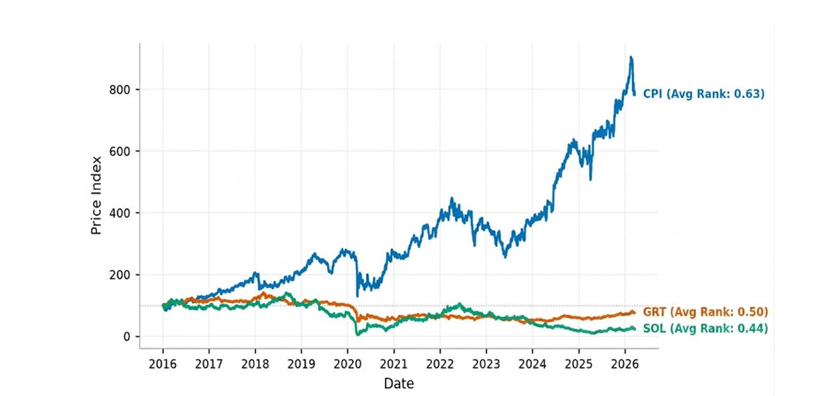
3.2 Active Universe Construction
Because official historical constituent records are restricted, a value-traded proxy approximates the quarterly index review using only information observable at the time. Nominal value traded is unadjusted Close multiplied by Volume, smoothed with a 63-trading-day (about three-month) rolling average. At the end of each calendar quarter, securities are ranked by smoothed value traded and the top 40 form the universe for the next quarter. This was applied over 41 quarters (2016 Q3 to 2026 Q1), with about 1.5 securities entering and leaving per rebalance. The screen reduces the panel from 150,445 to 97,120 observations (a 35.44% reduction), and all later steps use only this panel (Figure 3.2).
Figure 3.2: Data Funnel for Active Universe Construction
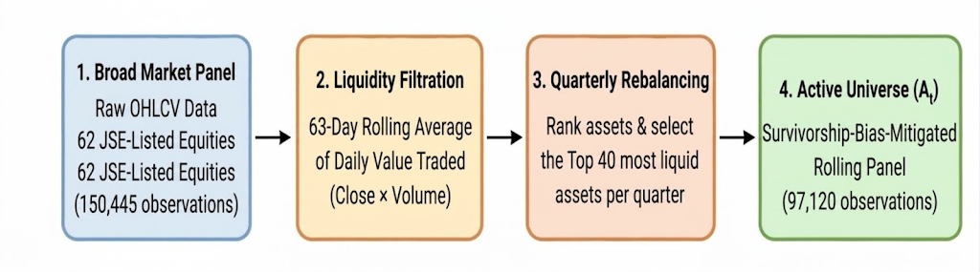
3.3 Target Variable
The target is the cross-sectional percentile rank of the next-day return on Adjusted Close, defined formally in Section 4.2. Ranking each date removes market-wide movements common to all securities, so the problem is purely relative. Ties, most often zero returns, receive average ranks. The result is 97,120 targets over 2,428 trading days (1 July 2016 to 18 March 2026) with 40 securities on every date. The target has a minimum of 0, a maximum of 1, a mean of 0.500 and a standard deviation of 0.2960, matching the theoretical 0.2959 for a discrete uniform distribution with 40 assets (Figure 3.3). Tied-return days account for 84 dates (3.46%).
Figure 3.3: Empirical Distribution of the Percentile Target Against the Uniform Baseline
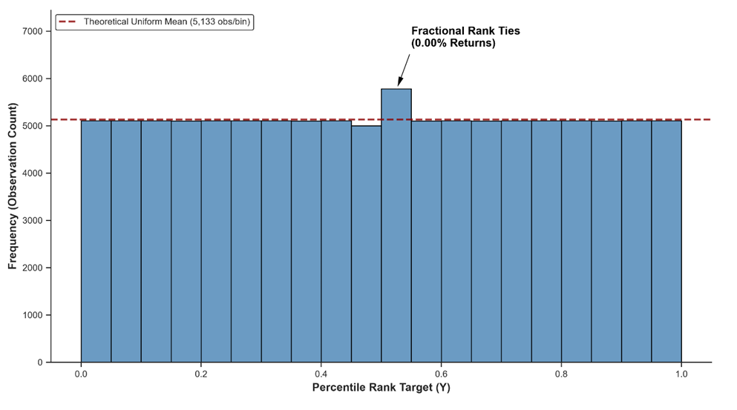
Figure 3.4 plots the daily target and its 63-day rolling mean for three representative securities. Three features stand out. The daily series is highly erratic, oscillating between the top and bottom deciles within short windows, which reflects the difficulty of next-day relative prediction. The rolling means show that relative performance trends persist over medium horizons, consistent with momentum. Finally, no security occupies the top or bottom of the cross-section permanently, so the percentile transformation produces a balanced, stationary target.
Figure 3.4: Target (Y) Dynamics for Representative Securities
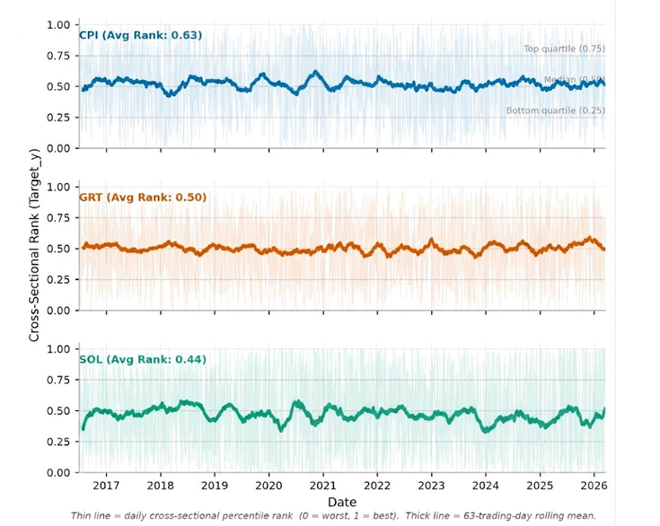
3.4 Predictors and Standardisation
Nine predictors are built exclusively from backward-looking windows (Table 3.2) and are defined in Section 4.3. Each is standardised daily into a cross-sectional z-score. A value of +2 means the security's reading is two standard deviations above the universe average on that date, whatever the market direction. Where cross-sectional dispersion is zero the value is set to zero, which never occurred. Dropping the 200-day initialisation window leaves 93,231 stock-day observations from 19 October 2016 to 18 March 2026 (Figure 3.5). The sample includes the 2020 COVID-19 shock, which provides a stress regime for the volatility and liquidity features.
Table 3.2: Predictor Summary
Feature | Dimension | Construction | Window
Mom_1M | Short-term momentum | Adjusted Close price ratio | 21 trading days
Mom_3M | Medium-term momentum | Adjusted Close price ratio | 63 trading days
Mom_6M | Longer-term momentum | Adjusted Close price ratio | 126 trading days
Vol_21D | Historical volatility | Rolling log return std dev | 21 trading days
RSI_14 | Price oscillation strength | Wilder RSI (EMA gains/losses) | 14 trading days
SMA_50_Ratio | Short-term mean reversion | Price to SMA ratio | 50 trading days
SMA_200_Ratio | Long-term mean reversion | Price to SMA ratio | 200 trading days
Volume_Shock_21D | Volume liquidity dynamics | Log volume deviation from mean | 21 trading days
Value_Traded_Shock_63D | Value-traded liquidity dynamics | Log VT deviation from mean | 63 trading days

Figure 3.5: Data Engineering Pipeline
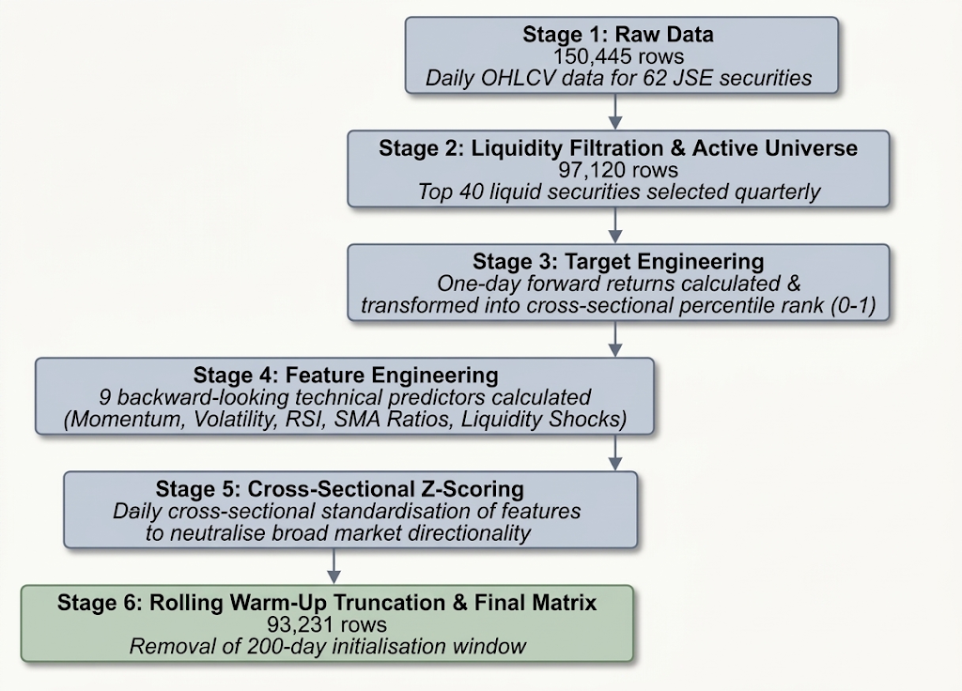
Figures 3.6.1 to 3.6.5 illustrate the standardised features for Naspers (NPN.JO). Momentum is noisier and more mean reverting at one month and smoother at three and six months. Volatility spikes during market dislocations such as 2020 before normalising. RSI and the moving-average ratios track relative price positioning, and the two shock measures are more erratic, reflecting episodic changes in trading activity.
Figure 3.6.1: Standardised Momentum Features, Naspers (NPN.JO)
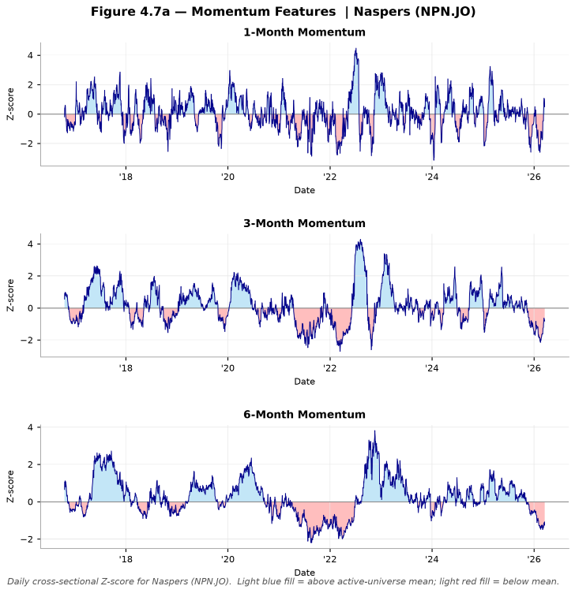
Figure 3.6.2: Standardised 21-Day Volatility, Naspers (NPN.JO)
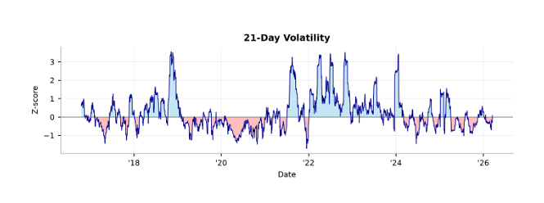
Figure 3.6.3: Standardised 14-Day RSI, Naspers (NPN.JO)
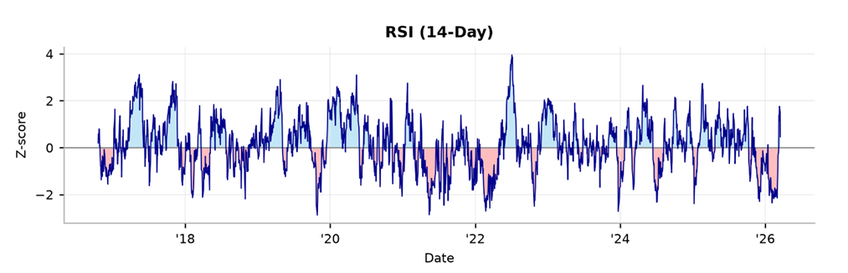
Figure 3.6.4: Standardised SMA50 and SMA200 Ratios, Naspers (NPN.JO)
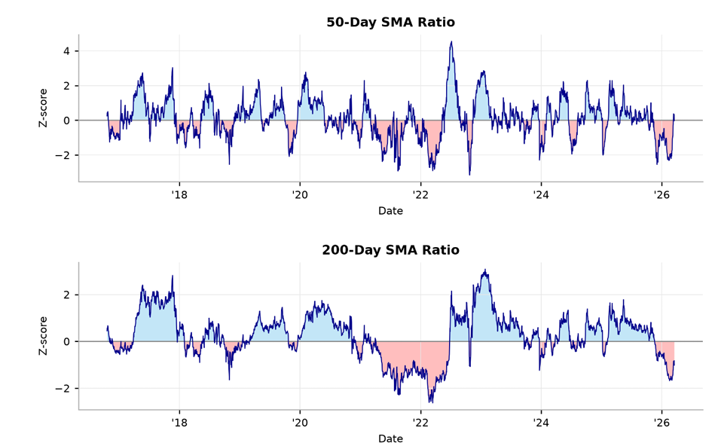
Figure 3.6.5: Standardised Volume and Value-Traded Shocks, Naspers (NPN.JO)
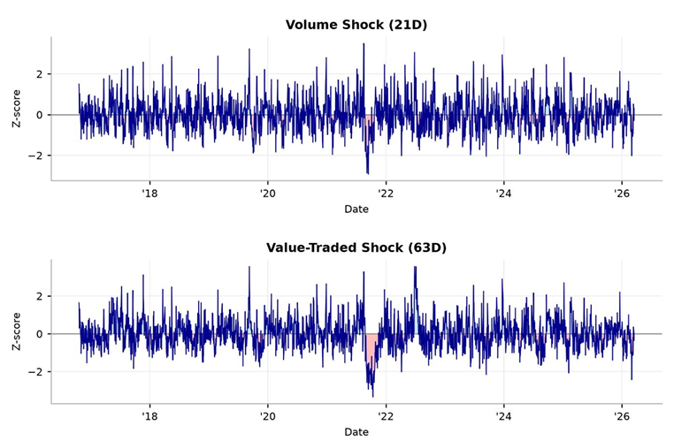
Standardised predictors have mean 0 and standard deviation of about 0.987 (the gap from 1 reflects daily variation in cross-section size), with extremes between about −6.0 and +5.8 that are consistent with genuine market events such as trading halts (Table 3.3). Winsorisation is therefore deferred to model estimation so that thresholds use training data only.
Table 3.3: Descriptive Statistics of the Final Predictive Matrix (N = 93,231)
Variable | Mean | Std Dev | Min | 25th Pct | Median | 75th Pct | Max
Target_Y | 0.500 | 0.295 | 0.000 | 0.256 | 0.500 | 0.744 | 1.000
Mom_1M | 0.000 | 0.987 | -3.426 | -0.600 | -0.058 | 0.550 | 5.657
Mom_3M | 0.000 | 0.987 | -3.012 | -0.605 | -0.092 | 0.511 | 5.801
Mom_6M | 0.000 | 0.987 | -3.571 | -0.612 | -0.119 | 0.475 | 5.836
Vol_21D | 0.000 | 0.987 | -2.554 | -0.704 | -0.239 | 0.498 | 5.505
RSI_14 | 0.000 | 0.987 | -3.655 | -0.683 | -0.028 | 0.667 | 3.956
SMA_50_Ratio | 0.000 | 0.987 | -3.976 | -0.594 | -0.042 | 0.560 | 5.255
SMA_200_Ratio | 0.000 | 0.987 | -3.873 | -0.598 | -0.075 | 0.541 | 5.353
Volume_Shock_21D | 0.000 | 0.987 | -5.957 | -0.651 | -0.053 | 0.588 | 5.282
Value_Traded_Shock_63D | 0.000 | 0.987 | -6.047 | -0.653 | -0.057 | 0.589 | 5.126

Table 3.4 shows one cross-sectional snapshot, the 40 active securities on a date in the out-of-sample period, sorted by realised target rank alongside their z-scored features. Feature values vary widely across securities, so each predictor carries real cross-sectional information. Single features do not cleanly separate top from bottom performers, for example extreme one-month momentum does not align with the best or worst outcomes, which fits the near-zero correlations reported below. The target column is uniformly distributed as designed.
Table 3.4: Cross-Sectional Ranking Snapshot, Quarter of 28 June 2024 (N = 40, Ranked by Target Y)- Highest to lowest and Z-scored features
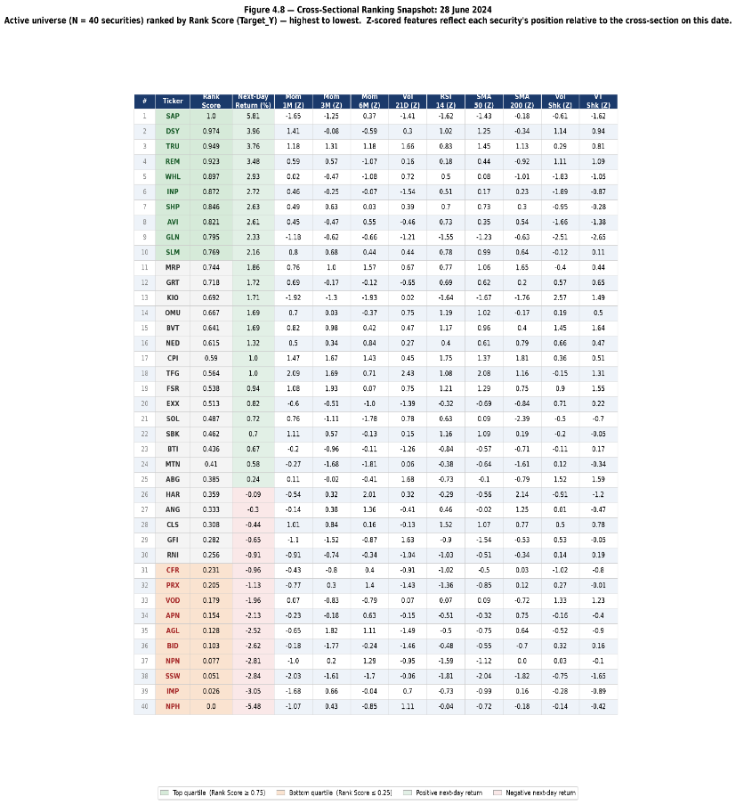
The snapshot shows us what at any given time what a cross-section may look like in any given quarter period.
3.5 Predictor Dependence
The Spearman correlation matrix (Figure 3.7) shows strong overlap among conceptually similar predictors. Table 3.5 lists the five highest pairs. The near perfect correlation between Mom_6M and SMA_200_Ratio arises because both measure price displacement from a lagged reference over comparable horizons, and RSI_14 and SMA_50_Ratio share sensitivity to short term trend strength. Variance inflation factors (Table 3.6) exceed 10 for SMA_200_Ratio and SMA_50_Ratio. This inflates OLS standard errors and can produce unstable or sign reversed coefficients, whereas tree ensembles can use correlated predictors interchangeably.
Figure 3.7: Spearman Rank Correlation Matrix
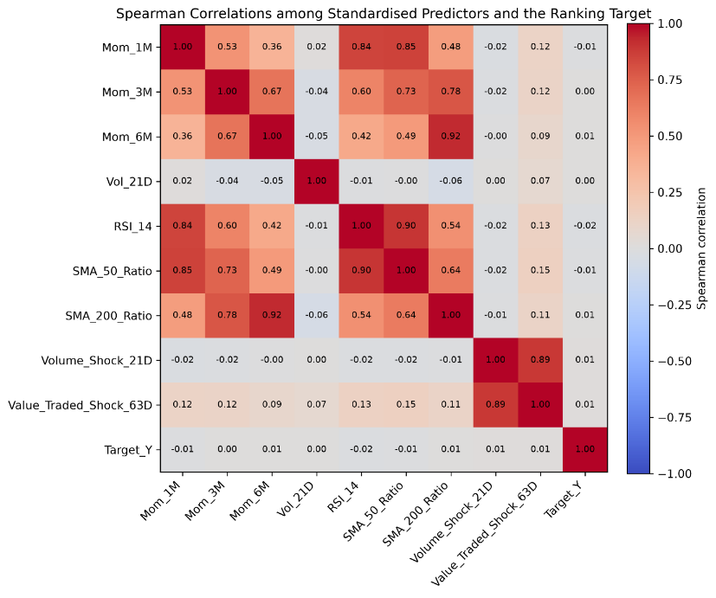
Table 3.5: Highest Pairwise Spearman Correlations (Pooled Panel, N = 93,231)
Feature 1 | Feature 2 | Spearman Correlation
Mom_6M | SMA_200_Ratio | 0.924
RSI_14 | SMA_50_Ratio | 0.895
Volume_Shock_21D | Value_Traded_Shock_63D | 0.890
Mom_1M | SMA_50_Ratio | 0.852
Mom_1M | RSI_14 | 0.844

The near perfect correlation (0.924) between 6 Month Momentum and the 200-Day SMA Ratio occurs because both mathematically capture price displacement from a lagged reference over comparable horizons. Similarly, the RSI and 50 Day SMA Ratio correlation (0.895) reflect their shared sensitivity to short-term trend strength.
Table 3.6: Variance Inflation Factors
Feature | VIF | Diagnostic Category
SMA_200_Ratio | 13.37 | High (VIF > 10)
SMA_50_Ratio | 10.16 | High (VIF > 10)
Mom_6M | 8.55 | Moderate (VIF 5 to 10)
Value_Traded_Shock_63D | 6.75 | Moderate (VIF 5 to 10)
Volume_Shock_21D | 6.52 | Moderate (VIF 5 to 10)
Mom_1M | 3.81 | Low (VIF < 5)
RSI_14 | 3.75 | Low (VIF < 5)
Mom_3M | 3.00 | Low (VIF < 5)
Vol_21D | 1.06 | Low (VIF < 5)

Every feature exhibits a near zero absolute correlation with the target variable. While expected under market efficiency theory, this carries critical modelling implications. For Pooled OLS, the lack of a monotonic signal means a constrained linear combination of inputs will likely perform close to random chance. For XGBoost, this zero correlation baseline is not disqualifying. The algorithm can detect nonlinear, conditional interactions (e.g., momentum predicting outperformance only when volatility is simultaneously low) that remain invisible to pairwise correlation analysis.
.
Table 3.7: Spearman Correlations Between Standardised Predictors and the Target
Feature | Spearman Correlation with Target_Y
Volume_Shock_21D | +0.011
Value_Traded_Shock_63D | +0.009
SMA_200_Ratio | +0.006
Mom_6M | +0.006
Mom_3M | +0.000
Vol_21D | +0.000
SMA_50_Ratio | -0.010
Mom_1M | -0.012
RSI_14 | -0.018

3.6 Chapter Summary
This chapter converted raw JSE market data into a point-in-time modelling panel. A broad panel of 150,445 stock-day observations across 62 securities was screened by rolling liquidity into a 40-stock active universe of 97,120 observations, and 93,231 remain after the 200-day initialisation window. The target is the daily cross-sectional percentile rank of the next-day return, and the nine predictors are standardised within each date. The predictors overlap strongly and have near-zero individual correlations with the target, so any advantage for XGBoost would have to come from non-linear or conditional structure. Chapter 4 sets out how the two models are specified, validated chronologically and compared

CHAPTER 4: METHODOLOGY
4.1 Research Design
The study is a comparative out-of-sample forecasting experiment. For each forecast origin date t (the date on which a prediction is made), models are estimated using information up to t and predictions are evaluated against the realised percentile outcome at t+1 (Gu et al., 2020; Krauss et al., 2017). Out-of-sample means the predictions are scored on data the models never saw during estimation or tuning. Chronological validation operates at two levels. At the outer level, an expanding window is used (Tashman, 2000): the model is trained on all history to date and tested on the next unseen quarter, and the training set then grows to include that quarter before the process repeats. At the inner level, XGBoost's tuning settings (hyperparameters, defined in Section 4.6) are selected on chronological folds contained entirely within the outer training sample. Both models face the same target, predictors, training information and test observations. No portfolio construction, transaction cost modelling or economic attribution is performed.
4.2 Target
The raw forward return for security $i$ at forecast origin date $t$ is
$$R_{i,t+1}=\frac{AdjClose_{i,t+1}}{AdjClose_{i,t}}-1.$$
Let $N_{t}$ denote the number of eligible securities on date $t$. The percentile target is defined as
$$Y_{i,t}=\frac{rank⁡\left(R_{i,t+1}\right)-1}{N_{t}-1},$$
Tied returns receive their mid-rank (the average of the ranks they span), so Y lies between 0 and 1. The best performer on a date scores 1, the median performer 0.5 and the worst 0, so the target measures relative performance within the day and removes market wide movements. The transformation concerns relative ordering and not return magnitude.
4.3 Predictors
Nine predictors, the input variables of both models, are computed from information available at or before the forecast origin. All price-based measures use Adjusted Close; the closing price corrected for dividends and corporate actions. Momentum, the cumulative return over a past window, is measured over 21, 63 and 126 trading days (about one, three and six months) (Jegadeesh and Titman, 1993):
$$Mom_1M_{i,t}=\frac{AdjClose_{i,t}}{AdjClose_{i,t-21}}-1, \\ Mom_3M_{i,t}=\frac{AdjClose_{i,t}}{AdjClose_{i,t-63}}-1,$$
$$Mom_6M_{i,t}=\frac{AdjClose_{i,t}}{AdjClose_{i,t-126}}-1.$$
Volatility measures how variable recent returns have been. It is the standard deviation of daily log returns (the natural log of the day-to-day price ratio) over the preceding 21 trading days (Ang et al., 2006). The daily log return is
$$r_{i,t}=\ln\left(\frac{AdjClose_{i,t}}{AdjClose_{i,t-1}}\right).$$
$$Vol_21D_{i,t}=SD\left(r_{i,t-20} , … , r_{i,t}\right).$$
The Relative Strength Index (RSI) is a bounded 0–100 indicator of the balance between recent gains and losses, with high values indicating strong recent gains. It is computed over 14 days with Wilder smoothing (an exponentially weighted average with α = 1/14; Wilder, 1978), where RS is the ratio of average gain to average loss:
$$RSI_{i,t}=100-\frac{100}{1+RS_{i,t}},$$
The moving-average ratios compare the current price with its simple average over the past 50 and 200 trading days, so a value above 1 means the price is above its recent trend (Brock et al., 1992; Lo et al., 2000):
$$SMA_50_Ratio_{i,t}=\frac{AdjClose_{i,t}}{SMA_{50,i,t}},$$
$$SMA_200_Ratio_{i,t}=\frac{AdjClose_{i,t}}{SMA_{200,i,t}}.$$
The volume shock measures how unusual current trading volume is relative to the security's own recent norm. It is the log of current volume minus the mean log volume over the preceding 21 trading days (Lee and Swaminathan, 2000):
$$Volume_Shock_21D_{i,t}=log⁡\left(Volume_{i,t}\right)-\operatorname{mean}\left[log⁡\left(Volume_{i,t-j}\right)\right],$$
The value traded shock applies the same idea over 63 days to nominal value traded (unadjusted Close multiplied by Volume), which captures the money traded and not only the number of shares:
$$VT_{i,t}=Close_{i,t}×Volume_{i,t},$$
$$Value_Traded_Shock_63D_{i,t}=log⁡\left(VT_{i,t}\right)-\operatorname{mean}\left[log⁡\left(VT_{i,t-j}\right)\right].$$
4.4 Standardisation and Outlier Treatment
Because the predictors are measured on different scales, each is converted to a z-score within each trading date, which expresses how many standard deviations a security's value lies above or below the average of all securities that day.
For predictor $k$, the cross-sectional z-score for security $i$ on date $t$ is
$$Z_{i,t,k}=\frac{X_{i,t,k}-μ_{t,k}}{s_{t,k}},$$
Where:
$$μ_{t,k}=\frac{1}{N_{t}}\sum_{i=1}^{N_{t}}{X_{i,t,k}}$$
is the cross-sectional mean and $s_{t,k}$ is the corresponding cross-sectional standard deviation.
Where the cross-sectional standard deviation is zero, the standardised value is set to zero.
Winsorisation, which caps extreme values at chosen percentiles to limit the influence of outliers, is then applied at the 1st and 99th percentiles. The thresholds are estimated from the training sample only and applied unchanged to validation and test observations, and the same applies within each inner validation fold, so no information from validation or test periods influences preprocessing.

4.5 Pooled Cross-Sectional OLS
Pooled OLS is the transparent linear benchmark. It is an ordinary linear regression that fits one set of coefficients across all securities and dates, estimated jointly across all stock-date observations in each outer training sample:
$$Y_{i,t}=β_{0}+β_{1}Z_{i,t,1}+β_{2}Z_{i,t,2}+⋯+β_{9}Z_{i,t,9}+ϵ_{i,t}.$$
Each coefficient β measures the average change in the target associated with a one standard deviation change in that predictor, and ε is the unexplained error. The fitted values serve as continuous scores, ranked within each forecast date. Standard errors for coefficient inference are clustered by date and security (allowing errors to be correlated within each date and within each security), but this inference is secondary to the out-of-sample comparison (Wooldridge, 2010).
4.6 XGBoost
XGBoost (Extreme Gradient Boosting) builds many small decision trees one after another, each correcting the errors left by the previous trees, and adds them together to form the prediction (Chen and Guestrin, 2016). It is estimated as a regression model with a squared-error objective (it minimises squared prediction errors) on the same percentile target. It is not implemented as XGBRanker, XGBoost's ranking-specific variant:
$${\hat{Y}}_{i,t}^{XGB}=f\left(Z_{i,t,1} , Z_{i,t,2} , … , Z_{i,t,9}\right),$$
where $f\left(⋅\right)$is represented by an ensemble of regression trees.
Hyperparameters are tuning settings fixed before training, as opposed to quantities learned from the data. The primary grid has 32 configurations formed from:
- learning rate $∈\left\{0.02,0.05\right\}$ (how much each new tree contributes);
- maximum depth $∈\left\{2,3\right\}$ (how many splits a tree may make);
- minimum child weight $∈\left\{5,15\right\}$ (the minimum amount of data required in a leaf, which limits overfitting);
- subsample $∈\left\{0.8,1.0\right\}$ (the share of observations used per tree);
- column subsampling $∈\left\{0.8,1.0\right\}$ (the share of predictors used per tree);
- reg_lambda = 10 (L2 penalty on leaf weights, which shrinks predictions);
- reg_alpha = 0.1 (L1 penalty on leaf weights, which pushes small weights to zero);
- gamma = 0 (the minimum improvement needed to make a split);
- squared-error objective;
- histogram tree construction (a fast method for finding splits);
- maximum of 1,000 boosting rounds (trees);
- early stopping patience of 50 rounds (training halts if validation error has not improved for 50 rounds)

4.7 Walk-Forward and Nested Validation
The outer design has nine expanding windows. The first trains on 19 October 2016 to 28 December 2023 and tests on 2 January to 28 March 2024. The last tests on 2 January to 18 March 2026. In total there are 554 out-of-sample dates and 22,136 paired stock-day predictions (the same stock-day scored by both models). The structure is summarised in Table 4.1. Because the label at t uses the price at t+1, a one-trading-date purge (removing the training observation adjacent to the evaluation period) is applied before each outer test period and each inner validation block, so no training label overlaps the evaluation period.
Table 4.1: Outer Walk-Forward Evaluation Structure
Component | Description
Number of outer windows | 9
Training design | Expanding
Primary test frequency | Quarterly
First training period | 19 October 2016 – 28 December 2023
First test period | 2 January 2024 – 28 March 2024
Final test period | 2 January 2026 – 18 March 2026
Total OOS dates | 554
Total paired stock-day predictions | 22,136

Within each outer training window, an inner loop selects the hyperparameters so that the test period is never used for tuning (nested validation) (Cawley and Talbot, 2010; Varma and Simon, 2006). The final 378 eligible training dates are split into three consecutive blocks of 126 dates, each validated on a model trained on all earlier data (minimum 504 dates, with the purge). The configuration with the highest mean validation IC (the ranking accuracy measure defined in Section 4.8) is chosen.
For candidate configuration $c$, the selection criterion is
$${\overset{‾}{IC}}_{c}=\frac{1}{F}\sum_{f=1}^{F}{{\overset{‾}{IC}}_{c,f}},$$
where $F=3$ denotes the number of inner folds.
Early stopping within each fold is based on RMSE: training halts once validation error stops improving, which determines how many boosting rounds are used. The final number of rounds is the median of the fold specific best rounds, rounded and at least one. The chosen configuration is then refitted on the full outer training window and used to predict the unseen test period. For both models, predicted scores are ranked cross-sectionally on each test date and compared with the realised ranking.
4.8 Evaluation Metrics
The primary metric is the daily Spearman Information Coefficient (IC): on each out-of-sample date, the rank correlation between predicted scores and realised percentile targets across securities (Spearman, 1904; Grinold and Kahn, 2000). It ranges from −1 to 1, where positive values mean securities predicted to do well tended to do well, and 0 means no ranking skill:
$$IC_{t}=Corr_{S}\left({\hat{Y}}_{i,t} , Y_{i,t}\right),$$
The mean daily IC averages this over all dates. The IC information ratio (ICIR) divides the mean IC by its standard deviation, so higher values indicate more consistent ranking skill:
$$\overset{‾}{IC}=\frac{1}{T}\sum_{t=1}^{T}{I}C_{t}.$$
$$ICIR=\frac{\overset{‾}{IC}}{SD\left(IC_{t}\right)}.$$
Observation level accuracy on the percentile target is measured by Mean Absolute Error (MAE, the average size of the prediction error) and Root Mean Squared Error (RMSE, which penalises large errors more heavily):
$$MAE=\frac{1}{N}\sum_{j=1}^{N}{∣Y_{j}-{\hat{Y}}_{j}∣}.$$
$$RMSE=\sqrt{\frac{1}{N}\sum_{j=1}^{N}{(}\left.Y_{j}-{\hat{Y}}_{j}{\left.)\right.}^{2}\right.}.$$
Quartile hit rates give the share of securities predicted to fall in the top (bottom) quartile that realise the top (bottom) quartile, against a random benchmark of about 25%. None of these measures is a return or profitability estimate.
4.9 Statistical Comparison
The primary comparison uses the paired daily IC difference (XGBoost IC minus OLS IC on the same date) and its mean:
$$Δ_{t}=IC_{XGB,t}-IC_{OLS,t}.$$
$$\overset{‾}{Δ}=\frac{1}{T}\sum_{t=1}^{T}{Δ_{t}}.$$
The parameter of interest is μ = E[Δt], the true mean daily difference. The null hypothesis is H₀: μ = 0 (no difference) against the one-sided alternative H₁: μ > 0 (XGBoost is better), and a two-sided test (H₁: μ ≠ 0) is also reported. Daily differences may be heteroskedastic (their variance changes over time) and serially dependent (neighbouring days are correlated), so ordinary standard errors would understate uncertainty. Inference therefore uses Newey–West heteroskedasticity and autocorrelation consistent (HAC) standard errors, which correct for both (Newey and West, 1987). The lag length, the number of days of dependence allowed for, is
$$q=\left\lfloor 4{\left(\frac{T}{100}\right)}^{2/9}\right\rfloor ,$$
which gives q = 5 for T = 554 daily observations. The test statistic is the mean difference divided by its HAC standard error:
$$z=\frac{\hat{μ}}{SE_{HAC}\left(\hat{μ}\right)}.$$
Differences in MAE and squared error are examined in a supplementary Diebold–Mariano-style analysis, a test of whether one model's forecast losses are lower than the others on average (Diebold and Mariano, 1995). XGBoost feature importance is measured as each predictor's share of total gain, the improvement in model fit contributed by splits on that predictor. It describes how the fitted model uses the predictors and is not a causal effect. Predictor dependence is assessed with pairwise Spearman correlations, variance inflation factors (VIFs, which show how much a predictor's estimate is inflated by its correlation with the others) and the condition number of the predictor matrix
4.10 Robustness Experiments
Robustness experiments re-run the analysis with one design choice changed, to check whether the main result depends on it. Two experiments test sensitivity to the forecasting horizon and to the regularisation search (Table 4.2). The first changes the horizon to 21 trading days, which uses a 21-date purge and a Newey–West lag of 21 because return intervals overlap. It also expands the grid from 32 to 96 configurations by allowing reg_lambda (the penalty strength on tree complexity) to take values 1, 5 and 10. The second keeps the one-day target and applies the same 96-configuration grid. It therefore separates the effect of regularisation flexibility from that of the horizon, which the first experiment changes simultaneously.
Table 4.2: Experimental Configurations
Configuration | Horizon | XGBoost Grid | Regularisation | Purge | Purpose
Primary | 1 day | 32 | $λ=10$fixed | 1 day | Main comparison
Alternative | 21 days | 96 | $$λ∈\left\{1 , 5 , 10\right\}$$ | 21 days | Horizon sensitivity
Expanded 1-day | 1 day | 96 | $$λ∈\left\{1 , 5 , 10\right\}$$ | 1 day | Regularisation sensitivity

4.11 Reproducibility
The analysis runs as a sequence of stages from raw extraction through universe construction, target and feature engineering, validation, estimation and paired comparison. Each stage writes audit outputs that check duplicate keys, missing values, target bounds, standardisation conditions, purge boundaries, preprocessing thresholds and the equality of the OLS and XGBoost evaluation samples. The random seed is fixed at 42. All source code required to replicate this analysis is available in a public repository. Methodological limitations are discussed in Section 6.5
CHAPTER 5: RESULTS
5.1 Evaluation Coverage
The evaluation covers nine consecutive quarterly out-of-sample windows from 2 January 2024 to 18 March 2026. Both models predicted the same securities and dates, giving 554 paired trading dates and 22,136 paired stock-day predictions. The final window contains 54 dates.
Figure 5.1 shows the walk-forward schedule. Each of the nine models is trained on all data from October 2016 up to a purged boundary date and tested on the following quarter, so the training window expands while every test quarter remains unseen.
Figure 5.1: Quarterly Expanding-Window Out-of-Sample Validation Design
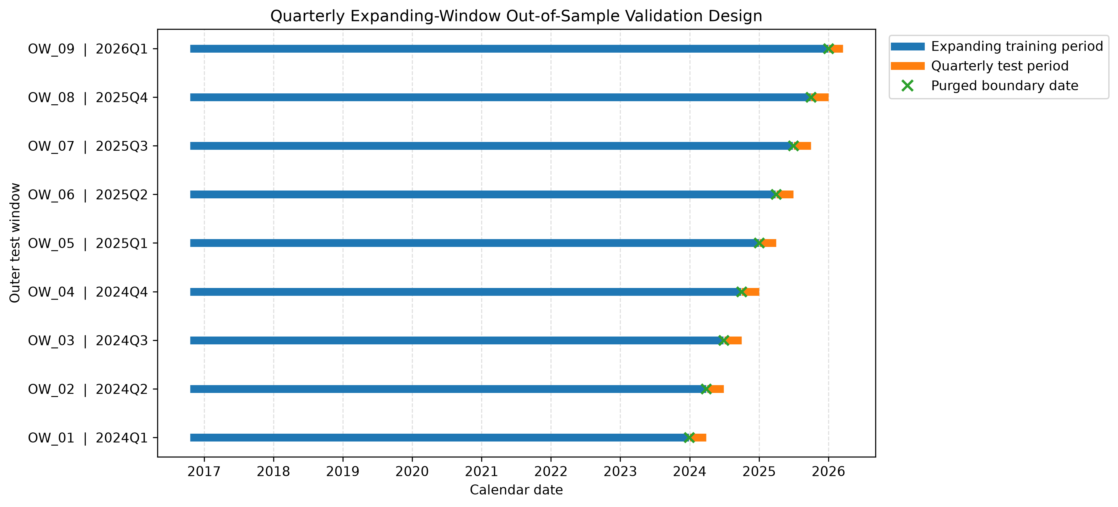
5.2 Aggregate Performance
Table 5.1: Out-of-Sample Forecasting Performance, 2024 Q1–2026 Q1
Performance Metric | Pooled OLS | XGBoost | Difference (XGB − OLS)
Out-of-sample predictions | 22,136 | 22,136 | 0
Evaluation trading dates | 554 | 554 | 0
Mean daily IC | +0.01991 | +0.01480 | −0.00511
Median daily IC | +0.02692 | +0.01871 | −0.00822
Daily IC standard deviation | 0.23379 | 0.21978 | −0.01401
Unannualised ICIR | 0.08516 | 0.06734 | −0.01781
Positive IC days | 54.15% | 53.61% | −0.54 percentage points
Observation-level MAE | 0.25631 | 0.25641 | +0.00010
Observation-level RMSE | 0.29594 | 0.29600 | +0.00006
Mean top-quartile hit rate | 28.00% | 26.88% | −1.12 percentage points
Mean bottom-quartile hit rate | 25.60% | 25.02% | −0.58 percentage points

Pooled OLS recorded the higher mean IC (0.01991 against 0.01480) and median IC (0.02692 against 0.01871). The mean difference of −0.00511 is measured on the correlation scale. It is not a return difference. OLS also recorded the higher ICIR (0.08516 against 0.06734). Both models had positive IC on slightly more than half of the days (54.15% and 53.61%). XGBoost's daily IC was less dispersed (standard deviation 0.21978 against 0.23379, about 6% lower), but this came with a lower mean.
Observation level errors were almost identical (MAE 0.25631 and 0.25641; RMSE 0.29594 and 0.29600), and both were slightly above the constant prediction benchmarks of 0.250 and about 0.289. The models therefore show little point-prediction skill, and IC remains the relevant ranking measure. Top-quartile hit rates were 28.00% for OLS and 26.88% for XGBoost, and bottom-quartile hit rates were 25.60% and 25.02%, against a random benchmark of 25%.
5.3 Statistical Significance
Table 5.2: Paired Newey–West HAC Inference on Daily IC Differences
Diagnostic | Value
Paired daily observations | 554
Newey-West maximum lag | 5
Mean IC difference (XGB − OLS) | −0.00511
Newey-West standard error | 0.00687
Asymptotic z-statistic | −0.7441
One-sided p-value | 0.7716
Two-sided p-value | 0.4568
95% confidence interval | [−0.01856, 0.00835]

The mean IC difference is −0.00511 with a HAC standard error of 0.00687, giving z = −0.744, a one-sided p-value of 0.7716 and a two-sided p-value of 0.4568. The 95% confidence interval [−0.01856, 0.00835] contains zero. The data therefore do not establish a statistically significant difference in mean daily IC. This does not prove the models are equivalent: the interval is compatible with an OLS advantage larger than observed and with an XGBoost advantage.
5.4 Quarterly Performance
Table 5.3: Quarterly Out-of-Sample Performance
Outer Window | Quarter | Trading Days | OLS Mean IC | XGB Mean IC | XGB − OLS | OLS Top Hit | XGB Top Hit
OW_01 | 2024 Q1 | 62 | +0.0136 | +0.0183 | +0.0048 | 26.1% | 27.4%
OW_02 | 2024 Q2 | 61 | +0.0421 | +0.0491 | +0.0071 | 28.4% | 27.5%
OW_03 | 2024 Q3 | 64 | −0.0198 | −0.0159 | +0.0039 | 24.8% | 24.8%
OW_04 | 2024 Q4 | 63 | +0.0646 | +0.0627 | −0.0019 | 28.9% | 28.6%
OW_05 | 2025 Q1 | 62 | −0.0719 | −0.0685 | +0.0035 | 20.0% | 19.0%
OW_06 | 2025 Q2 | 60 | +0.0643 | +0.0696 | +0.0053 | 30.8% | 31.8%
OW_07 | 2025 Q3 | 65 | +0.0470 | +0.0264 | −0.0206 | 29.5% | 26.8%
OW_08 | 2025 Q4 | 63 | −0.0015 | −0.0271 | −0.0257 | 30.6% | 28.1%
OW_09 | 2026 Q1 | 54 | +0.0455 | +0.0222 | −0.0233 | 33.5% | 28.1%

Relative performance varied over time. XGBoost had the higher mean IC in five of nine quarters (2024 Q1 to Q3 and 2025 Q1 to Q2) with an average advantage of about 0.0049. OLS led in the other four (2024 Q4 and 2025 Q3 to 2026 Q1) with an average advantage of about 0.0179. These larger OLS margins drive the aggregate result. Both models had weak or negative quarters, most notably 2025 Q1 (−0.0719 for OLS and −0.0685 for XGBoost), so positive aggregate IC does not imply uniformly positive ranking performance.
Figure 5.2 plots the 21-day rolling mean IC of each model. The two series move closely together: both are strongest in April to June 2024, late 2024 and July 2025, and both fall sharply in early 2025, so the models largely agree on when the ranking signal is strong or weak. Periods in which the lines separate are short and not consistently in one direction, although OLS is visibly higher than XGBoost between about October 2025 and early 2026. Figure 5.3 shows the corresponding quarterly means from Table 5.3.
Figure 5.2: Rolling 21-Day Mean Daily Information Coefficient, Pooled OLS and XGBoost (Primary Grid)
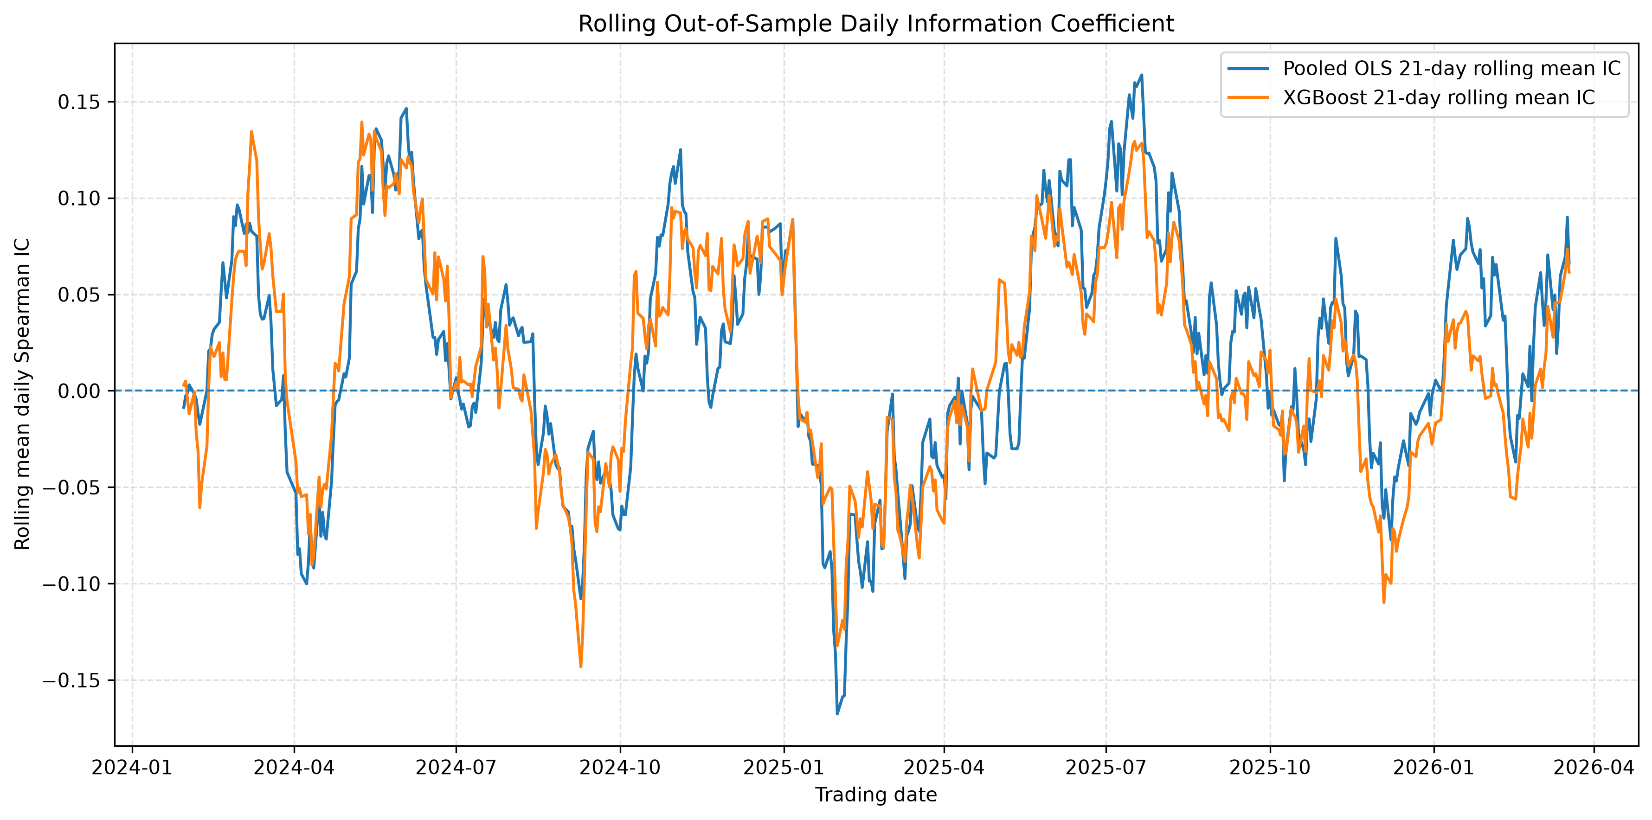
Figure 5.3: Mean Daily Information Coefficient by Test Quarter (Primary Grid)
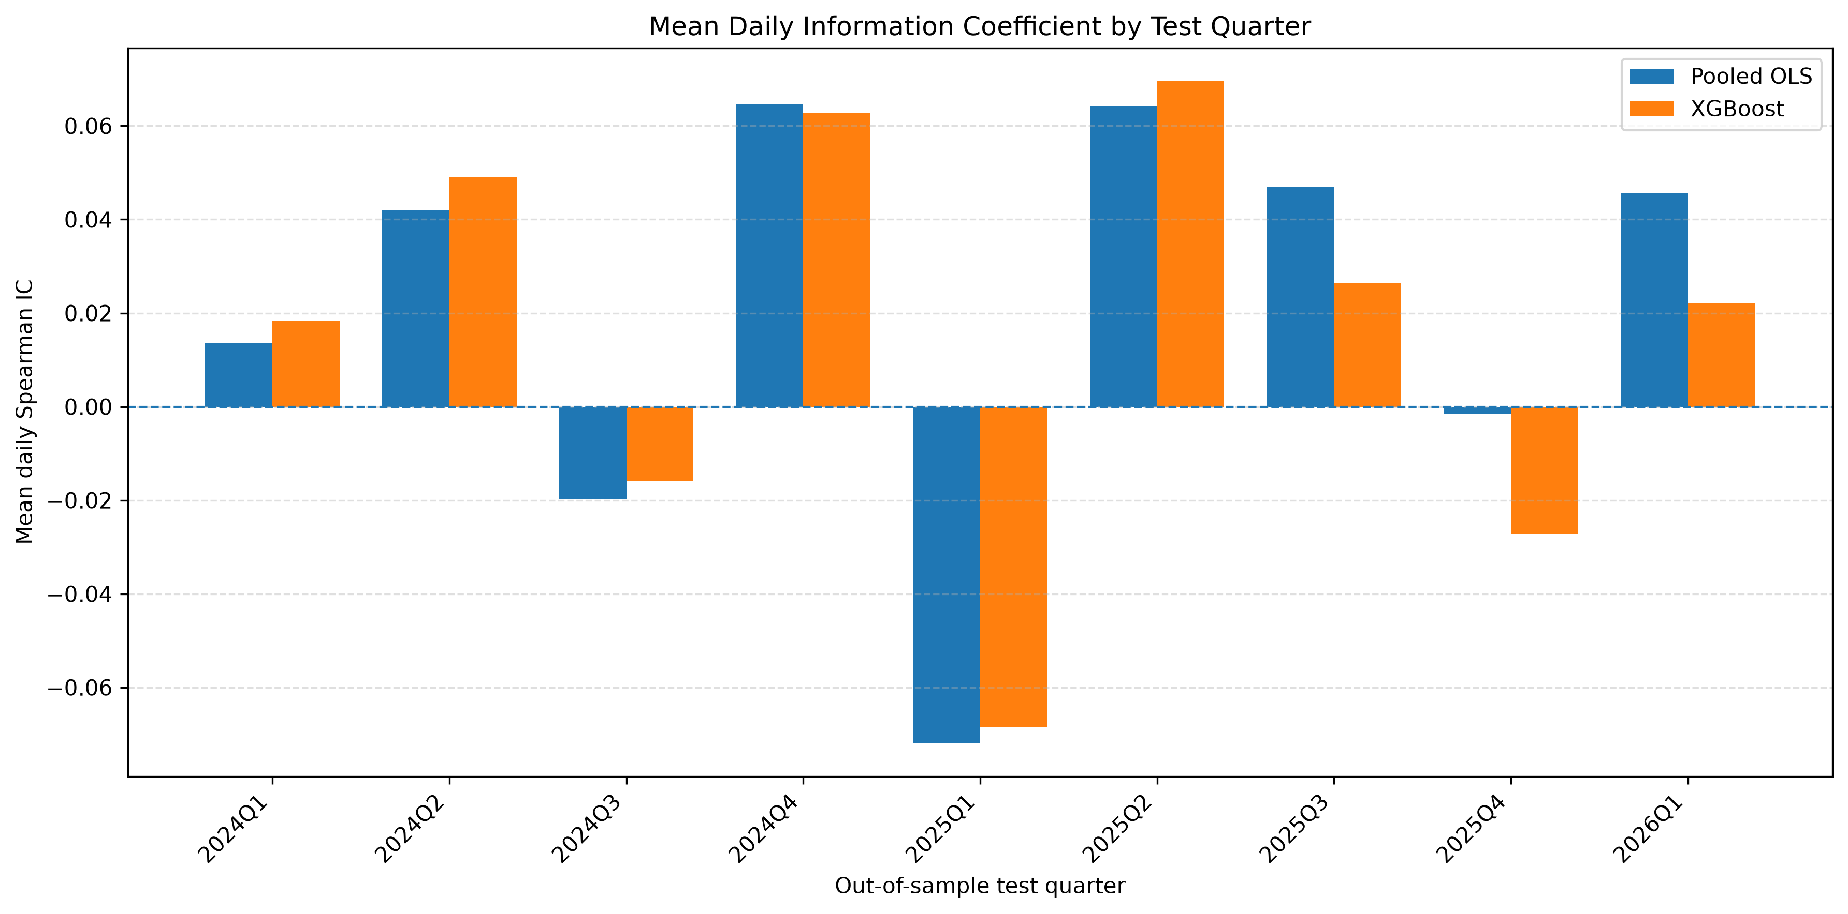
5.5 XGBoost Complexity and Feature Importance
Under the primary grid, validation favoured simple models. Six of nine outer windows selected a maximum depth of 2 and three selected depth 3. Learning rates were 0.02 or 0.05, and boosting rounds ranged from 8 to 73 with a median of 22. This describes the chosen configurations under this grid and does not show that non-linearity is absent from the JSE.
OLS coefficients were stable across the expanding windows (Figure 5.4). SMA_200_Ratio was consistently the largest positive coefficient (0.013 to 0.015), RSI_14 (−0.012 to −0.016) and Mom_6M (−0.007 to −0.009) were consistently negative, and SMA_50_Ratio was positive throughout. The opposite signs on closely correlated predictors, such as Mom_6M and SMA_200_Ratio (correlation 0.924), are consistent with the multicollinearity noted in Section 3.5 and should be read as conditional effects and not as stand-alone relationships. Mom_1M is the only predictor whose sign changes, from positive in 2024 to slightly negative from 2025 Q1, at magnitudes close to zero. The Vol_21D coefficient is essentially zero throughout.
Figure 5.4: Pooled OLS Coefficient Stability Across Expanding Training Windows
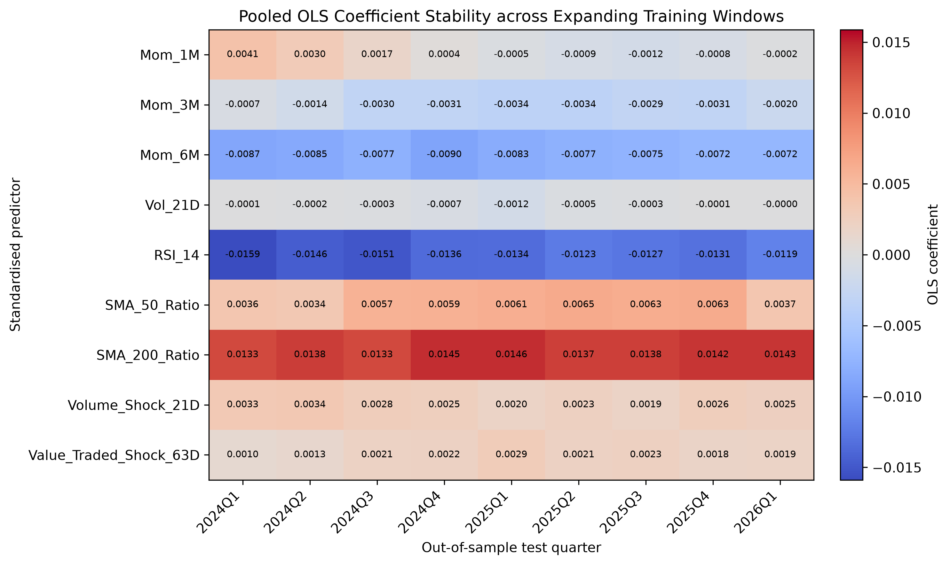
XGBoost's gain importance is more evenly spread (Figure 5.5). RSI_14 had the highest gain in every window (about 13% to 33%), most other predictors each contributed roughly 8% to 15%, and some recorded zero gain in particular windows: Mom_3M in OW_02, OW_06 and OW_07, Mom_6M in OW_02 and SMA_50_Ratio in OW_06.
Figure 5.5: XGBoost Gain-Based Feature Importance Across Expanding Training Windows (Primary Grid)
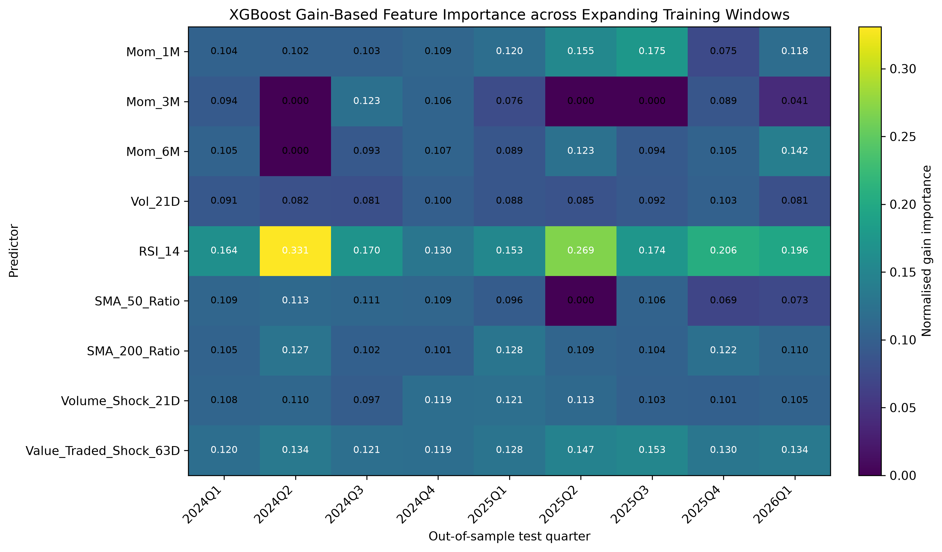
The two models weight predictors differently. OLS loads most heavily on SMA_200_Ratio, which receives only modest gain in XGBoost, while both give RSI_14 a prominent role. Given the correlations in Section 3.5, gain is shared among near substitutes, so importance reflects model usage and not independent or causal contributions, and OLS coefficients are likewise conditional on the correlated set.
5.6 Robustness Experiments
Expanded one-day grid. This experiment keeps the one-day target and the same nine windows, 554 test dates and 22,136 predictions, but expands the XGBoost search from 32 to 96 configurations by allowing reg_lambda to take the values 1, 5 and 10 (the primary grid fixed it at 10). Table 5.4 compares both XGBoost versions with Pooled OLS.
Table 5.4: Primary and Expanded XGBoost Grids Against Pooled OLS
Performance Metric | Pooled OLS | XGBoost (32 configs) | XGBoost (96 configs)
Mean daily IC | 0.0199 | 0.0148 | 0.0177
Median daily IC | 0.0269 | 0.0187 | 0.0197
Std. dev. of daily IC | 0.2338 | 0.2198 | 0.2169
ICIR | 0.0852 | 0.0673 | 0.0814
Positive-IC days | 54.15% | 53.61% | 54.51%
Top-quartile hit rate | 28.00% | 26.88% | 26.90%
Bottom-quartile hit rate | 25.60% | 25.02% | 25.18%
MAE | 0.25631 | 0.25641 | 0.25639
RMSE | 0.29594 | 0.29600 | 0.29599
Mean IC difference (XGB − OLS) | — | −0.0051 | −0.0022

The expanded grid improved XGBoost on every measure in Table 5.4 relative to the primary grid, although the improvement in MAE (0.25641 to 0.25639) and RMSE (0.29600 to 0.29599) was negligible. Mean IC rose from 0.0148 to 0.0177, ICIR from 0.0673 to 0.0814 and the share of positive-IC days from 53.61% to 54.51%, while the dispersion of daily IC fell slightly. The gap to OLS in mean IC narrowed from −0.0051 to −0.0022, by more than half. OLS nevertheless kept the higher mean IC, median IC, ICIR, quartile hit rates and (marginally) the lower MAE and RMSE and led on seven of the nine measures. XGBoost retained only the lower IC dispersion and a slightly higher share of positive-IC days.
The paired Newey–West test again found no significant difference (mean difference −0.0022, HAC standard error 0.0070, z = −0.322, one-sided p = 0.626, two-sided p = 0.748, 95% confidence interval [−0.0160, 0.0115]). By quarter, XGBoost had the higher mean IC in three of nine quarters (2024 Q1, 2024 Q2 and 2025 Q2) and OLS in the other six, a weaker quarterly record than under the primary grid (five of nine). XGBoost's largest wins were in 2024 Q2 (+0.0264) and 2025 Q2 (+0.0309), while OLS led by 0.0207 to 0.0257 in 2025 Q3, 2025 Q4 and 2026 Q1. This initial pattern hints that XGBoost's gains may be concentrated in calmer periods and that OLS may be more resilient in later, more difficult ones. It is only suggestive, as the quarters were not classified by market regime, the pattern is less clear under the primary grid, and nine windows cannot support a formal test.
Validation made use of the extra flexibility. A reg_lambda of 10 was selected in four windows, 1 in three and 5 in two, so the primary grid's fixed value was not selected in five of nine windows. Selected trees remained shallow (maximum depth 2 in four windows and 3 in five), with a learning rate of 0.05 in seven windows and between 12 and 73 boosting rounds. The result is consistent with the fixed regularisation in the primary grid having constrained XGBoost somewhat, but even with more tuning flexibility XGBoost did not overtake the linear benchmark.
21-day horizon. Under the 21-day horizon, mean IC was approximately +0.0014 for OLS and −0.0138 for XGBoost, so both models were weaker than at the one-day horizon and the relationship captured by this feature set is sensitive to horizon. This tests only one alternative horizon and this predictor set.
5.7 Summary of Results
Both models produced positive mean IC, with OLS higher (0.01991 against 0.01480 for XGBoost under the primary grid). XGBoost's daily IC was less dispersed, and the error measures were almost indistinguishable. XGBoost led in five of nine quarters, but OLS's larger margins in the other four drove the aggregate difference. The paired Newey–West test did not reject equality of mean IC (two-sided p = 0.4568). Expanding the XGBoost search to 96 configurations narrowed the gap (mean IC 0.0177) but did not change this conclusion (two-sided p = 0.748). The observed difference is small on the correlation scale and statistically indistinguishable from zero, so the evidence does not support a significant incremental improvement from XGBoost's non-linear flexibility at the one-day horizon. Positive average IC for both models is consistent with a small degree of ranking information in the predictors, but its magnitude is modest relative to daily variation.
CHAPTER 6: DISCUSSION AND CONCLUSION
6.1 Main Findings
Pooled OLS achieved a higher mean daily IC than XGBoost (0.01991 against 0.01480), but the difference of −0.00511 was not statistically significant (HAC standard error 0.00687, two-sided p = 0.4568, 95% confidence interval [−0.01856, 0.00835]). XGBoost therefore did not produce a statistically detectable improvement in ranking performance. The result is not proof that OLS is superior, and it does not show the models are equivalent, since the confidence interval is compatible with differences in either direction. Neither model dominated across quarters, and error measures were nearly identical. Expanding the XGBoost search to 96 configurations narrowed the mean IC gap to −0.0022 but left the result insignificant (two-sided p = 0.748), so the conclusion does not appear to depend on the fixed regularisation of the primary grid.
6.2 Relationship to the Literature
The result contrasts with the large gains reported by Gu, Kelly and Xiu (2020) for broad US universes and many characteristics. The environments differ: about 40 securities per date, nine price and volume based predictors, a one-day horizon and a percentile target. The finding is best read as a boundary condition: greater flexibility did not translate into a significant gain under these conditions, so gains documented elsewhere cannot be assumed to transfer to every market, feature set or horizon.
6.3 Possible Explanations
These explanations are hypotheses consistent with the results, not mechanisms established by the experiment.
Limited cross-sectional breadth. A cross-section of 38 to 40 securities offers few observations for learning conditional relationships, and repeated splitting leaves little data in each region of the predictor space. This is consistent with the shallow trees selected, but the study did not vary cross-section size, so it cannot establish this as the cause.
Horizon and signal-to-noise. The predictable component of next-day relative returns is small. Mean IC was only 0.01 to 0.02, and it weakened at 21 days. This does not show that technical signals decay with horizon in general, since only one predictor set and one alternative horizon were tested.
Feature-space composition. A flexible model cannot exploit non-linear information that its inputs do not contain. The result applies to this technical, trading-activity feature set and does not show that XGBoost would fail with accounting, macroeconomic or alternative data.
Information overlap. Correlations of 0.89 to 0.92 between several predictor pairs mean the effective dimensionality is well below nine. RSI_14's high gain therefore does not show it carries unique information independent of related predictors such as SMA_50_Ratio.
Possible regime dependence. The quarterly results offer an initial, tentative indication that XGBoost's advantage appeared mainly in calmer quarters while OLS performed better in the later, more difficult quarters. If confirmed, this would suggest that the linear benchmark is more robust to changing market conditions, whereas a flexible model may fit relationships that weaken during regime shifts. The evidence is too limited to establish this. Quarters were not defined by an objective regime measure, the pattern differs between the primary and expanded grids, and no test of regime dependence was conducted. More research is needed to confirm it.
6.4 Implications
Greater model flexibility is an empirical hypothesis to be tested out of sample, not an assumption. XGBoost's capacity for non-linearity did not yield a significant improvement over a transparent linear benchmark, and nested validation selected predominantly shallow models. This does not mean non-linearities are absent from JSE returns. The study does not show which model would be more profitable, because no portfolio, transaction costs, turnover or implementation constraints were modelled. The practical conclusion is narrow: under this statistical framework XGBoost did not significantly improve daily ranking accuracy over the pooled linear benchmark, so the incremental value of non-linear modelling should be tested and not presumed.
6.5 Limitations
Universe. The results are specific to a liquid universe of about 40 securities and may not generalise to smaller or less liquid stocks. Survivorship bias is mitigated but not eliminated, because 11 ticker histories were unavailable and official constituent records were not accessible.
Features and data. Only technical and trading-activity predictors from daily data were used, and the data come from Yahoo Finance, so residual errors cannot be excluded despite the audits.
Model and search. Only one non-linear architecture was examined, with researcher-defined grids. The expanded grid varied only reg_lambda, so other tuning dimensions and wider searches remain untested.
Target and timing. The percentile target discards return magnitude, so findings concern relative ranking accuracy and not return forecasting. Features at date t are linked to the close-to-close return from t to t+1, so same-close implementability is not claimed. The complete-feature requirement sometimes reduces the cross-section below 40.
No economic evaluation. A difference in IC does not translate mechanically into a difference in investment returns, so conclusions about profitability are outside the scope of this study.
6.6 Future Research
Future work could (i) add accounting and macroeconomic predictors, (ii) extend the universe beyond the Top 40 to test whether cross-sectional breadth matters, (iii) compare other non-linear models such as random forests, LightGBM and neural networks, (iv) evaluate several horizons (for example 1, 5, 10 and 21 days), (v) search wider hyperparameter spaces beyond regularisation, (vi) translate rankings into portfolios with realistic costs and constraints, (vii) test regime dependence by classifying periods using objective measures such as market volatility, and (viii) apply the framework to other African markets.
6.7 Contribution and Conclusion
The study provides a controlled comparison of a transparent pooled linear benchmark and a gradient-boosting model in a South African equity setting, with the same predictors, target, chronological periods and out-of-sample observations. Its safeguards include point-in-time universe construction, OHLC consistency checks, target-horizon purging, training-only winsorisation, nested hyperparameter selection and paired HAC inference.
Over 554 out-of-sample trading dates and 22,136 paired predictions, both models produced positive average ranking skill, with Pooled OLS slightly ahead of XGBoost, but the difference was not statistically significant. The additional non-linear flexibility of XGBoost did not yield a detectable improvement over the pooled linear benchmark in this JSE universe, with these predictors and at this horizon. The finding should not be extended to all machine-learning methods, securities, feature sets or horizons. More broadly, model complexity should be justified by rigorous out-of-sample testing and not assumed to improve forecasts. The study provides an empirical baseline for assessing when non-linear methods add value in South African and other emerging-market equity data.

References
Amihud, Y. 2002. Illiquidity and stock returns: Cross-section and time-series effects. Journal of Financial Markets, 5(1), pp. 31–56.
Ang, A., Hodrick, R.J., Xing, Y. and Zhang, X. 2006. The cross-section of volatility and expected returns. The Journal of Finance, 61(1), pp. 259–299.
Arlot, S. and Celisse, A. 2010. A survey of cross-validation procedures for model selection. Statistics Surveys, 4, pp. 40–79.
Arnott, R.D., Harvey, C.R. and Markowitz, H. 2019. A backtesting protocol in the era of machine learning. The Journal of Financial Data Science, 1(1), pp. 64–74.
Bartens, R. and Hassan, S. 2010. Value, size and momentum portfolios in real time: The cross section of South African stocks. Australian Journal of Management, 35(2), pp. 181–202.
Basiewicz, P.G. and Auret, C.J. 2009. Another look at the cross-section of average returns on the JSE. Investment Analysts Journal, 38(69), pp. 23–38.
Brock, W., Lakonishok, J. and LeBaron, B. 1992. Simple technical trading rules and the stochastic properties of stock returns. The Journal of Finance, 47(5), pp. 1731–1764.
Cawley, G.C. and Talbot, N.L.C. 2010. On over-fitting in model selection and subsequent selection bias in performance evaluation. Journal of Machine Learning Research, 11, pp. 2079–2107.
Chen, T. and Guestrin, C. 2016. XGBoost: A scalable tree boosting system. Proceedings of the 22nd ACM SIGKDD International Conference on Knowledge Discovery and Data Mining, pp. 785–794.
Diebold, F.X. and Mariano, R.S. 1995. Comparing predictive accuracy. Journal of Business & Economic Statistics, 13(3), pp. 253–263.
Fieberg, C., Metko, D., Poddig, T. and Loy, T. 2023. Machine learning techniques for cross-sectional equity returns’ prediction. OR Spectrum, 45, pp. 289–323.
Grinold, R.C. and Kahn, R.N. 2000. Active Portfolio Management: A Quantitative Approach for Producing Superior Returns and Controlling Risk. 2nd ed. New York: McGraw-Hill.
Gu, S., Kelly, B. and Xiu, D. 2020. Empirical asset pricing via machine learning. The Review of Financial Studies, 33(5), pp. 2223–2273.
Hanauer, M.X. and Kalsbach, T. 2023. Machine learning and the cross-section of emerging market stock returns. Emerging Markets Review, 55, Article 101022.
Hyndman, R.J. and Koehler, A.B. 2006. Another look at measures of forecast accuracy. International Journal of Forecasting, 22(4), pp. 679–688.
Jegadeesh, N. 1990. Evidence of predictable behavior of security returns. The Journal of Finance, 45(3), pp. 881–898.
Jegadeesh, N. and Titman, S. 1993. Returns to buying winners and selling losers: Implications for stock market efficiency. The Journal of Finance, 48(1), pp. 65–91.
Krauss, C., Do, X.A. and Huck, N. 2017. Deep neural networks, gradient-boosted trees, random forests: Statistical arbitrage on the S&P 500. European Journal of Operational Research, 259(2), pp. 689–702.
Lee, C.M.C. and Swaminathan, B. 2000. Price momentum and trading volume. The Journal of Finance, 55(5), pp. 2017–2069.
Lo, A.W., Mamaysky, H. and Wang, J. 2000. Foundations of technical analysis: Computational algorithms, statistical inference, and empirical implementation. The Journal of Finance, 55(4), pp. 1705–1765.
Martin, I.W.R. and Nagel, S. 2022. Market efficiency in the age of big data. Journal of Financial Economics, 145(1), pp. 154–177.
Muller, C. and Ward, M. 2013. Style-based effects on the Johannesburg Stock Exchange: A graphical time-series approach. Investment Analysts Journal, 42(77), pp. 1–16.
Newey, W.K. and West, K.D. 1987. A simple, positive semi-definite, heteroskedasticity and autocorrelation consistent covariance matrix. Econometrica, 55(3), pp. 703–708.
Shumway, T. 1997. The delisting bias in CRSP data. The Journal of Finance, 52(1), pp. 327–340.
Spearman, C. 1904. The proof and measurement of association between two things. The American Journal of Psychology, 15(1), pp. 72–101.
Tashman, L.J. 2000. Out-of-sample tests of forecasting accuracy: An analysis and review. International Journal of Forecasting, 16(4), pp. 437–450.
Van Rensburg, P. and Robertson, M. 2003. Style characteristics and the cross-section of JSE returns. Investment Analysts Journal, 32(57), pp. 7–15.
Varma, S. and Simon, R. 2006. Bias in error estimation when using cross-validation for model selection. BMC Bioinformatics, 7, Article 91.
Wilder, J.W. 1978. New Concepts in Technical Trading Systems. Greensboro, NC: Trend Research.
Wooldridge, J.M. 2010. Econometric Analysis of Cross Section and Panel Data. 2nd ed. Cambridge, MA: MIT Press.

https://github.com/Lamack-cell

