**School of Information Technologies and Engineering, ADA University**

**CSCI2303 – Intro to Computer Networks**

**Fall 2024 – 10/7/2024**

**Assignment 2 by Laman Panakhova 16882**

**Packet Tracer - Basic Switch and End Device Configuration**

**Addressing Table**

| **Device** | **Interface** | **IP Address** | **Subnet Mask** |
| --- | --- | --- | --- |
| Room-145 | VLAN 1 | 128.107.20.10 | 255.255.255.0 |
| Room-146 | VLAN 1 | 128.107.20.15 | 255.255.255.0 |
| Manager | NIC | 128.107.20.25 | 255.255.255.0 |
| Reception | NIC | 128.107.20.30 | 255.255.255.0 |

*Blank Line, No additional information*

***Objectives***

*=   Configure hostnames and IP addresses on two Cisco Internetwork Operating System (IOS) switches using the command-line interface (CLI).*

*=   Use Cisco IOS commands to specify or limit access to the device configurations.*

*=   Use IOS commands to save the running configuration.*

*=   Configure two host devices with IP addresses.*

*=   Verify connectivity between the two PC end devices.*

***Scenario***

*As a recently hired LAN technician, your network manager has asked you to demonstrate your ability to configure a small LAN. Your tasks include configuring initial settings on two switches using the Cisco IOS and configuring IP address parameters on host devices to provide end-to-end connectivity. You are to use two switches and two hosts/PCs on a cabled and powered network.*

***Instructions***

*Configure the devices to fulfill the requirements below.*

***Requirements***

*=   Use a console connection to access each switch.*

*=   Name****Room-145****and****Room-146****switches.*

*=   Use the****ADA1234****password for all lines.*

*=   Use the* ***ADAClass*** *secret password.*

*=   Encrypt all clear text passwords.*

*=   Configure an appropriate message-of-the-day (MOTD) banner.*

*=   Configure addressing for all devices according to the Addressing Table.*

*=   Save your configurations.*

*=   Verify connectivity between all devices.*

**Steps:**

1. I started with connecting 2 end devices (PC-PT PC0/ PC-PT PC1) with 2 intermediary devices (2960-24TT Switch0/2960-24TT Switch2) in the Cisco Packet Tracer application. The first PC is a manager PC which is connected to switch 0 which will be called Room-145. Similarly, the second PC is a reception PC which is connected to switch 2 which will be called Room-146. Additionally, the switches are connected with the straight-through cable.

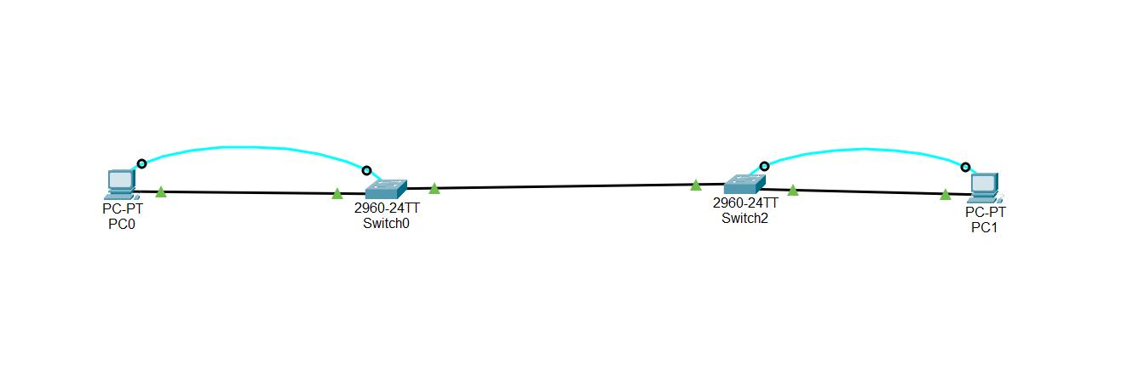

1. We run these commands in CLI of each switch. We change the hostnames and we set the passwords. Also, we change the IP addresses.

1. Then we access to the PC desktop IP configuration. We set the IP addresses and subnet masks.   
   A screenshot of a computer

   Description automatically generated

1. In the end we verify the connectivity by command ping.

The display is successful.