**School of Information Technologies and Engineering, ADA University**

**CSCI2303 – Intro to Computer Networks**

**Fall 2024 – 9/28/2024**

**Assignment 1 by Laman Panakhova 16882**

**Instructions:**

*Task 1: Establish Basic Connections, Access the CLI – use end device and intermediary device.*

*Task 2: Establish a terminal session with Switch.*

*Task 3: Enter privileged EXEC mode and examine the current switch configuration.*

*Task 4: Assign a name to a switch, secure access to the console line, secure privileged mode access, configure an encrypted password to secure access to privileged mode, configure a MOTD Banner.*

*Task 5: Save and Verify Configuration Files to NVRAM.*

**Steps:**

1. I started with connecting an end device (PC-PT PC3) with an intermediary device (2960-24TT Switch3) in the Cisco Packet Tracer application.

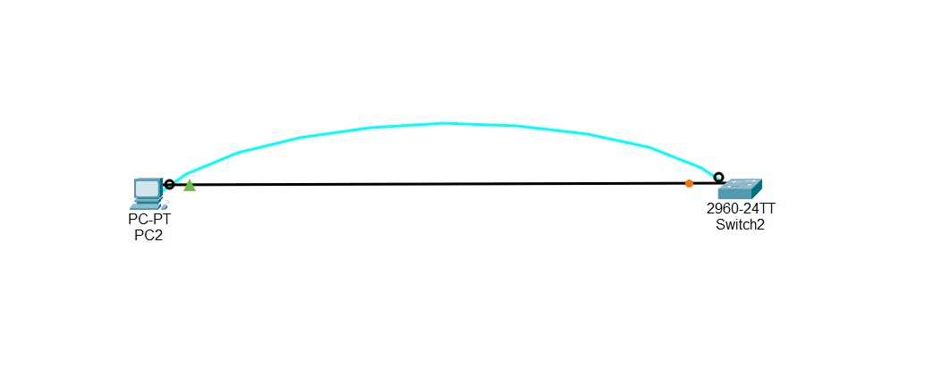

1. Once connected, I **entered Privileged EXEC mode** by typing enable. Then I **checked the current switch configuration** using the show running-config command.

1. Next, I began configuring the switch: First, I assigned a name to the switch to make it easier to identify - hostname. Then secured the console line by setting a password - line console 0, making sure only authorized users can access it - password. After that protected privileged access by setting an encrypted password to prevent unauthorized changes - enable secret. Created a Message of the Day (MOTD) banner to display a custom message when someone connects to the switch - banner motd.
2. Finally, I **saved the configuration** to NVRAM, ensuring that all our changes are kept even if the switch is restarted - running-config startup-config, and **verified the saved configuration** to make sure everything was properly stored - show startup-config.

1. In the very end I tried to exit and enter the switch again to check if the passwords and name of the switch was shown correctly - exit.

