Lamar A. Sims

April 17, 2016

Data Comm Project Report

**Description**

I have made a simple program with the thought of TCP in mind. I use Java for the programming language and use Eclipse and Android Studio for the IDEs. I developed it for Android 5.1.1, which is what my smartphone runs. It is a messaging application between a server and client. In particular the server is my laptop and the client is my smartphone, but other PCs should be able to connect to my server as well. I use sockets to make the connections between my server and client and input and output streams to pass the messages between my laptop and smartphone. The server only allows direct messaging between it and one client, I did this just to keep it simple. Through this I have been able to make an application that allows my smartphone to connect to my laptop, through the internet over Wi-Fi, when my laptop it is running as a server and I can pass messages between them, as if I was texting between two other phones.

I did not have a group so I did all of this by myself.

**How to run applications**

1. Open up application on smartphone and start the server on the laptop

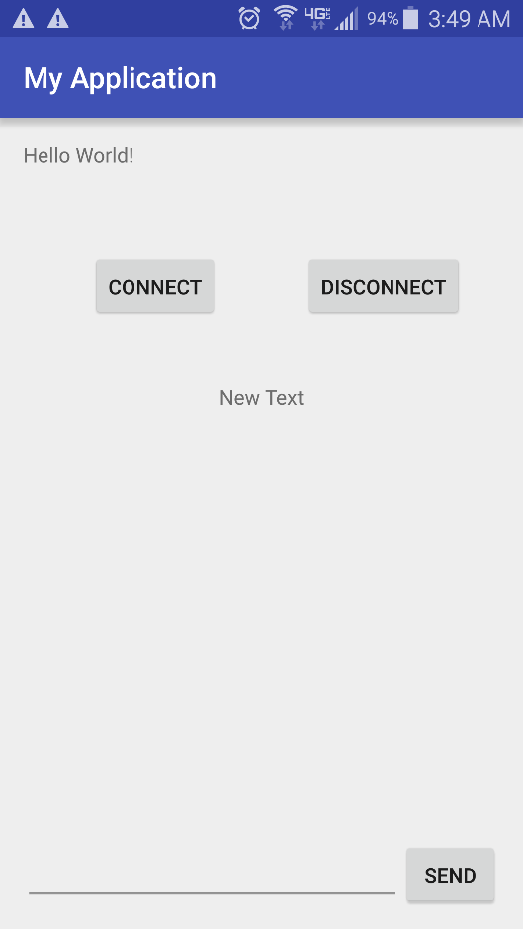

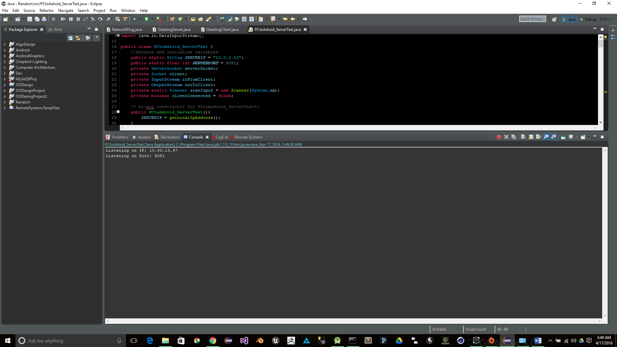

1. Connect smartphone application to the laptop application

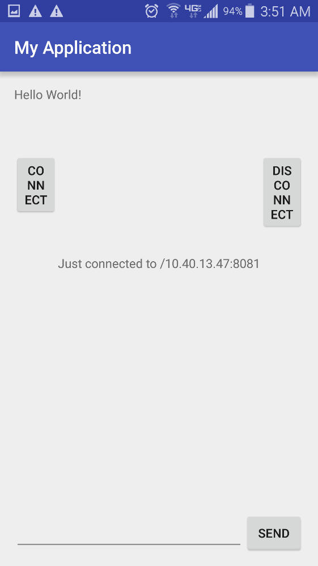

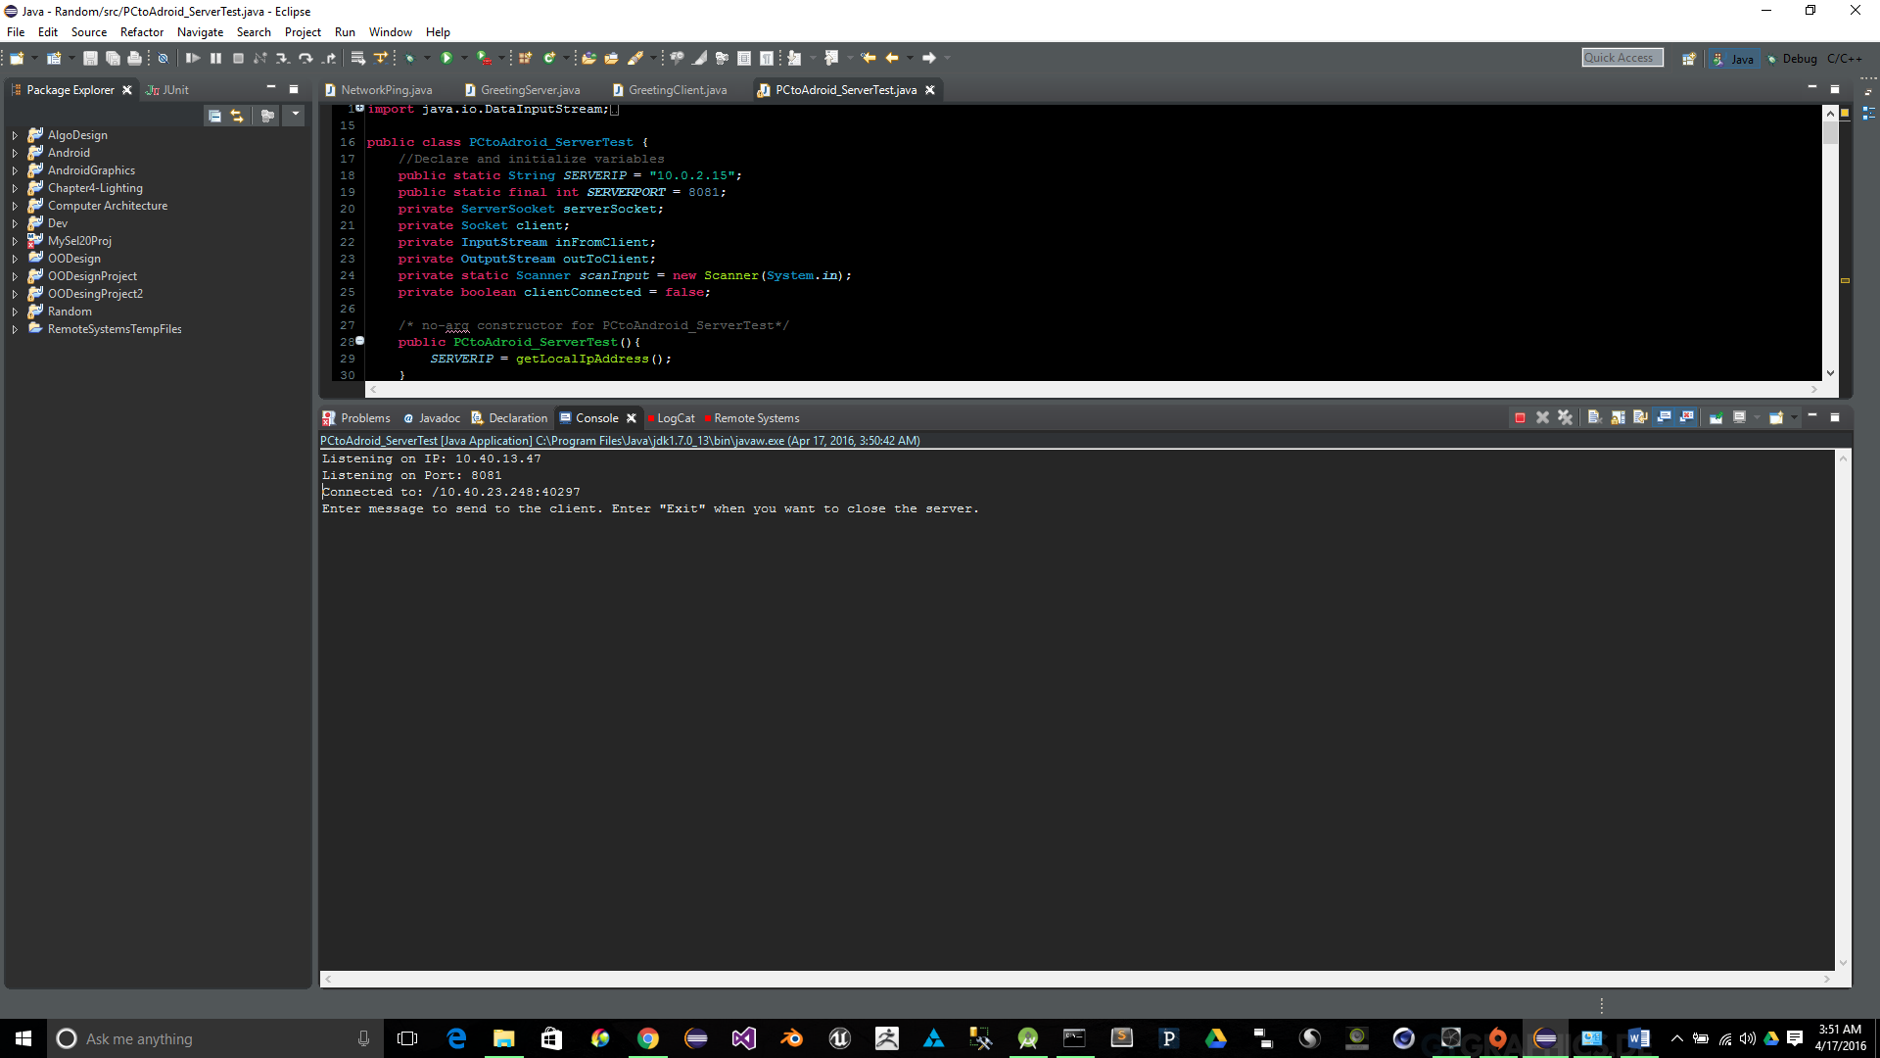

1. Then exchange messages between the two devices

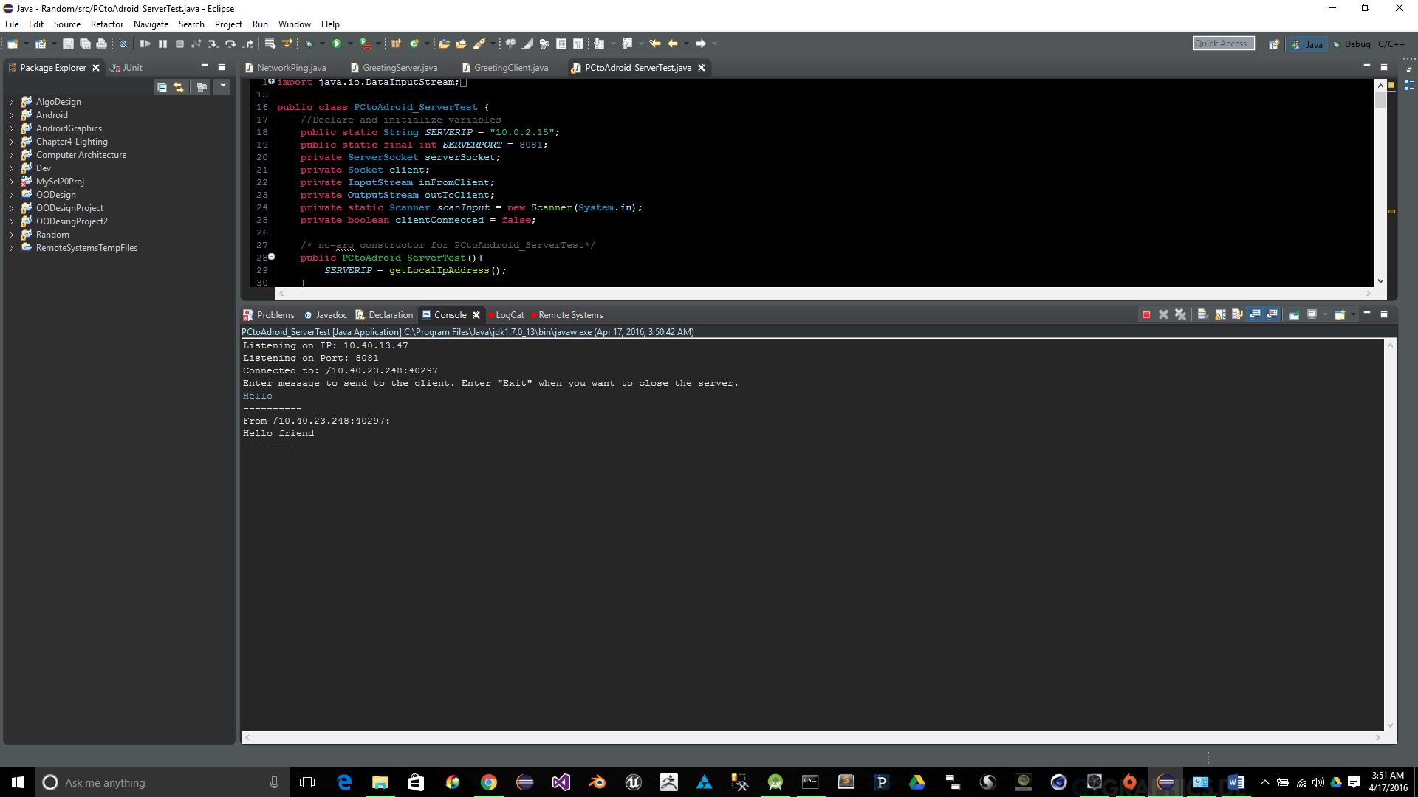

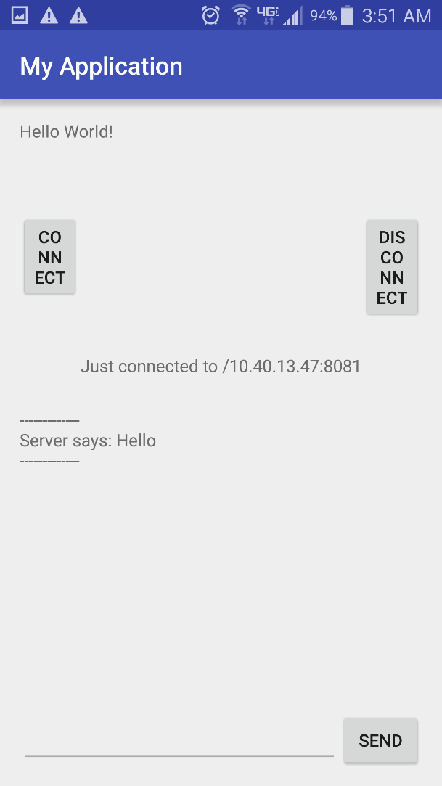

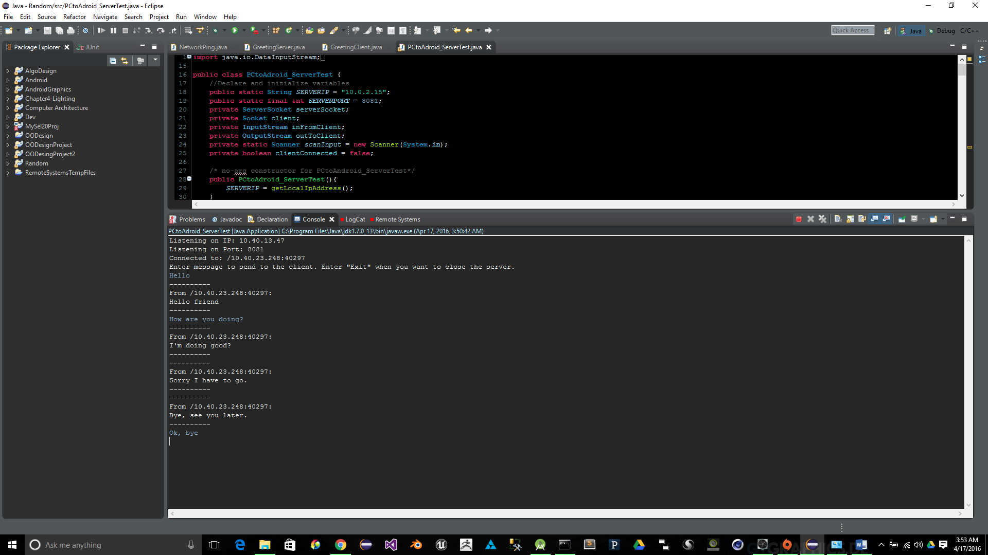

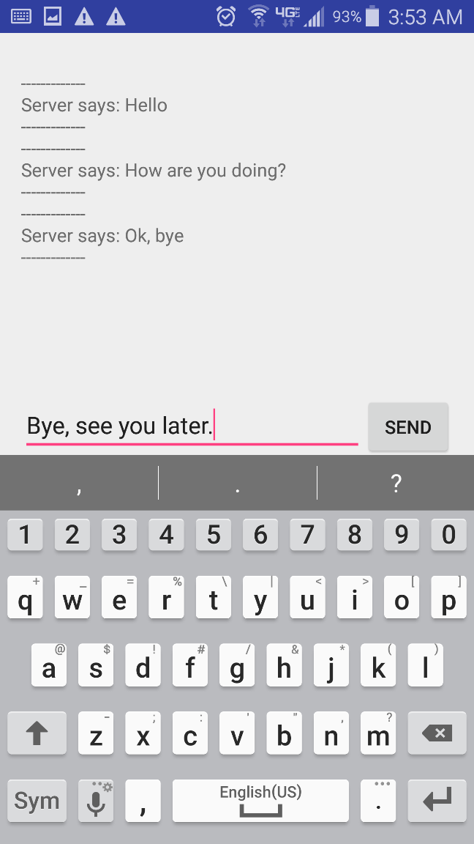

1. Then disconnect the phone from the server.

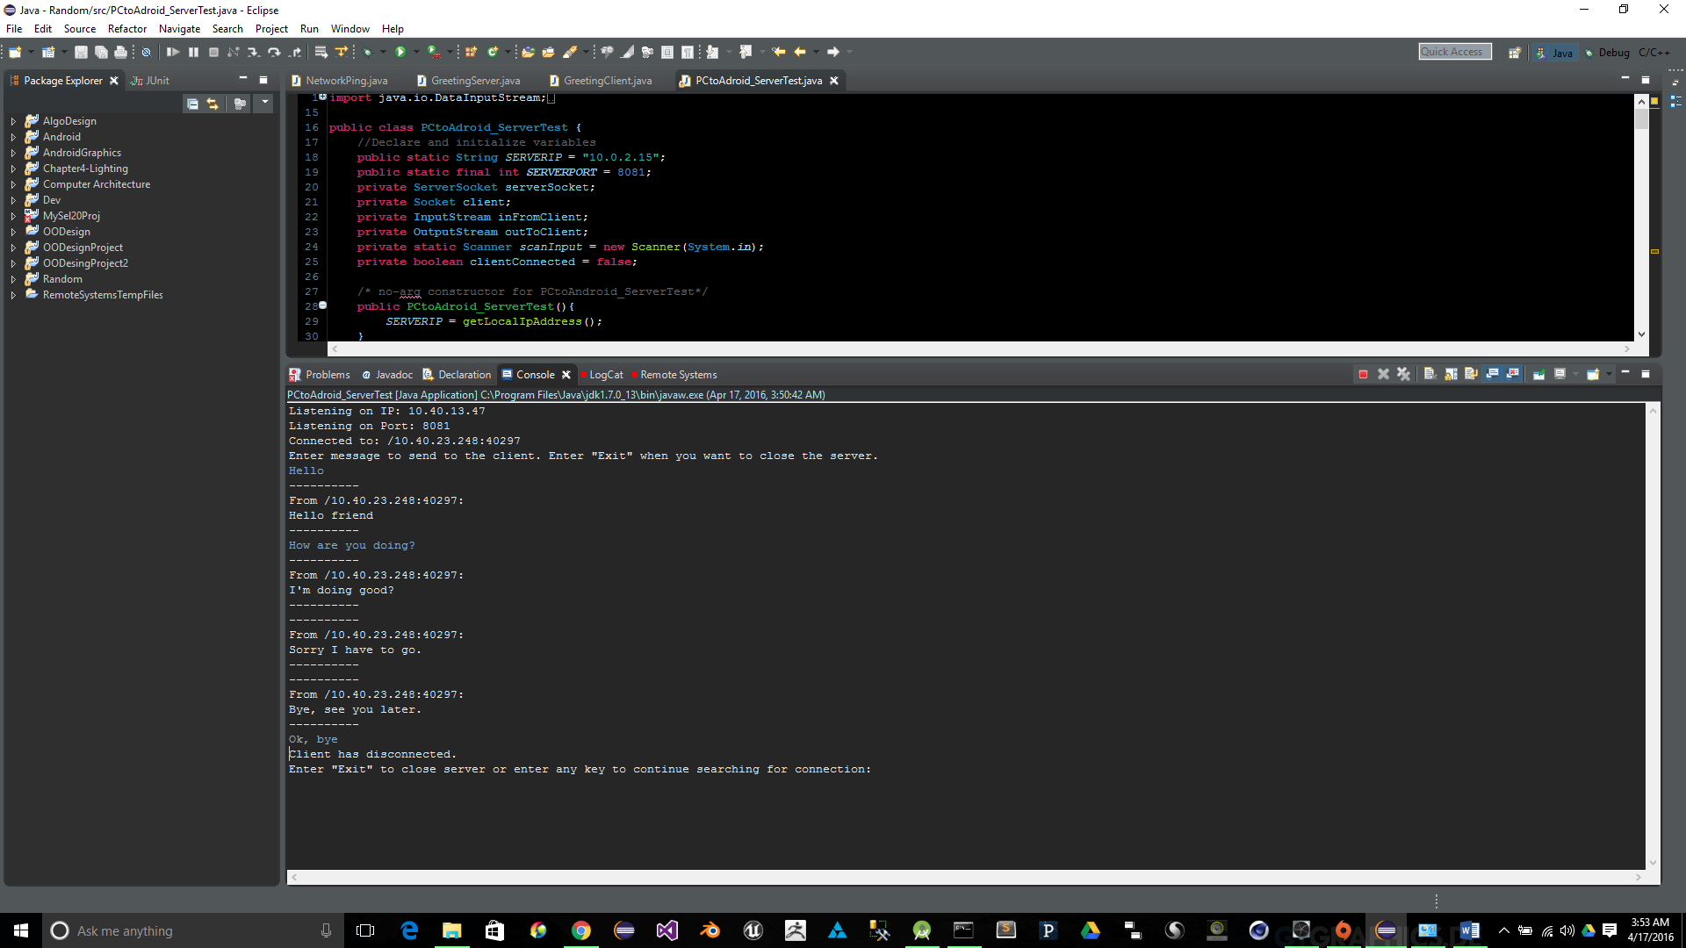

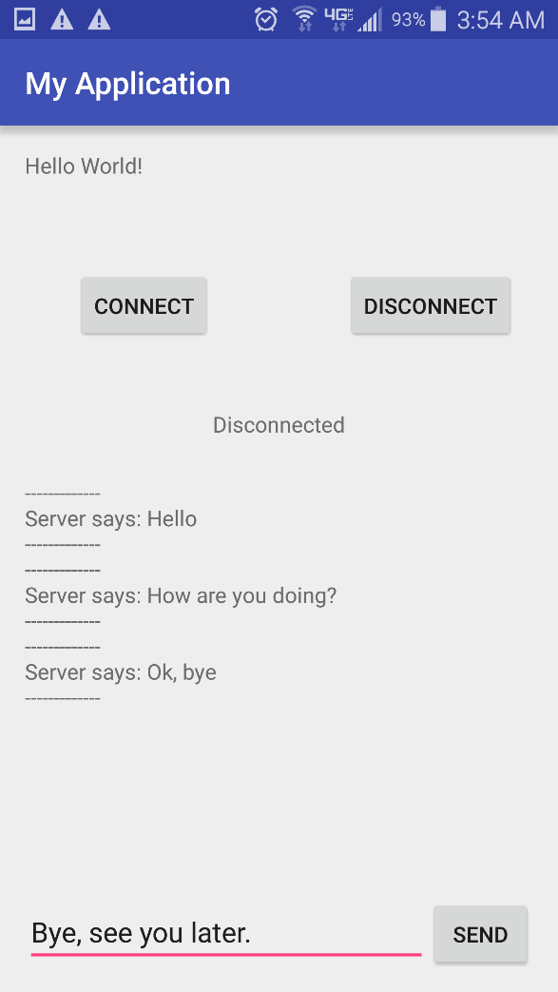

1. Then close the server

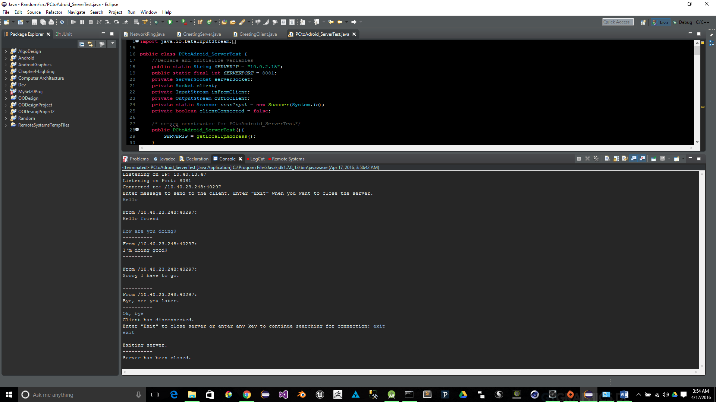

**Applies to concepts learned**

It applies to the concepts we learned because I have to get the IP address that my laptop runs on and specify a port that allows other devices to connect to my laptop. Then to send messages between my laptop application and smartphone application it has to use the TCP/IP protocols to get the messages from one device to the other device by using the IP address of my laptop and the port it is on to determine where to send the messages to.