|  |
| --- |
| Georgia Southern University |
| Final Project Report |
| Group: Guardians of The Galaxy |
|  |
| **Charles McKinley**  **Lamar Sims**  **Patrick Meehan** |
|  |
|  |
|  |

|  |
| --- |
|  |

Table of Contents

# Executive Summary…………………………………………………………………..2

# Team Organization …………………………………………………………………...3

# Scope………………………………………………………………………………………….3

# Functional Scenarios………………………………………………………………….8

# Future Opportunities…………………………………………………………………8

# SQL Queries……………………………………………………………………………….9

# Logical Model……………………………………………………………………………28

# Physical Model………………………………………………………………………….49

# Graphical User Interface……………………………………………………………58

# Post-Mortem……………………………………………………………………..64

# References………………………………………………………………………..65

# Schema…………………………………………………………………………….66

**1.) Executive Summary**

This project will deal with government officials and bills of Georgia. At a critical time when elections for new officials has passed, we figured creating a database that could show you the government officials and the bills they’ve been working on would be beneficial to make. One of the many things a government official does it created bills that could possibly become laws. With the creation of a user-friendly interface, you could access such information as which government official represents your county and also which bills was voted either yes or no.

**Bills**

Each bill has its own id and it is separated among sessions. When a new bill is getting discussed, it has a name and belongs to a certain general assembly.

**General Assembly**

Each general assembly will have a certain house type. Within each house type, there contains committee names. The name of each committee has its own committee id. The name of each committee also contains its own action which is identified by an action id. The committee action is also linked to the bill and session it was included with.

**People**

Each person has their own id and is addressed by first name and last name. They also contain the name of the county they represent and the name of the position they have. People are also authored with each unique bill and session.

**2.) Team Organization**

All team member apart of this group will participate in fulfilling the requirements given to us by our professor and collaborate amongst each other to stay within guidelines and have everything completed within the time allowed

i. Patrick: Did the initial outline for the database as well as contributed a good amount in creating the GUI. Connected the database to the GUI as well as create the code behind it.

ii. Lamar: I did the logical model as well as change into physical model. Wrote all insert statements and created Schema for database. I as well created GUI outline, helped create and code the GUI as well.

iii. Charles: Gathered all data information in building the report and created 10 questions for the queries

**3.) Scope**

The scope of the government officials’ database will cover a database with bills, government officials who are in the general assembly, and individual people are representatives. We will also be providing a GUI to connect to the database for ease of access. We will also provide a report detailing the work completed with the models and diagrams created during the project.

**Data Requirements**

**Sessions:**

Sessions is connected to Bills. Each session has its own id and it also described to have its own type as well.

Sessions_ID

SessionType

**Bills:**

Bills have a unique id for each individual one and each bill is linked to a specific session. Each bills also has a name and a specific house type it is linked to.

Bill_ID

Sessions_ID

HouseType

Name

**GovernorSigned:**

If the bills get approved then the governor will sign it. This will contain a signed ID associated with the particular bill and particular session it was included in. This will also include the date the bill was signed.

signedID

Bill_ID

Sessions_ID

dateSigned

**Votes:**

Each bill will have votes. Within the votes, you have a vote ID that is associated with the particular house type, bill, and session it was included in. The votes would either contain a yea, a nay, a not voting, or excused.

voteID

Bill_ID

Sessions_ID

HouseType

Yay

Nay

NotVoting

Excused

**General Assembly:**

Within the general assembly, there contains a house type each member is associated with.

HouseType

**CommitteeNames:**

With each housetype, there contains a committee name.

HouseType

committeeName

**CommitteeAction:**

With the name of each committee and committee type being represented, the committee action has its own action id. Each action id will be associated with the bill and session it took place with.

actionID

HouseType

committeeName

Bill_ID

Sessions_ID

**Committees:**

Each committee has its own committee id. The committee is associated with a certain house type, committee name, and each individual included within the committee.

committeeID

HouseType

committeeName

pID

**Authored:**

Authored contains an authoredID with each unique PID. Authored is also associated with each different bill and session as well.

authoredID

pID

Bill_ID

Sessions_ID

**Counties:**

Each County has is identified by county name.

CountyName

**People:**

Each person is identified by their personal id. Along with their id, each person has a first name, a last name, and is associated to their position name and the name of the county they’re representing.

PID

FirstName

lastName

CountyName

pName

**Positions:**

Each position is label by a name.

pName

**4.) Functional Requirements (Scenarios)**

System Requirements:

* The GUI should be user friendly and easy to use for anyone who would want or have access to the information
* The GUI shall be able to not only manipulate database records but also retrieve them as well.
* The database shall successfully handle the addition of any new information
* The database shall successfully allow updates and changes to the data wherever is needed
* The database shall successfully allow the removal of data but also prevent any data from being accidentally deleted
* The database shall successfully calculate complex queries

**5.) Future Opportunities**

This database we have provided is only limited to the state of Georgia. A future idea would be to possibly expand the size of it. It could get as big as including all general assemblies from all fifty states or we could break it down into different regions instead. That possibility is limitless.

Another possible feature that could be added along in the future is the ability to follow the bill through the creation process and to also keep track of bills by county. Such features as these could be done with more time allowed attached with the right code and queries. The feature of tracking could interest more people into following politics as well as the bills they’re most interested in knowing about.

One more possible future opportunity would be adding a profile of each politician. The profile would update if things had change with the politician. Whether their term ended or they got a promotion to a new position, the database would keep up with that. If we connected the profile they have within our GUI to their social media pages, it could give those who use our program a different view of the politician.

**6.) SQL Queries**

Charles McKinley’s 10 Questions:

1. What are the names of each committee?

select * from CommitteeNames;

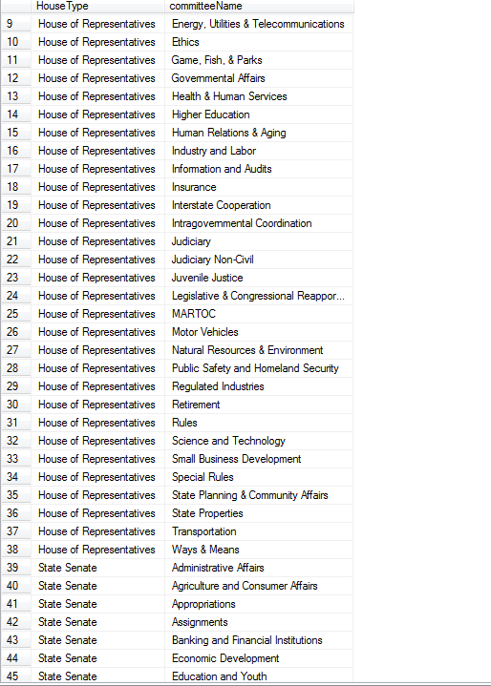

1. Which committees is a part of the State Senate?

select * from CommitteeNames

where HouseType = 'State Senate';

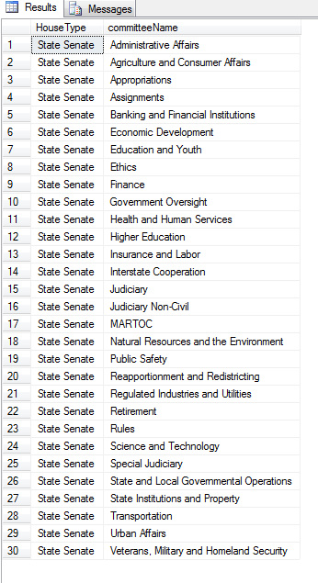

1. Which committee is a part of the House of Representatives?

select * from CommitteeNames

where HouseType = 'House Of Representatives';

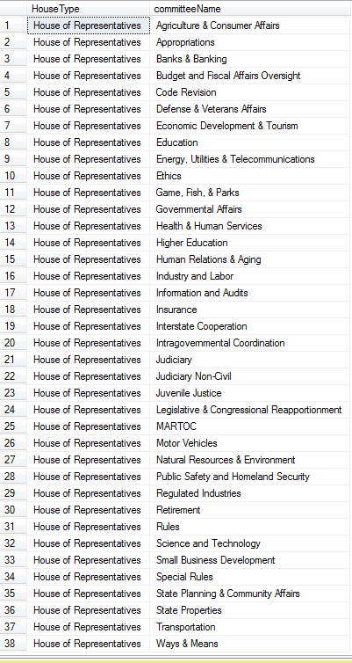

1. Which bills went to the House of Representatives?

select * from Bills

where HouseType = 'House Of Representatives';

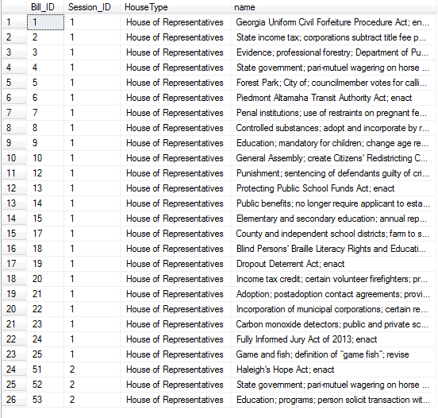

1. Which bills went to the State Senate?

select * from Bills

where HouseType = 'State Senate';

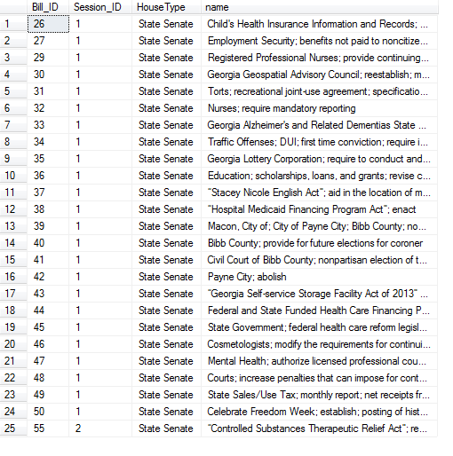

1. Which bills went to the State Senate that has an id higher than 35?

select * from Bills

where HouseType = 'State Senate' AND Bill_ID > 35;

1. Which bills went to the House of Representatives that has an id greater than 20 but was in the second session?

select * from Bills

where HouseType = 'House of Representatives' AND Bill_ID > 20

AND Session_ID = '2';

1. Which bills went to the House of Representatives that has an id greater than 10 but less than 30 that was in the first session?

select * from Bills

where HouseType = 'House of Representatives' AND Bill_ID > 10 AND Bill_ID < 30

AND Session_ID = '1';

1. Which people has the last name of Johnson?

select PID, FirstName, LastName From People

where LastName = 'Johnson';

1. Which person either has the last names of Hayes or has an ID between 500 and 515?

select PID, FirstName, LastName From People

where LastName = 'Hayes' OR (PID > '500' AND PID < '515');

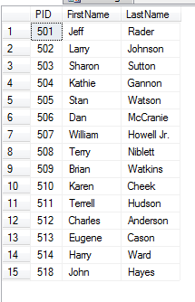

Patrick Meehan 10 queries

1. Politician who has authored most bills:

Select p.firstName as First_Name, p.lastName as Last_Name, p.pName as Government_Position, s.Bills_Authored

From (Select a.PID, count(*) as Bills_Authored, rank() over (order by count(*) desc) as rank From Authored a group by a.PID) s

join People p on p.PID = s.PID

Where s.rank = 1

1. Bills that became laws

Select Distinct name as Bill_Name From GovernorSigned gs join Bills b on b.Bill_ID = gs.Bill_ID

1. Politicians who aren’t on a Committee

Select p.firstName, p.lastName, p.pName From People p Where NOT EXISTS(Select PID From Committees c Where c.PID=p.PID)

1. Politician who sits on most Committees:

Select p.firstName as First_Name, p.lastName as Last_Name, p.pName a Government_Position, s.Number_of_Commitees

From (Select a.PID, count(*) as Number_of_Commitees, rank() over (order by count(*) desc) as rank From Committees a group by a.PID) s join People p on p.PID = s.PID Where s.rank = 1

1. Most abstained from vote on bill

SELECT name, NotVoting

   FROM Votes v join Bills b on v.Bill_ID = b.Bill_ID

   WHERE NotVoting = (SELECT MAX(NotVoting) FROM Votes);

1. Highest supported bill

SELECT name, v.Yea

   FROM Votes v join Bills b on v.Bill_ID = b.Bill_ID

   WHERE Yea = (SELECT MAX(Yea) FROM Votes);

1. Committee that passed the most bills

Select top 1 c.committeeName from (

select top 1 ca.committeeName

from CommitteeAction ca

group by ca.committeeName

order by count(*) desc) s join Committees c on c.committeeName = s.committeeName

1. Bill voted on most times

Select b.name from (

select top 1 v.Bill_ID

from Votes v

group by v.Bill_ID

order by count(*) desc) s join Bills b on b.Bill_ID = s.Bill_ID

1. Counties with highest number of Political officers

select CountyName,count(*) as n from

(select * from People where CountyName != 'null') s

group by CountyName having count(*) =(select max(n) from

(select CountyName,count(*) as n from

(select * from People where CountyName != 'null')

a group by CountyName) county)

1. Counties with least number of representatives

select CountyName,count(*) as n from

(select * from People where CountyName != 'null') s

group by CountyName having count(*) =(select min(n) from

(select CountyName,count(*) as n from

(select * from People where CountyName != 'null')

a group by CountyName) county)

Lamar Sims 10 queries

--1. What are the names of all politicians in Georgia

Select firstName, lastName

From People;

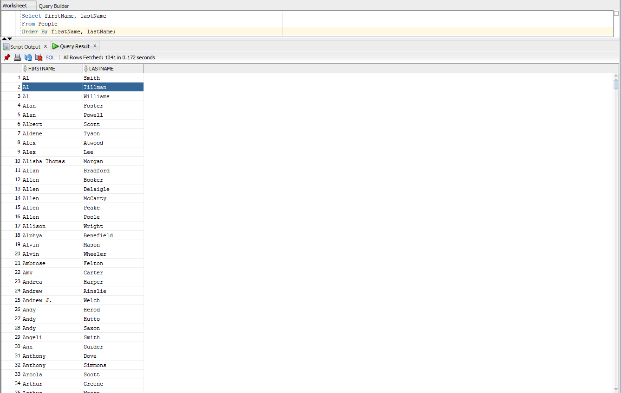

--2. What county does each politician work under

Select CountyName, firstName, lastName

From People

Order By CountyName;

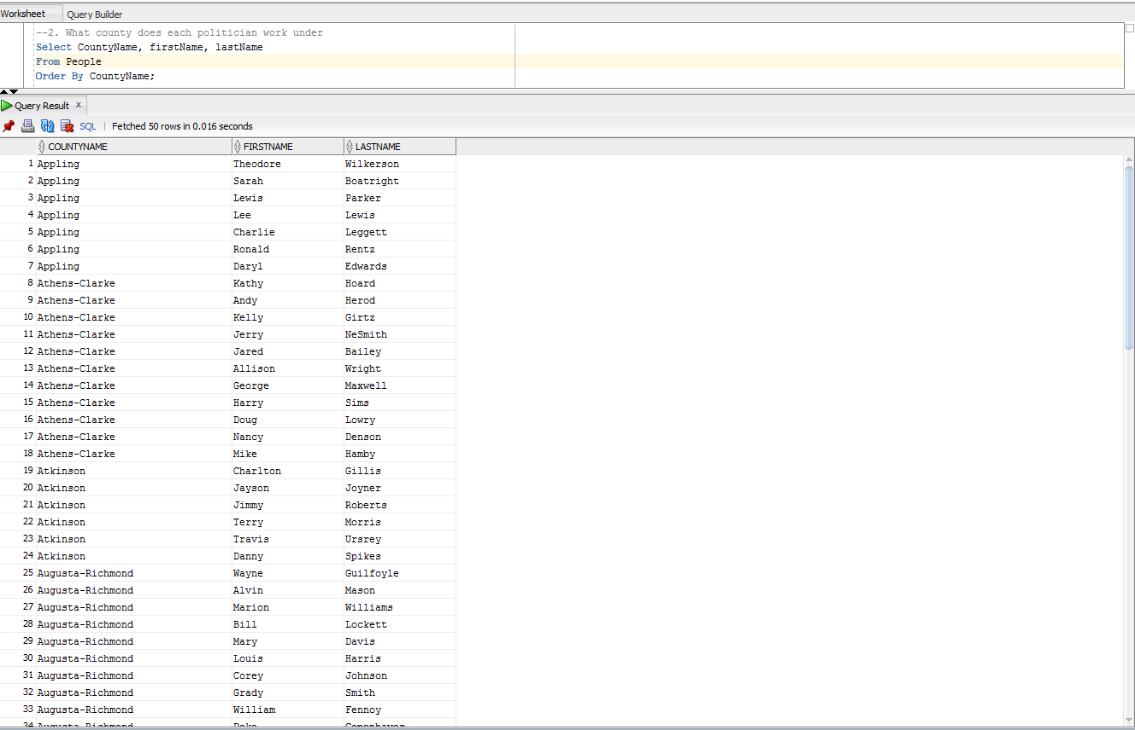

--3. What is the assembly position of each politician, if applicable

Select firstName, lastName, pName

From People

Where pName = 'Representative' Or pName = 'Senator'

Order By pName;

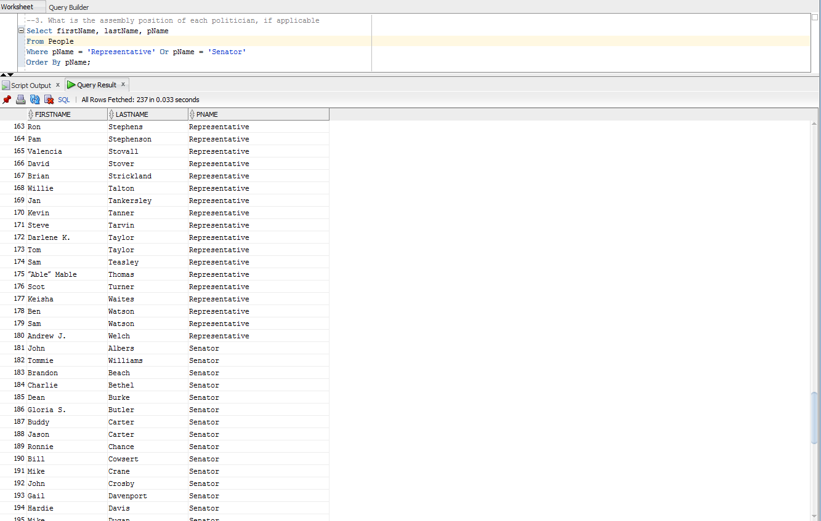

--4. What is the political position of each politician

Select pName, firstName, lastName

From People

Order By firstName, lastName;

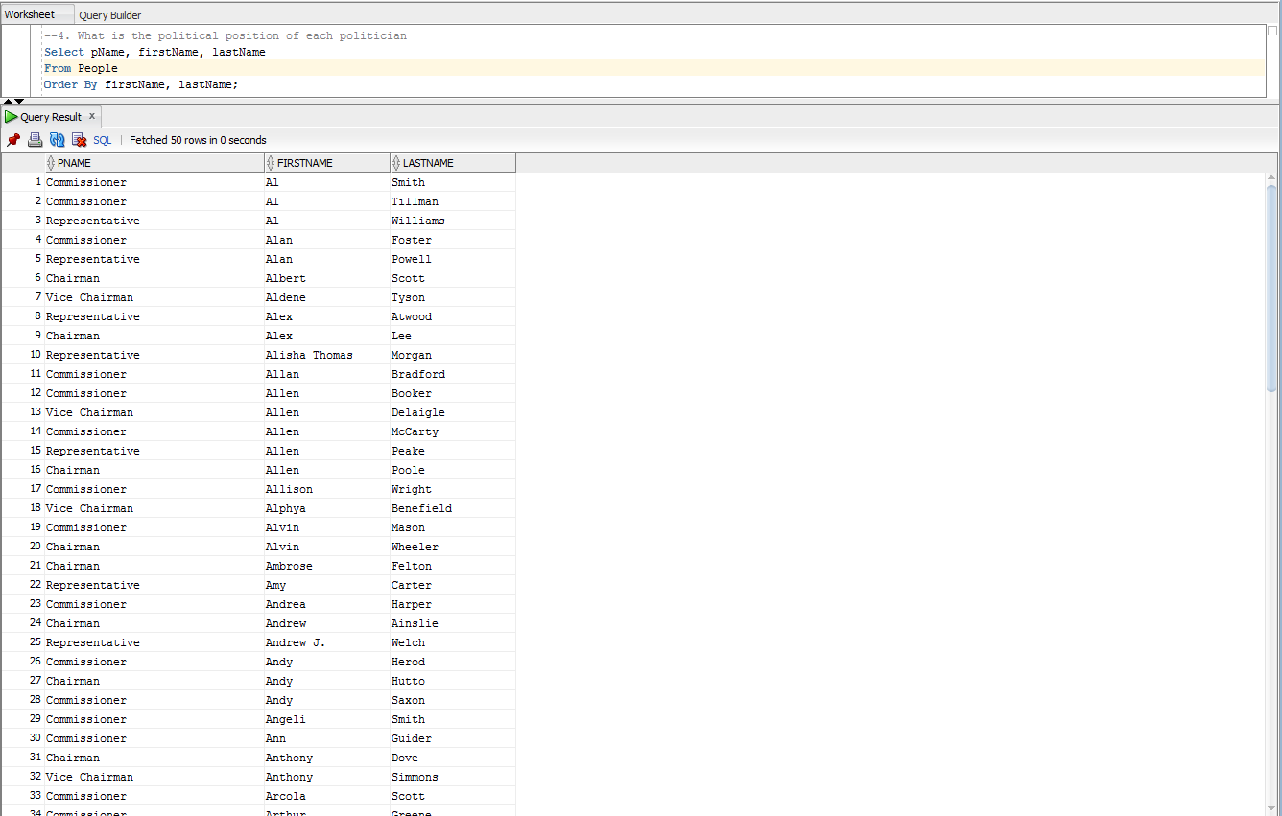

--5. What laws has each politician had a hand in creating/writing

Select firstName, lastName, Bills.Bill_ID, Bills.name

From People

Join Authored On People.PID = Authored.PID

Join Bills On Authored.BILL_ID = Bills.Bill_ID

Order By firstName, lastName;

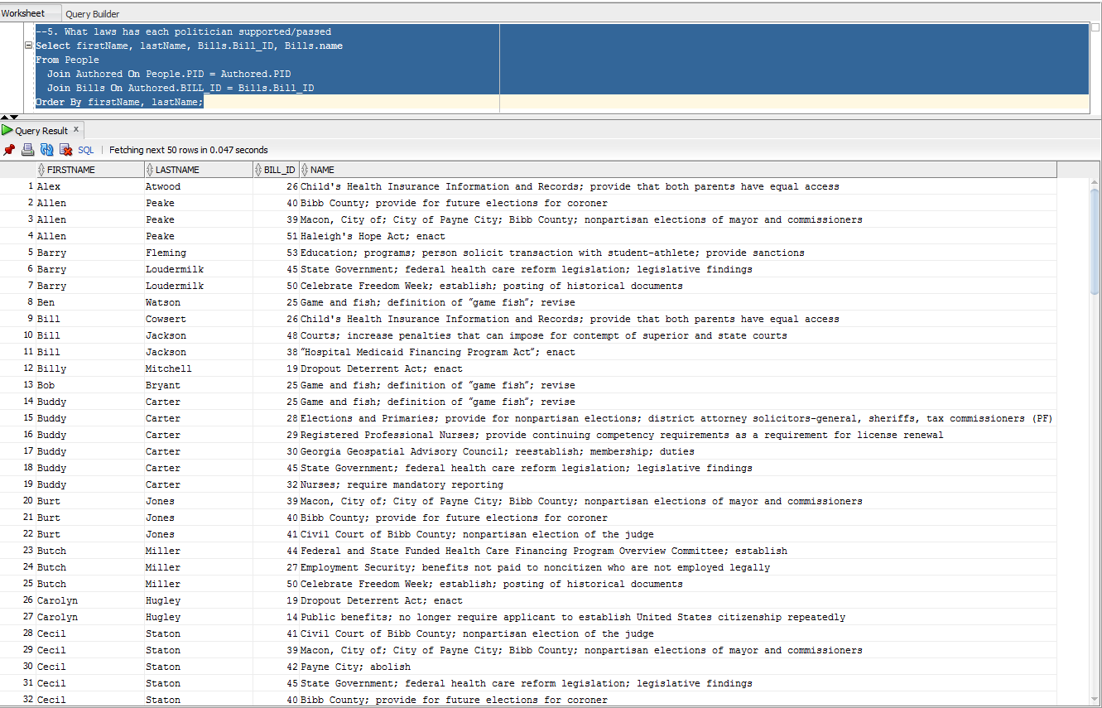

--6. What laws has each politician supported/passed

Select Bills.Bill_ID, firstName, lastName, Bills.name

From People

Join Authored On People.PID = Authored.PID

Join GovernorSigned On GovernorSigned.Bill_ID = Authored.Bill_ID

Join Bills On GovernorSigned.Bill_ID = Bills.Bill_ID

Order By Bills.Bill_ID;

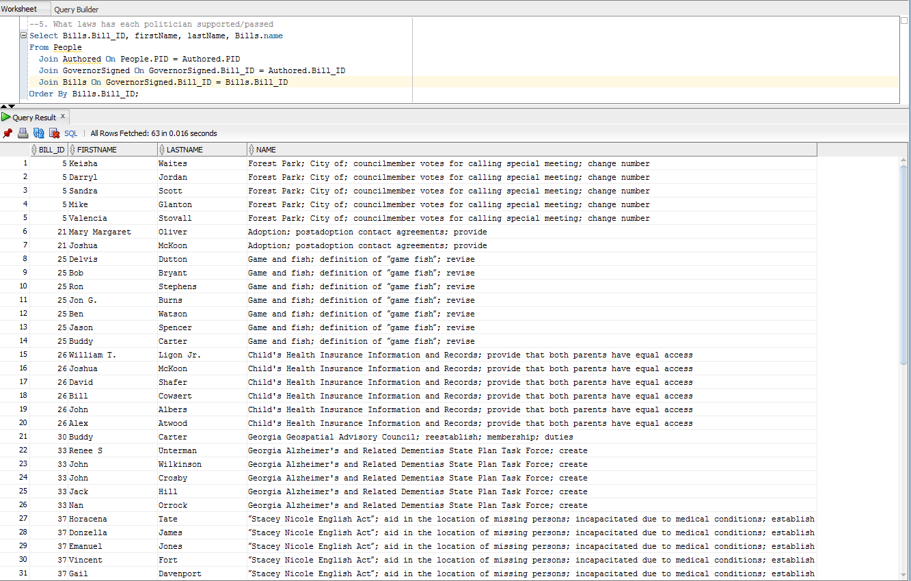

--7. Who are the politicians on each committee

Select committeeName, firstName, lastName

From Committees

Join People On Committees.PID = People.PID

Order By committeeName;

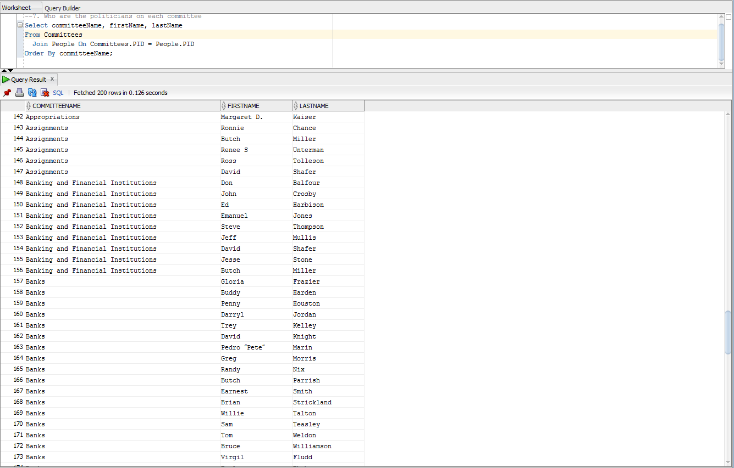

--8. How many politicians are not in the general assembly

Select Count(*)

From People

Where PID Not In

(Select PID

From Committees);

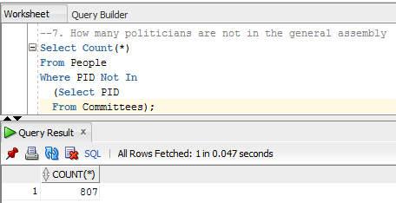

--9. How many politicians are on committees that took action on bills

Select Count(*)

From People

Where PID In

(Select PID

From Committees

Where committeeName In (

Select committeeName

From CommitteeAction));

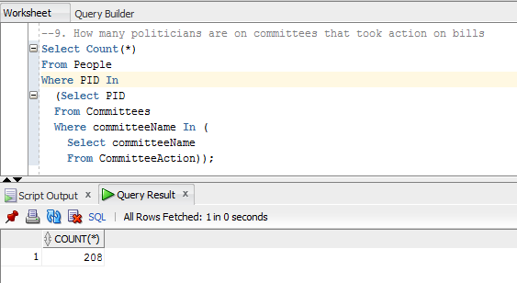

--10. How many politicians have had their bills voted on

Select Count(*)

From People

Where PID In

(Select Distinct PID

From Authored

Where Bill_ID In (

Select Distinct Bill_ID

From Votes));

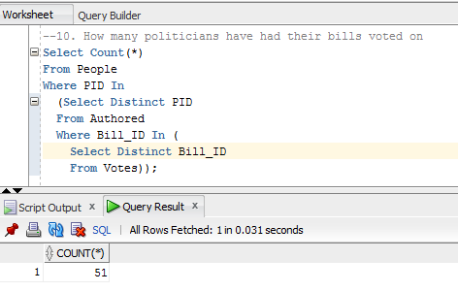

**7.) Logical Model**

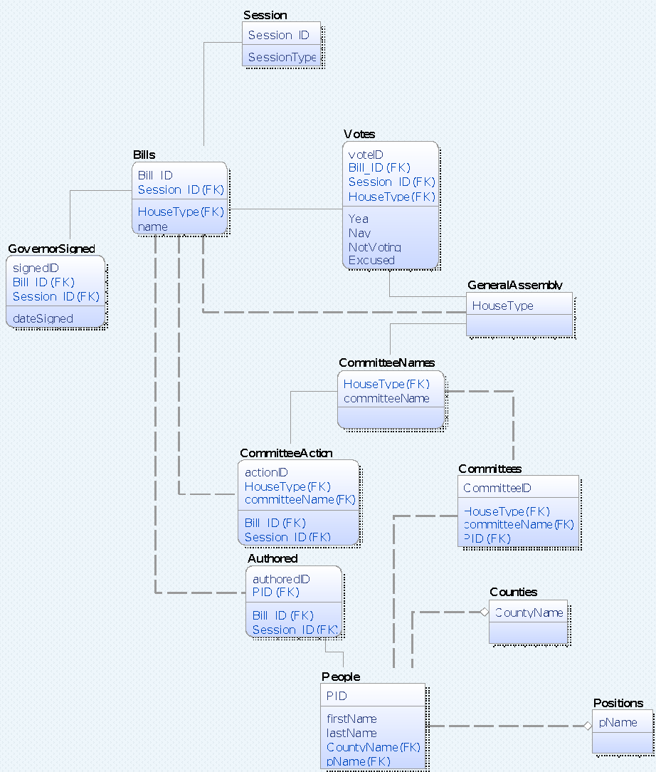

**Database Tables:**

Table of Sessions

SESSION_ID SESSIONSTYPE

---------- --------------------------------

        1 2013-2014 Regular Sessions

        2 2015-2016 Regular Sessions

Table of Bills

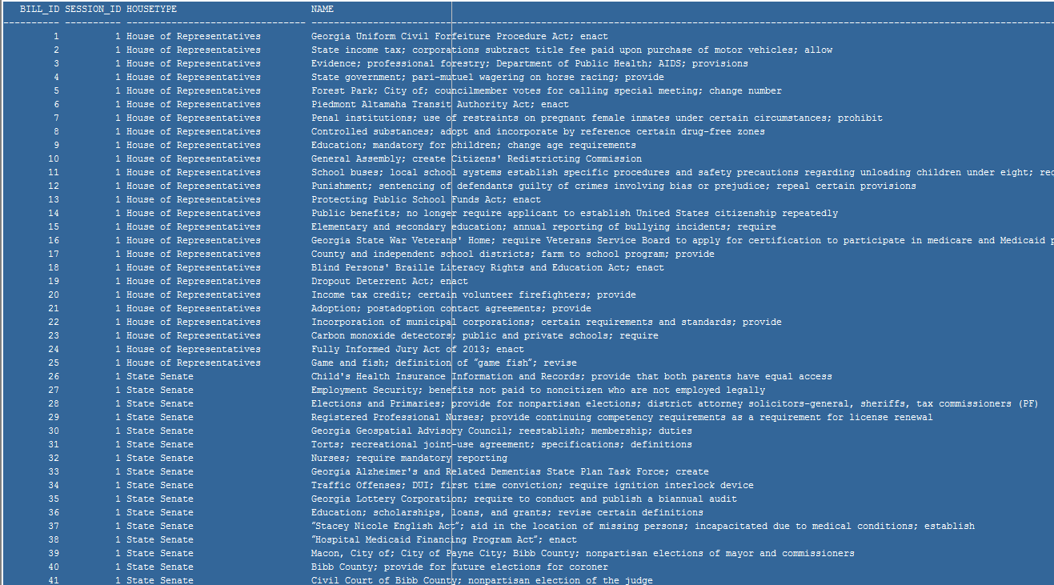

Table of Governor Signed

 SIGNEDID    BILL_ID SESSION_ID DATESIGNED

---------- ---------- ---------- ----------

        1          5          1 07-MAY-13

        2         21          1 07-MAY-13

        3         25          1 06-MAY-13

        4         26          1 06-MAY-13

        5         30          1 07-MAY-13

        6         33          1 06-MAY-13

        7         37          1 24-APR-14

        8         38          1 13-FEB-13

        9         38          1 14-FEB-13

       10         38          1 24-APR-13

       11         43          1 06-MAY-13

       12         44          1 07-MAY-13

       13         47          1 21-APR-14

       14         48          1 06-MAY-13

Table of Votes

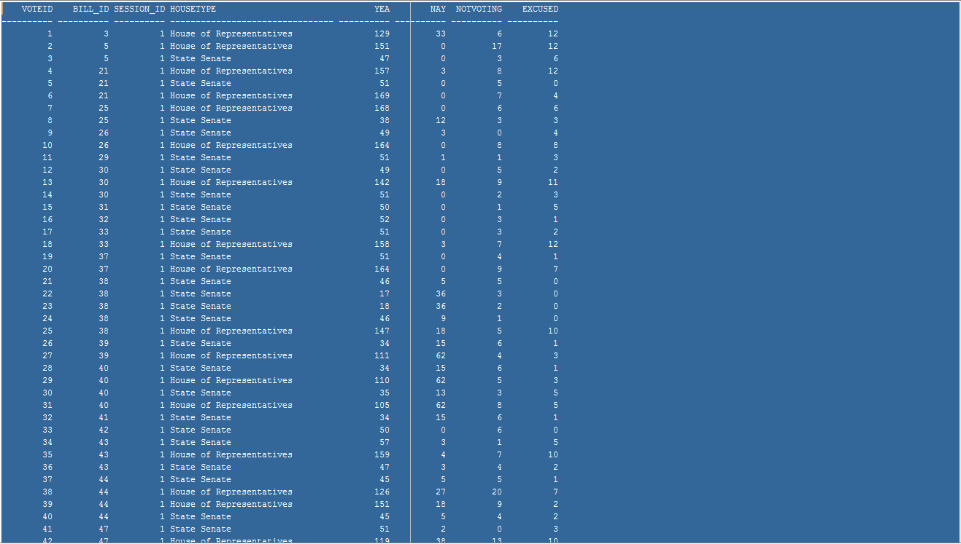

Table of General Assembly

HOUSETYPE

--------------------------------

House of Representatives

State Senate

Table of Committee Names

HOUSETYPE                        COMMITTEENAME

-------------------------------- --------------------------------------------------

House of Representatives         Agriculture  Affairs

House of Representatives         Appropriations

House of Representatives         Banks

House of Representatives         Budget and Fiscal Affairs Oversight

House of Representatives         Code Revision

House of Representatives         Defense  Affairs

House of Representatives         Economic Development

House of Representatives         Education

House of Representatives         Energy, Utilities

House of Representatives         Ethics

House of Representatives         Game, Fish,

House of Representatives         Governmental Affairs

House of Representatives         Health  Services

House of Representatives         Higher Education

House of Representatives         Human Relations

House of Representatives         Industry and Labor

House of Representatives         Information and Audits

House of Representatives         Insurance

House of Representatives         Interstate Cooperation

House of Representatives         Intragovernmental Coordination

House of Representatives         Judiciary

House of Representatives         Judiciary Non-Civil

House of Representatives         Juvenile Justice

House of Representatives         Legislative  Reapportionment

House of Representatives         MARTOC

House of Representatives         Motor Vehicles

House of Representatives         Natural Resources

House of Representatives         Public Safety and Homeland Security

House of Representatives         Regulated Industries

House of Representatives         Retirement

House of Representatives         Rules

House of Representatives         Science and Technology

House of Representatives         Small Business Development

House of Representatives         Special Rules

House of Representatives         State Planning  Affairs

House of Representatives         State Properties

House of Representatives         Transportation

House of Representatives         Ways

State Senate                     Administrative Affairs

State Senate                     Agriculture and Consumer Affairs

State Senate                     Appropriations

State Senate                     Assignments

State Senate                     Banking and Financial Institutions

State Senate                     Economic Development

State Senate                     Education and Youth

State Senate                     Ethics

State Senate                     Finance

State Senate                     Government Oversight

State Senate                     Health and Human Services

State Senate                     Higher Education

State Senate                     Insurance and Labor

State Senate                     Interstate Cooperation

State Senate                     Judiciary

State Senate                     Judiciary Non-Civil

State Senate                     MARTOC

State Senate                     Natural Resources and the Environment

State Senate                     Public Safety

State Senate                     Reapportionment and Redistricting

State Senate                     Regulated Industries and Utilities

State Senate                     Retirement

State Senate                     Rules

State Senate                     Science and Technology

State Senate                     Special Judiciary

State Senate                     State Institutions and Property

State Senate                     State and Local Governmental Operations

State Senate                     Transportation

State Senate                     Urban Affairs

State Senate                     Veterans, Military and Homeland Security

Table of Committee Action

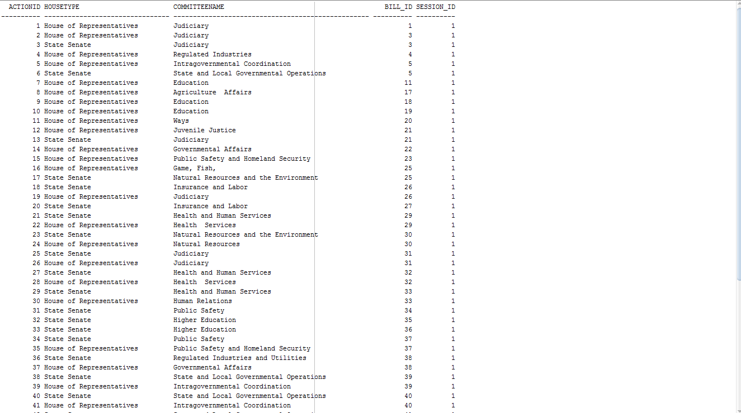

Table of Authored

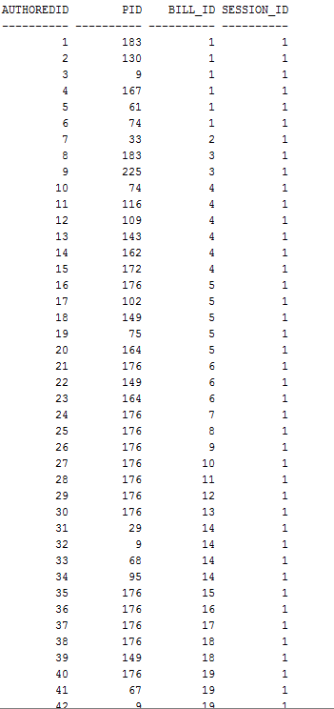

Tables of Counties

COUNTYNAME

--------------------------------

Appling

Athens-Clarke

Atkinson

Augusta-Richmond

Bacon

Baker

Baldwin

Banks

Barrow

Bartow

Ben Hill

Berrien

Bibb

Bleckley

Brantley

Brooks

Bryan

Bulloch

Burke

Butts

Calhoun

Camden

Candler

Carroll

Catoosa

Charlton

Chatham

Chattooga

Cherokee

Clay

Clayton

Clinch

Cobb

Coffee

Colquitt

Columbia

Columbus-Muscogee

Cook

Coweta

Crawford

Crisp

Cusseta-Chattahoochee

Dade

Dawson

Decatur

Dekalb

Dodge

Dooly

Dougherty

Douglas

Early

Echols

Effingham

Elbert

Emanuel

Evans

Fannin

Fayette

Floyd

Forsyth

Franklin

Fulton

Georgetown-Quitman

Gilmer

Glascock

Glynn

Gordon

Grady

Greene

Gwinnett

Habersham

Hall

Hancock

Haralson

Harris

Hart

Heard

Henry

Houston

Irwin

Jackson

Jasper

Jeff Davis

Jefferson

Jenkins

Johnson

Jones

Lamar

Lanier

Laurens

Lee

Liberty

Lincoln

Long

Lowndes

Lumpkin

Macon

Madison

Marion

McDuffie

McIntosh

Meriwether

Miler

Mitchell

Monroe

Montgomery

Morgan

Murray

Newton

Oconee

Oglethorpe

Paulding

Peach

Pickens

Pierce

Pike

Polk

Pulaski

Putnam

Rabun

Randolph

Rockdale

Schley

Screven

Seminole

Spalding

Stephens

Stewart

Sumter

Talbot

Taliaferro

Tattnall

Taylor

Telfair

Terrell

Thomas

Tift

Toombs

Towns

Treutlen

Troup

Turner

Twiggs

Union

Upson

Walker

Walton

Ware

Warren

Washington

Wayne

Webster

Wheeler

White

Whitfield

Wilcox

Wilkes

Wilkinson

Worth

Table of Positions

PNAME

--------------------------------

Attorney General

Chairman

Chief Financial Officer

Clerk

Commissioner

Commissioner of Agriculture

Commissioner of Insurance

Commissioner of Labor

Councilor

County Administrator

Executive Assistant

Finance Personnel Director

Governor

Interim CEO

Interim Chairman

Lieutenant Governor

Manager

Mayor

Representative

Secretary of State

Senator

Sole Commissioner

State School Superintendent

Vice Chairman

Table of People

      PID FIRSTNAME          LASTNAME           COUNTYNAME                       PNAME

---------- ------------------ ------------------ -------------------------------- --------------------------------

        1 Nathan             Deal                                                Governor

        2 Casey              Cagle                                               Lieutenant Governor

        3 Sam                Olens                                               Attorney General

        4 Brian              Kemp                                                Secretary of State

        5 John               Barge                                               State School Superintendent

        6 Gary               Black                                               Commissioner of Agriculture

        7 Ralph              Hudgens                                             Commissioner of Insurance

        8 Mark               Butler                                              Commissioner of Labor

        9 Stacey             Abrams                                              Representative

       10 Kimberly           Alexander                                           Representative

       11 Stephen            Allison                                             Representative

       12 Tonya              Anderson                                            Representative

       13 Alex               Atwood                                              Representative

       14 Mandi L.           Ballinger                                           Representative

       15 Timothy            Barr                                                Representative

       16 Paul               Battles                                             Representative

       17 Sharon             Beasley-Teague                                      Representative

       18 Simone             Bell                                                Representative

       19 Karen              Bennett                                             Representative

       20 Patty              Bentley                                             Representative

       21 Tommy              Benton                                              Representative

       22 James              Beverly                                             Representative

       23 Ellis              Black                                               Representative

       24 Bruce              Broadrick                                           Representative

       25 Buzz               Brockway                                            Representative

       26 Tyrone             Brooks                                              Representative

       27 Roger              Bruce                                               Representative

       28 Bob                Bryant                                              Representative

       29 Debbie             Buckner                                             Representative

       30 Jon G.             Burns                                               Representative

       31 Michael            Caldwell                                            Representative

       32 Johnnie            Caldwell Jr.                                        Representative

       33 John               Carson                                              Representative

       34 Amy                Carter                                              Representative

       35 David              Casas                                               Representative

       36 Joyce              Chandler                                            Representative

       37 Mickey             Channell                                            Representative

       38 Jeff               Chapman                                             Representative

       39 Mike               Cheokas                                             Representative

       40 Josh               Clark                                               Representative

       41 Valerie            Clark                                               Representative

       42 Brooks             Coleman                                             Representative

       43 Kevin              Cooke                                               Representative

       44 Christian          Coomer                                              Representative

       45 Sharon             Cooper                                              Representative

       46 Dee                Dawkins-Haigler                                     Representative

       47 John               Deffenbaugh                                         Representative

       48 Katie M.           Dempsey                                             Representative

       49 Pam                Dickerson                                           Representative

       50 Robert             Dickey                                              Representative

       51 Tom                Dickson                                             Representative

       52 Matt               Dollar                                              Representative

       53 Demetrius          Douglas                                             Representative

       54 Karla              Drenner                                             Representative

       55 Mike               Dudgeon                                             Representative

       56 Winfred J          Dukes                                               Representative

       57 Emory              Dunahoo                                             Representative

       58 Geoff              Duncan                                              Representative

       59 Delvis             Dutton                                              Representative

       60 Chuck              Efstration                                          Representative

       61 Earl               Ehrhart                                             Representative

       62 Terry              England                                             Representative

       63 Bubber             Epps                                                Representative

       64 Carl Von           Epps                                                Representative

       65 Stacey             Evans                                               Representative

       66 Barry              Fleming                                             Representative

       67 Hugh               Floyd                                               Representative

       68 Virgil             Fludd                                               Representative

       69 Gloria             Frazier                                             Representative

       70 Spencer            Frye                                                Representative

       71 Carol              Fullerton                                           Representative

       72 Pat                Gardner                                             Representative

       73 Dan                Gasaway                                             Representative

       74 Harry              Geisinger                                           Representative

       75 Mike               Glanton                                             Representative

       76 Rich               Golick                                              Representative

       77 J. Craig           Gordon                                              Representative

       78 Micah              Gravley                                             Representative

       79 Gerald E           Greene                                              Representative

       80 Charles            Gregory                                             Representative

       81 Mark               Hamilton                                            Representative

       82 Ben                Harbin                                              Representative

       83 Buddy              Harden                                              Representative

       84 Brett              Harrell                                             Representative

       85 Matt               Hatchett                                            Representative

       86 Lee                Hawkins                                             Representative

       87 Michele            Henson                                              Representative

       88 Dustin             Hightower                                           Representative

       89 Bill               Hitchens                                            Representative

       90 Scott              Holcomb                                             Representative

       91 Susan              Holmes                                              Representative

       92 Doug               Holt                                                Representative

       93 Penny              Houston                                             Representative

       95 Carolyn            Hugley                                              Representative

       96 Mack               Jackson                                             Representative

       97 Mike               Jacobs                                              Representative

       98 Rick               Jasperse                                            Representative

       99 Jan                Jones                                               Representative

      100 LaDawn             Jones                                               Representative

      101 Sheila             Jones                                               Representative

      102 Darryl             Jordan                                              Representative

      103 Margaret D.        Kaiser                                              Representative

      104 Trey               Kelley                                              Representative

      105 Dar'shun           Kendrick                                            Representative

**Example Data**

--insert data into Positions

--elected Positions

Insert Into Positions

Values(‘Governor’);

Insert Into Positions

Values(‘Lieutenant Governor’);

Insert Into Positions

Values(‘Representative’);

Insert Into Positions

Values(‘Senator’);

Insert Into Positions

Values(‘Attorney General’);

Insert Into Positions

Values(‘Secretary of State’);

Insert Into Positions

Values(‘State School Superintendent’);

Insert Into Positions

Values(‘Commissioner of Agriculture’);

Insert Into Positions

Values(‘Commissioner of Insurance’);

Insert Into Positions

Values(‘Commissioner of Labor’);

--county’s Positions

Insert Into Positions

Values(‘Mayor’);

Insert Into Positions

Values(‘Chairman’);

Insert Into Positions

Values(‘Interim Chairman’);

Insert Into Positions

Values(‘Interim CEO’);

Insert Into Positions

Values(‘Vice Chairman’);

Insert Into Positions

Values(‘Commissioner’);

Insert Into Positions

Values(‘Sole Commissioner’);

Insert Into Positions

Values(‘Councilor’);

Insert Into Positions

Values(‘Manager’);

Insert Into Positions

Values(‘Clerk’);

Insert Into Positions

Values(‘County Administrator’);

Insert Into Positions

Values(‘Executive Assistant’);

Insert Into Positions

Values(‘Chief Financial Officer’);

Insert Into Positions

Values(‘Finance Personnel Director’);

--Insert data into GeneralAssembly

Insert Into GeneralAssembly

Values(‘House of Representatives’);

Insert Into GeneralAssembly

Values(‘State Senate’);

--Insert data into CommitteeNames

Insert Into CommitteeNames

Values(‘House of Representatives’, ‘Agriculture & Consumer Affairs’);

Insert Into CommitteeNames

Values(‘House of Representatives’, ‘Appropriations’);

Insert Into CommitteeNames

Values(‘House of Representatives’, ‘Banks & Banking’);

Insert Into CommitteeNames

Values(‘House of Representatives’, ‘Budget and Fiscal Affairs Oversight’);

Insert Into CommitteeNames

Values(‘House of Representatives’, ‘Code Revision’);

Insert Into CommitteeNames

Values(‘House of Representatives’, ‘Defense & Veterans Affairs’);

Insert Into CommitteeNames

Values(‘House of Representatives’, ‘Economic Development & Tourism’);

Insert Into CommitteeNames

Values(‘House of Representatives’, ‘Education’);

Insert Into CommitteeNames

Values(‘House of Representatives’, ‘Energy, Utilities & Telecommunications’);

Insert Into CommitteeNames

Values(‘House of Representatives’, ‘Ethics’);

Insert Into CommitteeNames

Values(‘House of Representatives’, ‘Game, Fish, & Parks’);

Insert Into CommitteeNames

Values(‘House of Representatives’, ‘Governmental Affairs’);

Insert Into CommitteeNames  
Values(‘House of Representatives’, ‘Health & Human Services’);

Insert Into CommitteeNames

Values(‘House of Representatives’, ‘Higher Education’);

Insert Into CommitteeNames

Values(‘House of Representatives’, ‘Human Relations & Aging’);

Insert Into CommitteeNames

Values(‘House of Representatives’, ‘Industry and Labor’);

Insert Into CommitteeNames

Values(‘House of Representatives’, ‘Information and Audits’);

Insert Into CommitteeNames

Values(‘House of Representatives’, ‘Insurance’);

Insert Into CommitteeNames

Values(‘House of Representatives’, ‘Interstate Cooperation’);

Insert Into CommitteeNames

Values(‘House of Representatives’, ‘Intragovernmental Coordination’);

Insert Into CommitteeNames

Values(‘House of Representatives’, ‘Judiciary’);

Insert Into CommitteeNames

Values(‘House of Representatives’, ‘Judiciary Non-Civil’);

Insert Into CommitteeNames

Values(‘House of Representatives’, ‘Juvenile Justice’);

Insert Into CommitteeNames

Values(‘House of Representatives’, ‘Legislative & Congressional Reapportionment’);

Insert Into CommitteeNames

Values(‘House of Representatives’, ‘MARTOC’);

Insert Into CommitteeNames

Values(‘House of Representatives’, ‘Motor Vehicles’);

Insert Into CommitteeNames

Values(‘House of Representatives’, ‘Natural Resources & Environment’);

Insert Into CommitteeNames

Values(‘House of Representatives’, ‘Public Safety and Homeland Security’);

Insert Into CommitteeNames

Values(‘House of Representatives’, ‘Regulated Industries’);

Insert Into CommitteeNames

Values(‘House of Representatives’, ‘Retirement’);

Insert Into CommitteeNames

Values(‘House of Representatives’, ‘Rules’);

Insert Into CommitteeNames

Values(‘House of Representatives’, ‘Science and Technology’);

Insert Into CommitteeNames

Values(‘House of Representatives’, ‘Small Business Development’);

Insert Into CommitteeNames

Values(‘House of Representatives’, ‘Special Rules’);

Insert Into CommitteeNames

Values(‘House of Representatives’, ‘State Planning & Community Affairs’);

Insert Into CommitteeNames

Values(‘House of Representatives’, ‘State Properties’);

Insert Into CommitteeNames

Values(‘House of Representatives’, ‘Transportation’);

Insert Into CommitteeNames

Values(‘House of Representatives’, ‘Ways & Means’);

Insert Into CommitteeNames

Values(‘State Senate’, ‘Administrative Affairs’);

Insert Into CommitteeNames

Values(‘State Senate’, ‘Agriculture and Consumer Affairs’);

Insert Into CommitteeNames

Values(‘State Senate’, ‘Appropriations’);

Insert Into CommitteeNames

Values(‘State Senate’, ‘Assignments’);

Insert Into CommitteeNames

Values(‘State Senate’, ‘Banking and Financial Institutions’);

Insert Into CommitteeNames

Values(‘State Senate’, ‘Economic Development’);

Insert Into CommitteeNames

Values(‘State Senate’, ‘Education and Youth’);

Insert Into CommitteeNames

Values(‘State Senate’, ‘Ethics’);

Insert Into CommitteeNames

Values(‘State Senate’, ‘Finance’);

Insert Into CommitteeNames

Values(‘State Senate’, ‘Government Oversight’);

Insert Into CommitteeNames

Values(‘State Senate’, ‘Health and Human Services’);

Insert Into CommitteeNames

Values(‘State Senate’, ‘Higher Education’);

Insert Into CommitteeNames

Values(‘State Senate’, ‘Insurance and Labor’);

Insert Into CommitteeNames

Values(‘State Senate’, ‘Interstate Cooperation’);

Insert Into CommitteeNames

Values(‘State Senate’, ‘Judiciary’);

Insert Into CommitteeNames

Values(‘State Senate’, ‘Judiciary Non-Civil’);

Insert Into CommitteeNames

Values(‘State Senate’, ‘MARTOC’);

Insert Into CommitteeNames

Values(‘State Senate’, ‘Natural Resources and the Environment’);

Insert Into CommitteeNames

Values(‘State Senate’, ‘Public Safety’);

Insert Into CommitteeNames

Values(‘State Senate’, ‘Reapportionment and Redistricting’);

Insert Into CommitteeNames

Values(‘State Senate’, ‘Regulated Industries and Utilities’);

Insert Into CommitteeNames

Values(‘State Senate’, ‘Reitrement’);

Insert Into CommitteeNames

Values(‘State Senate’, ‘Rules’);

Insert Into CommitteeNames

Values(‘State Senate’, ‘Science and Technology’);

Insert Into CommitteeNames

Values(‘State Senate’, ‘Special Judiciary’);

Insert Into CommitteeNames

Values(‘State Senate’, ‘State and Local Governmental Operations’);

Insert Into CommitteeNames

Values(‘State Senate’, ‘State Institutions and Property’);

Insert Into CommitteeNames

Values(‘State Senate’, ‘Transportation’);

Insert Into CommitteeNames

Values(‘State Senate’, ‘Urban Affairs’);

Insert Into CommitteeNames

Values(‘State Senate’, ‘Veterans, Military and Homeland Security’);

**8.) Physical Model**

**Entity Name: Session**

**Entity Logical Only: No**

Sessions_ID - No

SessionType - No

**Entity Name: Bills**

**Entity Logical Only: No**

Bill_ID - No

Sessions_ID - No

HouseType - No

Name - No

**Entity Name: GovernorSigned**

**Entity Logical Only: No**

signedID - No

Bill_ID - No

Sessions_ID - No

dateSigned - No

**Entity Name: Votes**

**Entity Logical Only: No**

voteID - No

Bill_ID - No

Sessions_ID - No

HouseType - No

Yay - No

Nay - No

NotVoting - No

Excused - No

**Entity Name: GeneralAssembly**

**Entity Logical Only: No**

HouseType - No

**Entity Name: CommitteeNames**

**Entity Logical Only: No**

HouseType - No

committeeName - No

**Entity Name: CommitteeAction**

**Entity Logical Only: No**

actionID - No

HouseType - No

committeeName - No

Bill_ID - No

Sessions_ID - No

**Entity Name: Committee**

**Entity Logical Only: No**

committeeID - No

HouseType - No

committeeName - No

pID - No

**Entity Name: Authored**

**Entity Logical Only: No**

authoredID - No

pID - No

Bill_ID - No

Sessions_ID - No

**Entity Name: Counties**

**Entity Logical Only: No**

CountyName - No

**Entity Name: People**

**Entity Logical Only: No**

PID

FirstName - No

lastName - No

CountyName - No

pName - No

**Entity Name: Positions**

**Entity Logical Only: No**

pName - No

**Volumetrics**

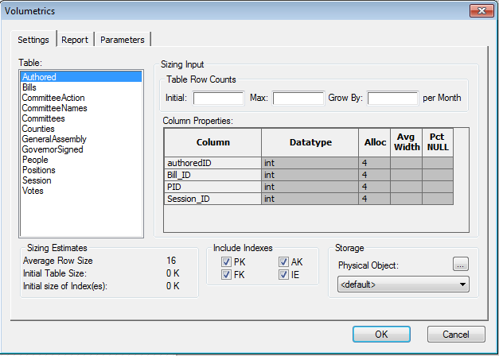

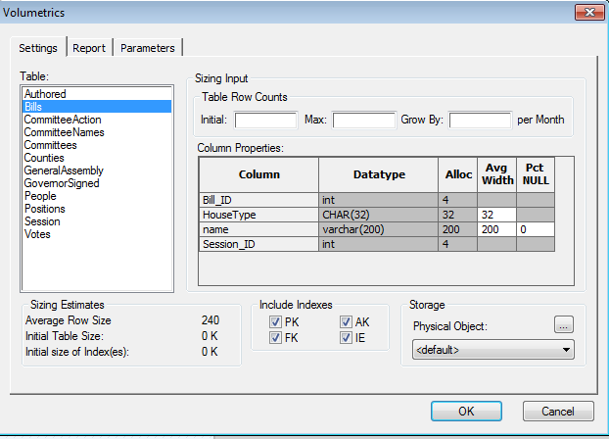

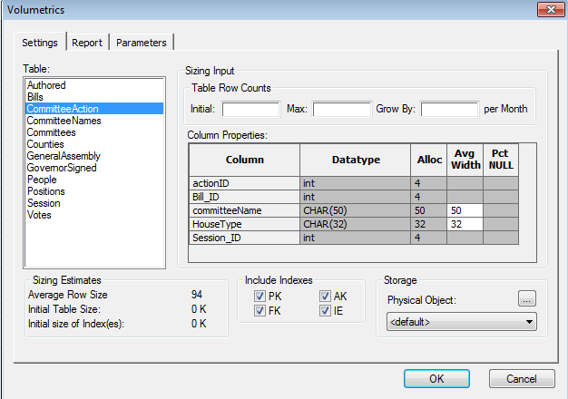

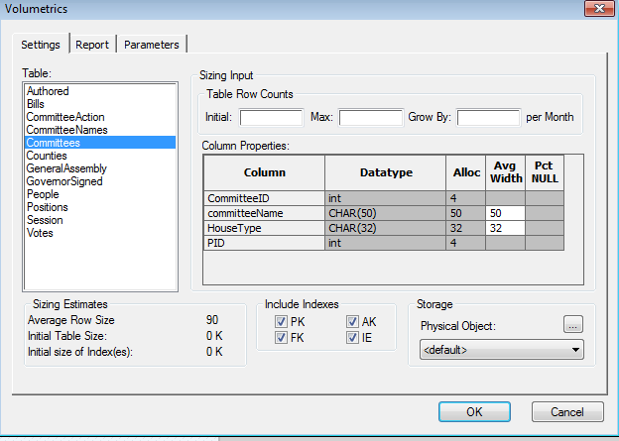

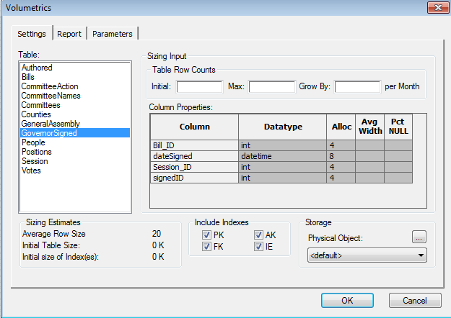

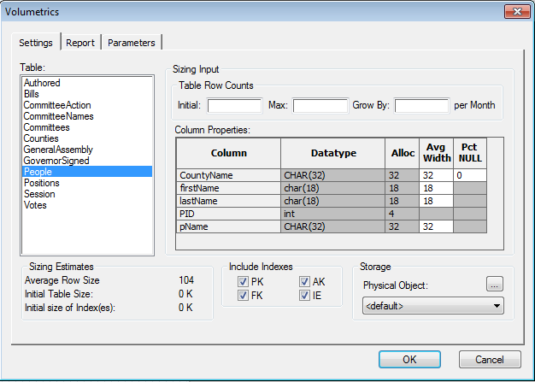

**9.) Graphical User Interface**

Adding a new committee

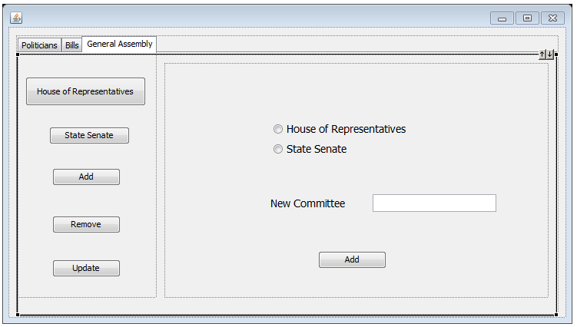

Adding a new bill

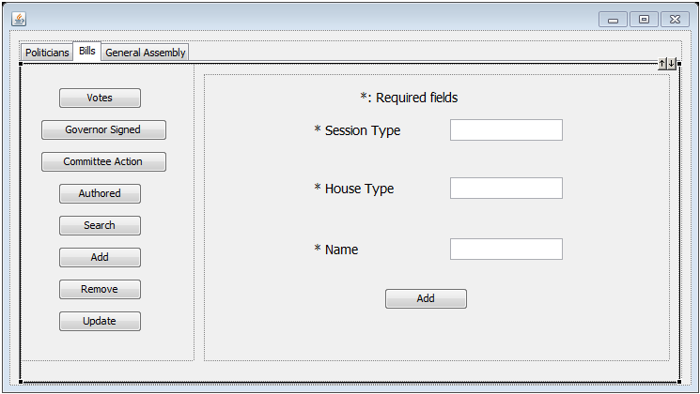

Adding a new politician

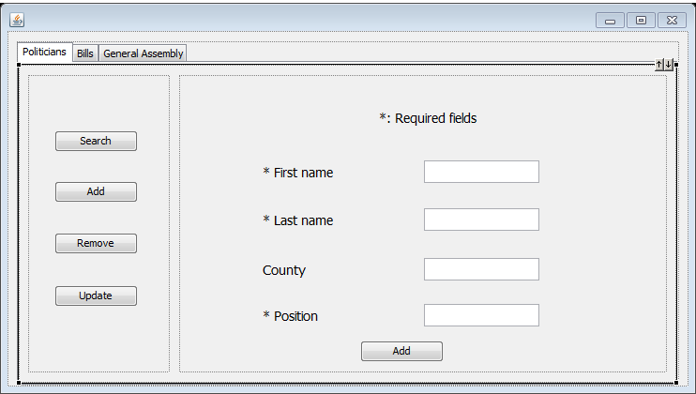

Committee Action

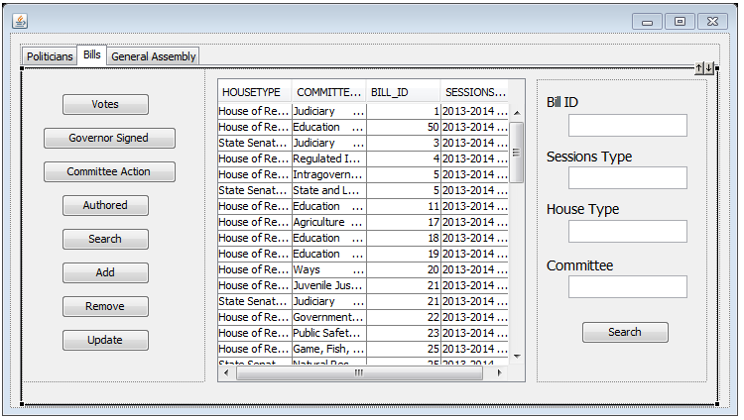

Governor Signed

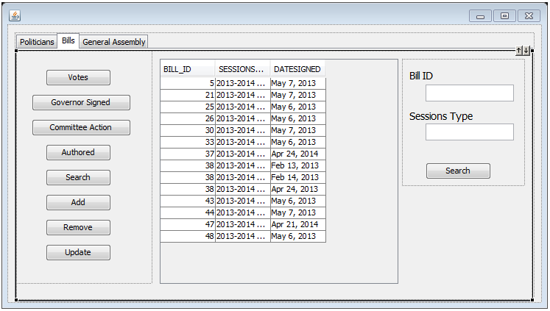

Authored

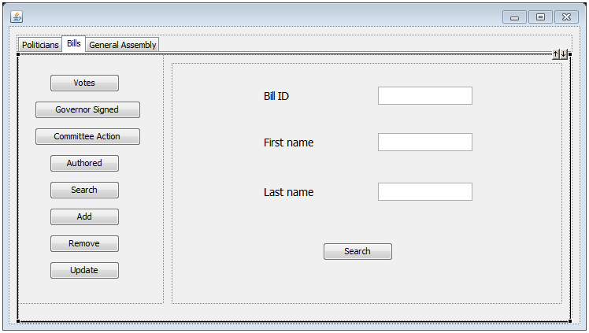

All of the Politicians

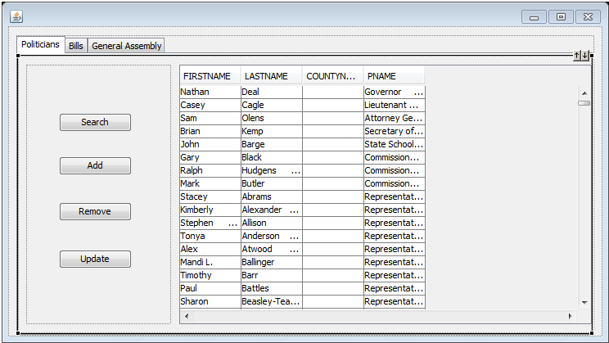

All of the bills

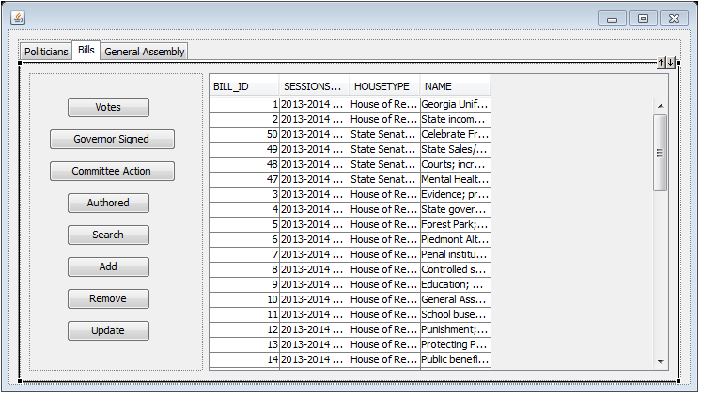

General Assembly

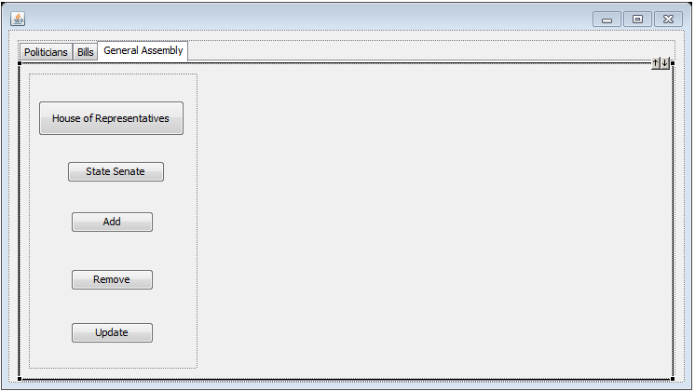

House of Representatives

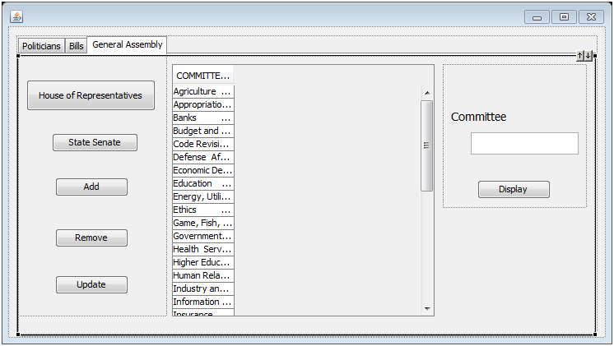

**10.) Post-mortem**

Upon the completion of our database, the team has learned many new things as well as techniques, thanks to many failures. With one key one being able to connect our database to both Oracle and SQL Server. Our database is larger than anticipated, but still runs quick and has much room for improvement. We saw that if we could add a way to keep track of the bills throughout the creation process would be a key improvement to our database, and the user experience. A big improvement we could make in the future is to do denormalization to cut down on the amount of joins needed. Overall our project was a great experience and we believe it will help to develop our skills with development in our future.

**11.) References**

<http://www.legis.ga.gov/Legislation/en-US/Search.aspx>

<http://www.house.ga.gov/communications/en-US/LegislativeReports.aspx>

<http://www.senate.ga.gov/sos/en-US/Journal.aspx>

<http://www.senate.ga.gov/sos/en-US/SenateCalendars.aspx>

<http://www.house.ga.gov/clerk/en-US/HouseCalendars.aspx>

[http://www.legis.ga.gov/Legislation/en-US/](http://www.legis.ga.gov/Legislation/en-US/default.aspx)

[default.aspx](http://www.legis.ga.gov/Legislation/en-US/default.aspx)

**11.) Schema**

Drop Table Votes;

Drop Table GovernorSigned;

Drop Table CommitteeAction;

Drop Table Committees;

Drop Table CommitteeNames;

Drop Table Authored;

Drop Table People;

Drop Table Counties;

Drop Table Positions;

Drop Table Bills;

Drop Table Session;

Drop Table GeneralAssembly;

CREATE TABLE [Session]

(

[Session_ID]         int  NOT NULL ,

[SessionType]        CHAR(32)  NOT NULL

)

go

ALTER TABLE [Session]

ADD CONSTRAINT [XPKSession] PRIMARY KEY  NONCLUSTERED ([Session_ID] ASC)

go

CREATE TABLE [Bills]

(

[Bill_ID]            int  NOT NULL ,

[Session_ID]         int  NOT NULL ,

[HouseType]          CHAR(32)  NOT NULL ,

[name]               varchar(128)  NULL

)

go

ALTER TABLE [Bills]

ADD CONSTRAINT [XPKBills] PRIMARY KEY  NONCLUSTERED ([Bill_ID] ASC,[Session_ID] ASC)

go

CREATE TABLE [CommitteeNames]

(

[HouseType]          CHAR(32)  NOT NULL ,

[committeeName]      CHAR(50)  NOT NULL

)

go

ALTER TABLE [CommitteeNames]

ADD CONSTRAINT [XPKCommitteeNames] PRIMARY KEY  NONCLUSTERED ([HouseType] ASC,[committeeName] ASC)

go

CREATE TABLE [CommitteeAction]

(

[actionID]           int  NOT NULL ,

[HouseType]          CHAR(32)  NOT NULL ,

[committeeName]      CHAR(50)  NOT NULL ,

[Bill_ID]            int  NOT NULL ,

[Session_ID]         int  NOT NULL

)

go

ALTER TABLE [CommitteeAction]

ADD CONSTRAINT [XPKCommitteeAction] PRIMARY KEY  NONCLUSTERED ([actionID] ASC,[HouseType] ASC,[committeeName] ASC)

go

CREATE TABLE [Counties]

(

[CountyName]         CHAR(32)  NOT NULL

)

go

ALTER TABLE [Counties]

ADD CONSTRAINT [XPKCounties] PRIMARY KEY  NONCLUSTERED ([CountyName] ASC)

go

CREATE TABLE [GovernorSigned]

(

[signedID]           int  NOT NULL ,

[Bill_ID]            int  NOT NULL ,

[Session_ID]         int  NOT NULL ,

[dateSigned]         datetime  NOT NULL

)

go

ALTER TABLE [GovernorSigned]

ADD CONSTRAINT [XPKGovernorSigned] PRIMARY KEY  NONCLUSTERED ([signedID] ASC,[Bill_ID] ASC,[Session_ID] ASC)

go

CREATE TABLE [GeneralAssembly]

(

[HouseType]          CHAR(32)  NOT NULL

)

go

ALTER TABLE [GeneralAssembly]

ADD CONSTRAINT [XPKGeneralAssembly] PRIMARY KEY  NONCLUSTERED ([HouseType] ASC)

go

CREATE TABLE [People]

(

[PID]                int  NOT NULL ,

[firstName]          char(18)  NOT NULL ,

[lastName]           char(18)  NOT NULL ,

[CountyName]         CHAR(32)  NULL ,

[pName]              CHAR(32)  NOT NULL

)

go

ALTER TABLE [People]

ADD CONSTRAINT [XPKPeople] PRIMARY KEY  NONCLUSTERED ([PID] ASC)

go

CREATE TABLE [Committees]

(

[CommitteeID]        int  NOT NULL ,

[HouseType]          CHAR(32)  NOT NULL ,

[committeeName]      CHAR(50)  NOT NULL ,

[PID]                int  NOT NULL

)

go

ALTER TABLE [Committees]

ADD CONSTRAINT [XPKCommitees] PRIMARY KEY  NONCLUSTERED ([CommitteeID] ASC)

go

CREATE TABLE [Authored]

(

[authoredID]         int  NOT NULL ,

[PID]                int  NOT NULL ,

[Bill_ID]            int  NOT NULL ,

[Session_ID]         int  NOT NULL

)

go

ALTER TABLE [Authored]

ADD CONSTRAINT [XPKAuthored] PRIMARY KEY  NONCLUSTERED ([authoredID] ASC,[PID] ASC)

go

CREATE TABLE [Positions]

(

[pName]              CHAR(32)  NOT NULL

)

go

ALTER TABLE [Positions]

ADD CONSTRAINT [XPKPositions] PRIMARY KEY  NONCLUSTERED ([pName] ASC)

go

CREATE TABLE [Votes]

(

[voteID]             int  NOT NULL ,

[Bill_ID]            int  NOT NULL ,

[Session_ID]         int  NOT NULL ,

[HouseType]          CHAR(32)  NOT NULL ,

[Yea]                INT  NOT NULL ,

[Nay]                INT  NOT NULL ,

[NotVoting]          INT  NOT NULL ,

[Excused]            INT  NOT NULL

)

go

ALTER TABLE [Votes]

ADD CONSTRAINT [XPKVotes] PRIMARY KEY  NONCLUSTERED ([voteID] ASC,[Bill_ID] ASC,[Session_ID] ASC,[HouseType] ASC)

go

ALTER TABLE [Bills]

ADD CONSTRAINT [R_42] FOREIGN KEY ([Session_ID]) REFERENCES [Session]([Session_ID])

ON DELETE NO ACTION

ON UPDATE NO ACTION

go

ALTER TABLE [Bills]

ADD CONSTRAINT [R_96] FOREIGN KEY ([HouseType]) REFERENCES [GeneralAssembly]([HouseType])

ON DELETE NO ACTION

ON UPDATE NO ACTION

go

ALTER TABLE [CommitteeNames]

ADD CONSTRAINT [R_98] FOREIGN KEY ([HouseType]) REFERENCES [GeneralAssembly]([HouseType])

ON DELETE NO ACTION

ON UPDATE NO ACTION

go

ALTER TABLE [CommitteeAction]

ADD CONSTRAINT [R_89] FOREIGN KEY ([Bill_ID],[Session_ID]) REFERENCES [Bills]([Bill_ID],[Session_ID])

ON DELETE NO ACTION

ON UPDATE NO ACTION

go

ALTER TABLE [CommitteeAction]

ADD CONSTRAINT [R_99] FOREIGN KEY ([HouseType],[committeeName]) REFERENCES [CommitteeNames]([HouseType],[committeeName])

ON DELETE NO ACTION

ON UPDATE NO ACTION

go

ALTER TABLE [GovernorSigned]

ADD CONSTRAINT [R_97] FOREIGN KEY ([Bill_ID],[Session_ID]) REFERENCES [Bills]([Bill_ID],[Session_ID])

ON DELETE NO ACTION

ON UPDATE NO ACTION

go

ALTER TABLE [People]

ADD CONSTRAINT [R_84] FOREIGN KEY ([pName]) REFERENCES [Positions]([pName])

ON DELETE NO ACTION

ON UPDATE NO ACTION

go

ALTER TABLE [People]

ADD CONSTRAINT [R_87] FOREIGN KEY ([CountyName]) REFERENCES [Counties]([CountyName])

ON DELETE NO ACTION

ON UPDATE NO ACTION

go

ALTER TABLE [Committees]

ADD CONSTRAINT [R_85] FOREIGN KEY ([PID]) REFERENCES [People]([PID])

ON DELETE NO ACTION

ON UPDATE NO ACTION

go

ALTER TABLE [Committees]

ADD CONSTRAINT [R_100] FOREIGN KEY ([HouseType],[committeeName]) REFERENCES [CommitteeNames]([HouseType],[committeeName])

ON DELETE NO ACTION

ON UPDATE NO ACTION

go

ALTER TABLE [Authored]

ADD CONSTRAINT [R_91] FOREIGN KEY ([PID]) REFERENCES [People]([PID])

ON DELETE NO ACTION

ON UPDATE NO ACTION

go

ALTER TABLE [Authored]

ADD CONSTRAINT [R_92] FOREIGN KEY ([Bill_ID],[Session_ID]) REFERENCES [Bills]([Bill_ID],[Session_ID])

ON DELETE NO ACTION

ON UPDATE NO ACTION

go

ALTER TABLE [Votes]

ADD CONSTRAINT [R_94] FOREIGN KEY ([Bill_ID],[Session_ID]) REFERENCES [Bills]([Bill_ID],[Session_ID])

ON DELETE NO ACTION

ON UPDATE NO ACTION

go

ALTER TABLE [Votes]

ADD CONSTRAINT [R_95] FOREIGN KEY ([HouseType]) REFERENCES [GeneralAssembly]([HouseType])

ON DELETE NO ACTION

ON UPDATE NO ACTION

go

CREATE TRIGGER tD_Session ON Session FOR DELETE AS

/* ERwin Builtin Trigger */

/* DELETE trigger on Session */

BEGIN

 DECLARE  @errno   int,

          @errmsg  varchar(255)

   /* ERwin Builtin Trigger */

   /* Session  Bills on parent delete no action */

   /* ERWIN_RELATION:CHECKSUM="0000ea68", PARENT_OWNER="", PARENT_TABLE="Session"

   CHILD_OWNER="", CHILD_TABLE="Bills"

   P2C_VERB_PHRASE="", C2P_VERB_PHRASE="",

   FK_CONSTRAINT="R_42", FK_COLUMNS="Session_ID" */

   IF EXISTS (

     SELECT * FROM deleted,Bills

     WHERE

       /*  %JoinFKPK(Bills,deleted," = "," AND") */

       Bills.Session_ID = deleted.Session_ID

   )

   BEGIN

     SELECT @errno  = 30001,

            @errmsg = 'Cannot delete Session because Bills exists.'

     GOTO error

   END

   /* ERwin Builtin Trigger */

   RETURN

error:

   raiserror @errno @errmsg

   rollback transaction

END

go

CREATE TRIGGER tU_Session ON Session FOR UPDATE AS

/* ERwin Builtin Trigger */

/* UPDATE trigger on Session */

BEGIN

 DECLARE  @numrows int,

          @nullcnt int,

          @validcnt int,

          @insSession_ID int,

          @errno   int,

          @errmsg  varchar(255)

 SELECT @numrows = @@rowcount

 /* ERwin Builtin Trigger */

 /* Session  Bills on parent update no action */

 /* ERWIN_RELATION:CHECKSUM="000108eb", PARENT_OWNER="", PARENT_TABLE="Session"

   CHILD_OWNER="", CHILD_TABLE="Bills"

   P2C_VERB_PHRASE="", C2P_VERB_PHRASE="",

   FK_CONSTRAINT="R_42", FK_COLUMNS="Session_ID" */

 IF

   /* %ParentPK(" OR",UPDATE) */

   UPDATE(Session_ID)

 BEGIN

   IF EXISTS (

     SELECT * FROM deleted,Bills

     WHERE

       /*  %JoinFKPK(Bills,deleted," = "," AND") */

       Bills.Session_ID = deleted.Session_ID

   )

   BEGIN

     SELECT @errno  = 30005,

            @errmsg = 'Cannot update Session because Bills exists.'

     GOTO error

   END

 END

 /* ERwin Builtin Trigger */

 RETURN

error:

   raiserror @errno @errmsg

   rollback transaction

END

go

CREATE TRIGGER tD_Bills ON Bills FOR DELETE AS

/* ERwin Builtin Trigger */

/* DELETE trigger on Bills */

BEGIN

 DECLARE  @errno   int,

          @errmsg  varchar(255)

   /* ERwin Builtin Trigger */

   /* Bills  GovernorSigned on parent delete no action */

   /* ERWIN_RELATION:CHECKSUM="00066b26", PARENT_OWNER="", PARENT_TABLE="Bills"

   CHILD_OWNER="", CHILD_TABLE="GovernorSigned"

   P2C_VERB_PHRASE="", C2P_VERB_PHRASE="",

   FK_CONSTRAINT="R_97", FK_COLUMNS="Bill_ID""Session_ID" */

   IF EXISTS (

     SELECT * FROM deleted,GovernorSigned

     WHERE

       /*  %JoinFKPK(GovernorSigned,deleted," = "," AND") */

       GovernorSigned.Bill_ID = deleted.Bill_ID AND

       GovernorSigned.Session_ID = deleted.Session_ID

   )

   BEGIN

     SELECT @errno  = 30001,

            @errmsg = 'Cannot delete Bills because GovernorSigned exists.'

     GOTO error

   END

   /* ERwin Builtin Trigger */

   /* Bills  Votes on parent delete no action */

   /* ERWIN_RELATION:CHECKSUM="00000000", PARENT_OWNER="", PARENT_TABLE="Bills"

   CHILD_OWNER="", CHILD_TABLE="Votes"

   P2C_VERB_PHRASE="", C2P_VERB_PHRASE="",

   FK_CONSTRAINT="R_94", FK_COLUMNS="Bill_ID""Session_ID" */

   IF EXISTS (

     SELECT * FROM deleted,Votes

     WHERE

       /*  %JoinFKPK(Votes,deleted," = "," AND") */

       Votes.Bill_ID = deleted.Bill_ID AND

       Votes.Session_ID = deleted.Session_ID

   )

   BEGIN

     SELECT @errno  = 30001,

            @errmsg = 'Cannot delete Bills because Votes exists.'

     GOTO error

   END

   /* ERwin Builtin Trigger */

   /* Bills  Authored on parent delete no action */

   /* ERWIN_RELATION:CHECKSUM="00000000", PARENT_OWNER="", PARENT_TABLE="Bills"

   CHILD_OWNER="", CHILD_TABLE="Authored"

   P2C_VERB_PHRASE="", C2P_VERB_PHRASE="",

   FK_CONSTRAINT="R_92", FK_COLUMNS="Bill_ID""Session_ID" */

   IF EXISTS (

     SELECT * FROM deleted,Authored

     WHERE

       /*  %JoinFKPK(Authored,deleted," = "," AND") */

       Authored.Bill_ID = deleted.Bill_ID AND

       Authored.Session_ID = deleted.Session_ID

   )

   BEGIN

     SELECT @errno  = 30001,

            @errmsg = 'Cannot delete Bills because Authored exists.'

     GOTO error

   END

   /* ERwin Builtin Trigger */

   /* Bills  CommitteeAction on parent delete no action */

   /* ERWIN_RELATION:CHECKSUM="00000000", PARENT_OWNER="", PARENT_TABLE="Bills"

   CHILD_OWNER="", CHILD_TABLE="CommitteeAction"

   P2C_VERB_PHRASE="", C2P_VERB_PHRASE="",

   FK_CONSTRAINT="R_89", FK_COLUMNS="Bill_ID""Session_ID" */

   IF EXISTS (

     SELECT * FROM deleted,CommitteeAction

     WHERE

       /*  %JoinFKPK(CommitteeAction,deleted," = "," AND") */

       CommitteeAction.Bill_ID = deleted.Bill_ID AND

       CommitteeAction.Session_ID = deleted.Session_ID

   )

   BEGIN

     SELECT @errno  = 30001,

            @errmsg = 'Cannot delete Bills because CommitteeAction exists.'

     GOTO error

   END

   /* ERwin Builtin Trigger */

   /* GeneralAssembly  Bills on child delete no action */

   /* ERWIN_RELATION:CHECKSUM="00000000", PARENT_OWNER="", PARENT_TABLE="GeneralAssembly"

   CHILD_OWNER="", CHILD_TABLE="Bills"

   P2C_VERB_PHRASE="", C2P_VERB_PHRASE="",

   FK_CONSTRAINT="R_96", FK_COLUMNS="HouseType" */

   IF EXISTS (SELECT * FROM deleted,GeneralAssembly

     WHERE

       /* %JoinFKPK(deleted,GeneralAssembly," = "," AND") */

       deleted.HouseType = GeneralAssembly.HouseType AND

       NOT EXISTS (

         SELECT * FROM Bills

         WHERE

           /* %JoinFKPK(Bills,GeneralAssembly," = "," AND") */

           Bills.HouseType = GeneralAssembly.HouseType

       )

   )

   BEGIN

     SELECT @errno  = 30010,

            @errmsg = 'Cannot delete last Bills because GeneralAssembly exists.'

     GOTO error

   END

   /* ERwin Builtin Trigger */

   /* Session  Bills on child delete no action */

   /* ERWIN_RELATION:CHECKSUM="00000000", PARENT_OWNER="", PARENT_TABLE="Session"

   CHILD_OWNER="", CHILD_TABLE="Bills"

   P2C_VERB_PHRASE="", C2P_VERB_PHRASE="",

   FK_CONSTRAINT="R_42", FK_COLUMNS="Session_ID" */

   IF EXISTS (SELECT * FROM deleted,Session

     WHERE

       /* %JoinFKPK(deleted,Session," = "," AND") */

       deleted.Session_ID = Session.Session_ID AND

       NOT EXISTS (

         SELECT * FROM Bills

         WHERE

           /* %JoinFKPK(Bills,Session," = "," AND") */

           Bills.Session_ID = Session.Session_ID

       )

   )

   BEGIN

     SELECT @errno  = 30010,

            @errmsg = 'Cannot delete last Bills because Session exists.'

     GOTO error

   END

   /* ERwin Builtin Trigger */

   RETURN

error:

   raiserror @errno @errmsg

   rollback transaction

END

go

CREATE TRIGGER tU_Bills ON Bills FOR UPDATE AS

/* ERwin Builtin Trigger */

/* UPDATE trigger on Bills */

BEGIN

 DECLARE  @numrows int,

          @nullcnt int,

          @validcnt int,

          @insBill_ID int,

          @insSession_ID int,

          @errno   int,

          @errmsg  varchar(255)

 SELECT @numrows = @@rowcount

 /* ERwin Builtin Trigger */

 /* Bills  GovernorSigned on parent update no action */

 /* ERWIN_RELATION:CHECKSUM="00074096", PARENT_OWNER="", PARENT_TABLE="Bills"

   CHILD_OWNER="", CHILD_TABLE="GovernorSigned"

   P2C_VERB_PHRASE="", C2P_VERB_PHRASE="",

   FK_CONSTRAINT="R_97", FK_COLUMNS="Bill_ID""Session_ID" */

 IF

   /* %ParentPK(" OR",UPDATE) */

   UPDATE(Bill_ID) OR

   UPDATE(Session_ID)

 BEGIN

   IF EXISTS (

     SELECT * FROM deleted,GovernorSigned

     WHERE

       /*  %JoinFKPK(GovernorSigned,deleted," = "," AND") */

       GovernorSigned.Bill_ID = deleted.Bill_ID AND

       GovernorSigned.Session_ID = deleted.Session_ID

   )

   BEGIN

     SELECT @errno  = 30005,

            @errmsg = 'Cannot update Bills because GovernorSigned exists.'

     GOTO error

   END

 END

 /* ERwin Builtin Trigger */

 /* Bills  Votes on parent update no action */

 /* ERWIN_RELATION:CHECKSUM="00000000", PARENT_OWNER="", PARENT_TABLE="Bills"

   CHILD_OWNER="", CHILD_TABLE="Votes"

   P2C_VERB_PHRASE="", C2P_VERB_PHRASE="",

   FK_CONSTRAINT="R_94", FK_COLUMNS="Bill_ID""Session_ID" */

 IF

   /* %ParentPK(" OR",UPDATE) */

   UPDATE(Bill_ID) OR

   UPDATE(Session_ID)

 BEGIN

   IF EXISTS (

     SELECT * FROM deleted,Votes

     WHERE

       /*  %JoinFKPK(Votes,deleted," = "," AND") */

       Votes.Bill_ID = deleted.Bill_ID AND

       Votes.Session_ID = deleted.Session_ID

   )

   BEGIN

     SELECT @errno  = 30005,

            @errmsg = 'Cannot update Bills because Votes exists.'

     GOTO error

   END

 END

 /* ERwin Builtin Trigger */

 /* Bills  Authored on parent update no action */

 /* ERWIN_RELATION:CHECKSUM="00000000", PARENT_OWNER="", PARENT_TABLE="Bills"

   CHILD_OWNER="", CHILD_TABLE="Authored"

   P2C_VERB_PHRASE="", C2P_VERB_PHRASE="",

   FK_CONSTRAINT="R_92", FK_COLUMNS="Bill_ID""Session_ID" */

 IF

   /* %ParentPK(" OR",UPDATE) */

   UPDATE(Bill_ID) OR

   UPDATE(Session_ID)

 BEGIN

   IF EXISTS (

     SELECT * FROM deleted,Authored

     WHERE

       /*  %JoinFKPK(Authored,deleted," = "," AND") */

       Authored.Bill_ID = deleted.Bill_ID AND

       Authored.Session_ID = deleted.Session_ID

   )

   BEGIN

     SELECT @errno  = 30005,

            @errmsg = 'Cannot update Bills because Authored exists.'

     GOTO error

   END

 END

 /* ERwin Builtin Trigger */

 /* Bills  CommitteeAction on parent update no action */

 /* ERWIN_RELATION:CHECKSUM="00000000", PARENT_OWNER="", PARENT_TABLE="Bills"

   CHILD_OWNER="", CHILD_TABLE="CommitteeAction"

   P2C_VERB_PHRASE="", C2P_VERB_PHRASE="",

   FK_CONSTRAINT="R_89", FK_COLUMNS="Bill_ID""Session_ID" */

 IF

   /* %ParentPK(" OR",UPDATE) */

   UPDATE(Bill_ID) OR

   UPDATE(Session_ID)

 BEGIN

   IF EXISTS (

     SELECT * FROM deleted,CommitteeAction

     WHERE

       /*  %JoinFKPK(CommitteeAction,deleted," = "," AND") */

       CommitteeAction.Bill_ID = deleted.Bill_ID AND

       CommitteeAction.Session_ID = deleted.Session_ID

   )

   BEGIN

     SELECT @errno  = 30005,

            @errmsg = 'Cannot update Bills because CommitteeAction exists.'

     GOTO error

   END

 END

 /* ERwin Builtin Trigger */

 /* GeneralAssembly  Bills on child update no action */

 /* ERWIN_RELATION:CHECKSUM="00000000", PARENT_OWNER="", PARENT_TABLE="GeneralAssembly"

   CHILD_OWNER="", CHILD_TABLE="Bills"

   P2C_VERB_PHRASE="", C2P_VERB_PHRASE="",

   FK_CONSTRAINT="R_96", FK_COLUMNS="HouseType" */

 IF

   /* %ChildFK(" OR",UPDATE) */

   UPDATE(HouseType)

 BEGIN

   SELECT @nullcnt = 0

   SELECT @validcnt = count(*)

     FROM inserted,GeneralAssembly

       WHERE

         /* %JoinFKPK(inserted,GeneralAssembly) */

         inserted.HouseType = GeneralAssembly.HouseType

   /* %NotnullFK(inserted," IS NULL","select @nullcnt = count(*) from inserted where"," AND") */

   IF @validcnt + @nullcnt != @numrows

   BEGIN

     SELECT @errno  = 30007,

            @errmsg = 'Cannot update Bills because GeneralAssembly does not exist.'

     GOTO error

   END

 END

 /* ERwin Builtin Trigger */

 /* Session  Bills on child update no action */

 /* ERWIN_RELATION:CHECKSUM="00000000", PARENT_OWNER="", PARENT_TABLE="Session"

   CHILD_OWNER="", CHILD_TABLE="Bills"

   P2C_VERB_PHRASE="", C2P_VERB_PHRASE="",

   FK_CONSTRAINT="R_42", FK_COLUMNS="Session_ID" */

 IF

   /* %ChildFK(" OR",UPDATE) */

   UPDATE(Session_ID)

 BEGIN

   SELECT @nullcnt = 0

   SELECT @validcnt = count(*)

     FROM inserted,Session

       WHERE

         /* %JoinFKPK(inserted,Session) */

         inserted.Session_ID = Session.Session_ID

   /* %NotnullFK(inserted," IS NULL","select @nullcnt = count(*) from inserted where"," AND") */

   IF @validcnt + @nullcnt != @numrows

   BEGIN

     SELECT @errno  = 30007,

            @errmsg = 'Cannot update Bills because Session does not exist.'

     GOTO error

   END

 END

 /* ERwin Builtin Trigger */

 RETURN

error:

   raiserror @errno @errmsg

   rollback transaction

END

go

CREATE TRIGGER tD_CommitteeNames ON CommitteeNames FOR DELETE AS

/* ERwin Builtin Trigger */

/* DELETE trigger on CommitteeNames */

BEGIN

 DECLARE  @errno   int,

          @errmsg  varchar(255)

   /* ERwin Builtin Trigger */

   /* CommitteeNames  Committees on parent delete no action */

   /* ERWIN_RELATION:CHECKSUM="00039fe8", PARENT_OWNER="", PARENT_TABLE="CommitteeNames"

   CHILD_OWNER="", CHILD_TABLE="Committees"

   P2C_VERB_PHRASE="", C2P_VERB_PHRASE="",

   FK_CONSTRAINT="R_100", FK_COLUMNS="HouseType""committeeName" */

   IF EXISTS (

     SELECT * FROM deleted,Committees

     WHERE

       /*  %JoinFKPK(Committees,deleted," = "," AND") */

       Committees.HouseType = deleted.HouseType AND

       Committees.committeeName = deleted.committeeName

   )

   BEGIN

     SELECT @errno  = 30001,

            @errmsg = 'Cannot delete CommitteeNames because Committees exists.'

     GOTO error

   END

   /* ERwin Builtin Trigger */

   /* CommitteeNames  CommitteeAction on parent delete no action */

   /* ERWIN_RELATION:CHECKSUM="00000000", PARENT_OWNER="", PARENT_TABLE="CommitteeNames"

   CHILD_OWNER="", CHILD_TABLE="CommitteeAction"

   P2C_VERB_PHRASE="", C2P_VERB_PHRASE="",

   FK_CONSTRAINT="R_99", FK_COLUMNS="HouseType""committeeName" */

   IF EXISTS (

     SELECT * FROM deleted,CommitteeAction

     WHERE

       /*  %JoinFKPK(CommitteeAction,deleted," = "," AND") */

       CommitteeAction.HouseType = deleted.HouseType AND

       CommitteeAction.committeeName = deleted.committeeName

   )

   BEGIN

     SELECT @errno  = 30001,

            @errmsg = 'Cannot delete CommitteeNames because CommitteeAction exists.'

     GOTO error

   END

   /* ERwin Builtin Trigger */

   /* GeneralAssembly  CommitteeNames on child delete no action */

   /* ERWIN_RELATION:CHECKSUM="00000000", PARENT_OWNER="", PARENT_TABLE="GeneralAssembly"

   CHILD_OWNER="", CHILD_TABLE="CommitteeNames"

   P2C_VERB_PHRASE="", C2P_VERB_PHRASE="",

   FK_CONSTRAINT="R_98", FK_COLUMNS="HouseType" */

   IF EXISTS (SELECT * FROM deleted,GeneralAssembly

     WHERE

       /* %JoinFKPK(deleted,GeneralAssembly," = "," AND") */

       deleted.HouseType = GeneralAssembly.HouseType AND

       NOT EXISTS (

         SELECT * FROM CommitteeNames

         WHERE

           /* %JoinFKPK(CommitteeNames,GeneralAssembly," = "," AND") */

           CommitteeNames.HouseType = GeneralAssembly.HouseType

       )

   )

   BEGIN

     SELECT @errno  = 30010,

            @errmsg = 'Cannot delete last CommitteeNames because GeneralAssembly exists.'

     GOTO error

   END

   /* ERwin Builtin Trigger */

   RETURN

error:

   raiserror @errno @errmsg

   rollback transaction

END

go

CREATE TRIGGER tU_CommitteeNames ON CommitteeNames FOR UPDATE AS

/* ERwin Builtin Trigger */

/* UPDATE trigger on CommitteeNames */

BEGIN

 DECLARE  @numrows int,

          @nullcnt int,

          @validcnt int,

          @insHouseType CHAR(32),

          @inscommitteeName CHAR(50),

          @errno   int,

          @errmsg  varchar(255)

 SELECT @numrows = @@rowcount

 /* ERwin Builtin Trigger */

 /* CommitteeNames  Committees on parent update no action */

 /* ERWIN_RELATION:CHECKSUM="00040805", PARENT_OWNER="", PARENT_TABLE="CommitteeNames"

   CHILD_OWNER="", CHILD_TABLE="Committees"

   P2C_VERB_PHRASE="", C2P_VERB_PHRASE="",

   FK_CONSTRAINT="R_100", FK_COLUMNS="HouseType""committeeName" */

 IF

   /* %ParentPK(" OR",UPDATE) */

   UPDATE(HouseType) OR

   UPDATE(committeeName)

 BEGIN

   IF EXISTS (

     SELECT * FROM deleted,Committees

     WHERE

       /*  %JoinFKPK(Committees,deleted," = "," AND") */

       Committees.HouseType = deleted.HouseType AND

       Committees.committeeName = deleted.committeeName

   )

   BEGIN

     SELECT @errno  = 30005,

            @errmsg = 'Cannot update CommitteeNames because Committees exists.'

     GOTO error

   END

 END

 /* ERwin Builtin Trigger */

 /* CommitteeNames  CommitteeAction on parent update no action */

 /* ERWIN_RELATION:CHECKSUM="00000000", PARENT_OWNER="", PARENT_TABLE="CommitteeNames"

   CHILD_OWNER="", CHILD_TABLE="CommitteeAction"

   P2C_VERB_PHRASE="", C2P_VERB_PHRASE="",

   FK_CONSTRAINT="R_99", FK_COLUMNS="HouseType""committeeName" */

 IF

   /* %ParentPK(" OR",UPDATE) */

   UPDATE(HouseType) OR

   UPDATE(committeeName)

 BEGIN

   IF EXISTS (

     SELECT * FROM deleted,CommitteeAction

     WHERE

       /*  %JoinFKPK(CommitteeAction,deleted," = "," AND") */

       CommitteeAction.HouseType = deleted.HouseType AND

       CommitteeAction.committeeName = deleted.committeeName

   )

   BEGIN

     SELECT @errno  = 30005,

            @errmsg = 'Cannot update CommitteeNames because CommitteeAction exists.'

     GOTO error

   END

 END

 /* ERwin Builtin Trigger */

 /* GeneralAssembly  CommitteeNames on child update no action */

 /* ERWIN_RELATION:CHECKSUM="00000000", PARENT_OWNER="", PARENT_TABLE="GeneralAssembly"

   CHILD_OWNER="", CHILD_TABLE="CommitteeNames"

   P2C_VERB_PHRASE="", C2P_VERB_PHRASE="",

   FK_CONSTRAINT="R_98", FK_COLUMNS="HouseType" */

 IF

   /* %ChildFK(" OR",UPDATE) */

   UPDATE(HouseType)

 BEGIN

   SELECT @nullcnt = 0

   SELECT @validcnt = count(*)

     FROM inserted,GeneralAssembly

       WHERE

         /* %JoinFKPK(inserted,GeneralAssembly) */

         inserted.HouseType = GeneralAssembly.HouseType

   /* %NotnullFK(inserted," IS NULL","select @nullcnt = count(*) from inserted where"," AND") */

   IF @validcnt + @nullcnt != @numrows

   BEGIN

     SELECT @errno  = 30007,

            @errmsg = 'Cannot update CommitteeNames because GeneralAssembly does not exist.'

     GOTO error

   END

 END

 /* ERwin Builtin Trigger */

 RETURN

error:

   raiserror @errno @errmsg

   rollback transaction

END

go

CREATE TRIGGER tD_CommitteeAction ON CommitteeAction FOR DELETE AS

/* ERwin Builtin Trigger */

/* DELETE trigger on CommitteeAction */

BEGIN

 DECLARE  @errno   int,

          @errmsg  varchar(255)

   /* ERwin Builtin Trigger */

   /* CommitteeNames  CommitteeAction on child delete no action */

   /* ERWIN_RELATION:CHECKSUM="0002f681", PARENT_OWNER="", PARENT_TABLE="CommitteeNames"

   CHILD_OWNER="", CHILD_TABLE="CommitteeAction"

   P2C_VERB_PHRASE="", C2P_VERB_PHRASE="",

   FK_CONSTRAINT="R_99", FK_COLUMNS="HouseType""committeeName" */

   IF EXISTS (SELECT * FROM deleted,CommitteeNames

     WHERE

       /* %JoinFKPK(deleted,CommitteeNames," = "," AND") */

       deleted.HouseType = CommitteeNames.HouseType AND

       deleted.committeeName = CommitteeNames.committeeName AND

       NOT EXISTS (

         SELECT * FROM CommitteeAction

         WHERE

           /* %JoinFKPK(CommitteeAction,CommitteeNames," = "," AND") */

           CommitteeAction.HouseType = CommitteeNames.HouseType AND

           CommitteeAction.committeeName = CommitteeNames.committeeName

       )

   )

   BEGIN

     SELECT @errno  = 30010,

            @errmsg = 'Cannot delete last CommitteeAction because CommitteeNames exists.'

     GOTO error

   END

   /* ERwin Builtin Trigger */

   /* Bills  CommitteeAction on child delete no action */

   /* ERWIN_RELATION:CHECKSUM="00000000", PARENT_OWNER="", PARENT_TABLE="Bills"

   CHILD_OWNER="", CHILD_TABLE="CommitteeAction"

   P2C_VERB_PHRASE="", C2P_VERB_PHRASE="",

   FK_CONSTRAINT="R_89", FK_COLUMNS="Bill_ID""Session_ID" */

   IF EXISTS (SELECT * FROM deleted,Bills

     WHERE

       /* %JoinFKPK(deleted,Bills," = "," AND") */

       deleted.Bill_ID = Bills.Bill_ID AND

       deleted.Session_ID = Bills.Session_ID AND

       NOT EXISTS (

         SELECT * FROM CommitteeAction

         WHERE

           /* %JoinFKPK(CommitteeAction,Bills," = "," AND") */

           CommitteeAction.Bill_ID = Bills.Bill_ID AND

           CommitteeAction.Session_ID = Bills.Session_ID

       )

   )

   BEGIN

     SELECT @errno  = 30010,

            @errmsg = 'Cannot delete last CommitteeAction because Bills exists.'

     GOTO error

   END

   /* ERwin Builtin Trigger */

   RETURN

error:

   raiserror @errno @errmsg

   rollback transaction

END

go

CREATE TRIGGER tU_CommitteeAction ON CommitteeAction FOR UPDATE AS

/* ERwin Builtin Trigger */

/* UPDATE trigger on CommitteeAction */

BEGIN

 DECLARE  @numrows int,

          @nullcnt int,

          @validcnt int,

          @insHouseType CHAR(32),

          @inscommitteeName CHAR(50),

          @insactionID int,

          @errno   int,

          @errmsg  varchar(255)

 SELECT @numrows = @@rowcount

 /* ERwin Builtin Trigger */

 /* CommitteeNames  CommitteeAction on child update no action */

 /* ERWIN_RELATION:CHECKSUM="0002e5a2", PARENT_OWNER="", PARENT_TABLE="CommitteeNames"

   CHILD_OWNER="", CHILD_TABLE="CommitteeAction"

   P2C_VERB_PHRASE="", C2P_VERB_PHRASE="",

   FK_CONSTRAINT="R_99", FK_COLUMNS="HouseType""committeeName" */

 IF

   /* %ChildFK(" OR",UPDATE) */

   UPDATE(HouseType) OR

   UPDATE(committeeName)

 BEGIN

   SELECT @nullcnt = 0

   SELECT @validcnt = count(*)

     FROM inserted,CommitteeNames

       WHERE

         /* %JoinFKPK(inserted,CommitteeNames) */

         inserted.HouseType = CommitteeNames.HouseType and

         inserted.committeeName = CommitteeNames.committeeName

   /* %NotnullFK(inserted," IS NULL","select @nullcnt = count(*) from inserted where"," AND") */

   IF @validcnt + @nullcnt != @numrows

   BEGIN

     SELECT @errno  = 30007,

            @errmsg = 'Cannot update CommitteeAction because CommitteeNames does not exist.'

     GOTO error

   END

 END

 /* ERwin Builtin Trigger */

 /* Bills  CommitteeAction on child update no action */

 /* ERWIN_RELATION:CHECKSUM="00000000", PARENT_OWNER="", PARENT_TABLE="Bills"

   CHILD_OWNER="", CHILD_TABLE="CommitteeAction"

   P2C_VERB_PHRASE="", C2P_VERB_PHRASE="",

   FK_CONSTRAINT="R_89", FK_COLUMNS="Bill_ID""Session_ID" */

 IF

   /* %ChildFK(" OR",UPDATE) */

   UPDATE(Bill_ID) OR

   UPDATE(Session_ID)

 BEGIN

   SELECT @nullcnt = 0

   SELECT @validcnt = count(*)

     FROM inserted,Bills

       WHERE

         /* %JoinFKPK(inserted,Bills) */

         inserted.Bill_ID = Bills.Bill_ID and

         inserted.Session_ID = Bills.Session_ID

   /* %NotnullFK(inserted," IS NULL","select @nullcnt = count(*) from inserted where"," AND") */

   IF @validcnt + @nullcnt != @numrows

   BEGIN

     SELECT @errno  = 30007,

            @errmsg = 'Cannot update CommitteeAction because Bills does not exist.'

     GOTO error

   END

 END

 /* ERwin Builtin Trigger */

 RETURN

error:

   raiserror @errno @errmsg

   rollback transaction

END

go

CREATE TRIGGER tD_Counties ON Counties FOR DELETE AS

/* ERwin Builtin Trigger */

/* DELETE trigger on Counties */

BEGIN

 DECLARE  @errno   int,

          @errmsg  varchar(255)

   /* ERwin Builtin Trigger */

   /* Counties  People on parent delete no action */

   /* ERWIN_RELATION:CHECKSUM="0000f139", PARENT_OWNER="", PARENT_TABLE="Counties"

   CHILD_OWNER="", CHILD_TABLE="People"

   P2C_VERB_PHRASE="", C2P_VERB_PHRASE="",

   FK_CONSTRAINT="R_87", FK_COLUMNS="CountyName" */

   IF EXISTS (

     SELECT * FROM deleted,People

     WHERE

       /*  %JoinFKPK(People,deleted," = "," AND") */

       People.CountyName = deleted.CountyName

   )

   BEGIN

     SELECT @errno  = 30001,

            @errmsg = 'Cannot delete Counties because People exists.'

     GOTO error

   END

   /* ERwin Builtin Trigger */

   RETURN

error:

   raiserror @errno @errmsg

   rollback transaction

END

go

CREATE TRIGGER tU_Counties ON Counties FOR UPDATE AS

/* ERwin Builtin Trigger */

/* UPDATE trigger on Counties */

BEGIN

 DECLARE  @numrows int,

          @nullcnt int,

          @validcnt int,

          @insCountyName CHAR(32),

          @errno   int,

          @errmsg  varchar(255)

 SELECT @numrows = @@rowcount

 /* ERwin Builtin Trigger */

 /* Counties  People on parent update no action */

 /* ERWIN_RELATION:CHECKSUM="000109a4", PARENT_OWNER="", PARENT_TABLE="Counties"

   CHILD_OWNER="", CHILD_TABLE="People"

   P2C_VERB_PHRASE="", C2P_VERB_PHRASE="",

   FK_CONSTRAINT="R_87", FK_COLUMNS="CountyName" */

 IF

   /* %ParentPK(" OR",UPDATE) */

   UPDATE(CountyName)

 BEGIN

   IF EXISTS (

     SELECT * FROM deleted,People

     WHERE

       /*  %JoinFKPK(People,deleted," = "," AND") */

       People.CountyName = deleted.CountyName

   )

   BEGIN

     SELECT @errno  = 30005,

            @errmsg = 'Cannot update Counties because People exists.'

     GOTO error

   END

 END

 /* ERwin Builtin Trigger */

 RETURN

error:

   raiserror @errno @errmsg

   rollback transaction

END

go

CREATE TRIGGER tD_GovernorSigned ON GovernorSigned FOR DELETE AS

/* ERwin Builtin Trigger */

/* DELETE trigger on GovernorSigned */

BEGIN

 DECLARE  @errno   int,

          @errmsg  varchar(255)

   /* ERwin Builtin Trigger */

   /* Bills  GovernorSigned on child delete no action */

   /* ERWIN_RELATION:CHECKSUM="000163a3", PARENT_OWNER="", PARENT_TABLE="Bills"

   CHILD_OWNER="", CHILD_TABLE="GovernorSigned"

   P2C_VERB_PHRASE="", C2P_VERB_PHRASE="",

   FK_CONSTRAINT="R_97", FK_COLUMNS="Bill_ID""Session_ID" */

   IF EXISTS (SELECT * FROM deleted,Bills

     WHERE

       /* %JoinFKPK(deleted,Bills," = "," AND") */

       deleted.Bill_ID = Bills.Bill_ID AND

       deleted.Session_ID = Bills.Session_ID AND

       NOT EXISTS (

         SELECT * FROM GovernorSigned

         WHERE

           /* %JoinFKPK(GovernorSigned,Bills," = "," AND") */

           GovernorSigned.Bill_ID = Bills.Bill_ID AND

           GovernorSigned.Session_ID = Bills.Session_ID

       )

   )

   BEGIN

     SELECT @errno  = 30010,

            @errmsg = 'Cannot delete last GovernorSigned because Bills exists.'

     GOTO error

   END

   /* ERwin Builtin Trigger */

   RETURN

error:

   raiserror @errno @errmsg

   rollback transaction

END

go

CREATE TRIGGER tU_GovernorSigned ON GovernorSigned FOR UPDATE AS

/* ERwin Builtin Trigger */

/* UPDATE trigger on GovernorSigned */

BEGIN

 DECLARE  @numrows int,

          @nullcnt int,

          @validcnt int,

          @insBill_ID int,

          @insSession_ID int,

          @inssignedID int,

          @errno   int,

          @errmsg  varchar(255)

 SELECT @numrows = @@rowcount

 /* ERwin Builtin Trigger */

 /* Bills  GovernorSigned on child update no action */

 /* ERWIN_RELATION:CHECKSUM="000160c2", PARENT_OWNER="", PARENT_TABLE="Bills"

   CHILD_OWNER="", CHILD_TABLE="GovernorSigned"

   P2C_VERB_PHRASE="", C2P_VERB_PHRASE="",

   FK_CONSTRAINT="R_97", FK_COLUMNS="Bill_ID""Session_ID" */

 IF

   /* %ChildFK(" OR",UPDATE) */

   UPDATE(Bill_ID) OR

   UPDATE(Session_ID)

 BEGIN

   SELECT @nullcnt = 0

   SELECT @validcnt = count(*)

     FROM inserted,Bills

       WHERE

         /* %JoinFKPK(inserted,Bills) */

         inserted.Bill_ID = Bills.Bill_ID and

         inserted.Session_ID = Bills.Session_ID

   /* %NotnullFK(inserted," IS NULL","select @nullcnt = count(*) from inserted where"," AND") */

   IF @validcnt + @nullcnt != @numrows

   BEGIN

     SELECT @errno  = 30007,

            @errmsg = 'Cannot update GovernorSigned because Bills does not exist.'

     GOTO error

   END

 END

 /* ERwin Builtin Trigger */

 RETURN

error:

   raiserror @errno @errmsg

   rollback transaction

END

go

CREATE TRIGGER tD_GeneralAssembly ON GeneralAssembly FOR DELETE AS

/* ERwin Builtin Trigger */

/* DELETE trigger on GeneralAssembly */

BEGIN

 DECLARE  @errno   int,

          @errmsg  varchar(255)

   /* ERwin Builtin Trigger */

   /* GeneralAssembly  CommitteeNames on parent delete no action */

   /* ERWIN_RELATION:CHECKSUM="0002e326", PARENT_OWNER="", PARENT_TABLE="GeneralAssembly"

   CHILD_OWNER="", CHILD_TABLE="CommitteeNames"

   P2C_VERB_PHRASE="", C2P_VERB_PHRASE="",

   FK_CONSTRAINT="R_98", FK_COLUMNS="HouseType" */

   IF EXISTS (

     SELECT * FROM deleted,CommitteeNames

     WHERE

       /*  %JoinFKPK(CommitteeNames,deleted," = "," AND") */

       CommitteeNames.HouseType = deleted.HouseType

   )

   BEGIN

     SELECT @errno  = 30001,

            @errmsg = 'Cannot delete GeneralAssembly because CommitteeNames exists.'

     GOTO error

   END

   /* ERwin Builtin Trigger */

   /* GeneralAssembly  Bills on parent delete no action */

   /* ERWIN_RELATION:CHECKSUM="00000000", PARENT_OWNER="", PARENT_TABLE="GeneralAssembly"

   CHILD_OWNER="", CHILD_TABLE="Bills"

   P2C_VERB_PHRASE="", C2P_VERB_PHRASE="",

   FK_CONSTRAINT="R_96", FK_COLUMNS="HouseType" */

   IF EXISTS (

     SELECT * FROM deleted,Bills

     WHERE

       /*  %JoinFKPK(Bills,deleted," = "," AND") */

       Bills.HouseType = deleted.HouseType

   )

   BEGIN

     SELECT @errno  = 30001,

            @errmsg = 'Cannot delete GeneralAssembly because Bills exists.'

     GOTO error

   END

   /* ERwin Builtin Trigger */

   /* GeneralAssembly  Votes on parent delete no action */

   /* ERWIN_RELATION:CHECKSUM="00000000", PARENT_OWNER="", PARENT_TABLE="GeneralAssembly"

   CHILD_OWNER="", CHILD_TABLE="Votes"

   P2C_VERB_PHRASE="", C2P_VERB_PHRASE="",

   FK_CONSTRAINT="R_95", FK_COLUMNS="HouseType" */

   IF EXISTS (

     SELECT * FROM deleted,Votes

     WHERE

       /*  %JoinFKPK(Votes,deleted," = "," AND") */

       Votes.HouseType = deleted.HouseType

   )

   BEGIN

     SELECT @errno  = 30001,

            @errmsg = 'Cannot delete GeneralAssembly because Votes exists.'

     GOTO error

   END

   /* ERwin Builtin Trigger */

   RETURN

error:

   raiserror @errno @errmsg

   rollback transaction

END

go

CREATE TRIGGER tU_GeneralAssembly ON GeneralAssembly FOR UPDATE AS

/* ERwin Builtin Trigger */

/* UPDATE trigger on GeneralAssembly */

BEGIN

 DECLARE  @numrows int,

          @nullcnt int,

          @validcnt int,

          @insHouseType CHAR(32),

          @errno   int,

          @errmsg  varchar(255)

 SELECT @numrows = @@rowcount

 /* ERwin Builtin Trigger */

 /* GeneralAssembly  CommitteeNames on parent update no action */

 /* ERWIN_RELATION:CHECKSUM="000331b2", PARENT_OWNER="", PARENT_TABLE="GeneralAssembly"

   CHILD_OWNER="", CHILD_TABLE="CommitteeNames"

   P2C_VERB_PHRASE="", C2P_VERB_PHRASE="",

   FK_CONSTRAINT="R_98", FK_COLUMNS="HouseType" */

 IF

   /* %ParentPK(" OR",UPDATE) */

   UPDATE(HouseType)

 BEGIN

   IF EXISTS (

     SELECT * FROM deleted,CommitteeNames

     WHERE

       /*  %JoinFKPK(CommitteeNames,deleted," = "," AND") */

       CommitteeNames.HouseType = deleted.HouseType

   )

   BEGIN

     SELECT @errno  = 30005,

            @errmsg = 'Cannot update GeneralAssembly because CommitteeNames exists.'

     GOTO error

   END

 END

 /* ERwin Builtin Trigger */

 /* GeneralAssembly  Bills on parent update no action */

 /* ERWIN_RELATION:CHECKSUM="00000000", PARENT_OWNER="", PARENT_TABLE="GeneralAssembly"

   CHILD_OWNER="", CHILD_TABLE="Bills"

   P2C_VERB_PHRASE="", C2P_VERB_PHRASE="",

   FK_CONSTRAINT="R_96", FK_COLUMNS="HouseType" */

 IF

   /* %ParentPK(" OR",UPDATE) */

   UPDATE(HouseType)

 BEGIN

   IF EXISTS (

     SELECT * FROM deleted,Bills

     WHERE

       /*  %JoinFKPK(Bills,deleted," = "," AND") */

       Bills.HouseType = deleted.HouseType

   )

   BEGIN

     SELECT @errno  = 30005,

            @errmsg = 'Cannot update GeneralAssembly because Bills exists.'

     GOTO error

   END

 END

 /* ERwin Builtin Trigger */

 /* GeneralAssembly  Votes on parent update no action */

 /* ERWIN_RELATION:CHECKSUM="00000000", PARENT_OWNER="", PARENT_TABLE="GeneralAssembly"

   CHILD_OWNER="", CHILD_TABLE="Votes"

   P2C_VERB_PHRASE="", C2P_VERB_PHRASE="",

   FK_CONSTRAINT="R_95", FK_COLUMNS="HouseType" */

 IF

   /* %ParentPK(" OR",UPDATE) */

   UPDATE(HouseType)

 BEGIN

   IF EXISTS (

     SELECT * FROM deleted,Votes

     WHERE

       /*  %JoinFKPK(Votes,deleted," = "," AND") */

       Votes.HouseType = deleted.HouseType

   )

   BEGIN

     SELECT @errno  = 30005,

            @errmsg = 'Cannot update GeneralAssembly because Votes exists.'

     GOTO error

   END

 END

 /* ERwin Builtin Trigger */

 RETURN

error:

   raiserror @errno @errmsg

   rollback transaction

END

go

CREATE TRIGGER tD_People ON People FOR DELETE AS

/* ERwin Builtin Trigger */

/* DELETE trigger on People */

BEGIN

 DECLARE  @errno   int,

          @errmsg  varchar(255)

   /* ERwin Builtin Trigger */

   /* People  Authored on parent delete no action */

   /* ERWIN_RELATION:CHECKSUM="0004078f", PARENT_OWNER="", PARENT_TABLE="People"

   CHILD_OWNER="", CHILD_TABLE="Authored"

   P2C_VERB_PHRASE="", C2P_VERB_PHRASE="",

   FK_CONSTRAINT="R_91", FK_COLUMNS="PID" */

   IF EXISTS (

     SELECT * FROM deleted,Authored

     WHERE

       /*  %JoinFKPK(Authored,deleted," = "," AND") */

       Authored.PID = deleted.PID

   )

   BEGIN

     SELECT @errno  = 30001,

            @errmsg = 'Cannot delete People because Authored exists.'

     GOTO error

   END

   /* ERwin Builtin Trigger */

   /* People  Committees on parent delete no action */

   /* ERWIN_RELATION:CHECKSUM="00000000", PARENT_OWNER="", PARENT_TABLE="People"

   CHILD_OWNER="", CHILD_TABLE="Committees"

   P2C_VERB_PHRASE="", C2P_VERB_PHRASE="",

   FK_CONSTRAINT="R_85", FK_COLUMNS="PID" */

   IF EXISTS (

     SELECT * FROM deleted,Committees

     WHERE

       /*  %JoinFKPK(Committees,deleted," = "," AND") */

       Committees.PID = deleted.PID

   )

   BEGIN

     SELECT @errno  = 30001,

            @errmsg = 'Cannot delete People because Committees exists.'

     GOTO error

   END

   /* ERwin Builtin Trigger */

   /* Counties  People on child delete no action */

   /* ERWIN_RELATION:CHECKSUM="00000000", PARENT_OWNER="", PARENT_TABLE="Counties"

   CHILD_OWNER="", CHILD_TABLE="People"

   P2C_VERB_PHRASE="", C2P_VERB_PHRASE="",

   FK_CONSTRAINT="R_87", FK_COLUMNS="CountyName" */

   IF EXISTS (SELECT * FROM deleted,Counties

     WHERE

       /* %JoinFKPK(deleted,Counties," = "," AND") */

       deleted.CountyName = Counties.CountyName AND

       NOT EXISTS (

         SELECT * FROM People

         WHERE

           /* %JoinFKPK(People,Counties," = "," AND") */

           People.CountyName = Counties.CountyName

       )

   )

   BEGIN

     SELECT @errno  = 30010,

            @errmsg = 'Cannot delete last People because Counties exists.'

     GOTO error

   END

   /* ERwin Builtin Trigger */

   /* Positions  People on child delete no action */

   /* ERWIN_RELATION:CHECKSUM="00000000", PARENT_OWNER="", PARENT_TABLE="Positions"

   CHILD_OWNER="", CHILD_TABLE="People"

   P2C_VERB_PHRASE="", C2P_VERB_PHRASE="",

   FK_CONSTRAINT="R_84", FK_COLUMNS="pName" */

   IF EXISTS (SELECT * FROM deleted,Positions

     WHERE

       /* %JoinFKPK(deleted,Positions," = "," AND") */

       deleted.pName = Positions.pName AND

       NOT EXISTS (

         SELECT * FROM People

         WHERE

           /* %JoinFKPK(People,Positions," = "," AND") */

           People.pName = Positions.pName

       )

   )

   BEGIN

     SELECT @errno  = 30010,

            @errmsg = 'Cannot delete last People because Positions exists.'

     GOTO error

   END

   /* ERwin Builtin Trigger */

   RETURN

error:

   raiserror @errno @errmsg

   rollback transaction

END

go

CREATE TRIGGER tU_People ON People FOR UPDATE AS

/* ERwin Builtin Trigger */

/* UPDATE trigger on People */

BEGIN

 DECLARE  @numrows int,

          @nullcnt int,

          @validcnt int,

          @insPID int,

          @errno   int,

          @errmsg  varchar(255)

 SELECT @numrows = @@rowcount

 /* ERwin Builtin Trigger */

 /* People  Authored on parent update no action */

 /* ERWIN_RELATION:CHECKSUM="00049ceb", PARENT_OWNER="", PARENT_TABLE="People"

   CHILD_OWNER="", CHILD_TABLE="Authored"

   P2C_VERB_PHRASE="", C2P_VERB_PHRASE="",

   FK_CONSTRAINT="R_91", FK_COLUMNS="PID" */

 IF

   /* %ParentPK(" OR",UPDATE) */

   UPDATE(PID)

 BEGIN

   IF EXISTS (

     SELECT * FROM deleted,Authored

     WHERE

       /*  %JoinFKPK(Authored,deleted," = "," AND") */

       Authored.PID = deleted.PID

   )

   BEGIN

     SELECT @errno  = 30005,

            @errmsg = 'Cannot update People because Authored exists.'

     GOTO error

   END

 END

 /* ERwin Builtin Trigger */

 /* People  Committees on parent update no action */

 /* ERWIN_RELATION:CHECKSUM="00000000", PARENT_OWNER="", PARENT_TABLE="People"

   CHILD_OWNER="", CHILD_TABLE="Committees"

   P2C_VERB_PHRASE="", C2P_VERB_PHRASE="",

   FK_CONSTRAINT="R_85", FK_COLUMNS="PID" */

 IF

   /* %ParentPK(" OR",UPDATE) */

   UPDATE(PID)

 BEGIN

   IF EXISTS (

     SELECT * FROM deleted,Committees

     WHERE

       /*  %JoinFKPK(Committees,deleted," = "," AND") */

       Committees.PID = deleted.PID

   )

   BEGIN

     SELECT @errno  = 30005,

            @errmsg = 'Cannot update People because Committees exists.'

     GOTO error

   END

 END

 /* ERwin Builtin Trigger */

 /* Counties  People on child update no action */

 /* ERWIN_RELATION:CHECKSUM="00000000", PARENT_OWNER="", PARENT_TABLE="Counties"

   CHILD_OWNER="", CHILD_TABLE="People"

   P2C_VERB_PHRASE="", C2P_VERB_PHRASE="",

   FK_CONSTRAINT="R_87", FK_COLUMNS="CountyName" */

 IF

   /* %ChildFK(" OR",UPDATE) */

   UPDATE(CountyName)

 BEGIN

   SELECT @nullcnt = 0

   SELECT @validcnt = count(*)

     FROM inserted,Counties

       WHERE

         /* %JoinFKPK(inserted,Counties) */

         inserted.CountyName = Counties.CountyName

   /* %NotnullFK(inserted," IS NULL","select @nullcnt = count(*) from inserted where"," AND") */

   select @nullcnt = count(*) from inserted where

     inserted.CountyName IS NULL

   IF @validcnt + @nullcnt != @numrows

   BEGIN

     SELECT @errno  = 30007,

            @errmsg = 'Cannot update People because Counties does not exist.'

     GOTO error

   END

 END

 /* ERwin Builtin Trigger */

 /* Positions  People on child update no action */

 /* ERWIN_RELATION:CHECKSUM="00000000", PARENT_OWNER="", PARENT_TABLE="Positions"

   CHILD_OWNER="", CHILD_TABLE="People"

   P2C_VERB_PHRASE="", C2P_VERB_PHRASE="",

   FK_CONSTRAINT="R_84", FK_COLUMNS="pName" */

 IF

   /* %ChildFK(" OR",UPDATE) */

   UPDATE(pName)

 BEGIN

   SELECT @nullcnt = 0

   SELECT @validcnt = count(*)

     FROM inserted,Positions

       WHERE

         /* %JoinFKPK(inserted,Positions) */

         inserted.pName = Positions.pName

   /* %NotnullFK(inserted," IS NULL","select @nullcnt = count(*) from inserted where"," AND") */

   select @nullcnt = count(*) from inserted where

     inserted.pName IS NULL

   IF @validcnt + @nullcnt != @numrows

   BEGIN

     SELECT @errno  = 30007,

            @errmsg = 'Cannot update People because Positions does not exist.'

     GOTO error

   END

 END

 /* ERwin Builtin Trigger */

 RETURN

error:

   raiserror @errno @errmsg

   rollback transaction

END

go

CREATE TRIGGER tD_Committees ON Committees FOR DELETE AS

/* ERwin Builtin Trigger */

/* DELETE trigger on Committees */

BEGIN

 DECLARE  @errno   int,

          @errmsg  varchar(255)

   /* ERwin Builtin Trigger */

   /* CommitteeNames  Committees on child delete no action */

   /* ERWIN_RELATION:CHECKSUM="00029e09", PARENT_OWNER="", PARENT_TABLE="CommitteeNames"

   CHILD_OWNER="", CHILD_TABLE="Committees"

   P2C_VERB_PHRASE="", C2P_VERB_PHRASE="",

   FK_CONSTRAINT="R_100", FK_COLUMNS="HouseType""committeeName" */

   IF EXISTS (SELECT * FROM deleted,CommitteeNames

     WHERE

       /* %JoinFKPK(deleted,CommitteeNames," = "," AND") */

       deleted.HouseType = CommitteeNames.HouseType AND

       deleted.committeeName = CommitteeNames.committeeName AND

       NOT EXISTS (

         SELECT * FROM Committees

         WHERE

           /* %JoinFKPK(Committees,CommitteeNames," = "," AND") */

           Committees.HouseType = CommitteeNames.HouseType AND

           Committees.committeeName = CommitteeNames.committeeName

       )

   )

   BEGIN

     SELECT @errno  = 30010,

            @errmsg = 'Cannot delete last Committees because CommitteeNames exists.'

     GOTO error

   END

   /* ERwin Builtin Trigger */

   /* People  Committees on child delete no action */

   /* ERWIN_RELATION:CHECKSUM="00000000", PARENT_OWNER="", PARENT_TABLE="People"

   CHILD_OWNER="", CHILD_TABLE="Committees"

   P2C_VERB_PHRASE="", C2P_VERB_PHRASE="",

   FK_CONSTRAINT="R_85", FK_COLUMNS="PID" */

   IF EXISTS (SELECT * FROM deleted,People

     WHERE

       /* %JoinFKPK(deleted,People," = "," AND") */

       deleted.PID = People.PID AND

       NOT EXISTS (

         SELECT * FROM Committees

         WHERE

           /* %JoinFKPK(Committees,People," = "," AND") */

           Committees.PID = People.PID

       )

   )

   BEGIN

     SELECT @errno  = 30010,

            @errmsg = 'Cannot delete last Committees because People exists.'

     GOTO error

   END

   /* ERwin Builtin Trigger */

   RETURN

error:

   raiserror @errno @errmsg

   rollback transaction

END

go

CREATE TRIGGER tU_Committees ON Committees FOR UPDATE AS

/* ERwin Builtin Trigger */

/* UPDATE trigger on Committees */

BEGIN

 DECLARE  @numrows int,

          @nullcnt int,

          @validcnt int,

          @insCommitteeID int,

          @errno   int,

          @errmsg  varchar(255)

 SELECT @numrows = @@rowcount

 /* ERwin Builtin Trigger */

 /* CommitteeNames  Committees on child update no action */

 /* ERWIN_RELATION:CHECKSUM="0002ab08", PARENT_OWNER="", PARENT_TABLE="CommitteeNames"

   CHILD_OWNER="", CHILD_TABLE="Committees"

   P2C_VERB_PHRASE="", C2P_VERB_PHRASE="",

   FK_CONSTRAINT="R_100", FK_COLUMNS="HouseType""committeeName" */

 IF

   /* %ChildFK(" OR",UPDATE) */

   UPDATE(HouseType) OR

   UPDATE(committeeName)

 BEGIN

   SELECT @nullcnt = 0

   SELECT @validcnt = count(*)

     FROM inserted,CommitteeNames

       WHERE

         /* %JoinFKPK(inserted,CommitteeNames) */

         inserted.HouseType = CommitteeNames.HouseType and

         inserted.committeeName = CommitteeNames.committeeName

   /* %NotnullFK(inserted," IS NULL","select @nullcnt = count(*) from inserted where"," AND") */

   IF @validcnt + @nullcnt != @numrows

   BEGIN

     SELECT @errno  = 30007,

            @errmsg = 'Cannot update Committees because CommitteeNames does not exist.'

     GOTO error

   END

 END

 /* ERwin Builtin Trigger */

 /* People  Committees on child update no action */

 /* ERWIN_RELATION:CHECKSUM="00000000", PARENT_OWNER="", PARENT_TABLE="People"

   CHILD_OWNER="", CHILD_TABLE="Committees"

   P2C_VERB_PHRASE="", C2P_VERB_PHRASE="",

   FK_CONSTRAINT="R_85", FK_COLUMNS="PID" */

 IF

   /* %ChildFK(" OR",UPDATE) */

   UPDATE(PID)

 BEGIN

   SELECT @nullcnt = 0

   SELECT @validcnt = count(*)

     FROM inserted,People

       WHERE

         /* %JoinFKPK(inserted,People) */

         inserted.PID = People.PID

   /* %NotnullFK(inserted," IS NULL","select @nullcnt = count(*) from inserted where"," AND") */

   IF @validcnt + @nullcnt != @numrows

   BEGIN

     SELECT @errno  = 30007,

            @errmsg = 'Cannot update Committees because People does not exist.'

     GOTO error

   END

 END

 /* ERwin Builtin Trigger */

 RETURN

error:

   raiserror @errno @errmsg

   rollback transaction

END

go

CREATE TRIGGER tD_Authored ON Authored FOR DELETE AS

/* ERwin Builtin Trigger */

/* DELETE trigger on Authored */

BEGIN

 DECLARE  @errno   int,

          @errmsg  varchar(255)

   /* ERwin Builtin Trigger */

   /* Bills  Authored on child delete no action */

   /* ERWIN_RELATION:CHECKSUM="00025595", PARENT_OWNER="", PARENT_TABLE="Bills"

   CHILD_OWNER="", CHILD_TABLE="Authored"

   P2C_VERB_PHRASE="", C2P_VERB_PHRASE="",

   FK_CONSTRAINT="R_92", FK_COLUMNS="Bill_ID""Session_ID" */

   IF EXISTS (SELECT * FROM deleted,Bills

     WHERE

       /* %JoinFKPK(deleted,Bills," = "," AND") */

       deleted.Bill_ID = Bills.Bill_ID AND

       deleted.Session_ID = Bills.Session_ID AND

       NOT EXISTS (

         SELECT * FROM Authored

         WHERE

           /* %JoinFKPK(Authored,Bills," = "," AND") */

           Authored.Bill_ID = Bills.Bill_ID AND

           Authored.Session_ID = Bills.Session_ID

       )

   )

   BEGIN

     SELECT @errno  = 30010,

            @errmsg = 'Cannot delete last Authored because Bills exists.'

     GOTO error

   END

   /* ERwin Builtin Trigger */

   /* People  Authored on child delete no action */

   /* ERWIN_RELATION:CHECKSUM="00000000", PARENT_OWNER="", PARENT_TABLE="People"

   CHILD_OWNER="", CHILD_TABLE="Authored"

   P2C_VERB_PHRASE="", C2P_VERB_PHRASE="",

   FK_CONSTRAINT="R_91", FK_COLUMNS="PID" */

   IF EXISTS (SELECT * FROM deleted,People

     WHERE

       /* %JoinFKPK(deleted,People," = "," AND") */

       deleted.PID = People.PID AND

       NOT EXISTS (

         SELECT * FROM Authored

         WHERE

           /* %JoinFKPK(Authored,People," = "," AND") */

           Authored.PID = People.PID

       )

   )

   BEGIN

     SELECT @errno  = 30010,

            @errmsg = 'Cannot delete last Authored because People exists.'

     GOTO error

   END

   /* ERwin Builtin Trigger */

   RETURN

error:

   raiserror @errno @errmsg

   rollback transaction

END

go

CREATE TRIGGER tU_Authored ON Authored FOR UPDATE AS

/* ERwin Builtin Trigger */

/* UPDATE trigger on Authored */

BEGIN

 DECLARE  @numrows int,

          @nullcnt int,

          @validcnt int,

          @insPID int,

          @insauthoredID int,

          @errno   int,

          @errmsg  varchar(255)

 SELECT @numrows = @@rowcount

 /* ERwin Builtin Trigger */

 /* Bills  Authored on child update no action */

 /* ERWIN_RELATION:CHECKSUM="0002900b", PARENT_OWNER="", PARENT_TABLE="Bills"

   CHILD_OWNER="", CHILD_TABLE="Authored"

   P2C_VERB_PHRASE="", C2P_VERB_PHRASE="",

   FK_CONSTRAINT="R_92", FK_COLUMNS="Bill_ID""Session_ID" */

 IF

   /* %ChildFK(" OR",UPDATE) */

   UPDATE(Bill_ID) OR

   UPDATE(Session_ID)

 BEGIN

   SELECT @nullcnt = 0

   SELECT @validcnt = count(*)

     FROM inserted,Bills

       WHERE

         /* %JoinFKPK(inserted,Bills) */

         inserted.Bill_ID = Bills.Bill_ID and

         inserted.Session_ID = Bills.Session_ID

   /* %NotnullFK(inserted," IS NULL","select @nullcnt = count(*) from inserted where"," AND") */

   IF @validcnt + @nullcnt != @numrows

   BEGIN

     SELECT @errno  = 30007,

            @errmsg = 'Cannot update Authored because Bills does not exist.'

     GOTO error

   END

 END

 /* ERwin Builtin Trigger */

 /* People  Authored on child update no action */

 /* ERWIN_RELATION:CHECKSUM="00000000", PARENT_OWNER="", PARENT_TABLE="People"

   CHILD_OWNER="", CHILD_TABLE="Authored"

   P2C_VERB_PHRASE="", C2P_VERB_PHRASE="",

   FK_CONSTRAINT="R_91", FK_COLUMNS="PID" */

 IF

   /* %ChildFK(" OR",UPDATE) */

   UPDATE(PID)

 BEGIN

   SELECT @nullcnt = 0

   SELECT @validcnt = count(*)

     FROM inserted,People

       WHERE

         /* %JoinFKPK(inserted,People) */

         inserted.PID = People.PID

   /* %NotnullFK(inserted," IS NULL","select @nullcnt = count(*) from inserted where"," AND") */

   IF @validcnt + @nullcnt != @numrows

   BEGIN

     SELECT @errno  = 30007,

            @errmsg = 'Cannot update Authored because People does not exist.'

     GOTO error

   END

 END

 /* ERwin Builtin Trigger */

 RETURN

error:

   raiserror @errno @errmsg

   rollback transaction

END

go

CREATE TRIGGER tD_Positions ON Positions FOR DELETE AS

/* ERwin Builtin Trigger */

/* DELETE trigger on Positions */

BEGIN

 DECLARE  @errno   int,

          @errmsg  varchar(255)

   /* ERwin Builtin Trigger */

   /* Positions  People on parent delete no action */

   /* ERWIN_RELATION:CHECKSUM="0000e368", PARENT_OWNER="", PARENT_TABLE="Positions"

   CHILD_OWNER="", CHILD_TABLE="People"

   P2C_VERB_PHRASE="", C2P_VERB_PHRASE="",

   FK_CONSTRAINT="R_84", FK_COLUMNS="pName" */

   IF EXISTS (

     SELECT * FROM deleted,People

     WHERE

       /*  %JoinFKPK(People,deleted," = "," AND") */

       People.pName = deleted.pName

   )

   BEGIN

     SELECT @errno  = 30001,

            @errmsg = 'Cannot delete Positions because People exists.'

     GOTO error

   END

   /* ERwin Builtin Trigger */

   RETURN

error:

   raiserror @errno @errmsg

   rollback transaction

END

go

CREATE TRIGGER tU_Positions ON Positions FOR UPDATE AS

/* ERwin Builtin Trigger */

/* UPDATE trigger on Positions */

BEGIN

 DECLARE  @numrows int,

          @nullcnt int,

          @validcnt int,

          @inspName CHAR(32),

          @errno   int,

          @errmsg  varchar(255)

 SELECT @numrows = @@rowcount

 /* ERwin Builtin Trigger */

 /* Positions  People on parent update no action */

 /* ERWIN_RELATION:CHECKSUM="0001027c", PARENT_OWNER="", PARENT_TABLE="Positions"

   CHILD_OWNER="", CHILD_TABLE="People"

   P2C_VERB_PHRASE="", C2P_VERB_PHRASE="",

   FK_CONSTRAINT="R_84", FK_COLUMNS="pName" */

 IF

   /* %ParentPK(" OR",UPDATE) */

   UPDATE(pName)

 BEGIN

   IF EXISTS (

     SELECT * FROM deleted,People

     WHERE

       /*  %JoinFKPK(People,deleted," = "," AND") */

       People.pName = deleted.pName

   )

   BEGIN

     SELECT @errno  = 30005,

            @errmsg = 'Cannot update Positions because People exists.'

     GOTO error

   END

 END

 /* ERwin Builtin Trigger */

 RETURN

error:

   raiserror @errno @errmsg

   rollback transaction

END

go

CREATE TRIGGER tD_Votes ON Votes FOR DELETE AS

/* ERwin Builtin Trigger */

/* DELETE trigger on Votes */

BEGIN

 DECLARE  @errno   int,

          @errmsg  varchar(255)

   /* ERwin Builtin Trigger */

   /* GeneralAssembly  Votes on child delete no action */

   /* ERWIN_RELATION:CHECKSUM="00026f07", PARENT_OWNER="", PARENT_TABLE="GeneralAssembly"

   CHILD_OWNER="", CHILD_TABLE="Votes"

   P2C_VERB_PHRASE="", C2P_VERB_PHRASE="",

   FK_CONSTRAINT="R_95", FK_COLUMNS="HouseType" */

   IF EXISTS (SELECT * FROM deleted,GeneralAssembly

     WHERE

       /* %JoinFKPK(deleted,GeneralAssembly," = "," AND") */

       deleted.HouseType = GeneralAssembly.HouseType AND

       NOT EXISTS (

         SELECT * FROM Votes

         WHERE

           /* %JoinFKPK(Votes,GeneralAssembly," = "," AND") */

           Votes.HouseType = GeneralAssembly.HouseType

       )

   )

   BEGIN

     SELECT @errno  = 30010,

            @errmsg = 'Cannot delete last Votes because GeneralAssembly exists.'

     GOTO error

   END

   /* ERwin Builtin Trigger */

   /* Bills  Votes on child delete no action */

   /* ERWIN_RELATION:CHECKSUM="00000000", PARENT_OWNER="", PARENT_TABLE="Bills"

   CHILD_OWNER="", CHILD_TABLE="Votes"

   P2C_VERB_PHRASE="", C2P_VERB_PHRASE="",

   FK_CONSTRAINT="R_94", FK_COLUMNS="Bill_ID""Session_ID" */

   IF EXISTS (SELECT * FROM deleted,Bills

     WHERE

       /* %JoinFKPK(deleted,Bills," = "," AND") */

       deleted.Bill_ID = Bills.Bill_ID AND

       deleted.Session_ID = Bills.Session_ID AND

       NOT EXISTS (

         SELECT * FROM Votes

         WHERE

           /* %JoinFKPK(Votes,Bills," = "," AND") */

           Votes.Bill_ID = Bills.Bill_ID AND

           Votes.Session_ID = Bills.Session_ID

       )

   )

   BEGIN

     SELECT @errno  = 30010,

            @errmsg = 'Cannot delete last Votes because Bills exists.'

     GOTO error

   END

   /* ERwin Builtin Trigger */

   RETURN

error:

   raiserror @errno @errmsg

   rollback transaction

END

go

CREATE TRIGGER tU_Votes ON Votes FOR UPDATE AS

/* ERwin Builtin Trigger */

/* UPDATE trigger on Votes */

BEGIN

 DECLARE  @numrows int,

          @nullcnt int,

          @validcnt int,

          @insBill_ID int,

          @insSession_ID int,

          @insHouseType CHAR(32),

          @insvoteID int,

          @errno   int,

          @errmsg  varchar(255)

 SELECT @numrows = @@rowcount

 /* ERwin Builtin Trigger */

 /* GeneralAssembly  Votes on child update no action */

 /* ERWIN_RELATION:CHECKSUM="0002b8a7", PARENT_OWNER="", PARENT_TABLE="GeneralAssembly"

   CHILD_OWNER="", CHILD_TABLE="Votes"

   P2C_VERB_PHRASE="", C2P_VERB_PHRASE="",

   FK_CONSTRAINT="R_95", FK_COLUMNS="HouseType" */

 IF

   /* %ChildFK(" OR",UPDATE) */

   UPDATE(HouseType)

 BEGIN

   SELECT @nullcnt = 0

   SELECT @validcnt = count(*)

     FROM inserted,GeneralAssembly

       WHERE

         /* %JoinFKPK(inserted,GeneralAssembly) */

         inserted.HouseType = GeneralAssembly.HouseType

   /* %NotnullFK(inserted," IS NULL","select @nullcnt = count(*) from inserted where"," AND") */

   IF @validcnt + @nullcnt != @numrows

   BEGIN

     SELECT @errno  = 30007,

            @errmsg = 'Cannot update Votes because GeneralAssembly does not exist.'

     GOTO error

   END

 END

 /* ERwin Builtin Trigger */

 /* Bills  Votes on child update no action */

 /* ERWIN_RELATION:CHECKSUM="00000000", PARENT_OWNER="", PARENT_TABLE="Bills"

   CHILD_OWNER="", CHILD_TABLE="Votes"

   P2C_VERB_PHRASE="", C2P_VERB_PHRASE="",

   FK_CONSTRAINT="R_94", FK_COLUMNS="Bill_ID""Session_ID" */

 IF

   /* %ChildFK(" OR",UPDATE) */

   UPDATE(Bill_ID) OR

   UPDATE(Session_ID)

 BEGIN

   SELECT @nullcnt = 0

   SELECT @validcnt = count(*)

     FROM inserted,Bills

       WHERE

         /* %JoinFKPK(inserted,Bills) */

         inserted.Bill_ID = Bills.Bill_ID and

         inserted.Session_ID = Bills.Session_ID

   /* %NotnullFK(inserted," IS NULL","select @nullcnt = count(*) from inserted where"," AND") */

   IF @validcnt + @nullcnt != @numrows

   BEGIN

     SELECT @errno  = 30007,

            @errmsg = 'Cannot update Votes because Bills does not exist.'

     GOTO error

   END

 END

 /* ERwin Builtin Trigger */

 RETURN

error:

   raiserror @errno @errmsg

   rollback transaction

END

go

--Insert data into Session

Insert Into Session

Values(1, '2013-2014 Regular Session');

Insert Into Session

Values(2, '2015-2016 Regular Session');

--insert data into Positions

--elected Positions

Insert Into Positions

Values('Governor');

Insert Into Positions

Values('Lieutenant Governor');

Insert Into Positions

Values('Representative');

Insert Into Positions

Values('Senator');

Insert Into Positions

Values('Attorney General');

Insert Into Positions

Values('Secretary of State');

Insert Into Positions

Values('State School Superintendent');

Insert Into Positions

Values('Commissioner of Agriculture');

Insert Into Positions

Values('Commissioner of Insurance');

Insert Into Positions

Values('Commissioner of Labor');

--county's Positions

Insert Into Positions

Values('Mayor');

Insert Into Positions

Values('Chairman');

Insert Into Positions

Values('Interim Chairman');

Insert Into Positions

Values('Interim CEO');

Insert Into Positions

Values('Vice Chairman');

Insert Into Positions

Values('Commissioner');

Insert Into Positions

Values('Sole Commissioner');

Insert Into Positions

Values('Councilor');

Insert Into Positions

Values('Manager');

Insert Into Positions

Values('Clerk');

Insert Into Positions

Values('County Administrator');

Insert Into Positions

Values('Executive Assistant');

Insert Into Positions

Values('Chief Financial Officer');

Insert Into Positions

Values('Finance Personnel Director');

--insert data into Counties

Insert Into Counties

Values('Appling');

Insert Into Counties

Values('Athens-Clarke');

Insert Into Counties

Values('Atkinson');

Insert Into Counties

Values('Augusta-Richmond ');

Insert Into Counties

Values('Bacon');

Insert Into Counties

Values('Baker');

Insert Into Counties

Values('Baldwin');

Insert Into Counties

Values('Banks');

Insert Into Counties

Values('Barrow');

Insert Into Counties

Values('Bartow');

Insert Into Counties

Values('Ben Hill');

Insert Into Counties

Values('Berrien');

Insert Into Counties

Values('Bibb');

Insert Into Counties

Values('Bleckley');

Insert Into Counties

Values('Brantley');

Insert Into Counties

Values('Brooks');

Insert Into Counties

Values('Bryan');

Insert Into Counties

Values('Bulloch');

Insert Into Counties

Values('Burke');

Insert Into Counties

Values('Butts');

Insert Into Counties

Values('Calhoun');

Insert Into Counties

Values('Camden');

Insert Into Counties

Values('Candler');

Insert Into Counties

Values('Carroll');

Insert Into Counties

Values('Catoosa');

Insert Into Counties

Values('Charlton');

Insert Into Counties

Values('Chatham');

Insert Into Counties

Values('Chattooga');

Insert Into Counties

Values('Cherokee');

Insert Into Counties

Values('Clay');

Insert Into Counties

Values('Clayton');

Insert Into Counties

Values('Clinch');

Insert Into Counties

Values('Cobb');

Insert Into Counties

Values('Coffee');

Insert Into Counties

Values('Colquitt');

Insert Into Counties

Values('Columbia');

Insert Into Counties

Values('Columbus-Muscogee');

Insert Into Counties

Values('Cook');

Insert Into Counties

Values('Coweta');

Insert Into Counties

Values('Crawford');

Insert Into Counties

Values('Crisp');

Insert Into Counties

Values('Cusseta-Chattahoochee');

Insert Into Counties

Values('Dade');

Insert Into Counties

Values('Dawson');

Insert Into Counties

Values('Decatur');

Insert Into Counties

Values('Dekalb');

Insert Into Counties

Values('Dodge');

Insert Into Counties

Values('Dooly');

Insert Into Counties

Values('Dougherty');

Insert Into Counties

Values('Douglas');

Insert Into Counties

Values('Early');

Insert Into Counties

Values('Echols');

Insert Into Counties

Values('Effingham');

Insert Into Counties

Values('Elbert');

Insert Into Counties

Values('Emanuel');

Insert Into Counties

Values('Evans');

Insert Into Counties

Values('Fannin');

Insert Into Counties

Values('Fayette');

Insert Into Counties

Values('Floyd');

Insert Into Counties

Values('Forsyth');

Insert Into Counties

Values('Franklin');

Insert Into Counties

Values('Fulton');

Insert Into Counties

Values('Georgetown-Quitman');

Insert Into Counties

Values('Gilmer');

Insert Into Counties

Values('Glascock');

Insert Into Counties

Values('Glynn');

Insert Into Counties

Values('Gordon');

Insert Into Counties

Values('Grady');

Insert Into Counties

Values('Greene');

Insert Into Counties

Values('Gwinnett');

Insert Into Counties

Values('Habersham');

Insert Into Counties

Values('Hall');

Insert Into Counties

Values('Hancock');

Insert Into Counties

Values('Haralson');

Insert Into Counties

Values('Harris');

Insert Into Counties

Values('Hart');

Insert Into Counties

Values('Heard');

Insert Into Counties

Values('Henry');

Insert Into Counties

Values('Houston');

Insert Into Counties

Values('Irwin');

Insert Into Counties

Values('Jackson');

Insert Into Counties

Values('Jasper');

Insert Into Counties

Values('Jeff Davis');

Insert Into Counties

Values('Jefferson');

Insert Into Counties

Values('Jenkins');

Insert Into Counties

Values('Johnson');

Insert Into Counties

Values('Jones');

Insert Into Counties

Values('Lamar');

Insert Into Counties

Values('Lanier');

Insert Into Counties

Values('Laurens');

Insert Into Counties

Values('Lee');

Insert Into Counties

Values('Liberty');

Insert Into Counties

Values('Lincoln');

Insert Into Counties

Values('Long');

Insert Into Counties

Values('Lowndes');

Insert Into Counties

Values('Lumpkin');

Insert Into Counties

Values('Macon');

Insert Into Counties

Values('Marion');

Insert Into Counties

Values('Madison');

Insert Into Counties

Values('McDuffie');

Insert Into Counties

Values('McIntosh');

Insert Into Counties

Values('Meriwether');

Insert Into Counties

Values('Miler');

Insert Into Counties

Values('Mitchell');

Insert Into Counties

Values('Monroe');

Insert Into Counties

Values('Montgomery');

Insert Into Counties

Values('Morgan');

Insert Into Counties

Values('Murray');

Insert Into Counties

Values('Newton');

Insert Into Counties

Values('Oconee');

Insert Into Counties

Values('Oglethorpe');

Insert Into Counties

Values('Paulding');

Insert Into Counties

Values('Peach');

Insert Into Counties

Values('Pickens');

Insert Into Counties

Values('Pierce');

Insert Into Counties

Values('Pike');

Insert Into Counties

Values('Polk');

Insert Into Counties

Values('Pulaski');

Insert Into Counties

Values('Putnam');

Insert Into Counties

Values('Rabun');

Insert Into Counties

Values('Randolph');

Insert Into Counties

Values('Rockdale');

Insert Into Counties

Values('Schley');

Insert Into Counties

Values('Screven');

Insert Into Counties

Values('Seminole');

Insert Into Counties

Values('Spalding');

Insert Into Counties

Values('Stephens');

Insert Into Counties

Values('Stewart');

Insert Into Counties

Values('Sumter');

Insert Into Counties

Values('Talbot');

Insert Into Counties

Values('Taliaferro');

Insert Into Counties

Values('Tattnall');

Insert Into Counties

Values('Taylor');

Insert Into Counties

Values('Telfair');

Insert Into Counties

Values('Terrell');

Insert Into Counties

Values('Thomas');

Insert Into Counties

Values('Tift');

Insert Into Counties

Values('Toombs');

Insert Into Counties

Values('Towns');

Insert Into Counties

Values('Treutlen');

Insert Into Counties

Values('Troup');

Insert Into Counties

Values('Turner');

Insert Into Counties

Values('Twiggs');

Insert Into Counties

Values('Union');

Insert Into Counties

Values('Upson');

Insert Into Counties

Values('Walker');

Insert Into Counties

Values('Walton');

Insert Into Counties

Values('Ware');

Insert Into Counties

Values('Warren');

Insert Into Counties

Values('Washington');

Insert Into Counties

Values('Wayne');

Insert Into Counties

Values('Webster');

Insert Into Counties

Values('Wheeler');

Insert Into Counties

Values('White');

Insert Into Counties

Values('Whitfield');

Insert Into Counties

Values('Wilcox');

Insert Into Counties

Values('Wilkes');

Insert Into Counties

Values('Wilkinson');

Insert Into Counties

Values('Worth');

--Insert data into GeneralAssembly

Insert Into GeneralAssembly

Values('House of Representatives');

Insert Into GeneralAssembly

Values('State Senate');

--Insert data into CommitteeNames

Insert Into CommitteeNames

Values('House of Representatives', 'Agriculture & Consumer Affairs');

Insert Into CommitteeNames

Values('House of Representatives', 'Appropriations');

Insert Into CommitteeNames

Values('House of Representatives', 'Banks & Banking');

Insert Into CommitteeNames

Values('House of Representatives', 'Budget and Fiscal Affairs Oversight');

Insert Into CommitteeNames

Values('House of Representatives', 'Code Revision');

Insert Into CommitteeNames

Values('House of Representatives', 'Defense & Veterans Affairs');

Insert Into CommitteeNames

Values('House of Representatives', 'Economic Development & Tourism');

Insert Into CommitteeNames

Values('House of Representatives', 'Education');

Insert Into CommitteeNames

Values('House of Representatives', 'Energy, Utilities & Telecommunications');

Insert Into CommitteeNames

Values('House of Representatives', 'Ethics');

Insert Into CommitteeNames

Values('House of Representatives', 'Game, Fish, & Parks');

Insert Into CommitteeNames

Values('House of Representatives', 'Governmental Affairs');

Insert Into CommitteeNames

Values('House of Representatives', 'Health & Human Services');

Insert Into CommitteeNames

Values('House of Representatives', 'Higher Education');

Insert Into CommitteeNames

Values('House of Representatives', 'Human Relations & Aging');

Insert Into CommitteeNames

Values('House of Representatives', 'Industry and Labor');

Insert Into CommitteeNames

Values('House of Representatives', 'Information and Audits');

Insert Into CommitteeNames

Values('House of Representatives', 'Insurance');

Insert Into CommitteeNames

Values('House of Representatives', 'Interstate Cooperation');

Insert Into CommitteeNames

Values('House of Representatives', 'Intragovernmental Coordination');

Insert Into CommitteeNames

Values('House of Representatives', 'Judiciary');

Insert Into CommitteeNames

Values('House of Representatives', 'Judiciary Non-Civil');

Insert Into CommitteeNames

Values('House of Representatives', 'Juvenile Justice');

Insert Into CommitteeNames

Values('House of Representatives', 'Legislative & Congressional Reapportionment');

Insert Into CommitteeNames

Values('House of Representatives', 'MARTOC');

Insert Into CommitteeNames

Values('House of Representatives', 'Motor Vehicles');

Insert Into CommitteeNames

Values('House of Representatives', 'Natural Resources & Environment');

Insert Into CommitteeNames

Values('House of Representatives', 'Public Safety and Homeland Security');

Insert Into CommitteeNames

Values('House of Representatives', 'Regulated Industries');

Insert Into CommitteeNames

Values('House of Representatives', 'Retirement');

Insert Into CommitteeNames

Values('House of Representatives', 'Rules');

Insert Into CommitteeNames

Values('House of Representatives', 'Science and Technology');

Insert Into CommitteeNames

Values('House of Representatives', 'Small Business Development');

Insert Into CommitteeNames

Values('House of Representatives', 'Special Rules');

Insert Into CommitteeNames

Values('House of Representatives', 'State Planning & Community Affairs');

Insert Into CommitteeNames

Values('House of Representatives', 'State Properties');

Insert Into CommitteeNames

Values('House of Representatives', 'Transportation');

Insert Into CommitteeNames

Values('House of Representatives', 'Ways & Means');

Insert Into CommitteeNames

Values('State Senate', 'Administrative Affairs');

Insert Into CommitteeNames

Values('State Senate', 'Agriculture and Consumer Affairs');

Insert Into CommitteeNames

Values('State Senate', 'Appropriations');

Insert Into CommitteeNames

Values('State Senate', 'Assignments');

Insert Into CommitteeNames

Values('State Senate', 'Banking and Financial Institutions');

Insert Into CommitteeNames

Values('State Senate', 'Economic Development');

Insert Into CommitteeNames

Values('State Senate', 'Education and Youth');

Insert Into CommitteeNames

Values('State Senate', 'Ethics');

Insert Into CommitteeNames

Values('State Senate', 'Finance');

Insert Into CommitteeNames

Values('State Senate', 'Government Oversight');

Insert Into CommitteeNames

Values('State Senate', 'Health and Human Services');

Insert Into CommitteeNames

Values('State Senate', 'Higher Education');

Insert Into CommitteeNames

Values('State Senate', 'Insurance and Labor');

Insert Into CommitteeNames

Values('State Senate', 'Interstate Cooperation');

Insert Into CommitteeNames

Values('State Senate', 'Judiciary');

Insert Into CommitteeNames

Values('State Senate', 'Judiciary Non-Civil');

Insert Into CommitteeNames

Values('State Senate', 'MARTOC');

Insert Into CommitteeNames

Values('State Senate', 'Natural Resources and the Environment');

Insert Into CommitteeNames

Values('State Senate', 'Public Safety');

Insert Into CommitteeNames

Values('State Senate', 'Reapportionment and Redistricting');

Insert Into CommitteeNames

Values('State Senate', 'Regulated Industries and Utilities');

Insert Into CommitteeNames

Values('State Senate', 'Retirement');

Insert Into CommitteeNames

Values('State Senate', 'Rules');

Insert Into CommitteeNames

Values('State Senate', 'Science and Technology');

Insert Into CommitteeNames

Values('State Senate', 'Special Judiciary');

Insert Into CommitteeNames

Values('State Senate', 'State and Local Governmental Operations');

Insert Into CommitteeNames

Values('State Senate', 'State Institutions and Property');

Insert Into CommitteeNames

Values('State Senate', 'Transportation');

Insert Into CommitteeNames

Values('State Senate', 'Urban Affairs');

Insert Into CommitteeNames

Values('State Senate', 'Veterans, Military and Homeland Security');

--Insert data into Bills

Insert Into Bills

Values(1, 1, 'House of Representatives', 'Georgia Uniform Civil Forfeiture Procedure Act; enact');

Insert Into Bills

Values(2, 1, 'House of Representatives', 'State income tax; corporations subtract title fee paid upon purchase of motor vehicles; allow');

Insert Into Bills

Values(3, 1,'House of Representatives', 'Evidence; professional forestry; Department of Public Health; AIDS; provisions');

Insert Into Bills

Values(4, 1, 'House of Representatives', 'State government; pari-mutuel wagering on horse racing; provide');

Insert Into Bills

Values(5, 1, 'House of Representatives', 'Forest Park; City of; councilmember votes for calling special meeting; change number');

Insert Into Bills

Values(6, 1, 'House of Representatives', 'Piedmont Altamaha Transit Authority Act; enact');

Insert Into Bills

Values(7, 1, 'House of Representatives', 'Penal institutions; use of restraints on pregnant female inmates under certain circumstances; prohibit');

Insert Into Bills

Values(8, 1, 'House of Representatives', 'Controlled substances; adopt and incorporate by reference certain drug-free zones');

Insert Into Bills

Values(9, 1, 'House of Representatives', 'Education; mandatory for children; change age requirements');

Insert Into Bills

Values(10, 1, 'House of Representatives', 'General Assembly; create Citizens'' Redistricting Commission');

Insert Into Bills

Values(11, 1, 'House of Representatives', 'School buses; local school systems establish specific procedures and safety precautions regarding unloading children under eight; require');

Insert Into Bills

Values(12, 1, 'House of Representatives', 'Punishment; sentencing of defendants guilty of crimes involving bias or prejudice; repeal certain provisions');

Insert Into Bills

Values(13, 1, 'House of Representatives', 'Protecting Public School Funds Act; enact');

Insert Into Bills

Values(14, 1, 'House of Representatives', 'Public benefits; no longer require applicant to establish United States citizenship repeatedly');

Insert Into Bills

Values(15, 1, 'House of Representatives', 'Elementary and secondary education; annual reporting of bullying incidents; require');

Insert Into Bills

Values(16, 1, 'House of Representatives', 'Georgia State War Veterans'' Home; require Veterans Service Board to apply for certification to participate in medicare and Medicaid programs');

Insert Into Bills

Values(17, 1, 'House of Representatives', 'County and independent school districts; farm to school program; provide');

Insert Into Bills

Values(18, 1, 'House of Representatives', 'Blind Persons'' Braille Literacy Rights and Education Act; enact');

Insert Into Bills

Values(19, 1, 'House of Representatives', 'Dropout Deterrent Act; enact');

Insert Into Bills

Values(20, 1, 'House of Representatives', 'Income tax credit; certain volunteer firefighters; provide');

Insert Into Bills

Values(21, 1, 'House of Representatives', 'Adoption; postadoption contact agreements; provide');

Insert Into Bills

Values(22, 1, 'House of Representatives', 'Incorporation of municipal corporations; certain requirements and standards; provide');

Insert Into Bills

Values(23, 1, 'House of Representatives', 'Carbon monoxide detectors; public and private schools; require');

Insert Into Bills

Values(24, 1, 'House of Representatives', 'Fully Informed Jury Act of 2013; enact');

Insert Into Bills

Values(25, 1, 'House of Representatives', 'Game and fish; definition of “game fish”; revise');

Insert Into Bills

Values(26, 1, 'State Senate', 'Child''s Health Insurance Information and Records; provide that both parents have equal access');

Insert Into Bills

Values(27, 1, 'State Senate', 'Employment Security; benefits not paid to noncitizen who are not employed legally');

Insert Into Bills

Values(28, 1, 'State Senate', 'Elections and Primaries; provide for nonpartisan elections; district attorney solicitors-general, sheriffs, tax commissioners (PF)');

Insert Into Bills

Values(29, 1, 'State Senate', 'Registered Professional Nurses; provide continuing competency requirements as a requirement for license renewal');

Insert Into Bills

Values(30, 1, 'State Senate', 'Georgia Geospatial Advisory Council; reestablish; membership; duties');

Insert Into Bills

Values(31, 1, 'State Senate', 'Torts; recreational joint-use agreement; specifications; definitions');

Insert Into Bills

Values(32, 1, 'State Senate', 'Nurses; require mandatory reporting');

Insert Into Bills

Values(33, 1, 'State Senate', 'Georgia Alzheimer''s and Related Dementias State Plan Task Force; create');

Insert Into Bills

Values(34, 1, 'State Senate', 'Traffic Offenses; DUI; first time conviction; require ignition interlock device');

Insert Into Bills

Values(35, 1, 'State Senate', 'Georgia Lottery Corporation; require to conduct and publish a biannual audit');

Insert Into Bills

Values(36, 1, 'State Senate', 'Education; scholarships, loans, and grants; revise certain definitions');

Insert Into Bills

Values(37, 1, 'State Senate', '“Stacey Nicole English Act”; aid in the location of missing persons; incapacitated due to medical conditions; establish');

Insert Into Bills

Values(38, 1, 'State Senate', '“Hospital Medicaid Financing Program Act”; enact');

Insert Into Bills

Values(39, 1, 'State Senate', 'Macon, City of; City of Payne City; Bibb County; nonpartisan elections of mayor and commissioners');

Insert Into Bills

Values(40, 1, 'State Senate', 'Bibb County; provide for future elections for coroner');

Insert Into Bills

Values(41, 1, 'State Senate', 'Civil Court of Bibb County; nonpartisan election of the judge');

Insert Into Bills

Values(42, 1, 'State Senate', 'Payne City; abolish');

Insert Into Bills

Values(43, 1, 'State Senate', '“Georgia Self-service Storage Facility Act of 2013” change the due date for monthly rental payments');

Insert Into Bills

Values(44, 1, 'State Senate', 'Federal and State Funded Health Care Financing Program Overview Committee; establish');

Insert Into Bills

Values(45, 1, 'State Senate', 'State Government; federal health care reform legislation; legislative findings');

Insert Into Bills

Values(46, 1, 'State Senate', 'Cosmetologists; modify the requirements for continuing education');

Insert Into Bills

Values(47, 1, 'State Senate', 'Mental Health; authorize licensed professional counselor to perform certain acts; secure certification');

Insert Into Bills

Values(48, 1, 'State Senate', 'Courts; increase penalties that can impose for contempt of superior and state courts');

Insert Into Bills

Values(49, 1, 'State Senate', 'State Sales/Use Tax; monthly report; net receipts from online dealers; products sold in Georgia');

Insert Into Bills

Values(50, 1, 'State Senate', 'Celebrate Freedom Week; establish; posting of historical documents');

Insert Into Bills

Values(51, 2, 'House of Representatives', 'Haleigh''s Hope Act; enact');

Insert Into Bills

Values(52, 2, 'House of Representatives', 'State government; pari-mutuel wagering on horse racing; provisions');

Insert Into Bills

Values(53, 2, 'House of Representatives', 'Education; programs; person solicit transaction with student-athlete; provide sanctions');

Insert Into Bills

Values(54, 2, 'State Senate', '“Georgia Road Safety and Driver''s License Integrity Act”; provide persons who possess lawful alien status are only category of noncitizens (PF)');

Insert Into Bills

Values(55, 2, 'State Senate', '“Controlled Substances Therapeutic Relief Act”; repeal provisions; provide for medical use of marijuana; definitions (PF)');

Insert Into GovernorSigned

Values(1, 5, 1, '2013-05-07');

Insert Into GovernorSigned

Values(2, 21, 1, '2013-05-07');

Insert Into GovernorSigned

Values(3, 25, 1, '2013-05-06');

Insert Into GovernorSigned

Values(4, 26, 1, '2013-05-06');

Insert Into GovernorSigned

Values(5, 30, 1, '2013-05-07');

Insert Into GovernorSigned

Values(6, 33, 1, '2013-05-06');

Insert Into GovernorSigned

Values(7, 37, 1, '2014-04-24');

Insert Into GovernorSigned

Values(8, 38, 1, '2013-02-13');

Insert Into GovernorSigned

Values(9, 38, 1, '2013-02-14');

Insert Into GovernorSigned

Values(10, 38, 1, '2013-04-24');

Insert Into GovernorSigned

Values(11, 43, 1, '2013-05-06');

Insert Into GovernorSigned

Values(12, 44, 1, '2013-05-07');

Insert Into GovernorSigned

Values(13, 47, 1, '2014-04-21');

Insert Into GovernorSigned

Values(14, 48, 1, '2013-05-06');

Insert Into Votes

Values(1, 3, 1, 'House of Representatives', 129, 33, 6, 12);

Insert Into Votes

Values(2, 5, 1, 'House of Representatives', 151, 0, 17, 12);

Insert Into Votes

Values(3, 5, 1, 'State Senate', 47, 0, 3, 6);

Insert Into Votes

Values(4, 21, 1, 'House of Representatives', 157, 3, 8, 12);

Insert Into Votes

Values(5, 21, 1, 'State Senate', 51, 0, 5, 0);

Insert Into Votes

Values(6, 21, 1, 'House of Representatives', 169, 0, 7, 4);

Insert Into Votes

Values(7, 25, 1, 'House of Representatives', 168, 0, 6, 6);

Insert Into Votes

Values(8, 25, 1, 'State Senate', 38, 12, 3, 3);

Insert Into Votes

Values(9, 26, 1, 'State Senate', 49, 3, 0, 4);

Insert Into Votes

Values(10, 26, 1, 'House of Representatives', 164, 0, 8, 8);

Insert Into Votes

Values(11, 29, 1, 'State Senate', 51, 1, 1, 3);

Insert Into Votes

Values(12, 30, 1, 'State Senate', 49, 0, 5, 2);

Insert Into Votes

Values(13, 30, 1, 'House of Representatives', 142, 18, 9, 11);

Insert Into Votes

Values(14, 30, 1, 'State Senate', 51, 0, 2, 3);

Insert Into Votes

Values(15, 31, 1, 'State Senate', 50, 0, 1, 5);

Insert Into Votes

Values(16, 32, 1, 'State Senate', 52, 0, 3, 1);

Insert Into Votes

Values(17, 33, 1, 'State Senate', 51, 0, 3, 2);

Insert Into Votes

Values(18, 33, 1, 'House of Representatives', 158, 3, 7, 12);

Insert Into Votes

Values(19, 37, 1, 'State Senate', 51, 0, 4, 1);

Insert Into Votes

Values(20, 37, 1, 'House of Representatives', 164, 0, 9, 7);

Insert Into Votes

Values(21, 38, 1, 'State Senate', 46, 5, 5, 0);

Insert Into Votes

Values(22, 38, 1, 'State Senate', 17, 36, 3, 0);

Insert Into Votes

Values(23, 38, 1, 'State Senate', 18, 36, 2, 0);

Insert Into Votes

Values(24, 38, 1, 'State Senate', 46, 9, 1, 0);

Insert Into Votes

Values(25, 38, 1, 'House of Representatives', 147, 18, 5, 10);

Insert Into Votes

Values(26, 39, 1, 'State Senate', 34, 15, 6, 1);

Insert Into Votes

Values(27, 39, 1, 'House of Representatives', 111, 62, 4, 3);

Insert Into Votes

Values(28, 40, 1, 'State Senate', 34, 15, 6, 1);

Insert Into Votes

Values(29, 40, 1, 'House of Representatives', 110, 62, 5, 3);

Insert Into Votes

Values(30, 40, 1, 'State Senate', 35, 13, 3, 5);

Insert Into Votes

Values(31, 40, 1, 'House of Representatives', 105, 62, 8, 5);

Insert Into Votes

Values(32, 41, 1, 'State Senate', 34, 15, 6, 1);

Insert Into Votes

Values(33, 42, 1, 'State Senate', 50, 0, 6, 0);

Insert Into Votes

Values(34, 43, 1, 'State Senate', 57, 3, 1, 5);

Insert Into Votes

Values(35, 43, 1, 'House of Representatives', 159, 4, 7, 10);

Insert Into Votes

Values(36, 43, 1, 'State Senate', 47, 3, 4, 2);

Insert Into Votes

Values(37, 44, 1, 'State Senate', 45, 5, 5, 1);

Insert Into Votes

Values(38, 44, 1, 'House of Representatives', 126, 27, 20, 7);

Insert Into Votes

Values(39, 44, 1, 'House of Representatives', 151, 18, 9, 2);

Insert Into Votes

Values(40, 44, 1, 'State Senate', 45, 5, 4, 2);

Insert Into Votes

Values(41, 47, 1, 'State Senate', 51, 2, 0, 3);

Insert Into Votes

Values(42, 47, 1, 'House of Representatives', 119, 38, 13, 10);

Insert Into Votes

Values(43, 47, 1, 'State Senate', 47, 4, 4, 1);

Insert Into Votes

Values(44, 48, 1, 'State Senate', 42, 9, 2, 3);

Insert Into Votes

Values(45, 48, 1, 'House of Representatives', 116, 49, 6, 9);

Insert Into Votes

Values(46, 48, 1, 'State Senate', 45, 4, 5, 2);

Insert Into Votes

Values(47, 50, 1, 'State Senate', 42, 8, 1, 5);

Insert Into CommitteeAction

Values(1, 'House of Representatives', 'Judiciary', 1, 1);

Insert Into CommitteeAction

Values(2, 'House of Representatives', 'Judiciary', 3, 1);

Insert Into CommitteeAction

Values(3, 'State Senate', 'Judiciary', 3, 1);

Insert Into CommitteeAction

Values(4, 'House of Representatives', 'Regulated Industries', 4, 1);

Insert Into CommitteeAction

Values(5, 'House of Representatives', 'Intragovernmental Coordination', 5, 1);

Insert Into CommitteeAction

Values(6, 'State Senate', 'State and Local Governmental Operations', 5, 1);

Insert Into CommitteeAction

Values(7, 'House of Representatives', 'Education', 11, 1);

Insert Into CommitteeAction

Values(8, 'House of Representatives', 'Agriculture & Consumer Affairs', 17, 1);

Insert Into CommitteeAction

Values(9, 'House of Representatives', 'Education', 18, 1);

Insert Into CommitteeAction

Values(10, 'House of Representatives', 'Education', 19, 1);

Insert Into CommitteeAction

Values(11, 'House of Representatives', 'Ways & Means', 20, 1);

Insert Into CommitteeAction

Values(12, 'House of Representatives', 'Juvenile Justice', 21, 1);

Insert Into CommitteeAction

Values(13, 'State Senate', 'Judiciary', 21, 1);

Insert Into CommitteeAction

Values(14, 'House of Representatives', 'Governmental Affairs', 22, 1);

Insert Into CommitteeAction

Values(15, 'House of Representatives', 'Public Safety and Homeland Security', 23, 1);

Insert Into CommitteeAction

Values(16, 'House of Representatives', 'Game, Fish, & Parks', 25, 1);

Insert Into CommitteeAction

Values(17, 'State Senate', 'Natural Resources and the Environment', 25, 1);

Insert Into CommitteeAction

Values(18, 'State Senate', 'Insurance and Labor', 26, 1);

Insert Into CommitteeAction

Values(19, 'House of Representatives', 'Judiciary', 26, 1);

Insert Into CommitteeAction

Values(20, 'State Senate', 'Insurance and Labor', 27, 1);

Insert Into CommitteeAction

Values(21, 'State Senate', 'Health and Human Services', 29, 1);

Insert Into CommitteeAction

Values(22, 'House of Representatives', 'Health & Human Services', 29, 1);

Insert Into CommitteeAction

Values(23, 'State Senate', 'Natural Resources and the Environment', 30, 1);

Insert Into CommitteeAction

Values(24, 'House of Representatives', 'Natural Resources & Environment', 30, 1);

Insert Into CommitteeAction

Values(25, 'State Senate', 'Judiciary', 31, 1);

Insert Into CommitteeAction

Values(26, 'House of Representatives', 'Judiciary', 31, 1);

Insert Into CommitteeAction

Values(27, 'State Senate', 'Health and Human Services', 32, 1);

Insert Into CommitteeAction

Values(28, 'House of Representatives', 'Health & Human Services', 32, 1);

Insert Into CommitteeAction

Values(29, 'State Senate', 'Health and Human Services', 33, 1);

Insert Into CommitteeAction

Values(30, 'House of Representatives', 'Human Relations & Aging', 33, 1);

Insert Into CommitteeAction

Values(31, 'State Senate', 'Public Safety', 34, 1);

Insert Into CommitteeAction

Values(32, 'State Senate', 'Higher Education', 35, 1);

Insert Into CommitteeAction

Values(33, 'State Senate', 'Higher Education', 36, 1);

Insert Into CommitteeAction

Values(34, 'State Senate', 'Public Safety', 37, 1);

Insert Into CommitteeAction

Values(35, 'House of Representatives', 'Public Safety and Homeland Security', 37, 1);

Insert Into CommitteeAction

Values(36, 'State Senate', 'Regulated Industries and Utilities', 38, 1);

Insert Into CommitteeAction

Values(37, 'House of Representatives', 'Governmental Affairs', 38, 1);

Insert Into CommitteeAction

Values(38, 'State Senate', 'State and Local Governmental Operations', 39, 1);

Insert Into CommitteeAction

Values(39, 'House of Representatives', 'Intragovernmental Coordination', 39, 1);

Insert Into CommitteeAction

Values(40, 'State Senate', 'State and Local Governmental Operations', 40, 1);

Insert Into CommitteeAction

Values(41, 'House of Representatives', 'Intragovernmental Coordination', 40, 1);

Insert Into CommitteeAction

Values(42, 'State Senate', 'State and Local Governmental Operations', 41, 1);

Insert Into CommitteeAction

Values(43, 'House of Representatives', 'Intragovernmental Coordination', 41, 1);

Insert Into CommitteeAction

Values(44, 'State Senate', 'State and Local Governmental Operations', 42, 1);

Insert Into CommitteeAction

Values(45, 'House of Representatives', 'Intragovernmental Coordination', 42, 1);

Insert Into CommitteeAction

Values(46, 'State Senate', 'Regulated Industries and Utilities', 43, 1);

Insert Into CommitteeAction

Values(47, 'House of Representatives', 'Judiciary', 43, 1);

Insert Into CommitteeAction

Values(48, 'State Senate', 'Health and Human Services', 44, 1);

Insert Into CommitteeAction

Values(49, 'House of Representatives', 'Human Relations & Aging', 44, 1);

Insert Into CommitteeAction

Values(50, 'State Senate', 'Health and Human Services', 45, 1);

Insert Into CommitteeAction

Values(51, 'State Senate', 'Regulated Industries and Utilities', 46, 1);

Insert Into CommitteeAction

Values(52, 'State Senate', 'Health and Human Services', 47, 1);

Insert Into CommitteeAction

Values(53, 'House of Representatives', 'Health & Human Services', 47, 1);

Insert Into CommitteeAction

Values(54, 'State Senate', 'Judiciary', 48, 1);

Insert Into CommitteeAction

Values(55, 'House of Representatives', 'Judiciary', 48, 1);

Insert Into CommitteeAction

Values(56, 'State Senate', 'Finance', 49, 1);

Insert Into CommitteeAction

Values(57, 'State Senate', 'Education and Youth', 50, 1);

Insert Into CommitteeAction

Values(58, 'House of Representatives', 'Education', 50, 1);

--insert data into People

Insert Into People

Values(1, 'Nathan', 'Deal', NULL, 'Governor');

Insert Into People

Values(2, 'Casey', 'Cagle', NULL, 'Lieutenant Governor');

Insert Into People

Values(3, 'Sam', 'Olens', NULL, 'Attorney General');

Insert Into People

Values(4, 'Brian', 'Kemp', NULL, 'Secretary of State');

Insert Into People

Values(5, 'John', 'Barge', NULL, 'State School Superintendent');

Insert Into People

Values(6, 'Gary', 'Black', NULL, 'Commissioner of Agriculture');

Insert Into People

Values(7, 'Ralph', 'Hudgens', NULL, 'Commissioner of Insurance');

Insert Into People

Values(8, 'Mark', 'Butler', NULL, 'Commissioner of Labor');

Insert Into People

Values(9, 'Stacey', 'Abrams', NULL, 'Representative');

Insert Into People

Values(10, 'Kimberly', 'Alexander', NULL, 'Representative');

Insert Into People

Values(11, 'Stephen', 'Allison', NULL, 'Representative');

Insert Into People

Values(12, 'Tonya', 'Anderson', NULL, 'Representative');

Insert Into People

Values(13, 'Alex', 'Atwood', NULL, 'Representative');

Insert Into People

Values(14, 'Mandi L.', 'Ballinger', NULL, 'Representative');

Insert Into People

Values(15, 'Timothy', 'Barr', NULL, 'Representative');

Insert Into People

Values(16, 'Paul', 'Battles', NULL, 'Representative');

Insert Into People

Values(17, 'Sharon', 'Beasley-Teague', NULL, 'Representative');

Insert Into People

Values(18, 'Simone', 'Bell', NULL, 'Representative');

Insert Into People

Values(19, 'Karen', 'Bennett', NULL, 'Representative');

Insert Into People

Values(20, 'Patty', 'Bentley', NULL, 'Representative');

Insert Into People

Values(21, 'Tommy', 'Benton', NULL, 'Representative');

Insert Into People

Values(22, 'James', 'Beverly', NULL, 'Representative');

Insert Into People

Values(23, 'Ellis', 'Black', NULL, 'Representative');

Insert Into People

Values(24, 'Bruce', 'Broadrick', NULL, 'Representative');

Insert Into People

Values(25, 'Buzz', 'Brockway', NULL, 'Representative');

Insert Into People

Values(26, 'Tyrone', 'Brooks', NULL, 'Representative');

Insert Into People

Values(27, 'Roger', 'Bruce', NULL, 'Representative');

Insert Into People

Values(28, 'Bob', 'Bryant', NULL, 'Representative');

Insert Into People

Values(29, 'Debbie', 'Buckner', NULL, 'Representative');

Insert Into People

Values(30, 'Jon G.', 'Burns', NULL, 'Representative');

Insert Into People

Values(31, 'Michael', 'Caldwell', NULL, 'Representative');

Insert Into People

Values(32, 'Johnnie', 'Caldwell Jr.', NULL, 'Representative');

Insert Into People

Values(33, 'John', 'Carson', NULL, 'Representative');

Insert Into People

Values(34, 'Amy', 'Carter', NULL, 'Representative');

Insert Into People

Values(35, 'David', 'Casas', NULL, 'Representative');

Insert Into People

Values(36, 'Joyce', 'Chandler', NULL, 'Representative');

Insert Into People

Values(37, 'Mickey', 'Channell', NULL, 'Representative');

Insert Into People

Values(38, 'Jeff', 'Chapman', NULL, 'Representative');

Insert Into People

Values(39, 'Mike', 'Cheokas', NULL, 'Representative');

Insert Into People

Values(40, 'Josh', 'Clark', NULL, 'Representative');

Insert Into People

Values(41, 'Valerie', 'Clark', NULL, 'Representative');

Insert Into People

Values(42, 'Brooks', 'Coleman', NULL, 'Representative');

Insert Into People

Values(43, 'Kevin', 'Cooke', NULL, 'Representative');

Insert Into People

Values(44, 'Christian', 'Coomer', NULL, 'Representative');

Insert Into People

Values(45, 'Sharon', 'Cooper', NULL, 'Representative');

Insert Into People

Values(46, 'Dee', 'Dawkins-Haigler', NULL, 'Representative');

Insert Into People

Values(47, 'John', 'Deffenbaugh', NULL, 'Representative');

Insert Into People

Values(48, 'Katie M.', 'Dempsey', NULL, 'Representative');

Insert Into People

Values(49, 'Pam', 'Dickerson', NULL, 'Representative');

Insert Into People

Values(50, 'Robert', 'Dickey', NULL, 'Representative');

Insert Into People

Values(51, 'Tom', 'Dickson', NULL, 'Representative');

Insert Into People

Values(52, 'Matt', 'Dollar', NULL, 'Representative');

Insert Into People

Values(53, 'Demetrius', 'Douglas', NULL, 'Representative');

Insert Into People

Values(54, 'Karla', 'Drenner', NULL, 'Representative');

Insert Into People

Values(55, 'Mike', 'Dudgeon', NULL, 'Representative');

Insert Into People

Values(56, 'Winfred J', 'Dukes', NULL, 'Representative');

Insert Into People

Values(57, 'Emory', 'Dunahoo', NULL, 'Representative');

Insert Into People

Values(58, 'Geoff', 'Duncan', NULL, 'Representative');

Insert Into People

Values(59, 'Delvis', 'Dutton', NULL, 'Representative');

Insert Into People

Values(60, 'Chuck', 'Efstration', NULL, 'Representative');

Insert Into People

Values(61, 'Earl', 'Ehrhart', NULL, 'Representative');

Insert Into People

Values(62, 'Terry', 'England', NULL, 'Representative');

Insert Into People

Values(63, 'Bubber', 'Epps', NULL, 'Representative');

Insert Into People

Values(64, 'Carl Von', 'Epps', NULL, 'Representative');

Insert Into People

Values(65, 'Stacey', 'Evans', NULL, 'Representative');

Insert Into People

Values(66, 'Barry', 'Fleming', NULL, 'Representative');

Insert Into People

Values(67, 'Hugh', 'Floyd', NULL, 'Representative');

Insert Into People

Values(68, 'Virgil', 'Fludd', NULL, 'Representative');

Insert Into People

Values(69, 'Gloria', 'Frazier', NULL, 'Representative');

Insert Into People

Values(70, 'Spencer', 'Frye', NULL, 'Representative');

Insert Into People

Values(71, 'Carol', 'Fullerton', NULL, 'Representative');

Insert Into People

Values(72, 'Pat', 'Gardner', NULL, 'Representative');

Insert Into People

Values(73, 'Dan', 'Gasaway', NULL, 'Representative');

Insert Into People

Values(74, 'Harry', 'Geisinger', NULL, 'Representative');

Insert Into People

Values(75, 'Mike', 'Glanton', NULL, 'Representative');

Insert Into People

Values(76, 'Rich', 'Golick', NULL, 'Representative');

Insert Into People

Values(77, 'J. Craig', 'Gordon', NULL, 'Representative');

Insert Into People

Values(78, 'Micah', 'Gravley', NULL, 'Representative');

Insert Into People

Values(79, 'Gerald E', 'Greene', NULL, 'Representative');

Insert Into People

Values(80, 'Charles', 'Gregory', NULL, 'Representative');

Insert Into People

Values(81, 'Mark', 'Hamilton', NULL, 'Representative');

Insert Into People

Values(82, 'Ben', 'Harbin', NULL, 'Representative');

Insert Into People

Values(83, 'Buddy', 'Harden', NULL, 'Representative');

Insert Into People

Values(84, 'Brett', 'Harrell', NULL, 'Representative');

Insert Into People

Values(85, 'Matt', 'Hatchett', NULL, 'Representative');

Insert Into People

Values(86, 'Lee', 'Hawkins', NULL, 'Representative');

Insert Into People

Values(87, 'Michele', 'Henson', NULL, 'Representative');

Insert Into People

Values(88, 'Dustin', 'Hightower', NULL, 'Representative');

Insert Into People

Values(89, 'Bill', 'Hitchens', NULL, 'Representative');

Insert Into People

Values(90, 'Scott', 'Holcomb', NULL, 'Representative');

Insert Into People

Values(91, 'Susan', 'Holmes', NULL, 'Representative');

Insert Into People

Values(92, 'Doug', 'Holt', NULL, 'Representative');

Insert Into People

Values(93, 'Penny', 'Houston', NULL, 'Representative');

Insert Into People

Values(94, 'Henry “Wayne”', 'Howard', NULL, 'Representative');

Insert Into People

Values(95, 'Carolyn', 'Hugley', NULL, 'Representative');

Insert Into People

Values(96, 'Mack', 'Jackson', NULL, 'Representative');

Insert Into People

Values(97, 'Mike', 'Jacobs', NULL, 'Representative');

Insert Into People

Values(98, 'Rick', 'Jasperse', NULL, 'Representative');

Insert Into People

Values(99, 'Jan', 'Jones', NULL, 'Representative');

Insert Into People

Values(100, 'LaDawn', 'Jones', NULL, 'Representative');

Insert Into People

Values(101, 'Sheila', 'Jones', NULL, 'Representative');

Insert Into People

Values(102, 'Darryl', 'Jordan', NULL, 'Representative');

Insert Into People

Values(103, 'Margaret D.', 'Kaiser', NULL, 'Representative');

Insert Into People

Values(104, 'Trey', 'Kelley', NULL, 'Representative');

Insert Into People

Values(105, 'Dar''shun', 'Kendrick', NULL, 'Representative');

Insert Into People

Values(106, 'E. Culver “Rusty”', 'Kidd', NULL, 'Representative');

Insert Into People

Values(107, 'Tom', 'Kirby', NULL, 'Representative');

Insert Into People

Values(108, 'David', 'Knight', NULL, 'Representative');

Insert Into People

Values(109, 'Edward', 'Lindsey', NULL, 'Representative');

Insert Into People

Values(110, 'Eddie', 'Lumsden', NULL, 'Representative');

Insert Into People

Values(111, 'Ronnie', 'Mabra', NULL, 'Representative');

Insert Into People

Values(112, 'Pedro “Pete”', 'Marin', NULL, 'Representative');

Insert Into People

Values(113, 'Chuck', 'Martin', NULL, 'Representative');

Insert Into People

Values(114, 'Howard', 'Maxwell', NULL, 'Representative');

Insert Into People

Values(115, 'Rahn', 'Mayo', NULL, 'Representative');

Insert Into People

Values(116, 'Tom', 'McCall', NULL, 'Representative');

Insert Into People

Values(117, 'Dewey', 'McClain', NULL, 'Representative');

Insert Into People

Values(118, 'John', 'Meadows', NULL, 'Representative');

Insert Into People

Values(119, 'Billy', 'Mitchell', NULL, 'Representative');

Insert Into People

Values(120, 'Sam', 'Moore', NULL, 'Representative');

Insert Into People

Values(121, 'Alisha Thomas', 'Morgan', NULL, 'Representative');

Insert Into People

Values(122, 'Greg', 'Morris', NULL, 'Representative');

Insert Into People

Values(123, 'Howard', 'Mosby', NULL, 'Representative');

Insert Into People

Values(124, 'Chad', 'Nimmer', NULL, 'Representative');

Insert Into People

Values(125, 'Randy', 'Nix', NULL, 'Representative');

Insert Into People

Values(126, 'Larry', 'O''Neal', NULL, 'Representative');

Insert Into People

Values(127, 'Mary Margaret', 'Oliver', NULL, 'Representative');

Insert Into People

Values(128, 'B.J.', 'Pak', NULL, 'Representative');

Insert Into People

Values(129, 'Butch', 'Parrish', NULL, 'Representative');

Insert Into People

Values(130, 'Don', 'Parsons', NULL, 'Representative');

Insert Into People

Values(131, 'Allen', 'Peake', NULL, 'Representative');

Insert Into People

Values(132, 'John David', 'Pezold', NULL, 'Representative');

Insert Into People

Values(133, 'Alan', 'Powell', NULL, 'Representative');

Insert Into People

Values(134, 'Jay', 'Powell', NULL, 'Representative');

Insert Into People

Values(135, 'Brian', 'Prince', NULL, 'Representative');

Insert Into People

Values(136, 'Jimmy', 'Pruett', NULL, 'Representative');

Insert Into People

Values(137, 'Regina', 'Quick', NULL, 'Representative');

Insert Into People

Values(138, 'Paulette', 'Rakestraw', NULL, 'Representative');

Insert Into People

Values(139, 'David', 'Ralston', NULL, 'Representative');

Insert Into People

Values(140, 'Matt', 'Ramsey', NULL, 'Representative');

Insert Into People

Values(141, 'Nikki T.', 'Randall', NULL, 'Representative');

Insert Into People

Values(142, 'Tom', 'Rice', NULL, 'Representative');

Insert Into People

Values(143, 'Lynne', 'Riley', NULL, 'Representative');

Insert Into People

Values(144, 'Jay', 'Roberts', NULL, 'Representative');

Insert Into People

Values(145, 'Carl', 'Rogers', NULL, 'Representative');

Insert Into People

Values(146, 'Terry', 'Rogers', NULL, 'Representative');

Insert Into People

Values(147, 'Dale', 'Rutledge', NULL, 'Representative');

Insert Into People

Values(148, 'Ed', 'Rynders', NULL, 'Representative');

Insert Into People

Values(149, 'Sandra', 'Scott', NULL, 'Representative');

Insert Into People

Values(150, 'Ed', 'Setzler', NULL, 'Representative');

Insert Into People

Values(151, 'Dexter', 'Sharper', NULL, 'Representative');

Insert Into People

Values(152, 'Jason', 'Shaw', NULL, 'Representative');

Insert Into People

Values(153, 'Barbara', 'Sims', NULL, 'Representative');

Insert Into People

Values(154, 'Chuck', 'Sims', NULL, 'Representative');

Insert Into People

Values(155, 'Earnest', 'Smith', NULL, 'Representative');

Insert Into People

Values(156, 'Lynn', 'Smith', NULL, 'Representative');

Insert Into People

Values(157, 'Michael', 'Smith', NULL, 'Representative');

Insert Into People

Values(158, 'Richard H.', 'Smith', NULL, 'Representative');

Insert Into People

Values(159, 'Calvin', 'Smyre', NULL, 'Representative');

Insert Into People

Values(160, 'Jason', 'Spencer', NULL, 'Representative');

Insert Into People

Values(161, 'Mickey', 'Stephens', NULL, 'Representative');

Insert Into People

Values(162, 'Ron', 'Stephens', NULL, 'Representative');

Insert Into People

Values(163, 'Pam', 'Stephenson', NULL, 'Representative');

Insert Into People

Values(164, 'Valencia', 'Stovall', NULL, 'Representative');

Insert Into People

Values(165, 'David', 'Stover', NULL, 'Representative');

Insert Into People

Values(166, 'Brian', 'Strickland', NULL, 'Representative');

Insert Into People

Values(167, 'Willie', 'Talton', NULL, 'Representative');

Insert Into People

Values(168, 'Jan', 'Tankersley', NULL, 'Representative');

Insert Into People

Values(169, 'Kevin', 'Tanner', NULL, 'Representative');

Insert Into People

Values(170, 'Steve', 'Tarvin', NULL, 'Representative');

Insert Into People

Values(171, 'Darlene K.', 'Taylor', NULL, 'Representative');

Insert Into People

Values(172, 'Tom', 'Taylor', NULL, 'Representative');

Insert Into People

Values(173, 'Sam', 'Teasley', NULL, 'Representative');

Insert Into People

Values(174, '“Able” Mable', 'Thomas', NULL, 'Representative');

Insert Into People

Values(175, 'Scot', 'Turner', NULL, 'Representative');

Insert Into People

Values(176, 'Keisha', 'Waites', NULL, 'Representative');

Insert Into People

Values(177, 'Ben', 'Watson', NULL, 'Representative');

Insert Into People

Values(178, 'Sam', 'Watson', NULL, 'Representative');

Insert Into People

Values(179, 'Andrew J.', 'Welch', NULL, 'Representative');

Insert Into People

Values(180, 'Tom', 'Weldon', NULL, 'Representative');

Insert Into People

Values(181, 'David', 'Wilkerson', NULL, 'Representative');

Insert Into People

Values(182, 'Joe', 'Wilkinson', NULL, 'Representative');

Insert Into People

Values(183, 'Wendell', 'Willard', NULL, 'Representative');

Insert Into People

Values(184, '“Coach”', 'Williams', NULL, 'Representative');

Insert Into People

Values(185, 'Al', 'Williams', NULL, 'Representative');

Insert Into People

Values(186, 'Chuck', 'Williams', NULL, 'Representative');

Insert Into People

Values(187, 'Bruce', 'Williamson', NULL, 'Representative');

Insert Into People

Values(188, 'John P', 'Yates', NULL, 'Representative');

Insert Into People

Values(189, 'John', 'Albers', NULL, 'Senator');

Insert Into People

Values(190, 'Don', 'Balfour', NULL, 'Senator');

Insert Into People

Values(191, 'Brandon', 'Beach', NULL, 'Senator');

Insert Into People

Values(192, 'Charlie', 'Bethel', NULL, 'Senator');

Insert Into People

Values(193, 'Dean', 'Burke', NULL, 'Senator');

Insert Into People

Values(194, 'Gloria S.', 'Butler', NULL, 'Senator');

Insert Into People

Values(195, 'Buddy', 'Carter', NULL, 'Senator');

Insert Into People

Values(196, 'Jason', 'Carter', NULL, 'Senator');

Insert Into People

Values(197, 'Ronnie', 'Chance', NULL, 'Senator');

Insert Into People

Values(198, 'Bill', 'Cowsert', NULL, 'Senator');

Insert Into People

Values(199, 'Mike', 'Crane', NULL, 'Senator');

Insert Into People

Values(200, 'John', 'Crosby', NULL, 'Senator');

Insert Into People

Values(201, 'Gail', 'Davenport', NULL, 'Senator');

Insert Into People

Values(202, 'Hardie', 'Davis', NULL, 'Senator');

Insert Into People

Values(203, 'Mike', 'Dugan', NULL, 'Senator');

Insert Into People

Values(204, 'Vincent', 'Fort', NULL, 'Senator');

Insert Into People

Values(205, 'Frank', 'Ginn', NULL, 'Senator');

Insert Into People

Values(206, 'Tim', 'Golden', NULL, 'Senator');

Insert Into People

Values(207, 'Steve', 'Gooch', NULL, 'Senator');

Insert Into People

Values(208, 'Ed', 'Harbison', NULL, 'Senator');

Insert Into People

Values(209, 'Tyler', 'Harper', NULL, 'Senator');

Insert Into People

Values(210, 'Bill', 'Heath', NULL, 'Senator');

Insert Into People

Values(211, 'Steve', 'Henson', NULL, 'Senator');

Insert Into People

Values(212, 'Hunter', 'Hill', NULL, 'Senator');

Insert Into People

Values(213, 'Jack', 'Hill', NULL, 'Senator');

Insert Into People

Values(214, 'Judson', 'Hill', NULL, 'Senator');

Insert Into People

Values(215, 'Chuck', 'Hufstetler', NULL, 'Senator');

Insert Into People

Values(216, 'Bill', 'Jackson', NULL, 'Senator');

Insert Into People

Values(217, 'Lester G.', 'Jackson', NULL, 'Senator');

Insert Into People

Values(218, 'Donzella', 'James', NULL, 'Senator');

Insert Into People

Values(219, 'Rick', 'Jeffares', NULL, 'Senator');

Insert Into People

Values(220, 'Burt', 'Jones', NULL, 'Senator');

Insert Into People

Values(221, 'Emanuel', 'Jones', NULL, 'Senator');

Insert Into People

Values(222, 'William T.', 'Ligon Jr.', NULL, 'Senator');

Insert Into People

Values(223, 'Barry', 'Loudermilk', NULL, 'Senator');

Insert Into People

Values(224, 'David', 'Lucas', NULL, 'Senator');

Insert Into People

Values(225, 'Joshua', 'McKoon', NULL, 'Senator');

Insert Into People

Values(226, 'Fran', 'Miller', NULL, 'Senator');

Insert Into People

Values(227, 'Butch', 'Miller', NULL, 'Senator');

Insert Into People

Values(228, 'Jeff', 'Mullis', NULL, 'Senator');

Insert Into People

Values(229, 'Jack', 'Murphy', NULL, 'Senator');

Insert Into People

Values(230, 'Nan', 'Orrock', NULL, 'Senator');

Insert Into People

Values(231, 'Ronald B.', 'Ramsey Sr.', NULL, 'Senator');

Insert Into People

Values(232, 'Valencia', 'Seay', NULL, 'Senator');

Insert Into People

Values(233, 'David', 'Shafer', NULL, 'Senator');

Insert Into People

Values(234, 'Freddie Powell', 'Sims', NULL, 'Senator');

Insert Into People

Values(235, 'Cecil', 'Staton', NULL, 'Senator');

Insert Into People

Values(236, 'Jesse', 'Stone', NULL, 'Senator');

Insert Into People

Values(237, 'Horacena', 'Tate', NULL, 'Senator');

Insert Into People

Values(238, 'Bruce', 'Thompson', NULL, 'Senator');

Insert Into People

Values(239, 'Curt', 'Thompson', NULL, 'Senator');

Insert Into People

Values(240, 'Steve', 'Thompson', NULL, 'Senator');

Insert Into People

Values(241, 'Lindsey', 'Tippins', NULL, 'Senator');

Insert Into People

Values(242, 'Ross', 'Tolleson', NULL, 'Senator');

Insert Into People

Values(243, 'Renee S', 'Unterman', NULL, 'Senator');

Insert Into People

Values(244, 'John', 'Wilkinson', NULL, 'Senator');

Insert Into People

Values(245, 'Tommie', 'Williams', NULL, 'Senator');

Insert Into People

Values(246, 'Lewis', 'Parker', 'Appling', 'Chairman');

Insert Into People

Values(247, 'Sarah', 'Boatright', 'Appling', 'Commissioner');

Insert Into People

Values(248, 'Theodore', 'Wilkerson', 'Appling', 'Commissioner');

Insert Into People

Values(249, 'Daryl', 'Edwards', 'Appling', 'Commissioner');

Insert Into People

Values(250, 'Ronald', 'Rentz', 'Appling', 'Commissioner');

Insert Into People

Values(251, 'Charlie', 'Leggett', 'Appling', 'Commissioner');

Insert Into People

Values(252, 'Lee', 'Lewis', 'Appling', 'Commissioner');

Insert Into People

Values(253, 'Nancy', 'Denson', 'Athens-Clarke', 'Mayor');

Insert Into People

Values(254, 'Doug', 'Lowry', 'Athens-Clarke', 'Commissioner');

Insert Into People

Values(255, 'Harry', 'Sims', 'Athens-Clarke', 'Commissioner');

Insert Into People

Values(256, 'George', 'Maxwell', 'Athens-Clarke', 'Commissioner');

Insert Into People

Values(257, 'Allison', 'Wright', 'Athens-Clarke', 'Commissioner');

Insert Into People

Values(258, 'Jared', 'Bailey', 'Athens-Clarke', 'Commissioner');

Insert Into People

Values(259, 'Jerry', 'NeSmith', 'Athens-Clarke', 'Commissioner');

Insert Into People

Values(260, 'Kathy', 'Hoard', 'Athens-Clarke', 'Commissioner');

Insert Into People

Values(261, 'Andy', 'Herod', 'Athens-Clarke', 'Commissioner');

Insert Into People

Values(262, 'Kelly', 'Girtz', 'Athens-Clarke', 'Commissioner');

Insert Into People

Values(263, 'Mike', 'Hamby', 'Athens-Clarke', 'Commissioner');

Insert Into People

Values(264, 'Terry', 'Morris', 'Atkinson', 'Chairman');

Insert Into People

Values(265, 'Jimmy', 'Roberts', 'Atkinson', 'Commissioner');

Insert Into People

Values(266, 'Jayson', 'Joyner', 'Atkinson', 'Commissioner');

Insert Into People

Values(267, 'Charlton', 'Gillis', 'Atkinson', 'Commissioner');

Insert Into People

Values(268, 'Danny', 'Spikes', 'Atkinson', 'Commissioner');

Insert Into People

Values(269, 'Travis', 'Ursrey', 'Atkinson', 'Commissioner');

Insert Into People

Values(270, 'Deke', 'Copenhaver', 'Augusta-Richmond', 'Mayor');

Insert Into People

Values(271, 'William', 'Fennoy', 'Augusta-Richmond', 'Commissioner');

Insert Into People

Values(272, 'Ben', 'Hasan', 'Augusta-Richmond', 'Commissioner');

Insert Into People

Values(273, 'Corey', 'Johnson', 'Augusta-Richmond', 'Commissioner');

Insert Into People

Values(274, 'Louis', 'Harris', 'Augusta-Richmond', 'Commissioner');

Insert Into People

Values(275, 'Mary', 'Davis', 'Augusta-Richmond', 'Commissioner');

Insert Into People

Values(276, 'Wayne', 'Guilfoyle', 'Augusta-Richmond', 'Commissioner');

Insert Into People

Values(277, 'Alvin', 'Mason', 'Augusta-Richmond', 'Commissioner');

Insert Into People

Values(278, 'Marion', 'Williams', 'Augusta-Richmond', 'Commissioner');

Insert Into People

Values(279, 'Bill', 'Lockett', 'Augusta-Richmond', 'Commissioner');

Insert Into People

Values(280, 'Grady', 'Smith', 'Augusta-Richmond', 'Commissioner');

Insert Into People

Values(281, 'Andy', 'Hutto', 'Bacon', 'Chairman');

Insert Into People

Values(282, 'Kenny', 'Murphy', 'Bacon', 'Commissioner');

Insert Into People

Values(283, 'Larry', 'Smith', 'Bacon', 'Commissioner');

Insert Into People

Values(284, 'Hobart', 'Taylor', 'Bacon', 'Commissioner');

Insert Into People

Values(285, 'Lee', 'Hagans', 'Bacon', 'Commissioner');

Insert Into People

Values(286, 'Roy', 'Newberry', 'Bacon', 'Commissioner');

Insert Into People

Values(287, 'Connie', 'Hobbs', 'Baker', 'Chairman');

Insert Into People

Values(288, 'Vann', 'Irvin', 'Baker', 'Vice Chairman');

Insert Into People

Values(289, 'Kevin', 'Coker', 'Baker', 'Commissioner');

Insert Into People

Values(290, 'Tommy', 'Rentz', 'Baker', 'Commissioner');

Insert Into People

Values(291, 'Rachel', 'Rish', 'Baker', 'Commissioner');

Insert Into People

Values(292, 'Dana', 'Meade', 'Baker', 'Commissioner');

Insert Into People

Values(293, 'Sammy', 'Hall', 'Baldwin', 'Chairman');

Insert Into People

Values(294, 'Emily', 'Davis', 'Baldwin', 'Vice Chairman');

Insert Into People

Values(295, 'Tommy', 'French', 'Baldwin', 'Vice Chairman');

Insert Into People

Values(296, 'Henry', 'Craig', 'Baldwin', 'Commissioner');

Insert Into People

Values(297, 'John', 'Westmoreland', 'Baldwin', 'Commissioner');

Insert Into People

Values(298, 'Jimmy', 'Hooper', 'Banks', 'Chairman');

Insert Into People

Values(299, 'Charles', 'Turk', 'Banks', 'Vice Chairman');

Insert Into People

Values(300, 'Danny', 'Maxwell', 'Banks', 'Commissioner');

Insert Into People

Values(301, 'David', 'Duckett', 'Banks', 'Commissioner');

Insert Into People

Values(302, 'Sammy', 'Reece', 'Banks', 'Commissioner');

Insert Into People

Values(303, 'Pat', 'Graham', 'Barrow', 'Chairman');

Insert Into People

Values(304, 'Joe', 'Goodman', 'Barrow', 'Commissioner');

Insert Into People

Values(305, 'Kenny', 'Shook', 'Barrow', 'Commissioner');

Insert Into People

Values(306, 'Steve', 'Worley', 'Barrow', 'Commissioner');

Insert Into People

Values(307, 'Isaiah', 'Berry', 'Barrow', 'Commissioner');

Insert Into People

Values(308, 'Billy', 'Parks', 'Barrow', 'Commissioner');

Insert Into People

Values(309, 'Ben', 'Hendrix', 'Barrow', 'Commissioner');

Insert Into People

Values(310, 'Steve', 'Taylor', 'Bartow', 'Sole Commissioner');

Insert Into People

Values(311, 'Philip', 'Jay III', ' Ben Hill', 'Chairman');

Insert Into People

Values(312, 'O.D.', 'Netter Jr', 'Ben Hill', 'Vice Chairman');

Insert Into People

Values(313, 'Scott', 'Downing', 'Ben Hill', 'Commissioner');

Insert Into People

Values(314, 'Bennie', 'Calloway', 'Ben Hill', 'Commissioner');

Insert Into People

Values(315, 'Daniel', 'Cowan', 'Ben Hill', 'Commissioner');

Insert Into People

Values(316, 'Steve', 'Sumner', 'Berrien', 'Chairman');

Insert Into People

Values(317, 'John', 'Nugent', 'Berrien', 'Commissioner');

Insert Into People

Values(318, 'Robert', 'Griner', 'Berrien', 'Commissioner');

Insert Into People

Values(319, 'Doc', 'Sumner', 'Berrien', 'Commissioner');

Insert Into People

Values(320, 'Jimmy', 'Parker', 'Berrien', 'Commissioner');

Insert Into People

Values(321, 'Robert', 'Reichert', 'Bibb', 'Mayor');

Insert Into People

Values(322, 'Gary', 'Bechtel', 'Bibb', 'Commissioner');

Insert Into People

Values(323, 'Larry', 'Schlesinger', 'Bibb', 'Commissioner');

Insert Into People

Values(324, 'Elaine', 'Lucas', 'Bibb', 'Commissioner');

Insert Into People

Values(325, 'Mallory', 'Jones III', 'Bibb', 'Commissioner');

Insert Into People

Values(326, 'Bert', 'Bivins III', 'Bibb', 'Commissioner');

Insert Into People

Values(327, 'Ed', 'Defore', 'Bibb', 'Commissioner');

Insert Into People

Values(328, 'Scotty', 'Shepherd', 'Bibb', 'Commissioner');

Insert Into People

Values(329, 'Virgil', 'Watkins Jr.', 'Bibb', 'Commissioner');

Insert Into People

Values(330, 'Al', 'Tillman', 'Bibb', 'Commissioner');

Insert Into People

Values(331, 'Robert', 'Brockman', 'Bleckley', 'Sole Commissioner');

Insert Into People

Values(332, 'Charlie', 'Summerlin', 'Brantley', 'Chairman');

Insert Into People

Values(333, 'Chris', 'Harris', 'Brantley', 'Vice Chairman');

Insert Into People

Values(334, 'James', 'Spradley', 'Brantley', 'Commissioner');

Insert Into People

Values(335, 'Michael', 'Edgy', 'Brantley', 'Commissioner');

Insert Into People

Values(336, 'Brian', 'Hendrix', 'Brantley', 'Commissioner');

Insert Into People

Values(337, 'Sanford', 'Jones', 'Brooks', 'Chairman');

Insert Into People

Values(338, 'Myra', 'Exum', 'Brooks', 'Vice Chairman');

Insert Into People

Values(339, 'Willie', 'Cody', 'Brooks', 'Commissioner');

Insert Into People

Values(340, 'James', 'Maxwell', 'Brooks', 'Commissioner');

Insert Into People

Values(341, 'Joe', 'Wingate', 'Brooks', 'Commissioner');

Insert Into People

Values(342, 'Jimmy', 'Burnsed', 'Bryan', 'Chairman');

Insert Into People

Values(343, 'Noah', 'Covington', 'Bryan', 'Commissioner');

Insert Into People

Values(344, 'Wade', 'Price', 'Bryan', 'Commissioner');

Insert Into People

Values(345, 'Steve', 'Myers', 'Bryan', 'Commissioner');

Insert Into People

Values(346, 'Carter', 'Infinger', 'Bryan', 'Commissioner');

Insert Into People

Values(347, 'Jimmy', 'Henderson', 'Bryan', 'Commissioner');

Insert Into People

Values(348, 'Garrett', 'Nevil', 'Bulloch', 'Chairman');

Insert Into People

Values(349, 'Anthony', 'Simmons', 'Bulloch', 'Vice Chairman');

Insert Into People

Values(350, 'Walter', 'Gibson', 'Bulloch', 'Commissioner');

Insert Into People

Values(351, 'Carolyn', 'Ethridge', 'Bulloch', 'Commissioner');

Insert Into People

Values(352, 'Ray', 'Mosley', 'Bulloch', 'Commissioner');

Insert Into People

Values(353, 'Robert', 'Rushing', 'Bulloch', 'Commissioner');

Insert Into People

Values(354, 'Roy', 'Thompson', 'Bulloch', 'Commissioner');

Insert Into People

Values(355, 'R. Wayne', 'Crockett', 'Burke', 'Chairman');

Insert Into People

Values(356, 'Allen', 'Delaigle', 'Burke', 'Vice Chairman');

Insert Into People

Values(357, 'Lucious', 'Abrams Jr.', 'Burke', 'Commissioner');

Insert Into People

Values(358, 'George', 'Deloach', 'Burke', 'Commissioner');

Insert Into People

Values(359, 'Terri', 'Kelly', 'Burke', 'Commissioner');

Insert Into People

Values(360, 'Roger', 'McDaniel', 'Butts', 'Chairman');

Insert Into People

Values(361, 'Robert', 'Henderson', 'Butts', 'Vice Chairman');

Insert Into People

Values(362, 'Jalaudin', 'Douglas', 'Butts', 'Commissioner');

Insert Into People

Values(363, 'Genous', 'Hodges', 'Butts', 'Commissioner');

Insert Into People

Values(364, 'Mike', 'Patterson', 'Butts', 'Commissioner');

Insert Into People

Values(365, 'Charlie', 'Williams', 'Calhoun', 'Chairman');

Insert Into People

Values(366, 'Normadean', 'Schramm', 'Calhoun', 'Vice Chairman');

Insert Into People

Values(367, 'Richard', 'West', 'Calhoun', 'Commissioner');

Insert Into People

Values(368, 'Earl', 'Scott', 'Calhoun', 'Commissioner');

Insert Into People

Values(369, 'Brenda', 'Weathersby', 'Calhoun', 'Commissioner');

Insert Into People

Values(370, 'Jimmy', 'Starling', 'Camden', 'Chairman');

Insert Into People

Values(371, 'Chuck', 'Clark', 'Camden', 'Vice Chairman');

Insert Into People

Values(372, 'Willis', 'Keene Jr.', 'Camden', 'Commissioner');

Insert Into People

Values(373, 'Tony', 'Sheppard', 'Camden', 'Commissioner');

Insert Into People

Values(374, 'Gary', 'Blount', 'Camden', 'Commissioner');

Insert Into People

Values(375, 'Glyn', 'Thrift', 'Candler', 'Chairman');

Insert Into People

Values(376, 'David', 'Jones', 'Candler', 'Commissioner');

Insert Into People

Values(377, 'Henry', 'Meridy', 'Candler', 'Commissioner');

Insert Into People

Values(378, 'David', 'Robinson', 'Candler', 'Commissioner');

Insert Into People

Values(379, 'Donny', 'Wells', 'Candler', 'Commissioner');

Insert Into People

Values(380, 'Marty', 'Smith', 'Carroll', 'Chairman');

Insert Into People

Values(381, 'Trent', 'North', 'Carroll', 'Commissioner');

Insert Into People

Values(382, 'Vicki', 'Anderson', 'Carroll', 'Commissioner');

Insert Into People

Values(383, 'Tommy', 'Lee', 'Carroll', 'Commissioner');

Insert Into People

Values(384, 'John', 'Wilson', 'Carroll', 'Commissioner');

Insert Into People

Values(385, 'Kevin', 'Jackson', 'Carroll', 'Commissioner');

Insert Into People

Values(386, 'George', 'Chambers', 'Carroll', 'Commissioner');

Insert Into People

Values(387, 'Keith', 'Green', 'Catoosa', 'Chairman');

Insert Into People

Values(388, 'Jeff', 'Long', 'Catoosa', 'Commissioner');

Insert Into People

Values(389, 'Bobby', 'Winters', 'Catoosa', 'Commissioner');

Insert Into People

Values(390, 'Jim', 'Cutler', 'Catoosa', 'Commissioner');

Insert Into People

Values(391, 'Dewayne', 'Hill', 'Catoosa', 'Commissioner');

Insert Into People

Values(392, 'Wade', 'Johnson', 'Charlton', 'Chairman');

Insert Into People

Values(393, 'Alphya', 'Benefield', 'Charlton', 'Vice Chairman');

Insert Into People

Values(394, 'James', 'Everett', 'Charlton', 'Commissioner');

Insert Into People

Values(395, 'Jesse', 'Crews', 'Charlton', 'Commissioner');

Insert Into People

Values(396, 'John', 'Meyer', 'Charlton', 'Commissioner');

Insert Into People

Values(397, 'Albert', 'Scott', 'Chatham', 'Chairman');

Insert Into People

Values(398, 'Helen', 'Stone', 'Chatham', 'Commissioner');

Insert Into People

Values(399, 'James', 'Holmes', 'Chatham', 'Commissioner');

Insert Into People

Values(400, 'Tony', 'Center', 'Chatham', 'Commissioner');

Insert Into People

Values(401, 'Patrick', 'Farrell', 'Chatham', 'Commissioner');

Insert Into People

Values(402, 'Yusuf', 'Shabazz', 'Chatham', 'Commissioner');

Insert Into People

Values(403, 'Lori', 'Brady', 'Chatham', 'Commissioner');

Insert Into People

Values(404, 'Dean', 'Kicklighter', 'Chatham', 'Commissioner');

Insert Into People

Values(405, 'Priscilla', 'Thomas', 'Chatham', 'Commissioner');

Insert Into People

Values(406, 'Jason', 'Winters', 'Chattooga', 'Sole Commissioner');

Insert Into People

Values(407, 'L.B', 'Ahrens', 'Cherokee', 'Chairman');

Insert Into People

Values(408, 'Harry', 'Johnston', 'Cherokee', 'Commissioner');

Insert Into People

Values(409, 'Ray', 'Gunnin', 'Cherokee', 'Commissioner');

Insert Into People

Values(410, 'Brian', 'Poole', 'Cherokee', 'Commissioner');

Insert Into People

Values(411, 'Jason', 'Nelms', 'Cherokee', 'Commissioner');

Insert Into People

Values(412, 'David', 'Shivers', 'Clay', 'Chairman');

Insert Into People

Values(413, 'Lee', 'Hubbard', 'Clay', 'Commissioner');

Insert Into People

Values(414, 'James', 'Snyder', 'Clay', 'Commissioner');

Insert Into People

Values(415, 'James', 'Davenport', 'Clay', 'Commissioner');

Insert Into People

Values(416, 'Ernest', 'Jenkins', 'Clay', 'Commissioner');

Insert Into People

Values(417, 'Jeffrey', 'Turner', 'Clayton', 'Chairman');

Insert Into People

Values(418, 'Shana', 'Rooks', 'Clayton', 'Vice Chairman');

Insert Into People

Values(419, 'Sonna', 'Singleton', 'Clayton', 'Commissioner');

Insert Into People

Values(420, 'Gail', 'Hambrick', 'Clayton', 'Commissioner');

Insert Into People

Values(421, 'Michael', 'Edmondson', 'Clayton', 'Commissioner');

Insert Into People

Values(422, 'Debra', 'Thomas', 'Clinch', 'Chairman');

Insert Into People

Values(423, 'Chad', 'Brown', 'Clinch', 'Vice Chairman');

Insert Into People

Values(424, 'Nan', 'Mikell', 'Clinch', 'Commissioner');

Insert Into People

Values(425, 'Henry', 'Moylan', 'Clinch', 'Commissioner');

Insert Into People

Values(426, 'Roger', 'Metts', 'Clinch', 'Commissioner');

Insert Into People

Values(427, 'Tim', 'Lee', 'Cobb', 'Chairman');

Insert Into People

Values(428, 'Helen', 'Goreham', 'Cobb', 'Commissioner');

Insert Into People

Values(429, 'Lisa', 'Cupid', 'Cobb', 'Commissioner');

Insert Into People

Values(430, 'Bob', 'Ott', 'Cobb', 'Commissioner');

Insert Into People

Values(431, 'JoAnn', 'Birrell', 'Cobb', 'Commissioner');

Insert Into People

Values(432, 'Frank', 'Jackson', 'Coffee', 'Chairman');

Insert Into People

Values(433, 'Jimmy', 'Kitchens', 'Coffee', 'Vice Chairman');

Insert Into People

Values(434, 'Tom', 'Rice', 'Coffee', 'Commissioner');

Insert Into People

Values(435, 'Johnny', 'Jowers', 'Coffee', 'Commissioner');

Insert Into People

Values(436, 'Charles', 'Deen', 'Coffee', 'Commissioner');

Insert Into People

Values(437, 'John', 'Alderman', 'Colquitt', 'Chairman');

Insert Into People

Values(438, 'Johnny', 'Hardin', 'Colquitt', 'Commissioner');

Insert Into People

Values(439, 'Ray', 'Saunders', 'Colquitt', 'Commissioner');

Insert Into People

Values(440, 'Donna', 'Herndon', 'Colquitt', 'Commissioner');

Insert Into People

Values(441, 'Terry', 'Clark', 'Colquitt', 'Commissioner');

Insert Into People

Values(442, 'James', 'Giddens', 'Colquitt', 'Commissioner');

Insert Into People

Values(443, 'Luke', 'String', 'Colquitt', 'Commissioner');

Insert Into People

Values(444, 'Ron', 'Cross', 'Columbia', 'Chairman');

Insert Into People

Values(445, 'Ron', 'Thigpen', 'Columbia', 'Vice Chairman');

Insert Into People

Values(446, 'Trey', 'Allen', 'Columbia', 'Commissioner');

Insert Into People

Values(447, 'William', 'Morris', 'Columbia', 'Commissioner');

Insert Into People

Values(448, 'Teresa', 'Tomlinson', 'Columbus-Muscogee', 'Mayor');

Insert Into People

Values(449, 'Jerry', 'Barnes', 'Columbus-Muscogee', 'Councilor');

Insert Into People

Values(450, 'Glenn', 'Davis', 'Columbus-Muscogee', 'Councilor');

Insert Into People

Values(451, 'Bruce', 'Huff', 'Columbus-Muscogee', 'Councilor');

Insert Into People

Values(452, 'Evelyn', 'Pugh', 'Columbus-Muscogee', 'Councilor');

Insert Into People

Values(453, 'Mike', 'Baker', 'Columbus-Muscogee', 'Councilor');

Insert Into People

Values(454, 'Gary', 'Allen', 'Columbus-Muscogee', 'Councilor');

Insert Into People

Values(455, 'Evelyn', 'Woodson', 'Columbus-Muscogee', 'Councilor');

Insert Into People

Values(456, 'C.E.', 'McDaniel', 'Columbus-Muscogee', 'Councilor');

Insert Into People

Values(457, 'Judy', 'Thomas', 'Columbus-Muscogee', 'Councilor');

Insert Into People

Values(458, 'Berry', 'Henderson', 'Columbus-Muscogee', 'Councilor');

Insert Into People

Values(459, 'Michael', 'Dinnerman', 'Cook', 'Chairman');

Insert Into People

Values(460, 'Jeff', 'Lane', 'Cook', 'Vice Chairman');

Insert Into People

Values(461, 'Debra', 'Robinson', 'Cook', 'Commissioner');

Insert Into People

Values(462, 'Randy', 'Lane', 'Cook', 'Commissioner');

Insert Into People

Values(463, 'Ronnie', 'Sumner', 'Cook', 'Commissioner');

Insert Into People

Values(464, 'Bob', 'Blackburn', 'Coweta', 'Chairman');

Insert Into People

Values(465, 'Paul', 'Poole', 'Coweta', 'Commissioner');

Insert Into People

Values(466, 'Tim', 'Lassetter', 'Coweta', 'Commissioner');

Insert Into People

Values(467, 'Rodney', 'Brooks', 'Coweta', 'Commissioner');

Insert Into People

Values(468, 'Al', 'Smith', 'Coweta', 'Commissioner');

Insert Into People

Values(469, 'Dean', 'Fripp', 'Crawford', 'Chairman');

Insert Into People

Values(470, 'Paul', 'Chapman', 'Crawford', 'Vice Chairman');

Insert Into People

Values(471, 'Frank', 'Hollis', 'Crawford', 'Commissioner');

Insert Into People

Values(472, 'Bobby', 'Blasingame', 'Crawford', 'Commissioner');

Insert Into People

Values(473, 'John', 'Thomas', 'Crawford', 'Commissioner');

Insert Into People

Values(474, 'Authur', 'James', 'Crisp', 'Chairman');

Insert Into People

Values(475, 'Clark', 'Henderson', 'Crisp', 'Vice Chairman');

Insert Into People

Values(476, 'Wallace', 'Mathis', 'Crisp', 'Commissioner');

Insert Into People

Values(477, 'Sam', 'Farrow Jr.', 'Crisp', 'Commissioner');

Insert Into People

Values(478, 'Larry', 'Felton', 'Crisp', 'Commissioner');

Insert Into People

Values(479, 'Emmett', 'Moore Jr.', 'Cusseta-Chattahoochee', 'Chairman');

Insert Into People

Values(480, 'Gerald', 'Douglas', 'Cusseta-Chattahoochee', 'Vice Chairman');

Insert Into People

Values(481, 'Donald', 'Moore', 'Cusseta-Chattahoochee', 'Commissioner');

Insert Into People

Values(482, 'Walter', 'Rosso', 'Cusseta-Chattahoochee', 'Commissioner');

Insert Into People

Values(483, 'James', 'Lawrence', 'Cusseta-Chattahoochee', 'Commissioner');

Insert Into People

Values(484, 'Ted', 'Rumley', 'Dade', 'Chairman');

Insert Into People

Values(485, 'Mitchell', 'Smith', 'Dade', 'Commissioner');

Insert Into People

Values(486, 'Scottie', 'Pittman', 'Dade', 'Commissioner');

Insert Into People

Values(487, 'Richard', 'Breeden', 'Dade', 'Commissioner');

Insert Into People

Values(488, 'Allan', 'Bradford', 'Dade', 'Commissioner');

Insert Into People

Values(489, 'Mike', 'Berg', 'Dawson', 'Chairman');

Insert Into People

Values(490, 'Gary', 'Pichon', 'Dawson', 'Commissioner');

Insert Into People

Values(491, 'James', 'Swafford', 'Dawson', 'Commissioner');

Insert Into People

Values(492, 'Jimmy', 'Hamby', 'Dawson', 'Commissioner');

Insert Into People

Values(493, 'Julie', 'Nix', 'Dawson', 'Commissioner');

Insert Into People

Values(494, 'Frank', 'Loeffler', 'Decatur', 'Chairman');

Insert Into People

Values(495, 'Dennis', 'Brinson', 'Decatur', 'Vice Chairman');

Insert Into People

Values(496, 'Oliver', 'Sellers', 'Decatur', 'Commissioner');

Insert Into People

Values(497, 'Russell', 'Smith', 'Decatur', 'Commissioner');

Insert Into People

Values(498, 'Jan', 'Godwin', 'Decatur', 'Commissioner');

Insert Into People

Values(499, 'David', 'Mosely', 'Decatur', 'Commissioner');

Insert Into People

Values(500, 'Lee', 'May', 'DeKalb', 'Interim CEO');

Insert Into People

Values(501, 'Jeff', 'Rader', 'DeKalb', 'Commissioner');

Insert Into People

Values(502, 'Larry', 'Johnson', 'DeKalb', 'Commissioner');

Insert Into People

Values(503, 'Sharon', 'Sutton', 'DeKalb', 'Commissioner');

Insert Into People

Values(504, 'Kathie', 'Gannon', 'DeKalb', 'Commissioner');

Insert Into People

Values(505, 'Stan', 'Watson', 'DeKalb', 'Commissioner');

Insert Into People

Values(506, 'Dan', 'McCranie', 'Dodge', 'Chairman');

Insert Into People

Values(507, 'William', 'Howell Jr.', 'Dodge', 'Commissioner');

Insert Into People

Values(508, 'Terry', 'Niblett', 'Dodge', 'Commissioner');

Insert Into People

Values(509, 'Brian', 'Watkins', 'Dodge', 'Commissioner');

Insert Into People

Values(510, 'Karen', 'Cheek', 'Dodge', 'Commissioner');

Insert Into People

Values(511, 'Terrell', 'Hudson', 'Dooly', 'Chairman');

Insert Into People

Values(512, 'Charles', 'Anderson', 'Dooly', 'Vice Chairman');

Insert Into People

Values(513, 'Eugene', 'Cason', 'Dooly', 'Commissioner');

Insert Into People

Values(514, 'Harry', 'Ward', 'Dooly', 'Commissioner');

Insert Into People

Values(515, 'David', 'Barron', 'Dooly', 'Commissioner');

Insert Into People

Values(516, 'Jeff', 'Sinyard', 'Dougherty', 'Chairman');

Insert Into People

Values(517, 'Lamar', 'Hudgins', 'Dougherty', 'Commissioner');

Insert Into People

Values(518, 'John', 'Hayes', 'Dougherty', 'Commissioner');

Insert Into People

Values(519, 'Clinton', 'Johnson', 'Dougherty', 'Commissioner');

Insert Into People

Values(520, 'Ewell', 'Lyle', 'Dougherty', 'Commissioner');

Insert Into People

Values(521, 'Harry', 'James', 'Dougherty', 'Commissioner');

Insert Into People

Values(522, 'Jack', 'Stone', 'Dougherty', 'Commissioner');

Insert Into People

Values(523, 'Tom', 'Worthan', 'Douglas', 'Chairman');

Insert Into People

Values(524, 'Henry', 'Mitchell III', 'Douglas', 'Commissioner');

Insert Into People

Values(525, 'Kelly', 'Robinson', 'Douglas', 'Commissioner');

Insert Into People

Values(526, 'Mike', 'Mulcare', 'Douglas', 'Commissioner');

Insert Into People

Values(527, 'Ann', 'Guider', 'Douglas', 'Commissioner');

Insert Into People

Values(528, 'June', 'Merritt', 'Early', 'Chairman');

Insert Into People

Values(529, 'Taylor', 'Bridges', 'Early', 'Commissioner');

Insert Into People

Values(530, 'Joseph', 'Glass', 'Early', 'Commissioner');

Insert Into People

Values(531, 'Jeffery', 'Haynes', 'Early', 'Commissioner');

Insert Into People

Values(532, 'F.C.', 'Wiggins', 'Early', 'Commissioner');

Insert Into People

Values(533, 'Robert', 'Davis', 'Echols', 'Chairman');

Insert Into People

Values(534, 'Jim', 'Carter', 'Echols', 'Vice Chairman');

Insert Into People

Values(535, 'Bobby', 'Walker', 'Echols', 'Commissioner');

Insert Into People

Values(536, 'Wendall', 'Kessler', 'Effingham', 'Chairman');

Insert Into People

Values(537, 'Forrest', 'Floyd', 'Effingham', 'Commissioner');

Insert Into People

Values(538, 'Vera', 'Jones', 'Effingham', 'Commissioner');

Insert Into People

Values(539, 'Reggie', 'Loper', 'Effingham', 'Commissioner');

Insert Into People

Values(540, 'Phil', 'Kieffer', 'Effingham', 'Commissioner');

Insert Into People

Values(541, 'Steve', 'Mason', 'Effingham', 'Commissioner');

Insert Into People

Values(542, 'Tommy', 'Lyon', 'Elbert', 'Chairman');

Insert Into People

Values(543, 'Harold', 'Reynolds', 'Elbert', 'Commissioner');

Insert Into People

Values(544, 'Kenneth', 'Ashworth', 'Elbert', 'Commissioner');

Insert Into People

Values(545, 'Horace', 'Harper', 'Elbert', 'Commissioner');

Insert Into People

Values(546, 'Frank', 'Evans', 'Elbert', 'Commissioner');

Insert Into People

Values(547, 'Freddie', 'Jones', 'Elbert', 'Commissioner');

Insert Into People

Values(548, 'Keith', 'Thompson', 'Emanuel', 'Chairman');

Insert Into People

Values(549, 'James', 'Canady', 'Emanuel', 'Commissioner');

Insert Into People

Values(550, 'Desse', 'Davis', 'Emanuel', 'Commissioner');

Insert Into People

Values(551, 'Hugh', 'Foskey', 'Emanuel', 'Commissioner');

Insert Into People

Values(552, 'Rusty', 'Lane', 'Emanuel', 'Commissioner');

Insert Into People

Values(553, 'Neil', 'Hammack', 'Evans', 'Chairman');

Insert Into People

Values(554, 'Irene', 'Burney', 'Evans', 'Commissioner');

Insert Into People

Values(555, 'Jack', 'Pinckard', 'Evans', 'Commissioner');

Insert Into People

Values(556, 'Del', 'Beasley', 'Evans', 'Commissioner');

Insert Into People

Values(557, 'Jill', 'Griffin', 'Evans', 'Commissioner');

Insert Into People

Values(558, 'Shela', 'Holland', 'Evans', 'Commissioner');

Insert Into People

Values(559, 'Bill', 'Simonds', 'Fannin', 'Chairman');

Insert Into People

Values(560, 'Earl', 'Johnson', 'Fannin', 'Commissioner');

Insert Into People

Values(561, 'Larry', 'Sosebee', 'Fannin', 'Commissioner');

Insert Into People

Values(562, 'Steve', 'Brown', 'Fayette', 'Chairman');

Insert Into People

Values(563, 'Charles', 'Oddo', 'Fayette', 'Vice Chairman');

Insert Into People

Values(564, 'David', 'Barlow', 'Fayette', 'Commissioner');

Insert Into People

Values(565, 'Randy', 'Ognio', 'Fayette', 'Commissioner');

Insert Into People

Values(566, 'Allen', 'McCarty', 'Fayette', 'Commissioner');

Insert Into People

Values(567, 'Irwin', 'Baqwell', 'Floyd', 'Chairman');

Insert Into People

Values(568, 'Larry', 'Maxey', 'Floyd', 'Vice Chairman');

Insert Into People

Values(569, 'Garry', 'Fricks', 'Floyd', 'Commissioner');

Insert Into People

Values(570, 'John', 'Mayers', 'Floyd', 'Commissioner');

Insert Into People

Values(571, 'Rhonda', 'Wallace', 'Floyd', 'Commissioner');

Insert Into People

Values(572, 'R.J.', 'Amos', 'Forsyth', 'Chairman');

Insert Into People

Values(573, 'Cindy', 'Mills', 'Forsyth', 'Vice Chairman');

Insert Into People

Values(574, 'Brian', 'Tam', 'Forsyth', 'Commissioner');

Insert Into People

Values(575, 'Todd', 'Levent', 'Forsyth', 'Commissioner');

Insert Into People

Values(576, 'Jim', 'Boff', 'Forsyth', 'Commissioner');

Insert Into People

Values(577, 'Thomas', 'Bridges', 'Franklin', 'Chairman');

Insert Into People

Values(578, 'Robert', 'Franklin', 'Franklin', 'Commissioner');

Insert Into People

Values(579, 'Clint', 'Harper', 'Franklin', 'Commissioner');

Insert Into People

Values(580, 'Jeffrey', 'Jacques', 'Franklin', 'Commissioner');

Insert Into People

Values(581, 'David', 'Strickland', 'Franklin', 'Commissioner');

Insert Into People

Values(582, 'John', 'Eaves', 'Fulton', 'Chairman');

Insert Into People

Values(583, 'Robb', 'Pitts', 'Fulton', 'Commissioner');

Insert Into People

Values(584, 'Liz', 'Hausmann', 'Fulton', 'Commissioner');

Insert Into People

Values(585, 'Tom', 'Lowe', 'Fulton', 'Commissioner');

Insert Into People

Values(586, 'Emma', 'Darnell', 'Fulton', 'Commissioner');

Insert Into People

Values(587, 'Joan', 'Garner', 'Fulton', 'Commissioner');

Insert Into People

Values(588, 'William', 'Edwards', 'Fulton', 'Commissioner');

Insert Into People

Values(589, 'Richard', 'Morris', 'Georgetown-Quitman', 'Chairman');

Insert Into People

Values(590, 'Danny', 'Blackmon', 'Georgetown-Quitman', 'Commissioner');

Insert Into People

Values(591, 'Carvel', 'Lewis', 'Georgetown-Quitman', 'Commissioner');

Insert Into People

Values(592, 'David', 'Kinsey', 'Georgetown-Quitman', 'Commissioner');

Insert Into People

Values(593, 'Willie', 'Bussey Jr.', 'Georgetown-Quitman', 'Commissioner');

Insert Into People

Values(594, 'J. C.', 'Sanford', 'Gilmer', 'Chairman');

Insert Into People

Values(595, 'Dallas', 'Miller', 'Gilmer', 'Commissioner');

Insert Into People

Values(596, 'Danny', 'Hall', 'Gilmer', 'Commissioner');

Insert Into People

Values(597, 'Audrey', 'Chalker', 'Glascock', 'Chairman');

Insert Into People

Values(598, 'Barbra', 'Hadden', 'Glascock', 'Vice Chairman');

Insert Into People

Values(599, 'Lori', 'Boyen', 'Glascock', 'Commissioner');

Insert Into People

Values(600, 'Michael', 'Browning', 'Glynn', 'Chairman');

Insert Into People

Values(601, 'Dale', 'Provenzano', 'Glynn', 'Commissioner');

Insert Into People

Values(602, 'Richard', 'Strickland', 'Glynn', 'Commissioner');

Insert Into People

Values(603, 'Mary', 'Hunt', 'Glynn', 'Commissioner');

Insert Into People

Values(604, 'Allen', 'Booker', 'Glynn', 'Commissioner');

Insert Into People

Values(605, 'Clyde', 'Taylor', 'Glynn', 'Commissioner');

Insert Into People

Values(606, 'Bob', 'Coleman', 'Glynn', 'Commissioner');

Insert Into People

Values(607, 'Becky', 'Hood', 'Gordon', 'Chairman');

Insert Into People

Values(608, 'Chad', 'Steward', 'Gordon', 'Vice Chairman');

Insert Into People

Values(609, 'Kevin', 'Cunningham', 'Gordon', 'Commissioner');

Insert Into People

Values(610, 'Jeff', 'Gazaway', 'Gordon', 'Commissioner');

Insert Into People

Values(611, 'Norris', 'Sexton', 'Gordon', 'Commissioner');

Insert Into People

Values(612, 'T.D.', 'David', 'Grady', 'Chairman');

Insert Into People

Values(613, 'LaFaye', 'Copeland', 'Grady', 'Vice Chairman');

Insert Into People

Values(614, 'Elwyn', 'Childs', 'Grady', 'Commissioner');

Insert Into People

Values(615, 'Billy', 'Poitevin', 'Grady', 'Commissioner');

Insert Into People

Values(616, 'Charlie', 'Norton', 'Grady', 'Commissioner');

Insert Into People

Values(617, 'Ed', 'Bullard', 'Greene', 'Chairman');

Insert Into People

Values(618, 'Marion', 'Rhodes', 'Greene', 'Commissioner');

Insert Into People

Values(619, 'Bob', 'Welsh', 'Greene', 'Commissioner');

Insert Into People

Values(620, 'Gerald', 'Torbert', 'Greene', 'Commissioner');

Insert Into People

Values(621, 'Jimmy', 'Britt', 'Greene', 'Commissioner');

Insert Into People

Values(622, 'Charlotte', 'Nash', 'Gwinnett', 'Chairman');

Insert Into People

Values(623, 'Jace', 'Brooks', 'Gwinnett', 'Commissioner');

Insert Into People

Values(624, 'Tommy', 'Hunter', 'Gwinnett', 'Commissioner');

Insert Into People

Values(625, 'John', 'Heard', 'Gwinnett', 'Commissioner');

Insert Into People

Values(626, 'Lynette', 'Howard', 'Gwinnett', 'Commissioner');

Insert Into People

Values(627, 'Chad', 'Henderson', 'Habersham', 'Chairman');

Insert Into People

Values(628, 'Sonny', 'James', 'Habersham', 'Commissioner');

Insert Into People

Values(629, 'Andrea', 'Harper', 'Habersham', 'Commissioner');

Insert Into People

Values(630, 'Natalie', 'Crawford', 'Habersham', 'Commissioner');

Insert Into People

Values(631, 'Ed', 'Nichols', 'Habersham', 'Commissioner');

Insert Into People

Values(632, 'Richard', 'Mecum', 'Hall', 'Chairman');

Insert Into People

Values(633, 'Craig', 'Lutz', 'Hall', 'Commissioner');

Insert Into People

Values(634, 'Billy', 'Powell', 'Hall', 'Commissioner');

Insert Into People

Values(635, 'Scott', 'Gibbs', 'Hall', 'Commissioner');

Insert Into People

Values(636, 'Jeff', 'Stowe', 'Hall', 'Commissioner');

Insert Into People

Values(637, 'Helen', 'Hudson', 'Hancock', 'Chairman');

Insert Into People

Values(638, 'Gloria', 'Cooper', 'Hancock', 'Commissioner');

Insert Into People

Values(639, 'Steve', 'Hill', 'Hancock', 'Commissioner');

Insert Into People

Values(640, 'Jesse', 'Bolden', 'Hancock', 'Commissioner');

Insert Into People

Values(641, 'Teresa', 'Kell', 'Hancock', 'Commissioner');

Insert Into People

Values(642, 'Allen', 'Poole', 'Haralson', 'Chairman');

Insert Into People

Values(643, 'Kenneth', 'Smith', 'Haralson', 'Commissioner');

Insert Into People

Values(644, 'Jamie', 'Bennett', 'Haralson', 'Commissioner');

Insert Into People

Values(645, 'John', 'Dobbs', 'Haralson', 'Commissioner');

Insert Into People

Values(646, 'Sammy', 'Robinson', 'Haralson', 'Commissioner');

Insert Into People

Values(647, 'Harry', 'Lange', 'Harris', 'Chairman');

Insert Into People

Values(648, 'Charles', 'Wyatt', 'Harris', 'Commissioner');

Insert Into People

Values(649, 'Jim', 'Woods', 'Harris', 'Commissioner');

Insert Into People

Values(650, 'Becky', 'Langston', 'Harris', 'Commissioner');

Insert Into People

Values(651, 'Joey', 'Loudermilk', 'Harris', 'Commissioner');

Insert Into People

Values(652, 'Joey', 'Dorsey', 'Hart', 'Chairman');

Insert Into People

Values(653, 'R. C.', 'Oglesby', 'Hart', 'Commissioner');

Insert Into People

Values(654, 'Frankie', 'Teasley', 'Hart', 'Commissioner');

Insert Into People

Values(655, 'Jimmy', 'Carey', 'Hart', 'Commissioner');

Insert Into People

Values(656, 'Bill', 'Myers', 'Hart', 'Commissioner');

Insert Into People

Values(657, 'Lee', 'Boone', 'Heard', 'Chairman');

Insert Into People

Values(658, 'Larry', 'Hooks', 'Heard', 'Commissioner');

Insert Into People

Values(659, 'Jacob', 'Cammon', 'Heard', 'Commissioner');

Insert Into People

Values(660, 'Gwen', 'Caldwell', 'Heard', 'Commissioner');

Insert Into People

Values(661, 'Frank', 'Crook', 'Heard', 'Commissioner');

Insert Into People

Values(662, 'Sandi', 'Allen', 'Heard', 'Commissioner');

Insert Into People

Values(663, 'Tommy', 'Smith', 'Henry', 'Chairman');

Insert Into People

Values(664, 'Bo', 'Moss', 'Henry', 'Commissioner');

Insert Into People

Values(665, 'Brian', 'Preston', 'Henry', 'Commissioner');

Insert Into People

Values(666, 'Gary', 'Barham', 'Henry', 'Commissioner');

Insert Into People

Values(667, 'Reid', 'Bowman Sr.', 'Henry', 'Commissioner');

Insert Into People

Values(668, 'Bruce', 'Holmes', 'Henry', 'Commissioner');

Insert Into People

Values(669, 'Tommy', 'Stalnaker', 'Houston', 'Chairman');

Insert Into People

Values(670, 'H. Jay', 'Walker III', 'Houston', 'Commissioner');

Insert Into People

Values(671, 'Gail', 'Robinson', 'Houston', 'Commissioner');

Insert Into People

Values(672, 'Larry', 'Thomson', 'Houston', 'Commissioner');

Insert Into People

Values(673, 'Tom', 'McMichael', 'Houston', 'Commissioner');

Insert Into People

Values(674, 'Joey', 'Whitley', 'Irwin', 'Chairman');

Insert Into People

Values(675, 'Aldene', 'Tyson', 'Irwin', 'Vice Chairman');

Insert Into People

Values(676, 'Larry', 'Harper', 'Irwin', 'Commissioner');

Insert Into People

Values(677, 'Tony', 'Hutto', 'Irwin', 'Commissioner');

Insert Into People

Values(678, 'Billy', 'Zorn', 'Irwin', 'Commissioner');

Insert Into People

Values(679, 'Tom', 'Crow', 'Jackson', 'Chairman');

Insert Into People

Values(680, 'Jim', 'Hix', 'Jackson', 'Commissioner');

Insert Into People

Values(681, 'Chas', 'Hardy', 'Jackson', 'Commissioner');

Insert Into People

Values(682, 'Bruce', 'Yates', 'Jackson', 'Commissioner');

Insert Into People

Values(683, 'Dwain', 'Smith', 'Jackson', 'Commissioner');

Insert Into People

Values(684, 'Gene', 'Trammell', 'Jasper', 'Chairman');

Insert Into People

Values(685, 'Carl', 'Pennamon', 'Jasper', 'Commissioner');

Insert Into People

Values(686, 'Bruce', 'Henry', 'Jasper', 'Commissioner');

Insert Into People

Values(687, 'Craig', 'Salmon', 'Jasper', 'Commissioner');

Insert Into People

Values(688, 'Doug', 'Luke', 'Jasper', 'Commissioner');

Insert Into People

Values(689, 'Ray', 'Wooten', 'Jeff Davis', 'Chairman');

Insert Into People

Values(690, 'Wayne', 'Hall', 'Jeff Davis', 'Vice Chairman');

Insert Into People

Values(691, 'Wanda', 'Marchant', 'Jeff Davis', 'Commissioner');

Insert Into People

Values(692, 'Hirosha', 'Thomas', 'Jeff Davis', 'Commissioner');

Insert Into People

Values(693, 'Steve', 'Toler', 'Jeff Davis', 'Commissioner');

Insert Into People

Values(694, 'Mitchell', 'McGraw', 'Jefferson', 'Chairman');

Insert Into People

Values(695, 'Gonice', 'Davis', 'Jefferson', 'Commissioner');

Insert Into People

Values(696, 'Johnny', 'Davis', 'Jefferson', 'Commissioner');

Insert Into People

Values(697, 'Charles', 'Davis', 'Jefferson', 'Commissioner');

Insert Into People

Values(698, 'H. G. Thomas', 'New', 'Jefferson', 'Commissioner');

Insert Into People

Values(699, 'James', 'Henry', 'Jenkins', 'Chairman');

Insert Into People

Values(700, 'Hiller', 'Spann', 'Jenkins', 'Vice Chairman');

Insert Into People

Values(701, 'Pam', 'Dwight', 'Jenkins', 'Commissioner');

Insert Into People

Values(702, 'Cynthia', 'McNeely', 'Jenkins', 'Commissioner');

Insert Into People

Values(703, 'Jason', 'Oglesby', 'Jenkins', 'Commissioner');

Insert Into People

Values(704, 'James', 'McAfees', 'Johnson', 'Chairman');

Insert Into People

Values(705, 'Jack', 'Foskey', 'Johnson', 'Vice Chairman');

Insert Into People

Values(706, 'Larry', 'Pope', 'Johnson', 'Commissioner');

Insert Into People

Values(707, 'Jerronney', 'Darrisaw', 'Johnson', 'Commissioner');

Insert Into People

Values(708, 'Felice', 'Pullen', 'Johnson', 'Commissioner');

Insert Into People

Values(709, 'Preston', 'Hawkins', 'Jones', 'Chairman');

Insert Into People

Values(710, 'Tommy', 'Robinson', 'Jones', 'Vice Chairman');

Insert Into People

Values(711, 'Larry', 'Childs', 'Jones', 'Commissioner');

Insert Into People

Values(712, 'Jonathan', 'Pitts', 'Jones', 'Commissioner');

Insert Into People

Values(713, 'Daylon', 'Martin', 'Jones', 'Commissioner');

Insert Into People

Values(714, 'Jay', 'Matthews', 'Lamar', 'Chairman');

Insert Into People

Values(715, 'Charles', 'Glass', 'Lamar', 'Vice Chairman');

Insert Into People

Values(716, 'Bennie', 'Horton', 'Lamar', 'Commissioner');

Insert Into People

Values(717, 'Van', 'Baker', 'Lamar', 'Commissioner');

Insert Into People

Values(718, 'Nancy', 'Thrash', 'Lamar', 'Commissioner');

Insert Into People

Values(719, 'Alex', 'Lee', 'Lanier', 'Chairman');

Insert Into People

Values(720, 'Paul', 'Brockington', 'Lanier', 'Commissioner');

Insert Into People

Values(721, 'Harold', 'Simpson', 'Lanier', 'Commissioner');

Insert Into People

Values(722, 'Scot', 'Green', 'Lanier', 'Commissioner');

Insert Into People

Values(723, 'Dennis', 'Fender', 'Lanier', 'Commissioner');

Insert Into People

Values(724, 'Tommy', 'Daniel', 'Laurens', 'Chairman');

Insert Into People

Values(725, 'Roscoe', 'Brower', 'Laurens', 'Commissioner');

Insert Into People

Values(726, 'Jon', 'Martin', 'Laurens', 'Commissioner');

Insert Into People

Values(727, 'Buddy', 'Adams', 'Laurens', 'Commissioner');

Insert Into People

Values(728, 'Emory', 'Lake', 'Laurens', 'Commissioner');

Insert Into People

Values(729, 'Rick', 'Muggridge', 'Lee', 'Chairman');

Insert Into People

Values(730, 'Dennis', 'Roland', 'Lee', 'Vice Chairman');

Insert Into People

Values(731, 'Edward', 'Duffy', 'Lee', 'Commissioner');

Insert Into People

Values(732, 'Gregory', 'Frich', 'Lee', 'Commissioner');

Insert Into People

Values(733, 'Luke', 'Singletary', 'Lee', 'Commissioner');

Insert Into People

Values(734, 'Donald', 'Lovette', 'Liberty', 'Chairman');

Insert Into People

Values(735, 'Patrick', 'Bowen', 'Liberty', 'Commissioner');

Insert Into People

Values(736, 'Justin', 'Frasier', 'Liberty', 'Commissioner');

Insert Into People

Values(737, 'Gary', 'Gilliard', 'Liberty', 'Commissioner');

Insert Into People

Values(738, 'Marion', 'Stevens', 'Liberty', 'Commissioner');

Insert Into People

Values(739, 'Connie', 'Thrift', 'Liberty', 'Commissioner');

Insert Into People

Values(740, 'Eddie', 'Walden', 'Liberty', 'Commissioner');

Insert Into People

Values(741, 'H. Wade', 'Johnson', 'Lincoln', 'Chairman');

Insert Into People

Values(742, 'Richard', 'Brown', 'Lincoln', 'Commissioner');

Insert Into People

Values(743, 'Cooper', 'Cliatt', 'Lincoln', 'Commissioner');

Insert Into People

Values(744, 'Robert', 'Glaze', 'Lincoln', 'Commissioner');

Insert Into People

Values(745, 'Billy', 'Goldman', 'Lincoln', 'Commissioner');

Insert Into People

Values(746, 'Robert', 'Long', 'Long', 'Chairman');

Insert Into People

Values(747, 'Gerald', 'Blocker', 'Long', 'Commissioner');

Insert Into People

Values(748, 'Earl', 'Gordon', 'Long', 'Commissioner');

Insert Into People

Values(749, 'Willie', 'Thompson', 'Long', 'Commissioner');

Insert Into People

Values(750, 'Bill', 'Slaughter', 'Lowndes', 'Chairman');

Insert Into People

Values(751, 'Joyce', 'Evans', 'Lowndes', 'Commissioner');

Insert Into People

Values(752, 'Eric', 'Griner', 'Lowndes', 'Commissioner');

Insert Into People

Values(753, 'Demarcus', 'Marshall', 'Lowndes', 'Commissioner');

Insert Into People

Values(754, 'Crawford', 'Powell', 'Lowndes', 'Commissioner');

Insert Into People

Values(755, 'Richard', 'Raines', 'Lowndes', 'Commissioner');

Insert Into People

Values(756, 'Chris', 'Dockery', 'Lumpkin', 'Chairman');

Insert Into People

Values(757, 'Clarence', 'Grindle', 'Lumpkin', 'Commissioner');

Insert Into People

Values(758, 'Steve', 'Shaw', 'Lumpkin', 'Commissioner');

Insert Into People

Values(759, 'Doug', 'Sherrill', 'Lumpkin', 'Commissioner');

Insert Into People

Values(760, 'Clarence', 'Stowers', 'Lumpkin', 'Commissioner');

Insert Into People

Values(761, 'Ambrose', 'Felton', 'Macon', 'Chairman');

Insert Into People

Values(762, 'Mickey', 'George', 'Macon', 'Commissioner');

Insert Into People

Values(763, 'Ben', 'Haugabook', 'Macon', 'Commissioner');

Insert Into People

Values(764, 'Bob', 'Melvin', 'Macon', 'Commissioner');

Insert Into People

Values(765, 'Gordon', 'Sutton', 'Macon', 'Commissioner');

Insert Into People

Values(766, 'Anthony', 'Dove', 'Madison', 'Chairman');

Insert Into People

Values(767, 'Dewitt', 'Bond', 'Madison', 'Commissioner');

Insert Into People

Values(768, 'Jim', 'Escoe', 'Madison', 'Commissioner');

Insert Into People

Values(769, 'John', 'Pethel', 'Madison', 'Commissioner');

Insert Into People

Values(770, 'Stanley', 'Thomas', 'Madison', 'Commissioner');

Insert Into People

Values(771, 'Michael', 'Youngblood', 'Madison', 'Commissioner');

Insert Into People

Values(772, 'George', 'Neal', 'Marion', 'Chairman');

Insert Into People

Values(773, 'Lawrence', 'Ogan', 'Marion', 'Vice Chairman');

Insert Into People

Values(774, 'Cecil', 'McMickle', 'Marion', 'Commissioner');

Insert Into People

Values(775, 'Norman', 'Royal', 'Marion', 'Commissioner');

Insert Into People

Values(776, 'Steven', 'Young', 'Marion', 'Commissioner');

Insert Into People

Values(777, 'Charles', 'Newton', 'McDuffie', 'Chairman');

Insert Into People

Values(778, 'Frederick', 'Favors', 'McDuffie', 'Commissioner');

Insert Into People

Values(779, 'William', 'Jopling', 'McDuffie', 'Commissioner');

Insert Into People

Values(780, 'Paul', 'McCorkle', 'McDuffie', 'Commissioner');

Insert Into People

Values(781, 'Sammie', 'Wilson', 'McDuffie', 'Commissioner');

Insert Into People

Values(782, 'Kelly', 'Spratt', 'McIntosh', 'Chairman');

Insert Into People

Values(783, 'David', 'Stevens', 'McIntosh', 'Vice Chairman');

Insert Into People

Values(784, 'Charles', 'Jordan', 'McIntosh', 'Commissioner');

Insert Into People

Values(785, 'Bill', 'Watson', 'McIntosh', 'Commissioner');

Insert Into People

Values(786, 'Joel', 'Williams', 'McIntosh', 'Commissioner');

Insert Into People

Values(787, 'Nancy', 'Jones', 'Meriwether', 'Chairman');

Insert Into People

Values(788, 'Emmitt', 'Clark', 'Meriwether', 'Commissioner');

Insert Into People

Values(789, 'Beth', 'Neely', 'Meriwether', 'Commissioner');

Insert Into People

Values(790, 'Vincent', 'Threadgill', 'Meriwether', 'Commissioner');

Insert Into People

Values(791, 'J. Larry', 'Whitlock Sr.', 'Meriwether', 'Commissioner');

Insert Into People

Values(792, 'Kreg', 'Freeman', 'Miller', 'Chairman');

Insert Into People

Values(793, 'Jerry', 'Bush', 'Miller', 'Commissioner');

Insert Into People

Values(794, 'G.C.', 'Jinks', 'Miller', 'Commissioner');

Insert Into People

Values(795, 'Frankie', 'Phillips', 'Miller', 'Commissioner');

Insert Into People

Values(796, 'Allen', 'Worsley', 'Miller', 'Commissioner');

Insert Into People

Values(797, 'Benjamin', 'Hayward', 'Mitchell', 'Chairman');

Insert Into People

Values(798, 'Reggie', 'Bostick', 'Mitchell', 'Commissioner');

Insert Into People

Values(799, 'Julius', 'Hatcher', 'Mitchell', 'Commissioner');

Insert Into People

Values(800, 'B. Keith', 'Jones', 'Mitchell', 'Commissioner');

Insert Into People

Values(801, 'David', 'Sullivan', 'Mitchell', 'Commissioner');

Insert Into People

Values(802, 'Michael', 'Bilderback', 'Monroe', 'Chairman');

Insert Into People

Values(803, 'Larry', 'Evans', 'Monroe', 'Commissioner');

Insert Into People

Values(804, 'James', 'Ham', 'Monroe', 'Commissioner');

Insert Into People

Values(805, 'Patsy', 'Miller', 'Monroe', 'Commissioner');

Insert Into People

Values(806, 'Joe', 'Proctor', 'Monroe', 'Commissioner');

Insert Into People

Values(807, 'Vernon', 'Sumner', 'Montgomery', 'Chairman');

Insert Into People

Values(808, 'Frank', 'Brantley', 'Montgomery', 'Vice Chairman');

Insert Into People

Values(809, 'John', 'Carpenter', 'Montgomery', 'Commissioner');

Insert Into People

Values(810, 'Clarence', 'Thomas', 'Montgomery', 'Commissioner');

Insert Into People

Values(811, 'Tim', 'Williamson', 'Montgomery', 'Commissioner');

Insert Into People

Values(812, 'Andrew', 'Ainslie', 'Morgan', 'Chairman');

Insert Into People

Values(813, 'Ronald', 'Milton', 'Morgan', 'Vice Chairman');

Insert Into People

Values(814, 'Philip', 'Clack', 'Morgan', 'Commissioner');

Insert Into People

Values(815, 'Donald', 'Harris', 'Morgan', 'Commissioner');

Insert Into People

Values(816, 'Ellen', 'Warren', 'Morgan', 'Commissioner');

Insert Into People

Values(817, 'Brittany', 'Pittman', 'Murray', 'Sole Commissioner');

Insert Into People

Values(818, 'Keith', 'Ellis', 'Newton', 'Chairman');

Insert Into People

Values(819, 'John', 'Douglas', 'Newton', 'Commissioner');

Insert Into People

Values(820, 'J.C.', 'Henderson', 'Newton', 'Commissioner');

Insert Into People

Values(821, 'Levie', 'Maddox', 'Newton', 'Commissioner');

Insert Into People

Values(822, 'Nancy', 'Schulz', 'Newton', 'Commissioner');

Insert Into People

Values(823, 'Lanier', 'Sims', 'Newton', 'Commissioner');

Insert Into People

Values(824, 'G. Melvin', 'Davis', 'Oconee', 'Chairman');

Insert Into People

Values(825, 'John', 'Daniell', 'Oconee', 'Commissioner');

Insert Into People

Values(826, 'Margaret', 'Hale', 'Oconee', 'Commissioner');

Insert Into People

Values(827, 'Jim', 'Luke', 'Oconee', 'Commissioner');

Insert Into People

Values(828, 'Mark', 'Saxon', 'Oconee', 'Commissioner');

Insert Into People

Values(829, 'Billy', 'Pittard', 'Oglethorpe', 'Chairman');

Insert Into People

Values(830, 'David', 'Clark', 'Oglethorpe', 'Commissioner');

Insert Into People

Values(831, 'George', 'Gabriel', 'Oglethorpe', 'Commissioner');

Insert Into People

Values(832, 'John', 'Meyer', 'Oglethorpe', 'Commissioner');

Insert Into People

Values(833, 'Phil', 'Sanders', 'Oglethorpe', 'Commissioner');

Insert Into People

Values(834, 'Andy', 'Saxon', 'Oglethorpe', 'Commissioner');

Insert Into People

Values(835, 'David', 'Austin', 'Paulding', 'Chairman');

Insert Into People

Values(836, 'David', 'Barnett', 'Paulding', 'Commissioner');

Insert Into People

Values(837, 'Dave', 'Carmichael', 'Paulding', 'Commissioner');

Insert Into People

Values(838, 'Tommie', 'Graham', 'Paulding', 'Commissioner');

Insert Into People

Values(839, 'Todd', 'Pownall', 'Paulding', 'Commissioner');

Insert Into People

Values(840, 'Melvin', 'Walker', 'Peach', 'Chairman');

Insert Into People

Values(841, 'Martin', 'Moseley', 'Peach', 'Vice Chairman');

Insert Into People

Values(842, 'Betty', 'Hill', 'Peach', 'Commissioner');

Insert Into People

Values(843, 'Roy', 'Lewis', 'Peach', 'Commissioner');

Insert Into People

Values(844, 'Walter', 'Smith', 'Peach', 'Commissioner');

Insert Into People

Values(845, 'Robert', 'Jones', 'Pickens', 'Chairman');

Insert Into People

Values(846, 'Jerry', 'Barnes', 'Pickens', 'Commissioner');

Insert Into People

Values(847, 'Becky', 'Denney', 'Pickens', 'Commissioner');

Insert Into People

Values(848, 'Mitchell', 'Bowen', 'Pierce', 'Chairman');

Insert Into People

Values(849, 'Carl', 'Boyette', 'Pierce', 'Commissioner');

Insert Into People

Values(850, 'W.K.', 'Cselle', 'Pierce', 'Commissioner');

Insert Into People

Values(851, 'Randy', 'Dixon', 'Pierce', 'Commissioner');

Insert Into People

Values(852, 'Harold', 'Rozier', 'Pierce', 'Commissioner');

Insert Into People

Values(853, 'J. Briar', 'Johnson', 'Pike', 'Chairman');

Insert Into People

Values(854, 'Carol', 'Bass', 'Pike', 'Commissioner');

Insert Into People

Values(855, 'Tamra', 'Jarrett', 'Pike', 'Commissioner');

Insert Into People

Values(856, 'James', 'Jenkins', 'Pike', 'Commissioner');

Insert Into People

Values(857, 'Tommy', 'Powers', 'Pike', 'Commissioner');

Insert Into People

Values(858, 'Marshelle', 'Thaxton', 'Polk', 'Chairman');

Insert Into People

Values(859, 'Stefanie', 'Burford', 'Polk', 'Vice Chairman');

Insert Into People

Values(860, 'Raymond', 'Barber', 'Polk', 'Commissioner');

Insert Into People

Values(861, 'Phillip', 'Bentley', 'Polk', 'Commissioner');

Insert Into People

Values(862, 'Billy', 'Croker', 'Polk', 'Commissioner');

Insert Into People

Values(863, 'Jason', 'Ward', 'Polk', 'Commissioner');

Insert Into People

Values(864, 'Butch', 'Hall', 'Pulaski', 'Sole Commissioner');

Insert Into People

Values(865, 'Stephen', 'Hersey', 'Putnam', 'Chairman');

Insert Into People

Values(866, 'Alan', 'Foster', 'Putnam', 'Commissioner');

Insert Into People

Values(867, 'Janie', 'Reid', 'Putnam', 'Commissioner');

Insert Into People

Values(868, 'Frederick', 'Ward', 'Putnam', 'Commissioner');

Insert Into People

Values(869, 'Billy', 'Webster', 'Putnam', 'Commissioner');

Insert Into People

Values(870, 'Greg', 'James', 'Rabun', 'Chairman');

Insert Into People

Values(871, 'Stephen', 'Arbitter', 'Rabun', 'Commissioner');

Insert Into People

Values(872, 'Kay', 'Darnell', 'Rabun', 'Commissioner');

Insert Into People

Values(873, 'Jimmy', 'Loudermilk', 'Rabun', 'Commissioner');

Insert Into People

Values(874, 'Will', 'Nichols', 'Rabun', 'Commissioner');

Insert Into People

Values(875, 'Jimmy', 'Bradley', 'Randolph', 'Chairman');

Insert Into People

Values(876, 'Steve', 'Jackson', 'Randolph', 'Commissioner');

Insert Into People

Values(877, 'Eugene', 'Palmer', 'Randolph', 'Commissioner');

Insert Into People

Values(878, 'Lamar', 'White', 'Randolph', 'Commissioner');

Insert Into People

Values(879, 'Wesley', 'Williams', 'Randolph', 'Commissioner');

Insert Into People

Values(880, 'Richard', 'Oden', 'Rockdale', 'Chairman');

Insert Into People

Values(881, 'Oz', 'Nesbitt', 'Rockdale', 'Commissioner');

Insert Into People

Values(882, 'JaNice', 'Ness', 'Rockdale', 'Commissioner');

Insert Into People

Values(883, 'Greg', 'Barineau', 'Schley', 'Chairman');

Insert Into People

Values(884, 'Douglas', 'Jamieson', 'Schley', 'Commissioner');

Insert Into People

Values(885, 'Sandra', 'Royal', 'Schley', 'Commissioner');

Insert Into People

Values(886, 'Angeli', 'Smith', 'Schley', 'Commissioner');

Insert Into People

Values(887, 'Ken', 'Wilson', 'Schley', 'Commissioner');

Insert Into People

Values(888, 'Will', 'Boyd', 'Screven', 'Chairman');

Insert Into People

Values(889, 'R. Gregg', 'Ellison', 'Screven', 'Vice Chairman');

Insert Into People

Values(890, 'Gary', 'Crews', 'Screven', 'Commissioner');

Insert Into People

Values(891, 'Dennis', 'Lawton', 'Screven', 'Commissioner');

Insert Into People

Values(892, 'Stan', 'Sheppard', 'Screven', 'Commissioner');

Insert Into People

Values(893, 'Roland', 'Stubbs', 'Screven', 'Commissioner');

Insert Into People

Values(894, 'J.C.', 'Warren', 'Screven', 'Commissioner');

Insert Into People

Values(895, 'Charles', 'Orrick', 'Seminole', 'Chairman');

Insert Into People

Values(896, 'Brenda', 'Peterson', 'Seminole', 'Vice Chairman');

Insert Into People

Values(897, 'Darius', 'Culverson', 'Seminole', 'Commissioner');

Insert Into People

Values(898, 'William', 'Lane', 'Seminole', 'Commissioner');

Insert Into People

Values(899, 'Samuel', 'Gardner', 'Spalding', 'Chairman');

Insert Into People

Values(900, 'Raymond', 'Ray', 'Spalding', 'Vice Chairman');

Insert Into People

Values(901, 'Gwen', 'Flowers-Taylor', 'Spalding', 'Commissioner');

Insert Into People

Values(902, 'Rita', 'Johnson', 'Spalding', 'Commissioner');

Insert Into People

Values(903, 'Bart', 'Miller', 'Spalding', 'Commissioner');

Insert Into People

Values(904, 'Dean', 'Scarborough', 'Stephens', 'Chairman');

Insert Into People

Values(905, 'Dennis', 'Bell', 'Stephens', 'Vice Chairman');

Insert Into People

Values(906, 'Michelle', 'Grafton', 'Stephens', 'Commissioner');

Insert Into People

Values(907, 'Stanley', 'London', 'Stephens', 'Commissioner');

Insert Into People

Values(908, 'Deborah', 'Whitlock', 'Stephens', 'Commissioner');

Insert Into People

Values(909, 'Joe', 'Williams', 'Stewart', 'Chairman');

Insert Into People

Values(910, 'Jimmy', 'Lee', 'Stewart', 'Vice Chairman');

Insert Into People

Values(911, 'Ernest', 'Brown', 'Stewart', 'Commissioner');

Insert Into People

Values(912, 'Arcola', 'Scott', 'Stewart', 'Commissioner');

Insert Into People

Values(913, 'Joseph', 'Williams', 'Stewart', 'Commissioner');

Insert Into People

Values(914, 'Randy', 'Howard', 'Sumter', 'Chairman');

Insert Into People

Values(915, 'Clay', 'Jones', 'Sumter', 'Commissioner');

Insert Into People

Values(916, 'Thomas', 'Jordan', 'Sumter', 'Commissioner');

Insert Into People

Values(917, 'George', 'Torbert', 'Sumter', 'Commissioner');

Insert Into People

Values(918, 'Mark', 'Waddell', 'Sumter', 'Commissioner');

Insert Into People

Values(919, 'R. Freeman', 'Montgomery', 'Talbot', 'Chairman');

Insert Into People

Values(920, 'Franklin', 'Holmes', 'Talbot', 'Vice Chairman');

Insert Into People

Values(921, 'Ken', 'Chapman', 'Talbot', 'Commissioner');

Insert Into People

Values(922, 'Robert', 'Lanier', 'Talbot', 'Commissioner');

Insert Into People

Values(923, 'Sher''Londa', 'Walker', 'Talbot', 'Commissioner');

Insert Into People

Values(924, 'Charles', 'Ware', 'Taliaferro', 'Chairman');

Insert Into People

Values(925, 'Jane', 'Hubert', 'Taliaferro', 'Commissioner');

Insert Into People

Values(926, 'Evelyn', 'Kendrick', 'Taliaferro', 'Commissioner');

Insert Into People

Values(927, 'J. Daniel', 'Shuman', 'Tattnall', 'Interim Chairman');

Insert Into People

Values(928, 'Herbert', 'Burkhalter', 'Tattnall', 'Commissioner');

Insert Into People

Values(929, 'Mourice', 'Collins', 'Tattnall', 'Commissioner');

Insert Into People

Values(930, 'Edward', 'Kennedy', 'Tattnall', 'Commissioner');

Insert Into People

Values(931, 'G.W.', 'Thompson', 'Tattnall', 'Commissioner');

Insert Into People

Values(932, 'Clinton', 'Perry', 'Taylor', 'Chairman');

Insert Into People

Values(933, 'Cicero', 'Latimore', 'Taylor', 'Commissioner');

Insert Into People

Values(934, 'Randall', 'Nelson', 'Taylor', 'Commissioner');

Insert Into People

Values(935, 'Russell', 'Pounds', 'Taylor', 'Commissioner');

Insert Into People

Values(936, 'Jerry', 'Weldon', 'Taylor', 'Commissioner');

Insert Into People

Values(937, 'Sheryl', 'Clark', 'Telfair', 'Chairman');

Insert Into People

Values(938, 'Mark', 'Smith', 'Telfair', 'Vice Chairman');

Insert Into People

Values(939, 'Arthur', 'Moore', 'Telfair', 'Commissioner');

Insert Into People

Values(940, 'Pat', 'Ray', 'Telfair', 'Commissioner');

Insert Into People

Values(941, 'Lawrence', 'Spires', 'Telfair', 'Commissioner');

Insert Into People

Values(942, 'Wilbur', 'Gamble', 'Terrell', 'Chairman');

Insert Into People

Values(943, 'Larry', 'Faust', 'Terrell', 'Commissioner');

Insert Into People

Values(944, 'Lucius', 'Holloway', 'Terrell', 'Commissioner');

Insert Into People

Values(945, 'Ernest', 'Johnson', 'Terrell', 'Commissioner');

Insert Into People

Values(946, 'Brad', 'Stafford', 'Terrell', 'Commissioner');

Insert Into People

Values(947, 'Moses', 'Gross', 'Thomas', 'Chairman');

Insert Into People

Values(948, 'Ken', 'Hickey', 'Thomas', 'Vice Chairman');

Insert Into People

Values(949, 'Hershel', 'Ansley', 'Thomas', 'Commissioner');

Insert Into People

Values(950, 'Merrill', 'Baker', 'Thomas', 'Commissioner');

Insert Into People

Values(951, 'Phillip', 'Brown', 'Thomas', 'Commissioner');

Insert Into People

Values(952, 'Wiley', 'Grady', 'Thomas', 'Commissioner');

Insert Into People

Values(953, 'J. Elaine', 'Mays', 'Thomas', 'Commissioner');

Insert Into People

Values(954, 'Mark', 'NeSmith', 'Thomas', 'Commissioner');

Insert Into People

Values(955, 'Grady', 'Thompson', 'Tift', 'Chairman');

Insert Into People

Values(956, 'Donnie', 'Hester', 'Tift', 'Commissioner');

Insert Into People

Values(957, 'Melissa', 'Hughes', 'Tift', 'Commissioner');

Insert Into People

Values(958, 'Michael', 'Jones', 'Tift', 'Commissioner');

Insert Into People

Values(959, 'Sherry', 'Miley', 'Tift', 'Commissioner');

Insert Into People

Values(960, 'Buck', 'Rigdon', 'Tift', 'Commissioner');

Insert Into People

Values(961, 'Robert', 'Setters', 'Tift', 'Commissioner');

Insert Into People

Values(962, 'Blake', 'Tillery', 'Toombs', 'Chairman');

Insert Into People

Values(963, 'Wendell', 'Dixon', 'Toombs', 'Commissioner');

Insert Into People

Values(964, 'Jeff', 'McCormick', 'Toombs', 'Commissioner');

Insert Into People

Values(965, 'Dennis', 'Nobles', 'Toombs', 'Commissioner');

Insert Into People

Values(966, 'Roy', 'Williams', 'Toombs', 'Commissioner');

Insert Into People

Values(967, 'Bill', 'Kendall', 'Towns', 'Sole Commissioner');

Insert Into People

Values(968, 'Alvin', 'Wheeler', 'Treutlen', 'Chairman');

Insert Into People

Values(969, 'Kimberly', 'Edge', 'Treutlen', 'Vice Chairman');

Insert Into People

Values(970, 'Hugh', 'Brantley', 'Treutlen', 'Commissioner');

Insert Into People

Values(971, 'Mary', 'Carvin', 'Treutlen', 'Commissioner');

Insert Into People

Values(972, 'Cashaunda', 'Smith', 'Treutlen', 'Commissioner');

Insert Into People

Values(973, 'Richard', 'Wolfe', 'Troup', 'Chairman');

Insert Into People

Values(974, 'Robert', 'Davis', 'Troup', 'Commissioner');

Insert Into People

Values(975, 'Richard', 'English', 'Troup', 'Commissioner');

Insert Into People

Values(976, 'Claude', 'Foster', 'Troup', 'Commissioner');

Insert Into People

Values(977, 'Julian', 'Jones', 'Troup', 'Commissioner');

Insert Into People

Values(978, 'Sam', 'McCard', 'Turner', 'Chairman');

Insert Into People

Values(979, 'Joe', 'Burgess', 'Turner', 'Commissioner');

Insert Into People

Values(980, 'Brad', 'Calhoun', 'Turner', 'Commissioner');

Insert Into People

Values(981, 'Daryl', 'Hall', 'Turner', 'Commissioner');

Insert Into People

Values(982, 'Gregory', 'Hudgins', 'Turner', 'Commissioner');

Insert Into People

Values(983, 'Kenneth', 'Fowler', 'Twiggs', 'Chairman');

Insert Into People

Values(984, 'Donald', 'Watson', 'Twiggs', 'Vice Chairman');

Insert Into People

Values(985, 'William', 'Bond', 'Twiggs', 'Commissioner');

Insert Into People

Values(986, 'Tommie', 'Bryant', 'Twiggs', 'Commissioner');

Insert Into People

Values(987, 'Donald', 'Floyd', 'Twiggs', 'Commissioner');

Insert Into People

Values(988, 'Lamar', 'Paris', 'Union', 'Sole Commissioner');

Insert Into People

Values(989, 'Bebe', 'Heiskell', 'Walker', 'Sole Commissioner');

Insert Into People

Values(990, 'Kevin', 'Little', 'Walton', 'Chairman');

Insert Into People

Values(991, 'Jeremy', 'Adams', 'Walton', 'Commissioner');

Insert Into People

Values(992, 'Clinton', 'Ayers', 'Walton', 'Commissioner');

Insert Into People

Values(993, 'Mark', 'Banks', 'Walton', 'Commissioner');

Insert Into People

Values(994, 'Kirklyn', 'Dixon', 'Walton', 'Commissioner');

Insert Into People

Values(995, 'Lamar', 'Palmer', 'Walton', 'Commissioner');

Insert Into People

Values(996, 'Timmy', 'Shelnutt', 'Walton', 'Commissioner');

Insert Into People

Values(997, 'James', 'Brown', 'Ware', 'Chairman');

Insert Into People

Values(998, 'Victor', 'Aldridge', 'Ware', 'Commissioner');

Insert Into People

Values(999, 'Gene', 'Dixon', 'Ware', 'Commissioner');

Insert Into People

Values(1000, 'Carlos', 'Nelson', 'Ware', 'Commissioner');

Insert Into People

Values(1001, 'Danny', 'Turner', 'Ware', 'Commissioner');

Insert Into People

Values(1002, 'John', 'Graham', 'Warren', 'Chairman');

Insert Into People

Values(1003, 'Richard', 'Burley', 'Warren', 'Commissioner');

Insert Into People

Values(1004, 'Rita', 'Johnson', 'Warren', 'Commissioner');

Insert Into People

Values(1005, 'Horace', 'Daniel', 'Washington', 'Chairman');

Insert Into People

Values(1006, 'Edward', 'Burten', 'Washington', 'Commissioner');

Insert Into People

Values(1007, 'Melton', 'Jones', 'Washington', 'Commissioner');

Insert Into People

Values(1008, 'Larry', 'Mathis', 'Washington', 'Commissioner');

Insert Into People

Values(1009, 'Frank', 'Simmons', 'Washington', 'Commissioner');

Insert Into People

Values(1010, 'John', 'Shaver', 'Wayne', 'Chairman');

Insert Into People

Values(1011, 'Franklin', 'Smith', 'Wayne', 'Vice Chairman');

Insert Into People

Values(1012, 'James', 'Cockfield', 'Wayne', 'Commissioner');

Insert Into People

Values(1013, 'James', 'Thomas', 'Wayne', 'Commissioner');

Insert Into People

Values(1014, 'Jerry', 'Wright', 'Wayne', 'Commissioner');

Insert Into People

Values(1015, 'Jason', 'Tinsley', 'Wayne', 'Commissioner');

Insert Into People

Values(1016, 'George', 'Moore', 'Webster', 'Chairman');

Insert Into People

Values(1017, 'Melvin', 'Crimes', 'Webster', 'Commissioner');

Insert Into People

Values(1018, 'Jack', 'Holbrook', 'Webster', 'Commissioner');

Insert Into People

Values(1019, 'Jonah', 'McCluster', 'Webster', 'Commissioner');

Insert Into People

Values(1020, 'David', 'Scott', 'Webster', 'Commissioner');

Insert Into People

Values(1021, 'Keith', 'McNeal', 'Wheeler', 'Chairman');

Insert Into People

Values(1022, 'James', 'Cartwright', 'Wheeler', 'Commissioner');

Insert Into People

Values(1023, 'Rochelle', 'Culver', 'Wheeler', 'Commissioner');

Insert Into People

Values(1024, 'Travis', 'Turner', 'White', 'Chairman');

Insert Into People

Values(1025, 'Craig', 'Bryant', 'White', 'Commissioner');

Insert Into People

Values(1026, 'Terry', 'Goodger', 'White', 'Commissioner');

Insert Into People

Values(1027, 'Lyn', 'Holcomb', 'White', 'Commissioner');

Insert Into People

Values(1028, 'Edwin', 'Nix', 'White', 'Commissioner');

Insert Into People

Values(1029, 'W. Michael', 'Babb', 'Whitfield', 'Chairman');

Insert Into People

Values(1030, 'Harold', 'Brooker', 'Whitfield', 'Commissioner');

Insert Into People

Values(1031, 'Lynn', 'Laughter', 'Whitfield', 'Commissioner');

Insert Into People

Values(1032, 'Gordon', 'Morehouse', 'Whitfield', 'Commissioner');

Insert Into People

Values(1033, 'Robby', 'Staten', 'Whitfield', 'Commissioner');

Insert Into People

Values(1034, 'Marvin', 'Keene', 'Wilcox', 'Chairman');

Insert Into People

Values(1035, 'David', 'Brown', 'Wilcox', 'Commissioner');

Insert Into People

Values(1036, 'Arthur', 'Greene', 'Wilcox', 'Commissioner');

Insert Into People

Values(1037, 'Jowan', 'Johnson', 'Wilcox', 'Commissioner');

Insert Into People

Values(1038, 'Tracy', 'Tyndal', 'Wilcox', 'Commissioner');

Insert Into People

Values(1039, 'Samuel', 'Moore', 'Wilkes', 'Chairman');

Insert Into People

Values(1040, 'Edward', 'Geddings', 'Wilkes', 'Commissioner');

Insert Into People

Values(1041, 'Divenski', 'Lee', 'Wilkes', 'Commissioner');

Insert Into People

Values(1042, 'Kerry', 'McAvoy', 'Wilkes', 'Commissioner');

Insert Into People

Values(1043, 'Clifford', 'Slaton', 'Wilkes', 'Commissioner');

Insert Into People

Values(1044, 'Dennis', 'Holder', 'Wilkinson', 'Chairman');

Insert Into People

Values(1045, 'Clifton', 'Brooks', 'Wilkinson', 'Commissioner');

Insert Into People

Values(1046, 'James', 'Hagins', 'Wilkinson', 'Commissioner');

Insert Into People

Values(1047, 'James', 'Howell', 'Wilkinson', 'Commissioner');

Insert Into People

Values(1048, 'John', 'Williams', 'Wilkinson', 'Commissioner');

Insert Into People

Values(1049, 'Mike', 'Cosby', 'Worth', 'Chairman');

Insert Into People

Values(1050, 'Bettye', 'Bozeman', 'Worth', 'Commissioner');

Insert Into People

Values(1051, 'Joe', 'Gaines', 'Worth', 'Commissioner');

Insert Into People

Values(1052, 'Ken', 'Hall', 'Worth', 'Commissioner');

Insert Into People

Values(1053, 'Billy', 'McDonald', 'Worth', 'Commissioner');

Insert Into Authored

Values(1, 183, 1, 1);

Insert Into Authored

Values(2, 130, 1, 1);

Insert Into Authored

Values(3, 9, 1, 1);

Insert Into Authored

Values(4, 167, 1, 1);

Insert Into Authored

Values(5, 61, 1, 1);

Insert Into Authored

Values(6, 74, 1, 1);

Insert Into Authored

Values(7, 33, 2, 1);

Insert Into Authored

Values(8, 183, 3, 1);

Insert Into Authored

Values(9, 225, 3, 1);

Insert Into Authored

Values(10, 74, 4, 1);

Insert Into Authored

Values(11, 116, 4, 1);

Insert Into Authored

Values(12, 109, 4, 1);

Insert Into Authored

Values(13, 143, 4, 1);

Insert Into Authored

Values(14, 162, 4, 1);

Insert Into Authored

Values(15, 172, 4, 1);

Insert Into Authored

Values(16, 176, 5, 1);

Insert Into Authored

Values(17, 102, 5, 1);

Insert Into Authored

Values(18, 149, 5, 1);

Insert Into Authored

Values(19, 75, 5, 1);

Insert Into Authored

Values(20, 164, 5, 1);

Insert Into Authored

Values(21, 176, 6, 1);

Insert Into Authored

Values(22, 149, 6, 1);

Insert Into Authored

Values(23, 164, 6, 1);

Insert Into Authored

Values(24, 176, 7, 1);

Insert Into Authored

Values(25, 176, 8, 1);

Insert Into Authored

Values(26, 176, 9, 1);

Insert Into Authored

Values(27, 176, 10, 1);

Insert Into Authored

Values(28, 176, 11, 1);

Insert Into Authored

Values(29, 176, 12, 1);

Insert Into Authored

Values(30, 176, 13, 1);

Insert Into Authored

Values(31, 29, 14, 1);

Insert Into Authored

Values(32, 9, 14, 1);

Insert Into Authored

Values(33, 68, 14, 1);

Insert Into Authored

Values(34, 95, 14, 1);

Insert Into Authored

Values(35, 176, 15, 1);

Insert Into Authored

Values(36, 176, 16, 1);

Insert Into Authored

Values(37, 176, 17, 1);

Insert Into Authored

Values(38, 176, 18, 1);

Insert Into Authored

Values(39, 149, 18, 1);

Insert Into Authored

Values(40, 176, 19, 1);

Insert Into Authored

Values(41, 67, 19, 1);

Insert Into Authored

Values(42, 9, 19, 1);

Insert Into Authored

Values(43, 95, 19, 1);

Insert Into Authored

Values(44, 119, 19, 1);

Insert Into Authored

Values(45, 19, 19, 1);

Insert Into Authored

Values(46, 149, 20, 1);

Insert Into Authored

Values(47, 127, 21, 1);

Insert Into Authored

Values(48, 225, 21, 1);

Insert Into Authored

Values(49, 127, 22, 1);

Insert Into Authored

Values(50, 87, 22, 1);

Insert Into Authored

Values(51, 123, 22, 1);

Insert Into Authored

Values(52, 105, 22, 1);

Insert Into Authored

Values(53, 101, 23, 1);

Insert Into Authored

Values(54, 149, 23, 1);

Insert Into Authored

Values(55, 174, 23, 1);

Insert Into Authored

Values(56, 87, 23, 1);

Insert Into Authored

Values(57, 151, 23, 1);

Insert Into Authored

Values(58, 164, 23, 1);

Insert Into Authored

Values(59, 80, 24, 1);

Insert Into Authored

Values(60, 177, 25, 1);

Insert Into Authored

Values(61, 30, 25, 1);

Insert Into Authored

Values(62, 162, 25, 1);

Insert Into Authored

Values(63, 28, 25, 1);

Insert Into Authored

Values(64, 59, 25, 1);

Insert Into Authored

Values(65, 160, 25, 1);

Insert Into Authored

Values(66, 195, 25, 1);

Insert Into Authored

Values(67, 222, 26, 1);

Insert Into Authored

Values(68, 225, 26, 1);

Insert Into Authored

Values(69, 233, 26, 1);

Insert Into Authored

Values(70, 198, 26, 1);

Insert Into Authored

Values(71, 189, 26, 1);

Insert Into Authored

Values(72, 13, 26, 1);

Insert Into Authored

Values(73, 189, 27, 1);

Insert Into Authored

Values(74, 227, 27, 1);

Insert Into Authored

Values(75, 225, 27, 1);

Insert Into Authored

Values(76, 207, 27, 1);

Insert Into Authored

Values(77, 212, 27, 1);

Insert Into Authored

Values(78, 199, 27, 1);

Insert Into Authored

Values(79, 195, 28, 1);

Insert Into Authored

Values(80, 195, 29, 1);

Insert Into Authored

Values(81, 195, 30, 1);

Insert Into Authored

Values(82, 225, 31, 1);

Insert Into Authored

Values(83, 195, 32, 1);

Insert Into Authored

Values(84, 243, 33, 1);

Insert Into Authored

Values(85, 244, 33, 1);

Insert Into Authored

Values(86, 200, 33, 1);

Insert Into Authored

Values(87, 213, 33, 1);

Insert Into Authored

Values(88, 230, 33, 1);

Insert Into Authored

Values(89, 218, 34, 1);

Insert Into Authored

Values(90, 218, 35, 1);

Insert Into Authored

Values(91, 218, 36, 1);

Insert Into Authored

Values(92, 201, 37, 1);

Insert Into Authored

Values(93, 204, 37, 1);

Insert Into Authored

Values(94, 221, 37, 1);

Insert Into Authored

Values(95, 218, 37, 1);

Insert Into Authored

Values(96, 237, 37, 1);

Insert Into Authored

Values(97, 194, 37, 1);

Insert Into Authored

Values(98, 171, 37, 1);

Insert Into Authored

Values(99, 192, 38, 1);

Insert Into Authored

Values(100, 219, 38, 1);

Insert Into Authored

Values(101, 216, 38, 1);

Insert Into Authored

Values(102, 85, 38, 1);

Insert Into Authored

Values(103, 235, 39, 1);

Insert Into Authored

Values(104, 220, 39, 1);

Insert Into Authored

Values(105, 131, 39, 1);

Insert Into Authored

Values(106, 235, 40, 1);

Insert Into Authored

Values(107, 220, 40, 1);

Insert Into Authored

Values(108, 131, 40, 1);

Insert Into Authored

Values(109, 235, 41, 1);

Insert Into Authored

Values(110, 220, 41, 1);

Insert Into Authored

Values(111, 235, 42, 1);

Insert Into Authored

Values(112, 236, 43, 1);

Insert Into Authored

Values(113, 109, 43, 1);

Insert Into Authored

Values(114, 214, 44, 1);

Insert Into Authored

Values(115, 233, 44, 1);

Insert Into Authored

Values(116, 243, 44, 1);

Insert Into Authored

Values(117, 227, 44, 1);

Insert Into Authored

Values(118, 207, 44, 1);

Insert Into Authored

Values(119, 212, 44, 1);

Insert Into Authored

Values(120, 107, 44, 1);

Insert Into Authored

Values(121, 214, 45, 1);

Insert Into Authored

Values(122, 207, 45, 1);

Insert Into Authored

Values(123, 223, 45, 1);

Insert Into Authored

Values(124, 195, 45, 1);

Insert Into Authored

Values(125, 243, 45, 1);

Insert Into Authored

Values(126, 235, 45, 1);

Insert Into Authored

Values(127, 194, 46, 1);

Insert Into Authored

Values(128, 243, 47, 1);

Insert Into Authored

Values(129, 93, 47, 1);

Insert Into Authored

Values(130, 236, 48, 1);

Insert Into Authored

Values(131, 225, 48, 1);

Insert Into Authored

Values(132, 200, 48, 1);

Insert Into Authored

Values(133, 216, 48, 1);

Insert Into Authored

Values(134, 222, 48, 1);

Insert Into Authored

Values(135, 231, 48, 1);

Insert Into Authored

Values(136, 97, 48, 1);

Insert Into Authored

Values(137, 211, 49, 1);

Insert Into Authored

Values(138, 237, 49, 1);

Insert Into Authored

Values(139, 194, 49, 1);

Insert Into Authored

Values(140, 201, 49, 1);

Insert Into Authored

Values(141, 222, 50, 1);

Insert Into Authored

Values(142, 233, 50, 1);

Insert Into Authored

Values(143, 189, 50, 1);

Insert Into Authored

Values(144, 223, 50, 1);

Insert Into Authored

Values(145, 227, 50, 1);

Insert Into Authored

Values(146, 207, 50, 1);

Insert Into Authored

Values(147, 61, 50, 1);

Insert Into Authored

Values(148, 131, 51, 2);

Insert Into Authored

Values(149, 74, 52, 2);

Insert Into Authored

Values(150, 66, 53, 2);

Insert Into Authored

Values(151, 225, 54, 2);

Insert Into Authored

Values(152, 239, 55, 2);

--Insert data into Committees

Insert Into Committees

Values(1, 'House of Representatives', 'Agriculture & Consumer Affairs', 20);

Insert Into Committees

Values(2, 'House of Representatives', 'Agriculture & Consumer Affairs', 23);

Insert Into Committees

Values(3, 'House of Representatives', 'Agriculture & Consumer Affairs', 30);

Insert Into Committees

Values(4, 'House of Representatives', 'Agriculture & Consumer Affairs', 34);

Insert Into Committees

Values(5, 'House of Representatives', 'Agriculture & Consumer Affairs', 50);

Insert Into Committees

Values(6, 'House of Representatives', 'Agriculture & Consumer Affairs', 56);

Insert Into Committees

Values(7, 'House of Representatives', 'Agriculture & Consumer Affairs', 62);

Insert Into Committees

Values(8, 'House of Representatives', 'Agriculture & Consumer Affairs', 63);

Insert Into Committees

Values(9, 'House of Representatives', 'Agriculture & Consumer Affairs', 64);

Insert Into Committees

Values(10, 'House of Representatives', 'Agriculture & Consumer Affairs', 83);

Insert Into Committees

Values(11, 'House of Representatives', 'Agriculture & Consumer Affairs', 91);

Insert Into Committees

Values(12, 'House of Representatives', 'Agriculture & Consumer Affairs', 98);

Insert Into Committees

Values(13, 'House of Representatives', 'Agriculture & Consumer Affairs', 103);

Insert Into Committees

Values(14, 'House of Representatives', 'Agriculture & Consumer Affairs', 107);

Insert Into Committees

Values(15, 'House of Representatives', 'Agriculture & Consumer Affairs', 116);

Insert Into Committees

Values(16, 'House of Representatives', 'Agriculture & Consumer Affairs', 137);

Insert Into Committees

Values(17, 'House of Representatives', 'Agriculture & Consumer Affairs', 144);

Insert Into Committees

Values(18, 'House of Representatives', 'Agriculture & Consumer Affairs', 147);

Insert Into Committees

Values(19, 'House of Representatives', 'Agriculture & Consumer Affairs', 168);

Insert Into Committees

Values(20, 'House of Representatives', 'Agriculture & Consumer Affairs', 171);

Insert Into Committees

Values(21, 'House of Representatives', 'Agriculture & Consumer Affairs', 178);

Insert Into Committees

Values(22, 'House of Representatives', 'Appropriations',9);

Insert Into Committees

Values(23, 'House of Representatives', 'Appropriations',11);

Insert Into Committees

Values(24, 'House of Representatives', 'Appropriations',13);

Insert Into Committees

Values(25, 'House of Representatives', 'Appropriations',16);

Insert Into Committees

Values(26, 'House of Representatives', 'Appropriations',23);

Insert Into Committees

Values(27, 'House of Representatives', 'Appropriations',25);

Insert Into Committees

Values(28, 'House of Representatives', 'Appropriations',28);

Insert Into Committees

Values(29, 'House of Representatives', 'Appropriations',30);

Insert Into Committees

Values(30, 'House of Representatives', 'Appropriations',34);

Insert Into Committees

Values(31, 'House of Representatives', 'Appropriations',35);

Insert Into Committees

Values(32, 'House of Representatives', 'Appropriations',37);

Insert Into Committees

Values(33, 'House of Representatives', 'Appropriations',39);

Insert Into Committees

Values(34, 'House of Representatives', 'Appropriations',40);

Insert Into Committees

Values(35, 'House of Representatives', 'Appropriations',41);

Insert Into Committees

Values(36, 'House of Representatives', 'Appropriations',42);

Insert Into Committees

Values(37, 'House of Representatives', 'Appropriations',48);

Insert Into Committees

Values(38, 'House of Representatives', 'Appropriations',50);

Insert Into Committees

Values(39, 'House of Representatives', 'Appropriations',51);

Insert Into Committees

Values(40, 'House of Representatives', 'Appropriations',52);

Insert Into Committees

Values(41, 'House of Representatives', 'Appropriations',61);

Insert Into Committees

Values(42, 'House of Representatives', 'Appropriations',62);

Insert Into Committees

Values(43, 'House of Representatives', 'Appropriations',63);

Insert Into Committees

Values(44, 'House of Representatives', 'Appropriations',64);

Insert Into Committees

Values(45, 'House of Representatives', 'Appropriations',65);

Insert Into Committees

Values(46, 'House of Representatives', 'Appropriations',72);

Insert Into Committees

Values(47, 'House of Representatives', 'Appropriations',75);

Insert Into Committees

Values(48, 'House of Representatives', 'Appropriations',76);

Insert Into Committees

Values(49, 'House of Representatives', 'Appropriations',79);

Insert Into Committees

Values(50, 'House of Representatives', 'Appropriations',81);

Insert Into Committees

Values(51, 'House of Representatives', 'Appropriations',82);

Insert Into Committees

Values(52, 'House of Representatives', 'Appropriations',83);

Insert Into Committees

Values(53, 'House of Representatives', 'Appropriations',85);

Insert Into Committees

Values(54, 'House of Representatives', 'Appropriations',86);

Insert Into Committees

Values(55, 'House of Representatives', 'Appropriations',87);

Insert Into Committees

Values(56, 'House of Representatives', 'Appropriations',88);

Insert Into Committees

Values(57, 'House of Representatives', 'Appropriations',89);

Insert Into Committees

Values(58, 'House of Representatives', 'Appropriations',93);

Insert Into Committees

Values(59, 'House of Representatives', 'Appropriations',94);

Insert Into Committees

Values(60, 'House of Representatives', 'Appropriations',95);

Insert Into Committees

Values(61, 'House of Representatives', 'Appropriations',98);

Insert Into Committees

Values(62, 'House of Representatives', 'Appropriations',99);

Insert Into Committees

Values(63, 'House of Representatives', 'Appropriations',101);

Insert Into Committees

Values(64, 'House of Representatives', 'Appropriations',103);

Insert Into Committees

Values(65, 'House of Representatives', 'Appropriations',109);

Insert Into Committees

Values(66, 'House of Representatives', 'Appropriations',113);

Insert Into Committees

Values(67, 'House of Representatives', 'Appropriations',114);

Insert Into Committees

Values(68, 'House of Representatives', 'Appropriations',115);

Insert Into Committees

Values(69, 'House of Representatives', 'Appropriations',121);

Insert Into Committees

Values(70, 'House of Representatives', 'Appropriations',122);

Insert Into Committees

Values(71, 'House of Representatives', 'Appropriations',124);

Insert Into Committees

Values(72, 'House of Representatives', 'Appropriations',125);

Insert Into Committees

Values(73, 'House of Representatives', 'Appropriations',127);

Insert Into Committees

Values(74, 'House of Representatives', 'Appropriations',129);

Insert Into Committees

Values(75, 'House of Representatives', 'Appropriations',130);

Insert Into Committees

Values(76, 'House of Representatives', 'Appropriations',131);

Insert Into Committees

Values(77, 'House of Representatives', 'Appropriations',133);

Insert Into Committees

Values(78, 'House of Representatives', 'Appropriations',134);

Insert Into Committees

Values(79, 'House of Representatives', 'Appropriations',136);

Insert Into Committees

Values(80, 'House of Representatives', 'Appropriations',140);

Insert Into Committees

Values(81, 'House of Representatives', 'Appropriations',142);

Insert Into Committees

Values(82, 'House of Representatives', 'Appropriations',144);

Insert Into Committees

Values(83, 'House of Representatives', 'Appropriations',145);

Insert Into Committees

Values(84, 'House of Representatives', 'Appropriations',146);

Insert Into Committees

Values(85, 'House of Representatives', 'Appropriations',148);

Insert Into Committees

Values(86, 'House of Representatives', 'Appropriations',150);

Insert Into Committees

Values(87, 'House of Representatives', 'Appropriations',153);

Insert Into Committees

Values(88, 'House of Representatives', 'Appropriations',156);

Insert Into Committees

Values(89, 'House of Representatives', 'Appropriations',158);

Insert Into Committees

Values(90, 'House of Representatives', 'Appropriations',159);

Insert Into Committees

Values(91, 'House of Representatives', 'Appropriations',162);

Insert Into Committees

Values(92, 'House of Representatives', 'Appropriations',168);

Insert Into Committees

Values(93, 'House of Representatives', 'Appropriations',171);

Insert Into Committees

Values(94, 'House of Representatives', 'Appropriations',172);

Insert Into Committees

Values(95, 'House of Representatives', 'Appropriations',177);

Insert Into Committees

Values(96, 'House of Representatives', 'Appropriations',179);

Insert Into Committees

Values(97, 'House of Representatives', 'Appropriations',180);

Insert Into Committees

Values(98, 'House of Representatives', 'Appropriations',183);

Insert Into Committees

Values(99, 'House of Representatives', 'Appropriations',185);

Insert Into Committees

Values(100, 'House of Representatives', 'Appropriations',186);

Insert Into Committees

Values(101, 'House of Representatives', 'Appropriations',188);

Insert Into Committees

Values(102, 'House of Representatives', 'Banks & Banking', 32);

Insert Into Committees

Values(103, 'House of Representatives', 'Banks & Banking', 44);

Insert Into Committees

Values(104, 'House of Representatives', 'Banks & Banking', 46);

Insert Into Committees

Values(105, 'House of Representatives', 'Banks & Banking', 50);

Insert Into Committees

Values(106, 'House of Representatives', 'Banks & Banking', 53);

Insert Into Committees

Values(107, 'House of Representatives', 'Banks & Banking', 57);

Insert Into Committees

Values(108, 'House of Representatives', 'Banks & Banking', 58);

Insert Into Committees

Values(109, 'House of Representatives', 'Banks & Banking', 59);

Insert Into Committees

Values(110, 'House of Representatives', 'Banks & Banking', 61);

Insert Into Committees

Values(111, 'House of Representatives', 'Banks & Banking', 68);

Insert Into Committees

Values(112, 'House of Representatives', 'Banks & Banking', 69);

Insert Into Committees

Values(113, 'House of Representatives', 'Banks & Banking', 83);

Insert Into Committees

Values(114, 'House of Representatives', 'Banks & Banking', 93);

Insert Into Committees

Values(115, 'House of Representatives', 'Banks & Banking', 102);

Insert Into Committees

Values(116, 'House of Representatives', 'Banks & Banking', 104);

Insert Into Committees

Values(117, 'House of Representatives', 'Banks & Banking', 108);

Insert Into Committees

Values(118, 'House of Representatives', 'Banks & Banking', 112);

Insert Into Committees

Values(119, 'House of Representatives', 'Banks & Banking', 122);

Insert Into Committees

Values(120, 'House of Representatives', 'Banks & Banking', 125);

Insert Into Committees

Values(121, 'House of Representatives', 'Banks & Banking', 129);

Insert Into Committees

Values(122, 'House of Representatives', 'Banks & Banking', 155);

Insert Into Committees

Values(123, 'House of Representatives', 'Banks & Banking', 166);

Insert Into Committees

Values(124, 'House of Representatives', 'Banks & Banking', 167);

Insert Into Committees

Values(125, 'House of Representatives', 'Banks & Banking', 173);

Insert Into Committees

Values(126, 'House of Representatives', 'Banks & Banking', 180);

Insert Into Committees

Values(127, 'House of Representatives', 'Banks & Banking', 187);

Insert Into Committees

Values(128, 'House of Representatives', 'Budget and Fiscal Affairs Oversight', 14);

Insert Into Committees

Values(129, 'House of Representatives', 'Budget and Fiscal Affairs Oversight', 31);

Insert Into Committees

Values(130, 'House of Representatives', 'Budget and Fiscal Affairs Oversight', 39);

Insert Into Committees

Values(131, 'House of Representatives', 'Budget and Fiscal Affairs Oversight', 69);

Insert Into Committees

Values(132, 'House of Representatives', 'Budget and Fiscal Affairs Oversight', 70);

Insert Into Committees

Values(133, 'House of Representatives', 'Budget and Fiscal Affairs Oversight', 73);

Insert Into Committees

Values(134, 'House of Representatives', 'Budget and Fiscal Affairs Oversight', 84);

Insert Into Committees

Values(135, 'House of Representatives', 'Budget and Fiscal Affairs Oversight', 93);

Insert Into Committees

Values(136, 'House of Representatives', 'Budget and Fiscal Affairs Oversight', 97);

Insert Into Committees

Values(137, 'House of Representatives', 'Budget and Fiscal Affairs Oversight', 100);

Insert Into Committees

Values(138, 'House of Representatives', 'Budget and Fiscal Affairs Oversight', 102);

Insert Into Committees

Values(139, 'House of Representatives', 'Budget and Fiscal Affairs Oversight', 110);

Insert Into Committees

Values(140, 'House of Representatives', 'Budget and Fiscal Affairs Oversight', 113);

Insert Into Committees

Values(141, 'House of Representatives', 'Budget and Fiscal Affairs Oversight', 170);

Insert Into Committees

Values(142, 'House of Representatives', 'Budget and Fiscal Affairs Oversight', 181);

Insert Into Committees

Values(143, 'House of Representatives', 'Budget and Fiscal Affairs Oversight', 184);

Insert Into Committees

Values(144, 'House of Representatives', 'Code Revision', 10);

Insert Into Committees

Values(145, 'House of Representatives', 'Code Revision', 15);

Insert Into Committees

Values(146, 'House of Representatives', 'Code Revision', 19);

Insert Into Committees

Values(147, 'House of Representatives', 'Code Revision', 31);

Insert Into Committees

Values(148, 'House of Representatives', 'Code Revision', 35);

Insert Into Committees

Values(149, 'House of Representatives', 'Code Revision', 78);

Insert Into Committees

Values(150, 'House of Representatives', 'Code Revision', 104);

Insert Into Committees

Values(151, 'House of Representatives', 'Code Revision', 111);

Insert Into Committees

Values(152, 'House of Representatives', 'Code Revision', 122);

Insert Into Committees

Values(153, 'House of Representatives', 'Code Revision', 128);

Insert Into Committees

Values(154, 'House of Representatives', 'Code Revision', 157);

Insert Into Committees

Values(155, 'House of Representatives', 'Code Revision', 163);

Insert Into Committees

Values(156, 'House of Representatives', 'Code Revision', 164);

Insert Into Committees

Values(157, 'House of Representatives', 'Code Revision', 179);

Insert Into Committees

Values(158, 'House of Representatives', 'Code Revision', 180);

Insert Into Committees

Values(159, 'House of Representatives', 'Defense & Veterans Affairs', 12);

Insert Into Committees

Values(160, 'House of Representatives', 'Defense & Veterans Affairs', 23);

Insert Into Committees

Values(161, 'House of Representatives', 'Defense & Veterans Affairs', 47);

Insert Into Committees

Values(162, 'House of Representatives', 'Defense & Veterans Affairs', 60);

Insert Into Committees

Values(163, 'House of Representatives', 'Defense & Veterans Affairs', 75);

Insert Into Committees

Values(164, 'House of Representatives', 'Defense & Veterans Affairs', 89);

Insert Into Committees

Values(165, 'House of Representatives', 'Defense & Veterans Affairs', 90);

Insert Into Committees

Values(166, 'House of Representatives', 'Defense & Veterans Affairs', 132);

Insert Into Committees

Values(167, 'House of Representatives', 'Defense & Veterans Affairs', 135);

Insert Into Committees

Values(168, 'House of Representatives', 'Defense & Veterans Affairs', 146);

Insert Into Committees

Values(169, 'House of Representatives', 'Defense & Veterans Affairs', 155);

Insert Into Committees

Values(170, 'House of Representatives', 'Defense & Veterans Affairs', 170);

Insert Into Committees

Values(171, 'House of Representatives', 'Defense & Veterans Affairs', 188);

Insert Into Committees

Values(172, 'House of Representatives', 'Economic Development & Tourism', 16);

Insert Into Committees

Values(173, 'House of Representatives', 'Economic Development & Tourism', 19);

Insert Into Committees

Values(174, 'House of Representatives', 'Economic Development & Tourism', 25);

Insert Into Committees

Values(175, 'House of Representatives', 'Economic Development & Tourism', 26);

Insert Into Committees

Values(176, 'House of Representatives', 'Economic Development & Tourism', 28);

Insert Into Committees

Values(177, 'House of Representatives', 'Economic Development & Tourism', 30);

Insert Into Committees

Values(178, 'House of Representatives', 'Economic Development & Tourism', 38);

Insert Into Committees

Values(179, 'House of Representatives', 'Economic Development & Tourism', 48);

Insert Into Committees

Values(180, 'House of Representatives', 'Economic Development & Tourism', 51);

Insert Into Committees

Values(181, 'House of Representatives', 'Economic Development & Tourism', 56);

Insert Into Committees

Values(182, 'House of Representatives', 'Economic Development & Tourism', 67);

Insert Into Committees

Values(183, 'House of Representatives', 'Economic Development & Tourism', 77);

Insert Into Committees

Values(184, 'House of Representatives', 'Economic Development & Tourism', 78);

Insert Into Committees

Values(185, 'House of Representatives', 'Economic Development & Tourism', 79);

Insert Into Committees

Values(186, 'House of Representatives', 'Economic Development & Tourism', 85);

Insert Into Committees

Values(187, 'House of Representatives', 'Economic Development & Tourism', 87);

Insert Into Committees

Values(188, 'House of Representatives', 'Economic Development & Tourism', 91);

Insert Into Committees

Values(189, 'House of Representatives', 'Economic Development & Tourism', 93);

Insert Into Committees

Values(190, 'House of Representatives', 'Economic Development & Tourism', 112);

Insert Into Committees

Values(191, 'House of Representatives', 'Economic Development & Tourism', 125);

Insert Into Committees

Values(192, 'House of Representatives', 'Economic Development & Tourism', 129);

Insert Into Committees

Values(193, 'House of Representatives', 'Economic Development & Tourism', 136);

Insert Into Committees

Values(194, 'House of Representatives', 'Economic Development & Tourism', 138);

Insert Into Committees

Values(195, 'House of Representatives', 'Economic Development & Tourism', 146);

Insert Into Committees

Values(196, 'House of Representatives', 'Economic Development & Tourism', 152);

Insert Into Committees

Values(197, 'House of Representatives', 'Economic Development & Tourism', 153);

Insert Into Committees

Values(198, 'House of Representatives', 'Economic Development & Tourism', 162);

Insert Into Committees

Values(199, 'House of Representatives', 'Economic Development & Tourism', 172);

Insert Into Committees

Values(200, 'House of Representatives', 'Economic Development & Tourism', 174);

Insert Into Committees

Values(201, 'House of Representatives', 'Economic Development & Tourism', 182);

Insert Into Committees

Values(202, 'House of Representatives', 'Economic Development & Tourism', 185);

Insert Into Committees

Values(203, 'House of Representatives', 'Education', 21);

Insert Into Committees

Values(204, 'House of Representatives', 'Education', 34);

Insert Into Committees

Values(205, 'House of Representatives', 'Education', 35);

Insert Into Committees

Values(206, 'House of Representatives', 'Education', 36);

Insert Into Committees

Values(207, 'House of Representatives', 'Education', 41);

Insert Into Committees

Values(208, 'House of Representatives', 'Education', 42);

Insert Into Committees

Values(209, 'House of Representatives', 'Education', 49);

Insert Into Committees

Values(210, 'House of Representatives', 'Education', 51);

Insert Into Committees

Values(211, 'House of Representatives', 'Education', 55);

Insert Into Committees

Values(212, 'House of Representatives', 'Education', 62);

Insert Into Committees

Values(213, 'House of Representatives', 'Education', 67);

Insert Into Committees

Values(214, 'House of Representatives', 'Education', 75);

Insert Into Committees

Values(215, 'House of Representatives', 'Education', 94);

Insert Into Committees

Values(216, 'House of Representatives', 'Education', 99);

Insert Into Committees

Values(217, 'House of Representatives', 'Education', 103);

Insert Into Committees

Values(218, 'House of Representatives', 'Education', 109);

Insert Into Committees

Values(219, 'House of Representatives', 'Education', 114);

Insert Into Committees

Values(220, 'House of Representatives', 'Education', 115);

Insert Into Committees

Values(221, 'House of Representatives', 'Education', 121);

Insert Into Committees

Values(222, 'House of Representatives', 'Education', 125);

Insert Into Committees

Values(223, 'House of Representatives', 'Education', 132);

Insert Into Committees

Values(224, 'House of Representatives', 'Education', 150);

Insert Into Committees

Values(225, 'House of Representatives', 'Education', 167);

Insert Into Committees

Values(226, 'House of Representatives', 'Education', 169);

Insert Into Committees

Values(227, 'House of Representatives', 'Education', 173);

Insert Into Committees

Values(228, 'House of Representatives', 'Energy, Utilities & Telecommunications', 11);

Insert Into Committees

Values(229, 'House of Representatives', 'Energy, Utilities & Telecommunications', 33);

Insert Into Committees

Values(230, 'House of Representatives', 'Energy, Utilities & Telecommunications', 48);

Insert Into Committees

Values(231, 'House of Representatives', 'Energy, Utilities & Telecommunications', 50);

Insert Into Committees

Values(232, 'House of Representatives', 'Energy, Utilities & Telecommunications', 54);

Insert Into Committees

Values(233, 'House of Representatives', 'Energy, Utilities & Telecommunications', 55);

Insert Into Committees

Values(234, 'House of Representatives', 'Energy, Utilities & Telecommunications', 69);

Insert Into Committees

Values(235, 'House of Representatives', 'Energy, Utilities & Telecommunications', 71);

Insert Into Committees

Values(236, 'House of Representatives', 'Energy, Utilities & Telecommunications', 74);

Insert Into Committees

Values(237, 'House of Representatives', 'Energy, Utilities & Telecommunications', 81);

Insert Into Committees

Values(238, 'House of Representatives', 'Energy, Utilities & Telecommunications', 82);

Insert Into Committees

Values(239, 'House of Representatives', 'Energy, Utilities & Telecommunications', 85);

Insert Into Committees

Values(240, 'House of Representatives', 'Energy, Utilities & Telecommunications', 91);

Insert Into Committees

Values(241, 'House of Representatives', 'Energy, Utilities & Telecommunications', 92);

Insert Into Committees

Values(242, 'House of Representatives', 'Energy, Utilities & Telecommunications', 113);

Insert Into Committees

Values(243, 'House of Representatives', 'Energy, Utilities & Telecommunications', 130);

Insert Into Committees

Values(244, 'House of Representatives', 'Energy, Utilities & Telecommunications', 155);

Insert Into Committees

Values(245, 'House of Representatives', 'Energy, Utilities & Telecommunications', 173);

Insert Into Committees

Values(246, 'House of Representatives', 'Energy, Utilities & Telecommunications', 184);

Insert Into Committees

Values(247, 'House of Representatives', 'Ethics', 9);

Insert Into Committees

Values(248, 'House of Representatives', 'Ethics', 29);

Insert Into Committees

Values(249, 'House of Representatives', 'Ethics', 68);

Insert Into Committees

Values(250, 'House of Representatives', 'Ethics', 85);

Insert Into Committees

Values(251, 'House of Representatives', 'Ethics', 95);

Insert Into Committees

Values(252, 'House of Representatives', 'Ethics', 99);

Insert Into Committees

Values(253, 'House of Representatives', 'Ethics', 126);

Insert Into Committees

Values(254, 'House of Representatives', 'Ethics', 140);

Insert Into Committees

Values(255, 'House of Representatives', 'Ethics', 173);

Insert Into Committees

Values(256, 'House of Representatives', 'Ethics', 182);

Insert Into Committees

Values(257, 'House of Representatives', 'Ethics', 183);

Insert Into Committees

Values(258, 'House of Representatives', 'Game, Fish, & Parks', 11);

Insert Into Committees

Values(259, 'House of Representatives', 'Game, Fish, & Parks', 17);

Insert Into Committees

Values(260, 'House of Representatives', 'Game, Fish, & Parks', 27);

Insert Into Committees

Values(261, 'House of Representatives', 'Game, Fish, & Parks', 30);

Insert Into Committees

Values(262, 'House of Representatives', 'Game, Fish, & Parks', 49);

Insert Into Committees

Values(263, 'House of Representatives', 'Game, Fish, & Parks', 57);

Insert Into Committees

Values(264, 'House of Representatives', 'Game, Fish, & Parks', 61);

Insert Into Committees

Values(265, 'House of Representatives', 'Game, Fish, & Parks', 108);

Insert Into Committees

Values(266, 'House of Representatives', 'Game, Fish, & Parks', 116);

Insert Into Committees

Values(267, 'House of Representatives', 'Game, Fish, & Parks', 118);

Insert Into Committees

Values(268, 'House of Representatives', 'Game, Fish, & Parks', 136);

Insert Into Committees

Values(269, 'House of Representatives', 'Game, Fish, & Parks', 144);

Insert Into Committees

Values(270, 'House of Representatives', 'Game, Fish, & Parks', 152);

Insert Into Committees

Values(271, 'House of Representatives', 'Game, Fish, & Parks', 160);

Insert Into Committees

Values(272, 'House of Representatives', 'Game, Fish, & Parks', 185);

Insert Into Committees

Values(273, 'House of Representatives', 'Governmental Affairs', 25);

Insert Into Committees

Values(274, 'House of Representatives', 'Governmental Affairs', 26);

Insert Into Committees

Values(275, 'House of Representatives', 'Governmental Affairs', 34);

Insert Into Committees

Values(276, 'House of Representatives', 'Governmental Affairs', 66);

Insert Into Committees

Values(277, 'House of Representatives', 'Governmental Affairs', 67);

Insert Into Committees

Values(278, 'House of Representatives', 'Governmental Affairs', 81);

Insert Into Committees

Values(279, 'House of Representatives', 'Governmental Affairs', 88);

Insert Into Committees

Values(280, 'House of Representatives', 'Governmental Affairs', 106);

Insert Into Committees

Values(281, 'House of Representatives', 'Governmental Affairs', 118);

Insert Into Committees

Values(282, 'House of Representatives', 'Governmental Affairs', 121);

Insert Into Committees

Values(283, 'House of Representatives', 'Governmental Affairs', 123);

Insert Into Committees

Values(284, 'House of Representatives', 'Governmental Affairs', 126);

Insert Into Committees

Values(285, 'House of Representatives', 'Governmental Affairs', 127);

Insert Into Committees

Values(286, 'House of Representatives', 'Governmental Affairs', 133);

Insert Into Committees

Values(287, 'House of Representatives', 'Governmental Affairs', 134);

Insert Into Committees

Values(288, 'House of Representatives', 'Governmental Affairs', 171);

Insert Into Committees

Values(289, 'House of Representatives', 'Governmental Affairs', 187);

Insert Into Committees

Values(290, 'House of Representatives', 'Health & Human Services', 15);

Insert Into Committees

Values(291, 'House of Representatives', 'Health & Human Services', 22);

Insert Into Committees

Values(292, 'House of Representatives', 'Health & Human Services', 24);

Insert Into Committees

Values(293, 'House of Representatives', 'Health & Human Services', 37);

Insert Into Committees

Values(294, 'House of Representatives', 'Health & Human Services', 39);

Insert Into Committees

Values(295, 'House of Representatives', 'Health & Human Services', 40);

Insert Into Committees

Values(296, 'House of Representatives', 'Health & Human Services', 41);

Insert Into Committees

Values(297, 'House of Representatives', 'Health & Human Services', 45);

Insert Into Committees

Values(298, 'House of Representatives', 'Health & Human Services', 48);

Insert Into Committees

Values(299, 'House of Representatives', 'Health & Human Services', 54);

Insert Into Committees

Values(300, 'House of Representatives', 'Health & Human Services', 71);

Insert Into Committees

Values(301, 'House of Representatives', 'Health & Human Services', 77);

Insert Into Committees

Values(302, 'House of Representatives', 'Health & Human Services', 83);

Insert Into Committees

Values(303, 'House of Representatives', 'Health & Human Services', 85);

Insert Into Committees

Values(304, 'House of Representatives', 'Health & Human Services', 86);

Insert Into Committees

Values(305, 'House of Representatives', 'Health & Human Services', 87);

Insert Into Committees

Values(306, 'House of Representatives', 'Health & Human Services', 92);

Insert Into Committees

Values(307, 'House of Representatives', 'Health & Human Services', 94);

Insert Into Committees

Values(308, 'House of Representatives', 'Health & Human Services', 98);

Insert Into Committees

Values(309, 'House of Representatives', 'Health & Human Services', 101);

Insert Into Committees

Values(310, 'House of Representatives', 'Health & Human Services', 103);

Insert Into Committees

Values(311, 'House of Representatives', 'Health & Human Services', 106);

Insert Into Committees

Values(312, 'House of Representatives', 'Health & Human Services', 119);

Insert Into Committees

Values(313, 'House of Representatives', 'Health & Human Services', 121);

Insert Into Committees

Values(314, 'House of Representatives', 'Health & Human Services', 123);

Insert Into Committees

Values(315, 'House of Representatives', 'Health & Human Services', 128);

Insert Into Committees

Values(316, 'House of Representatives', 'Health & Human Services', 130);

Insert Into Committees

Values(317, 'House of Representatives', 'Health & Human Services', 131);

Insert Into Committees

Values(318, 'House of Representatives', 'Health & Human Services', 136);

Insert Into Committees

Values(319, 'House of Representatives', 'Health & Human Services', 141);

Insert Into Committees

Values(320, 'House of Representatives', 'Health & Human Services', 145);

Insert Into Committees

Values(321, 'House of Representatives', 'Health & Human Services', 148);

Insert Into Committees

Values(322, 'House of Representatives', 'Health & Human Services', 151);

Insert Into Committees

Values(323, 'House of Representatives', 'Health & Human Services', 153);

Insert Into Committees

Values(324, 'House of Representatives', 'Health & Human Services', 161);

Insert Into Committees

Values(325, 'House of Representatives', 'Health & Human Services', 163);

Insert Into Committees

Values(326, 'House of Representatives', 'Health & Human Services', 177);

Insert Into Committees

Values(327, 'House of Representatives', 'Health & Human Services', 182);

Insert Into Committees

Values(328, 'House of Representatives', 'Higher Education', 34);

Insert Into Committees

Values(329, 'House of Representatives', 'Higher Education', 35);

Insert Into Committees

Values(330, 'House of Representatives', 'Higher Education', 48);

Insert Into Committees

Values(331, 'House of Representatives', 'Higher Education', 61);

Insert Into Committees

Values(332, 'House of Representatives', 'Higher Education', 71);

Insert Into Committees

Values(333, 'House of Representatives', 'Higher Education', 72);

Insert Into Committees

Values(334, 'House of Representatives', 'Higher Education', 90);

Insert Into Committees

Values(335, 'House of Representatives', 'Higher Education', 104);

Insert Into Committees

Values(336, 'House of Representatives', 'Higher Education', 108);

Insert Into Committees

Values(337, 'House of Representatives', 'Higher Education', 111);

Insert Into Committees

Values(338, 'House of Representatives', 'Higher Education', 140);

Insert Into Committees

Values(339, 'House of Representatives', 'Higher Education', 145);

Insert Into Committees

Values(340, 'House of Representatives', 'Higher Education', 154);

Insert Into Committees

Values(341, 'House of Representatives', 'Higher Education', 159);

Insert Into Committees

Values(342, 'House of Representatives', 'Higher Education', 177);

Insert Into Committees

Values(343, 'House of Representatives', 'Higher Education', 186);

Insert Into Committees

Values(344, 'House of Representatives', 'Human Relations & Aging', 17);

Insert Into Committees

Values(345, 'House of Representatives', 'Human Relations & Aging', 18);

Insert Into Committees

Values(346, 'House of Representatives', 'Human Relations & Aging', 21);

Insert Into Committees

Values(347, 'House of Representatives', 'Human Relations & Aging', 27);

Insert Into Committees

Values(348, 'House of Representatives', 'Human Relations & Aging', 37);

Insert Into Committees

Values(349, 'House of Representatives', 'Human Relations & Aging', 41);

Insert Into Committees

Values(350, 'House of Representatives', 'Human Relations & Aging', 46);

Insert Into Committees

Values(351, 'House of Representatives', 'Human Relations & Aging', 70);

Insert Into Committees

Values(352, 'House of Representatives', 'Human Relations & Aging', 73);

Insert Into Committees

Values(353, 'House of Representatives', 'Human Relations & Aging', 80);

Insert Into Committees

Values(354, 'House of Representatives', 'Human Relations & Aging', 107);

Insert Into Committees

Values(355, 'House of Representatives', 'Human Relations & Aging', 146);

Insert Into Committees

Values(356, 'House of Representatives', 'Human Relations & Aging', 149);

Insert Into Committees

Values(357, 'House of Representatives', 'Human Relations & Aging', 160);

Insert Into Committees

Values(358, 'House of Representatives', 'Industry and Labor', 24);

Insert Into Committees

Values(359, 'House of Representatives', 'Industry and Labor', 28);

Insert Into Committees

Values(360, 'House of Representatives', 'Industry and Labor', 46);

Insert Into Committees

Values(361, 'House of Representatives', 'Industry and Labor', 62);

Insert Into Committees

Values(362, 'House of Representatives', 'Industry and Labor', 66);

Insert Into Committees

Values(363, 'House of Representatives', 'Industry and Labor', 67);

Insert Into Committees

Values(364, 'House of Representatives', 'Industry and Labor', 81);

Insert Into Committees

Values(365, 'House of Representatives', 'Industry and Labor', 107);

Insert Into Committees

Values(366, 'House of Representatives', 'Industry and Labor', 109);

Insert Into Committees

Values(367, 'House of Representatives', 'Industry and Labor', 112);

Insert Into Committees

Values(368, 'House of Representatives', 'Industry and Labor', 117);

Insert Into Committees

Values(369, 'House of Representatives', 'Industry and Labor', 118);

Insert Into Committees

Values(370, 'House of Representatives', 'Industry and Labor', 124);

Insert Into Committees

Values(371, 'House of Representatives', 'Industry and Labor', 136);

Insert Into Committees

Values(372, 'House of Representatives', 'Information and Audits', 14);

Insert Into Committees

Values(373, 'House of Representatives', 'Information and Audits', 39);

Insert Into Committees

Values(374, 'House of Representatives', 'Information and Audits', 57);

Insert Into Committees

Values(375, 'House of Representatives', 'Information and Audits', 141);

Insert Into Committees

Values(376, 'House of Representatives', 'Information and Audits', 151);

Insert Into Committees

Values(377, 'House of Representatives', 'Information and Audits', 186);

Insert Into Committees

Values(378, 'House of Representatives', 'Insurance', 13);

Insert Into Committees

Values(379, 'House of Representatives', 'Insurance', 25);

Insert Into Committees

Values(380, 'House of Representatives', 'Insurance', 33);

Insert Into Committees

Values(381, 'House of Representatives', 'Insurance', 39);

Insert Into Committees

Values(382, 'House of Representatives', 'Insurance', 52);

Insert Into Committees

Values(383, 'House of Representatives', 'Insurance', 60);

Insert Into Committees

Values(384, 'House of Representatives', 'Insurance', 63);

Insert Into Committees

Values(385, 'House of Representatives', 'Insurance', 64);

Insert Into Committees

Values(386, 'House of Representatives', 'Insurance', 73);

Insert Into Committees

Values(387, 'House of Representatives', 'Insurance', 76);

Insert Into Committees

Values(388, 'House of Representatives', 'Insurance', 82);

Insert Into Committees

Values(389, 'House of Representatives', 'Insurance', 86);

Insert Into Committees

Values(390, 'House of Representatives', 'Insurance', 92);

Insert Into Committees

Values(391, 'House of Representatives', 'Insurance', 95);

Insert Into Committees

Values(392, 'House of Representatives', 'Insurance', 97);

Insert Into Committees

Values(393, 'House of Representatives', 'Insurance', 110);

Insert Into Committees

Values(394, 'House of Representatives', 'Insurance', 114);

Insert Into Committees

Values(395, 'House of Representatives', 'Insurance', 115);

Insert Into Committees

Values(396, 'House of Representatives', 'Insurance', 118);

Insert Into Committees

Values(397, 'House of Representatives', 'Insurance', 145);

Insert Into Committees

Values(398, 'House of Representatives', 'Insurance', 152);

Insert Into Committees

Values(399, 'House of Representatives', 'Insurance', 158);

Insert Into Committees

Values(400, 'House of Representatives', 'Insurance', 161);

Insert Into Committees

Values(401, 'House of Representatives', 'Insurance', 171);

Insert Into Committees

Values(402, 'House of Representatives', 'Insurance', 173);

Insert Into Committees

Values(403, 'House of Representatives', 'Insurance', 182);

Insert Into Committees

Values(404, 'House of Representatives', 'Insurance', 187);

Insert Into Committees

Values(405, 'House of Representatives', 'Interstate Cooperation', 38);

Insert Into Committees

Values(406, 'House of Representatives', 'Interstate Cooperation', 43);

Insert Into Committees

Values(407, 'House of Representatives', 'Interstate Cooperation', 52);

Insert Into Committees

Values(408, 'House of Representatives', 'Interstate Cooperation', 58);

Insert Into Committees

Values(409, 'House of Representatives', 'Interstate Cooperation', 65);

Insert Into Committees

Values(410, 'House of Representatives', 'Interstate Cooperation', 66);

Insert Into Committees

Values(411, 'House of Representatives', 'Interstate Cooperation', 80);

Insert Into Committees

Values(412, 'House of Representatives', 'Interstate Cooperation', 92);

Insert Into Committees

Values(413, 'House of Representatives', 'Interstate Cooperation', 105);

Insert Into Committees

Values(414, 'House of Representatives', 'Interstate Cooperation', 117);

Insert Into Committees

Values(415, 'House of Representatives', 'Interstate Cooperation', 120);

Insert Into Committees

Values(416, 'House of Representatives', 'Interstate Cooperation', 164);

Insert Into Committees

Values(417, 'House of Representatives', 'Interstate Cooperation', 176);

Insert Into Committees

Values(418, 'House of Representatives', 'Intragovernmental Coordination', 10);

Insert Into Committees

Values(419, 'House of Representatives', 'Intragovernmental Coordination', 12);

Insert Into Committees

Values(420, 'House of Representatives', 'Intragovernmental Coordination', 18);

Insert Into Committees

Values(421, 'House of Representatives', 'Intragovernmental Coordination', 20);

Insert Into Committees

Values(422, 'House of Representatives', 'Intragovernmental Coordination', 24);

Insert Into Committees

Values(423, 'House of Representatives', 'Intragovernmental Coordination', 33);

Insert Into Committees

Values(424, 'House of Representatives', 'Intragovernmental Coordination', 42);

Insert Into Committees

Values(425, 'House of Representatives', 'Intragovernmental Coordination', 53);

Insert Into Committees

Values(426, 'House of Representatives', 'Intragovernmental Coordination', 148);

Insert Into Committees

Values(427, 'House of Representatives', 'Intragovernmental Coordination', 154);

Insert Into Committees

Values(428, 'House of Representatives', 'Intragovernmental Coordination', 163);

Insert Into Committees

Values(429, 'House of Representatives', 'Intragovernmental Coordination', 166);

Insert Into Committees

Values(430, 'House of Representatives', 'Intragovernmental Coordination', 168);

Insert Into Committees

Values(431, 'House of Representatives', 'Intragovernmental Coordination', 169);

Insert Into Committees

Values(432, 'House of Representatives', 'Judiciary', 11);

Insert Into Committees

Values(433, 'House of Representatives', 'Judiciary', 27);

Insert Into Committees

Values(434, 'House of Representatives', 'Judiciary', 32);

Insert Into Committees

Values(435, 'House of Representatives', 'Judiciary', 65);

Insert Into Committees

Values(436, 'House of Representatives', 'Judiciary', 66);

Insert Into Committees

Values(437, 'House of Representatives', 'Judiciary', 76);

Insert Into Committees

Values(438, 'House of Representatives', 'Judiciary', 97);

Insert Into Committees

Values(439, 'House of Representatives', 'Judiciary', 100);

Insert Into Committees

Values(440, 'House of Representatives', 'Judiciary', 104);

Insert Into Committees

Values(441, 'House of Representatives', 'Judiciary', 109);

Insert Into Committees

Values(442, 'House of Representatives', 'Judiciary', 111);

Insert Into Committees

Values(443, 'House of Representatives', 'Judiciary', 126);

Insert Into Committees

Values(444, 'House of Representatives', 'Judiciary', 127);

Insert Into Committees

Values(445, 'House of Representatives', 'Judiciary', 134);

Insert Into Committees

Values(446, 'House of Representatives', 'Judiciary', 147);

Insert Into Committees

Values(447, 'House of Representatives', 'Judiciary', 163);

Insert Into Committees

Values(448, 'House of Representatives', 'Judiciary', 179);

Insert Into Committees

Values(449, 'House of Representatives', 'Judiciary', 180);

Insert Into Committees

Values(450, 'House of Representatives', 'Judiciary', 182);

Insert Into Committees

Values(451, 'House of Representatives', 'Judiciary', 183);

Insert Into Committees

Values(452, 'House of Representatives', 'Judiciary Non-Civil', 9);

Insert Into Committees

Values(453, 'House of Representatives', 'Judiciary Non-Civil', 13);

Insert Into Committees

Values(454, 'House of Representatives', 'Judiciary Non-Civil', 14);

Insert Into Committees

Values(455, 'House of Representatives', 'Judiciary Non-Civil', 44);

Insert Into Committees

Values(456, 'House of Representatives', 'Judiciary Non-Civil', 45);

Insert Into Committees

Values(457, 'House of Representatives', 'Judiciary Non-Civil', 49);

Insert Into Committees

Values(458, 'House of Representatives', 'Judiciary Non-Civil', 76);

Insert Into Committees

Values(459, 'House of Representatives', 'Judiciary Non-Civil', 78);

Insert Into Committees

Values(460, 'House of Representatives', 'Judiciary Non-Civil', 88);

Insert Into Committees

Values(461, 'House of Representatives', 'Judiciary Non-Civil', 105);

Insert Into Committees

Values(462, 'House of Representatives', 'Judiciary Non-Civil', 128);

Insert Into Committees

Values(463, 'House of Representatives', 'Judiciary Non-Civil', 140);

Insert Into Committees

Values(464, 'House of Representatives', 'Judiciary Non-Civil', 141);

Insert Into Committees

Values(465, 'House of Representatives', 'Judiciary Non-Civil', 150);

Insert Into Committees

Values(466, 'House of Representatives', 'Judiciary Non-Civil', 166);

Insert Into Committees

Values(467, 'House of Representatives', 'Judiciary Non-Civil', 183);

Insert Into Committees

Values(468, 'House of Representatives', 'Juvenile Justice', 11);

Insert Into Committees

Values(469, 'House of Representatives', 'Juvenile Justice', 13);

Insert Into Committees

Values(470, 'House of Representatives', 'Juvenile Justice', 18);

Insert Into Committees

Values(471, 'House of Representatives', 'Juvenile Justice', 36);

Insert Into Committees

Values(472, 'House of Representatives', 'Juvenile Justice', 44);

Insert Into Committees

Values(473, 'House of Representatives', 'Juvenile Justice', 49);

Insert Into Committees

Values(474, 'House of Representatives', 'Juvenile Justice', 59);

Insert Into Committees

Values(475, 'House of Representatives', 'Juvenile Justice', 60);

Insert Into Committees

Values(476, 'House of Representatives', 'Juvenile Justice', 65);

Insert Into Committees

Values(477, 'House of Representatives', 'Juvenile Justice', 90);

Insert Into Committees

Values(478, 'House of Representatives', 'Juvenile Justice', 94);

Insert Into Committees

Values(479, 'House of Representatives', 'Juvenile Justice', 97);

Insert Into Committees

Values(480, 'House of Representatives', 'Juvenile Justice', 101);

Insert Into Committees

Values(481, 'House of Representatives', 'Juvenile Justice', 105);

Insert Into Committees

Values(482, 'House of Representatives', 'Juvenile Justice', 121);

Insert Into Committees

Values(483, 'House of Representatives', 'Juvenile Justice', 127);

Insert Into Committees

Values(484, 'House of Representatives', 'Juvenile Justice', 137);

Insert Into Committees

Values(485, 'House of Representatives', 'Juvenile Justice', 138);

Insert Into Committees

Values(486, 'House of Representatives', 'Juvenile Justice', 151);

Insert Into Committees

Values(487, 'House of Representatives', 'Juvenile Justice', 155);

Insert Into Committees

Values(488, 'House of Representatives', 'Juvenile Justice', 160);

Insert Into Committees

Values(489, 'House of Representatives', 'Juvenile Justice', 167);

Insert Into Committees

Values(490, 'House of Representatives', 'Juvenile Justice', 176);

Insert Into Committees

Values(491, 'House of Representatives', 'Juvenile Justice', 178);

Insert Into Committees

Values(492, 'House of Representatives', 'Juvenile Justice', 179);

Insert Into Committees

Values(493, 'House of Representatives', 'Juvenile Justice', 180);

Insert Into Committees

Values(494, 'House of Representatives', 'Juvenile Justice', 181);

Insert Into Committees

Values(495, 'House of Representatives', 'Legislative & Congressional Reapportionment', 10);

Insert Into Committees

Values(496, 'House of Representatives', 'Legislative & Congressional Reapportionment', 17);

Insert Into Committees

Values(497, 'House of Representatives', 'Legislative & Congressional Reapportionment', 23);

Insert Into Committees

Values(498, 'House of Representatives', 'Legislative & Congressional Reapportionment', 43);

Insert Into Committees

Values(499, 'House of Representatives', 'Legislative & Congressional Reapportionment', 49);

Insert Into Committees

Values(500, 'House of Representatives', 'Legislative & Congressional Reapportionment', 51);

Insert Into Committees

Values(501, 'House of Representatives', 'Legislative & Congressional Reapportionment', 52);

Insert Into Committees

Values(502, 'House of Representatives', 'Legislative & Congressional Reapportionment', 61);

Insert Into Committees

Values(503, 'House of Representatives', 'Legislative & Congressional Reapportionment', 91);

Insert Into Committees

Values(504, 'House of Representatives', 'Legislative & Congressional Reapportionment', 96);

Insert Into Committees

Values(505, 'House of Representatives', 'Legislative & Congressional Reapportionment', 99);

Insert Into Committees

Values(506, 'House of Representatives', 'Legislative & Congressional Reapportionment', 115);

Insert Into Committees

Values(507, 'House of Representatives', 'Legislative & Congressional Reapportionment', 125);

Insert Into Committees

Values(508, 'House of Representatives', 'Legislative & Congressional Reapportionment', 148);

Insert Into Committees

Values(509, 'House of Representatives', 'Legislative & Congressional Reapportionment', 149);

Insert Into Committees

Values(510, 'House of Representatives', 'Legislative & Congressional Reapportionment', 150);

Insert Into Committees

Values(511, 'House of Representatives', 'Legislative & Congressional Reapportionment', 156);

Insert Into Committees

Values(512, 'House of Representatives', 'Legislative & Congressional Reapportionment', 158);

Insert Into Committees

Values(513, 'House of Representatives', 'Legislative & Congressional Reapportionment', 161);

Insert Into Committees

Values(514, 'House of Representatives', 'Legislative & Congressional Reapportionment', 167);

Insert Into Committees

Values(515, 'House of Representatives', 'Legislative & Congressional Reapportionment', 174);

Insert Into Committees

Values(516, 'House of Representatives', 'Legislative & Congressional Reapportionment', 188);

Insert Into Committees

Values(517, 'House of Representatives', 'MARTOC', 37);

Insert Into Committees

Values(518, 'House of Representatives', 'MARTOC', 74);

Insert Into Committees

Values(519, 'House of Representatives', 'MARTOC', 97);

Insert Into Committees

Values(520, 'House of Representatives', 'MARTOC', 119);

Insert Into Committees

Values(521, 'House of Representatives', 'MARTOC', 136);

Insert Into Committees

Values(522, 'House of Representatives', 'MARTOC', 143);

Insert Into Committees

Values(523, 'House of Representatives', 'MARTOC', 172);

Insert Into Committees

Values(524, 'House of Representatives', 'Motor Vehicles', 15);

Insert Into Committees

Values(525, 'House of Representatives', 'Motor Vehicles', 16);

Insert Into Committees

Values(526, 'House of Representatives', 'Motor Vehicles', 32);

Insert Into Committees

Values(527, 'House of Representatives', 'Motor Vehicles', 53);

Insert Into Committees

Values(528, 'House of Representatives', 'Motor Vehicles', 59);

Insert Into Committees

Values(529, 'House of Representatives', 'Motor Vehicles', 63);

Insert Into Committees

Values(530, 'House of Representatives', 'Motor Vehicles', 94);

Insert Into Committees

Values(531, 'House of Representatives', 'Motor Vehicles', 102);

Insert Into Committees

Values(532, 'House of Representatives', 'Motor Vehicles', 133);

Insert Into Committees

Values(533, 'House of Representatives', 'Motor Vehicles', 142);

Insert Into Committees

Values(534, 'House of Representatives', 'Motor Vehicles', 165);

Insert Into Committees

Values(535, 'House of Representatives', 'Motor Vehicles', 188);

Insert Into Committees

Values(536, 'House of Representatives', 'Natural Resources & Environment', 29);

Insert Into Committees

Values(537, 'House of Representatives', 'Natural Resources & Environment', 40);

Insert Into Committees

Values(538, 'House of Representatives', 'Natural Resources & Environment', 42);

Insert Into Committees

Values(539, 'House of Representatives', 'Natural Resources & Environment', 54);

Insert Into Committees

Values(540, 'House of Representatives', 'Natural Resources & Environment', 59);

Insert Into Committees

Values(541, 'House of Representatives', 'Natural Resources & Environment', 62);

Insert Into Committees

Values(542, 'House of Representatives', 'Natural Resources & Environment', 63);

Insert Into Committees

Values(543, 'House of Representatives', 'Natural Resources & Environment', 71);

Insert Into Committees

Values(544, 'House of Representatives', 'Natural Resources & Environment', 72);

Insert Into Committees

Values(545, 'House of Representatives', 'Natural Resources & Environment', 73);

Insert Into Committees

Values(546, 'House of Representatives', 'Natural Resources & Environment', 74);

Insert Into Committees

Values(547, 'House of Representatives', 'Natural Resources & Environment', 83);

Insert Into Committees

Values(548, 'House of Representatives', 'Natural Resources & Environment', 116);

Insert Into Committees

Values(549, 'House of Representatives', 'Natural Resources & Environment', 122);

Insert Into Committees

Values(550, 'House of Representatives', 'Natural Resources & Environment', 124);

Insert Into Committees

Values(551, 'House of Representatives', 'Natural Resources & Environment', 125);

Insert Into Committees

Values(552, 'House of Representatives', 'Natural Resources & Environment', 143);

Insert Into Committees

Values(553, 'House of Representatives', 'Natural Resources & Environment', 156);

Insert Into Committees

Values(554, 'House of Representatives', 'Natural Resources & Environment', 158);

Insert Into Committees

Values(555, 'House of Representatives', 'Natural Resources & Environment', 168);

Insert Into Committees

Values(556, 'House of Representatives', 'Natural Resources & Environment', 169);

Insert Into Committees

Values(557, 'House of Representatives', 'Natural Resources & Environment', 174);

Insert Into Committees

Values(558, 'House of Representatives', 'Natural Resources & Environment', 182);

Insert Into Committees

Values(559, 'House of Representatives', 'Natural Resources & Environment', 186);

Insert Into Committees

Values(560, 'House of Representatives', 'Public Safety and Homeland Security', 13);

Insert Into Committees

Values(561, 'House of Representatives', 'Public Safety and Homeland Security', 43);

Insert Into Committees

Values(562, 'House of Representatives', 'Public Safety and Homeland Security', 69);

Insert Into Committees

Values(563, 'House of Representatives', 'Public Safety and Homeland Security', 75);

Insert Into Committees

Values(564, 'House of Representatives', 'Public Safety and Homeland Security', 79);

Insert Into Committees

Values(565, 'House of Representatives', 'Public Safety and Homeland Security', 88);

Insert Into Committees

Values(566, 'House of Representatives', 'Public Safety and Homeland Security', 89);

Insert Into Committees

Values(567, 'House of Representatives', 'Public Safety and Homeland Security', 90);

Insert Into Committees

Values(568, 'House of Representatives', 'Public Safety and Homeland Security', 96);

Insert Into Committees

Values(569, 'House of Representatives', 'Public Safety and Homeland Security', 110);

Insert Into Committees

Values(570, 'House of Representatives', 'Public Safety and Homeland Security', 133);

Insert Into Committees

Values(571, 'House of Representatives', 'Public Safety and Homeland Security', 167);

Insert Into Committees

Values(572, 'House of Representatives', 'Public Safety and Homeland Security', 171);

Insert Into Committees

Values(573, 'House of Representatives', 'Public Safety and Homeland Security', 176);

Insert Into Committees

Values(574, 'House of Representatives', 'Regulated Industries', 19);

Insert Into Committees

Values(575, 'House of Representatives', 'Regulated Industries', 36);

Insert Into Committees

Values(576, 'House of Representatives', 'Regulated Industries', 43);

Insert Into Committees

Values(577, 'House of Representatives', 'Regulated Industries', 45);

Insert Into Committees

Values(578, 'House of Representatives', 'Regulated Industries', 47);

Insert Into Committees

Values(579, 'House of Representatives', 'Regulated Industries', 51);

Insert Into Committees

Values(580, 'House of Representatives', 'Regulated Industries', 64);

Insert Into Committees

Values(581, 'House of Representatives', 'Regulated Industries', 68);

Insert Into Committees

Values(582, 'House of Representatives', 'Regulated Industries', 76);

Insert Into Committees

Values(583, 'House of Representatives', 'Regulated Industries', 84);

Insert Into Committees

Values(584, 'House of Representatives', 'Regulated Industries', 113);

Insert Into Committees

Values(585, 'House of Representatives', 'Regulated Industries', 114);

Insert Into Committees

Values(586, 'House of Representatives', 'Regulated Industries', 119);

Insert Into Committees

Values(587, 'House of Representatives', 'Regulated Industries', 133);

Insert Into Committees

Values(588, 'House of Representatives', 'Regulated Industries', 140);

Insert Into Committees

Values(589, 'House of Representatives', 'Regulated Industries', 147);

Insert Into Committees

Values(590, 'House of Representatives', 'Regulated Industries', 161);

Insert Into Committees

Values(591, 'House of Representatives', 'Regulated Industries', 172);

Insert Into Committees

Values(592, 'House of Representatives', 'Regulated Industries', 179);

Insert Into Committees

Values(593, 'House of Representatives', 'Retirement', 16);

Insert Into Committees

Values(594, 'House of Representatives', 'Retirement', 20);

Insert Into Committees

Values(595, 'House of Representatives', 'Retirement', 21);

Insert Into Committees

Values(596, 'House of Representatives', 'Retirement', 22);

Insert Into Committees

Values(597, 'House of Representatives', 'Retirement', 26);

Insert Into Committees

Values(598, 'House of Representatives', 'Retirement', 29);

Insert Into Committees

Values(599, 'House of Representatives', 'Retirement', 42);

Insert Into Committees

Values(600, 'House of Representatives', 'Retirement', 44);

Insert Into Committees

Values(601, 'House of Representatives', 'Retirement', 77);

Insert Into Committees

Values(602, 'House of Representatives', 'Retirement', 79);

Insert Into Committees

Values(603, 'House of Representatives', 'Retirement', 86);

Insert Into Committees

Values(604, 'House of Representatives', 'Retirement', 114);

Insert Into Committees

Values(605, 'House of Representatives', 'Retirement', 118);

Insert Into Committees

Values(606, 'House of Representatives', 'Retirement', 143);

Insert Into Committees

Values(607, 'House of Representatives', 'Retirement', 180);

Insert Into Committees

Values(608, 'House of Representatives', 'Retirement', 181);

Insert Into Committees

Values(609, 'House of Representatives', 'Retirement', 184);

Insert Into Committees

Values(610, 'House of Representatives', 'Rules', 9);

Insert Into Committees

Values(611, 'House of Representatives', 'Rules', 21);

Insert Into Committees

Values(612, 'House of Representatives', 'Rules', 35);

Insert Into Committees

Values(613, 'House of Representatives', 'Rules', 37);

Insert Into Committees

Values(614, 'House of Representatives', 'Rules', 45);

Insert Into Committees

Values(615, 'House of Representatives', 'Rules', 48);

Insert Into Committees

Values(616, 'House of Representatives', 'Rules', 54);

Insert Into Committees

Values(617, 'House of Representatives', 'Rules', 61);

Insert Into Committees

Values(618, 'House of Representatives', 'Rules', 65);

Insert Into Committees

Values(619, 'House of Representatives', 'Rules', 76);

Insert Into Committees

Values(620, 'House of Representatives', 'Rules', 79);

Insert Into Committees

Values(621, 'House of Representatives', 'Rules', 81);

Insert Into Committees

Values(622, 'House of Representatives', 'Rules', 95);

Insert Into Committees

Values(623, 'House of Representatives', 'Rules', 96);

Insert Into Committees

Values(624, 'House of Representatives', 'Rules', 99);

Insert Into Committees

Values(625, 'House of Representatives', 'Rules', 109);

Insert Into Committees

Values(626, 'House of Representatives', 'Rules', 118);

Insert Into Committees

Values(627, 'House of Representatives', 'Rules', 122);

Insert Into Committees

Values(628, 'House of Representatives', 'Rules', 126);

Insert Into Committees

Values(629, 'House of Representatives', 'Rules', 129);

Insert Into Committees

Values(630, 'House of Representatives', 'Rules', 131);

Insert Into Committees

Values(631, 'House of Representatives', 'Rules', 133);

Insert Into Committees

Values(632, 'House of Representatives', 'Rules', 134);

Insert Into Committees

Values(633, 'House of Representatives', 'Rules', 140);

Insert Into Committees

Values(634, 'House of Representatives', 'Rules', 142);

Insert Into Committees

Values(635, 'House of Representatives', 'Rules', 144);

Insert Into Committees

Values(636, 'House of Representatives', 'Rules', 150);

Insert Into Committees

Values(637, 'House of Representatives', 'Rules', 153);

Insert Into Committees

Values(638, 'House of Representatives', 'Rules', 156);

Insert Into Committees

Values(639, 'House of Representatives', 'Rules', 158);

Insert Into Committees

Values(640, 'House of Representatives', 'Rules', 159);

Insert Into Committees

Values(641, 'House of Representatives', 'Rules', 162);

Insert Into Committees

Values(642, 'House of Representatives', 'Rules', 180);

Insert Into Committees

Values(643, 'House of Representatives', 'Rules', 183);

Insert Into Committees

Values(644, 'House of Representatives', 'Rules', 185);

Insert Into Committees

Values(645, 'House of Representatives', 'Science and Technology', 16);

Insert Into Committees

Values(646, 'House of Representatives', 'Science and Technology', 55);

Insert Into Committees

Values(647, 'House of Representatives', 'Science and Technology', 58);

Insert Into Committees

Values(648, 'House of Representatives', 'Science and Technology', 70);

Insert Into Committees

Values(649, 'House of Representatives', 'Science and Technology', 106);

Insert Into Committees

Values(650, 'House of Representatives', 'Science and Technology', 113);

Insert Into Committees

Values(651, 'House of Representatives', 'Science and Technology', 127);

Insert Into Committees

Values(652, 'House of Representatives', 'Science and Technology', 138);

Insert Into Committees

Values(653, 'House of Representatives', 'Science and Technology', 149);

Insert Into Committees

Values(654, 'House of Representatives', 'Science and Technology', 150);

Insert Into Committees

Values(655, 'House of Representatives', 'Science and Technology', 153);

Insert Into Committees

Values(656, 'House of Representatives', 'Science and Technology', 157);

Insert Into Committees

Values(657, 'House of Representatives', 'Science and Technology', 165);

Insert Into Committees

Values(658, 'House of Representatives', 'Science and Technology', 175);

Insert Into Committees

Values(659, 'House of Representatives', 'Science and Technology', 177);

Insert Into Committees

Values(660, 'House of Representatives', 'Small Business Development', 22);

Insert Into Committees

Values(661, 'House of Representatives', 'Small Business Development', 27);

Insert Into Committees

Values(662, 'House of Representatives', 'Small Business Development', 34);

Insert Into Committees

Values(663, 'House of Representatives', 'Small Business Development', 40);

Insert Into Committees

Values(664, 'House of Representatives', 'Small Business Development', 54);

Insert Into Committees

Values(665, 'House of Representatives', 'Small Business Development', 55);

Insert Into Committees

Values(666, 'House of Representatives', 'Small Business Development', 68);

Insert Into Committees

Values(667, 'House of Representatives', 'Small Business Development', 83);

Insert Into Committees

Values(668, 'House of Representatives', 'Small Business Development', 87);

Insert Into Committees

Values(669, 'House of Representatives', 'Small Business Development', 96);

Insert Into Committees

Values(670, 'House of Representatives', 'Small Business Development', 105);

Insert Into Committees

Values(671, 'House of Representatives', 'Small Business Development', 107);

Insert Into Committees

Values(672, 'House of Representatives', 'Small Business Development', 108);

Insert Into Committees

Values(673, 'House of Representatives', 'Small Business Development', 131);

Insert Into Committees

Values(674, 'House of Representatives', 'Small Business Development', 132);

Insert Into Committees

Values(675, 'House of Representatives', 'Small Business Development', 133);

Insert Into Committees

Values(676, 'House of Representatives', 'Small Business Development', 138);

Insert Into Committees

Values(677, 'House of Representatives', 'Small Business Development', 152);

Insert Into Committees

Values(678, 'House of Representatives', 'Small Business Development', 164);

Insert Into Committees

Values(679, 'House of Representatives', 'Small Business Development', 165);

Insert Into Committees

Values(680, 'House of Representatives', 'Small Business Development', 170);

Insert Into Committees

Values(681, 'House of Representatives', 'Special Rules', 12);

Insert Into Committees

Values(682, 'House of Representatives', 'Special Rules', 22);

Insert Into Committees

Values(683, 'House of Representatives', 'Special Rules', 56);

Insert Into Committees

Values(684, 'House of Representatives', 'Special Rules', 77);

Insert Into Committees

Values(685, 'House of Representatives', 'Special Rules', 80);

Insert Into Committees

Values(686, 'House of Representatives', 'Special Rules', 88);

Insert Into Committees

Values(687, 'House of Representatives', 'Special Rules', 91);

Insert Into Committees

Values(688, 'House of Representatives', 'Special Rules', 92);

Insert Into Committees

Values(689, 'House of Representatives', 'Special Rules', 120);

Insert Into Committees

Values(690, 'House of Representatives', 'Special Rules', 135);

Insert Into Committees

Values(691, 'House of Representatives', 'Special Rules', 138);

Insert Into Committees

Values(692, 'House of Representatives', 'Special Rules', 149);

Insert Into Committees

Values(693, 'House of Representatives', 'Special Rules', 157);

Insert Into Committees

Values(694, 'House of Representatives', 'Special Rules', 160);

Insert Into Committees

Values(695, 'House of Representatives', 'Special Rules', 167);

Insert Into Committees

Values(696, 'House of Representatives', 'Special Rules', 175);

Insert Into Committees

Values(697, 'House of Representatives', 'Special Rules', 176);

Insert Into Committees

Values(698, 'House of Representatives', 'State Planning & Community Affairs', 18);

Insert Into Committees

Values(699, 'House of Representatives', 'State Planning & Community Affairs', 31);

Insert Into Committees

Values(700, 'House of Representatives', 'State Planning & Community Affairs', 38);

Insert Into Committees

Values(701, 'House of Representatives', 'State Planning & Community Affairs', 43);

Insert Into Committees

Values(702, 'House of Representatives', 'State Planning & Community Affairs', 49);

Insert Into Committees

Values(703, 'House of Representatives', 'State Planning & Community Affairs', 56);

Insert Into Committees

Values(704, 'House of Representatives', 'State Planning & Community Affairs', 96);

Insert Into Committees

Values(705, 'House of Representatives', 'State Planning & Community Affairs', 117);

Insert Into Committees

Values(706, 'House of Representatives', 'State Planning & Community Affairs', 120);

Insert Into Committees

Values(707, 'House of Representatives', 'State Planning & Community Affairs', 136);

Insert Into Committees

Values(708, 'House of Representatives', 'State Planning & Community Affairs', 137);

Insert Into Committees

Values(709, 'House of Representatives', 'State Planning & Community Affairs', 146);

Insert Into Committees

Values(710, 'House of Representatives', 'State Planning & Community Affairs', 154);

Insert Into Committees

Values(711, 'House of Representatives', 'State Planning & Community Affairs', 175);

Insert Into Committees

Values(712, 'House of Representatives', 'State Planning & Community Affairs', 184);

Insert Into Committees

Values(713, 'House of Representatives', 'State Properties', 29);

Insert Into Committees

Values(714, 'House of Representatives', 'State Properties', 30);

Insert Into Committees

Values(715, 'House of Representatives', 'State Properties', 39);

Insert Into Committees

Values(716, 'House of Representatives', 'State Properties', 57);

Insert Into Committees

Values(717, 'House of Representatives', 'State Properties', 61);

Insert Into Committees

Values(718, 'House of Representatives', 'State Properties', 79);

Insert Into Committees

Values(719, 'House of Representatives', 'State Properties', 100);

Insert Into Committees

Values(720, 'House of Representatives', 'State Properties', 106);

Insert Into Committees

Values(721, 'House of Representatives', 'State Properties', 153);

Insert Into Committees

Values(722, 'House of Representatives', 'Transportation', 14);

Insert Into Committees

Values(723, 'House of Representatives', 'Transportation', 21);

Insert Into Committees

Values(724, 'House of Representatives', 'Transportation', 28);

Insert Into Committees

Values(725, 'House of Representatives', 'Transportation', 30);

Insert Into Committees

Values(726, 'House of Representatives', 'Transportation', 37);

Insert Into Committees

Values(727, 'House of Representatives', 'Transportation', 41);

Insert Into Committees

Values(728, 'House of Representatives', 'Transportation', 47);

Insert Into Committees

Values(729, 'House of Representatives', 'Transportation', 52);

Insert Into Committees

Values(730, 'House of Representatives', 'Transportation', 63);

Insert Into Committees

Values(731, 'House of Representatives', 'Transportation', 72);

Insert Into Committees

Values(732, 'House of Representatives', 'Transportation', 74);

Insert Into Committees

Values(733, 'House of Representatives', 'Transportation', 81);

Insert Into Committees

Values(734, 'House of Representatives', 'Transportation', 84);

Insert Into Committees

Values(735, 'House of Representatives', 'Transportation', 92);

Insert Into Committees

Values(736, 'House of Representatives', 'Transportation', 97);

Insert Into Committees

Values(737, 'House of Representatives', 'Transportation', 101);

Insert Into Committees

Values(738, 'House of Representatives', 'Transportation', 102);

Insert Into Committees

Values(739, 'House of Representatives', 'Transportation', 116);

Insert Into Committees

Values(740, 'House of Representatives', 'Transportation', 124);

Insert Into Committees

Values(741, 'House of Representatives', 'Transportation', 135);

Insert Into Committees

Values(742, 'House of Representatives', 'Transportation', 144);

Insert Into Committees

Values(743, 'House of Representatives', 'Transportation', 148);

Insert Into Committees

Values(744, 'House of Representatives', 'Transportation', 150);

Insert Into Committees

Values(745, 'House of Representatives', 'Transportation', 153);

Insert Into Committees

Values(746, 'House of Representatives', 'Transportation', 176);

Insert Into Committees

Values(747, 'House of Representatives', 'Transportation', 178);

Insert Into Committees

Values(748, 'House of Representatives', 'Transportation', 185);

Insert Into Committees

Values(749, 'House of Representatives', 'Ways & Means', 9);

Insert Into Committees

Values(750, 'House of Representatives', 'Ways & Means', 16);

Insert Into Committees

Values(751, 'House of Representatives', 'Ways & Means', 17);

Insert Into Committees

Values(752, 'House of Representatives', 'Ways & Means', 23);

Insert Into Committees

Values(753, 'House of Representatives', 'Ways & Means', 28);

Insert Into Committees

Values(754, 'House of Representatives', 'Ways & Means', 33);

Insert Into Committees

Values(755, 'House of Representatives', 'Ways & Means', 34);

Insert Into Committees

Values(756, 'House of Representatives', 'Ways & Means', 37);

Insert Into Committees

Values(757, 'House of Representatives', 'Ways & Means', 62);

Insert Into Committees

Values(758, 'House of Representatives', 'Ways & Means', 68);

Insert Into Committees

Values(759, 'House of Representatives', 'Ways & Means', 82);

Insert Into Committees

Values(760, 'House of Representatives', 'Ways & Means', 84);

Insert Into Committees

Values(761, 'House of Representatives', 'Ways & Means', 93);

Insert Into Committees

Values(762, 'House of Representatives', 'Ways & Means', 108);

Insert Into Committees

Values(763, 'House of Representatives', 'Ways & Means', 113);

Insert Into Committees

Values(764, 'House of Representatives', 'Ways & Means', 123);

Insert Into Committees

Values(765, 'House of Representatives', 'Ways & Means', 126);

Insert Into Committees

Values(766, 'House of Representatives', 'Ways & Means', 128);

Insert Into Committees

Values(767, 'House of Representatives', 'Ways & Means', 130);

Insert Into Committees

Values(768, 'House of Representatives', 'Ways & Means', 131);

Insert Into Committees

Values(769, 'House of Representatives', 'Ways & Means', 134);

Insert Into Committees

Values(770, 'House of Representatives', 'Ways & Means', 140);

Insert Into Committees

Values(771, 'House of Representatives', 'Ways & Means', 142);

Insert Into Committees

Values(772, 'House of Representatives', 'Ways & Means', 143);

Insert Into Committees

Values(773, 'House of Representatives', 'Ways & Means', 154);

Insert Into Committees

Values(774, 'House of Representatives', 'Ways & Means', 161);

Insert Into Committees

Values(775, 'House of Representatives', 'Ways & Means', 162);

Insert Into Committees

Values(776, 'House of Representatives', 'Ways & Means', 167);

Insert Into Committees

Values(777, 'House of Representatives', 'Ways & Means', 183);

Insert Into Committees

Values(778, 'House of Representatives', 'Ways & Means', 187);

Insert Into Committees

Values(779, 'State Senate', 'Administrative Affairs', 197);

Insert Into Committees

Values(780, 'State Senate', 'Administrative Affairs', 206);

Insert Into Committees

Values(781, 'State Senate', 'Administrative Affairs', 211);

Insert Into Committees

Values(782, 'State Senate', 'Administrative Affairs', 216);

Insert Into Committees

Values(783, 'State Senate', 'Administrative Affairs', 233);

Insert Into Committees

Values(784, 'State Senate', 'Administrative Affairs', 243);

Insert Into Committees

Values(785, 'State Senate', 'Agriculture and Consumer Affairs', 193);

Insert Into Committees

Values(786, 'State Senate', 'Agriculture and Consumer Affairs', 205);

Insert Into Committees

Values(787, 'State Senate', 'Agriculture and Consumer Affairs', 209);

Insert Into Committees

Values(788, 'State Senate', 'Agriculture and Consumer Affairs', 210);

Insert Into Committees

Values(789, 'State Senate', 'Agriculture and Consumer Affairs', 217);

Insert Into Committees

Values(790, 'State Senate', 'Agriculture and Consumer Affairs', 230);

Insert Into Committees

Values(791, 'State Senate', 'Agriculture and Consumer Affairs', 244);

Insert Into Committees

Values(792, 'State Senate', 'Agriculture and Consumer Affairs', 245);

Insert Into Committees

Values(793, 'State Senate', 'Appropriations', 190);

Insert Into Committees

Values(794, 'State Senate', 'Appropriations', 195);

Insert Into Committees

Values(795, 'State Senate', 'Appropriations', 197);

Insert Into Committees

Values(796, 'State Senate', 'Appropriations', 198);

Insert Into Committees

Values(797, 'State Senate', 'Appropriations', 200);

Insert Into Committees

Values(798, 'State Senate', 'Appropriations', 201);

Insert Into Committees

Values(799, 'State Senate', 'Appropriations', 204);

Insert Into Committees

Values(800, 'State Senate', 'Appropriations', 206);

Insert Into Committees

Values(801, 'State Senate', 'Appropriations', 207);

Insert Into Committees

Values(802, 'State Senate', 'Appropriations', 210);

Insert Into Committees

Values(803, 'State Senate', 'Appropriations', 213);

Insert Into Committees

Values(804, 'State Senate', 'Appropriations', 214);

Insert Into Committees

Values(805, 'State Senate', 'Appropriations', 216);

Insert Into Committees

Values(806, 'State Senate', 'Appropriations', 227);

Insert Into Committees

Values(807, 'State Senate', 'Appropriations', 228);

Insert Into Committees

Values(808, 'State Senate', 'Appropriations', 229);

Insert Into Committees

Values(809, 'State Senate', 'Appropriations', 232);

Insert Into Committees

Values(810, 'State Senate', 'Appropriations', 233);

Insert Into Committees

Values(811, 'State Senate', 'Appropriations', 234);

Insert Into Committees

Values(812, 'State Senate', 'Appropriations', 237);

Insert Into Committees

Values(813, 'State Senate', 'Appropriations', 239);

Insert Into Committees

Values(814, 'State Senate', 'Appropriations', 240);

Insert Into Committees

Values(815, 'State Senate', 'Appropriations', 241);

Insert Into Committees

Values(816, 'State Senate', 'Appropriations', 242);

Insert Into Committees

Values(817, 'State Senate', 'Appropriations', 243);

Insert Into Committees

Values(818, 'State Senate', 'Appropriations', 244);

Insert Into Committees

Values(819, 'State Senate', 'Appropriations', 245);

Insert Into Committees

Values(820, 'State Senate', 'Assignments', 197);

Insert Into Committees

Values(821, 'State Senate', 'Assignments', 227);

Insert Into Committees

Values(822, 'State Senate', 'Assignments', 233);

Insert Into Committees

Values(823, 'State Senate', 'Assignments', 242);

Insert Into Committees

Values(824, 'State Senate', 'Assignments', 243);

Insert Into Committees

Values(825, 'State Senate', 'Banking and Financial Institutions', 190);

Insert Into Committees

Values(826, 'State Senate', 'Banking and Financial Institutions', 200);

Insert Into Committees

Values(827, 'State Senate', 'Banking and Financial Institutions', 208);

Insert Into Committees

Values(828, 'State Senate', 'Banking and Financial Institutions', 221);

Insert Into Committees

Values(829, 'State Senate', 'Banking and Financial Institutions', 227);

Insert Into Committees

Values(830, 'State Senate', 'Banking and Financial Institutions', 228);

Insert Into Committees

Values(831, 'State Senate', 'Banking and Financial Institutions', 233);

Insert Into Committees

Values(832, 'State Senate', 'Banking and Financial Institutions', 236);

Insert Into Committees

Values(833, 'State Senate', 'Banking and Financial Institutions', 240);

Insert Into Committees

Values(834, 'State Senate', 'Economic Development', 189);

Insert Into Committees

Values(835, 'State Senate', 'Economic Development', 191);

Insert Into Committees

Values(836, 'State Senate', 'Economic Development', 197);

Insert Into Committees

Values(837, 'State Senate', 'Economic Development', 202);

Insert Into Committees

Values(838, 'State Senate', 'Economic Development', 203);

Insert Into Committees

Values(839, 'State Senate', 'Economic Development', 205);

Insert Into Committees

Values(840, 'State Senate', 'Economic Development', 207);

Insert Into Committees

Values(841, 'State Senate', 'Economic Development', 217);

Insert Into Committees

Values(842, 'State Senate', 'Economic Development', 218);

Insert Into Committees

Values(843, 'State Senate', 'Economic Development', 219);

Insert Into Committees

Values(844, 'State Senate', 'Economic Development', 224);

Insert Into Committees

Values(845, 'State Senate', 'Economic Development', 228);

Insert Into Committees

Values(846, 'State Senate', 'Economic Development', 238);

Insert Into Committees

Values(847, 'State Senate', 'Education and Youth', 193);

Insert Into Committees

Values(848, 'State Senate', 'Education and Youth', 204);

Insert Into Committees

Values(849, 'State Senate', 'Education and Youth', 215);

Insert Into Committees

Values(850, 'State Senate', 'Education and Youth', 218);

Insert Into Committees

Values(851, 'State Senate', 'Education and Youth', 226);

Insert Into Committees

Values(852, 'State Senate', 'Education and Youth', 227);

Insert Into Committees

Values(853, 'State Senate', 'Education and Youth', 234);

Insert Into Committees

Values(854, 'State Senate', 'Education and Youth', 236);

Insert Into Committees

Values(855, 'State Senate', 'Education and Youth', 237);

Insert Into Committees

Values(856, 'State Senate', 'Education and Youth', 241);

Insert Into Committees

Values(857, 'State Senate', 'Education and Youth', 244);

Insert Into Committees

Values(858, 'State Senate', 'Ethics', 194);

Insert Into Committees

Values(859, 'State Senate', 'Ethics', 200);

Insert Into Committees

Values(860, 'State Senate', 'Ethics', 202);

Insert Into Committees

Values(861, 'State Senate', 'Ethics', 216);

Insert Into Committees

Values(862, 'State Senate', 'Ethics', 219);

Insert Into Committees

Values(863, 'State Senate', 'Ethics', 222);

Insert Into Committees

Values(864, 'State Senate', 'Ethics', 225);

Insert Into Committees

Values(865, 'State Senate', 'Ethics', 227);

Insert Into Committees

Values(866, 'State Senate', 'Ethics', 236);

Insert Into Committees

Values(867, 'State Senate', 'Ethics', 239);

Insert Into Committees

Values(868, 'State Senate', 'Finance', 189);

Insert Into Committees

Values(869, 'State Senate', 'Finance', 190);

Insert Into Committees

Values(870, 'State Senate', 'Finance', 197);

Insert Into Committees

Values(871, 'State Senate', 'Finance', 202);

Insert Into Committees

Values(872, 'State Senate', 'Finance', 206);

Insert Into Committees

Values(873, 'State Senate', 'Finance', 210);

Insert Into Committees

Values(874, 'State Senate', 'Finance', 212);

Insert Into Committees

Values(875, 'State Senate', 'Finance', 213);

Insert Into Committees

Values(876, 'State Senate', 'Finance', 214);

Insert Into Committees

Values(877, 'State Senate', 'Finance', 233);

Insert Into Committees

Values(878, 'State Senate', 'Finance', 240);

Insert Into Committees

Values(879, 'State Senate', 'Finance', 243);

Insert Into Committees

Values(880, 'State Senate', 'Government Oversight', 191);

Insert Into Committees

Values(881, 'State Senate', 'Government Oversight', 192);

Insert Into Committees

Values(882, 'State Senate', 'Government Oversight', 203);

Insert Into Committees

Values(883, 'State Senate', 'Government Oversight', 210);

Insert Into Committees

Values(884, 'State Senate', 'Government Oversight', 211);

Insert Into Committees

Values(885, 'State Senate', 'Government Oversight', 230);

Insert Into Committees

Values(886, 'State Senate', 'Government Oversight', 232);

Insert Into Committees

Values(887, 'State Senate', 'Government Oversight', 244);

Insert Into Committees

Values(888, 'State Senate', 'Health and Human Services', 190);

Insert Into Committees

Values(889, 'State Senate', 'Health and Human Services', 193);

Insert Into Committees

Values(890, 'State Senate', 'Health and Human Services', 194);

Insert Into Committees

Values(891, 'State Senate', 'Health and Human Services', 195);

Insert Into Committees

Values(892, 'State Senate', 'Health and Human Services', 211);

Insert Into Committees

Values(893, 'State Senate', 'Health and Human Services', 214);

Insert Into Committees

Values(894, 'State Senate', 'Health and Human Services', 215);

Insert Into Committees

Values(895, 'State Senate', 'Health and Human Services', 217);

Insert Into Committees

Values(896, 'State Senate', 'Health and Human Services', 222);

Insert Into Committees

Values(897, 'State Senate', 'Health and Human Services', 226);

Insert Into Committees

Values(898, 'State Senate', 'Health and Human Services', 230);

Insert Into Committees

Values(899, 'State Senate', 'Health and Human Services', 233);

Insert Into Committees

Values(900, 'State Senate', 'Health and Human Services', 243);

Insert Into Committees

Values(901, 'State Senate', 'Higher Education', 195);

Insert Into Committees

Values(902, 'State Senate', 'Higher Education', 198);

Insert Into Committees

Values(903, 'State Senate', 'Higher Education', 202);

Insert Into Committees

Values(904, 'State Senate', 'Higher Education', 206);

Insert Into Committees

Values(905, 'State Senate', 'Higher Education', 217);

Insert Into Committees

Values(906, 'State Senate', 'Higher Education', 220);

Insert Into Committees

Values(907, 'State Senate', 'Higher Education', 225);

Insert Into Committees

Values(908, 'State Senate', 'Higher Education', 230);

Insert Into Committees

Values(909, 'State Senate', 'Insurance and Labor', 192);

Insert Into Committees

Values(910, 'State Senate', 'Insurance and Labor', 206);

Insert Into Committees

Values(911, 'State Senate', 'Insurance and Labor', 208);

Insert Into Committees

Values(912, 'State Senate', 'Insurance and Labor', 214);

Insert Into Committees

Values(913, 'State Senate', 'Insurance and Labor', 220);

Insert Into Committees

Values(914, 'State Senate', 'Insurance and Labor', 225);

Insert Into Committees

Values(915, 'State Senate', 'Insurance and Labor', 231);

Insert Into Committees

Values(916, 'State Senate', 'Insurance and Labor', 233);

Insert Into Committees

Values(917, 'State Senate', 'Insurance and Labor', 243);

Insert Into Committees

Values(918, 'State Senate', 'Interstate Cooperation', 202);

Insert Into Committees

Values(919, 'State Senate', 'Interstate Cooperation', 204);

Insert Into Committees

Values(920, 'State Senate', 'Interstate Cooperation', 208);

Insert Into Committees

Values(921, 'State Senate', 'Interstate Cooperation', 221);

Insert Into Committees

Values(922, 'State Senate', 'Interstate Cooperation', 234);

Insert Into Committees

Values(923, 'State Senate', 'Judiciary', 192);

Insert Into Committees

Values(924, 'State Senate', 'Judiciary', 196);

Insert Into Committees

Values(925, 'State Senate', 'Judiciary', 198);

Insert Into Committees

Values(926, 'State Senate', 'Judiciary', 200);

Insert Into Committees

Values(927, 'State Senate', 'Judiciary', 204);

Insert Into Committees

Values(928, 'State Senate', 'Judiciary', 214);

Insert Into Committees

Values(929, 'State Senate', 'Judiciary', 222);

Insert Into Committees

Values(930, 'State Senate', 'Judiciary', 225);

Insert Into Committees

Values(931, 'State Senate', 'Judiciary', 236);

Insert Into Committees

Values(932, 'State Senate', 'Judiciary', 241);

Insert Into Committees

Values(933, 'State Senate', 'Judiciary Non-Civil', 192);

Insert Into Committees

Values(934, 'State Senate', 'Judiciary Non-Civil', 200);

Insert Into Committees

Values(935, 'State Senate', 'Judiciary Non-Civil', 204);

Insert Into Committees

Values(936, 'State Senate', 'Judiciary Non-Civil', 212);

Insert Into Committees

Values(937, 'State Senate', 'Judiciary Non-Civil', 222);

Insert Into Committees

Values(938, 'State Senate', 'Judiciary Non-Civil', 225);

Insert Into Committees

Values(939, 'State Senate', 'Judiciary Non-Civil', 231);

Insert Into Committees

Values(940, 'State Senate', 'Judiciary Non-Civil', 236);

Insert Into Committees

Values(941, 'State Senate', 'Judiciary Non-Civil', 239);

Insert Into Committees

Values(942, 'State Senate', 'MARTOC', 194);

Insert Into Committees

Values(943, 'State Senate', 'MARTOC', 204);

Insert Into Committees

Values(944, 'State Senate', 'MARTOC', 207);

Insert Into Committees

Values(945, 'State Senate', 'MARTOC', 212);

Insert Into Committees

Values(946, 'State Senate', 'MARTOC', 222);

Insert Into Committees

Values(947, 'State Senate', 'MARTOC', 226);

Insert Into Committees

Values(948, 'State Senate', 'MARTOC', 227);

Insert Into Committees

Values(949, 'State Senate', 'Natural Resources and the Environment', 198);

Insert Into Committees

Values(950, 'State Senate', 'Natural Resources and the Environment', 205);

Insert Into Committees

Values(951, 'State Senate', 'Natural Resources and the Environment', 207);

Insert Into Committees

Values(952, 'State Senate', 'Natural Resources and the Environment', 209);

Insert Into Committees

Values(953, 'State Senate', 'Natural Resources and the Environment', 211);

Insert Into Committees

Values(954, 'State Senate', 'Natural Resources and the Environment', 213);

Insert Into Committees

Values(955, 'State Senate', 'Natural Resources and the Environment', 219);

Insert Into Committees

Values(956, 'State Senate', 'Natural Resources and the Environment', 234);

Insert Into Committees

Values(957, 'State Senate', 'Natural Resources and the Environment', 239);

Insert Into Committees

Values(958, 'State Senate', 'Natural Resources and the Environment', 242);

Insert Into Committees

Values(959, 'State Senate', 'Natural Resources and the Environment', 245);

Insert Into Committees

Values(960, 'State Senate', 'Public Safety', 189);

Insert Into Committees

Values(961, 'State Senate', 'Public Safety', 194);

Insert Into Committees

Values(962, 'State Senate', 'Public Safety', 195);

Insert Into Committees

Values(963, 'State Senate', 'Public Safety', 209);

Insert Into Committees

Values(964, 'State Senate', 'Public Safety', 216);

Insert Into Committees

Values(965, 'State Senate', 'Public Safety', 229);

Insert Into Committees

Values(966, 'State Senate', 'Public Safety', 232);

Insert Into Committees

Values(967, 'State Senate', 'Reapportionment and Redistricting', 190);

Insert Into Committees

Values(968, 'State Senate', 'Reapportionment and Redistricting', 192);

Insert Into Committees

Values(969, 'State Senate', 'Reapportionment and Redistricting', 197);

Insert Into Committees

Values(970, 'State Senate', 'Reapportionment and Redistricting', 204);

Insert Into Committees

Values(971, 'State Senate', 'Reapportionment and Redistricting', 208);

Insert Into Committees

Values(972, 'State Senate', 'Reapportionment and Redistricting', 211);

Insert Into Committees

Values(973, 'State Senate', 'Reapportionment and Redistricting', 212);

Insert Into Committees

Values(974, 'State Senate', 'Reapportionment and Redistricting', 216);

Insert Into Committees

Values(975, 'State Senate', 'Reapportionment and Redistricting', 233);

Insert Into Committees

Values(976, 'State Senate', 'Reapportionment and Redistricting', 237);

Insert Into Committees

Values(977, 'State Senate', 'Reapportionment and Redistricting', 245);

Insert Into Committees

Values(978, 'State Senate', 'Regulated Industries and Utilities', 197);

Insert Into Committees

Values(979, 'State Senate', 'Regulated Industries and Utilities', 205);

Insert Into Committees

Values(980, 'State Senate', 'Regulated Industries and Utilities', 208);

Insert Into Committees

Values(981, 'State Senate', 'Regulated Industries and Utilities', 211);

Insert Into Committees

Values(982, 'State Senate', 'Regulated Industries and Utilities', 213);

Insert Into Committees

Values(983, 'State Senate', 'Regulated Industries and Utilities', 214);

Insert Into Committees

Values(984, 'State Senate', 'Regulated Industries and Utilities', 219);

Insert Into Committees

Values(985, 'State Senate', 'Regulated Industries and Utilities', 220);

Insert Into Committees

Values(986, 'State Senate', 'Regulated Industries and Utilities', 224);

Insert Into Committees

Values(987, 'State Senate', 'Regulated Industries and Utilities', 225);

Insert Into Committees

Values(988, 'State Senate', 'Regulated Industries and Utilities', 229);

Insert Into Committees

Values(989, 'State Senate', 'Regulated Industries and Utilities', 233);

Insert Into Committees

Values(990, 'State Senate', 'Regulated Industries and Utilities', 243);

Insert Into Committees

Values(991, 'State Senate', 'Retirement', 193);

Insert Into Committees

Values(992, 'State Senate', 'Retirement', 199);

Insert Into Committees

Values(993, 'State Senate', 'Retirement', 209);

Insert Into Committees

Values(994, 'State Senate', 'Retirement', 212);

Insert Into Committees

Values(995, 'State Senate', 'Retirement', 221);

Insert Into Committees

Values(996, 'State Senate', 'Retirement', 224);

Insert Into Committees

Values(997, 'State Senate', 'Retirement', 226);

Insert Into Committees

Values(998, 'State Senate', 'Retirement', 234);

Insert Into Committees

Values(999, 'State Senate', 'Rules', 194);

Insert Into Committees

Values(1000, 'State Senate', 'Rules', 197);

Insert Into Committees

Values(1001, 'State Senate', 'Rules', 207);

Insert Into Committees

Values(1002, 'State Senate', 'Rules', 211);

Insert Into Committees

Values(1003, 'State Senate', 'Rules', 213);

Insert Into Committees

Values(1004, 'State Senate', 'Rules', 214);

Insert Into Committees

Values(1005, 'State Senate', 'Rules', 216);

Insert Into Committees

Values(1006, 'State Senate', 'Rules', 226);

Insert Into Committees

Values(1007, 'State Senate', 'Rules', 227);

Insert Into Committees

Values(1008, 'State Senate', 'Rules', 228);

Insert Into Committees

Values(1009, 'State Senate', 'Rules', 229);

Insert Into Committees

Values(1010, 'State Senate', 'Rules', 233);

Insert Into Committees

Values(1011, 'State Senate', 'Rules', 237);

Insert Into Committees

Values(1012, 'State Senate', 'Rules', 242);

Insert Into Committees

Values(1013, 'State Senate', 'Rules', 243);

Insert Into Committees

Values(1014, 'State Senate', 'Science and Technology', 191);

Insert Into Committees

Values(1015, 'State Senate', 'Science and Technology', 196);

Insert Into Committees

Values(1016, 'State Senate', 'Science and Technology', 215);

Insert Into Committees

Values(1017, 'State Senate', 'Science and Technology', 232);

Insert Into Committees

Values(1018, 'State Senate', 'Science and Technology', 238);

Insert Into Committees

Values(1019, 'State Senate', 'Special Judiciary', 196);

Insert Into Committees

Values(1020, 'State Senate', 'Special Judiciary', 199);

Insert Into Committees

Values(1021, 'State Senate', 'Special Judiciary', 201);

Insert Into Committees

Values(1022, 'State Senate', 'Special Judiciary', 218);

Insert Into Committees

Values(1023, 'State Senate', 'Special Judiciary', 221);

Insert Into Committees

Values(1024, 'State Senate', 'Special Judiciary', 231);

Insert Into Committees

Values(1025, 'State Senate', 'Special Judiciary', 239);

Insert Into Committees

Values(1026, 'State Senate', 'State and Local Governmental Operations', 194);

Insert Into Committees

Values(1027, 'State Senate', 'State and Local Governmental Operations', 199);

Insert Into Committees

Values(1028, 'State Senate', 'State and Local Governmental Operations', 212);

Insert Into Committees

Values(1029, 'State Senate', 'State and Local Governmental Operations', 215);

Insert Into Committees

Values(1030, 'State Senate', 'State and Local Governmental Operations', 218);

Insert Into Committees

Values(1031, 'State Senate', 'State and Local Governmental Operations', 222);

Insert Into Committees

Values(1032, 'State Senate', 'State and Local Governmental Operations', 237);

Insert Into Committees

Values(1033, 'State Senate', 'State Institutions and Property', 189);

Insert Into Committees

Values(1034, 'State Senate', 'State Institutions and Property', 199)

Insert Into Committees

Values(1035, 'State Senate', 'State Institutions and Property', 201);

Insert Into Committees

Values(1036, 'State Senate', 'State Institutions and Property', 216);

Insert Into Committees

Values(1037, 'State Senate', 'State Institutions and Property', 220);

Insert Into Committees

Values(1038, 'State Senate', 'State Institutions and Property', 224);

Insert Into Committees

Values(1039, 'State Senate', 'State Institutions and Property', 238);

Insert Into Committees

Values(1040, 'State Senate', 'Transportation', 191);

Insert Into Committees

Values(1041, 'State Senate', 'Transportation', 196);

Insert Into Committees

Values(1042, 'State Senate', 'Transportation', 197);

Insert Into Committees

Values(1043, 'State Senate', 'Transportation', 203);

Insert Into Committees

Values(1044, 'State Senate', 'Transportation', 205);

Insert Into Committees

Values(1045, 'State Senate', 'Transportation', 207);

Insert Into Committees

Values(1046, 'State Senate', 'Transportation', 216);

Insert Into Committees

Values(1047, 'State Senate', 'Transportation', 227);

Insert Into Committees

Values(1048, 'State Senate', 'Transportation', 232);

Insert Into Committees

Values(1049, 'State Senate', 'Transportation', 240);

Insert Into Committees

Values(1050, 'State Senate', 'Transportation', 241);

Insert Into Committees

Values(1051, 'State Senate', 'Transportation', 242);

Insert Into Committees

Values(1052, 'State Senate', 'Transportation', 245);

Insert Into Committees

Values(1053, 'State Senate', 'Urban Affairs', 194);

Insert Into Committees

Values(1054, 'State Senate', 'Urban Affairs', 196);

Insert Into Committees

Values(1055, 'State Senate', 'Urban Affairs', 201);

Insert Into Committees

Values(1056, 'State Senate', 'Urban Affairs', 204);

Insert Into Committees

Values(1057, 'State Senate', 'Urban Affairs', 211);

Insert Into Committees

Values(1058, 'State Senate', 'Urban Affairs', 217);

Insert Into Committees

Values(1059, 'State Senate', 'Urban Affairs', 224);

Insert Into Committees

Values(1060, 'State Senate', 'Urban Affairs', 230);

Insert Into Committees

Values(1061, 'State Senate', 'Urban Affairs', 231);

Insert Into Committees

Values(1062, 'State Senate', 'Urban Affairs', 237);

Insert Into Committees

Values(1063, 'State Senate', 'Veterans, Military and Homeland Security', 201);

Insert Into Committees

Values(1064, 'State Senate', 'Veterans, Military and Homeland Security', 203);

Insert Into Committees

Values(1065, 'State Senate', 'Veterans, Military and Homeland Security', 208);

Insert Into Committees

Values(1066, 'State Senate', 'Veterans, Military and Homeland Security', 212);

Insert Into Committees

Values(1067, 'State Senate', 'Veterans, Military and Homeland Security', 221);

Insert Into Committees

Values(1068, 'State Senate', 'Veterans, Military and Homeland Security', 238);