D.Frederick

12/2/2016 7:56:00 PM

df20160918_FRCSIM_detailed_Process_v07.docx

DRAFT December 2, 2016

**Purpose:**

This document provides detailed guidance on using the FRC Simulator (FRCSIM). A fantastic YouTube video describes how to build a Lego Car in SolidWorks. This document explains how to use the SolidWorks plug-in to configure the Lego Car with motors and create an export file suitable for input in to the Gazebo Robot Simulator. The Gazebo Robot Simulator allow FRC teams to develop our RoboRio code.

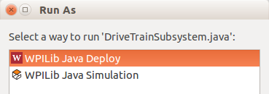

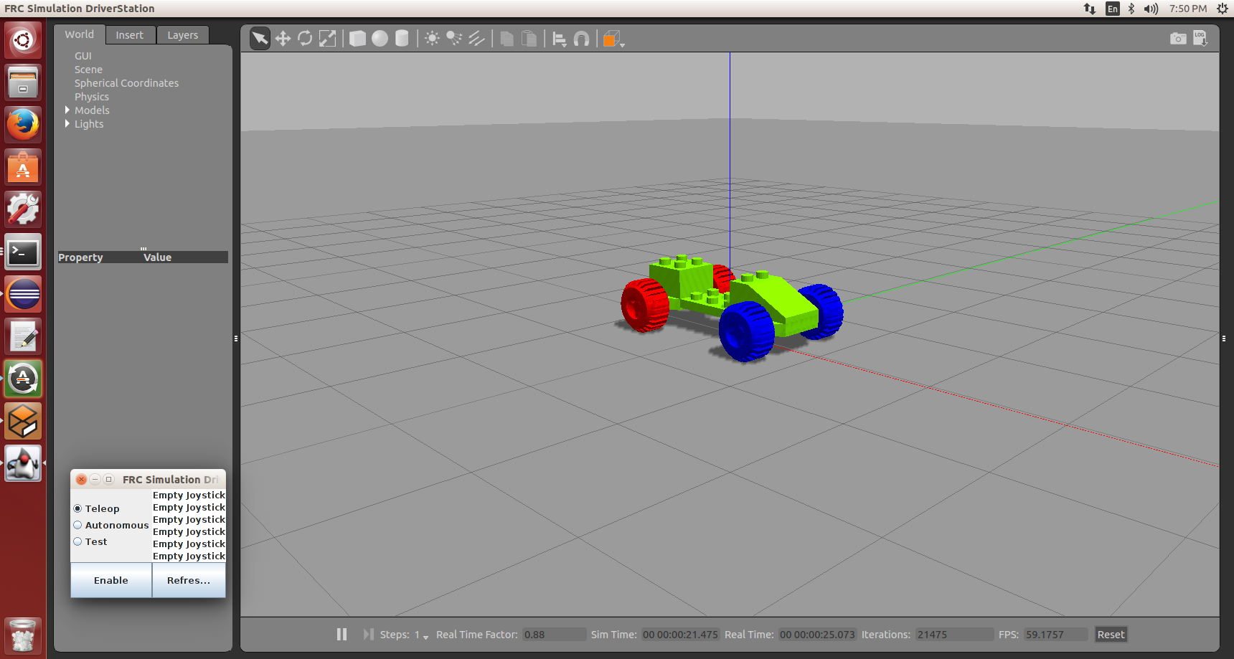

**FRCSIM:**

The FRC simulator provides a JAVA and C++ development environment for FRC robot software

**Required Resources:**

This capability requires a powerful workstation, SolidWorks 2014, Ubuntu 2014, and the FRCSIM application.

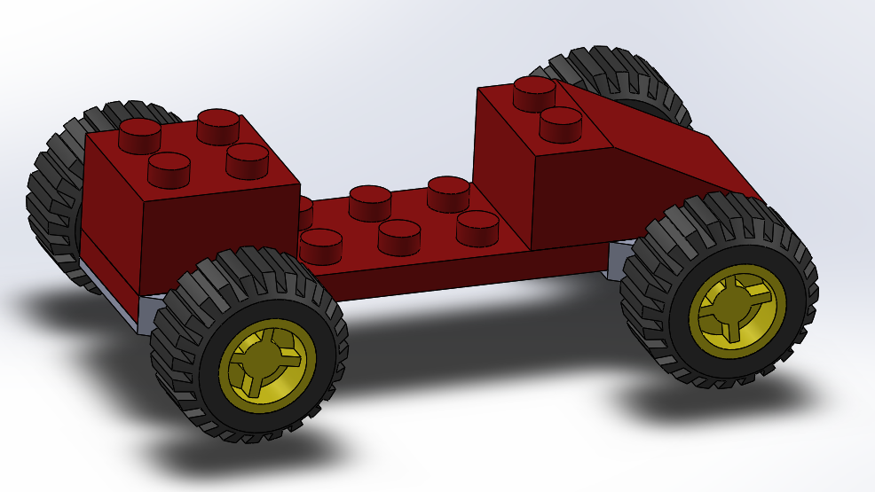

**Tested Configuration:**

* Windows 10 with 16 GB memory and SSD (likely need just 8 GB of memory)
* VMware Workstation 12.x
* SolidWorks 2014
* SolidWorks FRCSIM Export utility
* VM Containing Ubuntu 14.04 LTS
* VMware Tools installed on Ubuntu
* File Share established between Windows 10 and Ubuntu using native feature of VMware
* Eclipse with FRC plugins/add-on installed in Ubuntu
* Joystick or Gamepad

**References:**

WPI: **FRC JAVA Programming** https://wpilib.screenstepslive.com/s/4485/m/13809

WPI: **Using FRCSim with C++ and Java** <https://wpilib.screenstepslive.com/s/4485/m/23353>

WPI: **Command Based Programming**

https://wpilib.screenstepslive.com/s/4485/m/13810/l/241892-what-is-command-based-programming

**Limitations:**

FRCSIM cannot model CANTalons at this time.

**Process Overview:**

* Establish the Environment (SolidWorks, Ubuntu, FRCSIM)
* Build the Robot in SolidWorks
* Enhance the Robot and export
* Import into the Robot Simulator
* Write and Run your code!

**Establish the Environment**

1. Start with Windows 10 workstation.
2. Install VMware workstation.
3. Install Ubuntu 14.04 within Virtual Machine with Internet access.
4. Install VMWare tools. This is required to support a Windows to Ubuntu file share.
5. Install per FRCSIM documentation.

See: <https://wpilib.screenstepslive.com/s/4485/m/23353>

Lesson Learned: Ownership permissions under home directory are incorrect.

Needed to correct to that the user account (e.g., robot) owns the folder. May need to re-run the installation of the software.

/home/robot

robot@robotCPU:~$ ls -ltr

-rwxrwxr-x 1 robot robot 9721 Feb 11 2016 frcsim-installer.sh

drwxr-xr-x 6 robot robot 4096 Apr 1 22:29 wpilib

1. Within VMware configuration, set up a file share between the Windows Host and the Ubuntu Guest.

Windows shared file path: C:\Virtualization\Guests\Ubuntu_1

Ubuntu shared file path: /mnt/hgfs/Ubuntu1Share/

Files saved to the Windows file share are saved to the Ubuntu file share.

1. Procure SolidWorks.

See <http://www.solidworks.com/sw/education/robot-student-design-contest.htm>

1. Install SolidWorks on the workstation.
2. Install the FRC SolidWorks Plug-in.

NOTE: By default, SolidWorks is a “Y axis is Up” oriented system. Gazebo is a “Z axis is Up”. Within SolidWorks

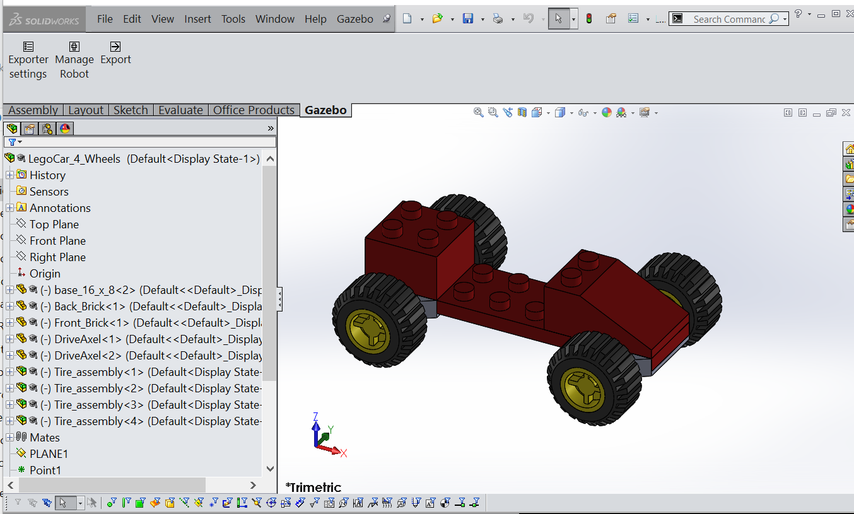

1. Check and update the SolidWorks Assembly z-axis.

**Build the Robot**

1. Watch the following YouTube and build a model car in SolidWorks

*SolidWorks Tutorial Parts and Assemblies:* at <https://www.youtube.com/watch?v=9f2huG_qQaE>

1. Within SolidWorks, update the Lego car with a reference **Plane**. Under the assembly tool bar option “Reference Geometry”, select “Plane”. Add a reference Plane where the plane is tangential to the bottom of the wheels. See the figure below.
2. Within SolidWorks, update the Lego car with a reference **Point**. Under the assembly tool bar option “Reference Geometry”, select “Plane”. Add a reference Point to the middle of the long leg base. See the figure below.

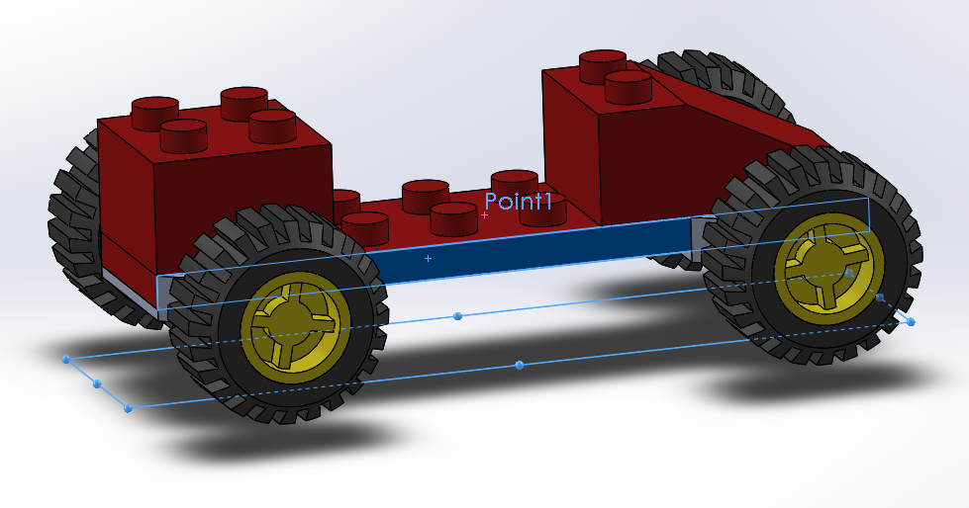

1. Within SolidWorks, update the Lego car with two axes. Under the assembly tool bar option “Reference Geometry”, select “axis”. The axis should go through the centers of the front wheels and rear wheels. One method for creating the axis is to define a “reference point” at the center of each wheel then create an axis from the two points.

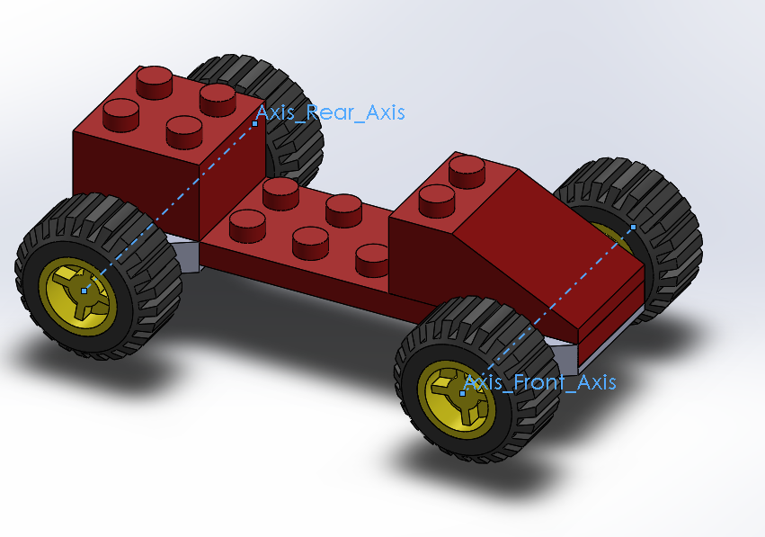

1. Save the Lego Car assembly. Make a backup of the Lego Car file.

**Enhance the Robot with FRC motors and Export**

1. Using the **Gazebo** tab within SolidWorks, Select **Manage** **Robot**.

*Notes*:

* The Gazebo plug-in does not behave well. It always wants to be the top screen.
* Some screens don’t appear to have an apply or clean exit button. Just use the x in the top right corner.

Leave **Export** as SDF.

Leave **Include FRC Field** to “No Field”.

1. Define the name for the Robot (e.g., LegoCar). Set the Name field to: **LegoCar**.
2. Click on **Select Model Origin.**

Select the following:

**Robot origin point** to the point in the middle of the 16-4 base.

**Base Plane** to the plane added to the robot at the bottom of the wheels.

**Direction Axis** – Select any long edge of the 16 x 8 base plate.

Select the green Checkmark.

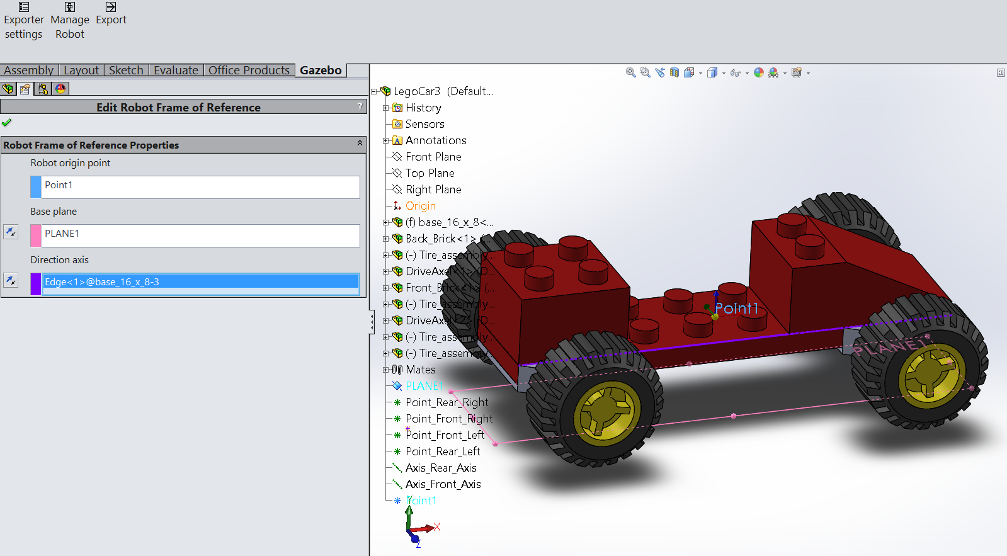

1. Define the main parts of your robot.

Click on the text in the **Link** box and set the name of the top link to **CarBody**

Select and drag the “+ New link /Add Link” at the bottom left of the display to the parent Link. Do this a total of 4 times.

Select and drag the “+ Simple Motor” at the bottom left of the display to the parent Link. Do this a total of 4 times.

Select the left most Joint

Set joint to type "Rotational"

Repeat for the additional joints

Select the middle of each “NewLinkX” and Set the names as:

FrontLeftWheel

FrontRightWheel

RearLeftWheel

RearRightWheel

1. Close the Manage Robot Dialog box by selecting the x in the top right corner.
2. SAVE the assembly. Select **File** => **Save**.

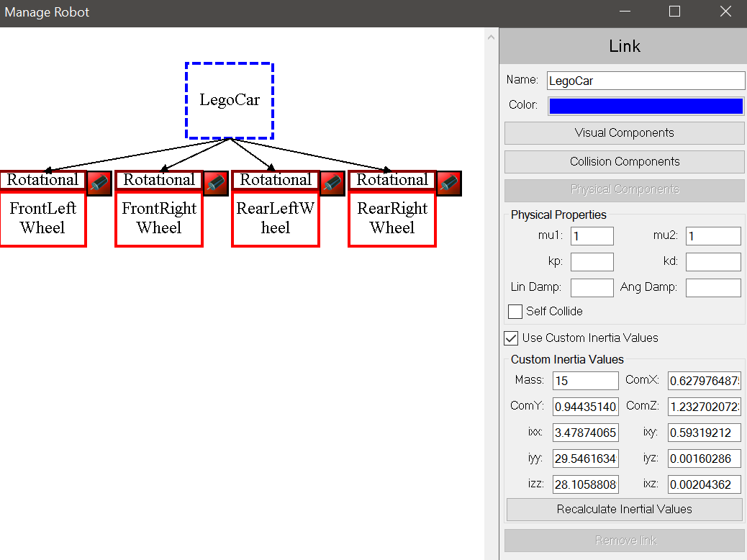

1. Re-Open the **Manage Robot** Dialog box by selecting **Manage Robot** on the Gazebo Tab.
2. Define the attributes of the robot components in Gazebo plug-in.

Select the Parent Link (CarBody).

Select a desired color.

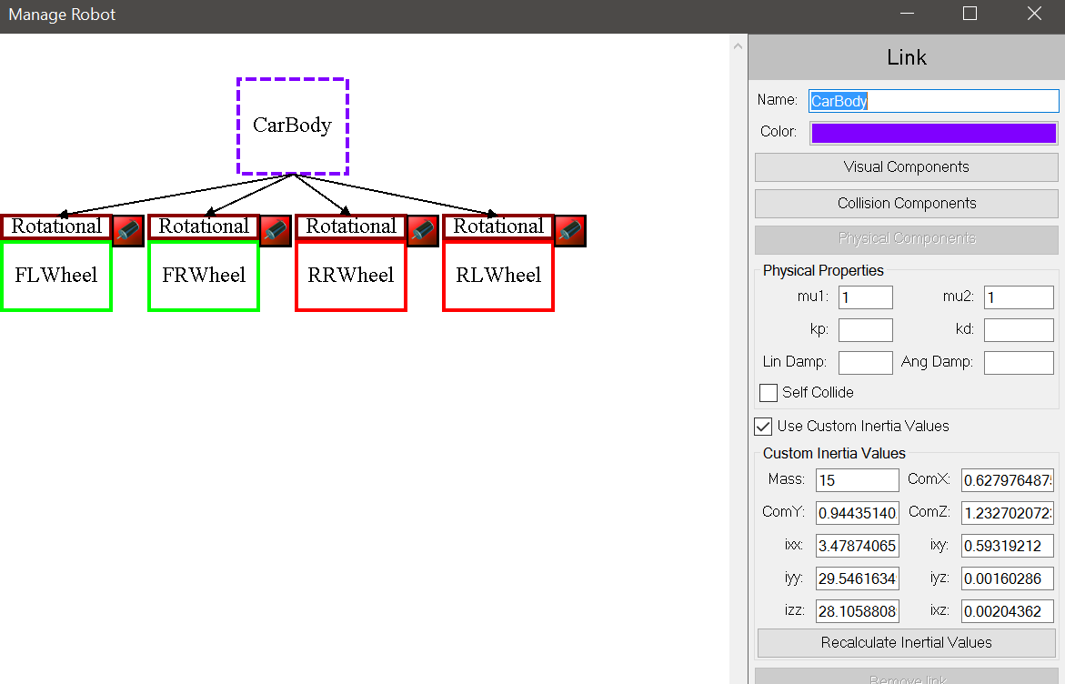

Select the **Visual Components** button.

Using the tree of components just left of the model, select the components which define the LegoCar body or select the components of the model car:

Base_16_8

DriveAxle1

DriveAxle2

BackBrick

FrontBrick

Select the green check mark.

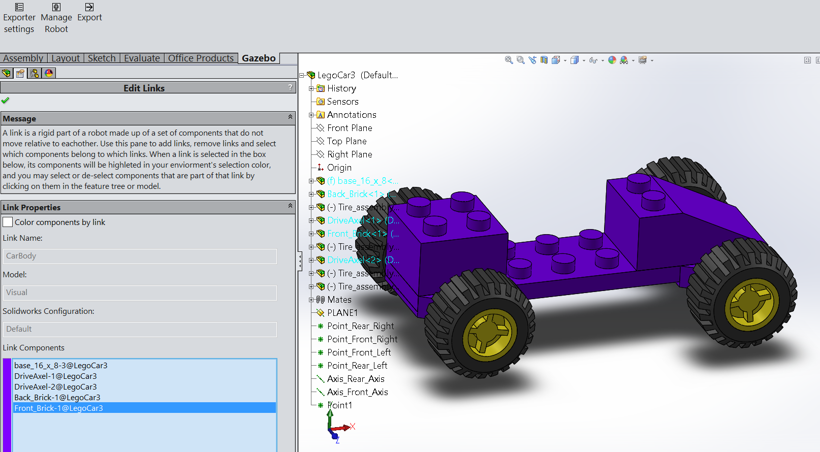

Select **Collision Components**.

Using the tree of components just left of the model, select the components which define the LegoCar body or select the components of the model car:

Base_16_8

BackBrick

FrontBrick

DriveAxle1

DriveAxle2

Select the green check mark.

Select **Physical Components.**

Using the tree of components just left of the model, select the components which define the LegoCar body or select the components of the model car:

Base_16_8

BackBrick

FrontBrick

DriveAxle1

DriveAxle2

Select the green Check mark

Note(s):

* The Physical Components button will be grayed out when the "Use Custom Inertia Values" checkbox is selected.
* To set or inspect the Physical Components, deselect the "Use Custom Inertia Values" checkbox and select the "Physical Components" button. Once the inspection/update is complete, re-enable the "Use Custom Inertia Values" checkbox and reset the mass to 15 Kg(?).
* The "Custom Inertia Values" have the mass of the robot changed from ??? to 15 units(?) to allow the robot to move.

Set mu1 and mu2 to the value of 1.

Select **Use Custom Inertial Values**.

Reduce the weight to 15.

Close the Manage Robot Dialog box by selecting the x in the top right corner.

SAVE the assembly. Select **File** => **Save**.

1. Set the attributes for each wheel.

Re-Open the Manage Robot Dialog box by selecting **Manage Robot** on the Gazebo Tab

Select the **FrontLeftWheel** Link (Box)

Select **Visual Components**.

Select the Front Left Wheel assembly on the model car.

Select the green Check mark.

Select **Collision Components**.

Select the Front Left Wheel assembly on the model car.

Select the green Check mark.

Select **Physical Components**.

Select the Front Left Wheel assembly on the model car.

Select the green check mark.

Set mu1 and mu2 to a value of 1. (Trying different values)

Notes Coefficients of friction.

See: http://www.engineeringtoolbox.com/friction-coefficients-d_778.html

Select **Use Custom Inertial Values**.

Reduce the weight to 5.

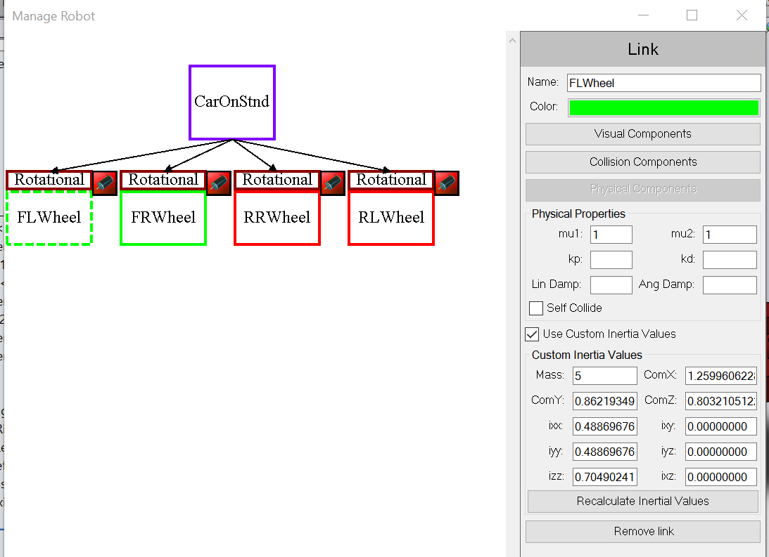

REPEAT the previous steps for the FrontRightWheel, RearLeftWheel and RearRightWheel.

Close the Manage Robot Dialog box by selecting the x in the top right corner.

SAVE the assembly. Select **File** => **Save**.

1. Configure the Robot Joints.

Re-Open the **Manage Robot** dialog box by selecting **Manage Robot** on the Gazebo Tab.

Select each of the 4 joints and perform the following:

Set Damping to 0.1

Set Friction to 0.1

Set Effort to 10 (Maximum force that can be applied to the wheel)

Check the "Is Continuous"

Select the Joint above the **FrontLeftWheel**.

Select the **Select Joint Pose**.

Select the axis that passes through the Front Wheels.

**None:**

* Inspect the circular Arrow and verify it is rotating in the direction of the Lego car moving forward
* If this needs to change, select the small icon button (with two opposite arrows to the left of the field)

(This was observed on the rear axis)

Close by selecting green checkmark.

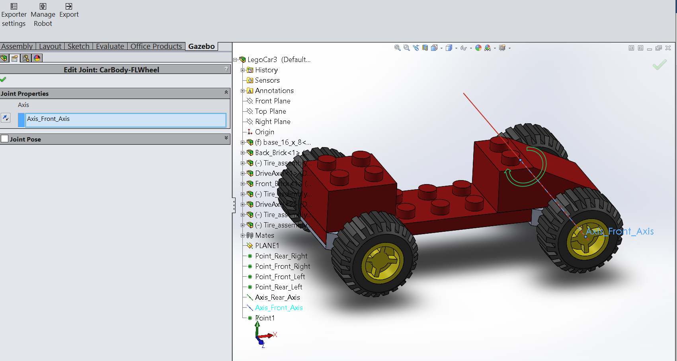

Select the Joint above the **FrontRightWheel**.

Select the **Select Joint Pose**.

Select the axis that passes through the Front Wheels.

**Note:**

* Inspect the circular Arrow and verify it is rotating in the direction of the Lego car moving forward
* If this needs to change, select the small icon button (with two opposite arrows to the left of the field)

Close by selecting green checkmark.

Select the Joint above the **RearLeftWheel**.

Select the **Select Joint Pose**.

Select the axis that passes through the Rear Wheels.

Inspect the circular Arrow and verify it is rotating in the direction of the Lego car moving forward

If this needs to change, select the small icon button (with two opposite arrows to the left of the field)

Close by selecting green checkmark

Select the Joint above the **RearRightWheel**.

Select the **Select Joint Pose**.

Select the axis that passes through the Rear Wheels.

**Note:**

* Inspect the circular Arrow and verify it is rotating in the direction of the Lego car moving forward
* If this needs to change, select the small icon button (with two opposite arrows to the left of the field)

(This was observed on the rear axis)

Close by selecting green check mark.

1. Set the motor PWM channel values.

Select each motor associated with each wheel and set the PWM channel as defined below. For all motors set the multiplier to 10.

Front Left = 1

Front Right = 2

Rear Left = 3

Rear Right = 4

Close the Manage Robot Dialog box by selecting the x in the top right corner.

SAVE the assembly. Select **File** => **Save**.

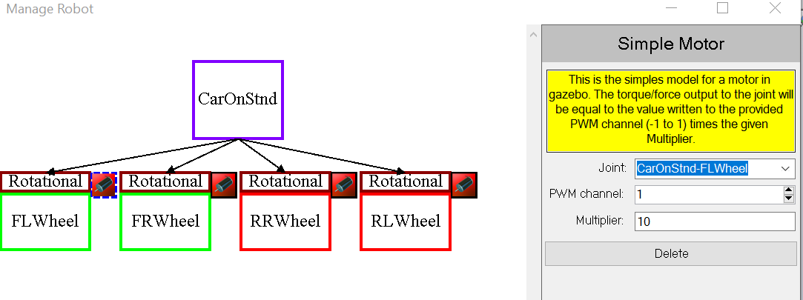

1. Export the Robot.

Select **Export**.

The Export Plug-in will validate everything and if OK, enable the **Export** button.

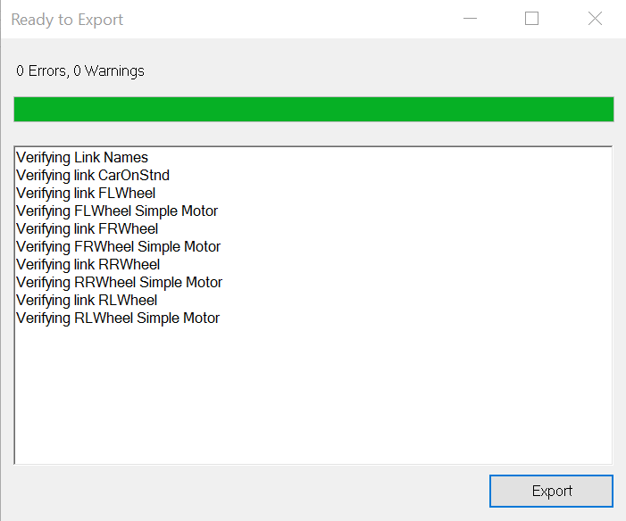

Browse to:

C:\Virtualization\Shared_Folders\Ubuntu1\New_models

Very important note:

Save the SolidWorks model. All of the Gazebo attributes are retained with the Robot. If you don’t save the SolidWorks assembly, then all of the setting will be lost.

**Run the Simulator**

On the Ubuntu virtual machine:

1. Install a joystick. Use the VMware controls to attach the joystick to the Ubuntu VM. Within VMware, select the VM tab, then removable devices.

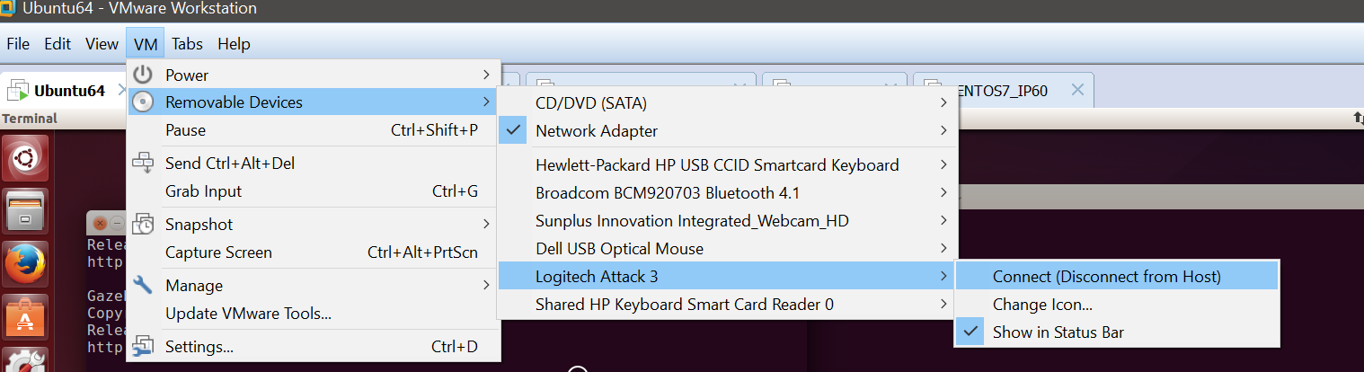

1. Copy the exported Robot model from the file share to the working locations. One time-saving approach is to use a script. (Scripts require the file name and locations to always be the same).

Run a script to copy the robot sdf file and world file to the working locations. See the following script.

Script Name: copyRobot

rm -R /home/robot/wpilib/simulation/models/LegoCar

cp -f /mnt/hgfs/Ubuntu1Share/New_models/LegoCar_Exported/LegoCar.world /home/robot/wpilib/simulation/worlds

cp -Rf /mnt/hgfs/Ubuntu1Share/New_models/LegoCar_Exported/LegoCar/ /home/robot/wpilib/simulation/models/

1. Start simulation using the following script. (Assumes your model is named: **Legocar**)

frcsim ~/wpilib/simulation/worlds/LegoCar.world

**Lesson learned:** Sometimes the Gazebo fails right away. In fact, I have seen it take 5 tries to start.

1. Start the Dashboard using the following command: ds_sim
2. Start Eclipse (in Ubuntu)
3. In eclipse, follow the process to build a framework for Robot code.
4. Once the code is ready, deploy the code to the simulator. This is the other option when deploying code.
5. On the simplified driver station, select the mode (TeleOp or Autonomous) and then Enable
6. When done with the simulation, select **Disable**.
7. Select the red square in the monitor console of Eclipse.
8. Copy the eclipse project to the Ubuntu/Windows file share.

**Other Recommendations:**

1. Learn how to use the JAVA debugger

**Shutdown the system**

1. Close the applications. Select each application and select the orange (x) at the top of each application. Shutdown the Gazabo simulator, the Drivers Station, Eclipse, and the multiple terminal windows.
2. Shutdown the Ubuntu virtual machine. Select the gear at the top right. Select **Shutdown** and then confirm on the big square **Shutdown** button.
3. Close VMWare.

========================================================================================

**Limitations:**

1. The FRCSIM can take a few tries to start.
2. Joystick methods are not working correctly (getX(), getY() and getZ() )

Use: Robot.oi.joystick1.getRawAxis(0)

// Robot.driveTrainSubSystem.ArcadeDrive(Robot.oi.joystick1.getY(),Robot.oi.joystick1.getX());

Robot.driveTrainSubSystem.ArcadeDrive(Robot.oi.joystick1.getRawAxis(0), Robot.oi.joystick1.getRawAxis(1));

Notes: Joystick

- Axis 0 - Left(-) and Right(+)

- Axis 1 - forward (-) and Back (+)

- Axis 2 - Rotate forward (-) and Back (+)

Seems like getX(), getY() and getZ() are not working - wrong order

1. The Analog Gyro does not support the “setSensitivity” method. Comment out in RoboMap.
2. Needed to rename a few sensors (one Time).

/home/robot/wpilib/simulation/plugins/

cp libencoder.so libgz_encoder.so

cp libgyro.so libgz_gyro.so

Export Utility issues:

* Top level screen always stays on top. Would be nice if it just behaved like other Windows applications.

Lesson Learned:

* SolidWorks created a robot that we relatively too heavy and would not move. Needed to override the values and reduce the weight. See the screen capture. Looks like you need to allow at least one calculation before overriding.
* Visual Components, Collision Components, and Physical Components are defined. Set all the same. Note that the Physical Component is greyed out once the “Use Custom Component Values” is checked.

========================================================================================

Purpose: This appendix describes how to change the orientation of the assembly template so the Z-axis goes upward.

This process is derived from <https://www.youtube.com/watch?v=ph48Gwd4xuU>.

1. In SolidWorks, start a new assembly. Select File => New => Assembly.
2. Select Isometric view. Observe the upward facing axis is a green arrow denoted as Y.
3. Select Top View. Select Right click=>View Orientation => Top icon
4. Select and hold the shift key and click on the red X axis. This will rotate the view to z axis to be facing out of the screen.
5. Update the standard view by doing the following: Bring up the **View Orientation** dialog box. Select the tool icon with clockwise arrow. Then immediately select the top view icon. The title of the tool can be observed by viewing the text displayed in the lower left corner.
6. SolidWorks will prompt you with a dialog box confirming the change. (“Changing this standard view will change the orientation of any standard orthogonal...”)
7. Now we need to rename and reverse the top and front SolidWorks Planes using the following steps:
   1. In the left window, select the "Front Plane". Right click and select "Feature properties".
   2. Rename "Front Plane" to "To Plan". Also update the Description field to the name "Top Plan".
   3. In the left window, select the "Top Plane". Right click and select "Feature properties".
   4. Rename "Top Plane" to "Front Plane". Also update the Description field to the name "Front Plan".
   5. In the left window, select the "To Plane". Right click and select "Feature properties".
   6. Rename " To Plane" to "Top Plane".
8. Save configuration as an "Assembly Template" with the name of AssemblyGazebo.
9. Resave with the name of the new robot car assembly and not a template.

Note: When creating new assemblies, the AssemblyGazebo template must be selected.

Parts may need to be rotated

X = Red, Y = Green, Z = Blue

<https://www.youtube.com/watch?v=DXE7Ze-xrmI>

Color Mapping (SolidWorks to Gazabo)

Black = Black

Blue = Bright Green

Yellow = Pink