Gumball Machine

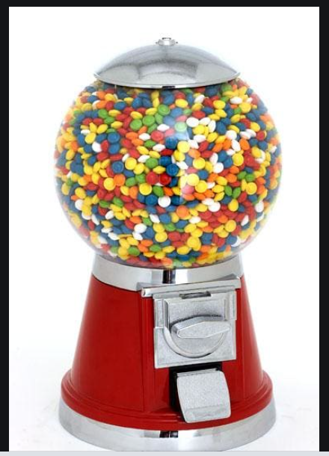

What does a Gumball Machine do?

What information does a gumball machine need to function?

**Nouns**

**Verbs**

**What does a Gumball machine need to do to function?**