Anova1.R

acarraro

2023-01-18

# Example 1, One Way ANOVA  
# Create Dataframe  
foods<-data.frame(milk=c(25.40,26.31,24.10,23.74,25.10,  
 23.40,21.80,23.50,22.75,21.60,  
 20.00,22.20,19.75,20.60,20.40),  
 food=c("Food1","Food1","Food1","Food1","Food1",  
 "Food2","Food2","Food2","Food2","Food2",  
 "Food3","Food3","Food3","Food3","Food3"),  
 stringsAsFactors = TRUE)  
  
# ANOVA test  
tm<-lm(milk ~ food, data = foods) # fit a linear model to the independent variable food   
summary(tm) # ANOVA table

##   
## Call:  
## lm(formula = milk ~ food, data = foods)  
##   
## Residuals:  
## Min 1Q Median 3Q Max   
## -1.19 -0.82 0.01 0.63 1.61   
##   
## Coefficients:  
## Estimate Std. Error t value Pr(>|t|)   
## (Intercept) 24.9300 0.4292 58.084 4.48e-16 ***  
## foodFood2 -2.3200 0.6070 -3.822 0.00243 **   
## foodFood3 -4.3400 0.6070 -7.150 1.16e-05 ***  
## ---  
## Signif. codes: 0 '***' 0.001 '**' 0.01 '*' 0.05 '.' 0.1 ' ' 1  
##   
## Residual standard error: 0.9597 on 12 degrees of freedom  
## Multiple R-squared: 0.8101, Adjusted R-squared: 0.7785   
## F-statistic: 25.6 on 2 and 12 DF, p-value: 4.684e-05

fm<-aov(milk ~ food, data = foods) # fit the ANOVA (there are different types of ANOVA)   
summary(fm) #

## Df Sum Sq Mean Sq F value Pr(>F)   
## food 2 47.16 23.582 25.6 4.68e-05 ***  
## Residuals 12 11.05 0.921   
## ---  
## Signif. codes: 0 '***' 0.001 '**' 0.01 '*' 0.05 '.' 0.1 ' ' 1

#Mean Sq is equal to Sum Sq divided by Df (degrees of freedom)  
# The number Multiple R-squared: 0.8101  
# is obtained as 0.8101 = (47.16)/(47.16+11.05)  
#F-statistic: 25.6 on 2 and 12 DF, p-value: 4.684e-05  
# the observations are 14 and the groups are 2  
# The test reveals that the diet is significant (but we still don't know which diet gives highest  
# milk production difference)  
  
# we see that the median is 0.01 (almost 0) and the 1st and 3rd quartiles are almost centered  
# around the median  
  
  
library(multcomp)

## Loading required package: mvtnorm

## Loading required package: survival

## Loading required package: TH.data

## Loading required package: MASS

##   
## Attaching package: 'TH.data'

## The following object is masked from 'package:MASS':  
##   
## geyser

par(mar=c(5,4,6,2)) # Change parameters for the plot margins  
tuk <- glht(fm, linfct=mcp(food="Tukey")) # Fit the general Linear Hypotheses  
plot(cld(tuk, level=0.05),col="lightgrey") # Plot the mean differences

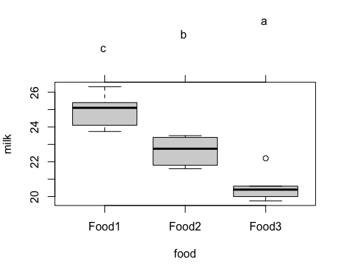

# Multiple comparisons  
  
TukeyHSD(fm) # Tukey test for multiple comparisons on the results of the ANOVA

## Tukey multiple comparisons of means  
## 95% family-wise confidence level  
##   
## Fit: aov(formula = milk ~ food, data = foods)  
##   
## $food  
## diff lwr upr p adj  
## Food2-Food1 -2.32 -3.939373 -0.7006265 0.0063517  
## Food3-Food1 -4.34 -5.959373 -2.7206265 0.0000322  
## Food3-Food2 -2.02 -3.639373 -0.4006265 0.0153900

plot(TukeyHSD(fm)) # Plot for tukey test

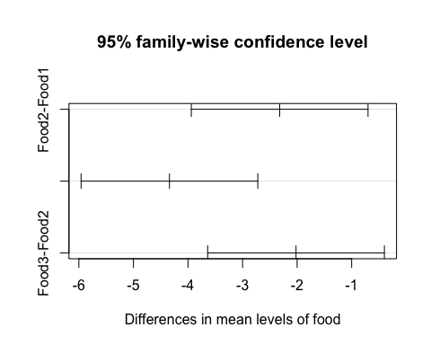

aggregate(foods$milk, by=list(foods$food), FUN = mean) # Means by group

## Group.1 x  
## 1 Food1 24.93  
## 2 Food2 22.61  
## 3 Food3 20.59