Summary Report

**Restaurant Lookup**

July 26th, 2017

Summer 2017

**REVISION HISTORY**

|  |  |  |  |
| --- | --- | --- | --- |
| **Version** | **Date** | **Organization/Point of Contact** | **Description of Changes** |
| 1.0 | 7/26/2017 |  | Initial |
|  |  |  |  |
|  |  |  |  |
|  |  |  |  |
|  |  |  |  |
|  |  |  |  |
|  |  |  |  |

**TABLE OF CONTENTS**

1. INTRODUCTION 1

2. REFERENCED DOCUMENTS 1

3. Detailed Test Results 1

3.1 JUnit Test Summary 1

3.2 Functional / GUI Testing 3

4. Recommendations 10

5. Glossary 10

6. acronyms 10

**LIST OF TABLES**

Table 1 Referenced Documents 1

Table 2 Junit Test Summary 1

**LIST OF FIGURES**

Figure 1:BST JUnit Test 2

Figure 2: IndexedList JUnit Test 3

Figure 3: Account Not Found 4

Figure 4 Username Password Mismatch 5

Figure 5 Valid Email, Invalid SSN. 6

Figure 6 Invalid Password, Mismatch 7

Figure 7 Valid Sign Up 7

Figure 8 Valid Coordinates 7

Figure 9 Invalid Coordinates 8

Figure 10 Valid Lat, Long, Radius and Restaurant Clicked 9

# INTRODUCTION

Restaurant Lookup is a tool by which a user might enter their location and radius and find a restaurant within a reasonable vicinity, and allow them to determine the distance from one to another end. This summary report includes the summary of each test cases by class and method using the techniques and the tools.

# REFERENCED DOCUMENTS

Table 1 Referenced Documents

|  |  |
| --- | --- |
| Document Name | Issuance Date |
|  |  |
|  |  |

# Detailed Test Results

The testing summary reports of Junit and Integration Testare provided below.

## 3.1 JUnit Test Summary

The table below summarizes the test cases employed for JUnit and the test results obtained for each test case:

Table : JUnit Test Summary

|  |  |  |  |  |  |
| --- | --- | --- | --- | --- | --- |
| **Test Class** | **Number of Test Cases** | **Number of PASS** | **Number of FAIL** | **Pass Percentage** | **Fail Percentage** |
| ACO | 2 | 2 | 0 | 100% | 0% |
| BST | 17 | 17 | 0 | 100% | 0% |
| MinHeap | 1 | 1 | 0 | 100% | 0% |
| OrderedList | 11 | 11 | 0 | 100% | 0% |
| IndexedList | 16 | 16 | 0 | 100% | 0% |
| WeightedGraph | 1 | 1 | 0 | 100% | 0% |
| Total | 48 | 48 | 0 | 100% | 0% |

There are 48 test cases and 48 of the test cases are pass. The calculated level of success for JUnit test is 100%. Figure 1 and 2 show the result of BST and IndexedList JUnit test.

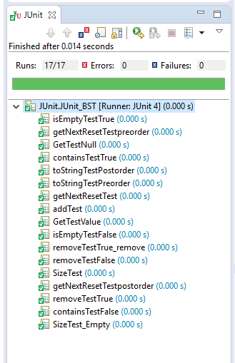

Figure 1:BST JUnit Test

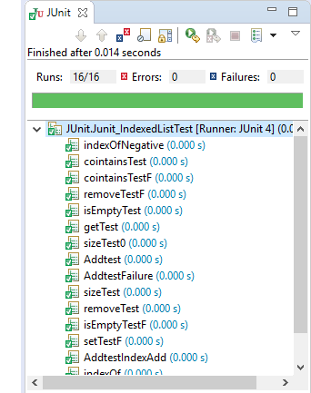

Figure 2: IndexedList JUnit Test

## 3.2 Functional / GUI Testing

Table : FunctionalTesting

|  |  |  |  |  |  |
| --- | --- | --- | --- | --- | --- |
| **Test Case** | **Actions** | **Intended Result** | **Pass** | **Fail** | **Result** |
| 001- Open Portal | Double Click | Portal Opens | Yes |  | Pass |
| 002- Attempt Login | Login with “aa” as username. “ag” as password. | Messagebox Containing “That account Cannot Be Found…” | Yes |  | Pass |
| 003-Attempt Login | Login with “aG” as username. “ag” as password. | Messagebox Containing “Username/Password Mismatch” | Yes |  | Pass |
| 004-Login Button | Login with “aG” as username. “Password@1” as password. | Opens Restaurant Lookup. | Yes |  | Pass |
| 005-Sign Up Button | Click Sign Up button. | Sign Up menu appears. | Yes |  | Pass |
| 006-Set Account Details | Attempt Sign Up without Information | Invalid Email Message | Yes |  | Pass |
| 007—Input invalid email | Input “gibberish” into email. | Invalid Email Message | Yes |  | Pass |
| 008-Input valid Email | Input “gibberish@aol.com” | Invalid SSN Message | Yes |  | Pass |
| 009-Input invalid SSN | Input “1” “11” “1111” | Invalid SSN Message | Yes |  | Pass |
| 010-Input valid SSN | Input “111” “22” “3333” | Invalid Password Message | Yes |  | Pass |
| 011-Password Mismatch | Input “Pass1” and “Pass2” | Your Passwords do not match Message | Yes |  | Pass |
| 012-Successful Signup | Input “Pass” and “Password@1” into the Username and Password fields respectively | Sign Up Successful message | Yes |  | Pass |
| 013- Restaurant Lookup | Input a latitude and longitude and press Search Nearby | The Distance Column Populates with haversine distances. | Yes |  | Pass |
| 014-Restaurant Lookup Invalid Coordinates | Input a latitude greater than |90| or longitude greater than |180| | Invalid Coordinates Message | Yes |  | Pass |
| 015-Restaurant Lookup Limit By Radius | Input a Radius alongside lat/long | Results are filtered by radius. | Yes |  | Pass |
| 016-Click Restaurant | Click an Entry in the table. | Upon clicking an entry in the table, restauarant details are populated above. | Yes |  | Pass |

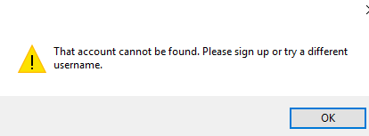

Figure : Account Not Found

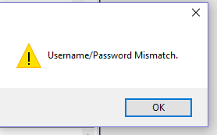

Figure Username Password Mismatch

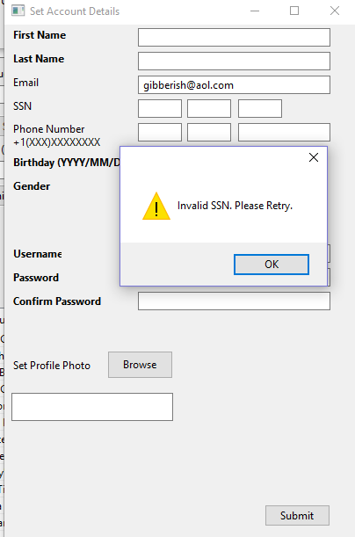

Figure Valid Email, Invalid SSN.

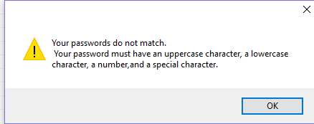

Figure Invalid Password, Mismatch

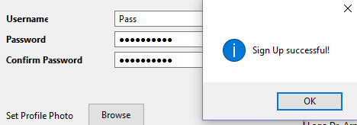

Figure Valid Sign Up

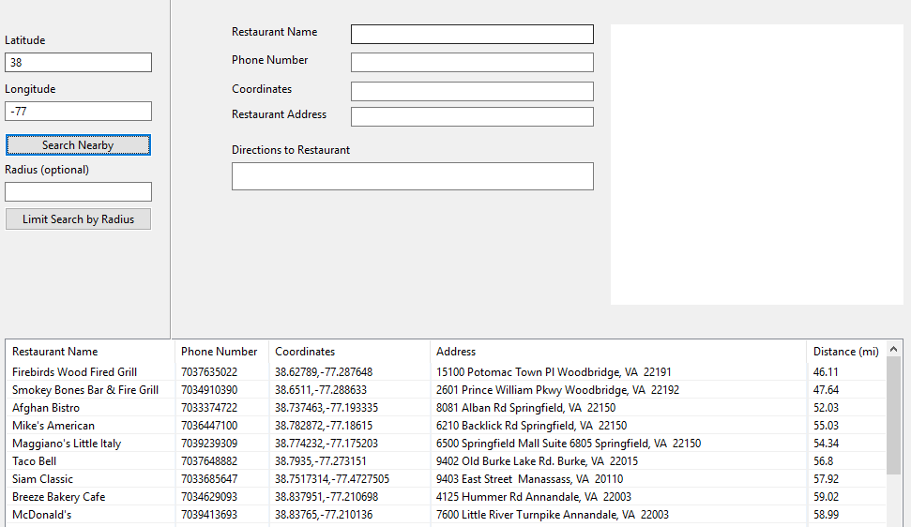

Figure Valid Coordinates

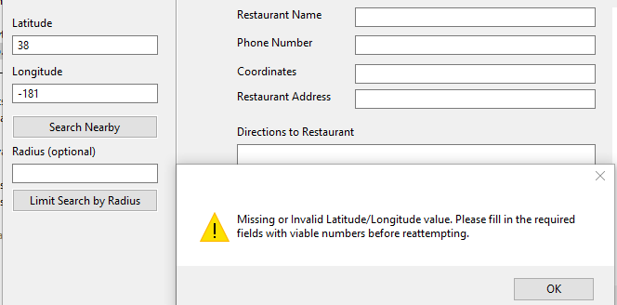

Figure Invalid Coordinates

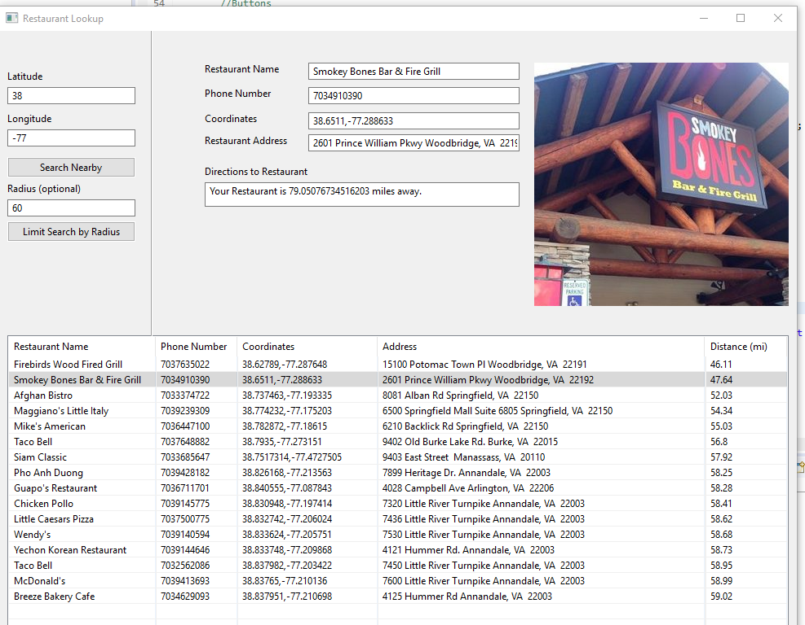

Figure Valid Lat, Long, Radius and Restaurant Clicked

# Recommendations

RL must be fixed for the frail points in the GUI before moving on to the production. One would recommend the use of SWTBot for additional testing. The design of the tool must be redesigned to make it more modern and user-friendly. The tool should have additional complexity metrics such as its own integrated shopping cart.

# Glossary

# acronyms

|  |  |
| --- | --- |
| RL | Restaurant Lookup |
|  |  |