Summary:

Medical legalization of cannabis causes no statistical difference in price of cannabis. Recreational legalization, however, causes significant decrease in price for high quality cannabis products. Findings based on consumer reviews detailing quality, price and location.

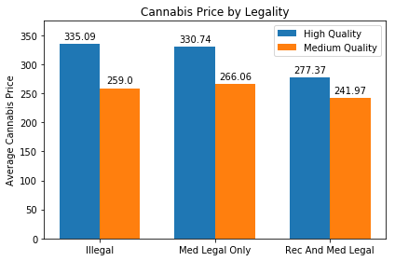

Above chart compares the average price for one ounce of cannabis based on state legalization laws. Average includes recreational, medical and black-market prices for recreational legal states; medical and black-market prices for medically legal states that do not allow recreational use; and black-market prices for states that do not allow medical or recreational use.

<https://medium.com/@jtkernan7/the-effects-of-cannabis-legalization-from-a-consumer-perspective-b03ec623698b>