|  |
| --- |
| JAVA PROJECT DESCRIPTION |
| PROJECT NAME: INTERNET SERVICE PROVIDER |
| **NAME: MURATIMANA Lambert**  **REG NO:221000893**  **CLASS number:07** |

1. **PLANNING**

Internet Service Provider Project (ISP) this system is used by administration of ISP of organizational’s dayly activities comprising internet provision, managing employees and customer’s datas , and creating plans and problem solving management .

Main points to look on are customers,plan and employees of the company.

**Goals and objectives :**

1. The admin of ISP companies will be able to access and further use the system properly.
2. Custmers will freely access the system to shop,contact the company and connect to their respective families.
3. The admin of ISP companies will be able to easily make use of this project.

4. Admin will be able to know all requirements used when designing a project.

5.The system will be maintainable in a case deteriorated.

6.Easy to use for every business customer .

This system is better for future generation as it will respond to existing problems as mentioned in above goals and objectives.

Some companies like MTN,TIGO and other financial businesses will be utilizing it.

**2.DESIGN**

**TECHNICAL REQUIREMENTS:**

The system was technically well designed using JAVA application by the help of Apache netBeans IDE.

The system also technically designed using MySql woerkbench as database to store information.

* **Usability**: the system is a user friendly based for easy access.
* **Reliability:**whenever system needed is available.
* **Maintainabilit:** this involves adding features and requirements in a case a system fails.
* **Security:** this is how a system keep customes’s datas and employees data safe.

**FUNCTIONAL REQUIREMENTS:**

* **Authentication functions:** this involves further validation by the admin.
* **System requirement:**  involve specifications for software and hardware such as computer ,database and more. these include the specific action that system takes to complete the task.
* **Administrative protocol:** to help us perform special operations include system reporting and testing to ensure the system runs properly.
* **external interfaces:** these are user preferences which help individual operate system easily.it may involve specific features like the interfaces ,navigations.

After that the main part the admin will emphasize is to login for authentication and the dashboard will be comprising navigations of:

* Create plan
* Manage customers
* Manage complains
* Manage employee
* Logout

Let design the system using the following use case Diagram for proper demonstra

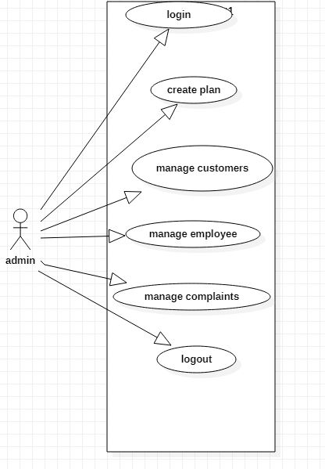

**3.DEVELOPMENTS**

**Technology Used :**

1. Jaava application.
2. Mysql in Database
3. IDE by using Netbeans 8.2
4. msql connector by connector

tables in a system are as follows:

* Admin
* Customer
* Complains
* Plan
* Employee

Primary and secondary keys were used in the system for further relationships using MySql connector.

**4.TESTING**

The system has been tested and we discovered that it well designed and developed for it can run in either windows or macs, the only issue is that its hard to import netbeans practical project to other apps like eclipse.

**5.DEPLOYMENT**

To distribute our project we had to take computers which have netbeans installed, wamp server for database, and connector in that way our system can be imported and accessed.