The Strategic Role of Information Systems in Forever 21’s Top Shop Acquisition

Module: COMP1792 – Information Systems

Tutor: Lorna Leslie

Date: 5 November 2025

Introduction
Forever 21’s €10 billion acquisition of Topshop presents a strategic opportunity to expand its global reach and attract younger, digital-first shoppers. As CIO, my goal is to demonstrate how integrated information systems can enhance operations, analytics, and marketing. This report outlines how strong data management, advanced analytics, and sound governance can drive efficiency, innovation, and competitive growth.

Data Inventory and Governance Challenges

Managing thousands of SKUs across stores and online platforms requires real-time stock visibility. Key challenges include siloed systems causing inconsistent data, manual errors creating duplication, and weak accountability reducing accuracy. To address these, an enterprise-wide data catalogue should integrate store, warehouse, and online records.

Each department (Footwear, Accessories) should assign a Data Steward to maintain data quality. Tracking KPIs such as verified stock location, daily update rate, and stock discrepancy percentage will sustain accuracy. A unified dashboard showing real-time metrics enables faster, data-driven decisions.

A structured summary of this governance framework is shown below.

Data Source | Department Owner | Update Frequency | Data Accuracy Rate (%) | Action / Responsibility
Store POS (Footwear & Accessories) | Retail Ops | Real-time | 98.3 | Auto-sync to central DB; daily reconciliation
Warehouse & Supplier Logs | Logistics / Procurement | Hourly–Daily | 95.6 | Barcode & EDI updates; routine verification
Online Orders & Returns | E-commerce / Customer Service | Real-time | 97.3 | Instant stock update; QC-based restock
Table 1

High-Speed Internet: Benefits and Challenges
High-speed internet supports real-time POS transactions, cloud inventory updates, and analytics dashboards. However, congestion, downtime, cybersecurity threats, and redundancy costs may occur. Dual-ISP failover, encrypted VPNs, and edge caching ensure secure, uninterrupted connectivity across stores.

Analytical Tools for Footwear and Accessories

Efficient operations depend on integrated systems:
- ERP for automated stock control and forecasting.
- CRM for tracking customer engagement and loyalty.
- BI tools (e.g., Power BI, Tableau) for analysing sales, returns, and fashion trends.
Together, these enable accurate forecasting and strategic retail planning.

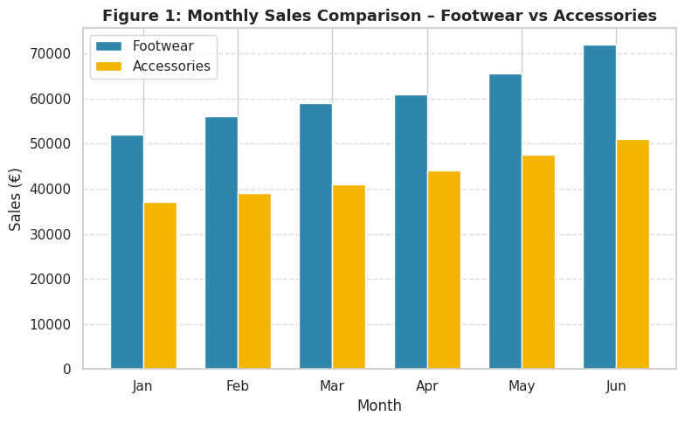

Figure 1

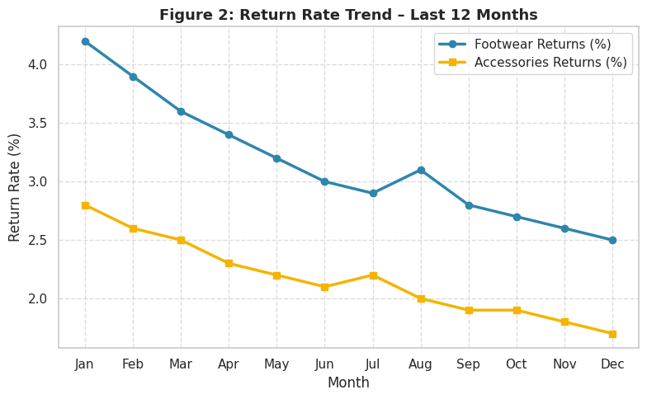

Figure 2

Ethical and Privacy Issues with Resolutions
Misuse of customer data, such as tracking purchase history without consent, poses ethical risks. Transparent opt-in systems, staff privacy training, and anonymised behavioural data prevent biased profiling. A privacy-by-design model and GDPR compliance reinforce customer trust and accountability.

Vulnerability of Information Resources
Databases and financial systems face threats from cyberattacks and insider misuse. Multi-Factor Authentication (MFA), encrypted off-site backups, and regular penetration testing protect data integrity and ensure business continuity.

Case Study: Social Marketing to Gain More Customers

Forever 21–Topshop can launch a TikTok challenge promoting limited-edition accessories to attract Gen Z shoppers. User-generated content and a “Shop the Look” microsite drive sales. Engagement likes, shares, and conversions can be tracked via a pie chart titled “Engagement by Platform (TikTok / Instagram / YouTube)”, strengthening brand visibility and online community engagement.

Figure 3

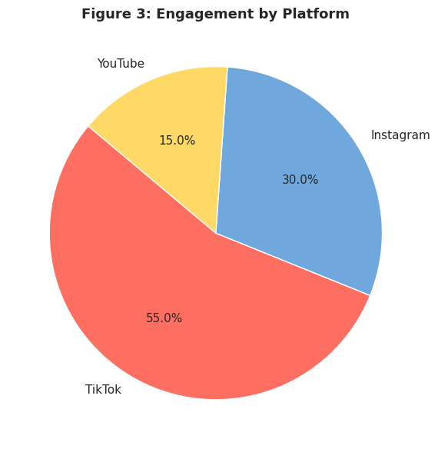

Conclusion
Integrated information systems will give Forever 21–Topshop real-time insight into inventory, customer behaviour, and performance. By improving data governance, applying analytics, and addressing ethical and security challenges, the acquisition becomes a digitally enabled growth strategy streamlining operations, enhancing loyalty, and positioning the brand as a global digital innovator.

