1. Website Specifications
i. Purpose of the Website
The purpose of this website is to provide an online platform that allows clients to interact effectively with the fitness training company’s services. The website will enable users to explore training programs, select personal trainers, book sessions, manage appointments, and provide feedback.
Goals
- Provide 24/7 access to fitness services and information
- Showcase training programs, fitness styles, and trainer expertise
- Display workout plans, transformations, and success stories
- Enhance online presence, making it easier for potential clients to discover the business
- Strengthen the brand image and credibility
- Collect client feedback and reviews for continuous improvement

ii. Target Audience
- Teenagers and adults aged 15 to 40
- Students and working individuals
- Fitness beginners and experienced gym-goers
- Health-conscious and goal-oriented individuals
- Budget-conscious clients looking for affordable training options

iii. Technical Aptitude
Users of the website are expected to:
- Be comfortable using mobile devices and computers
- Be able to create accounts and log in
- Complete online forms for bookings and registrations
- Navigate both mobile and desktop interfaces easily
- Select trainers, programs, and schedules
- Leave reviews, ratings, and feedback
- Browse fitness galleries and transformation results

iv. Type of Website Content
- Fitness program descriptions and pricing
- Trainer profiles and specializations
- Online booking system for training sessions
- Appointment viewing, rescheduling, and cancellation
- Contact details and location information
- Fitness gallery (before/after transformations, workouts)
- Company information and branding
- Login and sign-up system

2. Technical Brief
The website will be developed using the following tools and technologies:
- HTML5 – Structure of the website
- CSS3 – Styling and layout design
- Visual Studio Code – Code editor
- GitHub – Version control and project management
- GitHub Pages – Website hosting
- Canva – Designing visuals and graphics
- Pinterest – Inspiration for fitness designs and layouts

2. Information Design & Taxonomy
Site Map
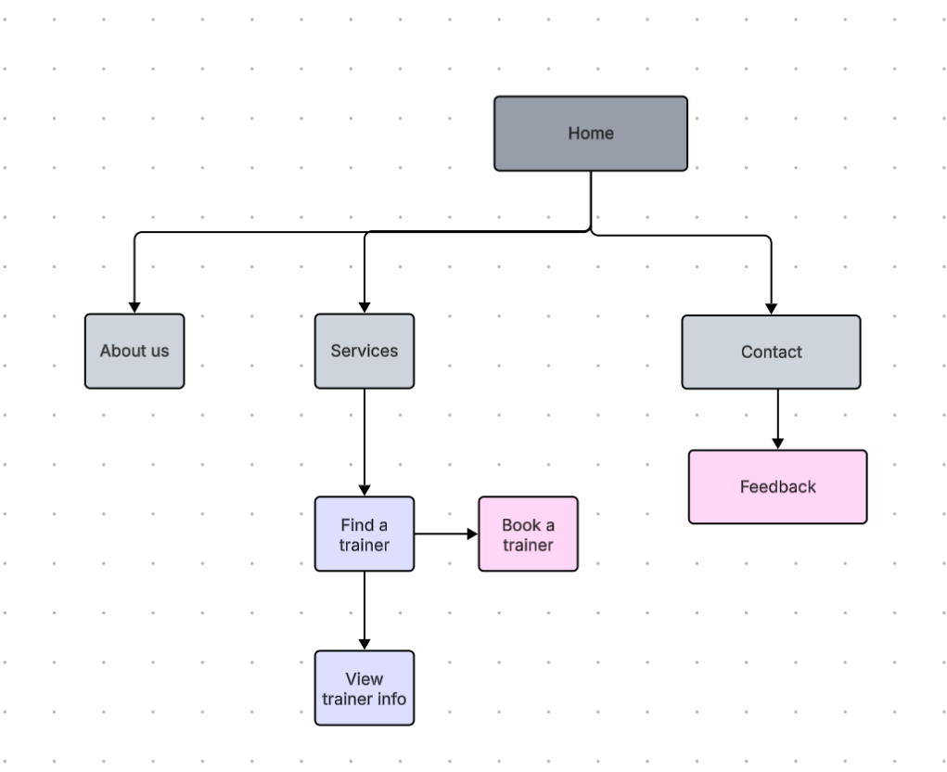
3. Page Template Design
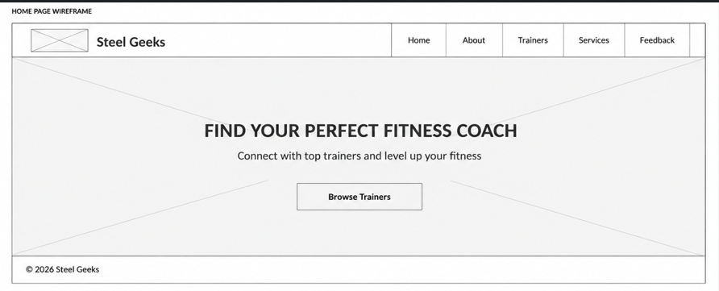
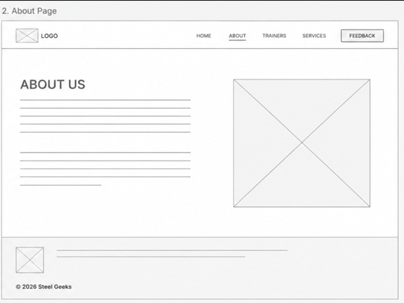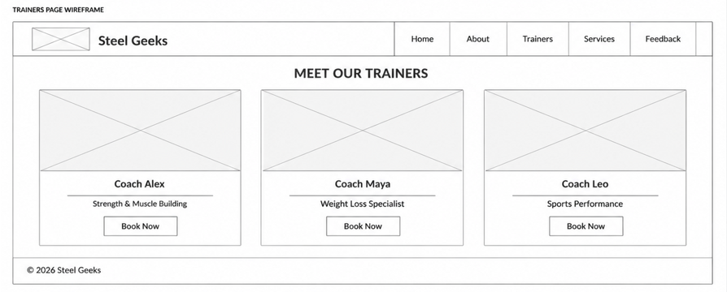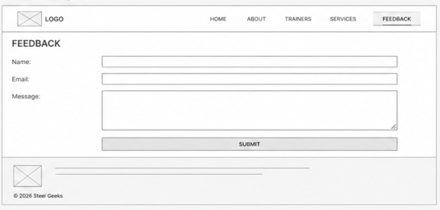
4. Technical Brief
The Fitness Geeks website will be developed using modern web technologies and software tools that are suitable for creating a responsive, attractive, and user-friendly fitness website.
Technologies to be Used
HTML5
HTML5 will be used to create the structure of the website pages such as the homepage, trainers page, classes page, and contact page.
CSS
CSS will be used to style the website by adding colors, layouts, fonts, spacing, animations, and responsive design features.
Bootstrap
Bootstrap will be used to simplify responsive web design and create professional-looking components such as navigation bars, cards, buttons, and grids.
JavaScript
JavaScript will be used to add interactivity to the website, such as image sliders, form validation, navigation effects, and dynamic content.

Software and Development Tools
Visual Studio Code (VS Code)
VS Code will be used as the main code editor for writing and managing HTML, CSS, JavaScript, and Bootstrap files.
Google Chrome
Chrome browser developer tools will be used for testing, debugging, and checking website responsiveness.
GitHub
GitHub may be used for storing and backing up the website project files and managing versions of the project.
Graphics and Design Tools
Canva
Canva will be used to design banners, promotional graphics, and fitness-themed visuals for the website.
Adobe Photoshop
These tools may be used to edit and optimize images before uploading them to the website.

5. Quality Assurance
Browser Compatibility test
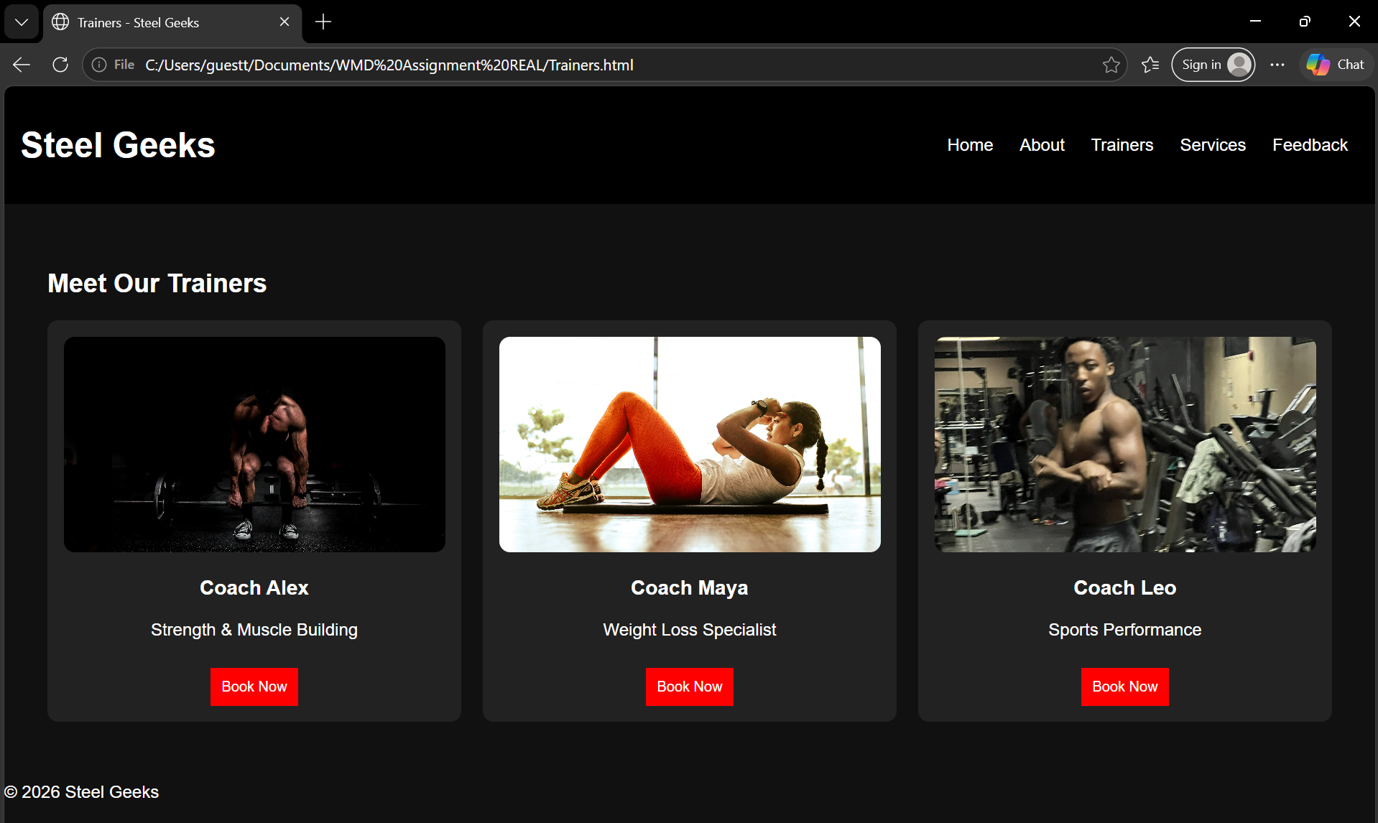
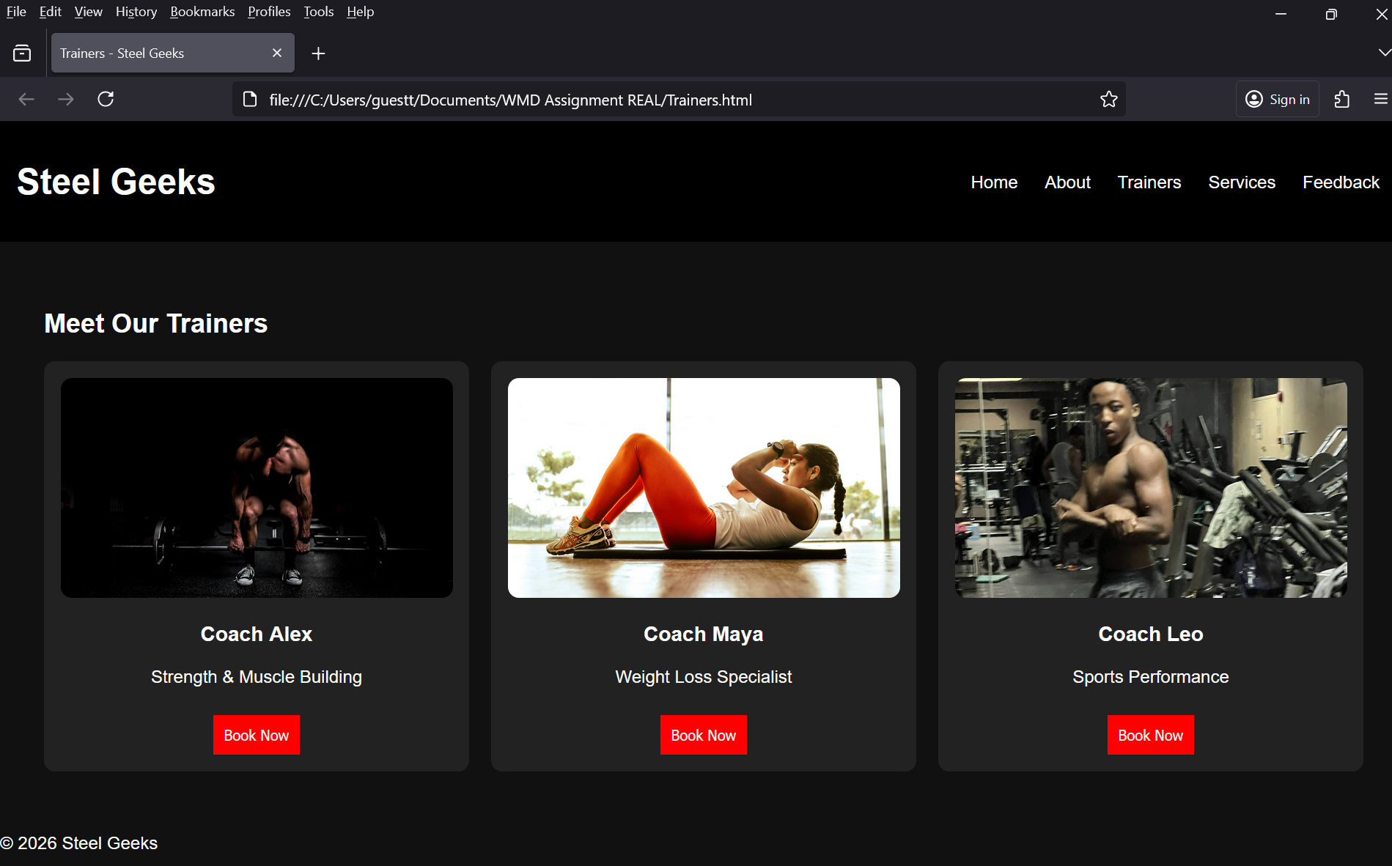

Mobile tests
