**WEB DEVELOPMENT**

**HTML**

Hyper Text Markup Language, Sir Tim Berners-Lee, 1993

We are going to learn HTML5.

**HEADING ELEMENT**

A heading element is used to write the heading.

It is represented by <h1>Content</h1>

The number inside the tag go up to 6 reducing in size i.e. 1 is the largest and 6 is the smallest heading.

NOTE: element is the whole <h1>Content</h1> thing and tag is just the <h1> (opening tag) and </h1> (closing tag)

**PARAGRAPH ELEMENT:**

A paragraph element is used to write paragraph. Two separate paragraphs have a line in between them.

It is represented by <p>this is a paragraph</p>

**HORIZONTAL RULE ELEMENT:**

A horizontal rule element is used to create a horizontal line between contents.

It is a Void element.

It can be represented by <hr /> or <hr>

It is recommended to use <hr /> over <hr>

**BREAK ELEMENT:**

A break element is used to break a paragraph from where it is used into a new line.

It is a void element.

It is represented by <br /> or <br>

It is recommended to use <br /> over <br>

**LIST ELEMENT:**

1. **UNORDERED LIST:**

It creates an unordered list (Like the list list not the one in python.)

To create an unordered list use <ul></ul> tags.

Between these another tag goes in i.e. <li></li>

Example:

<ul>

<li>Maggi</li>

<li>Paneer</li>

<li>Chicken</li>

</ul>

**OUTPUT:**

* Maggi
* Paneer
* Chicken

1. **ORDERED LIST:**

It creates an ordered list.

<ol>

<li>Maggi</li>

<li>Paneer</li>

<li>Chicken>/li>

</ol>

NOTE: creating a nested list results in indentations in the output.

NOTE: It is recommended to add indentation in your HTML code while creating list to increase the code readability.

**ANCHOR ELEMENT:**

This element helps us in creating hyperlinks (Texts that can be clicked to open another HTML file).

<a>This is another HTML file</a> #unactive hyperlink

We need to add an attribute for this element to work.

<a href = “link/location of file”>File</a> ad active Hyperlink

While executing it will look like this:

File

There are a lot more attributes that can be added to the opening tag for anchor element.

A global Attribute is an attribute that can be added to any element in HTML.

**IMAGE ELEMENT:**

This element adds an image into the website.

It takes **src** attribute for the link of the image.

<img src = “url”/>

It is a self-closing tag (Void element).

alt attribute is used to give the image a name which helps for screen readers to work on the website. (This attribute is also called alternative text description.)

**FILE PATHS:**

A file can be seen as the unique address if a file or a folder.

**1)ABSOLUTE FILE PATH:**

File path that is relative to the root folder.

Eg. C:/Projects/Bhabhi videos

**2)RELATIVE PATH:**

File path relative to the starting point where we are now.

../Maggi/Masala 🡪 .. can be used to consider a folder back as stariting point.

./Chappal/Ganda 🡪 . can be used to consider current folder as starting point.

**HTML BOILERPLATE:**

It is the structure of How an HTML file looks like.

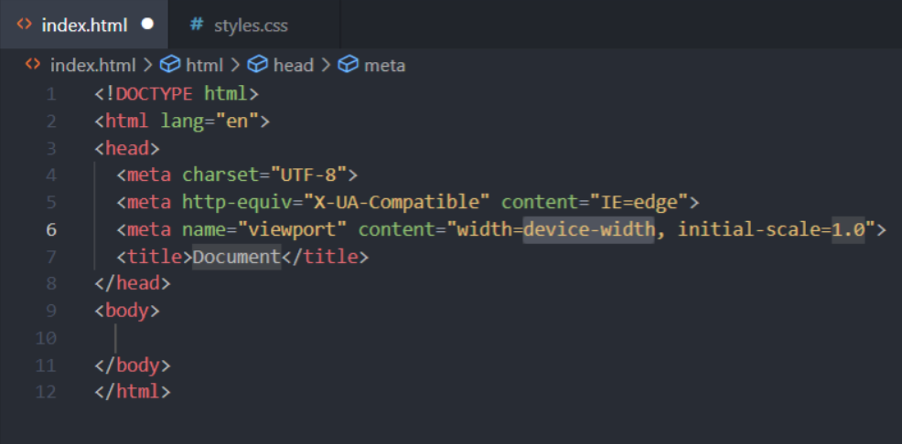

1. <!DOCTYPE html> : this line tells the browser that the file is written in html code.
2. <html lang = “en”></html> : this element contains the actual HTML content. The lang attribute tells the browser that the page is going to be in English language.
3. <head></head> : This element contains some of the important details about our website which does not gets displayed to the user. CSS also goes here
4. <meta charset = “UTF-8”> : this meta tag tells the browser that UTF-8 character set has been used.
5. <title>Title</title> : This element contains the Title to be displayed in the tab of the website.
6. <body></body> : this element contains all the content to be displayed into the website.

NOTE: The whole boiler plate can be written by typing ! and smashing enter (Not that chupapi one).

**CSS**

Cascading Style sheet,1996,Håkon Wium Lie

CSS lessgo

There are three ways to add CSS file into the HTML website

1. Inline: <tag style = “css” />
2. Internal: <style>css</style>
3. External: <link href = “style.css”/>

**INLINE**

As the name suggests in this way, we write the style to be added into the tag. Below is an example, the highlighted part is the CSS code.

**Example:**

<html style = “background: blue”>

</html>

**INTERNAL**

In this way we use a separate tag between <head></head>. This tag is <style></style>. Below is an example, the highlighted part is the CSS code

**Example:**

<html>

<head>

<style>

html{

background: red;

}

</style>

</head>

</html>

Since we are applying this CSS on the html tag we gave its name in the style tag. This is called CSS selector (element selector).

This way of adding stylesheet is best for single pages.

**EXTERNAL**

In this way we create another file with .css extension and this file contains the code element. We also have to provide the link of this stylesheet inside the head tag in the project. Below is an example.

|  |  |
| --- | --- |
| Index.html | style.css |
| <html>  <head>  <link  rel = “stylesheet”  href = “./style.css”  />  </head>  </html> | html{  background: green;  } |

rel: relationship: this refers to what is the role of the thing we are linking this to.

href: This shows where the file is located at.(directory of the stylesheet)

This way of adding stylesheet is best for multipage websites.

**CSS SELECTORS**

1. **Element Selector:** This type of selector selects an element.

**Example:**

h1{

color: blue;

}

1. **Class Selector:** Selects the class of specified name. A class can be added to a tag as an attribute. <h1 class = “red-text”>

**Example:**

.red-heading{

color: red

}

1. **ID selector:** Selects a particular id specified. An id tag can be added as an attribute. <h1 id = “main”>

Note: You cannot have more than one element with the same id in an HTML document

**Example:**

#main{

color = green

}

1. **Attribute Selector:** Selects the tag with the specified attribute.

**Example:**

p[draggable]{

color = “red”

}

This selects all the paragraph elements with draggable attached to it.

1. **Universal Selector:** This selects everything.

**Example:**

*{

color = “blue

}

**CSS Colors:**

We can specify the color type using two different ways, the first is using predefined names given to certain colors, and by specifying the hex code.

**Font Properties:**

1. Font size:

h1{

font-size: 20px;

}

1px = 1/96th inch

1pt = 1/72nd inch

1em = 100% of parent (defined as full width of letter m of parent. A parent can be considered as the tag it is enclosed in. say <h1> inside <body>)

1rem = 100% of root (defined as above but instead of parent it takes root i.e. html by default in browsers it is equivalent to 16px)

We can also use named font sizes.

1. Font weight:

h1{

font-weight: bold;

}

normal bold: keywords

lighter/bolder: Relative to Parent

number: 100-900

1. Font Family:

h1{

font-family: “Times New Roman”, sans-seriff

}

Here helvetica is a Type face.

Sans-seriff makes sure all the edges are at right angles.

We can find more fonts using google fonts and providing its link in the head under link tag.

1. Text Allign:

h1{

text-align: centre;

}

**CSS Box Model:**

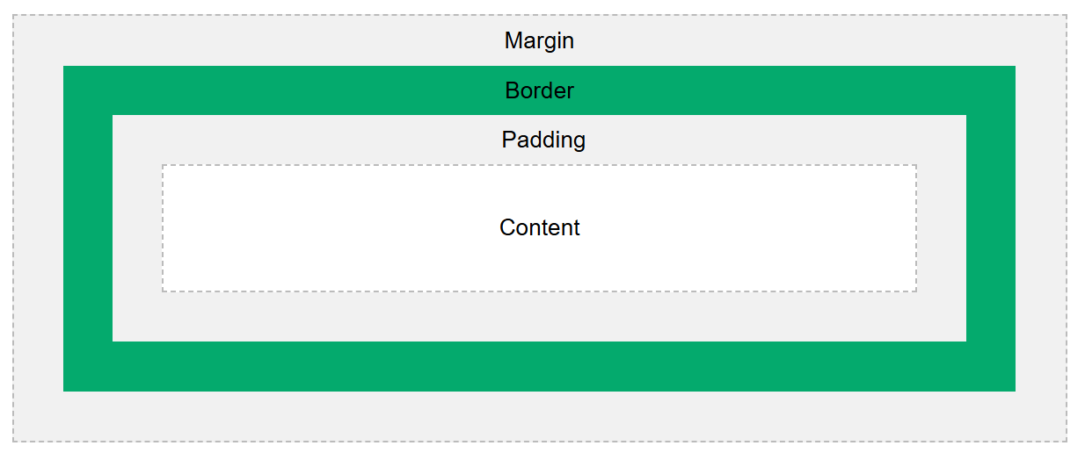

1. Border: This generates a border of specified width, style and color.

Example:

border: 10px solid black;

The border can be further modified by:

border-top: 0px (This changes the width of top border to 0px)

border-width: 0px 10px 20px 30px;

here the first is the top, right, bottom, left border.

1. Padding: this generates space between content and border.

Example:

padding: 20px;

1. Margin: This is the outside space between other content and the box.

Example:

margin: 10px;

Note: if only two values are specified into the width part

**Content Divison Element:**

This type of element is invisible while rendering. It is used to divide different piece of content and helps in managing elements by acting as an invisible box.

<div></div>

**The Cascade:**

In this we will learn about how the cascade works in CSS.

1. Position:

li{

color:red;

color: blue;

}

The color blue will be applied as it is after red. Li first becomes red then blue.

1. Specificity:

li {color: blue;}

.first-class {color: red;}

li[draggable] {color: purple;}

#first-id {color: orange;}

The importance goes from top to down. Here id is of the highest priority so the color is orange.

1. Type:

External 🡪 Internal 🡪 Inline

The increase in above order.

1. Importance:

color: red;

color: green !important;

we use !important to set the priority as high.