Self-Dispensing Hand Sanitizer

Abstract:

To make a contact-less self-dispensing sanitizer using an IR sensor. The IR sensor detects if a person places a hand below and activates the solenoid valve. The sensor keeps the valve open for a span of 3 seconds (can be set accordingly) to avoid overflow of the sanitizer liquid. It checks to see if the sensor is on every 3 seconds before opening again.

Components Used:

* IR sensor Module
* Arduino Nano
* Solenoid Valve
* 5v-12v DC converter
* 5v Relay module

Circuit:

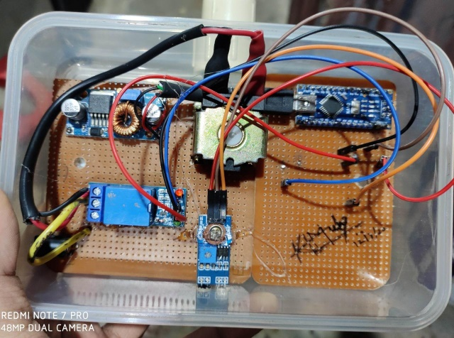

Working:

The Arduino detects the Input signal received from the IR sensor and sends an input to the relay. The relay switches to ON and the solenoid valve receives an ON signal. A sanitizer liquid container can be attached to the solenoid valve above. The dc converter adjusts the voltage accordingly, 12v for the solenoid and 5v for Arduino Nano to work. The code in Arduino has been written such that the sensor checks for a hand every 3 seconds, i.e. every 3 seconds the solenoid valve shuts off to prevent overflow of liquid and waits for a signal from the IR sensor.

Kartikeya H Mulay  
18BD1A1025

2nd Year EIE

KMIT, Hyderabad.