Laravel 5.2

Membuat API & Aplikasi Web dengan Laravel

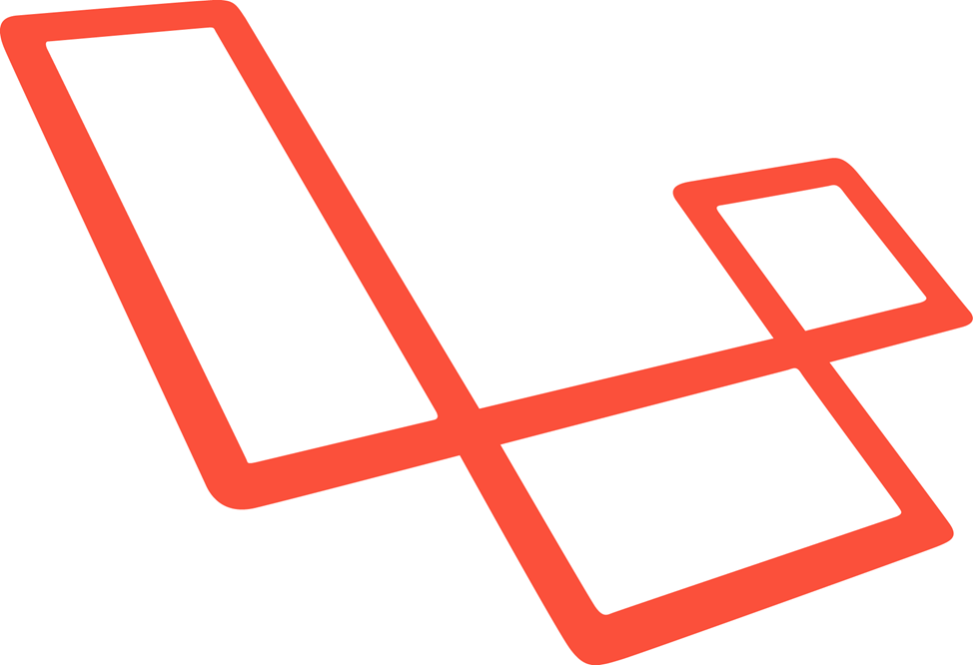

Lamhot JM Siagian

# Daftar Isi

1 Daftar Isi 1

3 Kata Pengantar 3

4 Pendahuluan 4

5 Instalasi 5

5.1 XAPPP 5

5.2 Homestead 5

6 Struktur 6

6.1 Struktur Direktori Root 6

6.2 Struktur Direktori Aplikasi 6

7 Routing 7

8 Respon 8

9 Debugging 9

10 Authentication 10

11 Pagination 11

12 API Version 12

13 Filter 13

14 Controller 14

15 Blade 15

16 Request Data 16

17 Form 17

18 Validation 18

19 Database 19

19.1 Seeding 19

20 Schema Builder 20

21 Migration 21

22 Eloquent ORM 22

23 Eloquent ORM 23

24 Eloquent Queries 24

25 Eloquent Queries 25

26 Eloquent Collections 26

27 Eloquent Relationships 27

28 Testing 28

29 Membuat API & Tips 29

29.1 Introduction 29

29.2 Sample Code 29

29.3 Useful Database Seeding 29

29.4 Planning and Creating Endpoints 29

29.5 Input and Output Theory 29

29.6 Status Code, Errors and Message 29

29.7 Endpoints Testing 29

29.8 Output Data 29

29.9 Data Relationship 29

29.10 Debugging 29

29.11 Authentication 29

29.12 Pagination 29

29.13 Documentation 29

29.14 API Versioning 29

30 Aplikasi CRUD 30

# Kata Pengantar

# Pendahuluan

# Instalasi

Ada banyak cara untuk menginstal Laravel. Kita dapat menginstal laraveL langsung pada mesin utama , atau kita dapat menggunakan *server bundle* seperti MAMP , XAMPP , dll. Dalam buku ini, akan dibahas mengenai installasi laravel pada Homestead dan XAMPP.

## XAPPP

## Homestead

# Struktur

## Struktur Direktori Root

## Struktur Direktori Aplikasi

# Routing

# Respon

# Debugging

# Authentication

# Pagination

# API Version

# Filter

# Controller

# Blade

# Request Data

# Form

# Validation

# Database

## Seeding

# Schema Builder

# Migration

# Eloquent ORM

# Eloquent ORM

# Eloquent Queries

# Eloquent Queries

# Eloquent Collections

# Eloquent Relationships

# Testing

# Membuat API & Tips

## Introduction

## Sample Code

## Useful Database Seeding

## Planning and Creating Endpoints

## Input and Output Theory

## Status Code, Errors and Message

## Endpoints Testing

## Output Data

## Data Relationship

## Debugging

## Authentication

## Pagination

## Documentation

## API Versioning

# Aplikasi CRUD