1. **Sign In Page / Landing Page:** After Sign In, you will be automatically redirected to Appointments page

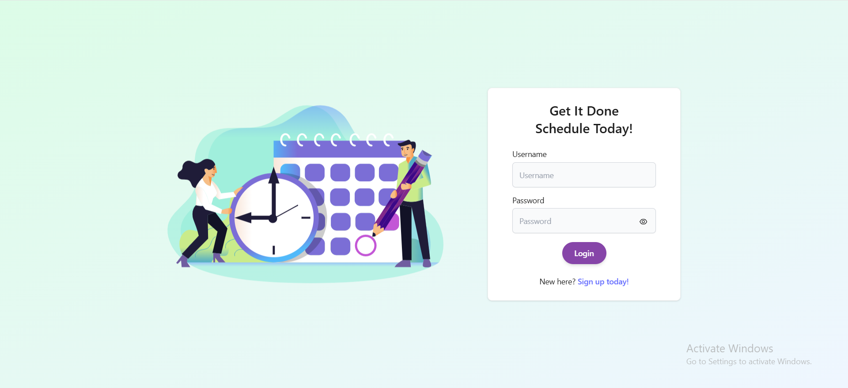

1. **Sign Up Page:** After Sign Up, you will be automatically redicted to Sign In page

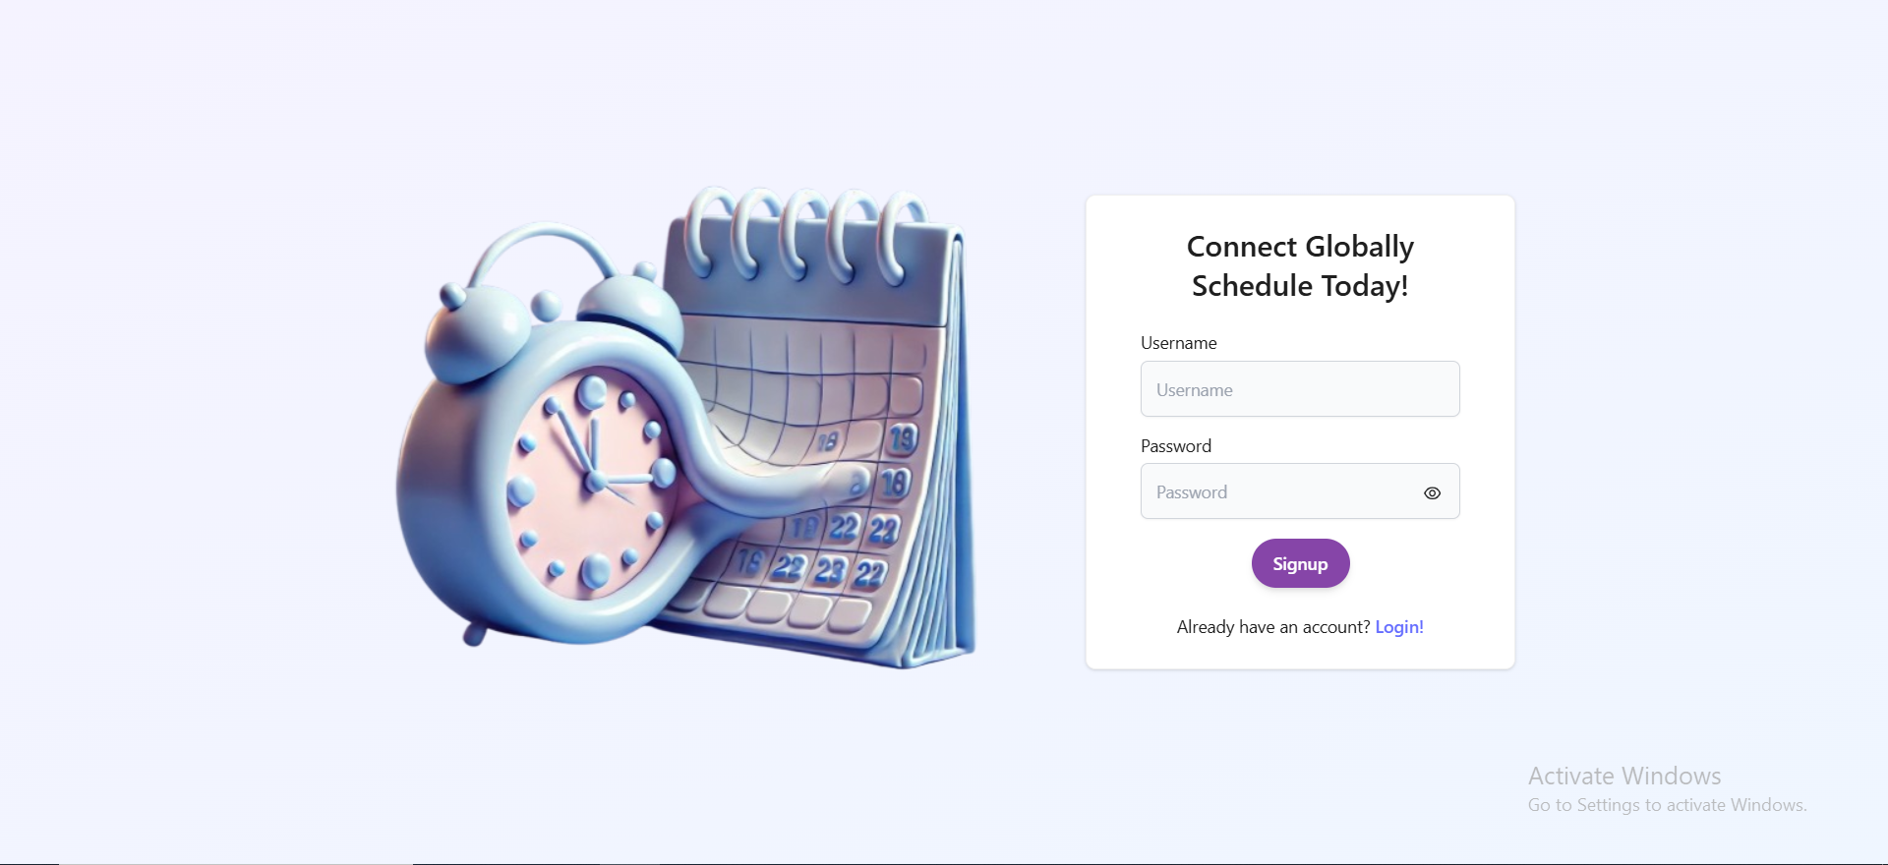

1. **Appointment Page (Create Appointment Tab):** User can create appointment from this page

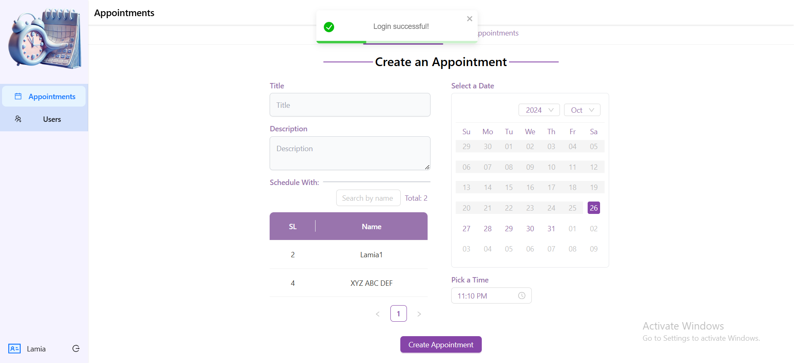

1. **Appointment Page (See Appointments Tab):** User can filter, search, cancel, accept, decline and edit an appointment based upon access.

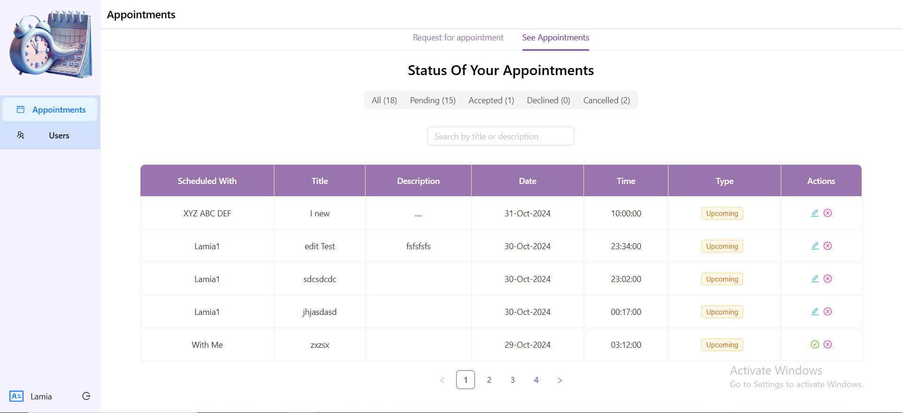

1. **User List:** A very simple users page where one user can easily find other users  
     
   