How the clinical reference and the method pool determine synthetic benchmark validity in medical image segmentation

1. Introduction
Rankings of segmentation algorithms are not stable. Maier-Hein and colleagues analysed 150 biomedical image analysis challenges in Nature Communications in 2018 and showed that an algorithm's rank moves with the test cases used, with the ranking scheme, with the annotators, and with how per-case scores are aggregated. Metrics Reloaded, in Nature Methods in 2024, subsequently gave the field a framework for choosing metrics appropriate to a problem.
That work establishes that rankings are fragile and names the sources. It does not answer the question a practitioner actually faces, which is what one would have to measure about a benchmark in order to know how far to trust it. This study asks that question for synthetic benchmarks in medical image segmentation, and reports that the answer has three parts rather than one.
The first part is the clinical reference. We show that the agreement between two clinical datasets about which method is better is not a fixed quantity. It falls from +0.944 between two disjoint halves of one dataset, to +0.563 on average between different datasets of the same modality, to no detectable agreement between modalities. Because the within-dataset value establishes that the measurement reproduces itself, the decline is genuine disagreement between references rather than noise. Any claim of the form "this benchmark agrees with clinical data at rho = x" is therefore incomplete until it says which clinical data.
The second part is the method pool, and this is the result we did not expect. The same synthetic benchmark, scored against the same clinical references, reaches 98 percent of the clinical-to-clinical ceiling when validity is assessed over a pool of 21 classical algorithms and one small network, and 49 percent of it when eleven modern architectures are added. A benchmark that appears nearly perfect for choosing between thresholding methods is roughly half as good at ordering the methods a practitioner would deploy. We also show that in a pool mixing trained and untrained methods, a cross-domain rank comparison measures which methods had domain-matched training rather than anything about the data, and that this can invert the sign of the reported correlation.
The third part is the benchmark data itself, and here the result is negative in a way we think is useful. We built a measurable background-texture statistic as a candidate design specification, calibrated it against clinical images, and tested it by constructing benchmarks from three generator families matched on it. Benchmarks matched to within 0.03 on that statistic differ by 0.115 in validity. The spread between generator families at a fixed value of the statistic is as large as the entire within-family effect of the statistic. The reduction fails.
Within a single modality, one property of the reference does predict the direction of its bias. The fraction of the frame occupied by the lesion determines whether a reference rewards high or low lesion-to-surround contrast, monotonically, and the relationship holds across four generator seeds, under both an overlap metric and a boundary metric, and over the enlarged method pool. A clinical dataset that took no part in constructing the relationship falls on it with the correct sign. We report the relationship and explicitly decline to report its crossover point as a portable constant, because that point moves with the pool, the reference and the metric.

1.1 Contributions
1. A measured hierarchy of rank agreement between clinical references, from within-dataset to across-modality, anchored by a within-dataset control that makes the decline interpretable.
2. Evidence that benchmark validity depends on the method pool it is assessed over, with the size of the effect quantified.
3. A demonstration that cross-domain rank comparison in a mixed pool measures training-domain match, with a case in which this inverts the sign of the reported correlation.
4. A tested and failed reduction of benchmark validity to a single measured image statistic, with the residual quantified across three generator families.
5. A within-modality relationship between a reference's lesion fraction and the direction of its design preference, confirmed across seeds, metrics and pool composition.

2. Methodology

2.1 Method pool
Thirty-two segmentation methods in eight families. Every method runs through one interface with one post-processing step, so no part of the ranking reflects differences in how outputs were cleaned up.
Table 1. Composition of the 32-method pool.
Family | n | Members
Background-referenced | 5 | adaptive Gaussian, adaptive mean, Otsu on grey, BGR and HSV corner distance
Colour-referenced | 4 | Otsu on a*, 92nd percentile of a*, redness ratio, Otsu on saturation
Clustering | 4 | k-means in Lab at k = 3, 4, 5; mean shift with Otsu on a*
Region and contour | 5 | watershed, GrabCut, flood fill, Chan-Vese, Canny with fill
Pixel classifiers | 3 | logistic regression (all and colour-only), gradient boosting
Small CNN | 1 | three-level U-Net, 117,681 parameters
Deep encoder-decoder | 5 | U-Net, U-Net++, LinkNet on ResNet-18; U-Net on MobileNetV2 and EfficientNet-B0
Deep other | 5 | DeepLabV3+, PSPNet, FPN, MAnet on ResNet-18; SegFormer on MiT-B0
Twenty-one of the methods are classical algorithms with no learned parameters. They span a wide range of segmentation principles at a wide range of performance, which gives the rank correlations something to order, and being untrained they carry no dependence on any dataset.
Eleven methods are trained. Three pixel classifiers are fitted on 264,292 pixels sampled from 250 FUSeg training images, balanced between lesion and non-lesion. The remaining eight architectures, plus the small U-Net, are trained on 393 FUSeg training images at 128 by 128 pixels. The ten modern architectures were chosen to vary along the two axes that modern segmentation varies along: seven decoders sharing one encoder, and three alternative encoders including a transformer.
No pretrained weights are used anywhere in this study. Every architecture is randomly initialised, so no method enters the pool carrying knowledge of an external dataset and the pool is not confounded by differences in pretraining corpora. All ten see identical data under an identical protocol, copied from the small U-Net so that new and old methods are comparable: Dice plus binary cross-entropy, Adam, horizontal flip augmentation, batch size 8, 30 epochs. The single deliberate difference is a learning rate of 1e-3 rather than 3e-3, because 3e-3 with Adam is not stable for models of 14 to 22 million parameters.
Decision thresholds are swept per model on FUSeg training images 400 to 550, a slice disjoint from the 393 used for training and from every evaluation split. Held-out Dice at the selected threshold ranges from 0.507 to 0.641, so the pool has genuine spread rather than ten near-identical models.

2.2 Clinical reference sets
Table 2. The five clinical reference sets, from three independent sources.
Reference | n scored | Modality | Median lesion fraction
Medetec | 152 | Wound photography | 0.102
FUSeg validation | 120 | Wound photography | 0.011
AZH test | 150 | Wound photography | 0.029
AZH train slice | 150 | Wound photography | 0.026
Kvasir-SEG | 120 | Colonoscopy | 0.106
Kvasir-SEG sessile | 120 | Colonoscopy | 0.043
The AZH train slice is a disjoint 150-image slice of the same dataset as AZH test and exists solely as a within-dataset control. FUSeg and AZH come from the same clinic, since the Foot Ulcer Segmentation Challenge was built from AZH Wound and Vascular Center data. Template matching 25 AZH patches against all 1,010 FUSeg frames at six scales gives a maximum normalised cross-correlation of 0.927 with no exact matches, so they are distinct images under different curation conventions rather than re-crops of one another. We treat them as one source throughout. Kvasir-SEG and its sessile subset likewise share a source.
Mask conventions differ and the difference matters. Medetec masks are 0/1 and FUSeg masks 0/255, so wound masks are binarised on any non-zero value; a fixed mid-range threshold silently empties the Medetec masks and produces a Dice of exactly zero for every method. Kvasir masks are JPEG-compressed and carry anti-aliased edge values, so binarising on any non-zero value inflates every lesion; Kvasir is thresholded at 127.

2.3 Synthetic benchmarks
Three generator families, built on different principles, each producing images with ground-truth masks and exposing its design properties as explicit parameters. Parametric generators are used rather than a learned generative model because the ablation and dose-response experiments require individual design properties to be switched off and swept independently, and a diffusion model does not offer those controls.
Generator A places a lesion on a uniform drape background and has no background texture parameter. Generator B renders textured skin with a shared luminance mottling field, a clinically calibrated tissue palette and clutter such as hair and gauze; its texture amplitude is the swept parameter. Generator C shares no code path with generator B and differs in every mechanism: spectral-filtered noise rather than upsampled Gaussian mottling, a radial vignette rather than a linear ramp, distance-field alpha blending rather than filled polygons, and a CIELAB Gaussian mixture rather than an HSV offset from skin tone.
We describe these as constructed on different principles rather than as independently constructed. They were written by the same author and share whatever unstated assumptions we hold about what a wound photograph looks like. Generator C exists specifically to break the shared-implementation assumption.
The background texture statistic is the median local standard deviation of shading-corrected luminance in a 9-pixel window, measured over background pixels only. Every image is resampled to a canonical 512 pixels before measurement. This is not cosmetic: measured natively, Medetec at 224 pixels reads 5.07 and FUSeg at 512 pixels reads 3.88, while resampled to a common 512 they read 2.69 and 3.88, which reverses their order. A statistic whose ordering of two datasets depends on the resolution they happen to be distributed at is not a property of the images.

2.4 Statistical protocol
Agreement is the Spearman rank correlation between two vectors of per-method mean Dice over the same method pool, with two-sided permutation p-values at 20,000 permutations and confidence intervals by bootstrap over methods at 5,000 resamples. At n = 32 methods a Spearman requires approximately |rho| of 0.35 to reach p < 0.05; at n = 22 the requirement is 0.43. Where we report an absence of agreement we state it as an absence of detectable agreement at this sample size.
Every relationship claimed in this paper is computed twice: with Dice, and with normalised surface Dice at a 2-pixel tolerance. The second is included because Dice carries a region-size bias and the framing experiment varies region size, so the two would otherwise be confounded by construction. Both metrics treat two empty masks as perfect agreement.
Every synthetic benchmark used in a reported relationship is built at four generator seeds and the relationship is computed independently for each. Single-seed results overturned two conclusions during this work and are not reported as findings anywhere in this paper.
A reference's preference over a design property is the slope of its rank agreement against the measured value of that property, fitted by ordinary least squares over the sweep and expressed per 10 units. An earlier version of this work used the Spearman correlation of agreement against the property instead. That statistic saturates: once the underlying relationship is monotone it returns exactly +1 or -1 regardless of magnitude, and at n = 32 it returned exactly +1.000 for five of eight conditions where the underlying agreements ranged from -0.33 to +0.36. The slope is continuous and does not saturate.

3. Results

3.1 Rank agreement falls in steps, and the decline is real
Table 3. Pairwise rank agreement between clinical references over the 32-method pool.
Pair | rho | p | 95% CI | Relationship
Kvasir vs Kvasir-sessile | +0.952 | <0.0001 | [+0.871, +0.982] | Same source
AZH test vs AZH train | +0.944 | <0.0001 | [+0.835, +0.984] | Same dataset
FUSeg vs AZH | +0.660 | 0.0001 | [+0.430, +0.804] | Same modality
Medetec vs AZH | +0.568 | 0.0012 | [+0.256, +0.781] | Same modality
Medetec vs FUSeg | +0.461 | 0.0081 | [+0.085, +0.758] | Same modality
Medetec vs Kvasir | +0.019 | 0.9172 | [-0.318, +0.360] | Across modality
Medetec vs Kvasir-sessile | -0.042 | 0.8185 | [-0.397, +0.338] | Across modality
AZH vs Kvasir | -0.191 | 0.2991 | [-0.506, +0.164] | Across modality
AZH vs Kvasir-sessile | -0.277 | 0.1289 | [-0.579, +0.081] | Across modality
FUSeg vs Kvasir | -0.477 | 0.0065 | [-0.706, -0.152] | Across modality
FUSeg vs Kvasir-sessile | -0.552 | 0.0011 | [-0.741, -0.224] | Across modality
The within-dataset control is what makes this interpretable. Splitting one dataset into two disjoint 150-image halves and scoring each independently gives +0.944. The measurement therefore reproduces itself at 0.94, and the drop to 0.56 between different datasets of the same modality is genuine disagreement between references rather than sampling noise. All three same-modality pairs are significant with confidence intervals excluding zero; over the earlier 22-method pool the weakest of them sat at p = 0.0385 with an interval touching zero, so the enlarged pool strengthened this structure rather than weakening it.
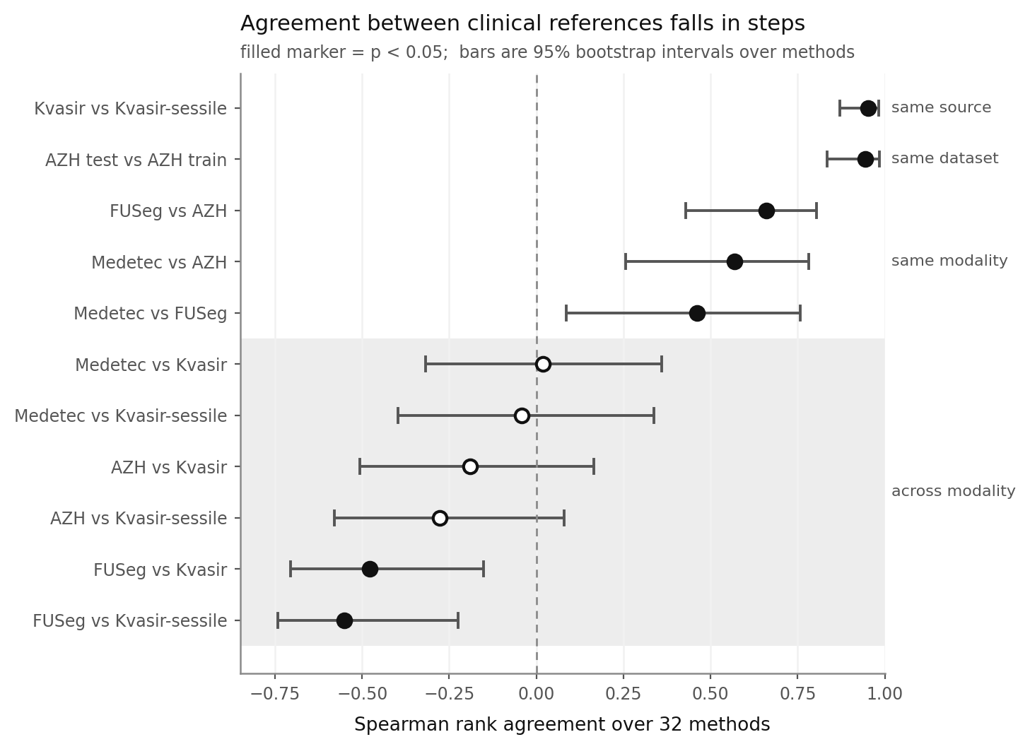
Figure 1. Pairwise rank agreement between clinical references, ordered by relationship, with 95 percent bootstrap intervals over methods. Filled markers are significant at p < 0.05. The shaded band marks across-modality pairs.

3.2 The apparent cross-modality inversion is a composition artifact
The pooled across-modality mean of -0.253 invites the reading that methods good at wound segmentation are worse than chance at colonoscopy. That reading is wrong, and the way it fails is itself a result.
Table 4. Mean agreement by method subset. The negative value exists only in the mixed pool.
Subset | Same modality | Across modality
All 32 methods | +0.563 | -0.253
22 classical and pixel-classifier methods | +0.511 | +0.108
10 modern architectures | +0.321 | +0.236
Table 5. Mean Dice by subset on each reference. The two groups exchange places between modalities.
Reference | 10 deep | 22 others | Gap
Medetec | 0.374 | 0.295 | +0.079
FUSeg | 0.581 | 0.132 | +0.449
AZH | 0.396 | 0.330 | +0.066
Kvasir | 0.062 | 0.200 | -0.138
Kvasir-sessile | 0.024 | 0.114 | -0.091
The deep models were trained on wound photography. They beat the untrained methods on all three wound references and collapse below them on both endoscopy references. Two groups exchanging places between domains produces a negative pooled rank correlation without any individual pair of methods inverting.
Two claims follow. First, within a homogeneous method pool there is no detectable cross-modality rank agreement: +0.108 and +0.236, neither significant, at a detection limit of 0.35. Second, and this is the transferable warning, in a pool mixing trained and untrained methods a cross-domain rank comparison measures which methods had domain-matched training. Its sign is set by pool composition. A practitioner comparing benchmarks across domains with such a pool will measure this artifact and can readily mistake it for a property of the data.
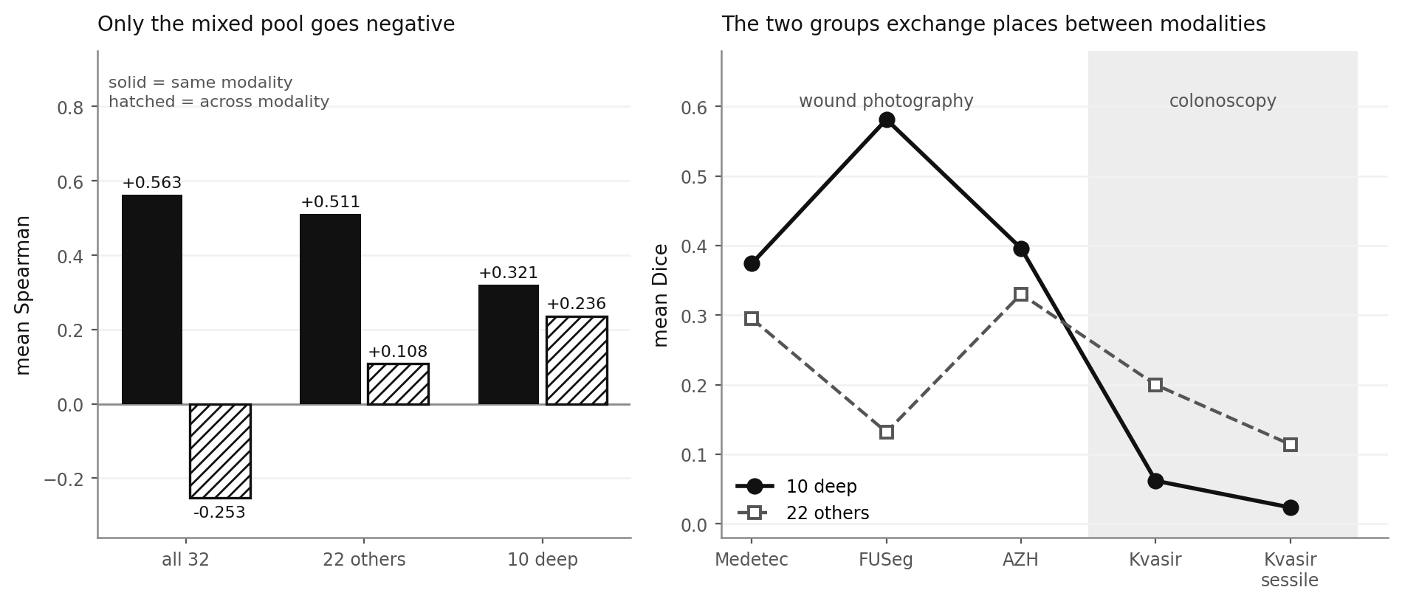
Figure 2. Left: mean agreement within and across modality for the full pool and for each subset; only the mixed pool goes negative. Right: mean Dice of each subset on the five references, showing the exchange of places between modalities.

3.3 Benchmark validity depends on the method pool
The clinical-to-clinical ceiling, measured on the two references no method was trained on, is Medetec against AZH at +0.568 (p = 0.0012). Generator B against those same references, over the 32-method pool:
Table 6. Generator B against the neutral clinical references, 32-method pool.
Texture amplitude | Measured texture | vs Medetec | vs AZH | Mean | % of ceiling
11 | 3.45 | +0.234 | +0.058 | +0.146 | 26%
28 | 4.30 | +0.366 | +0.157 | +0.261 | 46%
40 | 5.07 | +0.360 | +0.194 | +0.277 | 49%
Over the earlier 22-method pool, and against Medetec and FUSeg, the best configuration of the same generator reached 98 percent of the then-measured ceiling. Two changes account for the gap and both matter. FUSeg is excluded here because eleven methods were trained on its training split. And the pool now contains modern architectures whose relative ordering the synthetic benchmark does not reproduce.
A synthetic benchmark that appears to reach the clinical ceiling when assessed over classical methods reaches about half of it once the methods people deploy are in the pool. This is the most practically consequential result in the study. It says that validity figures for synthetic benchmarks are not portable across method pools, and that assessing validity over convenient classical baselines will overstate it. The texture dose-response itself survives the pool change: agreement rises monotonically with background texture, which is the direction reported over the smaller pool.
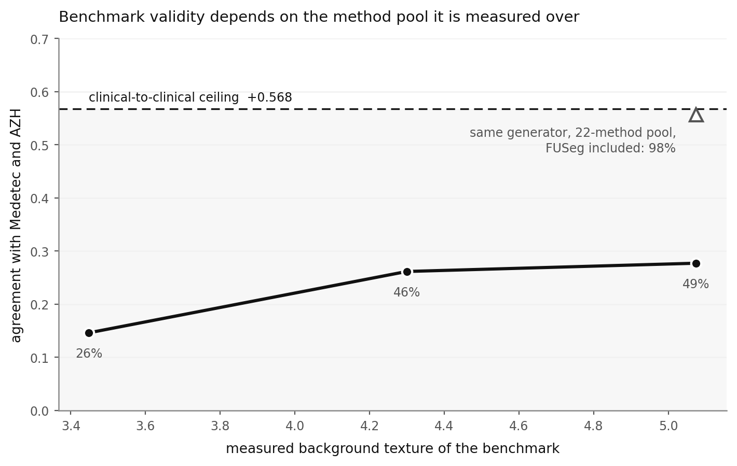
Figure 3. Generator B agreement with the neutral references as a function of measured background texture, against the clinical-to-clinical ceiling. The open triangle marks the same generator assessed over the 22-method pool with FUSeg included.

3.4 Within one modality, lesion fraction predicts the direction of bias
The primary curve is built from AZH, the wound reference no method was trained on. AZH frames were cropped around their own lesions to seven target lesion fractions. Every crop uses the same 140 frames and the same annotations, so lesion fraction is the only thing that differs between the seven references.
Table 7. Contrast verdict against reference lesion fraction, AZH crops, four seeds.
Lesion fraction | Verdict, Dice | sd | Verdict, NSD | sd
0.0353 | +0.077 | 0.006 | +0.080 | 0.005
0.0550 | +0.029 | 0.009 | +0.061 | 0.005
0.0801 | -0.002 | 0.010 | +0.038 | 0.005
0.1101 | -0.037 | 0.009 | +0.004 | 0.005
0.1598 | -0.060 | 0.008 | -0.041 | 0.005
0.2194 | -0.078 | 0.007 | -0.056 | 0.006
0.2981 | -0.086 | 0.007 | -0.079 | 0.007
Monotonicity against lesion fraction is Spearman -1.000 at p = 0.0005 in every one of the four seeds, under both metrics. Eight of eight seed and metric combinations are perfectly monotonic, and the seed standard deviation never exceeds 0.010 against a curve range of 0.163. The boundary metric is the load-bearing control here: Dice is biased by region size and this experiment varies region size, so a Dice-only result would be confounded by construction. The same construction on FUSeg crops gives monotonicity between -0.881 and -1.000, and is reported as a replication rather than as the primary result because eleven of the 32 methods were trained on FUSeg training images. Removing that contamination sharpened the relationship.
The crossover between rewarding high and low contrast sits between lesion fraction 0.110 and 0.160 in three of the four curve and metric combinations, and between 0.055 and 0.080 for the AZH curve under Dice. It moves with the reference, with the metric and with the method pool. The direction of the relationship moves with none of them, and we report the crossover as an interval observed under stated conditions rather than as a threshold for others to apply.
Medetec, at lesion fraction 0.1024 and taking no part in the construction, is predicted at -0.028 and measures +0.038 under Dice, and is predicted at +0.013 and measures +0.056 under normalised surface Dice. The residuals are 41 and 27 percent of the curve range. Across two independently built curves and three held-out datasets, every real clinical dataset lands above the curve at its own lesion fraction, four placements in one direction. The mechanism is visible: a crop taken to reach lesion fraction f is not the same object as a dataset natively framed at f, because cropping discards the surrounding limb and background that a natively framed dataset retains. Crop series therefore overstate the framing effect. The construction establishes direction and ordering, which is what is claimed, and is not a calibrated predictor.
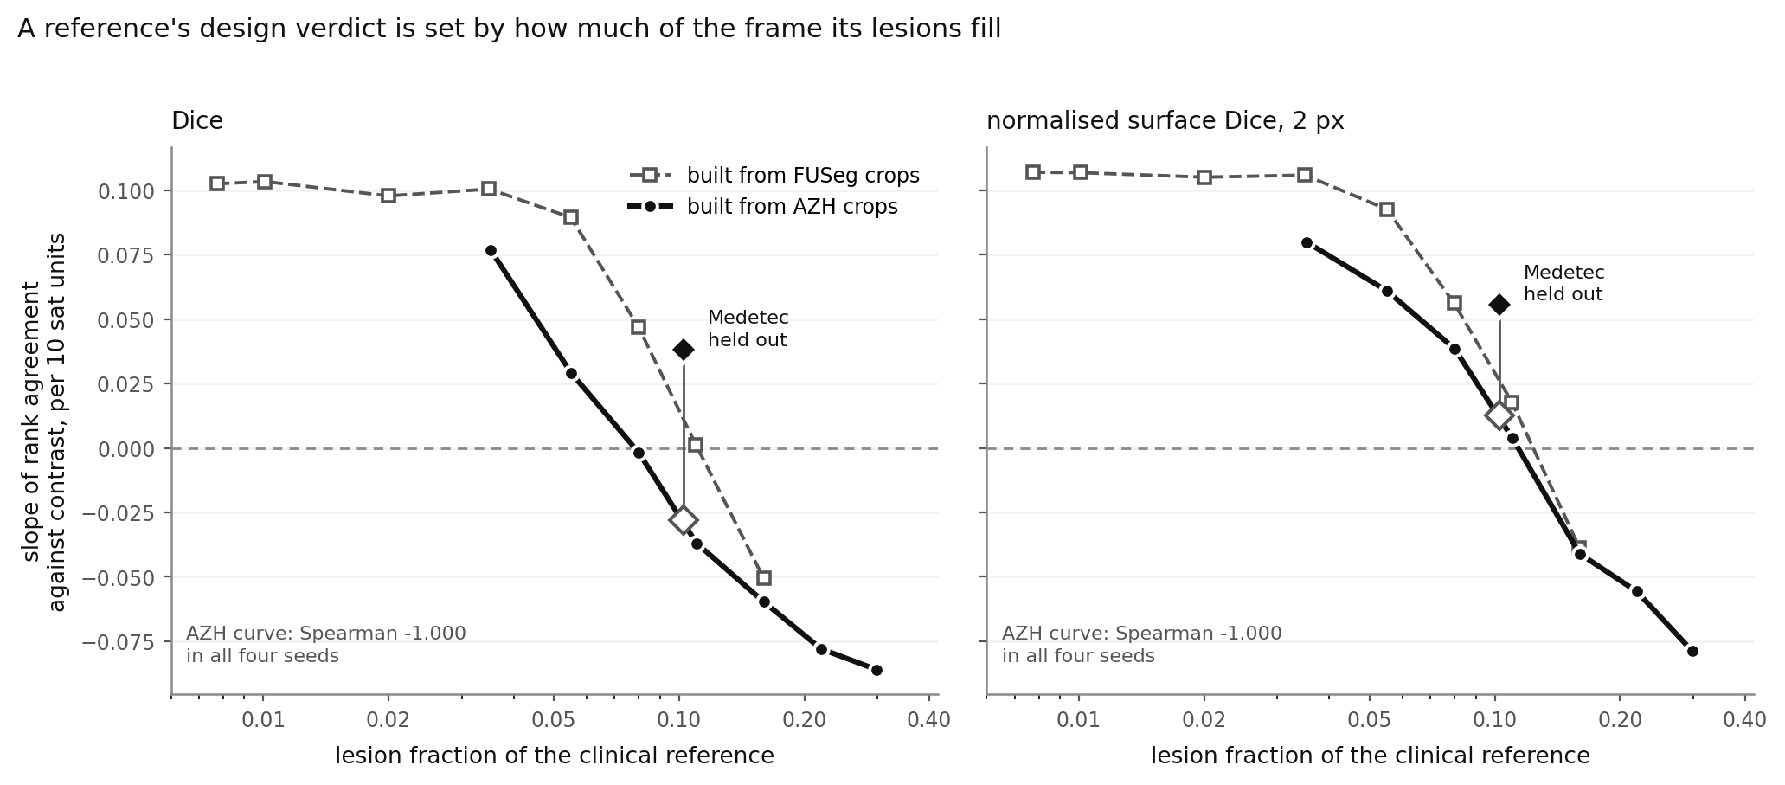
Figure 4. Contrast verdict against reference lesion fraction, on a log axis, for the AZH-built curve and the FUSeg-built replication, under both metrics. Medetec is overlaid as open predicted and filled measured markers joined by a residual stem.

3.5 Validity is not reducible to the measured texture statistic
If benchmark validity were a function of the background texture statistic, two benchmarks matched on it would agree.
Table 8. Four benchmarks spanning three generator families, against the neutral references.
Benchmark | Measured texture | vs Medetec | vs AZH | Mean
Generator A, uniform drape | 2.10 | -0.045 | -0.261 | -0.153
Generator C, no noise | 2.34 | +0.116 | -0.102 | +0.007
Generator C, noise 3.4 | 3.20 | +0.132 | -0.097 | +0.017
Generator B, texture ablated | 3.23 | +0.201 | +0.063 | +0.132
Two matched pairs. Generator C at 3.20 and generator B at 3.23 are matched to within 0.03 on the statistic and differ by 0.115 in validity. Generator A at 2.10 and generator C at 2.34 are matched to within 0.24 and differ by 0.160. For scale, the entire effect of sweeping texture within generator B across its clinical range is 0.131. The spread between generator families at a fixed value of the statistic is as large as the whole within-family effect of the statistic. The statistic captures something real, since texture predicts validity within a family, but it is not a specification a benchmark designer could target.
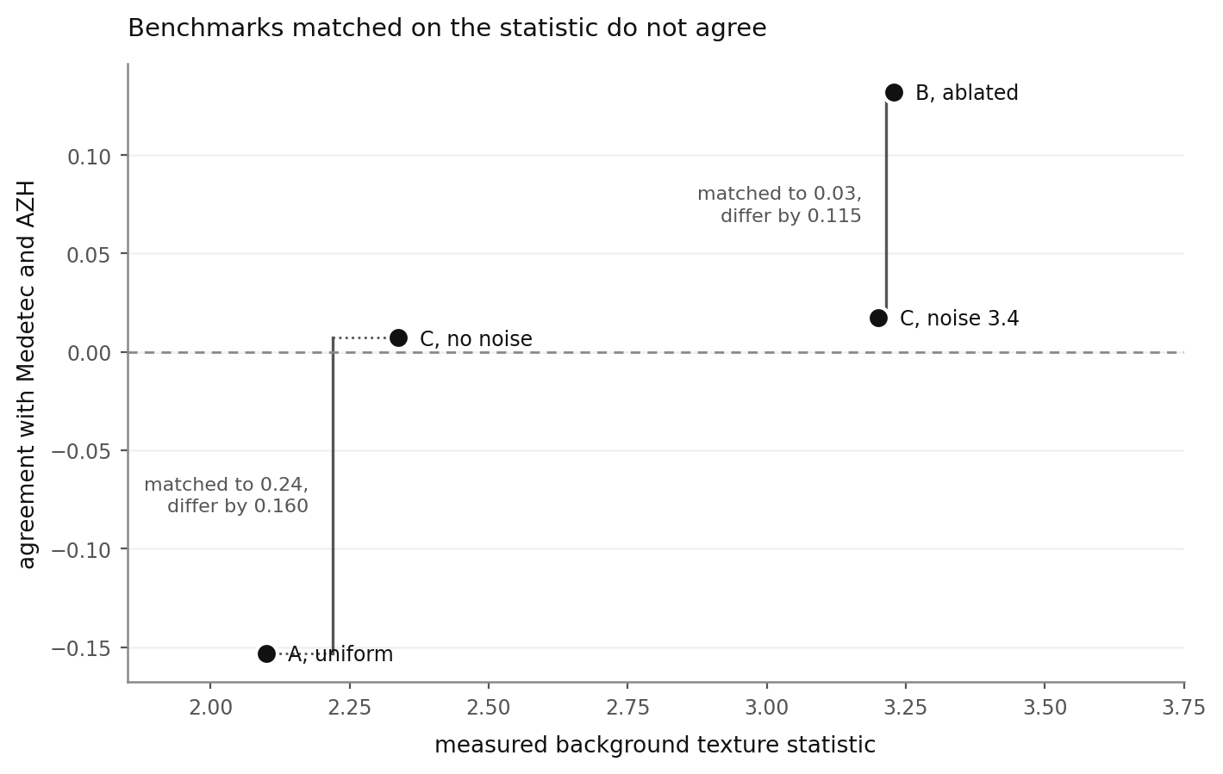
Figure 5. Validity against measured background texture for four benchmarks from three generator families. The two bracketed pairs are matched on the statistic and still disagree.

3.6 Cross-modality verdicts are not interpretable
Kvasir-SEG's median lesion fraction is 0.106, close to Medetec's 0.102, so the framing curve makes a prediction for it. Placed on the wound-built curve, Kvasir's residual was 0.040 and the sessile subset's was 1.607 on a 1.93 scale: one apparent bullseye and one of the largest misses the scale allows. Neither is meaningful. The underlying agreements between the synthetic wound benchmarks and the endoscopy references run from -0.19 to +0.13 with p-values from 0.39 to 0.96, so the verdict is a trend fitted through values not distinguishable from zero. This is a direct consequence of Section 3.1: a verdict about which synthetic design a reference prefers exists only where the benchmark and the reference agree about method ranking at all. The framing result is scoped to within-modality use for this reason, and not by assumption.

4. Discussion

4.1 What a validity figure means
The common form of a synthetic-benchmark validity claim is a single number: this benchmark agrees with clinical data at rho = x. This study shows that number is underspecified in three ways at once, and gives the size of each.
It depends on which clinical reference. Two datasets of the same modality agree with each other at 0.46 to 0.66, against 0.94 for two halves of one dataset. Quoting agreement against one reference tells the reader roughly half of what they need. It depends on the method pool: the same generator against the same references reaches 98 percent of ceiling over a mostly classical pool and 49 percent over a pool including modern architectures, which is the largest of the three dependences and the least discussed in the literature. And it does not depend on any single measured property of the benchmark images in a way that could be turned into a design specification, at least not for the most natural candidate.
The practical recommendation is narrow and we think defensible. Report benchmark agreement as a matrix over references rather than as a scalar, report the method pool it was computed over, and include a within-dataset control so a reader can tell how much of any decline is measurement noise. That control costs one extra scoring run on a disjoint slice and is what makes every other number in this study interpretable.

4.2 Why the method-pool dependence is not obvious
It would be reasonable to expect a benchmark that orders twenty-two methods correctly to order thirty-two correctly, since the added methods are simply more points on the same scale. That is not what happens, for a reason visible in Section 3.2: the added methods are not more of the same. They are trained and the others are not, and a benchmark's ability to reproduce the ordering within each group is not the same as its ability to reproduce the ordering between them.
This generalises beyond the present setting. Any evaluation that mixes trained and untrained methods, or methods trained on different corpora, is partly measuring training-domain match. Where the comparison crosses domains, Section 3.2 shows this can dominate to the point of flipping the sign of the reported correlation. Pretrained foundation models make this more pressing rather than less, since their training corpora are large, opaque and unequal across methods.

4.3 The framing result and what it is for
Within a modality, one measurable property of a reference predicts the direction of its design preference. A reference whose lesions fill little of the frame rewards high lesion-to-surround contrast; one whose lesions fill a lot rewards low contrast.
The use is diagnostic rather than prescriptive. A researcher who concludes from one clinical reference that a particular synthetic design property is realistic can check whether that conclusion would survive a reference framed differently, and the direction of the change is predictable from a quantity anyone can compute in one line. That is a check on a conclusion, not a recipe for building a benchmark.
It is also worth stating the contrast with domain randomization, because a reader's prior will be that literature. For training transfer, the established advice is to maximise variation, randomising textures, lighting and placement well beyond realism. Our validation results point the other way: within a generator family, agreement rises monotonically with background texture towards the clinical range. The two are not in conflict, they are different objectives. A benchmark exists to order methods as the deployment distribution would, so it should resemble that distribution. A training set exists to produce a method robust to distributions it has not seen, so it should exceed it. Section 3.2 gives an unusually clean illustration, in which models trained on one narrow domain reach 0.58 mean Dice on it and 0.02 to 0.06 on another.

4.4 Limitations
Five reference sets from three independent sources, and one of those sources supplies both endoscopy references, so every cross-modality conclusion rests on a single endoscopy collection. A second, independent endoscopy source would materially strengthen Sections 3.1 and 3.2 and is the most valuable single addition to this study.
Both modalities are colour photography of surface tissue under illumination. Nothing here establishes behaviour for volumetric modalities such as CT or MRI, where background texture and lesion fraction would need to be redefined.
The eleven trained methods are trained from random initialisation on 393 images at 128 by 128 pixels. They are real architectures under a real and identical protocol, which is what the study requires, but they are not the fully trained, augmented, pretrained models a practitioner would deploy. Neither nnU-Net nor a segmentation foundation model is included. We claim the pool spans modern architectural variation, not that it reproduces state-of-the-art performance.
Every agreement value is a Spearman over 32 points, so reported absences of agreement are absences of detectable agreement. The comparison of same-modality against across-modality pairs is a Mann-Whitney over 3 against 6 values, for which p = 0.0238 is the smallest attainable value; the individual pair significances carry that result, not the group test.
The framing references are cropped using the ground-truth mask centroid and area, which is oracle localisation that no deployable preprocessing pipeline could reproduce. The crops are instruments for varying one property in isolation, not proposed pipelines, and the real clinical datasets, curated without any oracle, land in the predicted places. AZH is distributed as 224 pixel patches at a median lesion fraction of 0.029 and cropping can only raise a lesion fraction, so the primary curve starts at 0.035 and only one held-out dataset falls inside its range.
Eleven of 32 methods were trained on FUSeg training images. The evaluation images are disjoint but the distribution is not, and the resulting inflation is large, which is why headline figures are reported against Medetec and AZH and the primary framing curve is built from AZH crops.
Finally, the three generator families were written by the same author. Generator C was built specifically to break shared implementation assumptions and shares no code path with generator B, but shared conceptual assumptions cannot be excluded.

4.5 Conclusion
Benchmark validity in medical image segmentation is a three-way property of the benchmark, the clinical reference, and the method pool. Rank agreement between clinical references falls from +0.944 within a dataset to +0.563 between datasets of one modality and to no detectable agreement across modalities, with a within-dataset control establishing that the decline is real. A synthetic benchmark's measured validity halves when modern architectures enter the method pool. The natural reduction of validity to a single measured image statistic fails. And within one modality, the fraction of the frame a reference's lesions occupy predicts the direction of its bias over synthetic design, monotonically, across four seeds and under both an overlap and a boundary metric.
What follows for practice is that a benchmark validity figure should be reported as a matrix over references, with the method pool named and a within-dataset control included, and that cross-domain rank comparisons over pools mixing trained and untrained methods should not be read as statements about the data.

