Mixing method types inflates rank agreement between clinical datasets and synthetic benchmarks in medical image segmentation

Abstract
Purpose. A synthetic test set for segmentation is usually trusted because it ranks methods the way a clinical dataset does. We asked how much that agreement depends on which methods are ranked.
Methods. We scored 57 methods in four groups, 18 classical algorithms, 14 networks trained from scratch on wound photographs, 11 ImageNet-pretrained networks and nnU-Net trained on the same photographs, and 14 networks trained from scratch on colonoscopy images, on 11 public clinical datasets in four modalities and on parametric synthetic wound images. Agreement is the Spearman correlation of per-method mean Dice, with 95% intervals from resampling methods.
Results. Within every group, colonoscopy datasets from different centres agreed strongly, while wound datasets did not agree more with each other than with other modalities. Mixing groups manufactured structure. Among the 11 modern networks, wound datasets agreed at 0.13 (−0.12 to 0.40); adding the 18 classical methods raised this to 0.80 (0.74 to 0.86) and made wound datasets anti-correlated with every other modality (−0.50). The synthetic benchmark's agreement with the wound datasets rose from 0.36 (−0.02 to 0.62) to 0.61 (0.39 to 0.77) in the same way.
Conclusion. Rank agreement computed over a pool that mixes classical and modern methods mainly measures the gap between the two groups. A synthetic benchmark validated that way says little about which modern model to deploy. Agreement should be reported within groups of comparable methods, with intervals.
Keywords. segmentation evaluation; benchmark validity; synthetic data; rank agreement; wound imaging; Simpson's paradox

Introduction
Hospitals, vendors and regulators increasingly test segmentation software on images other than those it was developed on. Synthetic images are attractive for this because they are unlimited, labelled exactly and free of patient data, and regulatory science already accepts in-silico evidence for some imaging questions [1, 2]. Before a synthetic test set is used to choose between methods, it has to be shown to rank methods the way clinical data would. The usual evidence is a rank correlation between method scores on the synthetic set and on one clinical dataset, sometimes compared with the correlation between two clinical datasets [3–5].
That evidence is only as good as the rank correlation it rests on, and rankings in medical image analysis are known to be fragile. Challenge rankings change with the test cases, metric, aggregation and annotators [6, 7], leaderboards change between hospitals [8, 9], and confidence intervals on reported performance are often missing or too narrow [10]. Outside medicine, whether benchmarks agree depends strongly on which models are compared [11, 12], and part of the disagreement between benchmarks comes from differences in how much each model was trained on each task [13, 14]. The correlation between in-distribution and out-of-distribution accuracy can even change sign with the set of models chosen [15, 16].
These observations point to a specific risk for segmentation. A typical method pool mixes classical algorithms with trained networks, and trained networks are fitted to one domain. When two groups of methods swap places between domains, a correlation computed over both groups can be large and of either sign even when there is no relationship within either group. This is Simpson's paradox [17, 18], and it would make a validity figure measure the gap between method groups rather than the benchmark.
We measured the size of this effect for segmentation, using wound photography as the case study. Wound photographs have no standard framing or acquisition protocol, several public datasets exist, and synthetic wound images have been proposed for evaluation [5, 19, 20]. We scored four groups of methods, including pretrained networks and nnU-Net [21], on 11 clinical datasets in four modalities and on synthetic wound benchmarks from three generators. The study asks three questions: whether agreement between clinical datasets follows modality within groups of comparable methods; how much mixing method groups changes that agreement; and how much it changes the measured validity of a synthetic benchmark.

Materials and Methods

Clinical datasets
Eleven public datasets with expert masks were used (Table 1). Wound photography: Medetec [22], CO2Wounds-V2 [23], the FUSeg challenge validation set [24] and the AZH chronic wound test set [25]. FUSeg and AZH come from one clinic and are treated as one source; CO2Wounds-V2 was photographed with smartphones in a leprosy programme in Colombia. Colonoscopy: Kvasir-SEG [26] and its sessile subset, CVC-ClinicDB [27], CVC-ColonDB [28] and ETIS-LaribPolypDB [29]. The two Kvasir sets share no image, and the two CVC sets come from one group. Dermoscopy: PH2 [30]. Thyroid ultrasound: the TN3K test split [31].
Up to 150 images were taken from each dataset, evenly spaced over the sorted file list so that video datasets cover many sequences. Masks were binarised at any non-zero value for wound sets and above 127 otherwise, and every dataset except FUSeg, Medetec and AZH was resampled to a long side of 256 pixels. 8 FUSeg images that are byte-identical to FUSeg training images or to each other were removed. A within-dataset control was built from AZH training images that no method saw; 47 of the first 150 were removed because image matching (SIFT features with RANSAC, 25 or more inliers) showed they are crops of FUSeg photographs.
Table 1. Clinical datasets. n is the number of images scored after exclusions; lesion fraction is the median share of image pixels inside the mask.
Dataset | Modality | Source | n | Empty masks | Lesion fraction
Medetec | Wound photography | Medetec archive | 152 | 0 | 0.098
CO2Wounds-V2 | Wound photography | Leprosy clinic, Colombia | 150 | 0 | 0.045
FUSeg (validation) | Wound photography | AZH Wound Center | 112 | 4 | 0.007
AZH (test) | Wound photography | AZH Wound Center | 150 | 10 | 0.019
AZH train slice (control) | Wound photography | AZH Wound Center | 103 | 8 | 0.011
Kvasir | Colonoscopy | Kvasir collection | 120 | 0 | 0.128
Kvasir-sessile | Colonoscopy | Kvasir collection | 120 | 0 | 0.043
CVC-ClinicDB | Colonoscopy | CVC, Barcelona | 150 | 0 | 0.067
CVC-ColonDB | Colonoscopy | CVC, Barcelona | 150 | 0 | 0.038
ETIS-Larib | Colonoscopy | ETIS, Paris | 150 | 0 | 0.020
PH2 | Dermoscopy | Porto | 150 | 0 | 0.231
TN3K (test) | Thyroid ultrasound | TN3K | 150 | 0 | 0.066

Methods and method groups
Fifty-nine methods were scored in five groups (Table 2). Classical methods have no learned parameters: thresholding on grey level, colour channels and corner-referenced colour distances, k-means and mean-shift clustering, watershed, GrabCut, flood fill, Chan-Vese and edge-based filling. Scratch-FUSeg methods are three pixel classifiers on colour and texture features, a three-level U-Net and ten architectures from segmentation_models_pytorch [32] (U-Net, U-Net++, DeepLabV3+, FPN, PSPNet, LinkNet and MA-Net on ResNet-18, U-Net on MobileNetV2 and EfficientNet-B0, and SegFormer) [33–43], all randomly initialised and trained at 128 by 128 pixels. Modern methods are the same ten architectures with ImageNet encoders [44], fine-tuned at 256 pixels with the aspect ratio kept, plus nnU-Net v2 in its 2D configuration [21]. Scratch-Kvasir methods repeat the Scratch-FUSeg recipe on Kvasir-SEG images outside both Kvasir test sets. SAM and MedSAM [45, 46] were prompted with one box per ground-truth component; because the prompt uses the answer, they are reported only as a performance reference and are not part of any ranking.
All FUSeg-trained methods used FUSeg training images 0 to 392, minus three that duplicate evaluation images; pixel classifiers used images 0 to 249. Decision thresholds were chosen on held-out training images (250 to 399 for the pixel classifiers, 400 to 549 for the networks); the three-level U-Net and nnU-Net used 0.5. The same slices of the Kvasir pool were used for Scratch-Kvasir. Classical methods are post-processed with a morphological closing and opening (5-pixel ellipse) and removal of components smaller than 0.05 percent of the image; trained methods have their probability map smoothed (Gaussian, sigma 2 pixels) before thresholding and the same component removal.
Table 2. Method groups. Held-out Dice is on FUSeg or Kvasir training images not used for fitting.
Group | n | Training data | Initialisation | Held-out Dice
Classical | 18 | none | none | not applicable
Scratch-FUSeg | 14 | FUSeg training images | random | 0.51 to 0.64 (networks)
Modern | 11 | FUSeg training images | ImageNet (10); nnU-Net (1) | 0.75 to 0.84 (pretrained)
Scratch-Kvasir | 14 | Kvasir-SEG training images | random | 0.66 to 0.81 (networks)
SAM, MedSAM | 2 | none (box prompts from ground truth) | public weights | reported separately

Synthetic benchmarks
Three parametric generators produce wound images with exact masks. Generator A places a lesion on a uniform drape and reproduces a published 45-image set [blinded]. Generator B renders textured skin with a luminance mottling field whose amplitude is a parameter, a calibrated tissue palette and clutter such as hair and gauze. Generator C shares no code with B and uses spectral noise, vignetting, distance-field blending and a CIELAB colour model. Each benchmark has 45 images in three wound classes. Generator B was built at mottling amplitudes 11, 28 and 40 with seeds 2024, 7 and 101, giving nine benchmarks; benchmark agreement is the mean over these nine unless stated.

Agreement and statistics
Agreement between two image sets is the Spearman correlation between their vectors of per-method mean Dice over the same methods. Pairs of clinical datasets are labelled within source (same clinic or group, no shared images), within modality (different sources) or across modality. Normalised surface Dice at 2 pixels [47] and Dice with empty-mask images excluded were computed for every result.
Uncertainty comes mainly from which methods happen to be in a pool. Every interval is therefore a 95% percentile interval from 2,000 resamples of methods with replacement, stratified by group. Whether same-modality pairs agree more than cross-modality pairs was tested exactly over all 13860 assignments of the observed modality labels to the 11 datasets (smallest attainable p 0.00007); whether the four wound datasets cluster was tested over all 330 ways of choosing four of the 11. The reliability of each dataset's ranking was estimated by split-half resampling of its images with the Spearman-Brown correction. For mixed pools we also report a stratified agreement, in which methods are ranked within their own group before the correlation is pooled. The pre-specified questions are the three listed in the Introduction; the texture analysis of generator B and the matched-benchmark comparison are exploratory.

Results

Method groups differ most between domains
Each FUSeg-trained group led on wound photographs and fell below the classical methods on every other modality (Fig. 1). Modern methods reached mean Dice 0.79 on FUSeg and 0.72 on Medetec, but 0.01 to 0.09 on colonoscopy. Scratch-Kvasir methods reversed the pattern on colonoscopy (0.64 on Kvasir) and stayed close to the classical methods on wound photographs (0.08 to 0.29 against 0.06 to 0.30). Box-prompted SAM and MedSAM averaged 0.63 to 0.86 across datasets. Each dataset ranked methods reliably within every group: split-half reliability for the modern group was 0.58 to 0.96 across datasets and 0.82 to 0.96 on the wound datasets.
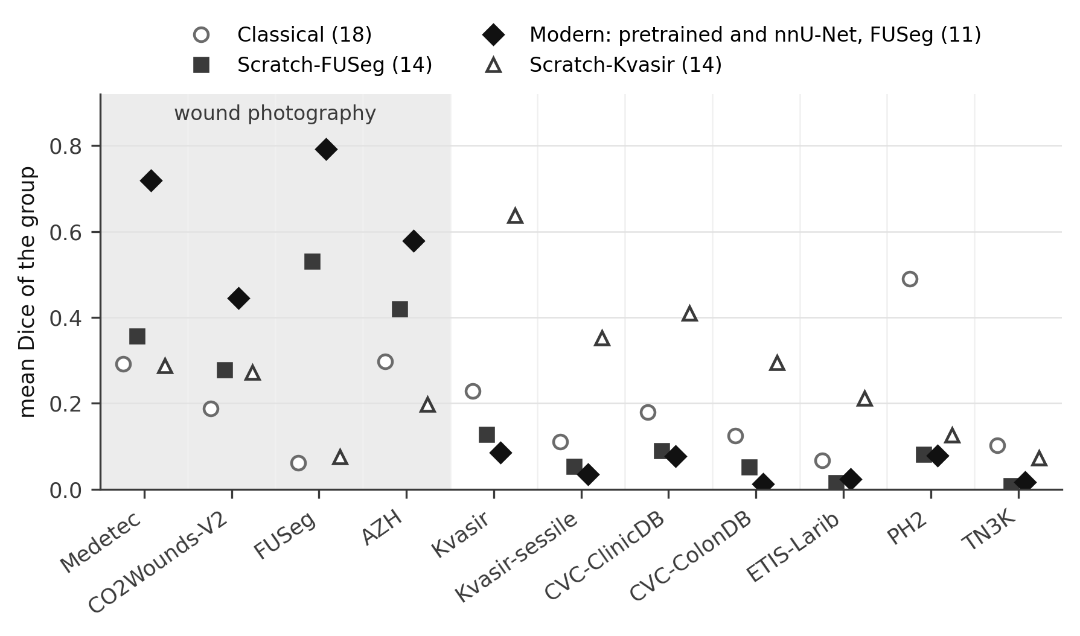
Figure 1. Mean Dice of each method group on each clinical dataset. The shaded area is wound photography, the training domain of the FUSeg-trained groups.

Clinical datasets agree within colonoscopy, not within wound photography
Within every group of comparable methods, same-modality pairs of datasets agreed more than cross-modality pairs (Table 3). The difference was 0.60 (95% CI 0.35 to 0.83) among classical methods, 0.47 (95% CI 0.23 to 0.71) among Scratch-FUSeg, 0.46 (95% CI 0.17 to 0.77) among modern methods and 0.50 (95% CI 0.25 to 0.76) among Scratch-Kvasir methods (p < 0.001, p = 0.004, p < 0.001 and p < 0.001 by the exact test).
This structure comes from colonoscopy. Colonoscopy datasets agreed with each other at 0.72 to 0.88 on average in every group. The four wound datasets did not cluster in any group of comparable methods (p = 0.276, p = 0.597, p = 0.545 and p = 0.379 for classical, Scratch-FUSeg, modern and Scratch-Kvasir), and among modern methods they agreed at 0.13 (95% CI −0.12 to 0.40), below the agreement of each dataset with itself on split halves. Wound datasets therefore rank comparable methods differently, and this is not explained by too few images per dataset.
Table 3. Agreement between clinical datasets by level, per method group, under Dice. Intervals are 95% method-bootstrap intervals.
Group | n | Control | Within source | Within modality | Across modality | Same minus across modality | Exact p
Classical | 18 | 0.96 | 0.69 | 0.67 | 0.08 | 0.60 (0.35 to 0.83) | p < 0.001
Scratch-FUSeg | 14 | 0.95 | 0.65 | 0.60 | 0.14 | 0.47 (0.23 to 0.71) | p = 0.004
Modern | 11 | 0.69 | 0.58 | 0.48 | 0.04 | 0.46 (0.17 to 0.77) | p < 0.001
Scratch-Kvasir | 14 | 0.85 | 0.54 | 0.68 | 0.16 | 0.50 (0.25 to 0.76) | p < 0.001

Mixing method groups manufactures agreement and disagreement
Pooling groups changed every one of these results (Fig. 2, Table 4). When the 18 classical methods were added to the 11 modern ones, agreement between wound datasets rose from 0.13 (95% CI −0.12 to 0.40) to 0.80 (95% CI 0.74 to 0.86), and wound datasets became anti-correlated with the other modalities (−0.50 (95% CI −0.62 to −0.35)), although neither group shows that relation on its own (0.09 and −0.01). Mixing classical with Scratch-FUSeg methods produced the same pattern at a smaller size (−0.26 (95% CI −0.45 to −0.09)). In each case the pooled value lies outside the range of the two within-group values, which is the signature of a composition effect [17]: the modern methods lead on wound photographs and trail on every other modality (Fig. 1), so any wound dataset ranks modern methods first and any other dataset ranks them last.
The mirror test with colonoscopy-trained methods behaved as this mechanism predicts. Scratch-Kvasir methods led on colonoscopy but stayed close to classical methods on wound photographs, so the two groups only partly swapped places. Agreement between colonoscopy and other datasets was 0.13 among classical and 0.20 among Scratch-Kvasir methods, and 0.02 when pooled: below both, but not negative. Ranking methods within their own group before pooling removed most of the manufactured structure: the stratified agreement between wound datasets in the classical plus modern pool was 0.32, against 0.80 for the ordinary correlation.
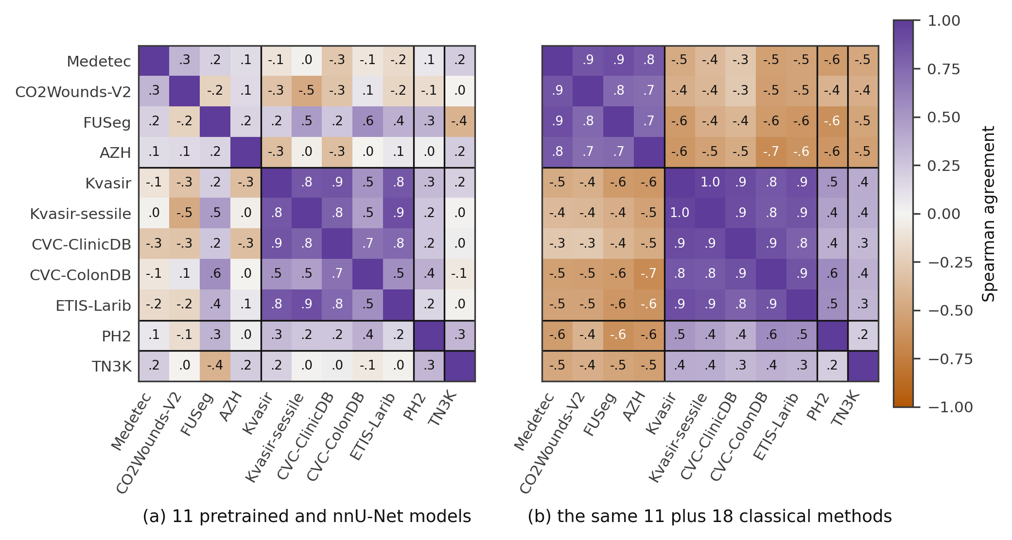
Figure 2. Agreement between clinical datasets under Dice. (a) The 11 modern methods. (b) The same 11 plus the 18 classical methods. Lines separate wound photography, colonoscopy, dermoscopy and ultrasound.
Table 4. Agreement by type of pair, per pool, under Dice. The training domain is wound photography for FUSeg-trained groups and colonoscopy for Scratch-Kvasir; for the classical group it is set to wound photography.
Pool | n | Within training domain | Training domain with other modalities | Other modalities with each other | Stratified, domain with others
Classical | 18 | 0.37 (0.14 to 0.61) | 0.09 (−0.15 to 0.30) | 0.04 | not applicable
Modern | 11 | 0.13 (−0.12 to 0.40) | −0.01 (−0.28 to 0.30) | 0.17 | not applicable
Classical + Modern | 29 | 0.80 (0.74 to 0.86) | −0.50 (−0.62 to −0.35) | 0.40 | 0.07
Scratch-FUSeg | 14 | 0.16 (−0.15 to 0.49) | 0.14 (−0.10 to 0.36) | 0.14 | not applicable
Classical + Scratch-FUSeg | 32 | 0.53 (0.33 to 0.70) | −0.26 (−0.45 to −0.09) | 0.41 | 0.11
Scratch-Kvasir | 14 | 0.83 (0.61 to 0.92) | 0.20 (−0.16 to 0.49) | 0.02 | not applicable
Classical + Scratch-Kvasir | 32 | 0.92 (0.83 to 0.96) | 0.02 (−0.09 to 0.11) | −0.08 | 0.15

The measured validity of a synthetic benchmark follows the pool
Generator B's agreement with the four wound datasets followed the same pattern (Table 5, Fig. 3). Among modern methods alone it was 0.36 (95% CI −0.02 to 0.62), and among classical methods alone 0.50 (95% CI 0.20 to 0.70). Over the mixed pool it rose to 0.61 (95% CI 0.39 to 0.77), a figure that would usually be read as strong validity. That figure reflects the modern methods scoring higher on synthetic and on clinical wound images alike: mean Dice on generator B at amplitude 40 was 0.44 for the modern group and 0.18 for the classical group. Within the stratified analysis the mixed-pool agreement fell to 0.47.
Which wound dataset the benchmark is compared with mattered as much as the pool. Among classical methods, agreement ranged from 0.36 with AZH to 0.68 with CO2Wounds-V2; among modern methods from 0.25 with Medetec to 0.52 with CO2Wounds-V2.
Table 5. Agreement of generator B with each wound dataset, per pool, under Dice: mean over nine benchmarks (three texture amplitudes by three seeds). Wound with wound is the mean agreement between the four clinical wound datasets over the same methods.
Pool | n | Medetec | CO2Wounds-V2 | FUSeg | AZH | Benchmark, mean | Wound with wound
Classical | 18 | 0.55 | 0.68 | 0.39 | 0.36 | 0.50 (0.20 to 0.70) | 0.37 (0.14 to 0.61)
Scratch-FUSeg | 14 | 0.01 | 0.48 | 0.07 | 0.23 | 0.20 (−0.11 to 0.44) | 0.16 (−0.15 to 0.49)
Modern | 11 | 0.25 | 0.52 | 0.27 | 0.40 | 0.36 (−0.02 to 0.62) | 0.13 (−0.12 to 0.40)
Scratch-Kvasir | 14 | 0.14 | 0.09 | −0.32 | 0.60 | 0.13 (−0.33 to 0.55) | 0.36 (0.03 to 0.65)
Classical + Scratch-FUSeg | 32 | 0.29 | 0.51 | 0.11 | 0.14 | 0.26 (0.01 to 0.49) | 0.53 (0.33 to 0.70)
Classical + Modern | 29 | 0.63 | 0.69 | 0.55 | 0.59 | 0.61 (0.39 to 0.77) | 0.80 (0.74 to 0.86)
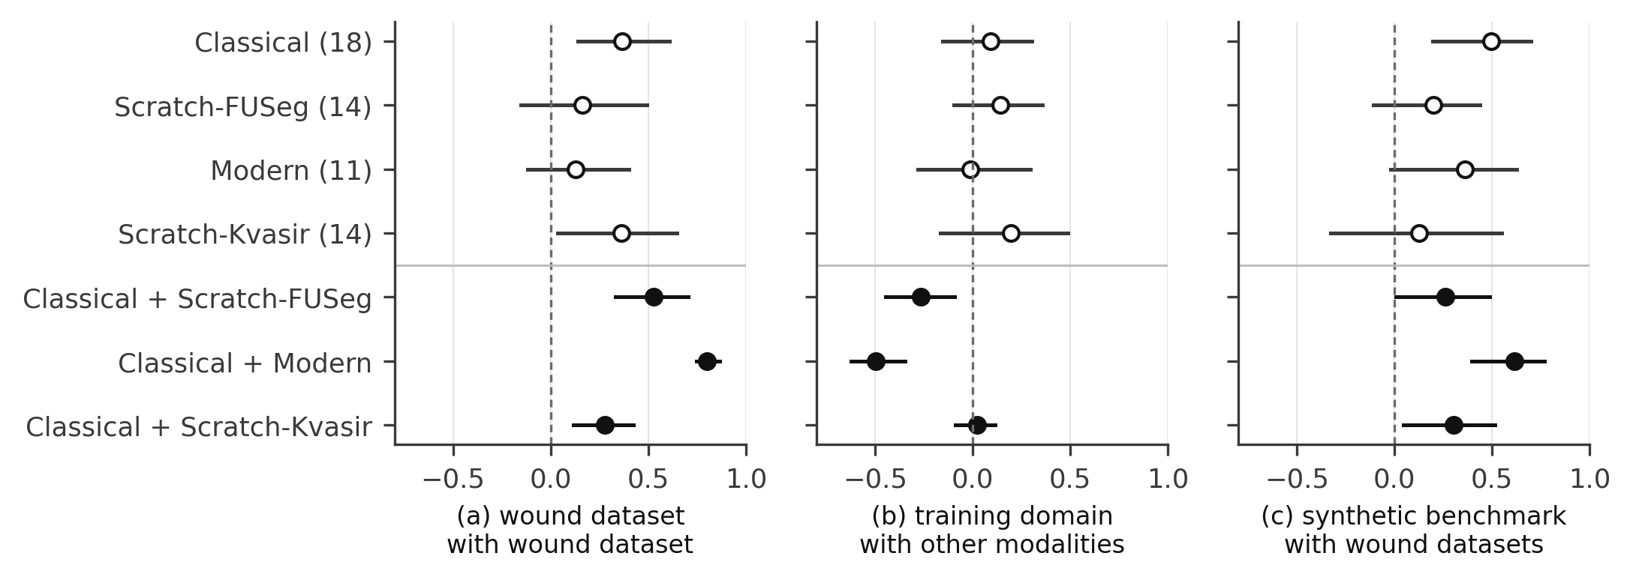
Figure 3. Agreement under Dice with 95% method-bootstrap intervals for each pool: (a) between wound datasets, (b) between the training-domain datasets and other modalities, (c) between generator B and the wound datasets. Filled points are mixed pools.

Texture and matched benchmarks (exploratory)
Over the mixed classical plus Scratch-FUSeg pool, generator B's agreement with the wound datasets rose with texture amplitude (0.14, 0.30 and 0.34 at amplitudes 11, 28 and 40). Within groups the trend depended on the dataset and the group: among classical methods 0.45, 0.52 and 0.53, and among modern methods 0.37, 0.36 and 0.35. Four benchmarks from three generators spanning measured background texture from about 2.1 to 3.3 gave similar agreement within each group once averaged over three seeds (Table 6), so the measured texture statistic did not predict validity in this range. In the mixed classical plus modern pool the same four benchmarks ranged from −0.60 to 0.32, because the modern methods scored near zero on the uniform-drape images of generator A and well on the others; the spread between benchmarks in a mixed pool reflects how each benchmark treats the two groups.
Table 6. Four benchmarks from three generators, mean (standard deviation) over seeds 2024, 7 and 101 of the agreement with the four wound datasets under Dice. Texture is the median local standard deviation of shading-corrected background luminance.
Benchmark | Texture | Classical | Modern | Classical + Modern | Classical + Scratch-FUSeg
Generator A, uniform drape | 2.10 (2.10 to 2.10) | 0.31 (sd 0.01) | 0.30 (sd 0.07) | −0.60 (sd 0.00) | −0.22 (sd 0.01)
Generator C, no noise | 2.37 (2.34 to 2.41) | 0.31 (sd 0.01) | 0.32 (sd 0.06) | 0.16 (sd 0.03) | 0.08 (sd 0.05)
Generator C, noise 3.4 | 3.27 (3.20 to 3.33) | 0.29 (sd 0.01) | 0.34 (sd 0.04) | 0.14 (sd 0.02) | 0.07 (sd 0.05)
Generator B, texture removed | 3.09 (2.98 to 3.23) | 0.40 (sd 0.02) | 0.31 (sd 0.04) | 0.32 (sd 0.01) | 0.13 (sd 0.01)

Robustness
Every result above holds under normalised surface Dice and with empty-mask images excluded. Under surface Dice the same-minus-across-modality difference was 0.42, 0.56, 0.44 and 0.69 for the four groups, wound datasets did not cluster within any group (p = 0.327 among modern methods), and mixing classical with modern methods again raised wound-to-wound agreement, from 0.31 to 0.87, and generator B's agreement, from 0.29 to 0.54. With empty-mask images excluded the corresponding Dice values were 0.12 and 0.79.

Discussion
A validity figure for a synthetic benchmark is a rank correlation, and a rank correlation over a mixed pool of methods is dominated by the largest differences between methods. In segmentation those differences are between classical and trained methods, and trained methods are tied to the domain they were trained on. The result is that a benchmark can show agreement of 0.61 with clinical wound data over a mixed pool while agreeing at only 0.36 over the modern networks a user would actually choose between. The clinical datasets behave the same way: four wound datasets that appear to agree strongly over the mixed pool disagree among modern networks.
This is the same phenomenon reported for language model benchmarks [11, 13] and for in-distribution versus out-of-distribution accuracy [15, 16], and in statistical terms it is Simpson's paradox [17, 18]. What is specific to segmentation is its size and direction. Mixing method types did not only inflate agreement within wound photography; it created anti-correlation between wound photography and every other modality, and positive agreement between modalities that share nothing. A study that reports one pooled correlation cannot tell these effects from real relationships between datasets.
Two findings matter for practice beyond synthetic data. First, colonoscopy datasets from different centres ranked methods consistently in every group, so a colonoscopy dataset is a reasonable proxy for another. Wound datasets were not, even among strong modern networks, so choosing a wound segmentation model on one public dataset is unlikely to transfer to another clinic, consistent with earlier reports of variable wound rankings across datasets [48]. Second, close work on synthetic test sets in CT reported strong transfer of rankings to clinical data [49] and found that transfer depends on the task [50]. Our results add that it also depends on the composition of the method pool, which should be reported alongside any such figure.
Four practices follow and each is inexpensive. Report agreement within groups of comparable methods, or with the stratified agreement used here, rather than over a mixed pool. Give intervals from resampling methods, which here were often wider than the differences being claimed. Report agreement against several clinical datasets, because the choice of dataset alone moved the result substantially. And report the split-half reliability of each dataset's ranking, so that low agreement can be told apart from noise.

Limitations
Wound photography is represented by four datasets from three sources, two of which share a clinic, and the synthetic benchmarks are wound images only. The colonoscopy result rests on five datasets from three sources.
The modern group has 11 networks, and its intervals are wide. Networks were fine-tuned on about 390 images under one protocol; larger training sets or other protocols may change the spread between them.
SAM and MedSAM were prompted with boxes taken from the ground truth, so their scores are an upper reference and they were not ranked.
Agreement was measured with Spearman correlation of mean Dice. Rankings based on other aggregations, such as per-image ranking or median scores, were not studied.
The synthetic benchmarks contain 45 images each and come from parametric generators written by the same group; learned generators such as diffusion models were not tested.
The texture and matched-benchmark analyses are exploratory, and the measured background texture of a benchmark varied by up to 0.48 between seeds.
The within-dataset control uses 103 AZH training images after exclusions, and image matching may miss some crops of FUSeg photographs.

Conclusions
Rank agreement between clinical datasets, and between a synthetic benchmark and clinical data, depends on which methods are ranked. Mixing classical and modern segmentation methods produced strong apparent agreement between wound datasets and strong apparent validity for a synthetic wound benchmark, both of which largely disappeared among modern networks alone. Validity figures should be reported within groups of comparable methods, against several clinical datasets and with intervals.

Statements and Declarations
Funding. No funding was received for this study.
Competing interests. The authors have no competing interests to declare.
Ethics approval. This study used only publicly available, de-identified datasets released for research use. No new images were collected and no ethics approval was required.
Consent to participate and to publish. Not applicable.
Data availability. All clinical datasets are available from their original distributors. Per-image scores for every method and dataset, the exclusion lists and the synthetic benchmarks are provided as Online Resources.
Code availability. The code for all methods, generators and analyses is provided as an Online Resource and will be released in a public repository on acceptance.
Use of AI tools. An AI assistant was used for code development, analysis scripting and language editing under the authors' direction. The authors checked all code, results and text and take full responsibility for them.

References
1. Badano, A., Graff, C.G., Badal, A., et al., 2018. Evaluation of digital breast tomosynthesis as replacement of full-field digital mammography using an in silico imaging trial. JAMA Network Open 1(7), e185474. https://doi.org/10.1001/jamanetworkopen.2018.5474
2. Sizikova, E., Saharkhiz, N., Sharma, D., et al., 2023. Knowledge-based in silico models and dataset for the comparative evaluation of mammography AI for a range of breast characteristics, lesion conspicuities and doses. In: Advances in Neural Information Processing Systems 36 (NeurIPS 2023), Datasets and Benchmarks Track, pp. 37401–37412. https://doi.org/10.52202/075280-1626
3. Kang, C., 2022. Is synthetic dataset reliable for benchmarking generalizable person re-identification? In: 2022 IEEE International Joint Conference on Biometrics (IJCB), pp. 1–8. https://arxiv.org/abs/2209.05047
4. Borsukiewicz, P., Lunghi, D., Ouédraogo, W.C., Klein, J., Bissyandé, T.F., 2026. Benchmarking face recognition without real faces. arXiv preprint. https://arxiv.org/abs/2607.14932
5. Hu, Q., Yuille, A., Zhou, Z., 2023. Synthetic data as validation. arXiv preprint arXiv:2310.16052. https://arxiv.org/abs/2310.16052
6. Maier-Hein, L., Eisenmann, M., Reinke, A., et al., 2018. Why rankings of biomedical image analysis competitions should be interpreted with care. Nature Communications 9, 5217. https://doi.org/10.1038/s41467-018-07619-7
7. Wiesenfarth, M., Reinke, A., Landman, B.A., et al., 2021. Methods and open-source toolkit for analyzing and visualizing challenge results. Scientific Reports 11, 2369. https://doi.org/10.1038/s41598-021-82017-6
8. Bassi, P.R.A.S., Li, W., Tang, Y., et al., 2024. Touchstone benchmark: Are we on the right way for evaluating AI algorithms for medical segmentation? In: Advances in Neural Information Processing Systems 37 (NeurIPS 2024), Datasets and Benchmarks Track. https://arxiv.org/abs/2411.03670
9. Ali, S., Ghatwary, N., Jha, D., et al., 2024. Assessing generalisability of deep learning-based polyp detection and segmentation methods through a computer vision challenge. Scientific Reports 14, 2032. https://doi.org/10.1038/s41598-024-52063-x
10. Christodoulou, E., Reinke, A., Houhou, R., et al., 2024. Confidence intervals uncovered: are we ready for real-world medical imaging AI? In: Medical Image Computing and Computer Assisted Intervention – MICCAI 2024, Lecture Notes in Computer Science 15010. Springer, Cham, pp. 124–132. https://doi.org/10.1007/978-3-031-72117-5_12
11. Perlitz, Y., Gera, A., Arviv, O., et al., 2024. Do these LLM benchmarks agree? Fixing benchmark evaluation with BenchBench. arXiv preprint arXiv:2407.13696. https://arxiv.org/abs/2407.13696
12. Dehghani, M., Tay, Y., Gritsenko, A.A., et al., 2021. The benchmark lottery. arXiv preprint arXiv:2107.07002. https://arxiv.org/abs/2107.07002
13. Zhang, G., Dominguez-Olmedo, R., Hardt, M., 2026. Train-before-test harmonizes language model rankings. In: International Conference on Learning Representations (ICLR 2026). https://arxiv.org/abs/2507.05195
14. Dominguez-Olmedo, R., Dorner, F.E., Hardt, M., 2025. Training on the test task confounds evaluation and emergence. In: International Conference on Learning Representations (ICLR 2025). https://arxiv.org/abs/2407.07890
15. Teney, D., Lin, Y., Oh, S.J., Abbasnejad, E., 2023. ID and OOD performance are sometimes inversely correlated on real-world datasets. In: Advances in Neural Information Processing Systems 36 (NeurIPS 2023). https://arxiv.org/abs/2209.00613
16. Fang, A., Ilharco, G., Wortsman, M., et al., 2022. Data determines distributional robustness in contrastive language image pre-training (CLIP). In: Proceedings of the 39th International Conference on Machine Learning (ICML 2022), PMLR 162, pp. 6216–6234. https://proceedings.mlr.press/v162/fang22a.html
17. Simpson, E.H., 1951. The interpretation of interaction in contingency tables. Journal of the Royal Statistical Society: Series B (Methodological) 13, 238–241. https://doi.org/10.1111/j.2517-6161.1951.tb00088.x
18. Kievit, R.A., Frankenhuis, W.E., Waldorp, L.J., Borsboom, D., 2013. Simpson's paradox in psychological science: a practical guide. Frontiers in Psychology 4, 513. https://doi.org/10.3389/fpsyg.2013.00513
19. Sarp, S., Kuzlu, M., Wilson, E., Guler, O., 2021. WG2AN: Synthetic wound image generation using generative adversarial network. The Journal of Engineering 2021(5), 286-294. https://doi.org/10.1049/tje2.12033
20. Basiri, R., Manji, K., Harton, F., Poonja, A., Popovic, M.R., Khan, S.S., 2023. Synthesizing diabetic foot ulcer images with diffusion model. arXiv preprint. https://arxiv.org/abs/2310.20140
21. Isensee, F., Jaeger, P.F., Kohl, S.A.A., Petersen, J., Maier-Hein, K.H., 2021. nnU-Net: A self-configuring method for deep learning-based biomedical image segmentation. Nature Methods 18(2), 203-211. https://doi.org/10.1038/s41592-020-01008-z
22. Medetec, 2014. Medetec wound database: medical image databases. Web resource, accessed 8 October 2026. http://www.medetec.co.uk/files/medetec-image-databases.html
23. Sanchez, K., Hinojosa, C., Mieles, O., Zhao, C., Ghanem, B., Arguello, H., 2024. CO2Wounds-V2: Extended chronic wounds dataset from leprosy patients. arXiv preprint arXiv:2408.10827. https://doi.org/10.48550/arXiv.2408.10827
24. Wang, C., Mahbod, A., Ellinger, I., Galdran, A., Gopalakrishnan, S., Niezgoda, J., Yu, Z., 2024. FUSeg: The Foot Ulcer Segmentation Challenge. Information 15(3), 140. https://doi.org/10.3390/info15030140
25. Wang, C., Anisuzzaman, D.M., Williamson, V., et al., 2020. Fully automatic wound segmentation with deep convolutional neural networks. Scientific Reports 10, 21897. https://doi.org/10.1038/s41598-020-78799-w
26. Jha, D., Smedsrud, P.H., Riegler, M.A., Halvorsen, P., de Lange, T., Johansen, D., Johansen, H.D., 2020. Kvasir-SEG: A segmented polyp dataset. In: MultiMedia Modeling, MMM 2020. Lecture Notes in Computer Science 11962, pp. 451-462. https://doi.org/10.1007/978-3-030-37734-2_37
27. Bernal, J., Sánchez, F.J., Fernández-Esparrach, G., Gil, D., Rodríguez, C., Vilariño, F., 2015. WM-DOVA maps for accurate polyp highlighting in colonoscopy: Validation vs. saliency maps from physicians. Computerized Medical Imaging and Graphics 43, 99-111. https://doi.org/10.1016/j.compmedimag.2015.02.007
28. Bernal, J., Sánchez, J., Vilariño, F., 2012. Towards automatic polyp detection with a polyp appearance model. Pattern Recognition 45(9), 3166-3182. https://doi.org/10.1016/j.patcog.2012.03.002
29. Silva, J., Histace, A., Romain, O., Dray, X., Granado, B., 2014. Toward embedded detection of polyps in WCE images for early diagnosis of colorectal cancer. International Journal of Computer Assisted Radiology and Surgery 9(2), 283-293. https://doi.org/10.1007/s11548-013-0926-3
30. Mendonça, T., Ferreira, P.M., Marques, J.S., Marçal, A.R.S., Rozeira, J., 2013. PH2: A dermoscopic image database for research and benchmarking. In: 2013 35th Annual International Conference of the IEEE Engineering in Medicine and Biology Society (EMBC), pp. 5437-5440. https://doi.org/10.1109/EMBC.2013.6610779
31. Gong, H., Chen, G., Wang, R., et al., 2021. Multi-task learning for thyroid nodule segmentation with thyroid region prior. In: 2021 IEEE 18th International Symposium on Biomedical Imaging (ISBI), pp. 257-261. https://doi.org/10.1109/ISBI48211.2021.9434087
32. Iakubovskii, P., 2019. Segmentation Models Pytorch. GitHub repository. https://github.com/qubvel-org/segmentation_models.pytorch
33. Ronneberger, O., Fischer, P., Brox, T., 2015. U-Net: Convolutional networks for biomedical image segmentation. In: Medical Image Computing and Computer-Assisted Intervention, MICCAI 2015. Lecture Notes in Computer Science 9351, pp. 234-241. https://doi.org/10.1007/978-3-319-24574-4_28
34. Zhou, Z., Siddiquee, M.M.R., Tajbakhsh, N., Liang, J., 2018. UNet++: A nested U-Net architecture for medical image segmentation. In: Deep Learning in Medical Image Analysis and Multimodal Learning for Clinical Decision Support. Lecture Notes in Computer Science 11045, pp. 3-11. https://doi.org/10.1007/978-3-030-00889-5_1
35. Chen, L.-C., Zhu, Y., Papandreou, G., Schroff, F., Adam, H., 2018. Encoder-decoder with atrous separable convolution for semantic image segmentation. In: Computer Vision, ECCV 2018. Lecture Notes in Computer Science 11211, pp. 833-851. https://doi.org/10.1007/978-3-030-01234-2_49
36. Lin, T.-Y., Dollár, P., Girshick, R., He, K., Hariharan, B., Belongie, S., 2017. Feature pyramid networks for object detection. In: Proceedings of the IEEE Conference on Computer Vision and Pattern Recognition (CVPR), pp. 936-944. https://doi.org/10.1109/CVPR.2017.106
37. Zhao, H., Shi, J., Qi, X., Wang, X., Jia, J., 2017. Pyramid scene parsing network. In: Proceedings of the IEEE Conference on Computer Vision and Pattern Recognition (CVPR), pp. 6230-6239. https://doi.org/10.1109/CVPR.2017.660
38. Chaurasia, A., Culurciello, E., 2017. LinkNet: Exploiting encoder representations for efficient semantic segmentation. In: 2017 IEEE Visual Communications and Image Processing (VCIP), pp. 1-4. https://doi.org/10.1109/VCIP.2017.8305148
39. Fan, T., Wang, G., Li, Y., Wang, H., 2020. MA-Net: A multi-scale attention network for liver and tumor segmentation. IEEE Access 8, 179656-179665. https://doi.org/10.1109/ACCESS.2020.3025372
40. He, K., Zhang, X., Ren, S., Sun, J., 2016. Deep residual learning for image recognition. In: Proceedings of the IEEE Conference on Computer Vision and Pattern Recognition (CVPR), pp. 770-778. https://doi.org/10.1109/CVPR.2016.90
41. Sandler, M., Howard, A., Zhu, M., Zhmoginov, A., Chen, L.-C., 2018. MobileNetV2: Inverted residuals and linear bottlenecks. In: Proceedings of the IEEE/CVF Conference on Computer Vision and Pattern Recognition (CVPR), pp. 4510-4520. https://doi.org/10.1109/CVPR.2018.00474
42. Tan, M., Le, Q., 2019. EfficientNet: Rethinking model scaling for convolutional neural networks. In: Proceedings of the 36th International Conference on Machine Learning (ICML 2019), PMLR 97, pp. 6105-6114. https://arxiv.org/abs/1905.11946
43. Xie, E., Wang, W., Yu, Z., Anandkumar, A., Alvarez, J.M., Luo, P., 2021. SegFormer: Simple and efficient design for semantic segmentation with transformers. In: Advances in Neural Information Processing Systems 34 (NeurIPS 2021), pp. 12077-12090. https://arxiv.org/abs/2105.15203
44. Deng, J., Dong, W., Socher, R., Li, L.-J., Li, K., Fei-Fei, L., 2009. ImageNet: a large-scale hierarchical image database. In: 2009 IEEE Conference on Computer Vision and Pattern Recognition (CVPR), pp. 248–255. https://doi.org/10.1109/CVPR.2009.5206848
45. Kirillov, A., Mintun, E., Ravi, N., et al., 2023. Segment anything. In: Proceedings of the IEEE/CVF International Conference on Computer Vision (ICCV 2023), pp. 4015–4026. https://doi.org/10.1109/ICCV51070.2023.00371
46. Ma, J., He, Y., Li, F., Han, L., You, C., Wang, B., 2024. Segment anything in medical images. Nature Communications 15, 654. https://doi.org/10.1038/s41467-024-44824-z
47. Nikolov, S., Blackwell, S., Zverovitch, A., et al., 2018. Deep learning to achieve clinically applicable segmentation of head and neck anatomy for radiotherapy. arXiv preprint. https://arxiv.org/abs/1809.04430
48. Lucho, S., Naemi, R., Castaneda, B., Treuillet, S., 2024. Can deep learning wound segmentation algorithms developed for a dataset be effective for another dataset? A specific focus on diabetic foot ulcers. IEEE Access 12, 173824-173835. https://doi.org/10.1109/ACCESS.2024.3502467
49. Tushar, F.I., Momy, U.H., Lo, J.Y., Rubin, G.D., 2026. iTRIALSPACE: programmable virtual lesion trials for controlled evaluation of lung CT models. arXiv preprint arXiv:2605.05761. https://arxiv.org/abs/2605.05761
50. Tushar, F.I., 2026. When does synthetic CT transfer? A label-free donor/host diagnostic for medical vision-language model routing on real lung CT. arXiv preprint arXiv:2606.29232. https://arxiv.org/abs/2606.29232

