**FINAL EMBEDDED SYSTEM**  LAMIAA DIBI- 200218327

Ans 1) DOWNLOAD DONE!  
Ans 2) PROGRAM RUN DONE!  
Ans 3) ACCESS DONE!

Ans 4) FILE OPENED!  
Ans 5) Firstly, I runned the simulator and the code started running.

if **I pressed the button and it resets the circuit when it connects to the ground.**  
Secondly, the lcd screen shows “great cow basic” ,

after 3 sec the word changes to “start test display on”, on line 1,0 where “START TEST” on top-left corner and “DISPLAY ON” on bottom-left

then after 3 sec “cursor on”on line 1.0 , 3 sec later “cursor off” on 0.0 ,

after 3 sec “flash on” on 1.1, then “off” on 0.0, “cursor and flash on” on line 1.0,

3 sec and then both of them “off” on 1.0,

after 3 sec “flashing display ” on 1.4, and it then flash for 500ms on and off 10 times (so it gives the effect of the line “Flashing Display” is really flashing), then “display and backl for 5 sec”,

lastly “end test”

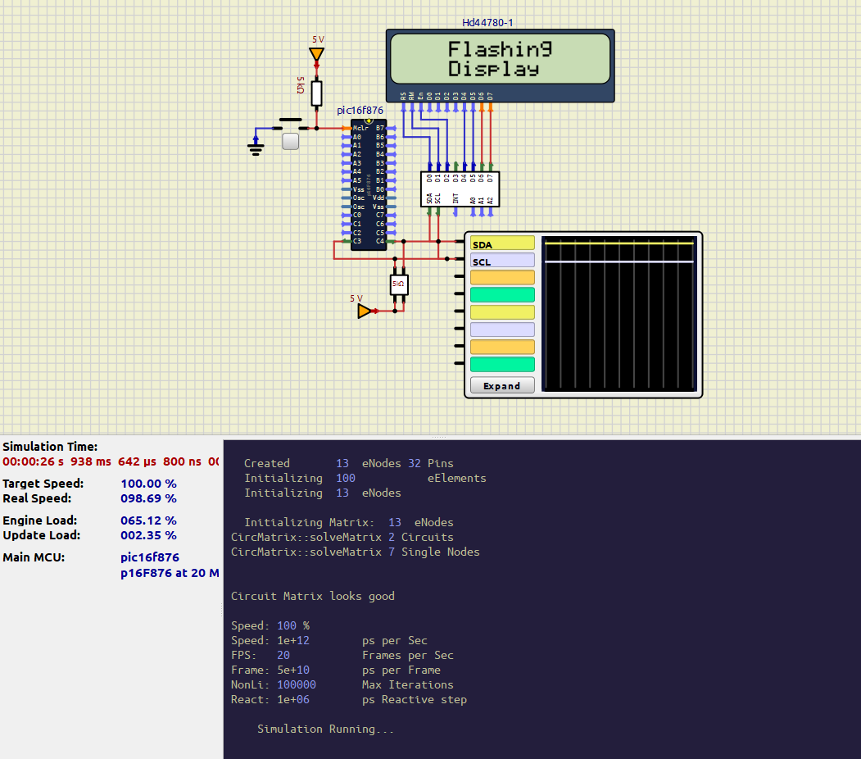

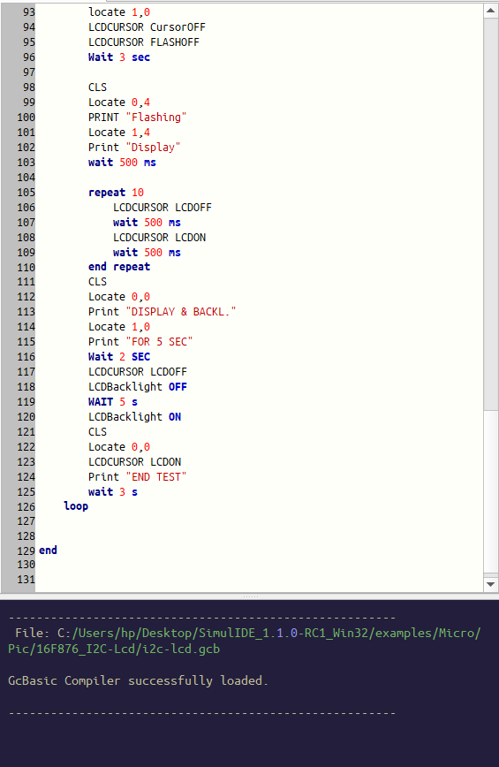

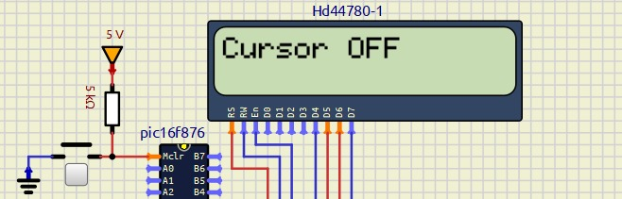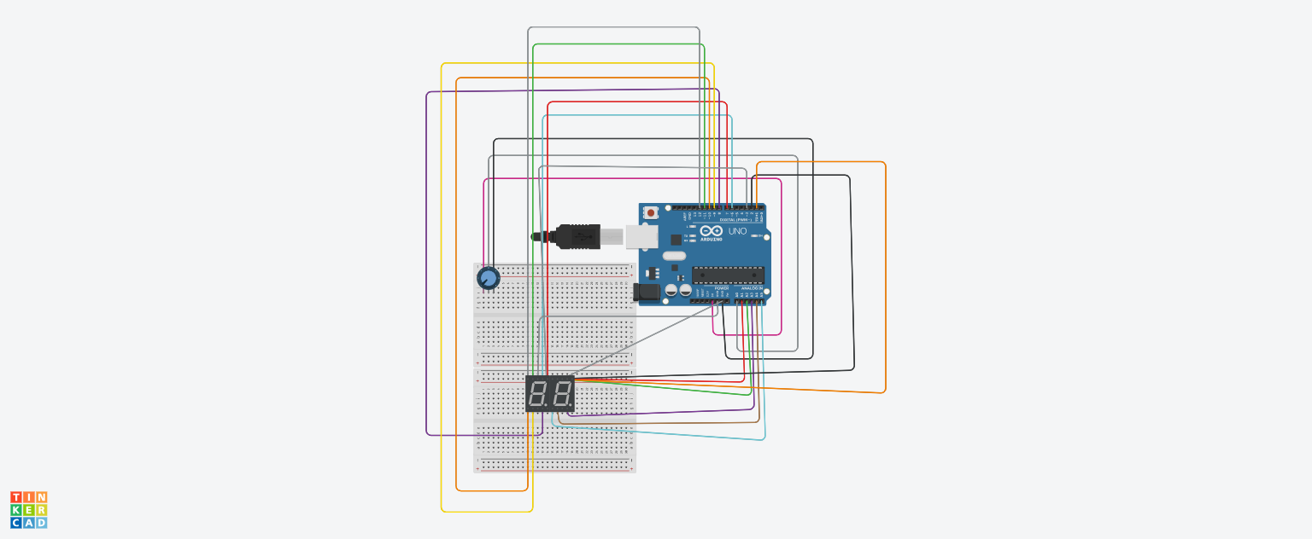

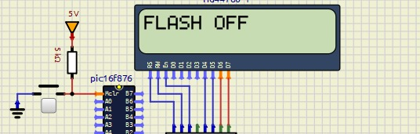

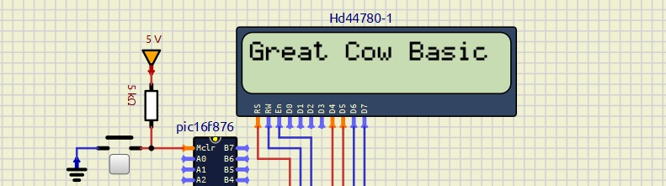

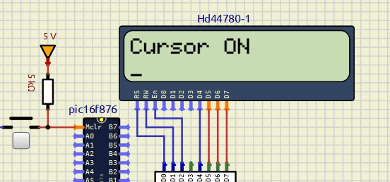

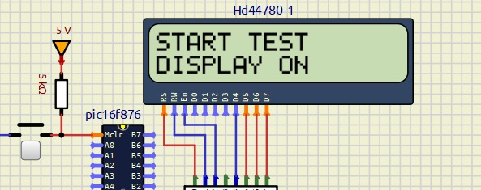

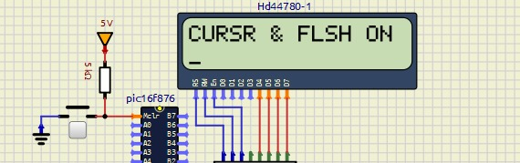

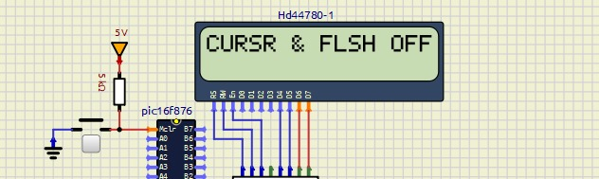

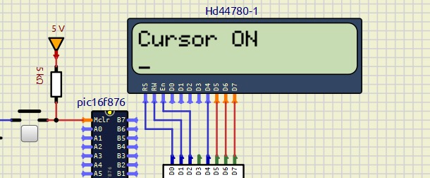

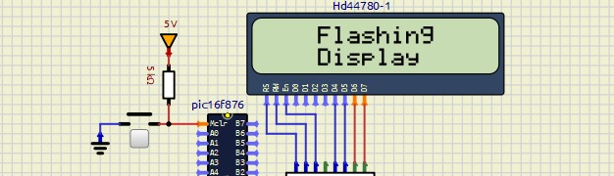

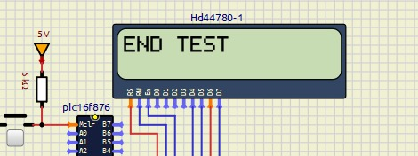

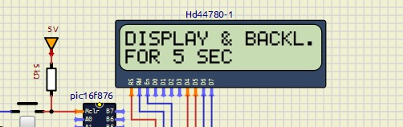

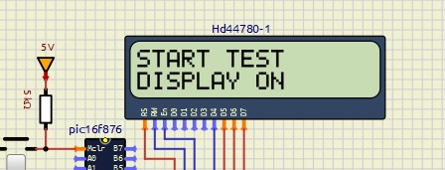

ANS 6) The code is for a microcontroller that controls an LCD screen.

It starts by disabling a particular setting (clearing a bit).

Then it sends the number 1 to the LCD display.

It then waits 4 milliseconds to give the LCD display time to process.

Next, it sends the number 128 to the LCD display.

Finally, it performs a short delay loop to ensure that there is a small pause before completing the process.

This process appears to set up or update the LCD with specific instructions and timing.

Meanings:

1. **bcf:** disables (sets to 0) a certain bit in a given register.
2. **movlw:** loads a given value into the working register (W) directly.
3. **movwf:** transfers the value from the working register (W) to an other register.
4. **call:** temporarily leaps to and executes a subroutine, which is a different piece of code, before returning.
5. **clrf:** resetting a register to its initial value of 0.
6. **decfsz:** reduces a register's value by 1. It moves on to the following instruction if the result is 0.
7. **goto:** advances to a designated line of code.
8. **nop:** For one instruction cycle, does nothing.

ANS 7) I2C, or "eye-squared-see," is at the bottom of the range of "inside the box" communication choices. A conventional Inter-IC (integrated circuit) bus is abbreviated as I2C. It is very light on hardware resources, yet it offers decent support for communication with a variety of sluggish, sporadically accessible on-board peripheral devices. It's a straightforward, short-range, low-bandwidth protocol. The majority of I2C devices on the market run at 400 Kbps, however some even reach low megahertz ranges. Because I2C has an integrated addressing scheme, connecting many devices is simple.

Eg.1 : **Real-Time Clocks (RTCs):** I2C is frequently used to link microcontrollers with real-time clock modules. For home automation devices such as digital clocks, timers, and scheduling systems, these RTC modules offer precise timekeeping.

Eg 2: **Touchscreen Controllers:** I2C is utilized to connect with touchscreen controllers in smartphones and tablets. This makes touch interactions accurate and responsive by allowing the main CPU to receive touch input data.