PROJECT1: Sales Invoice Generator

Screenshot to the program flow:

When running we must choose Invoices Table to be opened:

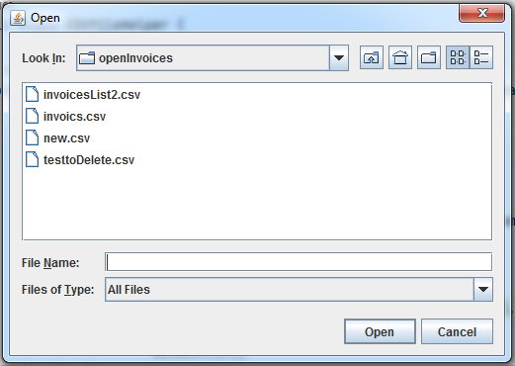

Then:

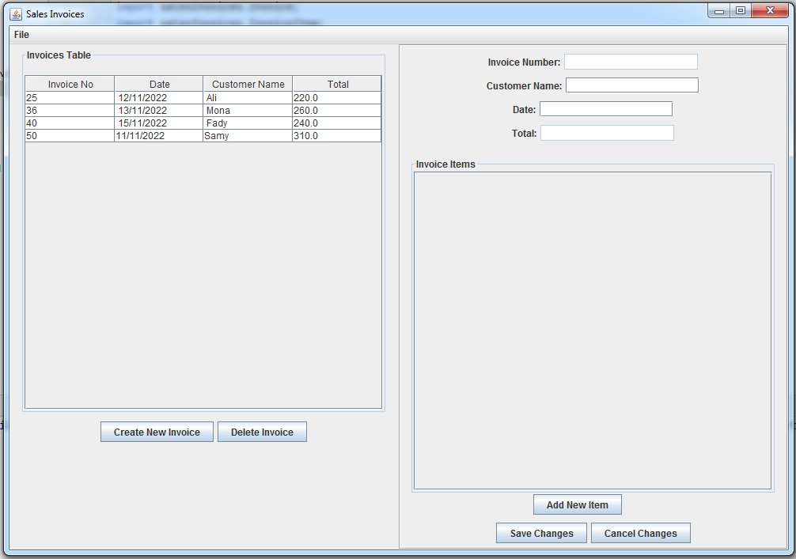

When select Invoice row, the data of this invoice appear in the right panel:

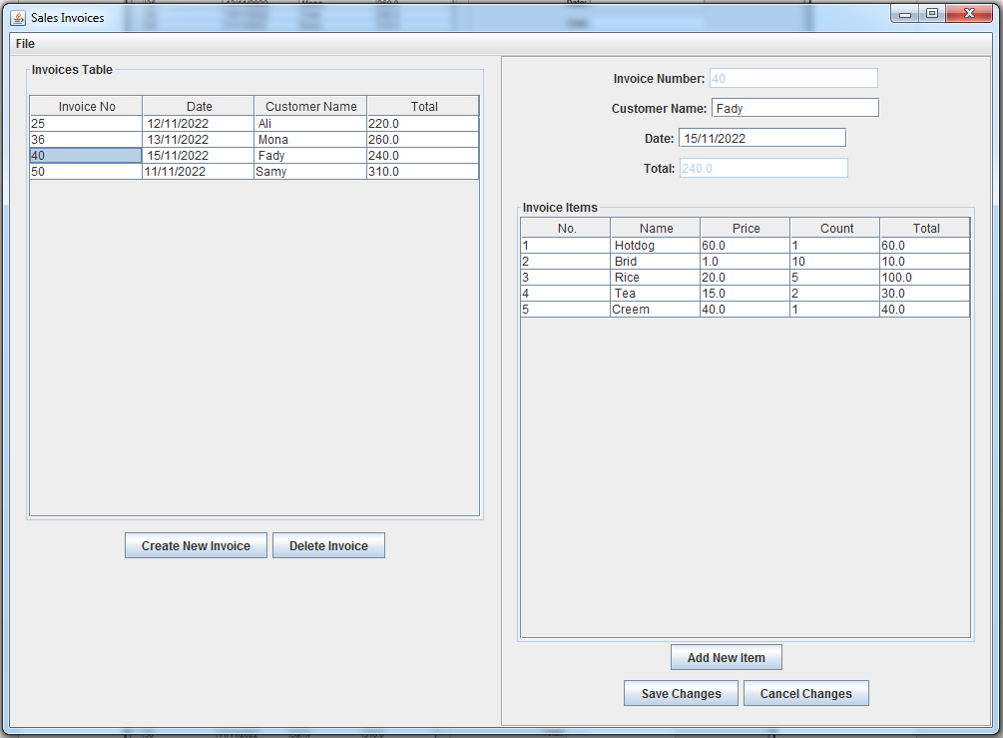

Changing Invoice Items or adding new items to invoice, we can do by “Add New Item” button:



After setting new item data:

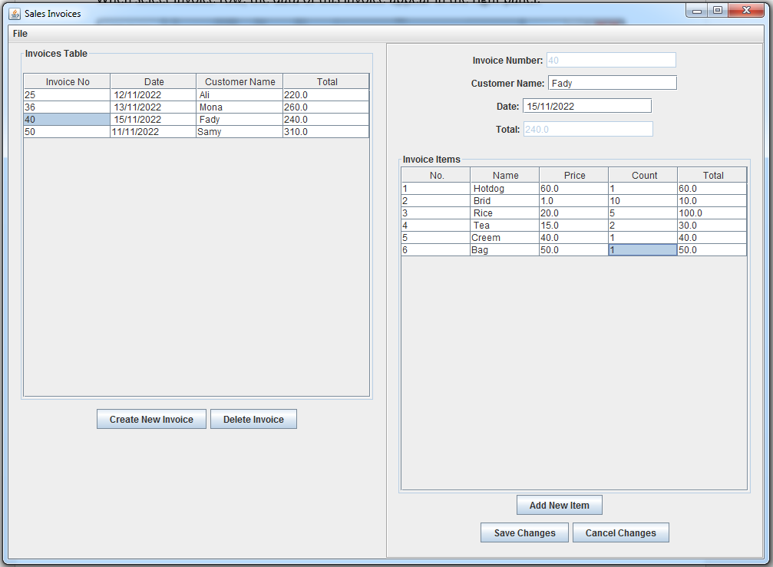

We can save changes in the same file with Invoice Number “40.csv”.

Also, we can “Cancel Changes” and that won’t overwrite the file.

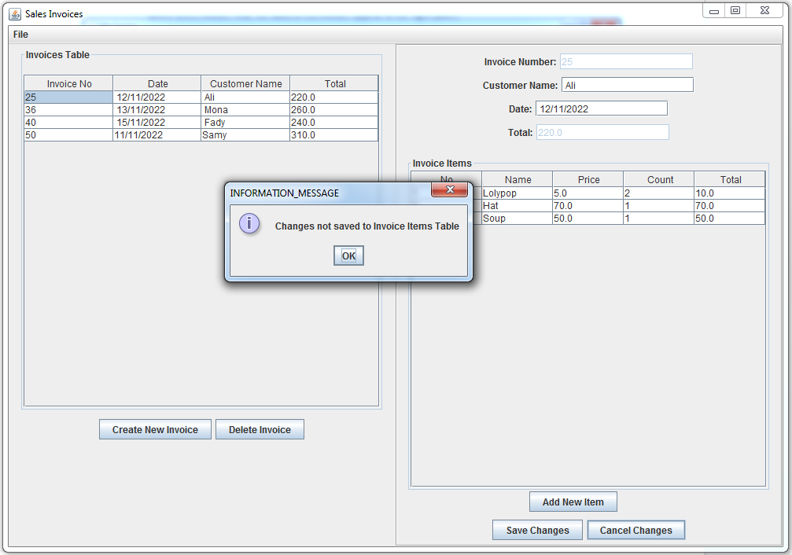

“Create New Invoice” will add a new row in the Invoices Table, also create new file to add this invoice items.

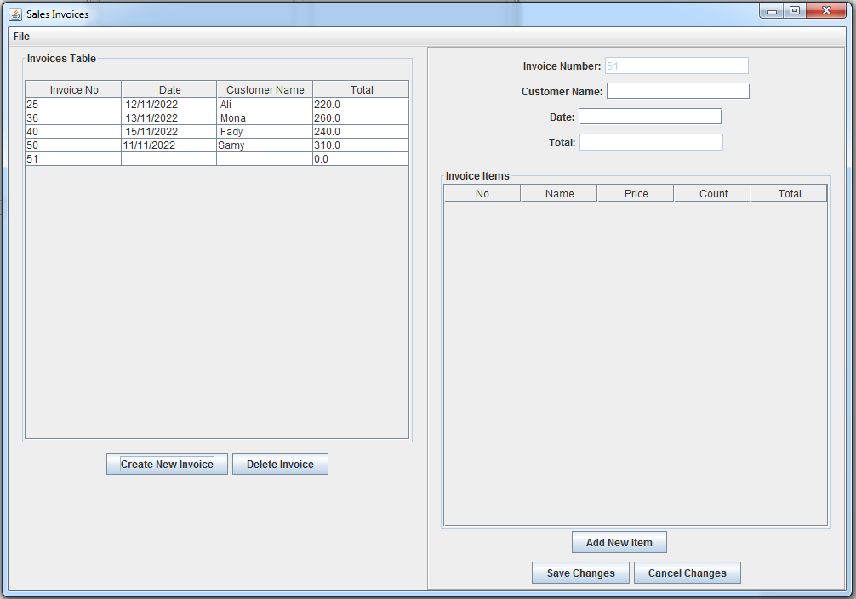

After fill the Invoice Data and “Save Changes” the new invoice will created:

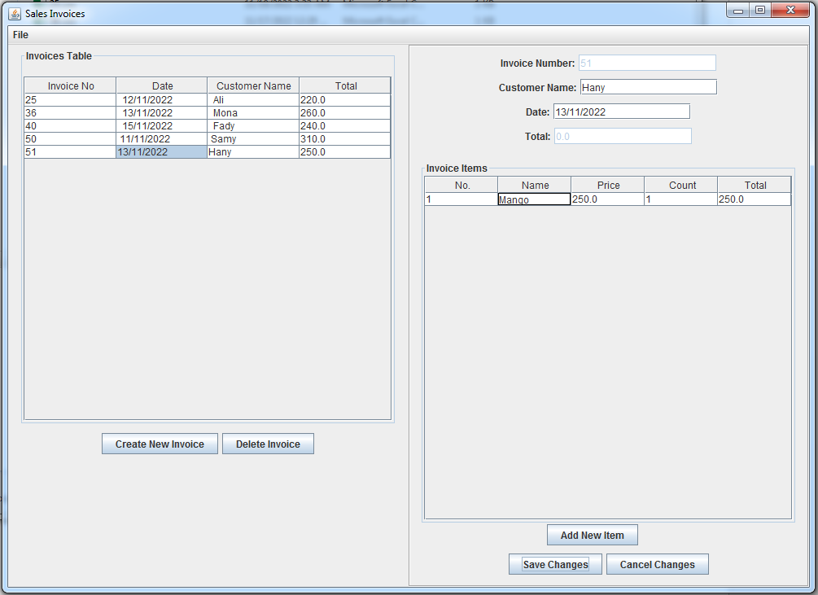

When select Invoice in Invoice Tables and press ”Delete Invoice” the invoice will deleted

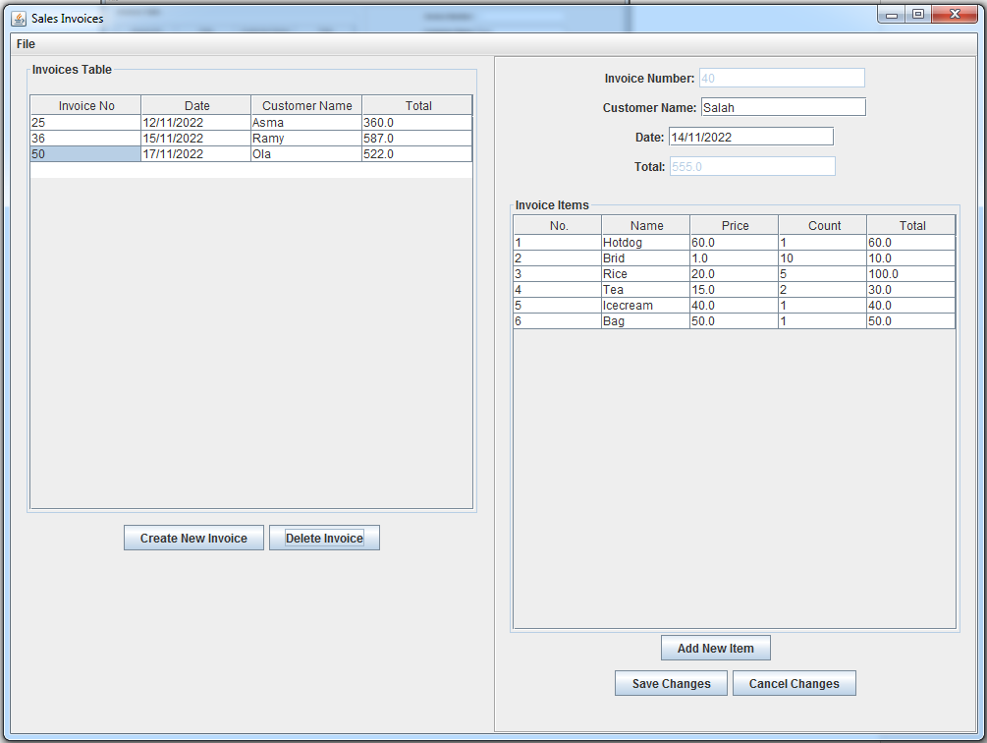

File 🡪 “Load File” will load new Table of invoices:

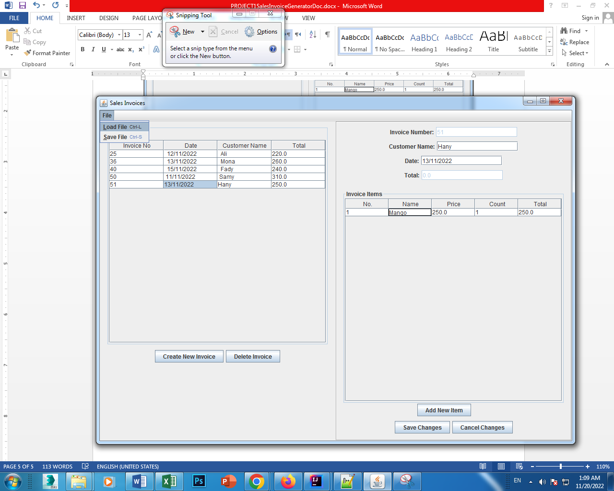

And finally “Save File” to save the table of Invoices

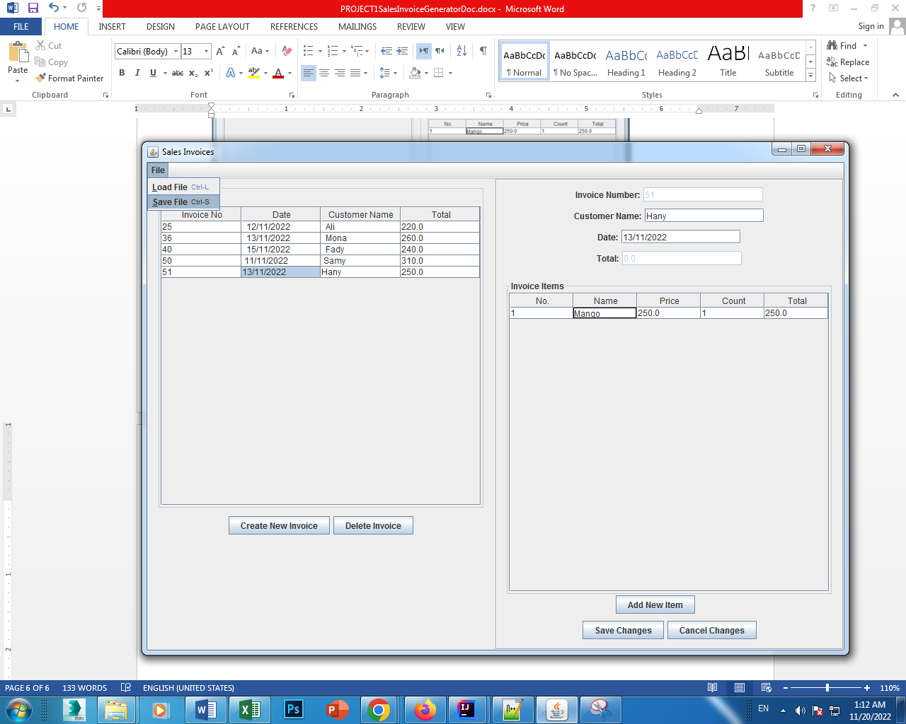

This is a screenshot for my project from the IntelliJ IDE:

