MIS444
Predictive Analytics in Business
COURSE PROJECT REPORT
Predicting Retail Product Sales with Regression
BigMart Sales Prediction Dataset
Student Name | ______________________________
Student ID | ______________________________
Course Code | MIS444
Submission Date | ______________________________

Project type: Regression | Target variable: Item_Outlet_Sales
Dataset source: Kaggle Big Mart Sales Prediction dataset

Report Overview
This report documents the end-to-end predictive analytics workflow used to estimate retail product sales. It follows the project requirements for data collection, preprocessing, exploratory analysis, feature selection, model development, optimization, evaluation, and business implications.
Section | Contents
1 | Introduction
2 | Business Problem and Objective
3 | Dataset Description
4 | Data Preprocessing
5 | Exploratory Data Analysis
6 | Feature Selection
7 | Model Development
8 | Model Optimization
9 | Model Evaluation and Validation
10 | Business Insights and Recommendations
11 | Limitations
12 | Conclusion
13 | AI Usage Disclosure
14 | References
Appendix A | Key Submission Checklist

Executive Summary
This project develops regression models to predict Item_Outlet_Sales for products sold through retail outlets. The dataset contains 8,523 observations and 12 variables. The workflow includes data-quality checks, missing-value treatment, categorical normalization, feature engineering, outlier analysis, exploratory data analysis, model comparison, hyperparameter optimization, and final validation.
Four baseline regression approaches were compared. The optimized Random Forest achieved the strongest test performance, with an RMSE of 1,025.15, MAE of 717.03, and R² of 0.613. Relative to the unoptimized Random Forest, optimization reduced test RMSE by 3.96% and improved R² by 0.033.
The analysis suggests that Item_MRP and outlet characteristics are important predictors of observed sales. Supermarket Type3 showed the highest average sales among outlet types in the dataset, while Starchy Foods had the highest average sales among item types. These findings are descriptive or predictive rather than causal and should therefore support, not replace, managerial judgment.

1. Introduction
Retail businesses need reliable estimates of expected product sales for inventory planning, assortment management, pricing analysis, and outlet-level resource allocation. Predictive analytics can help estimate sales from information that is available before or during retail operations.
This project applies supervised machine learning to the BigMart sales dataset. The central task is to predict the continuous variable Item_Outlet_Sales from product and outlet characteristics. The project therefore addresses a regression problem.

2. Business Problem and Objective
- Business problem: estimate the sales value of an individual product at a specific retail outlet from its available product and outlet characteristics.
- Target variable: Item_Outlet_Sales.
- Primary objective: compare multiple regression models, optimize a competitive model, validate its performance, and interpret the results in a business context.
- Business value: provide a repeatable sales-estimation tool that can support planning and scenario analysis while leaving final decisions to management.

3. Dataset Description
The project uses the Big Mart Sales Prediction dataset from Kaggle. The training data contains 8,523 observations and 12 variables. The variables describe product attributes and outlet characteristics, with Item_Outlet_Sales as the continuous target.
Variable | Description | Role / Type
Item_Identifier | Product identifier | Identifier
Item_Weight | Product weight | Numeric
Item_Fat_Content | Product fat-content category | Categorical
Item_Visibility | Share of outlet display area allocated to the item | Numeric
Item_Type | Product category | Categorical
Item_MRP | Maximum retail price | Numeric
Outlet_Identifier | Outlet identifier | Categorical
Outlet_Establishment_Year | Outlet establishment year | Numeric
Outlet_Size | Outlet size category | Categorical
Outlet_Location_Type | Outlet location tier | Categorical
Outlet_Type | Outlet format/type | Categorical
Item_Outlet_Sales | Observed sales value | Target

4. Data Preprocessing
The preprocessing stage focused on data quality and on preparing variables for machine learning. The assignment requires handling missing values, duplicates, outliers, and transformations before model development.

4.1 Missing Values
- Initial data-quality checks identified 1,463 missing values in Item_Weight and 2,410 missing values in Outlet_Size.
- Item_Weight was completed using product-level information where the same Item_Identifier had a known weight, with Item_Type median as a fallback for products with no observed weight.
- Outlet_Size was completed using the outlet-level structure in the data. The missing values belonged to three outlet identifiers, and their observed outlet type/location patterns supported assigning the corresponding outlet size consistently.
- After preprocessing, the working dataset contained zero missing values.

4.2 Duplicates
- The duplicate-row check returned 0 duplicated rows, so no observations were removed for duplication.

4.3 Transformation and Feature Engineering
- Item_Fat_Content labels were normalized into consistent Low Fat and Regular categories.
- Outlet_Age was derived from Outlet_Establishment_Year using the reference year 2013 so that outlet age could be treated as a continuous business attribute.
- Categorical variables were encoded within the modeling pipeline, while numerical predictors were imputed and robust-scaled as required by the selected preprocessing workflow.

4.4 Outlier Analysis
Potential outliers were assessed with the interquartile-range (IQR) rule for the main numerical variables. The resulting counts were:
Feature | Q1 | Q3 | Potential outliers | Share
Item_Weight | 8.774 | 16.850 | 0 | 0.00%
Item_Visibility | 0.027 | 0.095 | 144 | 1.69%
Item_MRP | 93.826 | 185.644 | 0 | 0.00%
Outlet_Age | 9.000 | 26.000 | 0 | 0.00%
Item_Outlet_Sales | 834.247 | 3101.296 | 186 | 2.18%

The analysis identified 144 potential outliers in Item_Visibility (1.69%) and 186 in Item_Outlet_Sales (2.18%). Item_Weight, Item_MRP, and Outlet_Age had no observations beyond their IQR bounds. The potential outliers were retained rather than automatically deleted because extreme sales and visibility values can represent genuine retail observations, and removing them without business justification could discard useful information.

5. Exploratory Data Analysis
EDA was used to understand the target distribution, explore relationships between predictors and sales, compare sales across outlet and product categories, and inspect correlations among numerical variables.
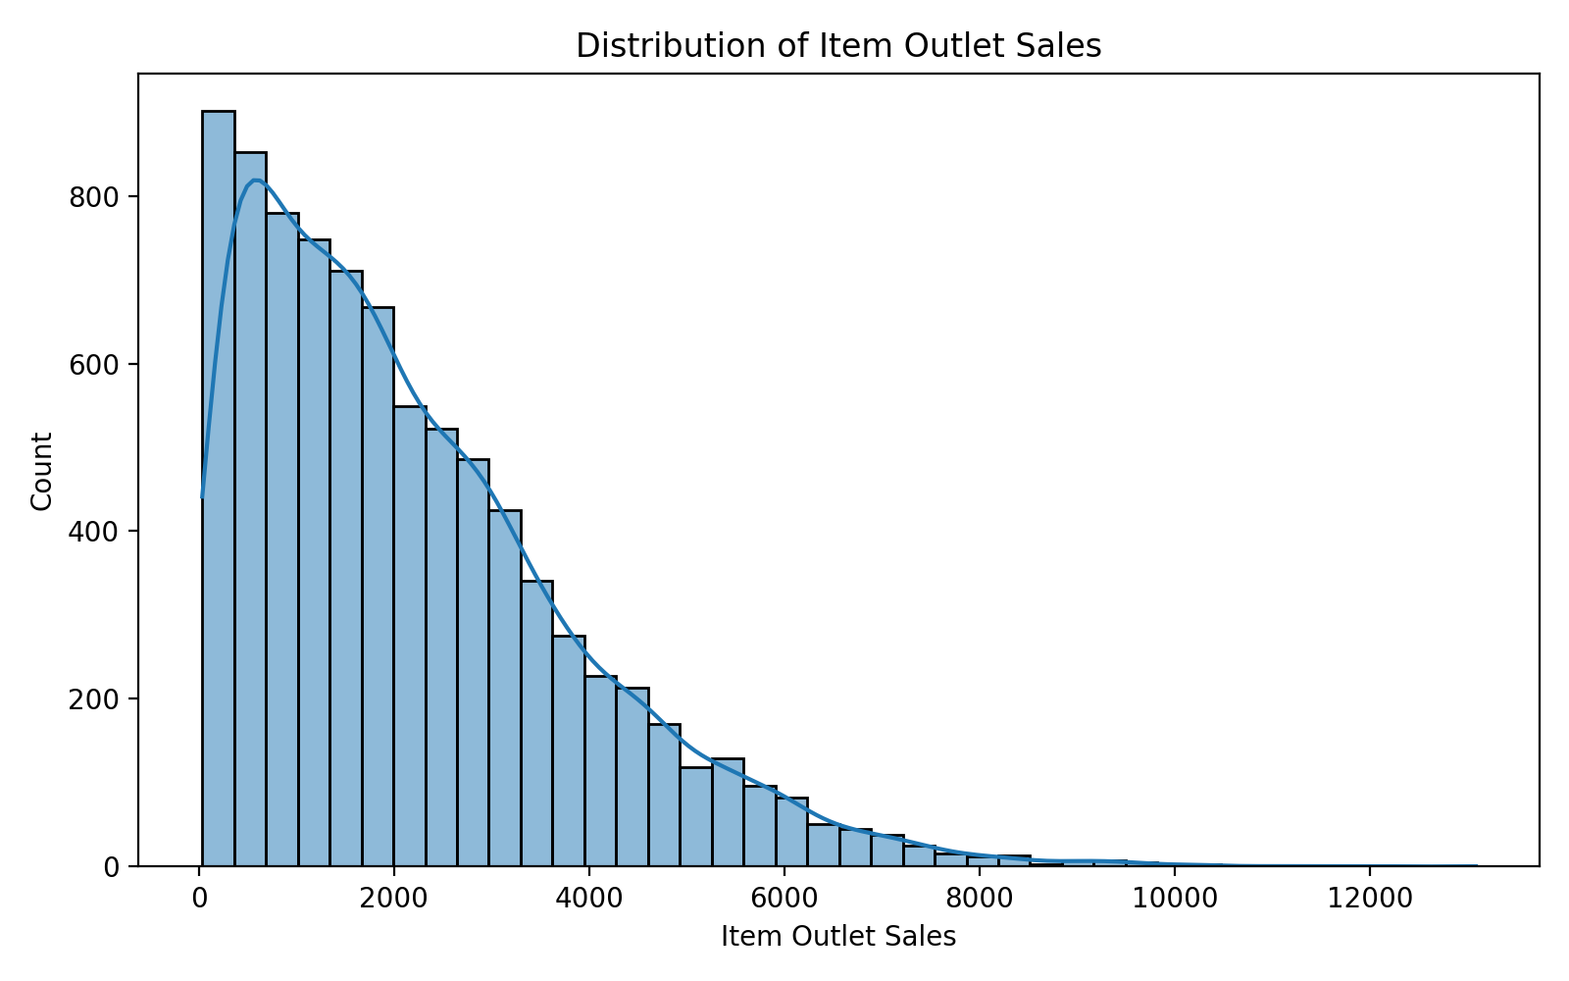
Figure 1. Distribution of item outlet sales
The sales distribution is strongly right-skewed: most observations have moderate sales values, while a smaller number of observations have substantially higher sales. This indicates that the model must perform across a wide range of sales outcomes and helps explain the presence of larger residuals for some high-sales observations.
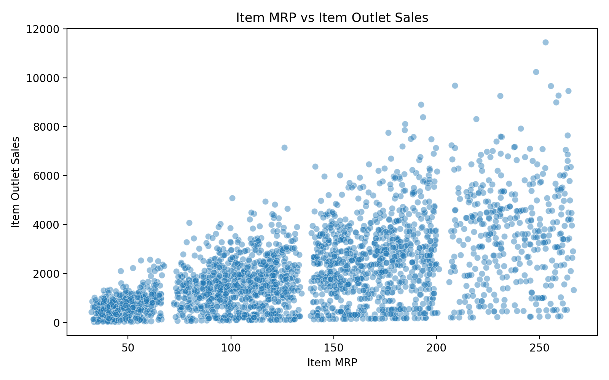
Figure 2. Item MRP versus item outlet sales
The Item_MRP versus sales scatterplot shows a clear upward pattern in the upper MRP ranges, while also showing substantial variability at similar MRP values. This supports using a non-linear model that can capture interactions with outlet and product characteristics rather than relying only on a single linear relationship.
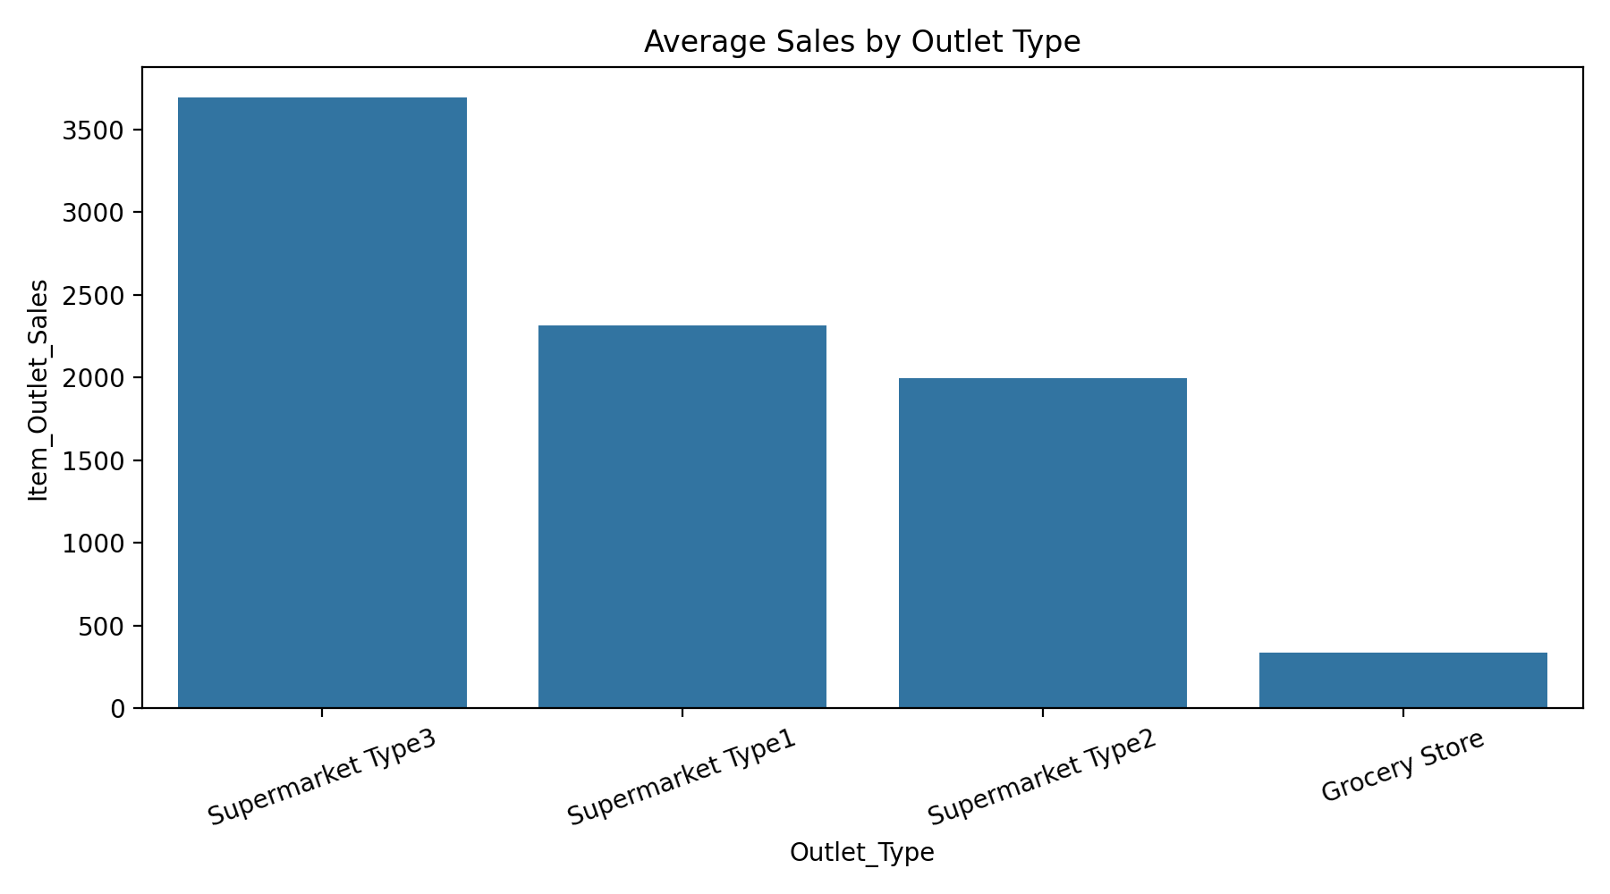
Figure 3. Average sales by outlet type
- Supermarket Type3 had the highest average sales among outlet types, at 3,694.04 in the executed analysis.
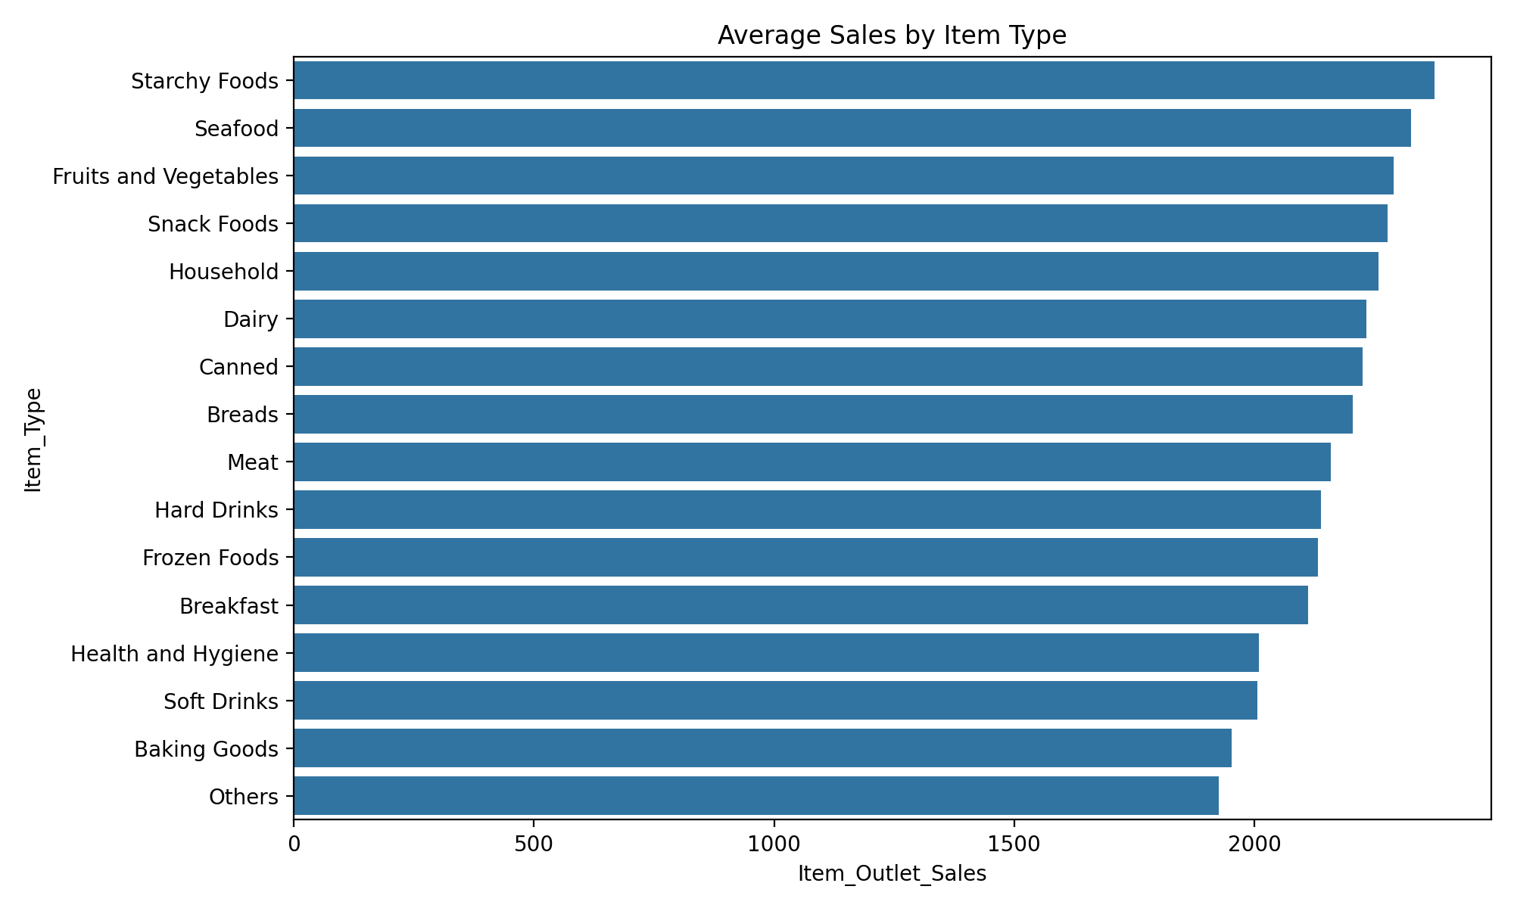
Figure 4. Average sales by item type
- Starchy Foods had the highest average sales among item categories, at 2,374.33 in the executed analysis.
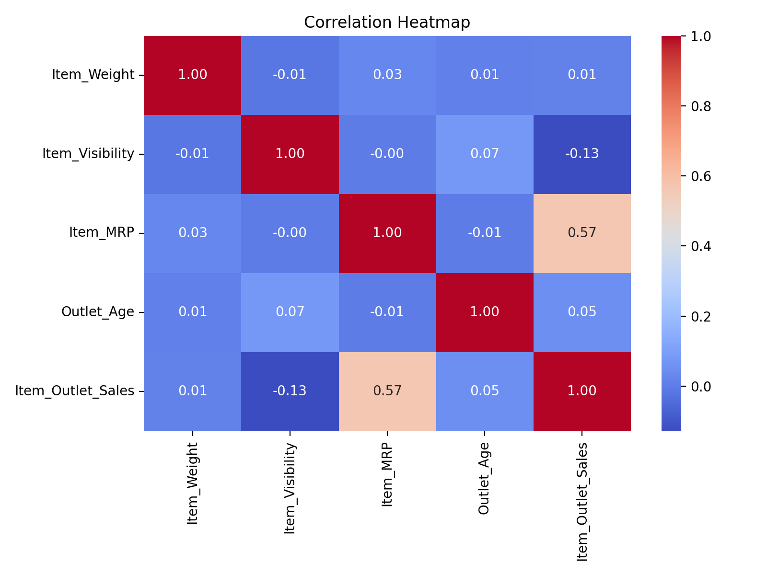
Figure 5. Correlation heatmap for numerical variables
The correlation heatmap shows the strongest simple linear association with the target among the displayed numerical variables for Item_MRP (0.57). Item_Visibility has a weak negative correlation with sales (-0.13), while Item_Weight and Outlet_Age have near-zero linear correlations with the target in this view. Correlation is only a linear measure and does not capture all non-linear or categorical effects.

6. Feature Selection
Identifier variables were considered carefully so that the model would not treat arbitrary labels as meaningful numeric quantities. Item_Identifier was not used as a direct predictive feature. The remaining product and outlet variables were retained because they contain potentially useful business information, while the model pipeline handled categorical encoding.
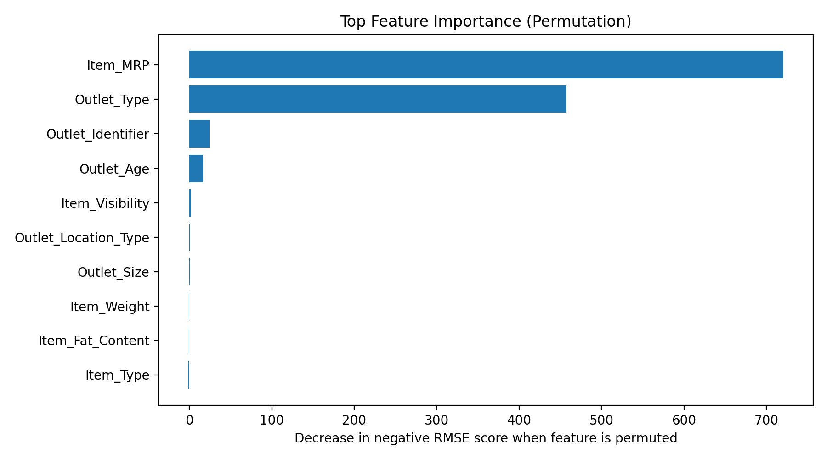
Figure 6. Top feature importance from permutation analysis
Permutation importance identified Item_MRP as the strongest predictor in the executed model, with a mean importance score of 720.72. Outlet_Type was the second strongest feature, with a mean importance of 457.64. These scores indicate predictive contribution within the fitted model; they do not establish causality.
Feature | Mean permutation importance | Std. dev.
Item_MRP | 720.72 | 34.36
Outlet_Type | 457.64 | 21.40
Outlet_Identifier | 24.65 | 4.71
Outlet_Age | 16.51 | 3.87
Item_Visibility | 1.89 | 2.76
Outlet_Location_Type | 0.31 | 0.20

7. Model Development
The data was divided into training and test sets using an 80/20 split with a fixed random state of 42. Preprocessing was integrated with the model pipeline so that transformations are learned from the training data and then applied to the test data.
Model | Purpose
Linear Regression | Baseline; interpretable linear relationship
Decision Tree Regressor | Non-linear rule-based model
Random Forest Regressor | Ensemble of decision trees
HistGradientBoosting Regressor | Boosting-based non-linear model

The use of multiple models provides a meaningful comparison between a simple linear baseline and more flexible non-linear ensemble methods. This is aligned with the requirement to train multiple models and compare performance.

8. Model Optimization
Random Forest was selected for hyperparameter optimization because it provided a strong baseline among the candidate models and can capture non-linear relationships and interactions among product and outlet attributes.
- Optimization method: RandomizedSearchCV.
- Validation strategy: 5-fold cross-validation within the training set.
- Hyperparameters explored included the number of trees, tree depth, minimum split size, minimum leaf size, and the number of features considered at each split.
- Optimization improved the Random Forest test RMSE from 1,067.37 to 1,025.15, a reduction of 3.96%.
- Test MAE improved from 743.43 to 717.03, a reduction of 3.55%.
- R² improved from 0.581 to 0.613, an increase of 0.033.

9. Model Evaluation and Validation
The project used MAE, MAPE, MSE, RMSE, and R², as required for regression evaluation. Lower values are preferable for MAE, MAPE, MSE, and RMSE, while a higher R² indicates greater explained variance.
Model | MAE | MAPE | MSE | RMSE | R²
Linear Regression | 792.02 | 106.25% | 1,143,541 | 1,069.36 | 0.579
Decision Tree | 800.78 | 58.45% | 1,321,589 | 1,149.60 | 0.514
Random Forest | 743.43 | 56.51% | 1,139,285 | 1,067.37 | 0.581
HistGradientBoosting | 747.72 | 58.00% | 1,160,131 | 1,077.09 | 0.573
Optimized Random Forest | 717.03 | 55.51% | 1,050,935 | 1,025.15 | 0.613

Metric | Interpretation
MAE | Average absolute prediction error in sales units; easier to interpret directly.
MAPE | Average absolute percentage error; can become large when actual values are small.
MSE | Average squared prediction error; gives stronger penalty to large errors.
RMSE | Square root of MSE; expressed in the same units as the target and useful for comparing model error.
R² | Proportion of target variance explained by the model relative to a mean baseline.

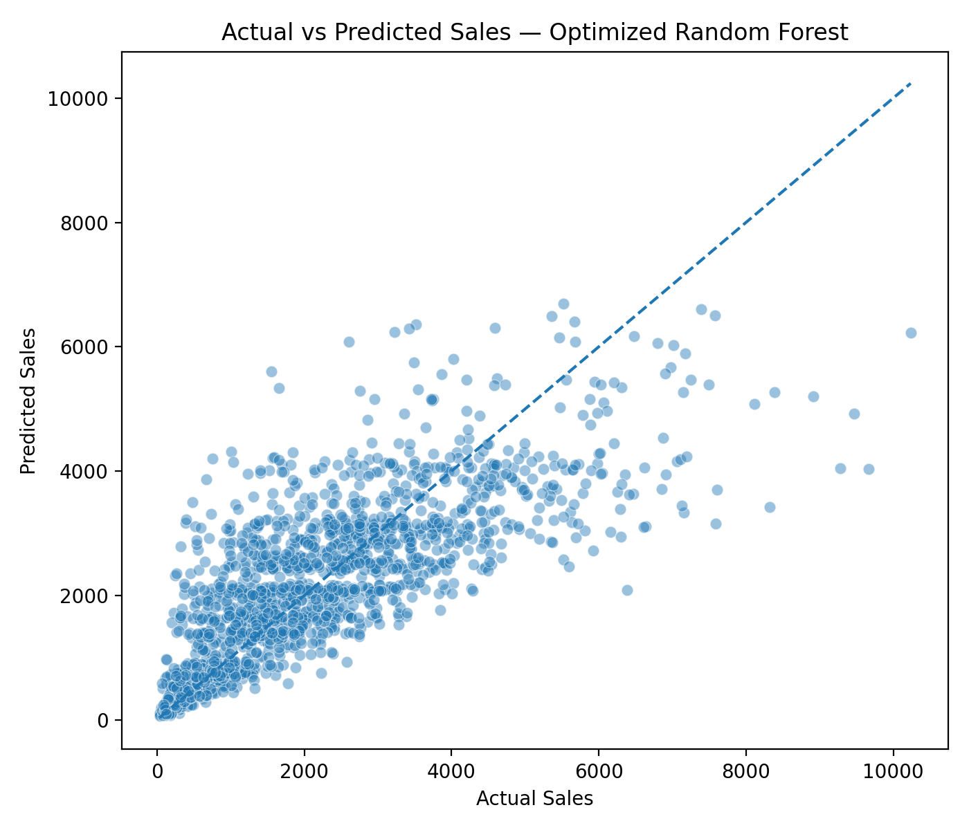
Figure 7. Actual versus predicted sales for the optimized Random Forest
The actual-versus-predicted plot shows that the optimized Random Forest follows the overall direction of the observed sales values but does not perfectly reproduce very high-sales observations. This is consistent with the final R² of 0.613: the model captures meaningful variation, but a substantial portion remains unexplained.
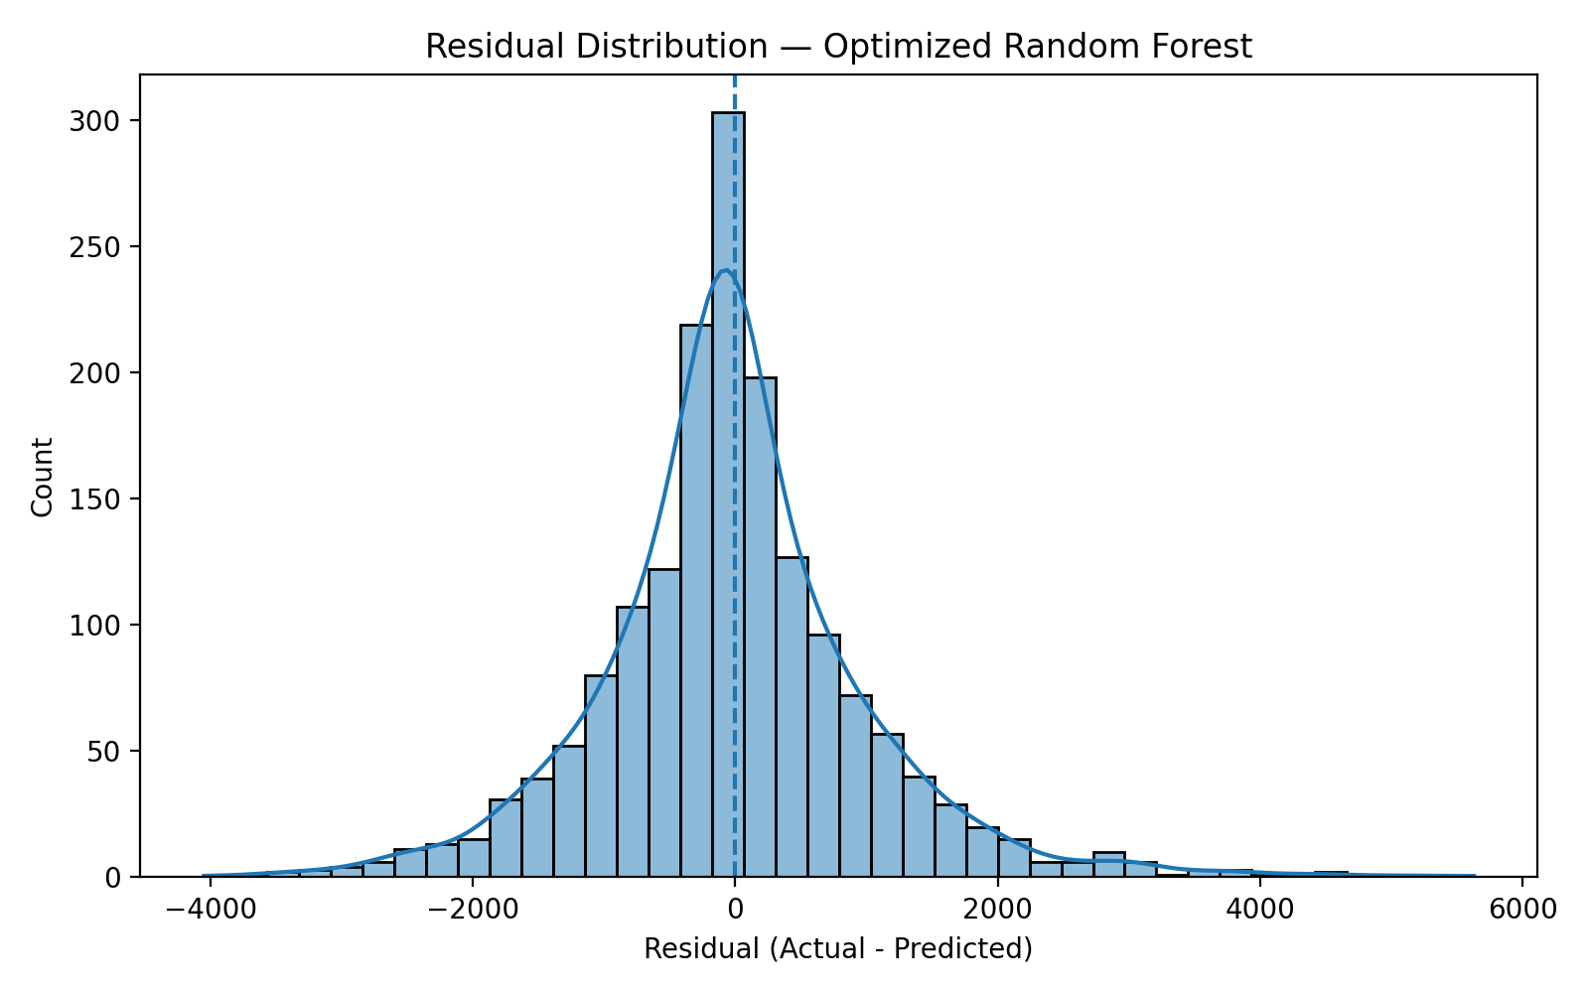
Figure 8. Residual distribution for the optimized Random Forest
Residuals are centered around zero with a noticeable spread and some larger errors in both directions. This indicates that the model is useful for general prediction but can still underpredict or overpredict individual observations, especially at the extremes.

10. Business Insights and Recommendations
The model is intended as decision support rather than an autonomous decision-maker. The following observations are based on the executed analysis and should be combined with operational knowledge and current business information.
- Use the optimized Random Forest for sales estimation and scenario analysis. Its lowest test RMSE among the evaluated models makes it the strongest candidate for the project workflow.
- Treat Item_MRP as an important predictive variable. The permutation analysis indicates strong predictive contribution, but this does not imply that increasing price will necessarily increase sales. Pricing decisions should also consider demand elasticity, competition, promotions, and margins.
- Examine what distinguishes Supermarket Type3 outlets because this outlet type has the highest observed average sales in the dataset. Operational practices, assortment, customer traffic, and product mix should be investigated before applying the pattern elsewhere.
- Review the Starchy Foods category as a potentially strong category for assortment and inventory analysis because it has the highest average sales in the executed EDA. Availability and product mix should be checked before expanding inventory commitments.
- Monitor prediction errors over time. The residual and actual-versus-predicted plots show that very high sales can remain difficult to predict, so managers should avoid treating individual predictions as exact values.

11. Limitations
- The analysis is based on historical observations and may not fully represent future market conditions.
- Predictive importance does not establish causality. In particular, the importance of Item_MRP should not be interpreted as proof that changing price will produce a specific sales response.
- The available features do not capture every factor that can influence sales, such as promotions, competitor actions, stock-outs, seasonality, local events, and changing consumer behavior.
- MAPE is relatively high compared with the other error metrics and should be interpreted cautiously because percentage errors can become unstable when actual sales values are small.
- Future deployment would require monitoring for data drift and periodic model retraining when the underlying retail environment changes.

12. Conclusion
This project demonstrates a complete regression workflow for retail sales prediction. The data was audited and cleaned, missing values and duplicates were addressed, outliers were assessed, EDA was conducted, and multiple regression models were compared. The optimized Random Forest was selected as the final model because it achieved the lowest test RMSE (1,025.15) and the highest R² (0.613) among the evaluated candidates.
The analysis also identified Item_MRP and outlet characteristics as important predictive factors. The results show how predictive analytics can support retail planning, while also highlighting the need to combine model outputs with managerial judgment and current business context.

13. AI Usage Disclosure
AI tools were used as learning and coding-support tools during the project. They were used to support explanation of predictive-analytics concepts and Python, Pandas, NumPy, and Scikit-learn code, and to assist with debugging and workflow organization. The project code was executed against the selected dataset, and the final submission is the student's responsibility. The student should understand and be able to explain the submitted code, model choices, evaluation metrics, interpretations, and business recommendations.

14. References
- Kaggle. Big Mart Sales Prediction Datasets. Dataset used for the project.
- MIS444. Course Project: Predictive Analytics in Business. Instructor-provided project brief.
- Scikit-learn documentation. Regression models, preprocessing, model selection, metrics, and inspection utilities.
- Pandas documentation. Data loading, cleaning, grouping, and tabular analysis.

Appendix A - Key Submission Checklist
- Completed notebook runs successfully and contains the full project workflow.
- Final report includes the actual model metrics from the executed run.
- EDA figures and result files are retained with the project.
- AI usage disclosure is included.
- GitHub repository contains the notebook, report, README, figures, and relevant results.
- GitHub repository link is submitted through the required course channel.
- No PowerPoint presentation is required according to the course brief.
Submission note: Replace the student name, student ID, and submission date fields on the title page before submission.

