Society for Computer Technology & Research’s
PUNE INSTITUTE OF COMPUTER TECHNOLOGY



Data Science and Big Data Analysis Lab [310257]
Mini-Project Report on

[Habit Recommendation System]

Submitted by

[Yashas Jain, 31420 ]
[Diksha Nishikant Deglurkar, 31410 ]

Class: - T.E (2019 course) Branch: -Computer Engineering

ACADEMIC YEAR: 2025-26

TABLE OF CONTENTS

CHAPTER NO. | NAME OF CHAPTER | PAGE NO
 | Introduction
 | Motivation
 | Objective/ Purpose
 | Scope of Project
 | Intended Audience (who all can use your project)
 | Functional requirements (Each function in project and its description in short)
 | Non-functional requirements (such as performance safety)
 | Operating Environment (Database, S/W and H/W requirements)
 | Architectural Diagram and Flowchart
10. | Implementation details along with screenshots
11. | Conclusion
12. | References

- INTRODUCTION

The COVID-19 Vaccination Data Analysis project aims to study and interpret vaccination trends across different states and union territories of India using real-world datasets. The dataset used in this project contains time-series information representing daily vaccination progress, including the number of doses administered, demographic distribution, and cumulative vaccination statistics.

This project is implemented using Python and leverages powerful data analysis libraries such as Pandas and NumPy for efficient data manipulation and computation. The analysis focuses on extracting meaningful insights such as state-wise vaccination performance, comparison between first and second dose coverage, and gender-based distribution of vaccination.

A key challenge addressed in this project is handling real-world data issues such as missing values, inconsistent entries, and incomplete records. To ensure accurate analysis, preprocessing steps such as data cleaning, type conversion, and filtering of invalid records are performed. The project also emphasizes extracting the most recent valid data for each state, which is critical for meaningful comparisons.

Overall, this project demonstrates how raw public health data can be transformed into actionable insights, helping in understanding vaccination coverage, identifying regional disparities, and supporting data-driven decision-making.

- MOTIVATION

The COVID-19 pandemic was one of the most significant global health crises, requiring large-scale vaccination campaigns across countries. Monitoring and analyzing vaccination data became essential for governments and organizations to evaluate progress and make informed decisions.

The motivation behind this project arises from the need to:
- Analyze vaccination progress across different states in India
- Understand the gap between first dose and second dose administration
- Identify gender-based disparities in vaccination
- Handle real-world datasets that contain missing and inconsistent values
- Apply data science techniques to derive insights from public health data

Vaccination datasets are often complex and noisy, making it important to apply proper data preprocessing techniques before analysis. This project highlights how such datasets can be cleaned and analyzed effectively to extract valuable insights.

Ultimately, the goal is to bridge the gap between raw data and meaningful interpretation, enabling better understanding of vaccination trends.

- OBJECTIVE/ PURPOSE

The primary objective of this project is to perform a comprehensive analysis of COVID-19 vaccination data in India and extract meaningful insights.

The specific objectives include:

- To analyze vaccination data across all Indian states and union territories
- To compute state-wise statistics for first and second dose administration
- To study gender-wise distribution of vaccination using available data
- To handle missing, inconsistent, and incomplete data effectively
- To extract the latest valid vaccination record for each state
- To perform data analysis using Python-based tools and libraries
- To present the results in a structured and interpretable format

- SCOPE OF PROJECT

In Scope
The scope of this project primarily focuses on performing structured data analysis on COVID-19 vaccination data using Python-based tools. The following activities are included within the scope:
- Data Loading and Preprocessing
The dataset is imported from a CSV file and processed using Python libraries such as Pandas. Initial preprocessing steps include formatting columns, converting data types (especially date fields), and organizing the dataset into an analysis-ready structure.
- Handling Missing and Inconsistent Data
Real-world datasets often contain missing or invalid entries. This project involves identifying such inconsistencies and applying appropriate techniques such as removal of null values (NaN) and filtering incomplete records to ensure data reliability.
- Extraction of Latest Valid Records per State
Since the dataset is time-series in nature, each state contains multiple entries over time. The project focuses on extracting the most recent valid record for each state to enable accurate and meaningful comparisons.
- State-wise Vaccination Analysis
The project computes and analyzes the number of first and second doses administered across different states and union territories. This helps in understanding regional vaccination progress and identifying leading and lagging states.
- Gender-based Vaccination Analysis
The dataset is used to evaluate vaccination distribution across genders. Total doses administered to male and female populations are analyzed to identify any disparities or trends.
- Visualization of Trends and Comparisons (Optional Extension)
Basic visualizations such as bar charts, line graphs, and pie charts may be included to represent vaccination trends, comparisons among states, and gender distribution in a more intuitive and interpretable manner.

Out of Scope
The following aspects are not included in the current version of the project:
- Real-time Data Streaming or Updates
The project operates on a static dataset and does not include real-time data fetching, live updates, or integration with external APIs.
- Predictive Modeling or Forecasting
No machine learning models are used to predict future vaccination trends or outcomes. The focus remains on descriptive and exploratory data analysis.
- Deep Learning or Advanced AI Techniques
Advanced techniques such as neural networks, deep learning models, or complex AI-based approaches are beyond the scope of this project.
- Deployment as a Full-scale Web Application
Although the project can be extended into a web-based dashboard (e.g., using Streamlit), full-scale deployment and hosting are not considered in this implementation.

- INTENDED AUDIENCE

This project is designed to be useful and relevant to a wide range of users across academic, professional, and research domains. By focusing on real-world COVID-19 vaccination data, the project provides insights that can benefit individuals and organizations working with data-driven decision-making.

The intended audience includes:
- Students studying Data Science, Machine Learning, or Big Data Analytics
This project serves as a practical example for students to understand how theoretical concepts in data science are applied to real-world datasets. It helps them gain hands-on experience in data preprocessing, handling missing values, performing analysis, and extracting meaningful insights using tools like Python and Pandas.
- Researchers analyzing COVID-19 vaccination trends
Researchers working in public health, epidemiology, or data science can utilize this project to study vaccination patterns, compare regional performance, and identify trends or disparities in vaccine distribution. The structured analysis can act as a foundation for further research and exploration.
- Government agencies and healthcare organizations seeking insights
Public health authorities and policymakers can benefit from such analysis to evaluate vaccination progress across different regions. Insights derived from the data can support decision-making, resource allocation, and strategy planning for improving vaccination coverage.
- Data analysts working with public datasets
Professionals dealing with open or government datasets can use this project as a reference for handling noisy and incomplete data. It demonstrates effective techniques for cleaning, transforming, and analyzing large datasets to derive actionable insights.
- Educators demonstrating real-world applications of data analysis
Instructors and trainers can use this project as a teaching example to showcase how data analysis techniques are applied in real-life scenarios. It helps bridge the gap between theoretical learning and practical implementation, making concepts more understandable and relatable.

This project, therefore, not only demonstrates technical skills but also highlights the practical impact of data analysis in addressing real-world problems, making it valuable for a diverse audience.

- FUNCTIONAL REQUIREMENTS

The system is designed to perform a sequence of well-defined operations to ensure accurate data processing and analysis. Each functional component of the system is described below:

Data Loading
- The system loads the COVID-19 vaccination dataset from a CSV file using the Pandas library.
- It ensures that the dataset is correctly read into a DataFrame structure for further processing.
- The loading process is designed to handle large datasets efficiently without data loss.

Data Cleaning and Preprocessing
- The system converts relevant columns, especially the date field (Updated On), into an appropriate datetime format to enable time-based analysis.
- It identifies and handles missing or null values using techniques such as dropna() or type conversion with error handling.
- Inconsistent, duplicate, or invalid rows are removed to maintain data integrity.
- Numeric columns are explicitly converted into proper numeric types to avoid computation errors during analysis.

Latest Record Extraction
- Since the dataset contains multiple entries per state over time, the system extracts the most recent valid record for each state.
- It ensures that only rows with complete and meaningful data (non-null values) are considered.
- This step guarantees that the analysis reflects the latest available vaccination status for each state.

State-wise Vaccination Analysis
- The system computes the number of first dose vaccinations administered in each state.
- It also calculates the number of second dose vaccinations administered across states.
- The results are organized in a structured format to allow easy comparison between different regions.
- Sorting and ranking mechanisms may be applied to identify top-performing states.

Gender-based Vaccination Analysis
- The system calculates the total number of vaccine doses administered to male individuals.
- Similarly, it computes the total number of doses administered to female individuals.
- This analysis helps identify trends and disparities in vaccination distribution across genders.

Result Output and Presentation
- The system displays the computed results in a clear and structured tabular format.
- Outputs are designed to be easily interpretable, allowing users to quickly understand key insights.
- Optional visual representations such as charts and graphs may be included to enhance readability and interpretation.

Summary of Functional Flow
- Load dataset
- Clean and preprocess data
- Extract latest valid records
- Perform state-wise and gender-based analysis
- Display results in an interpretable format

This structured approach ensures that the system performs accurate, reliable, and meaningful analysis on the vaccination dataset.

- Non-Functional Requirements
.
Non-functional requirements define the quality attributes and performance standards that the system must satisfy to ensure efficient and reliable operation.

Performance
- The system should be capable of processing the dataset efficiently within a short time frame, typically a few seconds on a standard machine.
- Data loading, preprocessing, and analysis operations should be optimized to avoid unnecessary computational overhead.
- The implementation should ensure smooth execution even when handling moderately large datasets.

Scalability
- The solution should be designed in a way that it can handle larger datasets with minimal or no changes to the core logic.
- As the dataset size increases, the system should maintain acceptable performance with proportional increases in computation time.
- The use of efficient data structures (such as Pandas DataFrames) ensures scalability for future extensions.

Accuracy
- The system must ensure high accuracy in results by properly handling missing, null, or inconsistent data.
- Data type conversions and validation steps should be implemented carefully to avoid incorrect computations.
- All analytical outputs should correctly reflect the underlying dataset after preprocessing.

Reliability
- The system should be robust enough to handle incomplete or imperfect datasets without crashing.
- Error handling mechanisms (such as safe type conversions and null checks) should be implemented to prevent runtime failures.
- The system should consistently produce correct outputs under normal operating conditions.

Usability
- The implementation should be simple, clear, and easy to understand, even for users with basic programming knowledge.
- Code structure should be organized and readable to facilitate learning and reuse.
- Outputs should be presented in a user-friendly format that allows quick interpretation of results.

Portability
- The project should be platform-independent and capable of running on any operating system that supports Python.
- It should not rely on system-specific configurations or dependencies.
- The use of standard libraries ensures compatibility across environments such as Windows, Linux, and macOS.

- OPERATING ENVIRONMENT

Software Requirements

Component | Specification
Operating System | Windows / Linux / macOS
Python | Version 3.8 or higher
Pandas | Data loading and manipulation
NumPy | Numerical computations
Jupyter Notebook | Code execution environment
Hardware Requirements

Component | Specification
Processor | Intel i3 or higher
RAM | Minimum 4 GB

- Architectural Diagram and Flowchart

System architecture
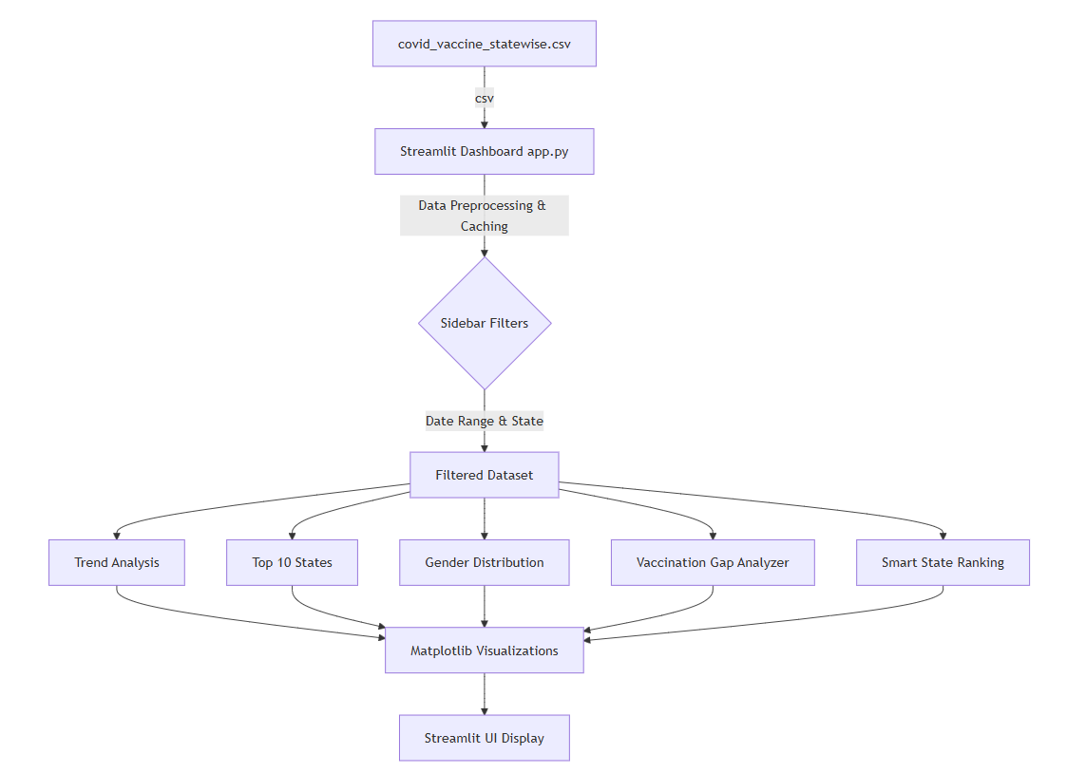

Flowchart
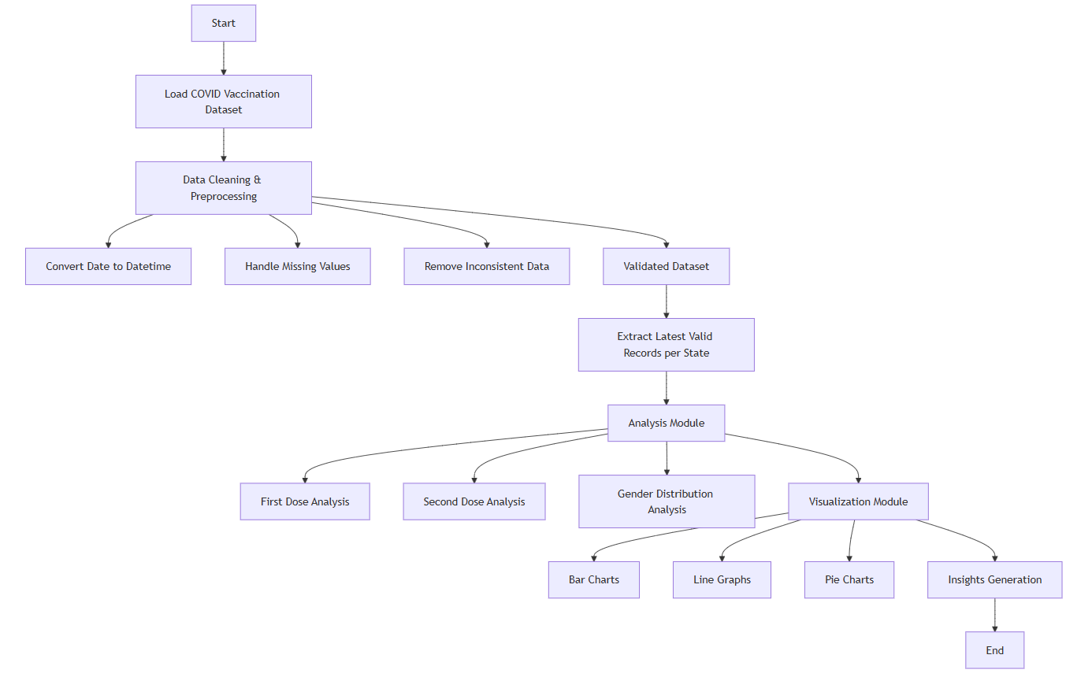

- Implementation details along with screenshots

10.1 Technology Stack
The project is implemented using the following technologies and tools:
- Python – Core programming language used for data processing and analysis
- Pandas – Used for data loading, cleaning, and manipulation
- NumPy – Used for numerical computations and efficient data handling
- Jupyter Notebook – Used as the development and execution environment

10.2 Data Processing
The dataset is processed through a series of well-defined steps to ensure accuracy and reliability:
- The dataset is loaded into a Pandas DataFrame for structured data handling
- The ‘Updated On’ column is converted into datetime format to enable time-based analysis
- Missing or null values are handled using appropriate techniques such as dropna()
- Invalid, inconsistent, or incomplete records are removed to maintain data integrity

10.3 Key Logic: Latest Valid Record Extraction
To obtain accurate state-wise analysis, it is necessary to extract the most recent valid data for each state. This is achieved using the following logic:
df = df.sort_values('Updated On')
clean_df = df.dropna(subset=['First Dose Administered', 'Second Dose Administered'])
latest_df = clean_df.groupby('State').tail(1)
This approach ensures that:
- Data is first sorted chronologically
- Only rows with valid (non-null) vaccination values are considered
- The latest valid entry for each state is selected
As a result, the analysis is based on the most recent and reliable data available.

10.4 Analysis Performed
The following analyses are carried out on the processed dataset:
- State-wise First Dose Vaccination
Determines the number of first dose vaccinations administered in each state
- State-wise Second Dose Vaccination
Determines the number of second dose vaccinations administered in each state
- Gender-based Analysis
  - Total vaccinations administered to male individuals
  - Total vaccinations administered to female individuals
These analyses provide insights into vaccination coverage and distribution patterns.

10.5 Execution
- The code is executed using Jupyter Notebook, which provides an interactive environment for development and visualization
- Results are displayed in a structured tabular format for easy interpretation
- The execution time is minimal (typically under 5 seconds), making the system efficient and responsive

- Conclusion

The COVID-19 Vaccination Data Analysis project successfully demonstrates how real-world datasets can be systematically processed, cleaned, and analyzed using fundamental data science techniques. By working with a large and complex time-series dataset, the project highlights the practical challenges involved in handling real-world data, such as missing values, inconsistent entries, and incomplete records. Through the use of Python libraries like Pandas and NumPy, the raw data is transformed into a structured and analysis-ready format, enabling accurate and meaningful computations. This process reinforces the importance of data preprocessing as a crucial step before performing any form of analysis.

A key aspect emphasized in this project is the necessity of proper data cleaning and validation. Handling missing and inconsistent data ensures that the results are reliable and free from misleading interpretations. By carefully filtering out invalid records and extracting the latest valid data for each state, the analysis maintains a high level of accuracy. The project also demonstrates how simple yet effective techniques can be used to extract meaningful insights from raw datasets, making the data more interpretable and useful for decision-making. This approach reflects real-world data analysis workflows where data quality directly impacts the credibility of results.

The analysis provides valuable insights into vaccination trends across India, including state-wise vaccination progress, differences between first and second dose coverage, and gender-based distribution of vaccine administration. These insights help in understanding regional disparities and identifying areas that may require additional focus or resources. Overall, the project highlights the practical application of data analysis in solving real-world problems and showcases how data-driven approaches can contribute to better understanding and management of large-scale public health initiatives such as vaccination programs.

- References

- scikit-learn Developers (2024). scikit-learn User Guide — Supervised Learning: Ensemble Methods. Available at: https://scikit-learn.org/stable/modules/ensemble.html
- scikit-learn Developers (2024). sklearn.metrics.pairwise.cosine_similarity. Available at: https://scikit-learn.org/stable/modules/generated/sklearn.metrics.pairwise.cosine_similarity.html
- pandas Development Team (2024). pandas Documentation — DataFrame.groupby. Available at: https://pandas.pydata.org/docs/reference/api/pandas.DataFrame.groupby.html
- pandas Development Team (2024). pandas Documentation — DataFrame.pivot_table / unstack. Available at: https://pandas.pydata.org/docs/reference/api/pandas.DataFrame.unstack.html
- Python Software Foundation (2024). Python 3 Documentation. Available at: https://docs.python.org/3/

