**2048 with AI algorithms**

By

**Sadia Afrin**

Roll: 1907037

**Arpita Kundu**

Roll: 1907050



**Submitted to:**

Md. Shahidul Salim

Lecturer

Most. Kaniz Fatema Isha

Lecturer

**Department of Computer Science and Engineering**

**Khulna University of Engineering & Technology**

**Khulna 9203, Bangladesh**

**2nd July, 2024**

**1 Introduction**

**1.1 Background Information about the Project:**

The idea for the app ‘DinLipi’ came from the realization that existing apps for managing schedules, tasks, notes and memories were scattered and hard to use together. People needed something that brings everything – like events, notes and to-dos – into one easy-to-use app. DinLipi has been created to solve this to encompass all these things in one single user-friendly application.

**1.2 Objectives and Goals of the Project:**

The prime goals of DinLipi are _

* Calendar management with event prioritization
* Weather updates integrated into visually appealing interface
* To-do-list creating including task accomplishment tracking and growth progress monitoring
* Note-taking functionality, including adding, saving, and deleting notes.
* Memory storage akin to Facebook/Instagram posts, with 'on this day' memory feature.

**2 Methodology**

**2.1 Detailed Description of Methods and Procedures:**

To build the game, we worked step by step, making improvements along the way. We used Python as programming language, Anaconda Spyder as IDE, tkinter interface for GUI. To store every information, we have used Firebase database, where each item is stored based on user ID. Our team organized the app using a structure that helps keep things organized, kind of like sorting different jobs into categories.

**Here is the Flow chart of the app:**

Fig – 2.1.1: Flow chart of DinLipi

**Included functionalities are:**

* **CalendarManager**: View calendar, manage event creation, scheduling, and priority settings.
* **WeatherAPI**: Integrates weather updates into the user interface with customize color of contents.
* **NoteManager**: Handles note creation, storage, and deletion functionalities.
* **ToDoListManager**: Manages to-do list creation, task completion status, and progress tracking.
* **MemoryManager**: Stores and retrieves memories, integrates 'on this day' feature.

**Included classes are:**

We have used structures for multiple classes depending on their objects. Here is a pseudocode of the format:

*struct CurrentData:Codable*

*{*

*let last_updated:String*

*let temp_c:Float*

*let wind_kph:Float*

*let humidity:Int*

*let is_day:Int*

*let feelslike_c:Decimal*

*let pressure_in:Decimal*

*let precip_in:Decimal*

*let cloud:Int*

*let uv:Decimal*

*}*

**Details description of each functionality:**

* **Calendar:**  
  We have used Swift UI to create the calendar. It shows the basic Gregorian calendar and the current day is marked blue. From here we can add events.
* **Events:**  
  In the event page, we can add event. While creating, a date picker will be open in a popup, which will pick date and time. We can set the event name and the event priority. Low priority will be colored as green, medium as yellow and high as low. User wise this is dynamic.
* **Weather:**  
  In the weather page we have implemented JSON parsing to fetch current weather

data using API from the site <https://www.weatherapi.com/>.

Here, we have customized the view. If it is day now, a day icon will be automatically set on the top right corner of the page. And same for night. We have set different colors for different UV index; cloud level and wind level and a label will always show current weather condition in different color.

*(Details in the tables in 2.2 result section)*

* **Notes:**  
  We have created the notes section using Storyboard. We can add, edit, store and delete notes and view all notes in the note table sorted by last entered.
* **To-do-list:**  
  This section is created using Swift UI. In the to-do-list page, we can add new to-do-item, and see items sorted by incomplete and complete status. On every to-do-cell, upon clicking, the status will be set into completed.   
  Growth i.e. work progress states daily update about completed and uncompleted tasks. And based on the percentage, it will be colored differently.

*(Details in the tables in 2.2 result section)*

* **Memories and Scrapbook:**

In memory page, we can add new memory. And those memories will be seen in to scrapbook serially in the scroll view. In the ‘on this day’ feature, memories of previous years of that day is shown in scroll view.

**2.2 Result:**

**The Functionality Showcase:**

* **Basic functionality:** It includes the basic splash screen, Sign up-Sign in functionalities and User manual.

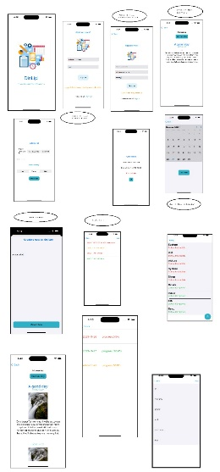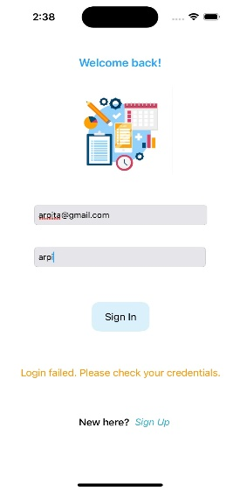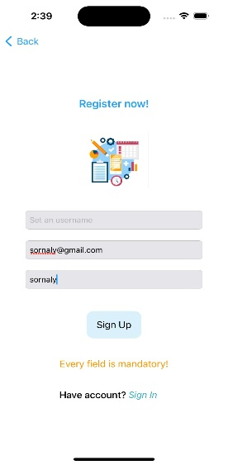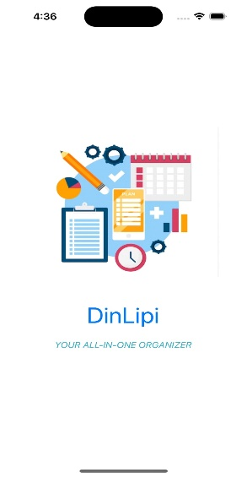

Fig – 2.2.1: Launch Screen, Sign Up & Login, User Manual

* **Calendar and Events**: Allows users to view calendar, add events with priority, view scheduled events based on priority.

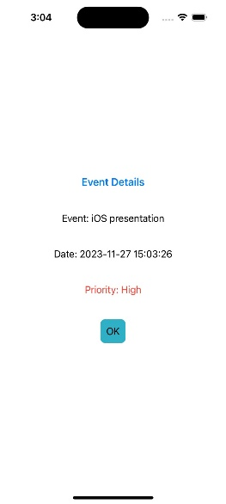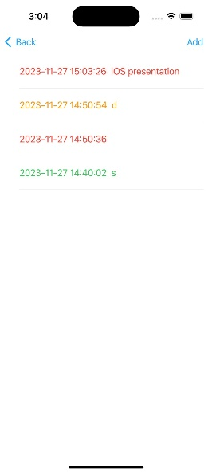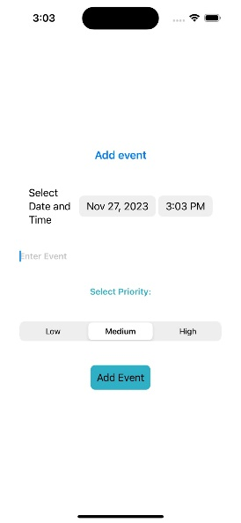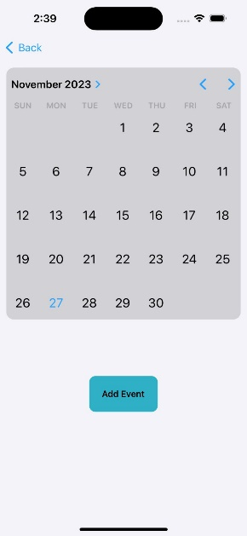

Fig – 2.2.2: Calendar, Add Event, Events Show.

* **Weather Integration**: Displays weather updates in a visually appealing interface.

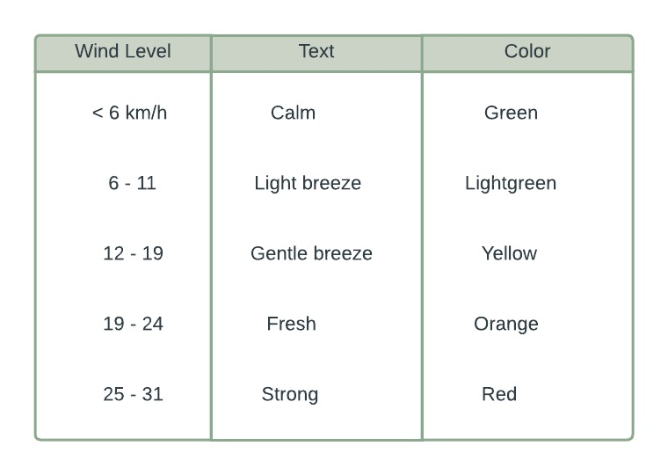

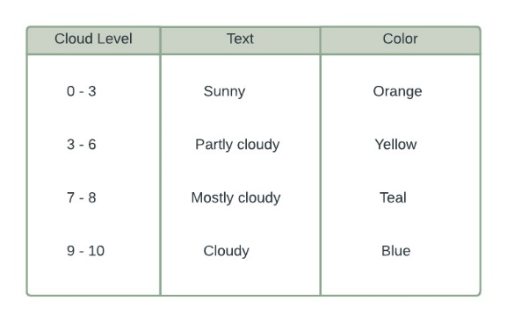

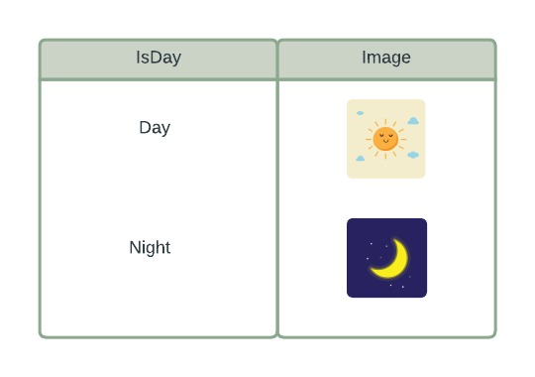

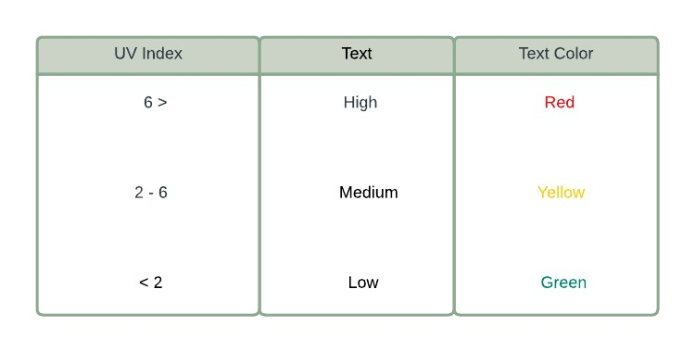

Fig – 2.2.3: Weather Details Tables

* **To-Do List and Growth Page**: Tracks tasks, marks completion, and shows daily progress.

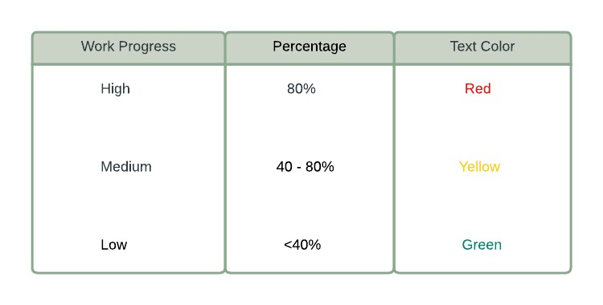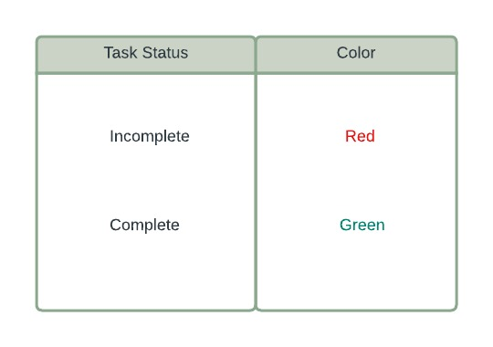

Fig – 2.2.4: Task Status & Work Progress

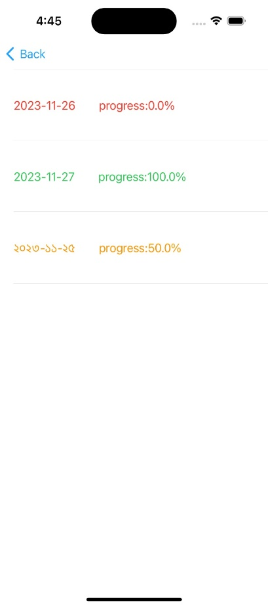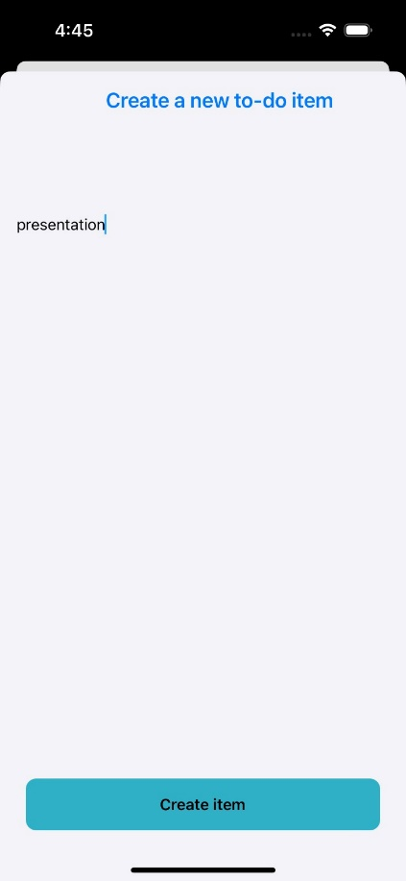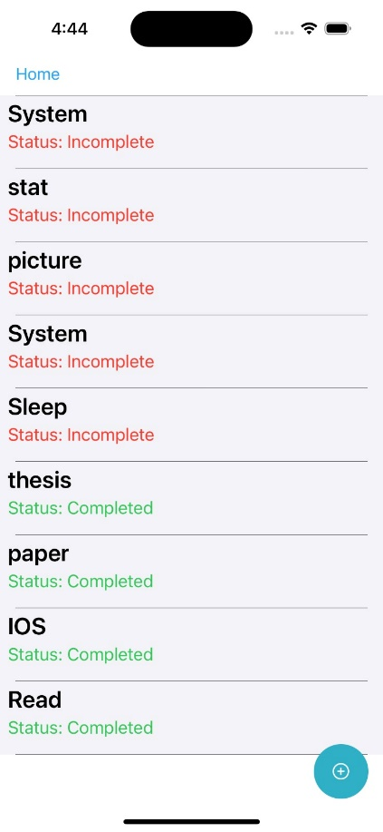

Fig – 2.2.5: To-Do List, Add Todo List, Work Progress

* **Memory Section**: Stores and displays memories, including 'on this day' feature.

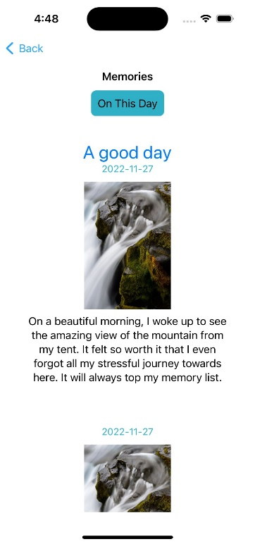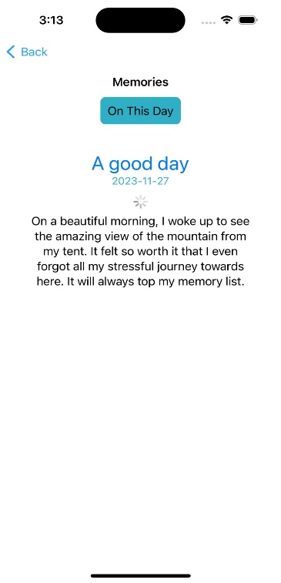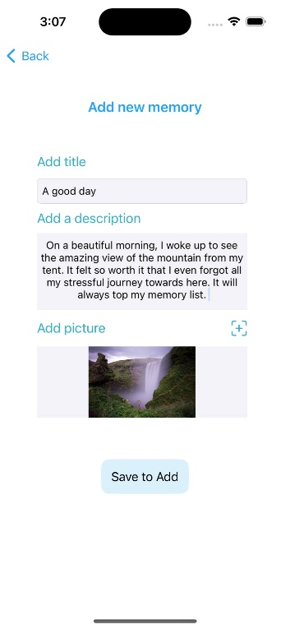

Fig - 2.2.6: Add Memory, Show All Memories, Day-wise Memory

* **Notes Section**: Stores, edits, discards and displays notes

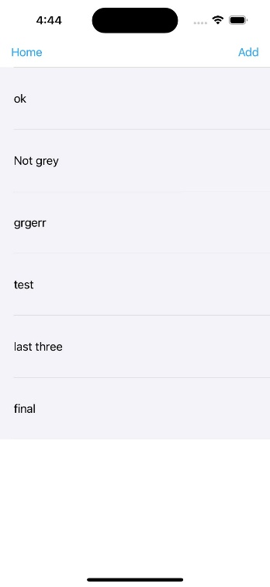

Fig – 2.2.7: Notes show & Add

**3 Discussion**

Integration of multiple features into DinLipi makes it a comprehensive organizational tool. The combination of event scheduling, to-do-items management, memory preservation option simplifies regular day-to-day life management. While building this application we gained a better knowledge about iOS applications development, JSON parsing, Firebase database. In a different platform like Xcode, we got introduced to a unique development experience.

**4 Conclusion and Future work**

To conclude, our app DinLipi offers an integrated solution for personal organization and keeping alive memory on iOS. Future work involves more refined user experience, more weather info using paid API keys, both in-app and push notifications and potentially expanding to other platforms for boarder accessibility.

**5 Reference**

* <https://www.programiz.com/swift-programming>
* <https://docs.swift.org/swift-book/documentation/the-swift-programming-language/thebasics/>
* <https://www.appbrewery.co/p/ios-course-resources/>
* <https://www.youtube.com/watch?v=ARFs3afcR4k>
* <https://www.youtube.com/watch?v=N92PO_xAUc4>