

Course Title : Peripherals & Interfacing Laboratory

Course No : CSE 3104

Project Title : Vending Machine

Submitted To,

##### Md. Repon Islam

##### Lecturer, Department of CSE,KUET.

##### Md. Badiuzzaman Shuvo

##### Lecturer, Department of CSE,KUET.

Submitted By,

Ankon Chowdhury

Roll : 1907048

Lamisa Bintee Mizan Deya

Roll : 1907049

3rd Year 1st Semester

Objectives:

* To know how to work with Arduino Uno
* To know how to operate with SIM 900a GSM module
* To learn about the operation of servo motor
* To know how to connect LCD display with I2C LCD module and then incorporate with the project
* To know the working principle of the vending machine

Introduction:

The purpose of this lab report is to present the design and implementation of a vending machine system using Arduino Uno microcontroller and SIM900A GSM module. The vending machine is an automated system commonly found in various public spaces, allowing users to select and purchase items without human intervention. By incorporating Arduino and GSM technology, we aim to enhance the functionality and interactivity and online payment unlike of the traditional vending machine.

The Arduino Uno serves as the core control unit of the system, providing a programmable platform to manage the different components and processes involved. The SIM900A GSM module enables communication between the vending machine and users through the Global System for Mobile (GSM) network.

The integration of the Arduino Uno and SIM900A GSM module allows for a range of advanced features and capabilities. Users can send SMS to the vending machine, initiating a purchase, obtaining information about the vending machine's status. The vending machine system also includes a selection mechanism, typically a servo motor, to dispense the selected items.

This lab report will outline the design and construction of the vending machine system, including the hardware components, circuitry, and software implementation. The system's functionality, such as user interaction, item selection, and dispensing, will be discussed in detail.

Apparatus Required:

* Arduino Uno
* SIM900A GSM Module,
* LCD Display
* I2C LCD Module
* Buck Converter
* Servo Motor
* 3.7V DC batteries (2 piece)
* Buzzer
* Breadboard
* Jumping wire and others

Flow Chart:

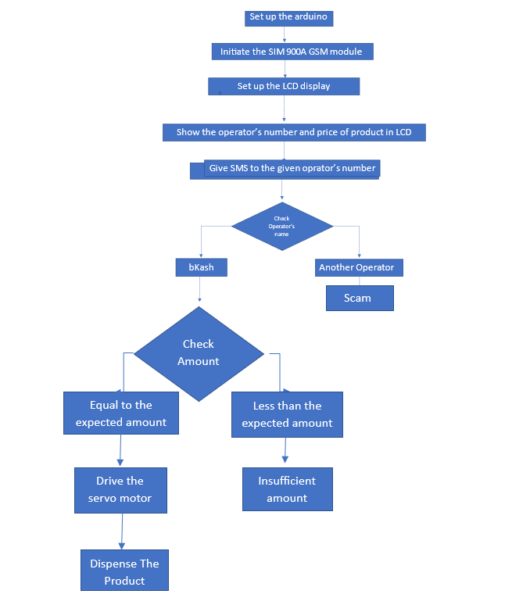

Principle of Arduino Uno:

The Arduino Uno is the core microcontroller board used in this system. It provides a programmable platform to control and coordinate the various components. The Arduino Uno has multiple digital and analog input/output pins, which can be used to interface with other peripherals.

Principle of SIM900A GSM Module:

The SIM900A GSM module enables communication between the vending machine and the user via SMS. It can send and receive text messages, making it ideal for accepting orders and providing feedback. The module uses a SIM card for network connectivity and supports GSM/GPRS communication.

Principle of LCD Display:

The LCD display is used to provide visual feedback and instructions to the user. It can display messages, item prices, and other relevant information. In this setup, both a standard LCD display and an I2C LCD module are utilized.

Principle of I2C LCD Module:

The I2C LCD module simplifies the connection between the LCD display and the Arduino Uno by utilizing the I2C protocol. This protocol reduces the number of wires required for communication, making the setup more compact and manageable.

Principle of Buck Converter:

The buck converter, also known as a step-down converter, is used to regulate the voltage supplied to the components in the vending machine system. It takes a higher input voltage and efficiently steps it down to a lower voltage suitable for the different peripherals. This ensures stable and reliable operation of the system.

Principle of Servo Motor:

The servo motor is responsible for dispensing the items in the vending machine. It is connected to the Arduino Uno and can be controlled to rotate and release items when a valid order is received. The servo motor's movement is precise, allowing for accurate dispensing.

Software Design(Pseudocode):

* Initialize the GSM module to enable communication with the mobile device.

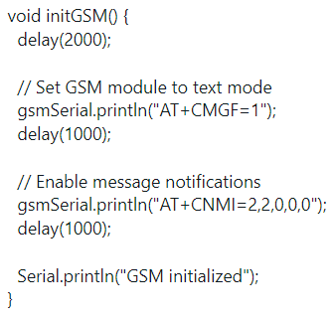

* Initialize the LCD display and I2C LCD module for displaying information.
* Set up the servo motor for product dispensing.

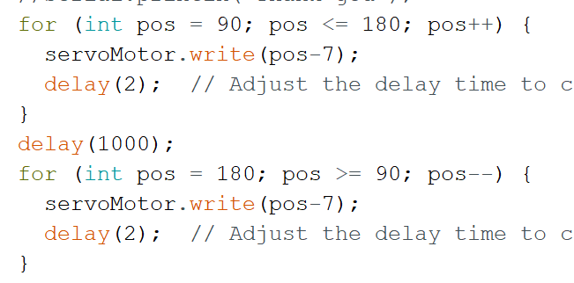

* Monitor for incoming SMS messages using the GSM module.
* Parse the incoming message to determine the amount of money that the buyer sends.

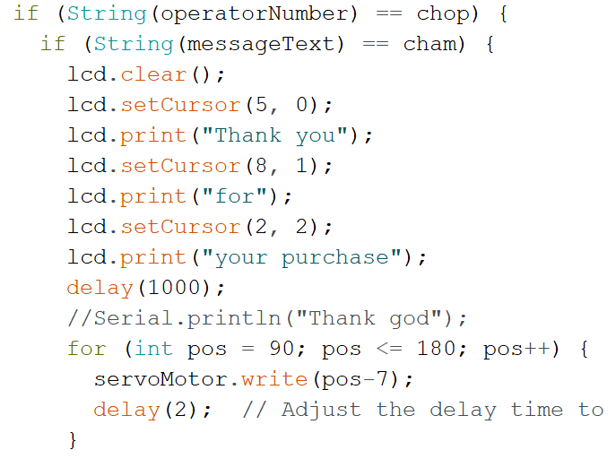

* If the money delivered is equal to the product’s price, deduct the corresponding amount from the user's account.

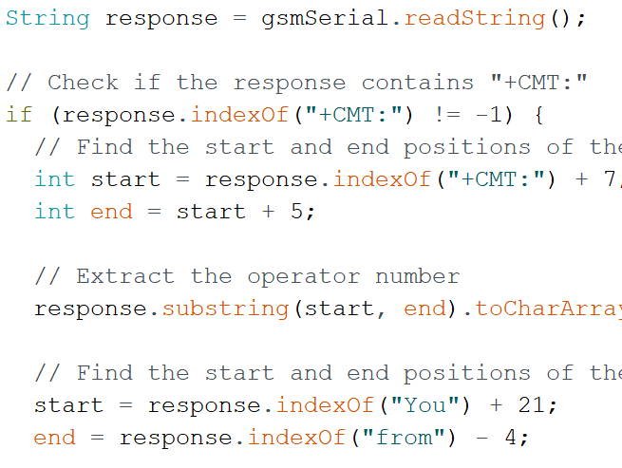

* Activate the servo motor to dispense the product.
* Update the LCD display with relevant information, such as operator number and transaction status.

Hardware Design:

* Arduino Uno: This will be the main controller for the vending machine.
* SIM900A GSM Module: Used for communication with a mobile device to receive vending requests.
* LCD Display: Used to display information such as product selection and payment details.
* I2C LCD Module: Used to interface the LCD display with the Arduino Uno.
* Buck Converter: Used to step down the voltage for powering the Arduino and other components.
* Servo Motor: Used to dispense the selected product.
* Jumping Wires: To connect various components with Arduino Uno.

System Testing:

We have tested this device for 3 cases.

* When the buyer sent money accurate to the expected amount, the motor would run and drive one chocolate.
* When the buyer sent money less than the expected amount, the product would not be driven. Rather there would be a message shown in the LCD display that “You don’t have sufficient money to purchase”
* When the same message that bKash sends was sent by any buyer from his mobile operator, the device would successfully detect that this message was not sent by bKash and gave a warning of “scamming”.

Prototype Design:

Overall Design:

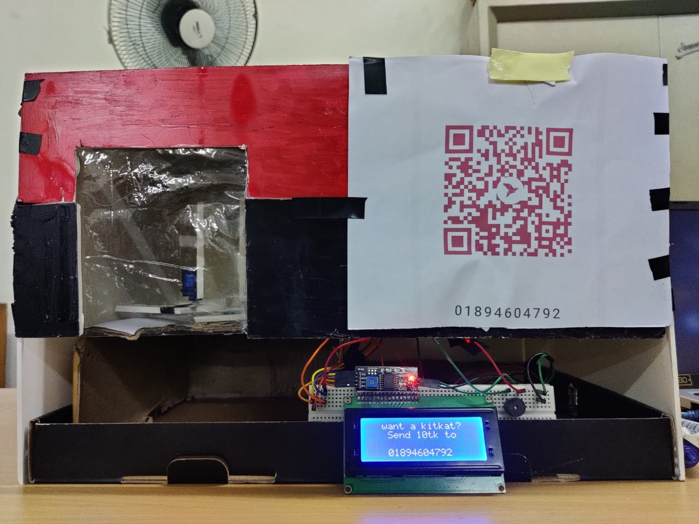

Item Dispense:

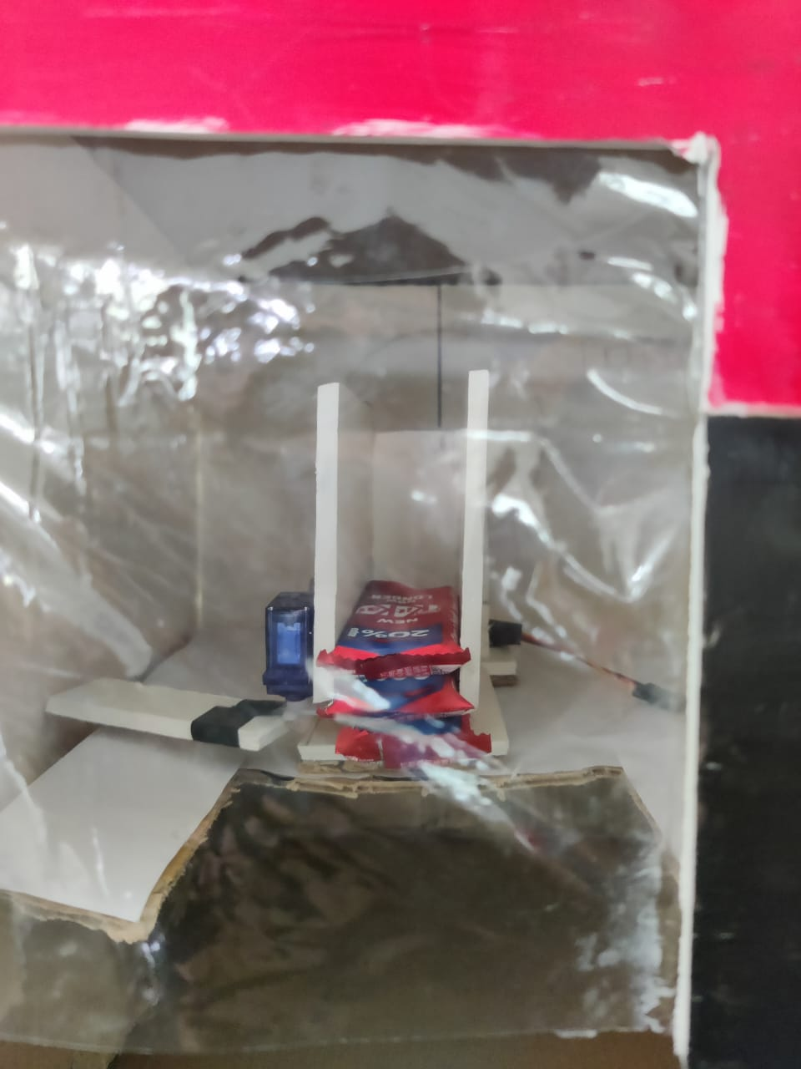

Arduino and GSM Connection:

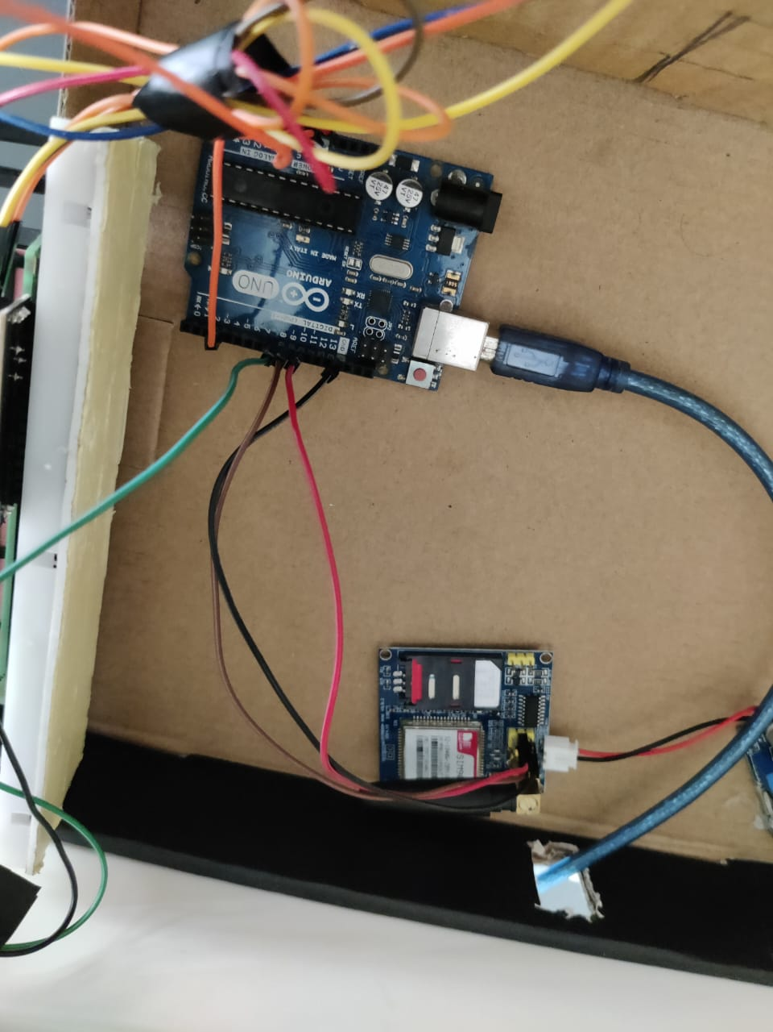

Battery Voltage reduced to 5.3V using buck converter:

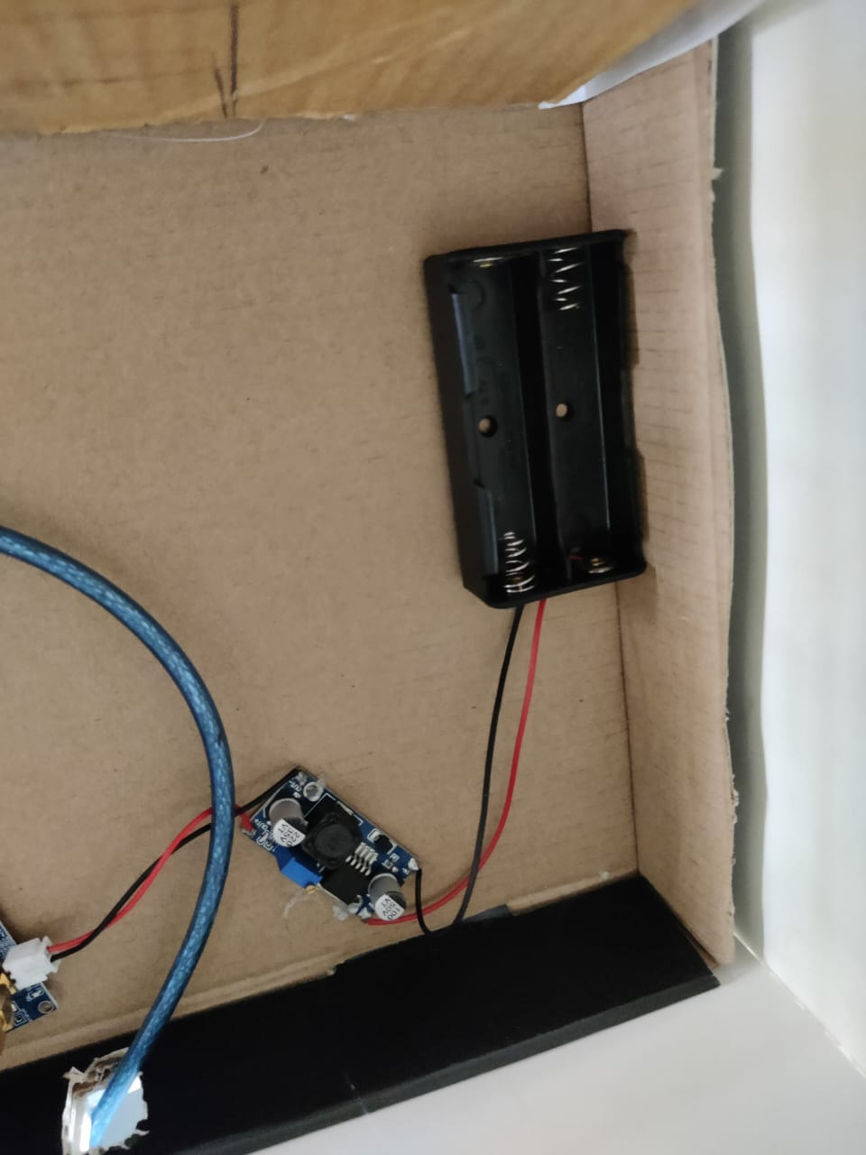

Experimental Results :

We have tested all the three cases mentioned above and got the perfect result each time.

Future Development Objectives:

* We want to use this machine for multiple products.
* We desire to design the layout more professionally
* We will try to use aluminium wire and wheels to dispense the products properly
* We will Send a response SMS to the user with the transaction status and remaining account balance.

Discussion:

From the project we have practically known about the application of the vending machine using Arduino Uno. We have gone through trials and errors and successfully solved the errors on our own with the help of internet. We have used SIM 900A GSM module which was completely new for us. We faced a lot of difficulties to connect the sim using this sim module. We have tested 3 cases to verify the results and gave the output as expected. We have designed our layout using card boards. We have carefully set the angle of the servo motor to drive it to dispense each product properly.

Conclusion:

The integration of the Arduino Uno, SIM900A GSM module, LCD display, I2C LCD module, buck converter, and servo motor allows for the creation of a vending machine system capable of accepting orders via SMS and dispensing items accordingly. This peripheral setup provides an efficient and user-friendly solution for automated vending.

References:

* <https://www.arduino.cc>
* <https://youtu.be/Pz11w0XE-CE>
* <https://youtu.be/nUcrrCJd1sY>
* <https://youtu.be/CvqHkXeXN3M>
* <https://circuitdigest.com/article/servo-motor-working-and-basics>