**Project**

Create a new database in phpMyAdmin “spy”:

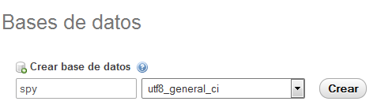

Create a new project called spyLamita in Eclipse.

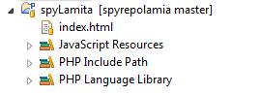

|  |
| --- |
| <!DOCTYPE html>  <html>  <head>  <title> Project </title>  </head>  <body background=*"pic.jpg"* width =*100%* height=*100%*>  <center>    <FONT SIZE=*20* FACE=*VERDANA*><b><U>Index</U></b></FONT><br><br><br>  <FONT SIZE=*5* FACE=*ARIAL*><b>Enlace 1: </b><A HREF=*"http://www.github.com"*>www.github.com</A> </FONT>  <FONT SIZE=*5* FACE=*ARIAL*><br><b>Enlace 2: </b><A HREF=*"http://www.google.com"*>www.google.com</A> </FONT>  <FONT SIZE=*5* FACE=*ARIAL*><br><b>Enlace 3: </b><A HREF=*"http://www.youtube.com"*>www.youtube.com</A> </FONT>  <FONT SIZE=*5* FACE=*ARIAL*><br><b>Enlace 4: </b><A HREF=*"http://www.iessacolomina.es"*>www.iessacolomina.es</A> </FONT>  <FONT SIZE=*5* FACE=*ARIAL*><br><b>Enlace 5: </b><A HREF=*"http://www.sites.google.com/site/sacolominadaw1415"*>www.sites.google.com/site/sacolominadaw1415.com</A> </FONT>  </center>    </body>  </html> |

To put your new project under version control with Git, right-click on your project, select Team → Share Project → Git

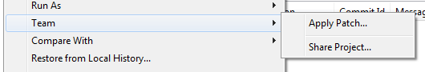

On the next dialog press the Create button.

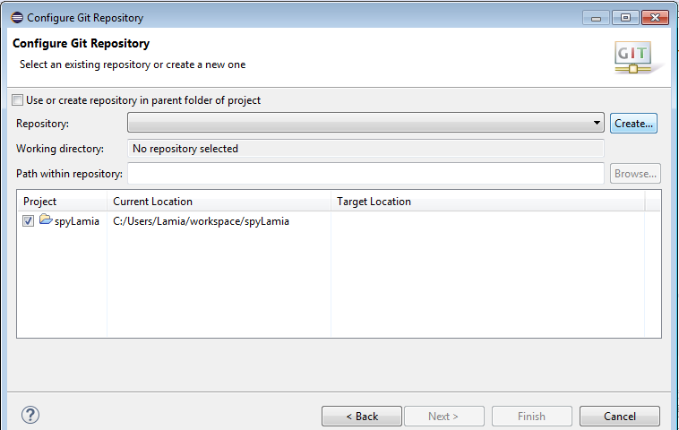

Create a new Git repository “spyRepoLamia”

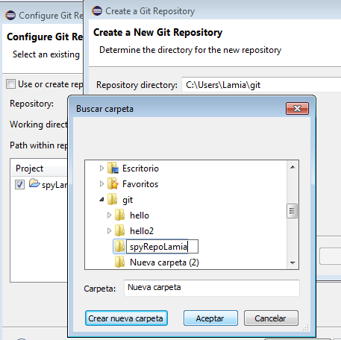

Select the Finish button to put your repository under Git version control.

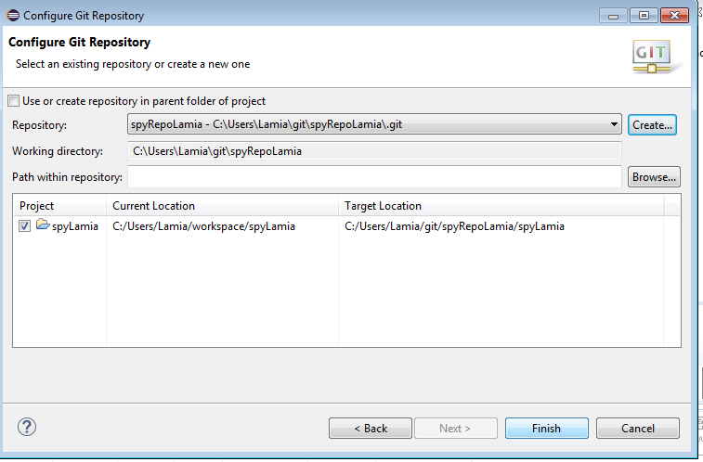

Select file which have changed and drag them into the Staged Changes area.

To commit the staged changes we write a descriptive commit message and press the Commit button.

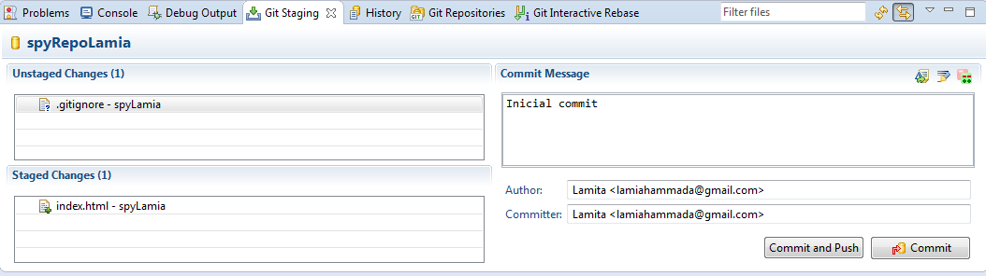

Create new repository in the Github

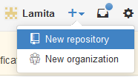

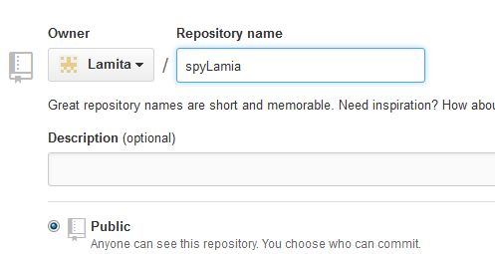

To push your changes to the Github: select Team > Remote > Push

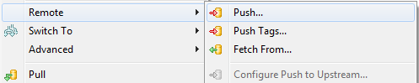

Copy the URI from github

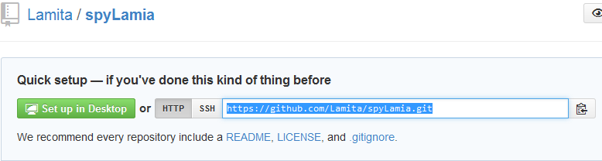

Paste the URI in the location “URI”

Write the password and press en Next

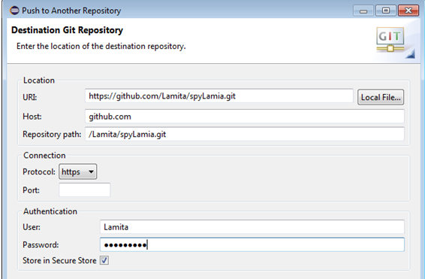

Choose en the Source ref “refs/heads/master” > Press in “All branches Spec”> Finish >OK

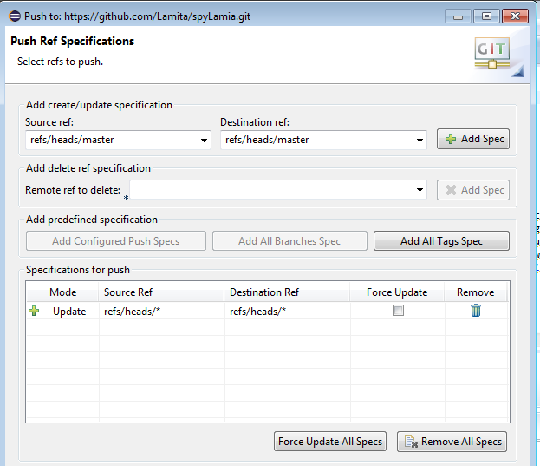

we can see my project in Github

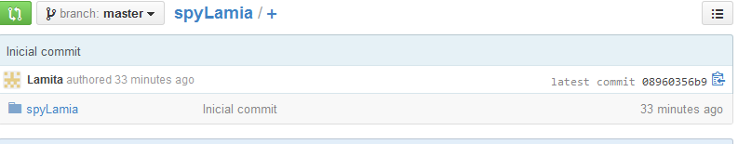

And the project of my partner victor

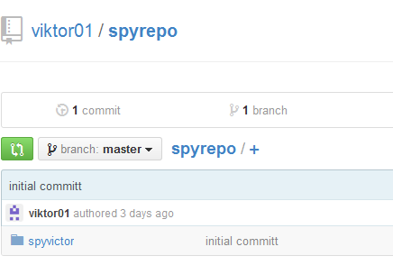

Press in the Fork for clone

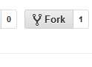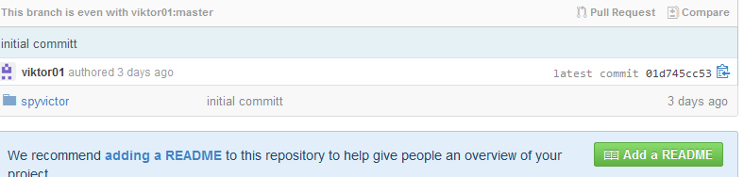

In Eclipse we have to Import the project:

Import > Git > Clone URI

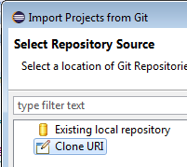

I have to do Copy-paste of my URI from “Github” to “ Source Git Repository”

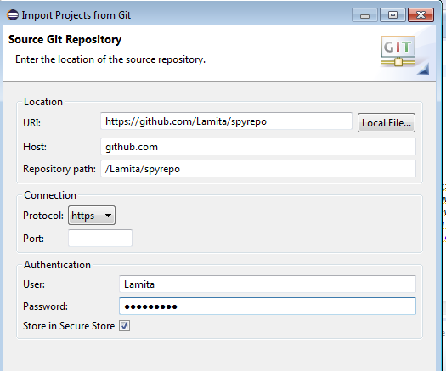

And now I have the project of my partner “Victor”:

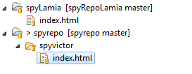

Create a new file Php “spy.php”

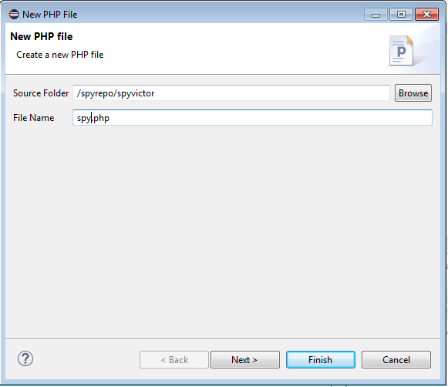

Select PHP file which have and drag them into the Staged Changes area.

To commit the staged we write a descriptive commit message and press the Commit button.

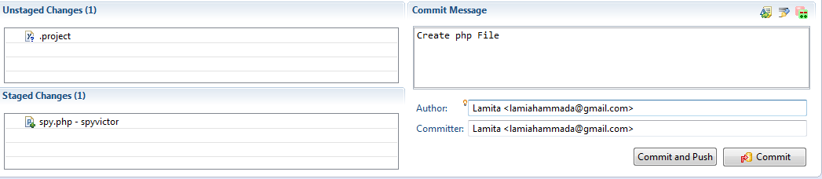

We can see the history:

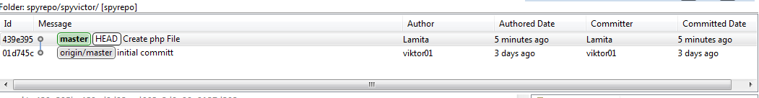

Create a new account en [www.Freesqldatabase.com](http://www.Freesqldatabase.com):

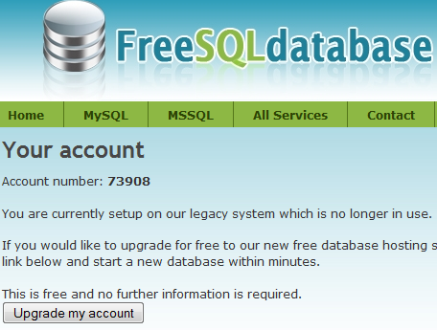

When we received our data from the new account, we have to fill the form like this picture:

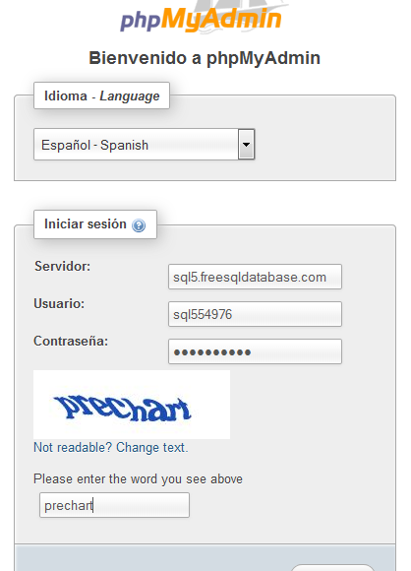

Then, we need to create a new database for spy with three columns: id, url_s, url_d

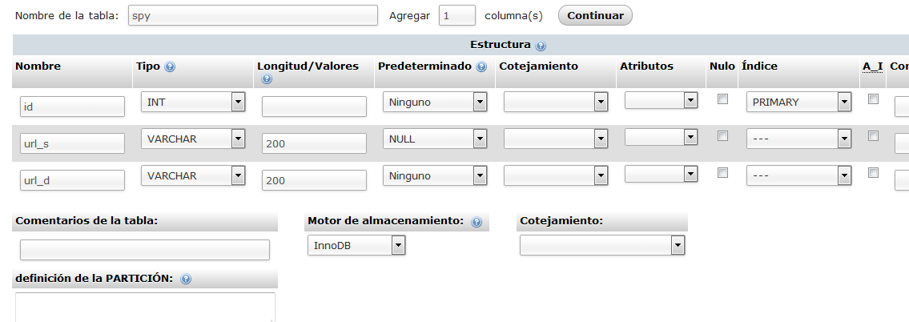

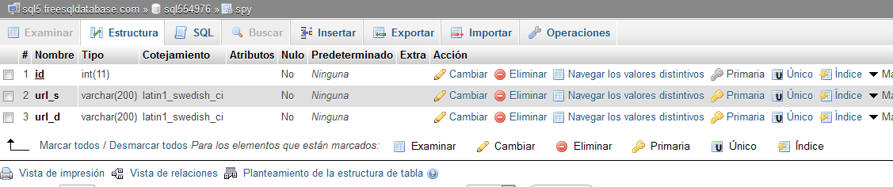

We need to create the php file in our project:

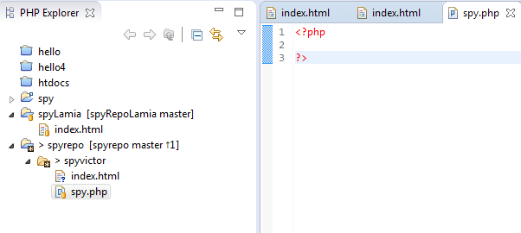

With this code we can insert our data

|  |
| --- |
| <?php  **if** ($_REQUEST) {  //Connect to the database  $link = mysqli_connect("sql5.freesqldatabase.com", "sql554976", "jF1*yZ5!", "sql554976", "3306");  //if exist any error, exit  **if** (! $link){  **echo**("Cannot connect to database");  **die**();  }  //get destiny URL  $url_d = $_REQUEST ["url"];  //get Previous URL  $url_s = $_SERVER['HTTP_REFERER'];  //Insert values in Database  $query = "INSERT INTO spy (url_d, url_s) VALUES ('$url_d','$url_s')";  $result = mysqli_query($link, $query);  **if**(!$result){  **echo** $query;  }  //Redirect to destiny URL  header("Location: $url_d/");  **exit**;  }  ?> |

In phpMyAdmin we can see the database whith url_d and url_s

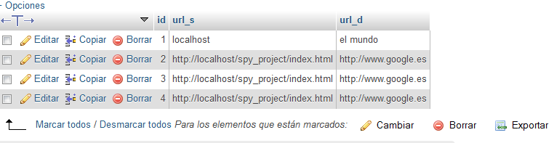

With the news changes a have to commit y push the files

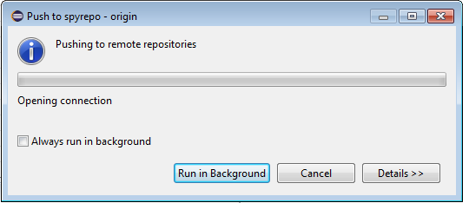

Now I have to create pull request, if victor accept my changes

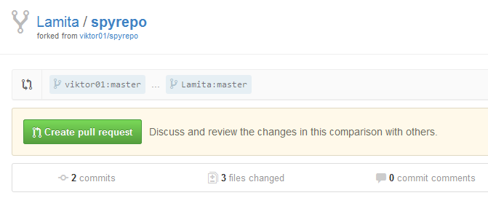

In this pictures I accept her changes

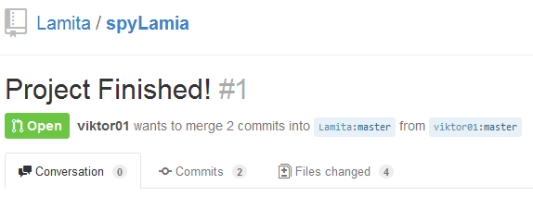

Confirm the merge to finish

