MSc Bioinformatics.

Olamide Okunola
S3559438.

Data Analytics
SCI4019-N-BF1-2025

Dr. Mengyuan Wang.

Applications of Data Analytics in Bioinformatics and Health Research.
5th January, 2026.

Declaration of Generative AI Use (delete one of the following as appropriate):

I DID use Generative AI technology in the development, writing, or editing of this assignment.

3000 Word Count.
Artificial Intelligence (AI) declaration statement for all assessments
I understand that to use the work and ideas of others, including AI-generated output, without full acknowledgement, is academic misconduct. I confirm that this assessment submission is all my own, original work and that all sources, summaries, paraphrases, and quotes are fully referenced as required by the University’s Academic Misconduct Regulations (relating to Taught Provision and Advanced Independent Work on Professional Doctorate courses).
DECLARATION OF AI USE: (delete one of the following as appropriate):
• I DID use Generative AI technology in the development, writing, or editing of this assignment.
If you DID use Generative AI technology in your assignment, please provide detailed responses to the following items:
1. Specify the reasons and purposes for using Generative AI technology in this assignment. Clearly explain how the Generative AI technology assisted in the development, writing, or editing processes.
2. EXTENT OF AI USE: Outline the sections or parts of the assignment that were developed, written, or edited with the assistance of Generative AI technology.
3. REFLECTION ON AI’S CONTRIBUTION: Reflect on how the Generative AI technology contributed to the assignment, including its limitations and advantages in the context of the assessment.
4. By including this statement in my assessment submission, I attest that the information provided in this Originality and use of AI Declaration Statement is accurate and complete to the best of my knowledge. I understand that providing false information is a violation of the University’s Academic Misconduct Regulations and may result in academic and/or disciplinary consequences.

Contents
Artificial Intelligence (AI) declaration statement for all assessments
Dataset 1: Gene Expression Analysis for Huntington’s Disease
Abstract…………………………………………………………………………....5
1.1 Introduction…………………………………………………………………...5
1.2 Materials and Methods……………………………………………………...5
1.3 Results………………………………………………………………………...6
1.4 Discussion…………………………………………………………………….8
1.5 Conclusion…………………………………………………………………….8
Dataset 2: Gender Differences in Infant Growth at One Month of Age
Abstract…………………………………………………………………………...10
2.1 Introduction…………………………………………………………………..10
2.2 Materials and Methods……………………………………………………...10
2.3 Results……………………………………………………………………......11
2.4 Discussion…………………………………………………………………….16
2.5 Conclusion…………………………………………………………………….16
Dataset 3: Post-Surgical Infection and Length of Hospital Stay in Infants
Abstract………………………………………………………………………………18
3.1 Introduction……………………………………………………………………...18
3.2 Materials and Methods…………………………………………………………18
3.3 Results…………………………………………………………………………...19
3.4 Discussion………………………………………………………………………..21
3.5 Conclusion………………………………………………………………………..21
Dataset 4: Effect of Birth Order on Infant Weight at One Month of Age
Abstract………………………………………………………………………………..23
4.1 Introduction……………………………………………………………………….23
4.2 Materials and Methods…………………………………………………………..23
4.3 Results…………………………………………………………………………….24
4.4 Discussion………………………………………………………………………...27
4.5 Conclusion………………………………………………………………………..27
Dataset 5: Glycaemic Control in Adolescents with Type 2 Diabetes: A Comparative Analysis of Treatment Approaches
Abstract………………………………………………………………………………29
5.1 Introduction……………………………………………………………………...29
5.2 Materials and Methods…………………………………………………………29
5.3 Results…………………………………………………………………………...30
5.4 Discussion………………………………………………………………………..32
5.5 Conclusion………………………………………………………………………..32
Dataset 6: Relationship Between Dog Cancer Risk and 2,4-D Herbicide Exposure
Abstract………………………………………………………………………………...34
6.1 Introduction………………………………………………………………………..34
6.2 Materials and Methods…………………………………………………………...34
6.3 Results……………………………………………………………………………..35
6.4 Discussion………………………………………………………………………….37
6.5 Conclusion………………………………………………………………………….37
Appendix: Declaration of Generative AI Use 39
Supplementary: 40

Report format:
Dataset 1: Gene Expression Analysis for Huntington’s Disease
Abstract
This study examined how gene expression in patients with Huntington's disease differed from that in healthy controls. Four genes were discovered to be significantly changed using independent-samples t-tests (α = 0.05). THBS3 and CCNB1 were downregulated, but DDR1 and SMAD7 were increased.
1.1 Introduction
The amplification of CAG trinucleotide repeats in the HTT gene is the cause of Huntington's disease (HD), a hereditary neurological condition (The Huntington’s Disease Collaborative Research Group, 1993). One of the main causes of neurodegeneration is alterations in gene expression. These alterations may aid in the discovery of therapeutic targets or biomarkers for Huntington's illness.
1.2 Materials and Methods
Twenty separate tissue samples from Huntington's disease and control groups were used to evaluate the expression levels of ten genes in the dataset (HD_Gene.sav). The mean gene expression of each group was compared using independent-samples t-tests. Variance equality was evaluated using Levene's test, with Welch's correction used when necessary. Significant genes were categorised as either up- or down-regulated, with statistical significance set at α = 0.05.
Hypothesis Formulation
Null: HD and control groups show no difference in gene expression (µHD = µControl).
Alternative: HD and control groups differ in gene expression (µHD ≠ µControl).
1.3 Results

1.3.1 Descriptive Statistics
Descriptive statistics showed differences in mean expression levels for the 10 genes between the two groups. The HD group had much higher mean expression for DDR1 and SMAD7. In differentiation, they showed lower mean expression for THBS3 and CCNB1 when compared to the controls. As displayed in Table 1 below.
Table 1: Descriptive statistics summary of the dataset (based on group)

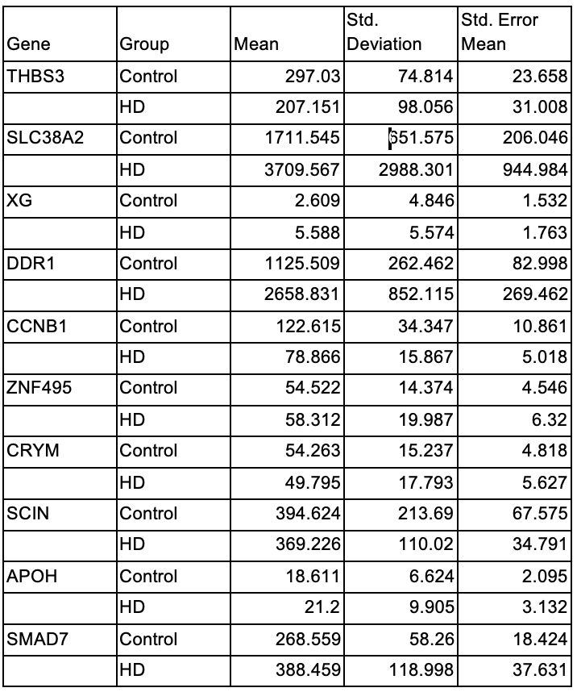

The gene expression discrepancies between the control and Huntington's disease groups are evident in Table 1. While THBS3 and CCNB1 were reduced in HD, DDR1 and SMAD7 were significantly higher.

Table 2: Summary of Independent Samples t-test

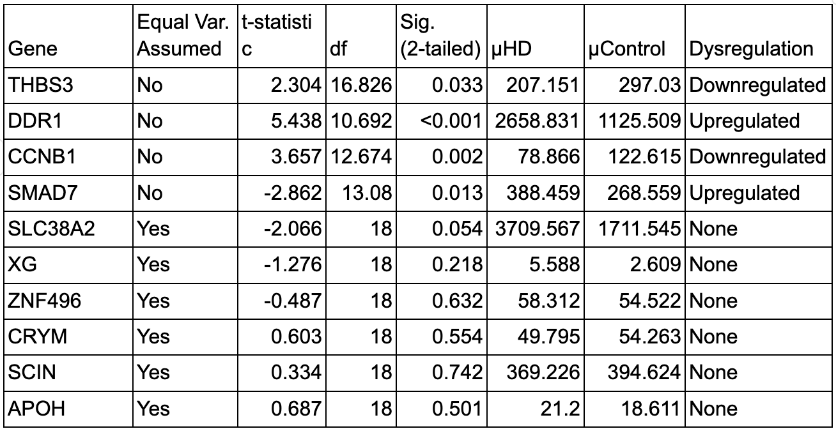

Four genes were discovered to be significantly dysregulated applying independent-samples t-tests, as shown in Table 2. In Huntington's disease, THBS3 and CCNB1 were downregulated, and DDR1 and SMAD7 were increased.
Figure 1 confirms four significantly dysregulated genes (where µControl = 0, µHD = 1). 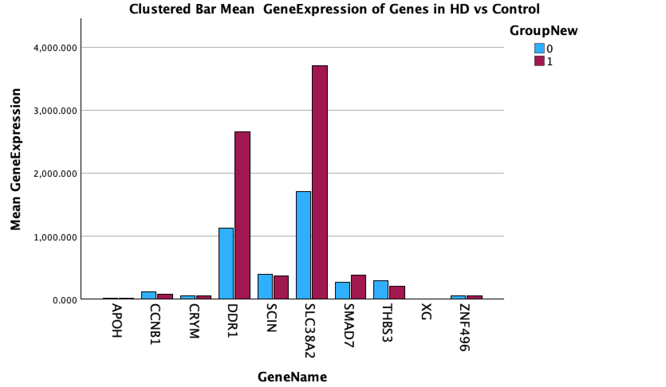Figure 1: Mean Gene Expression of Gene samples in Group(HD vs Control)
The bars show clear expression differences in DDR1, CCNB1, and SMAD7. In contrast, THBS3 shows a moderate difference that is still statistically significant.
1.5 Discussion and Conclusion
1.5.1 Discussion
Significant alterations in four genes were found in Huntington's disease, indicating disturbed transcription regulation. Changes in inflammation and signalling pathways are shown by the upregulation of DDR1 and SMAD7, downregulation of THBS3 and CCNB1, however, points to issues with cell-cycle and synaptic functions (Bates et al., 2015).
1.5.2 Conclusion
This study shows that DDR1 and SMAD7 are significantly increased in the Huntington's Disease molecular signature, while THBS3 and CCNB1 are significantly decreased. This dysregulation highlights the complexity of HD pathology and positions these four genes as potential biomarkers, and therapeutic targets for slowing or stopping disease progression.

Reference
Bates, G. P., Dorsey, R., Jones, L. & Tabrizi, S. J. (2015) ‘Huntington’s Disease’, Nature Reviews Disease Primers, 1, 15005. Available at: https://pubmed.ncbi.nlm.nih.gov/27188817/
The Huntington's Disease Collaborative Research Group. (1993) ‘A novel gene containing a trinucleotide repeat that is expanded and unstable on Huntington's disease chromosomes’, Cell, 72(6), pp. 971-983. Available at: https://doi.org/10.1016/0092-8674(93)90585-E

Dataset 2: Gender Differences in Infant Growth at One Month of Age
Abstract
This study examined gender disparities in head circumference, weight, and length at one month. Physical and neurological development is demonstrated by early newborn growth indicators. Using SPSS analyses of 256 newborns. While weight and length did not differ by gender, head circumference did differ by gender.
2.1 Introduction
For the purpose of assessing early health and development, tracking an infant's growth is essential. Length and weight indicate total physical development. An indirect measure of brain and neurological development is head circumference (World Health Organisation, 2006).
Using accepted statistical techniques, this study investigates gender variations in head circumference, weight, and length at one month of life as well as the correlations between these measurements (Field, 2018).
2.2 Materials and Methods
Data from 256 full-term newborns were analyzed at one month. Weight, length, head circumference, and gender were among the variables. The analysis was conducted using IBM SPSS 29.0. Normality checks and descriptive statistics were carried out. The genders were compared using independent-samples t-tests. Multiple linear regression was used to determine whether head circumference and length predicted newborn weight, and Pearson correlations were used to evaluate connections. The threshold for statistical significance was fixed at p < 0.05.
Hypothesis Formulation :
For Gender Differences (t-tests):
H₀: Mean growth metric do not vary between male and female infants.
H₁: Mean growth metric vary between male and female infants.
For Interrelationships (correlations):
H₀: Growth variables are not linearly related.
H₁: Growth variables are linearly related.
For Predictive Model (regression):
H₀: Length and head circumference do not predict weight.
H₁: At least one factor significantly predicts weight
2.3 Results
2.3.1 Descriptive Statistics
Table 1: Descriptive Statistics by Gender
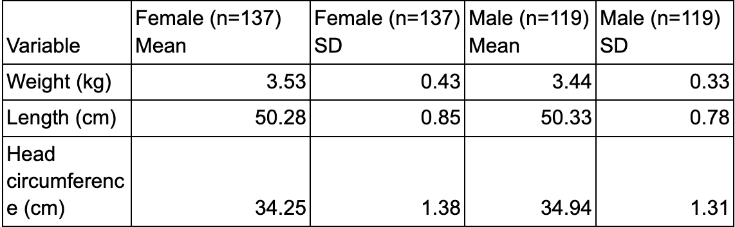
In the descriptive statistics table, males had a significantly larger head circumference, females were slightly heavier, and males were slightly longer.
Table 2: Independent-Samples t-Test Results
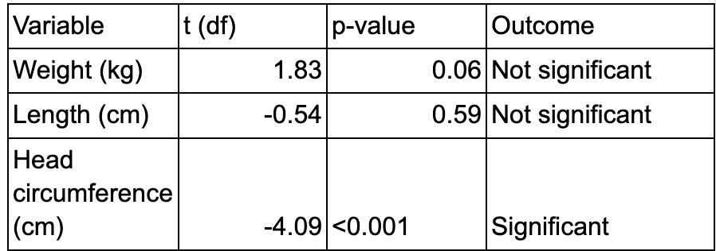
In Table 2, head circumference differed significantly by gender (p<0.001), but weight and length did not.
Figure 1 below illustrates birth weight by gender, showing similar medians and overlapping ranges.
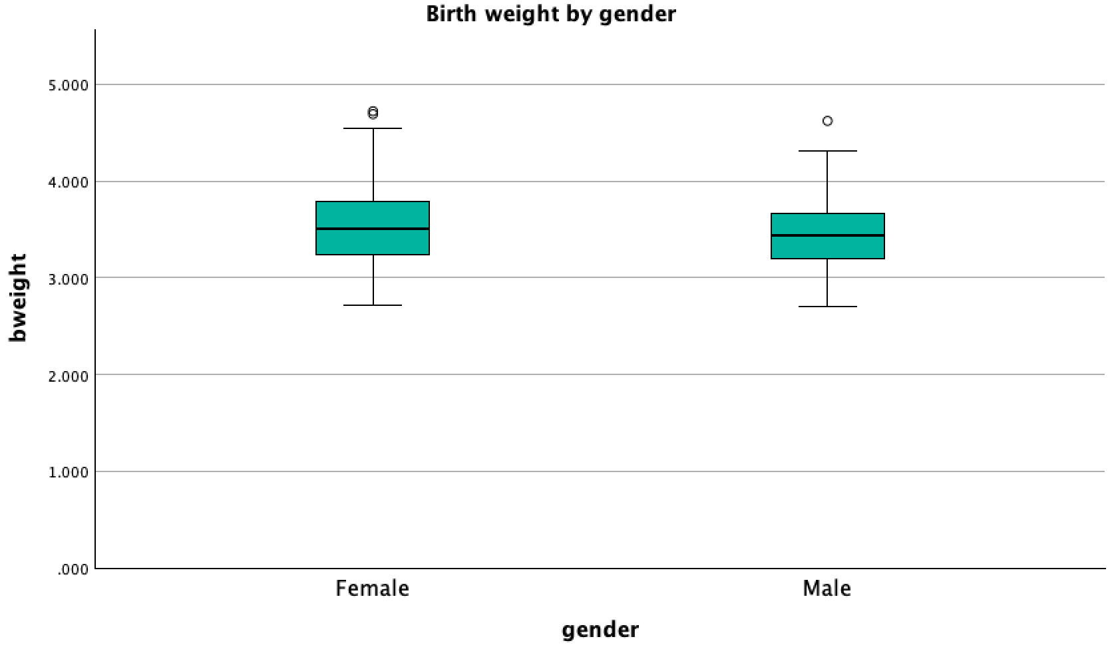Figure 1: Birth Weight (cm) by Gender
The median is roughly 50.5 cm for men and 50.0 cm for women, as seen in Figure 2. There are no outliers in the 50–51 cm interquartile range.
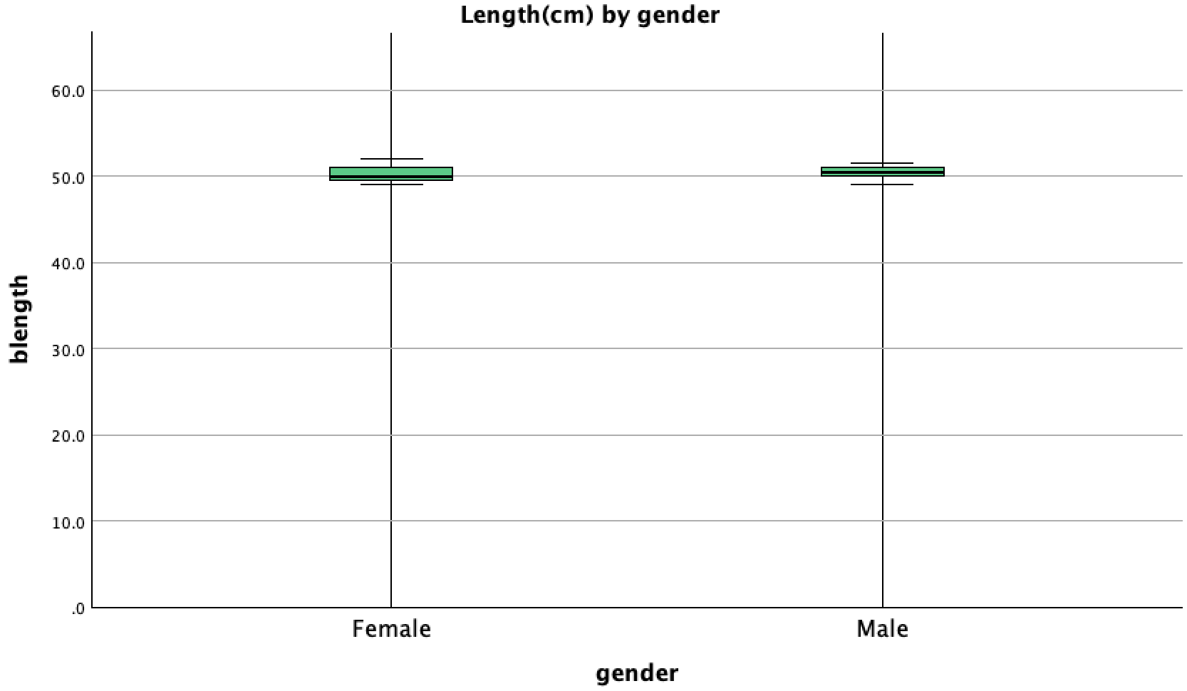
Figure 2: Birth Length level based on Gender
Figure 3 shows that the male group has a significantly higher median, than the female group. 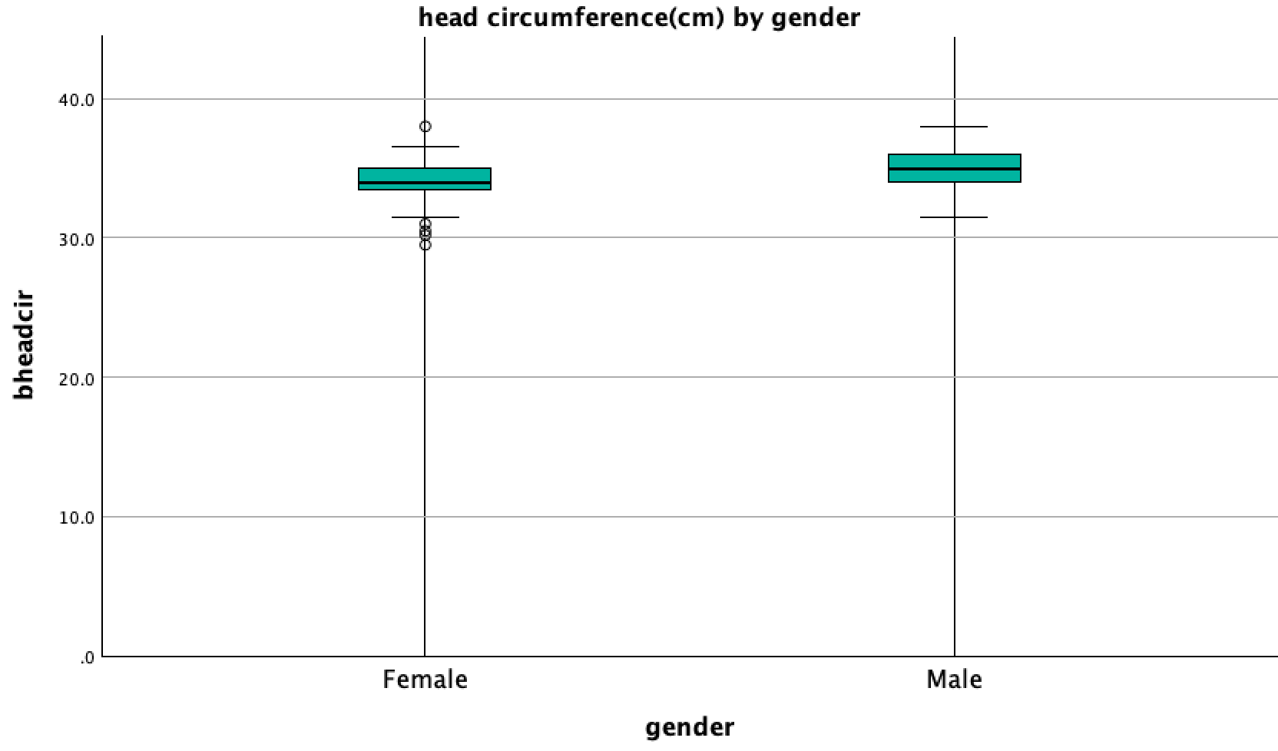
Figure 3: Boxplot showing the level of Head Circumference(cm) based on gender
Figure 4 shows a higher median head circumference for males. Weight and head circumference have a weakly positive correlation, suggests that the predictive usefulness is limited.
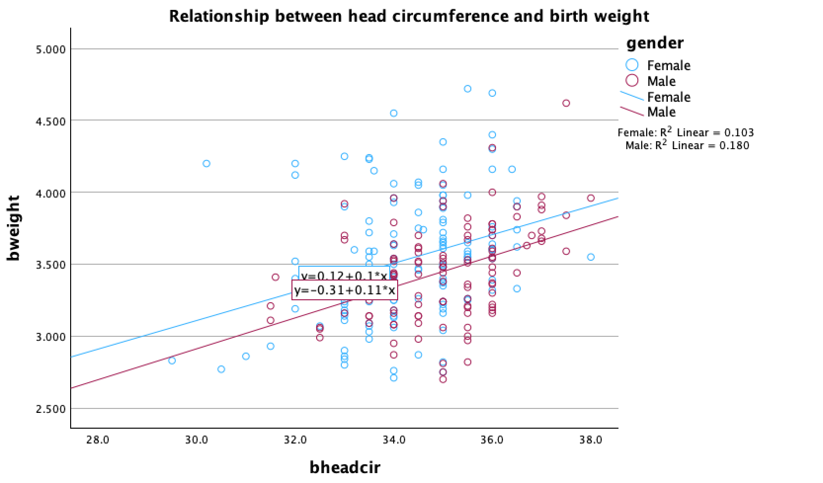
Figure 4: Scatterplot showing the relationship between Head circumference and birth weight
Weight-length correlations explained less than 20% of the variance, with R²=0.031 for females and 0.190 for males.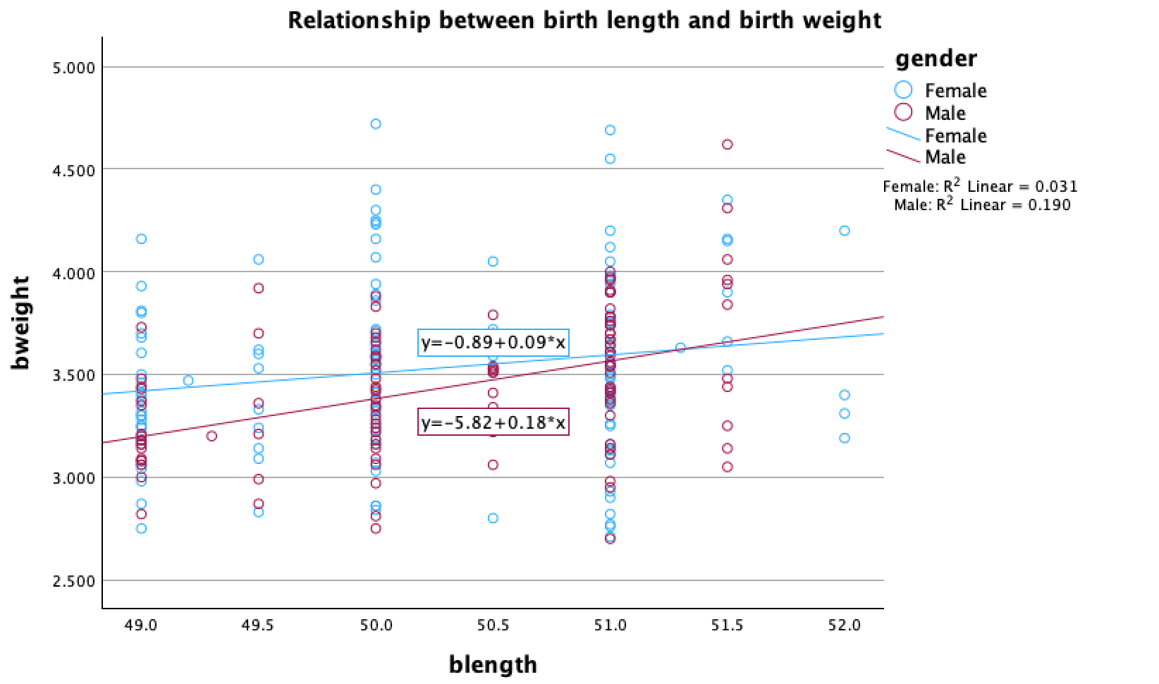Figure 5: Relationship between Head circumference and birth weight
Figure 5 also indicates that length explains less than 20% of weight variance.
Q–Q plot shows male head circumference being normal.
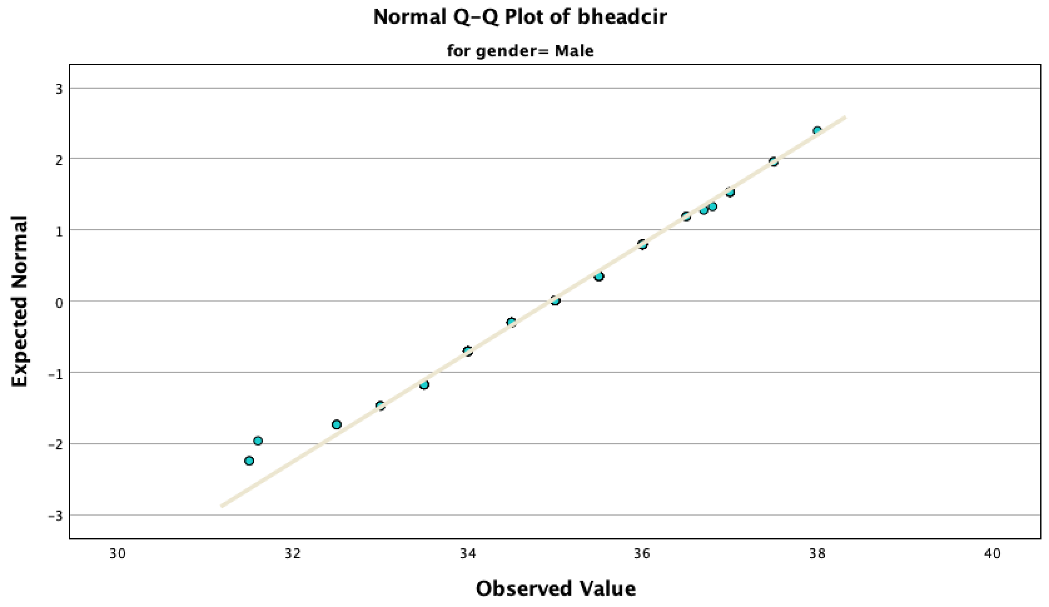
Figure 6: Normality Plot of Head Circumference for Male Gender

2.4 Discussion
The results show that after one month, male and female infants show comparable weight and length, while males have larger head circumferences, supporting evidence of early cranial dimorphism. Regression results showed limited explanatory power, suggesting additional biological influences on infant weight.
2.5 Conclusion
Male babies had larger head circumferences at one month. Their weight and length were similar for both sexes. Moderate early gender differences and moderate associations were found in growth assessments. This highlights the need for basic statistical techniques in studying baby growth.

Reference
Field, A. (2018) Discovering statistics using IBM SPSS Statistics. 5th edn. London: SAGE.
World Health Organization (2006) WHO child growth standards. Geneva: WHO.

Dataset 3: Post-Surgical Infection and Length of Hospital Stay in Infants.
Abstract
This study examined whether an infant's length of hospital stay is impacted by surgical infection. It also looked at relationships between the type of surgery and gestational age. Statistics were used to evaluate data from 141 newborns. Hospital stays were longer for infants with surgical infections. The type of operation and gestational age had minimal effect.
3.1 Introduction
Infants are vulnerable to complications such as infections following surgery. These could hinder their recuperation and result in additional hospital stays. Infection status, developmental maturity, and surgical difficulty have all been found to be important variables that influence extended hospital stays in newborns (Thompson and Patel, 2019). It is necessary to find out the effects of surgery type, maturity, and postoperative infection on the length of an infant's hospital stay.
3.2 Materials and Methods
A total of 141 newborns admitted to the hospital for surgery were included in the dataset. A between-subjects experimental design was employed. The length of stay, gestational age in weeks, surgery type (cardiac, abdominal, or other), and infection status (yes or no) were all noted.
IBM SPSS 29 was used for statistical analysis. One-way ANOVA evaluated the type of surgery, Pearson correlation looked at gestational age, and independent-samples t-tests compared duration of stay by infection status. The significance level was set at p < 0.05, and the null hypothesis assumed no effect.
Hypothesis Formulation
Infection Status (t-test):
H₀: Infection does not affect length of hospital stay.
H₁: Infection affects length of hospital stay.
Surgery Type (ANOVA) :
H₀: Length of stay does not differ across surgery types.
H₁: At least one surgery type differs in length of stay.
Age Relationship (correlation):
H₀: Age is not correlated with length of stay.
H₁: Age is correlated with length of stay
3.3 Results
3.3.1 Descriptive Statistics
Descriptive statistics show how surgery type revealed similar durations, while infants with infections stayed longer (45.52 vs. 33.20 days).
Table 1: Descriptive Statistics for Infection and Surgery Variables
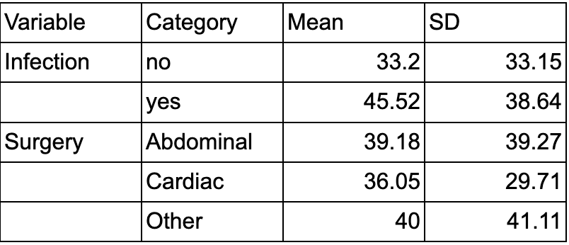
The t-test result was marginal, and this difference was not statistically significant, as Table 2 demonstrates (p = 0.06).
Table 2: Independent Samples T-test 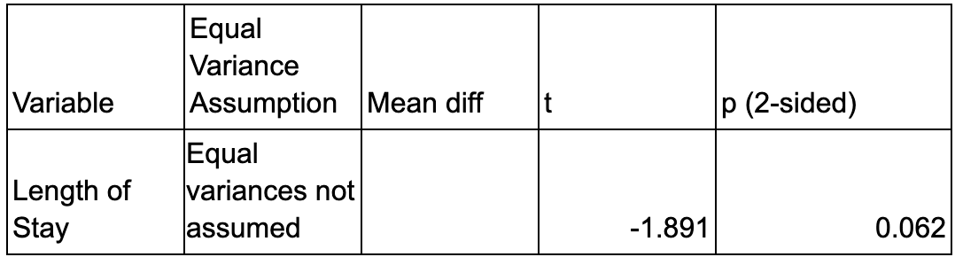
ANOVA showed no significant effect of surgery type on length of stay (p = 0.86), with means broadly similar across categories.​
Table 3: One-way ANOVA
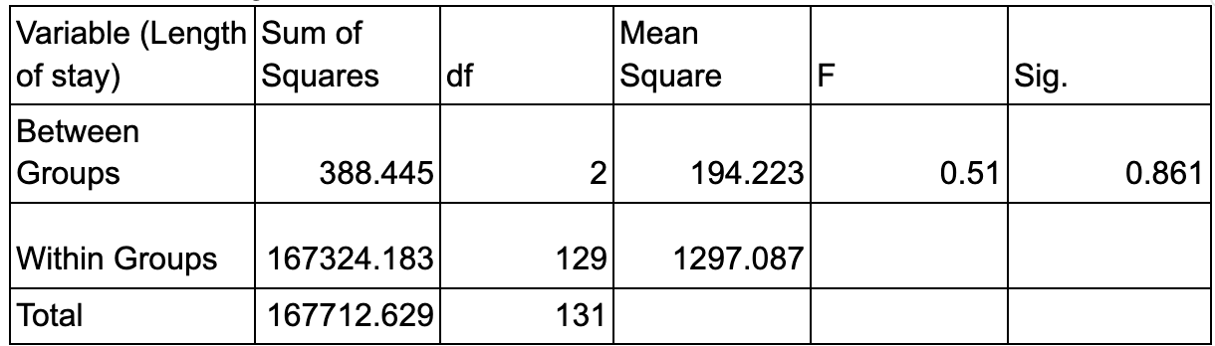
Gestational age showed a weak negative correlation with length of stay (r = -0.16, p = 0.065), suggesting slightly longer recoveries in less mature infants, although this was not statistically significant (Thompson and Patel, 2019).
Table 4: Correlation between Length of Stay and Gestation Age
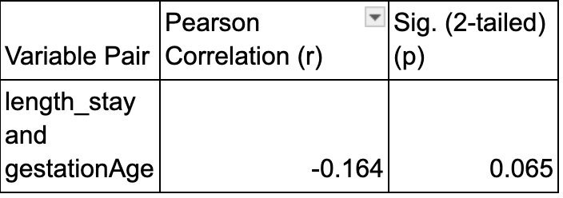
The length-of-stay distributions across surgery types support this finding, with substantial overlap in medians and distributions, suggesting that surgery type does not strongly influence length of stay.

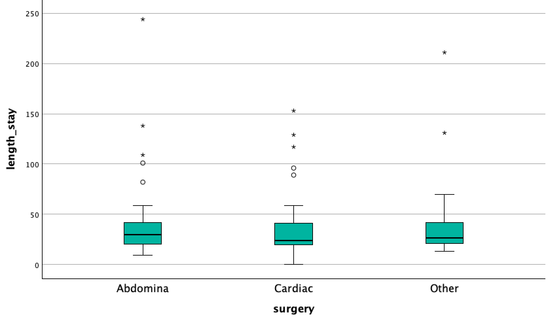
Figure 1: Length of Stay Based on Surgery Types
3.4 Discussion
The results show clinical relevance and corroborate earlier findings that surgical infection significantly extends hospital stay. Only a weak correlation was found between gestational age and recovery time, indicating little developmental influence. The type of surgery had no discernible impact. These findings emphasise the need for thorough postoperative monitoring and infection prevention in enhancing baby surgical outcomes.
3.5 Conclusion
Although there is insufficient statistical evidence to support this, postoperative infection is associated with longer hospital admissions for newborns. The type of operation and gestational age don't really matter. To improve recovery outcomes and reduce infection, prevention measures must be improved.

Reference
Thompson, A. and Patel, S. (2019) ‘Risk factors for prolonged recovery in infants undergoing surgery’, Pediatric Critical Care Medicine, 20(4), pp. 312–319.

Dataset 4: The Effect of Birth Order on Infant Weight at One Month of Age
Abstract
This study looked at whether gender affects the correlation between birth order and an baby's weight at one month. One-way ANOVA, two-way ANOVA (parity and gender), and ANCOVA were used to examine 550 data while controlling for newborn size and education. The impacts of gender were greater than those of birth order, which had a little but significant impact.
4.1 Introduction
Early growth is reflected in an infant's weight at one month; birth order, gender, and socioeconomic factors may affect results; these are frequently investigated using ANOVA-based techniques (Field, 2018).
To find out if parity predicts one-month newborn weight and if gender or education moderates this association, research was conducted (WHO, 2006).
4.2 Materials and Methods
550 babies with weight, length, head circumference, parity, gender, and education were included in the dataset. Using histograms, normality plots, outlier checks, and Levene's tests in SPSS 29.0, assumptions were evaluated. One-way ANOVA with Tukey post-hoc tests was utilised in examining mean weight differences between parity; two-way ANOVA and ANCOVA were then used to assess gender effects and account for variables.
Hypothesis Formulation
Parity (one-way ANOVA):
H₀: Infant weight does not differ across parity groups.
H₁: Infant weight differs across parity groups.
Parity × Gender (two-way ANOVA):
H₀: No main effect of parity, no main effect of gender, and no interaction.
H₁: At least one main effect or interaction is significant.
Adjusted Effects (ANCOVA):
H₀: After controlling for covariates, parity and gender do not predict weight.
H₁: At least one predictor significantly influences weight.
4.3 Results
Descriptive Statistics
Table 1: Weight at 1 month by parity (overall and by gender)
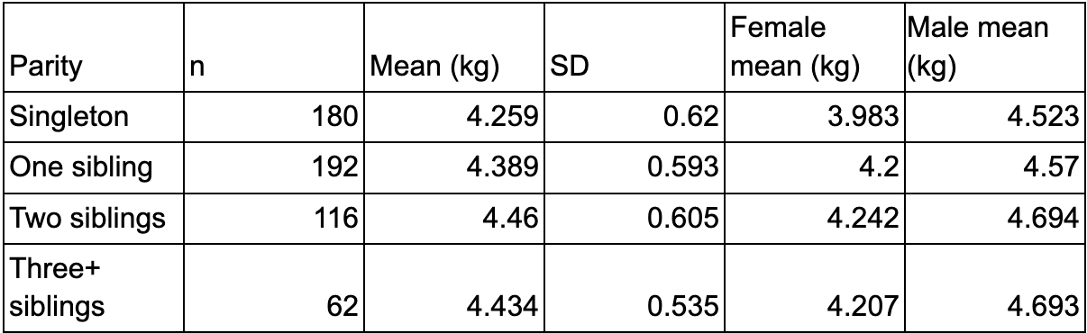
Table 1 summarises the mean infant weight at one month across parity groups and by gender. Mean weight increased slightly with higher birth order, with infants having two siblings showing the highest average weight.
Table 2: One-way ANOVA: Effect of Parity on Infant Weight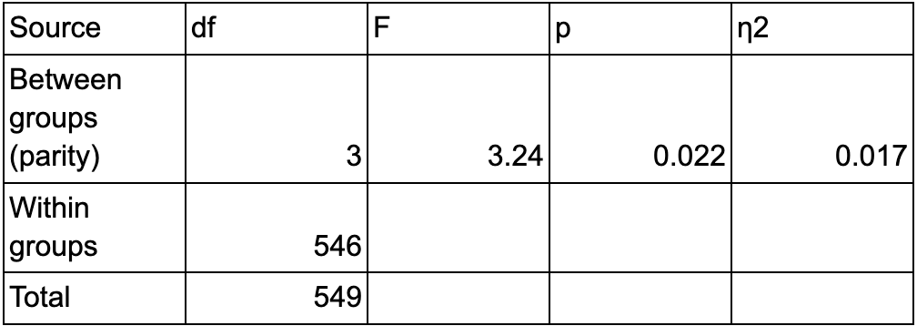
One-way ANOVA showed that Infant weight varied significantly across parity groups, F = 3.24, p = 0.022, although the effect size was small (η² = 0.017).

Table 3: Post Hoc Comparison for Weight by Parity

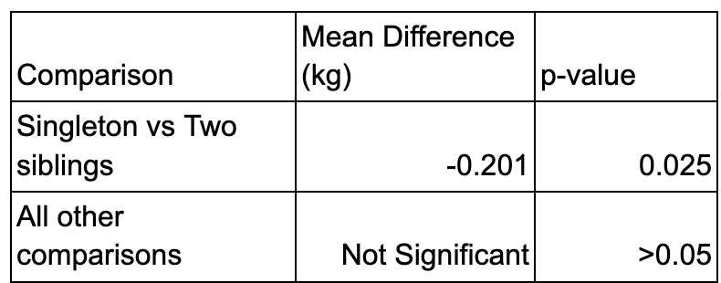

Post hoc analyses with Tukey’s test show that Singleton infants weighed significantly less than infants with two siblings (mean difference = -0.20 kg, p = 0.025); other comparisons were not statistically significant.
Table 4: Two-Way ANOVA Summary (Weight by Parity and Gender)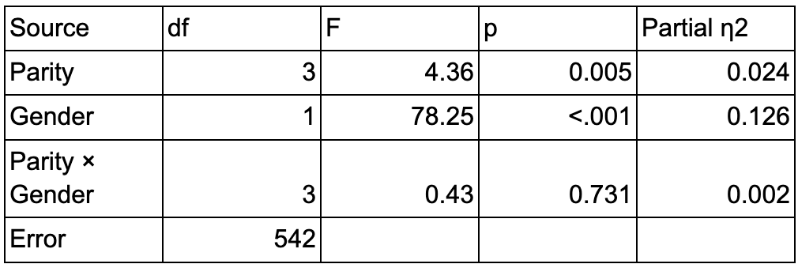
Gender significantly affected weight (p < 0.001), as shown in Table 4, whereas the parity × gender interaction was not significant (p = 0.731).

Table 5: ANCOVA Summary (Effects of Parity, Gender, and Covariates on Infant Weight)
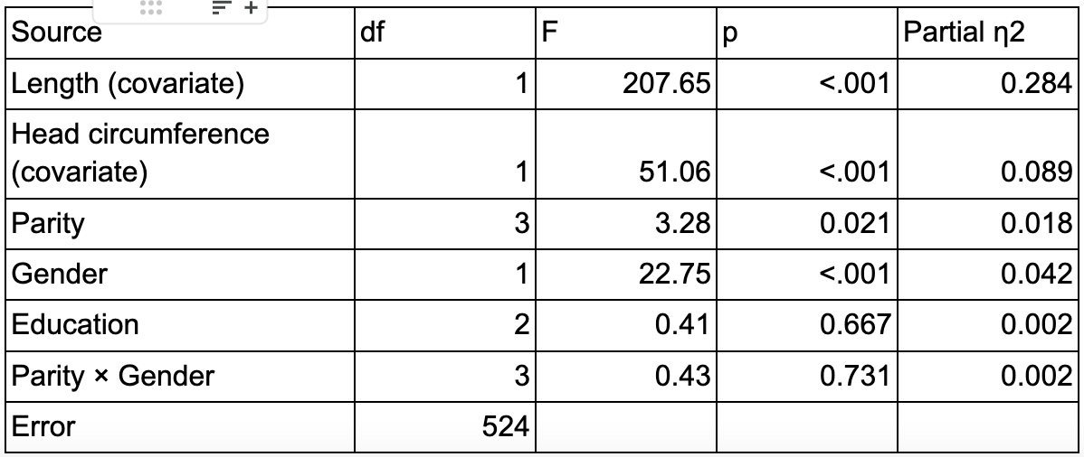
In the ANCOVA summary, following adjustment, weight was predicted by head size and length. gender and parity remained significant.
In Figure 1, later-born infants show marginally higher median weights, but distributions overlap significantly across parity groups.
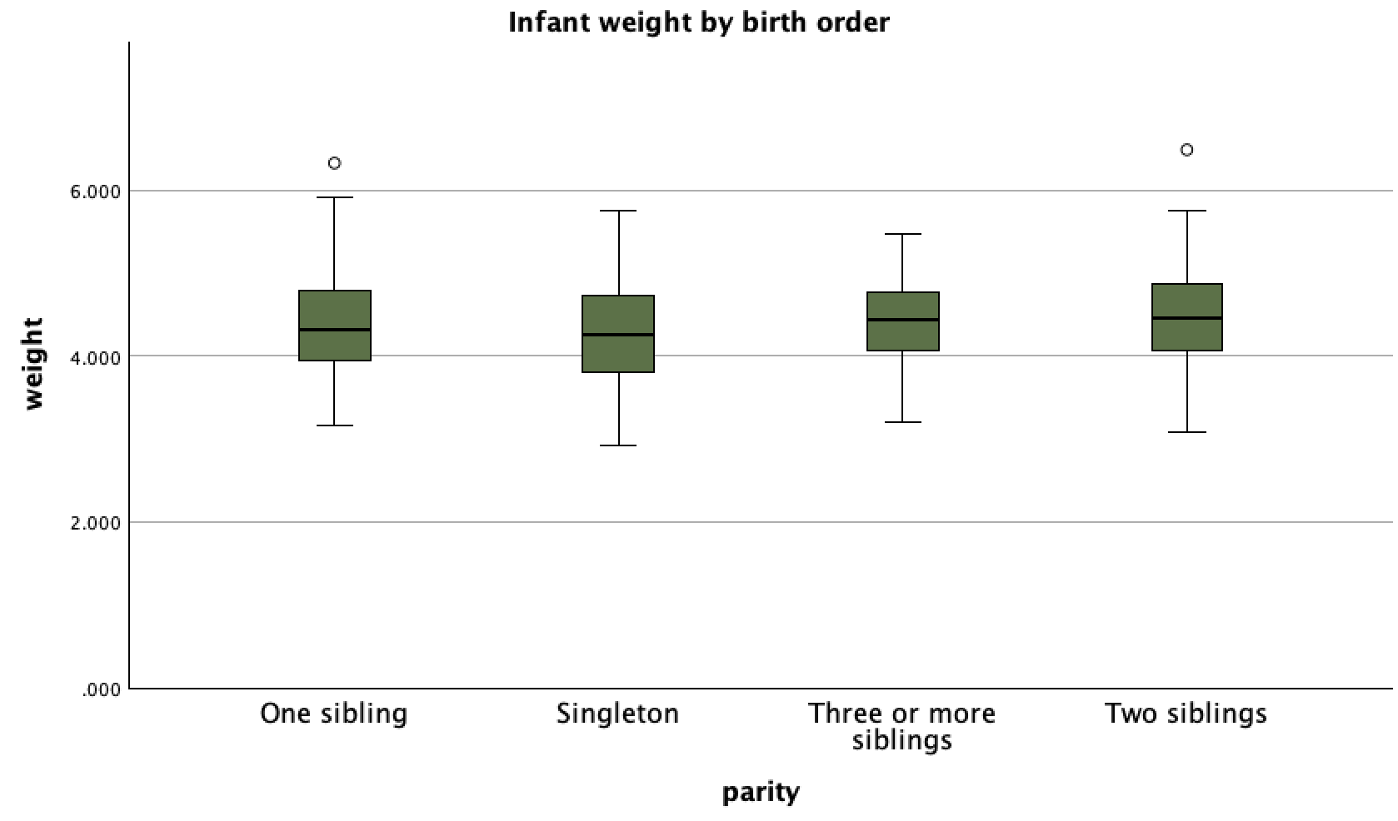
Figure 1: Infant weight by birth order
As visible in Figure 2, Male infants weigh more than female infants across parity groups, showing minimal interaction.
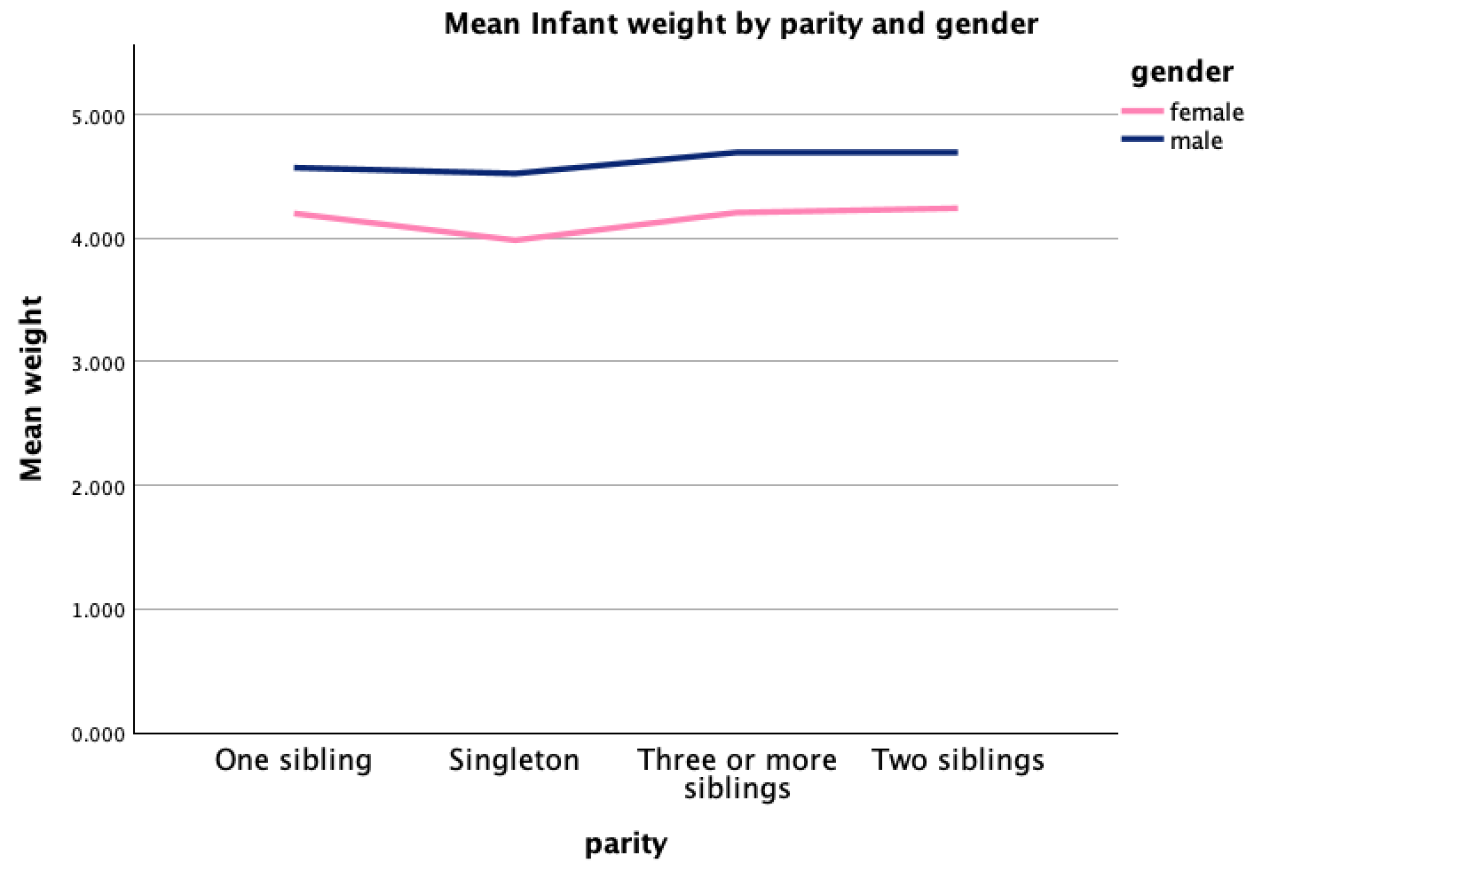
Figure 2: Mean Infant weight by parity*gender
4.4 Discussion
There was little variance explained by the statistically significant but small influence of birth order on infant weight. Babies born later were a little heavier, especially those with two siblings. The non-significant interaction suggests similar parity trends across genders, and boys were consistently heavier than girls.
4.5 Conclusion
One-month weight was slightly impacted by birth order. Gender did not affect parity patterns, and boys were heavier than girls. After adjustment, education was not an independent determinant.

Reference
- Field, A. (2018) Discovering statistics using IBM SPSS Statistics. 5th edn. London: SAGE.
- World Health Organization (2006) WHO child growth standards. Geneva: WHO.

Dataset 5: Glycaemic management in adolescents with type 2 diabetes: a comparative analysis of treatment approaches.
Abstract
This study compared three randomized treatment approaches for for adolescents metformin, metformin + rosiglitazone, and lifestyle modification were compared in this trial for teenagers with type 2 diabetes. Use of 699 participants' trial data with a success/failure binary: additional success rate estimation, a chi-square test for group differences, and odds ratios for effect quantification. The analysis showed that the most successful combination was metformin + rosiglitazone.
5.1 Introduction
The popularity of Youth-onset type 2 diabetes is rising worldwide. It develops swiftly and causes problems at a young age. Metformin is typically the first medication used in pharmacological treatment. However, research indicates that many adolescents may not maintain long-term glycemic control when using it alone (TODAY Study Group, 2012).
Intense lifestyle modifications and combination therapy with metformin and rosiglitazone have been investigated as alternative approaches. Comparing the efficacy of therapies for Type 2 diabetes in adolescents (Zeitler et al., 2014).
5.2 Materials and Methods
Treatment (metformin, metformin + rosiglitazone, lifestyle) and outcome (success/failure) were the two categorical factors that were examined. Treatment-outcome crosstabs with row percentages and Pearson's chi-square test were generated by SPSS 29.0. Cramér's V was used to evaluate the strength of the association. Using metformin as the reference group, Odds ratios and 95% confidence intervals were calculated using binary logistic regression. After verifying the assumptions, α=0.05 was used.
Hypothesis Formulation
Treatment Effectiveness (chi-square):
H₀: Treatment type is not associated with treatment success.
H₁: Treatment type is associated with treatment success.
Odds Ratios (logistic regression):
H₀: Odds of success do not differ from Metformin.
H₁: Odds of success differ from Metformin.
5.3 Results
The results section presents descriptive statistics and chi-square analyses examining treatment outcomes
Table 1: Outcome by treatment (counts and row %)
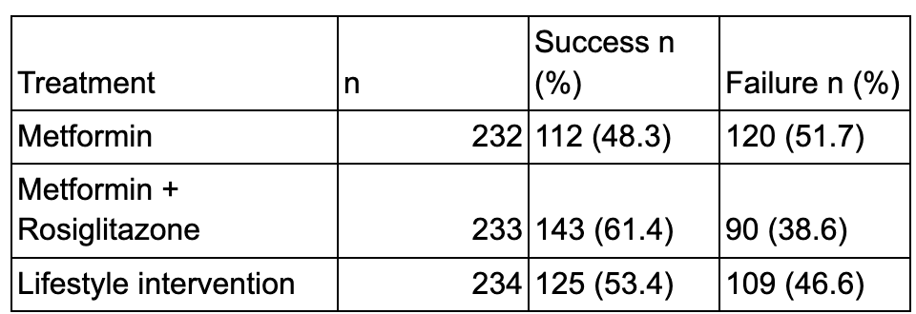
Metformin+rosiglitazone had a higher success rate (61.4%) than lifestyle (53.4%) and metformin (48.3%), while metformin alone is the least effective.
Table 2: Chi-Square Test Results for Treatment and Outcome
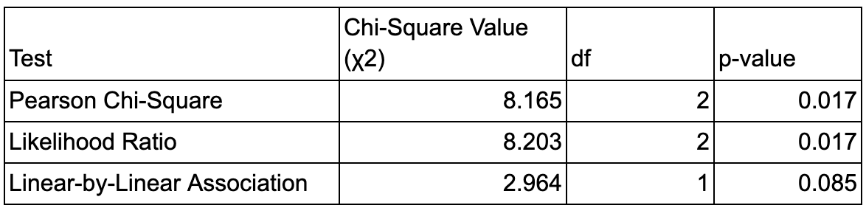
Table 2 shows how the relationship between treatment and outcome was found by the statistically signifcant chi-square test (χ²(2)=8.16, p=0.017). Cramér's V=0.108 indicated a small effect magnitude. but without a significant linear trend (p = 0.085).
Table 3: Measures of Association (Effect Size)
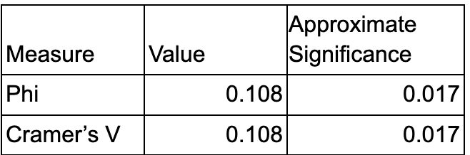
Table 3 shows a modest but significant relationship between the categorical variables, as indicated by the Phi and Cramer's V values (0.108, p=0.017).
Table 4: Comparison of Treatment Efficacy (Binary logistic regression)
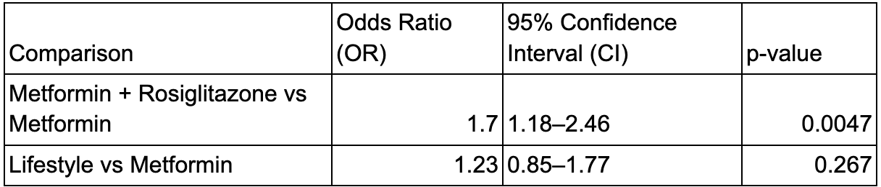
Metformin + rosiglitazone significantly increased success when compared to metformin (OR = 1.70, p = 0.0047), although lifestyle did not significantly improve success (OR = 1.23, p = 0.267).
The greatest success with metformin-rosiglitazone and the greatest failure with metformin is apparent in Figure 1.
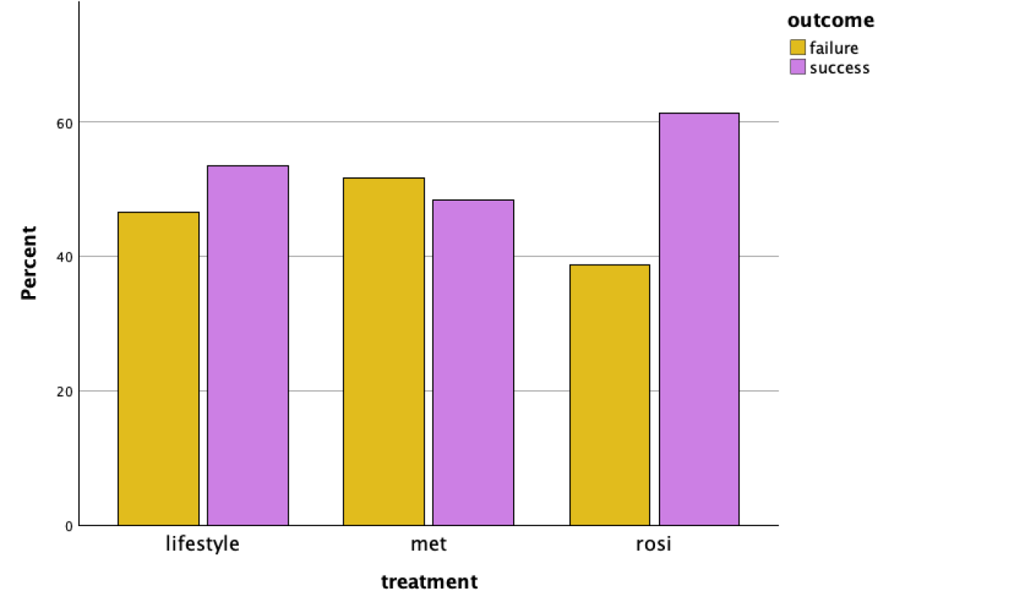
Figure 1: Percentage of Success vs Failure by treatment
5.4 Discussion
The findings demonstrate that Glycaemic management in teenagers with Type 2 diabetes was strongly impacted by treatment method. Previous study evidence supports the greater success rates of metformin plus rosiglitazone compared to metformin alone (TODAY Study Group, 2012).
Lifestyle results were average and did not differ statistically from metformin alone. which is consistent with studies showing that behavioural changes by themselves seldom maintain glycaemic control in young people (Zeitler et al., 2014).
5.5 Conclusion
The glycaemic-control result was correlated with treatment assignment in this randomised trial dataset (N=699). Compared to metformin alone, metformin plus rosiglitazone had the highest success rate and significantly higher chance of success.

Reference
- TODAY Study Group (2012) ‘A clinical trial to maintain glycemic control in youth with type 2 diabetes’, New England Journal of Medicine.
- Zeitler, P., Hirst, K., Pyle, L., Linder, B., Copeland, K., Arslanian, S. and TODAY Study Group (2014) ‘A clinical trial of metformin and rosiglitazone in youth with type 2 diabetes’, New England Journal of Medicine, 371(5), pp. 418–426.

Dataset 6: Relationship Between Dog Cancer Risk and 2,4-D Herbicide Exposure…
Abstract
This study examined the potential relationship between dog cancer risk and exposure to the pesticide 2,4-D. Odds ratios and chi-square analysis were utilised with data from 1,436 dogs. There is a distinct connection between herbicide exposure and dog cancer risk, as evidenced by the higher cancer rate in dogs exposed to 2,4-D.
6.1 Introduction
Concerns over the long-term health impacts of pesticides like 2,4 Dichlorophenoxyacetic acid (2,4-D) are raised by its widespread use in homes and farms. Herbicide exposure and dog cancer may be related, according to earlier research. These dogs can be a sign of health hazards from the environment (Zahm and Ward, 1998).
This study examines whether vulnerability to 2,4-D raises the risk of cancer in dogs using categorical analysis.
6.2 Materials and Methods
There were 1,436 dogs in the dataset, 491 with cancer diagnoses, and 945 in the control group. Two categorical factors were examined: cancer status (yes/no) and exposure to 2,4-D (yes/no). The percentages and frequencies were summed up using descriptive statistics. The relationship between exposure and cancer outcomes was examined using a chi-square test of independence. The degree of risk was assessed using unusual ratios with 95% confidence intervals. The limit for statistical significance was fixed at p < 0.05. IBM SPSS 29.0 was utilised for the analysis. The results were shown using bar charts and stacked bar charts.
Hypothesis Formulation
Exposure and Cancer (chi-square):
H₀: Exposure to 2,4-D is not related with cancer (O.R = 1).
H₁: Exposure to 2,4-D is related with cancer (O.R ≠ 1).
6.3 Results
Descriptive and inferential analyses examining the linkage between 2,4-D exposure and cancer outcomes are presented in this section.
Table 1: 2×2 contingency table (Observed counts)
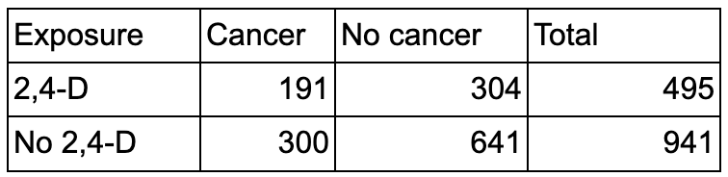
The table indicates that the cancer proportion appears higher among 2,4-D-exposed dogs than among unexposed dogs.
Table 2: Risk Estimate for 2,4-D Exposure
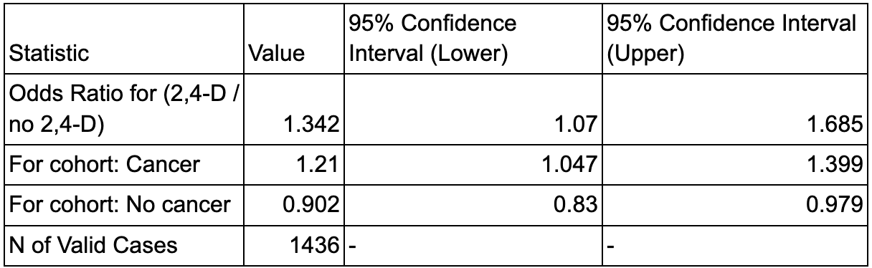
Table 2, however, indicates 2,4-D exposure increases cancer odds (OR=1.34) with a significant confidence interval.
Table 2: Chi-Square Test Summary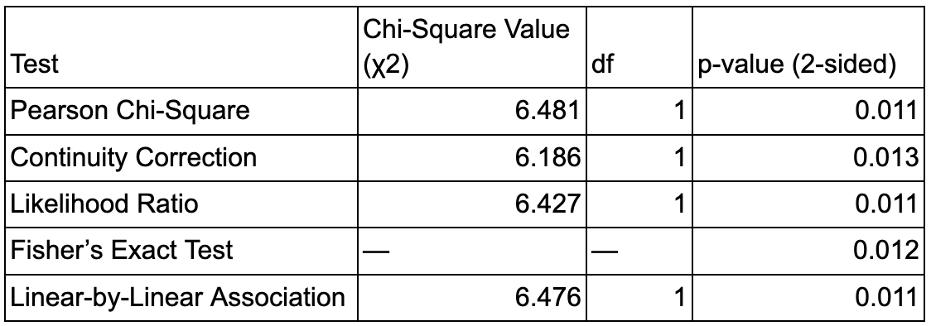
Exposure and cancer status were significantly correlated, according to the chi-square test (χ²(1)=6.19, p=0.0129 (Phi=0.066). This implies a minor impact.
As visible in Figure 1, the dogs who are vulnerable to 2,4-D have greater cancer rates than dogs who are not.

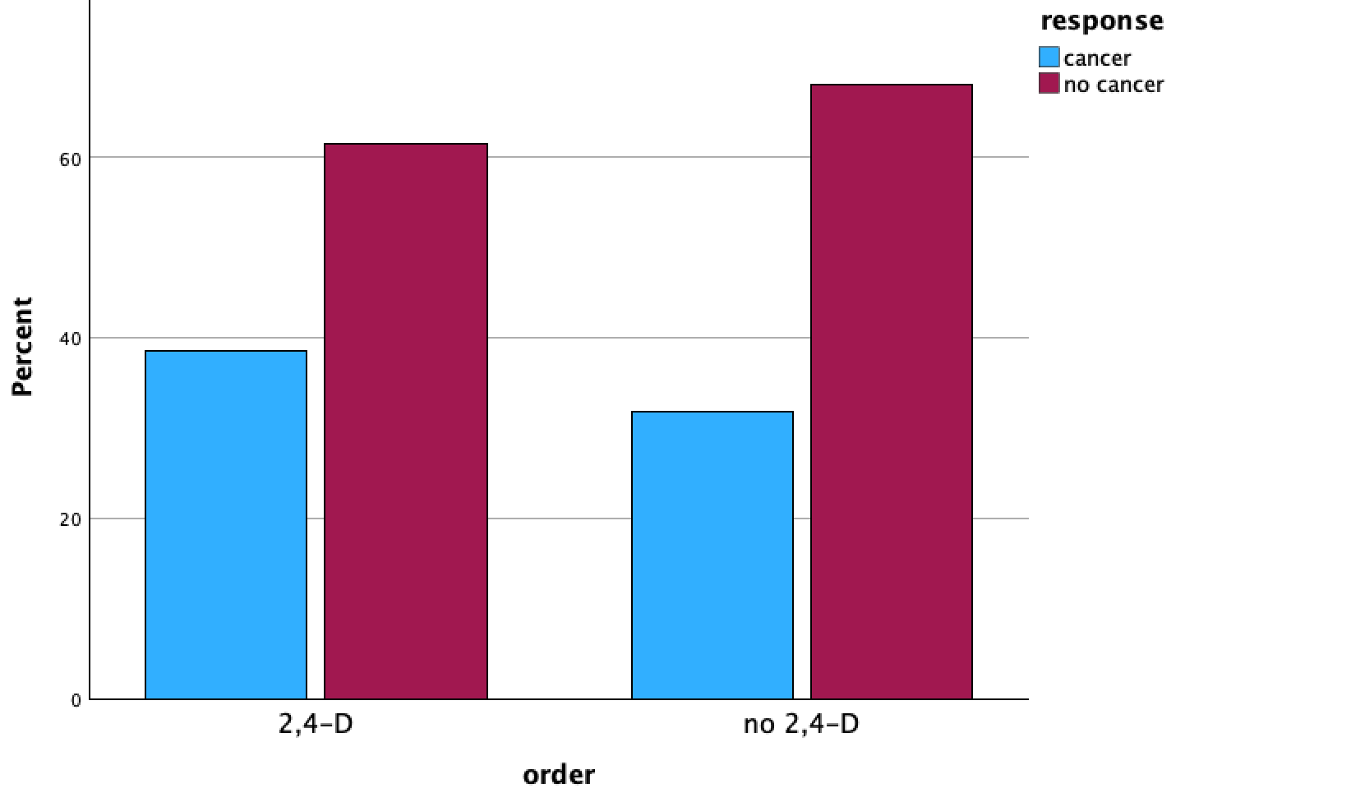
Figure 1: Percentage of cancer response by order

6.4 Discussion
The results demonstrate a connection between 2,4-D exposure and dog cancer. This validates earlier research linking herbicide exposure to cancer (Hayes et al., 1991). Cancer cases were higher in dogs exposed to 2,4-D than in dogs not exposed. Significant chi-square values and visualised percentage differences corroborated the greater cancer prevalence in dogs vulnerable to 2,4-D. These findings are consistent with other data that suggests environmental toxins may contribute to the development of cancer in humans and pets (Zahm and Ward, 1998).
6.5 Conclusion
Dogs' cancer risk has been linked with vulnerability to the toxic herbicide 2,4-D. Concerns regarding environmental chemicals that cause cancer are supported by these data. They also emphasise the need for greater research on long-term health impacts and the significance of using pesticides carefully.

Reference

- Hayes, H.M., Tarone, R.E., Cantor, K.P., Jessen, C.R., McCurnin, D.M. and Richardson, R.C. (1991) ‘Case–control study of canine malignant lymphoma: Positive association with dog owner’s use of 2,4-dichlorophenoxyacetic acid herbicides’, Journal of the National Cancer Institute, 83(17), pp. 1226–1231
- Zahm, S.H. and Ward, M.H. (1998) ‘Pesticides and childhood cancer’, Environmental Health Perspectives, 106(Suppl 3), pp. 893–908.

Appendix: Declaration of Generative AI Use
If you DID use Generative AI technology in your Assignment, please provide detailed responses in the Appendix of your assignment to the following items (1-3) and include statement (4):
5. Reasons and Purposes for Using Generative AI Technology
In this task, critical thinking and planning were supported by generative AI technology. It assisted in defining the primary study topics and identifying appropriate statistical techniques. Group differences, interaction effects, and correlations adjusted for variables were examined using one-way ANOVA, post-hoc analyses, two-way ANOVA, and ANCOVA. Additionally, AI assistance was employed to ensure adherence to academic conventions and to enhance logical structure.
6. EXTENT OF AI USE:
The assignment's conceptualisation and drafting phases were the only ones where generative AI was used. It aided in optimising statistical output interpretations. Using SPSS, the statistical analyses, data processing, and result creation were conducted by me.
7. REFLECTION ON AI’S CONTRIBUTION:
Concepts were made clearer, and the analytical process was more effective thanks to generative AI. It was particularly helpful in relating statistical methods to specific questions. Increased precision in writing and help in understanding the research question were its primary advantages.
However, AI did not directly influence analytical decisions or replace statistical interpretation. To ensure accuracy in method and academic excellence, all AI-assisted content was subjected to thoughtful assessment.
8. By including this statement in my assessment submission, I attest that the information provided in this Originality and use of AI Declaration Statement is accurate and complete to the best of my knowledge. I understand that providing false information is a violation of the University’s Academic Misconduct Regulations and may result in academic and/or disciplinary consequences.

Supplementary:
(Any additional materials about the program you would like to add. This part will not be scored.)
The supplementary materials help explain the analytical process and offer more technical and program-related information.
(Not assessed)
Supplementary Material A: Statistical Analysis Syntax
This section contains the SPSS syntax used to conduct descriptive analyses, one-way ANOVA, post-hoc tests, two-way ANOVA, and ANCOVA.
Supplementary Material B: Assumption Testing Outputs
This section presents diagnostic outputs, including normal Q–Q plots, homogeneity-of-variance tests, and linearity checks, conducted before inferential analyses.
Supplementary Material C: Additional Statistical Outputs and Visualisations
This section presents extended descriptive statistics, full post hoc comparison tables, and additional figures supporting the reported analyses.
Additional Information: After all tables have been created by me, i further took a screenshots of all my tables created and pasted on my reports. in order to stay within the expected word-count.

