PRISMA 2020 Flow Diagram
Healthcare Professionals' Experiences of EHR Adoption in Low-Income and Developing Countries
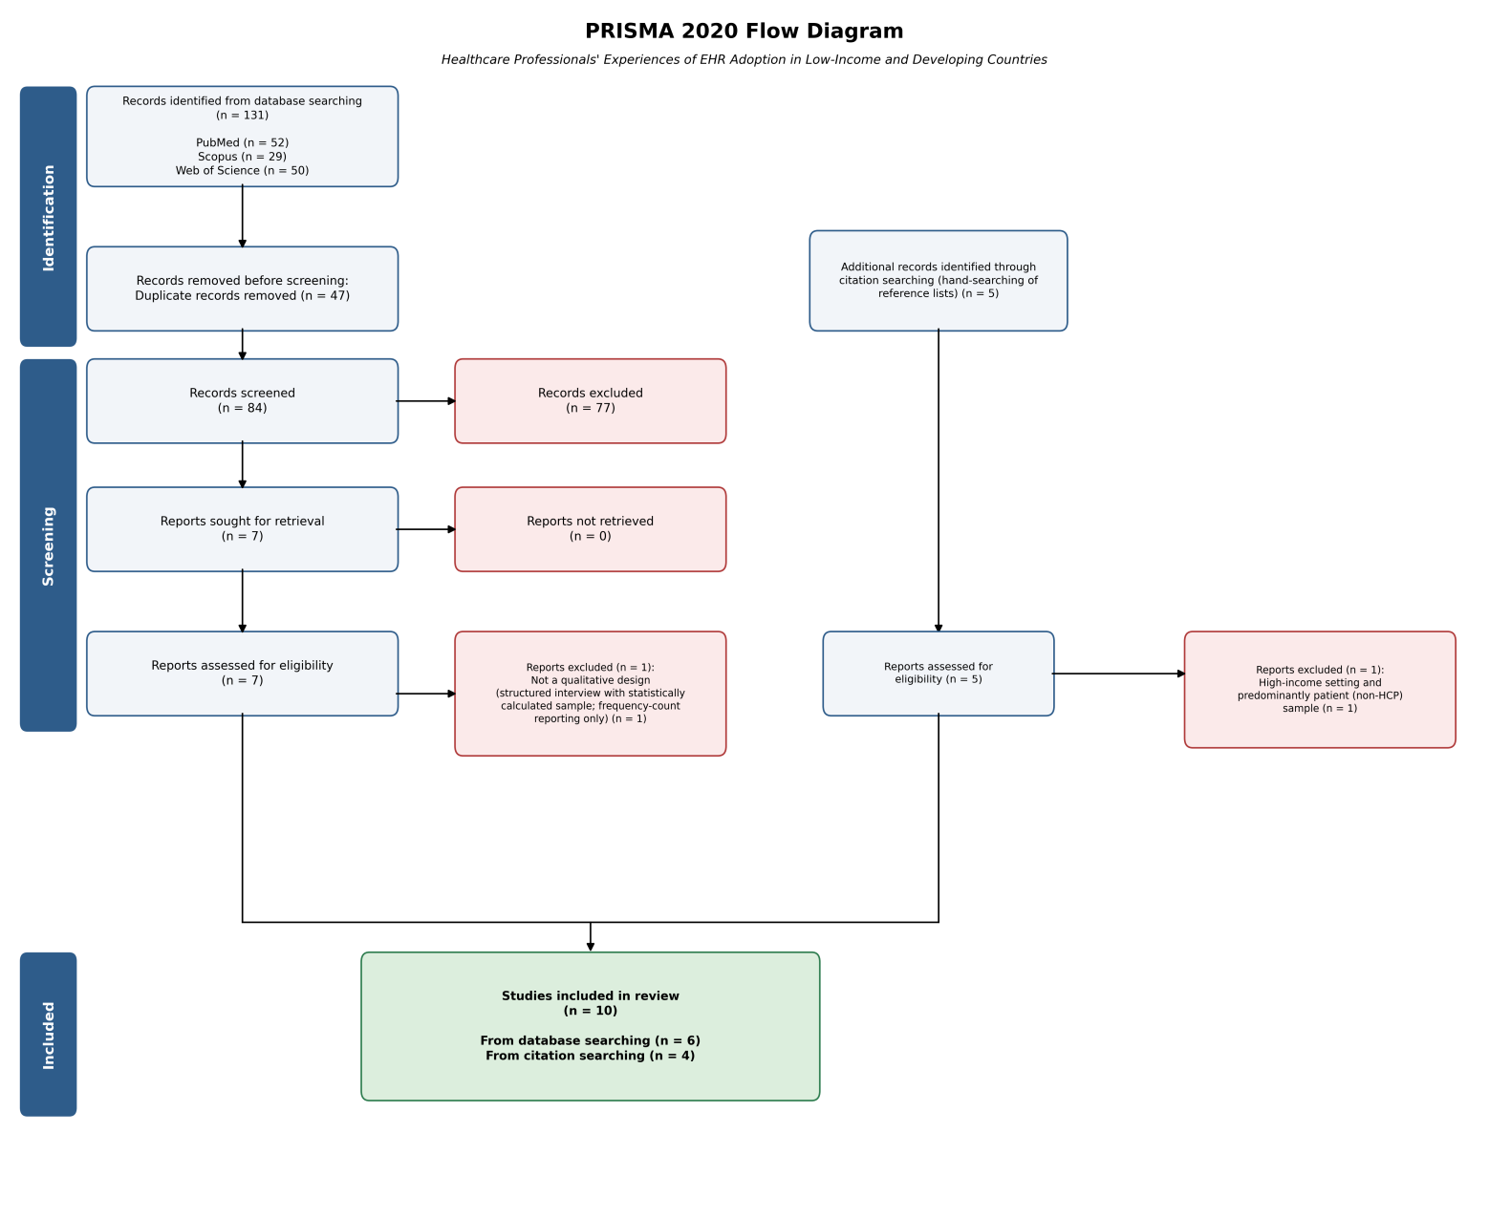
NB: Adapted from the PRISMA 2020 statement (Page et al., 2021). n = 131 records identified across three databases (PubMed, Scopus, Web of Science); 47 duplicates removed; 84 unique records screened; 77 excluded at title/abstract stage; 7 full texts assessed for eligibility, of which 1 was excluded (not a qualitative design); 5 additional records identified via citation searching, of which 1 was excluded (high-income setting, predominantly patient sample); 10 studies included in the final synthesis (6 from database searching, 4 from citation searching).

