1. **JDK, JRE, and JVM**

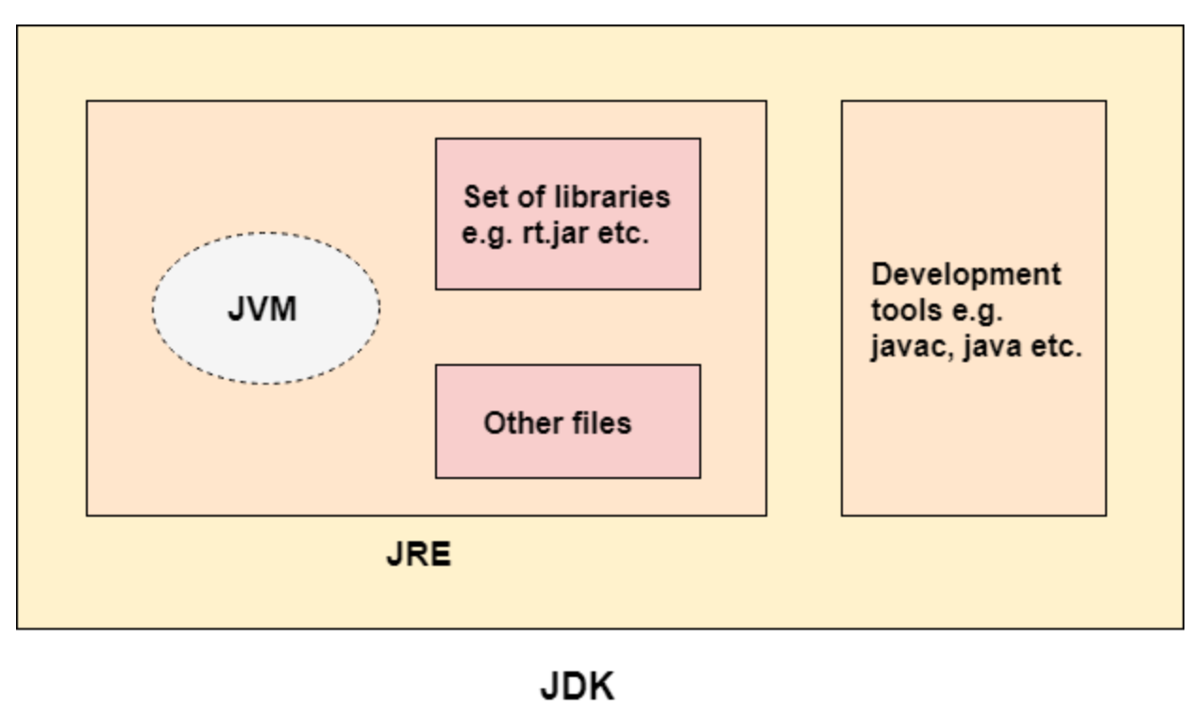

1. **JVM Architecture**

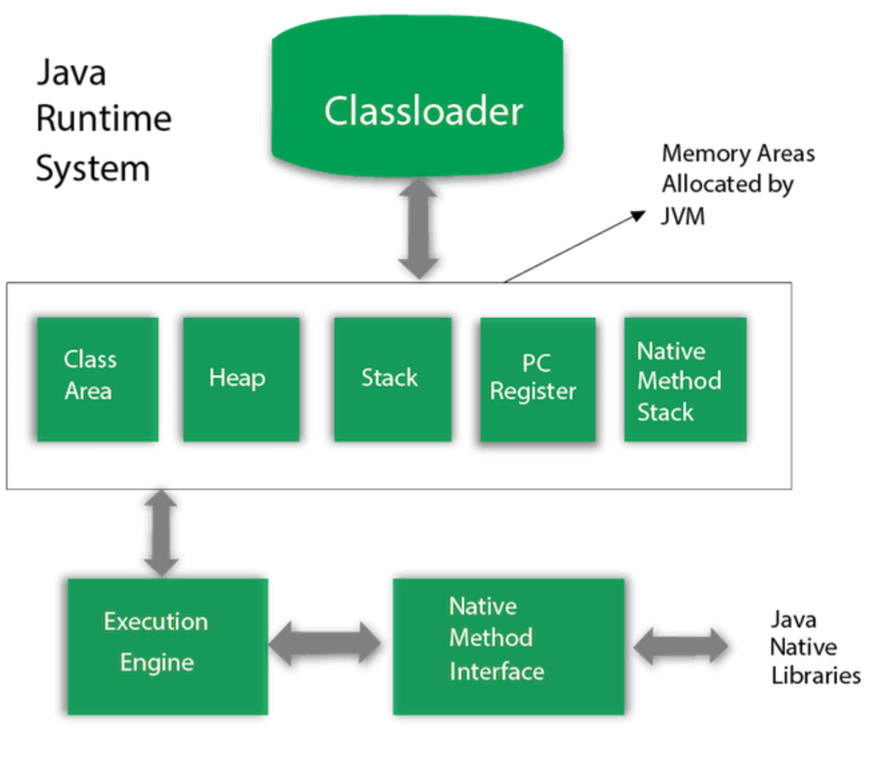

1. **Variables**

There are two types of data types in Java: primitive and non-primitive.

There are three types of variables in Java:

* local variable
* instance variable
* static variable