The following screen shots showing the HTTP GET and HTTP reply answer these questions:

1. Is your browser running HTTP version 1.0 or 1.1? What version of HTTP is the server running?

2. What languages (if any) does your browser indicate that it can accept to the server?

3. What is the IP address of your computer? Of the gaia.cs.umass.edu server?

4. What is the status code returned from the server to your browser?

5. When was the HTML file that you are retrieving last modified at the server?

6. How many bytes of content are being returned to your browser?

7. By inspecting the raw data in the packet content window, do you see any headers within the data that are not displayed in the packet-listing window? If so, name one. Answer: no, I don’t see any in the HTTP Message below

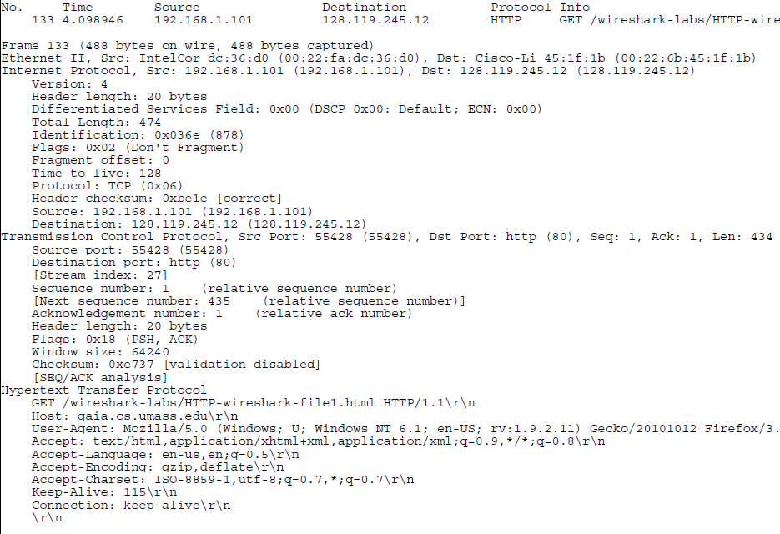

**Client ip address**: 192.168.1.101

**Gaia server ip address**: 128.119.245.12

**Client running: HTTP** 1.1

**Languages accepted: en**-us,en:q=0.5\r\n

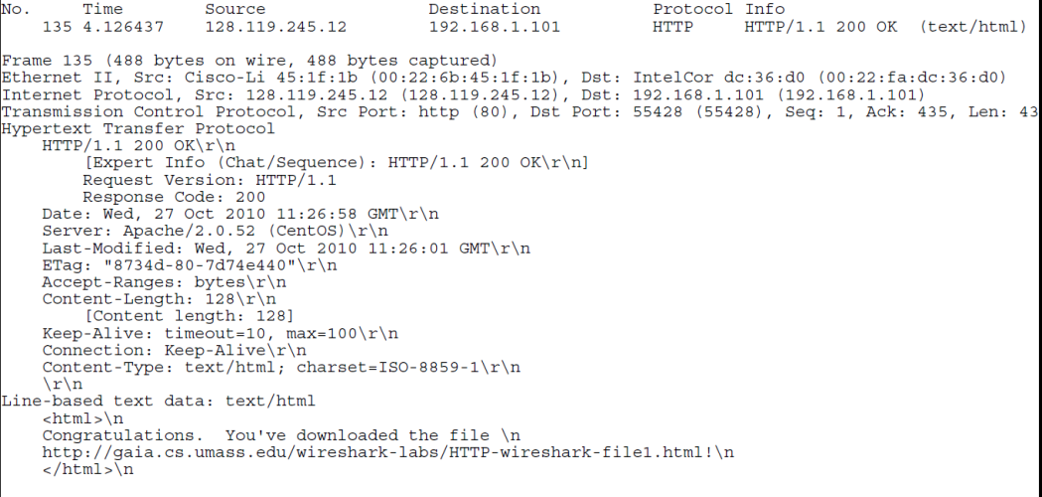

**Return status:** 200 ok

**Server running:** http/1.1

**Document last modified:** wed, 27 oct 2010 11:26:01

**Content length:** 128

**2. The HTTP CONDITIONAL GET/response interaction**

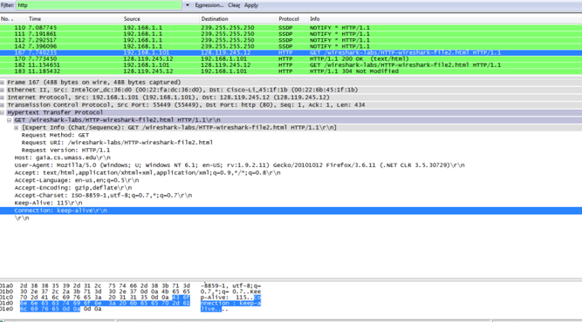

**First GET,then a reply,then another identical get then a reply (304 not modified)**

Answer the following questions:

8. Inspect the contents of the first HTTP GET request from your browser to the server. Do you see an “IF-MODIFIED-SINCE” line in the HTTP GET?

9. Inspect the contents of the server response. Did the server explicitly return the contents of the file? How can you tell?

10. Now inspect the contents of the second HTTP GET request from your browser to the server. Do you see an “IF-MODIFIED-SINCE:” line in the HTTP GET? If so, what information follows the “IF-MODIFIED-SINCE:” header?

11. What is the HTTP status code and phrase returned from the server in response to this second HTTP GET? Did the server explicitly return the contents of the file? Explain. Here are the four captures packets (two GETs and two REPLIES, in chronological order):

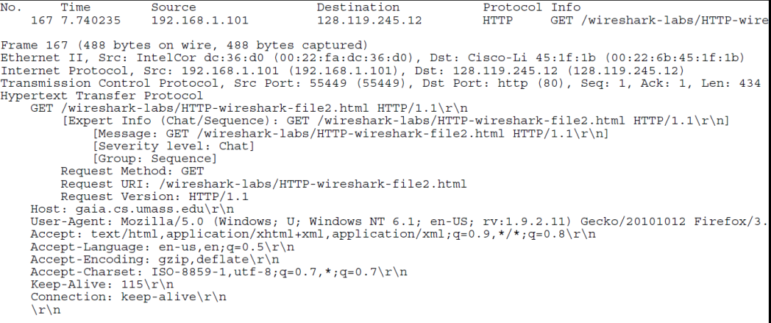

**There is no if-modifed-since in the first GET**

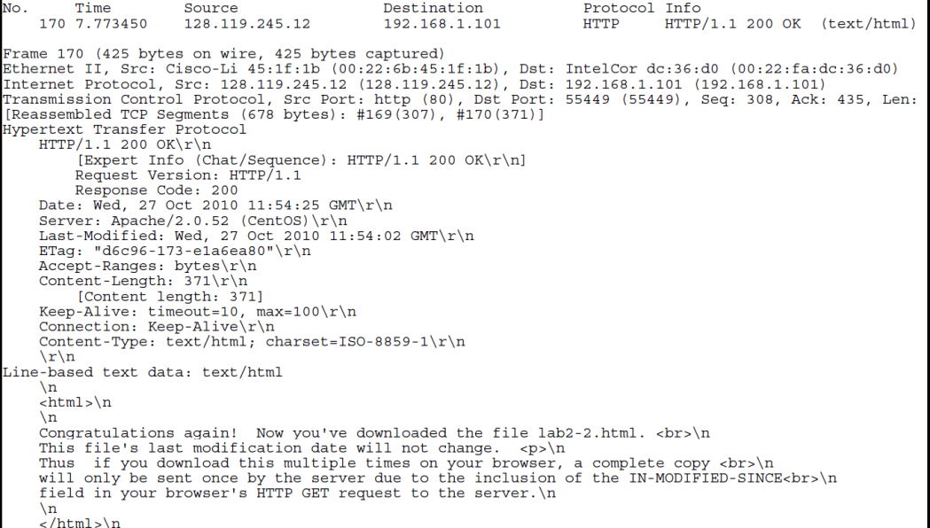

**Text returned in response to first GET**

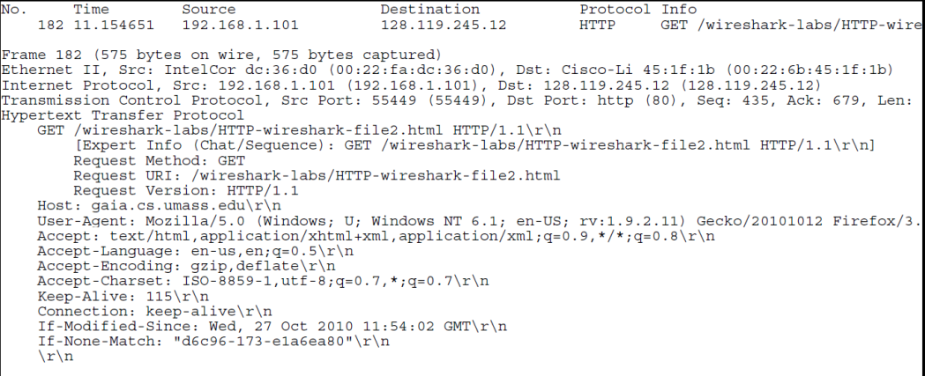

**2nd get has if-modified-since**

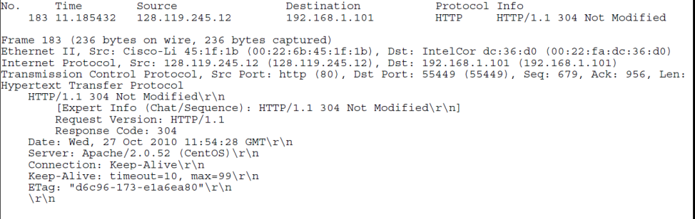

**The file has not been modified so the text of the file is not returned in the http message**

3. Retrieving Long Documents In our answer below, we use the http-ethereal-trace-3 packet trace file. The HTTP GET for the long document is packet 8 in the trace (at t=4.623732); the HTTP OK reply is packet 14 (at t=6.680432).

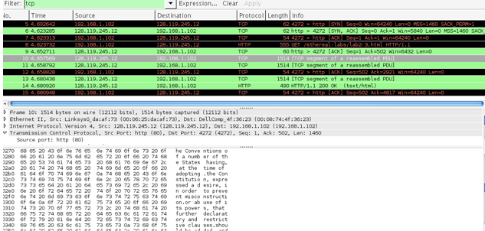

The HTTP repl7 carrying the text of the Bill of Rights are packets 10, 11, and 13. If you look into the ASCII content of packet 10, you can see the beginning of the text of the Bill or Rights. Note that packet 12 is a client-to-server TCP ACK.

Answer the following questions:

**12. How many HTTP GET request messages did your browser send? Answer: 1. Which packet number in the trace contains the GET message for the Bill or Rights?** Answer: 8.

**13. Which packet number in the trace contains the status code and phrase associated with the response to the HTTP GET request?** Answer: packet 10.

**14. What is the status code and Phrase in the response?** Answer: 200 (OK)

**15. How many data-containing TCP segments were needed to carry the single HTTP response and the text of the Bill of Rights?** Answer: three packets (10, 11, 13 in the trace)

4. HTML Documents with Embedded Objects In our answers below, we use the http-ethereal-trace-4 packet trace file.

Answer the following questions:

**16. How many HTTP GET request messages did your browser send?**

Answer: there were three HTTP GET messages sent: packet 10 in the trace (to get the base file), packet 17 (to get the Pearson logo) and packet 20 (to get the 5th edition textbook cover). To which Internet addresses were these GET requests sent? Each of these three GET messages were sent to different IP addresses! Packet 10 was sent to 128.119.245.12, packet 17 to 165.193.123.218, and packet 20 to 134.241.6.82.

**17. Can you tell whether your browser downloaded the two images serially, or whether they were downloaded from the two web sites in parallel? Explain. Answer**: The downloads occurred in parallel. Note that the two GET messages for the images are in packets 17 and 20. The 200OK reply containing the images sow up as packets 25, and 54. Thus the request for the second image file (packet 20) was made BEFORE packet 25, the first image file was received.

Answer the following questions:

**18. What is the server’s response (status code and phrase) in response to the initial HTTP GET message from your browser?** Answer: Packet 6 in the trace contains the first GET and packet 9 contains the REPLY. The server’s in packet 9 is: 401 Authorization Required

**19. When your browser’s sends the HTTP GET message for the second time, what new field is included in the HTTP GET message?** Answer: The HTTP GET includes the Authorization: Basic: field