**Question 4**

**Q.4.1**

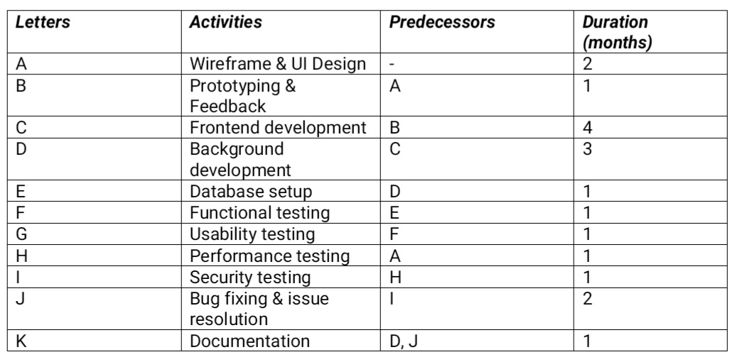

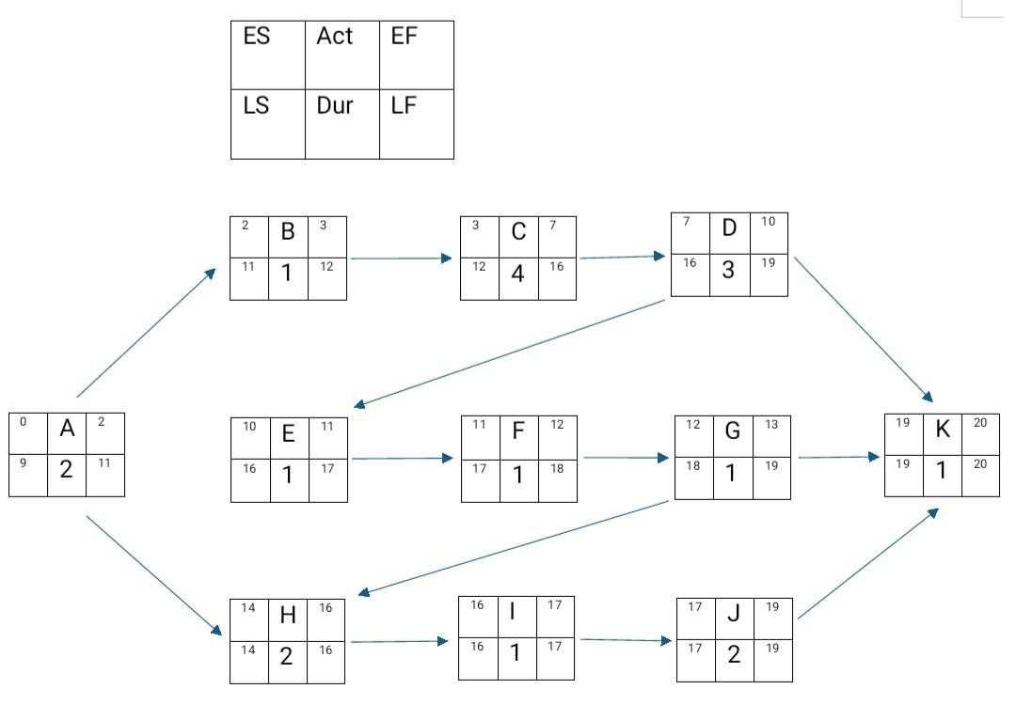

**Q.4.2**

Based on the diagram its likely we may reach the deadline. We had Divide the activities in your Work Breakdown Structure (WBS) into tiers. Make a table with all of the actions and their orders. For every activity in the table, add dependents and linkages.