**SOCIO-DEMOGRAPHIC CHARACTERISTICS AS DETERMINANTS OF PUPILS’ ACADEMIC PERFORMANCE:**

**THE CASE OF PRIMARY SCHOOLS IN KADUNA METROPOLIS**

**BY:**

**OMOFAIYE AMOS MOSES**

**PDE/19/0139**

**A PROJECT SUBMITTED TO THE DEPARTMENT OF EDUCATION, SCHOOL OF EDUCATION AND HUMANITIES IN PARTIAL FULFILLMENT OF THE REQUIREMENT FOR THE**

**AWARD OF PROFESSIONAL DIPLOMA IN EDUCATION,**

**BABCOCK UNIVERSITY, ILISHAN REMO, OGUN STATE**

**SUPERVISOR:**

**DR NMA JAMES**

**AUGUST, 2020**

# ABSTRACT

Education is not taken in vacuum. Quality education is impacted by the school environment, the teacher, the learner, and the home from which the learner comes to school. Various studies have studied one aspect or the other of these factors but in the face of the school feeding programme, there exists a knowledge gap in terms of whether household characteristics still influence the academic outcomes of the learners in Literacy and Numeracy. This study, therefore, set out to understand the relationship between the demographic characteristics of the parents of learners (who are currently participating in the Home Grown School Feeding Programme) and the academic performance of the learners in Literacy and Numeracy. Cross-sectional data were collected from 550 public school primary three learners in Kaduna Metropolis using a three stage simple random sampling technique. Descriptive analysis was carried on the data using frequency, mean, percentage, standard deviation and visualizations. Four hypotheses were postulated and tested using regression analysis. The study found that only 17.45 percent of the household heads obtained formal education above secondary school level and that more female learners live with guardians than male learners. Also, as household size increases, more female learners tend to leave their biological parents to go and stay with a guardian probably working as a maid. Learners from petty traders home perform significantly poor in both subjects. Learners from homes whose head does not have any form of formal education or only completed primary education perform significantly poor in both subjects. Learners from smaller households score significantly higher marks in both subjects. In all four cases of hypothesis testing, there was no sufficient evidence to accept the null. So the null hypotheses were rejected. It is therefore recommended that adult education, age-compact classrooms, and smaller households should be encouraged.

# CERTIFICATION

I certify that this work entitled “**Socio-demographic characteristics as determinants of pupils’ academic performance: The case of primary schools in Kaduna metropolis**” was carried out by **OMOFAIYE, Moses Amos (PDE/19/0139)**, in the Department of Education, School of Education and Humanities, Babcock University.

_______________________ ________________________

**Dr James, Nma C. Date**

Project Supervisor

_______________________ ________________________

**Professor Aderanti, Ruth A.**

Head of Department Date

# DEDICATION

This work is dedicated to God (the seed sower and director of my life), my mother (the nurturer of my fragile embryo) and my ever-caring sister (a near perfect substitute).

# ACKNOWLEDGEMENT

“As I was with Moses, so I will be with you. I will not leave you nor forsake you… and lo, I am with you always, even to the end of the age.” I thank the Almighty God for fulfilling His promise to me.

Many people get lecturers as supervisors. Some get advisers as their supervisors. But I got a mother as my supervisor. Dr James, Nma C., yourwords of encouragement and your motherly care has convinced me that there are still mothers in the teaching profession who prioritizes the issues of their supervisees. I thank you so much, ma. May God continue to bless the works of your hands.

Managing the classroom is a demanding task let alone managing a department. To the Head of Department, Professor Aderanti, Ruth A., I thank you for always listening to our concerns and always ensuring that such concerns were duly and appropriately addressed. May the God you serve, continue to treat you as the apple of His eye.

Although many believe that the jejune mind is not tabula rasa, it still needs suggestions before its resources can be mined. Thanks to all the lecturers of the department for using their wealth of understanding to disclose my lack of understanding to me. I cannot thank them enough for the great impact they have my in my life by ensuring that I become a certified teacher with the right mindset and the appropriate skills necessary for the educational workspace. I thank you.

My family is the giant that carries me whenever I find it difficult to walk, and such times are numerous. To all my family members: Mr. and Mrs. Awe, Mr. and Mrs. Solomon, Messrs Gbenga and Daniel Omofaiye, I say thank you all for being there always. And to my heart in another body: Justina, I say thank you for being there when it matters.

Almost everyone I have ever approached in for help in writing a thesis has been quick to offer it. Most people I work with are like that in general. They are always willing to what they can if I but ask in the appropriate manner. The list includes those who were gracious when asked and those who helped without even knowing they did. A big thank you to Daniel Akor, Justina Ayinmode, Agweche Emmanuel, David Tanko, the class of Ducibus, Assumpta Dagat, Courage Agbeti, Moses Stephen, the Headmaster, members of staff and management at Aliyu Makama Model Primary School, all the schools where samples were drawn, my course mates, ipablo and my Udacity community. Without your inputs, my study would have been stuck beyond retrieval.

**OMOFAIYE, Moses Amos**

**August, 2020**

# TABLE OF CONTENT

Table of Contents

ABSTRACT ii

CERTIFICATION iii

DEDICATION iv

ACKNOWLEDGEMENT v

TABLE OF CONTENT vii

CHAPTER ONE 1

1.1 Background to the study 1

# CHAPTER ONE

**INTRODUCTION**

## 1.1 Background to the study

Education is essential for the development of society. The more educated the people of a society are, the more civilized and well-disciplined the society might be (Muhammad et al., 2013). Formal education is obtained in schools through an array of subjects. Academic performance is an important parameter used in measuring students’ success or failure in a particular subject in school (Ellaet al., 2015). Academic performance is used synonymously with academic attainment. A student's academic performance attracts the attention of all those involved in education. This is so because academic performance is a proxy for measuring learning. Moreover, the improvement of students' achievements has always been one of the main goals of education(Salahuddin & Talukder, 2017).Educators want learning to improve and as such strife to raise pupils’ academic performance (PAP).

Many factors contribute to the academic performance of learners (pupils in this case). Some of these have been studied by researchers with many emphasizing the role of students, schools, governments, peer groups and so on. More often than not, some of these factors influencing the academic achievement of the students have been traced back to parents and family; being the primary platform on which learning not only begins but is nurtured, encouraged and developed which later transforms to the performance of the students (Ogunsola et al., 2014). The training and development of a child is naturally placed in the hands of the parents. This is congruent with the common assertion of sociologists that education can be an instrument of cultural change whose foundation begins from home. It is not out of place to imagine that parental socio–economic background can have effects on the academic achievement of children in school (Adewale & Ogunshola, 2012). Learning begins at home through interaction with one’s family. Parental involvement in a child’s education along with environmental and economic factors may affect child development in areas such as cognition, language, and social skills. Numerous studies in this area have demonstrated the importance of family interaction and involvement in the years prior to entering school (Bergsten, 1998; Hill, 2001; Wynn, 2002). Research findings have also shown that a continued effort of parental involvement throughout the child’s education can improve academic achievement (Driessen, Smit & Sleegers, 2005; Fan, 2001; Hong & Ho, 2005 in Rafiq et.al., 2013).

But if parental involvement is so important, are some parents better placed to influence their children academic output than others? Socioeconomic status is seen as one of the factors that affect learning; students learn better if they are from an above-average or average income family (Shawwa, Ahmad, Rhman, Merdad, Sara, Algethami,, Abu-shanab, & Balkhoyor, 2015). The impact of demographic, socioeconomic and educational patterns onacademic performance is an especially relevant issue in developing countries, where major inequality in the distribution of wealth is a serious social concern (Azhar, Nadeem, Naz, Perveen, & Sameen, 2013). Low-resource and low-income families may be unable to provide materials and fees needed by their children in school. According to Salahuddin et.al., (2017) one of the main factors that affects the academic performance of students is adequacy of money provided by the parents/guardians to the students. High income families may be able to provide more resources and as a result their children may have better academic outcomes than those from low income families. Daniyal, Nawaz, Aleem , and Hassan (2011) also found this to be true in Nigeria.

If parents do not have the resources, they may be unable to provide not only the needed academic resources for their wards but also the necessary nutrient intake. When a woman’s nutritional status improves, so does the nutrition of her young children (Ogunshola et.al., 2014). Low resource families or large households also create in the upbringing of children some identified problems such as feeding, poor clothing, insufficient funds, and lack of proper attention for children, disciplinary problems and malnutrition which impact negatively on children academic performance (Ella et.al., 2015). Moreover, Powell and Stellman (2010) and Van-Ejick and DeGraaf (2012) argued that children’s academic attainment depends on inputs of time and money from their parents, the more children there are in family the less of both inputs. These inputs are not money alone, but other essential things like attention, resource dilution and so on. For low-income households there is less money and this may translate to less time for the children because parents will be busy trying to get money to cater for the family needs. This means that the single constraint of not having adequate money can attract such undesirables as inadequate family resources, inadequate time for family interactions, lack of focus and attention to the children academic and nutritional needs thereby culminating in low academic performance for the children in the household.

To reduce this low academic performance issue among primary school students, the government of the federation and that of the state instituted a free education and free feeding programme in primary schools in the state. Pupils pay 100 naira per term as examination fee. Pupils may not pay this amount and still be allowed to write the examination provided they are ready to copy questions into their notebooks from the chalk board. In such case the chalkboard serves as the question paper while the pupil’s note is the answer booklet. Moreover, textbooks are provided. Pupils can share textbooks with their seat partners usually about 2-5. Also, pupils from primary one through three get nutritious age-grade relevant meals once every school day during breakfast to complement household consumption. These are expected to lighten the educational load on the pupils’ families and therefore raise the academic performance of the pupils.

## 1.2 Statement of the research problem

A conducive environment is necessary to enhance the academic performance of a child. A stimulating home environment can spur up a potential mediocre into an intellectual giant while an inhibiting one could turn a genius into a mediocre (Olakan, Osakinle, & Onijingin,2013). Taking care of children and also making provision for their needs, especially educational needs, are very important in determining the academic performance of children (Ella et.al., 2015). The home environment and family processes provide a network of physical, social, and intellectual forces and factors that affect the student’s learning. The family’s level of encouragement, expectations, and educational activities in the home is related to socio-economic status. Families from different socio-economic groups create different learning environments that affect the child’s academic achievement (Slaughter, 2007).

In situations where parents are unable to provide such conducive environments at home, a suitable alternative must be sought. The Free Education and The Home-Grown School Feeding Programme were introduced. It was supposed to help parents and pupils surmount the obstacles to learning at home thereby raising pupils’ academic performance. Various supporting programme like massive teacher training and school renovations were carried out.

Despite all these, pupils’ academic performance still varies substantially especially in literacy, and numeracy. Moreover, when overall subject scores are disaggregated into examination and continuous assessment there appears a bimodal distribution and substantial variance across aggregates. For pupils who do not have to worry about whether their school fees are paid or not, who enjoys meal at school during break time, and who are being taught by trained teachers with modern academic toolkits, this observation is unexpected. Could it be that there ‘are other aspects of parents’ demographics that should be addressed? This is a knowledge gap that this study hopes to address.

## 1.3 Objectives of the study

The general objective of the study is to assess how parents’ socio-demographic characteristics affect pupils’ academic performance in Kaduna Metropolis Primary Schools. The specific objectives of the study shall be to:

1. assess the socioeconomic characteristics of the primary school pupils in the study area
2. assess the socio-demographic characteristics of their parents
3. examine the relationship between the socio-demographic characteristics of the parents and the academic performance of the pupils, and
4. determine which components of the parents’ socio-demographic characteristics influence pupils’ academic performance.

It is the hope of the researcher that achieving these specific objectives will ultimately translate to the achievement of the general objectives of the study.

## 1.4 Research Questions

To address the knowledge gap, the following research questions will be raised:

1. Will parents’ occupation type have any influence on pupils’ academic performances in Literacy and Numeracy?
2. Will pupils’ household sizes have any influence on pupils’ academic performances in Literacy and Numeracy?
3. Will parents’ educational status have any influence on pupils’ academic performances in Literacy and Numeracy?

It is the hope of the researcher that providing answers to the research questions will ultimately answer the research problem and consequently fill the knowledge gap.

## 1.5 Hypotheses for the study

The following null hypotheses will be tested in order to achieve some of the objectives of this study.

1. There is no significant relationship between Parents’ occupation type (POT) and Pupils’ Academic Performance in Literacy and Numeracy (PAPLIN).
2. There is no significant relationship between pupils’ Household size and PAPLIN.
3. There is no significant relationship between Pupils’ socio-educational characteristics and PAPLIN.
4. There is no significant relationship between parents’ educational status and PAPLIN.

## 1.6 Significance of the study

Education is instituted to produce learning. Formal education is believed to make students learn specific skills. These skills are expected to be evident in the learners’ interaction with his/her environment. As a result, the society improves and becomes better overtime. Such is the reasoning behind the creation of schools and the advancement of education right from the early childhood years. Learning cannot be directly measured. Therefore, quantitative record of academic performance is used to proxy learning. The higher the academic performance the higher the amount of learning that has taken place.

Every country is concerned with improving the academic performance of its learners. But to improve something we must understand its dynamics. Earlier studies have pointed to the positive relationship between child nutrition, household income and academic performance. This relationship if enhanced is expected to raise the academic performance of the pupils. But the disheartening situation still persists. Hence, the need for this study.

The study has the potential of revealing which aspects of PSP that should be addressed in order to address the issue of undesirable PAPLIN in Kaduna Metropolis. The findings may be applicable to neighbouring metropolis or communities that have similar socio-demographic characteristics. The findings will therefore be a useful guide in steering the wheel of primary education to the desired state in the state.

## 1.7 Scope of the study

This study is limited to lower primary school pupils in Kaduna Metropolis. Specifically it is limited to primary three learners in Kaduna Metropolis.

## 1.8 Operational definition of terms

It is necessary at this juncture to define some constructs proposed to be used in this study.

1. Pupils’ Academic Performance in Literacy and Numeracy (PAPLIN)…………..This is the individual pupil score in Literacy and Numeracy. The score ranges from 0-100 and is made of two components -the continuous assessment part and the examination part.

2. Parents’ Socio-demographic Characteristics (PSC)…………….These are the population, economic, and social characteristics of the parents of the primary school pupils. Examples are age, household size, educational attainment, occupation, tribe etc.

3. Socio-educational characteristics………………… These are the social, anthropometric and educational characteristics of the pupils. These include sex, pastimes, educational ability classification, literacy and numeracy score, grade level, age, height, weight, either with parent or guardian etc.

# CHAPTER TWO

# LITERATURE REVIEW

This section presents a brief review of literature on socio-demographic characteristics of parents and the academic achievement if pupils. It sheds more light on the relevant theories and concepts, examines some empirical studies, visits some useful methodologies hitherto employed in literature and concludes by pointing out the peculiarities of this study.

## 2.1 Theoretical Framework

Many theories have been propounded to explain academic performance of learners.

1. The Triarchic Theory of Intellectual Abilities: According to the Theory of Intellectual Abilities (Sternberg, 1985; 1986:23), three kinds of intellectual abilities exist, namely analytical, creative and practical abilities. Measures of abilities tend to focus mainly on analytical abilities, whereas all three types of abilities need to be regarded as equally important. Research done by Sternberg (1997b:24) showed that: The more we teach and assess students based on a broader set of abilities, the more racially, ethnically, and socioeconomically diverse our achievers will be.
2. The Theory of Mental Self-Government Furthermore, research by Sternberg emphasizes that students' learning and thinking styles (Sternberg, 1997a) (which are usually ignored), together with their ability levels, play an important role in student performance (Sternberg, 1992:134; 1994:36-40; Sternberg and Grigorenko, 1997:295). The Theory of Mental Self-Government refers to an inventory of different thinking styles that gives an indication of people's preference of thinking patterns. Where the Triarchic Theory focuses on the ability itself, the theory of Mental Self-Government refers to different thinking styles which constitutes preference in the use of abilities (Sternberg, 1990:366-371). In light of the above theories, this study adopted the theory of mental self-Government as the most appropriate one in enhancing students ‘academic performance at UNZA main campus. The reason is that, the learning and thinking styles of students at campus can either be reinforced leading to excellent academic performance or hindered leading to poor academic performance. This is heavily contingent upon the availability and provision of a number of essential facilities such as good study materials, accommodation, conducive learning environment (lecture theatres), good water and sanitation facilities among others. These being available and in provision, students’ potential abilities of being analytical, creative and practical as described in triarchic theory also become reinforced.

## 2.2 Empirical review

This section presents the findings of some studies relating to academic performance.

**Academic Performance segregated by socio-demographic factors**

Several studies have been conducted in different countries to assess the factors which contribute to academic performance of students at different levels. In Pakistan, Farooq and Berhanu (2011) found that parents’ education and socio-economic status have significant effect on a student’s academic performance in Mathematics and English Language. A study conducted by Jayanthi, Balakrishnan, Ching, Latiff and Nasirudeen (2014) in Singapore revealed that the interest in pursuing a subject, co-curricular activities, nationality of a student and gender affect the academic performance of a student. Additionally, Sibanda, Iwu and Olumide (2015) found that, regular study, punctuality in school and self-motivation are the key determining factors which influence students’ academic performance in South Africa. Ali, Munir, Khan and Ahmed (2013) also found that daily study hours, parent’s socio-economic status and age have a significant impact on academic performance.

Moreover, Catherine (2015) found that socio-economic status of parents especially those with high incomes has a significant impact on academic performance of students within the Kitale Municipality of Kenya. Positive classroom environment has also been found as determining factor of academic performance (MolokoMphale & Mhlauli, 2014). Maganga (2016), Nghambi (2014) and Osei-Mensah (2012), indicated that the availability of teaching and learning materials, competency of teachers and the environment in which a school is located have an impact on students’ academic performance. Furthermore, students’ personality traits, personal goals and motivation as well as the support from teachers and the teacher’s level of experience significantly influence the academic performance of students (Ulate & Carballo, 2011). The discussion above suggests that academic performance of students is influenced by a combination of factors which includes but not limited to: Parents level of education, socio-economic status, interest in a subject, gender, regular studying, punctuality in class, self-motivation, availability of teaching and learning materials, and competency of teachers, school environment, personal goals, and personality traits. These factors could be classified into student, teacher, school and parents factors.

##### Student factors which contribute to academic performance

From the discussions above, it is evident that students play a critical role towards their academic performance. Students’ factors such as developing interest in a subject, engaging in co-curricular activities (Javanthi et al. 2014), regular studying, self-motivation, punctuality in school (Sibanda et al. 2015; Khan & Ahmed, 2013), and students personal goals as well as personality traits (Ulate & Carballo, 2011) affect their academic performance. According to Maric and Sakac (2014), students’ factors that affects their academic performance could be classified into Internal and social factors. They found that the internal factors that influence students’ academic performance included interest in content of a subject, internal satisfaction, and aspiration. The social factors also included social prestige and material reward. MeenuDev (2016) corroborated that students level of interest in a subject influence their academic performance. Similarly, Kpolovie, Joe, and Okoto (2014) asserted that student’s attitude to school and their interest in learning influence their academic performance.

Moreover, Komakech (2015) found that there is a positive relationship between students’ attendance to school and academic performance. Using correlational approach to assess attendance on academic performance in Nigeria, Oghuvbu (2017) had the same result as Komakeck. He found that there is a positive correlation between class attendance and academic performance. Stanca (2010) also found that class attendance has a statistical significant impact on academic performance. Several studies have also found the same relationship (Lukkarinnen, Koivukangas, Seppala, 2016; Aden, Yahye, Dahir, 2013; Duran-Narucki, 2008).

The attitude of students towards their learning have been found to have a significant relationship with academic performance. For example, Awang, Ahmad, Bakar, Ghani, Yunus et al. (2013) found that there is statistical significance relationship between students attitudes towards their learning and academic performance. Janssen and O’Brien (2014) argued that although students learning has an impact on academic performance, it is indirect. Notwithstanding their findings, Manoah, Indoshi and Othuon (2011) confirmed that in the case of mathematics, students’ attitude towards the subject has a direct impact on their academic performance. However, Uok and Langat (2015) found that students who had positive attitudes towards mathematics did not affect their mathematics score.

Afzal, Ali, Khan and Hamid (2010) asserted that students’ personal motivation plays a vital role towards their academic performance. They found that both intrinsic and extrinsic motivation has a positive on students’ academic performance. They added that intrinsic motivation has a strong predictor towards academic performance than extrinsic motivation. Similarly, Haider, Quereshi, Pirzada and Shahzadi (2015) concluded that motivation play an important role in the success of a student academics. In their study, they found that intrinsic and extrinsic motivation had a positive statistical significance relationship with academic performance. They outlined that students motivational characteristics such as self-exploration, altruism, and career focused and manages social pressure have a positive impact on their academic performance. Using structural equation modelling analysis to assess the effect of motivation on performance, Kusukar, Cate, Vos and Croiset (2013) categorised motivation into Random Autonomous Motivation (RAM), Controlled Motivation (CM) and Autonomous motivation (AM). They found that RAM which they define as intrinsic motivation is positively correlated with academic performance. Additionally, Amrai, Motlagh, Zalani and Parhon (2011) argued that the academic performance of students is affected by a combination of different motivational factors.

The literatures reviewed indicated that students factors which influence their academic performance is a combinations of several indicators. From this review, it was found that interest in a subject, regular studying, class attendance, self-motivation and attitude of student towards learning are the key factors which affect their academic performance. All the literature reviewed with the exception of Uok and Langat (2015) who found that there is a positive relationship between these factors and academic performance. This implies that if a student exhibit positive attitude towards these factors his/her academic performance will improve, all other things being equal.

##### Teacher factors which contribute to academic performance

Teachers play vital role towards the academic performance of students. A study conducted by Kimani, Kara and Njagi (2013) in Kenya on teacher factors influencing academic achievement, found that teachers experience, age, gender and professional qualification had no statistical significant relationship with academic performance of students. However, they noticed that performance targets, completion of syllabus, paying attention to weak students, assignments, student evaluation, and the teaching workload of a teacher had significant relationship with students’ academic performance. In Nigeria, Akiri and Ugborugbo (2009) also found that there is no statistical relationship between teacher effectiveness and academic performance.

Ganyaupfu (2013) on the other hand asserted that combination of teacher and student centred method have a positive effect on academic performance. They concluded that student centred method is more effective than teacher approach. Musili (2015) added that teacher experience and professional training have a significant impact on students performance. Blazar (2016) confirmed that the impact teachers have on the academic performance of their students is substantial. But stressed that little is known about the specific teacher factors which contributes to the academic performance of students.

Furthermore, Akinsolu (2010), concluded that teacher-student ratio, teacher’s experience and qualification has a significant impact on academic performance. Similarly, Ewetan and Ewetan (2015) emphasized that the level of teacher’s experience has significant impact on academic performance in English Language and Mathematics. They posited that school with teachers with more than 10 years’ experience perform better than school with teachers with less than 10 years’ experience.

Teacher factors that significantly affects students’ academic performance as reviewed above includes: Teachers teaching experience, completing of syllabus, paying attention to weak students, assignments, students’ evaluation, teacher effectiveness, teacher and student centred method of teaching, professional training, teacher to student ratio and qualification of teachers. It was also noticed that teacher’s age and gender have no effect on students’ academic performance.

Parent factors which contribute to academic performance

Recent studies have found that parental involvement have a positive impact on the academic performance their wards. McNeal (2014) for example, revealed that parent involvement directly affects the behaviour and students attitudes but indirectly influence their academic performance. In Ghana, Chowa, Masa and Tucker (2013) posited that the involvement of parents towards their wards academic performance is categorized into home-based and school-based parental involvement. Their study revealed that home-based parental involvement have a positive significant relationship with their wards academic performance but there is a negative relationship between school-based parental involvement and academic performance. Similarly, Mante, Awereh and Kumea (2014) also concluded that parental involvement affect the academic performance of their students but the direction of the impact wasn’t stated. Additionally, Mwirichia (2013) noticed that parental involvement in the academic performance of students has different forms. He found that there is parent involvement in educational activities at school, parent-school communication and parents’ involvement in academic activities at home. The study concluded that parent’s involvement in home academic activities have a direct influence on the academic performance of their wards; it was realized that parent’s involvement in academic activities at school has an indirect effect on academic performance; and the impact of parent-school communication on academic performance was found not to be a strong predictor. It was recommended that parents provide home-school tutorials for their wards and there should be rules to govern their children’s studying behaviour in the house. Caro (2011), also found that parent-school communication as a positive impact on their wards education.

Matinez (2015) emphasized that students with high level of parental involvement in their academics significantly perform better than those students with no parental involvement in English Language arts and Mathematics. Using a multiple mediational analysis, Topor, Keane, Shelton and Calkins (2010) found that there is a statistical significance association between parental involvement and the wards academic performance. In Pakistan, Rafiq, Fatima, Sohail, Saleem and Khan (2013) had the same results. They emphasized that parental involvement has a significant effect in improving the academic performance of students. In South Africa, Mutodi and Ngirande (2014) found that parent-teacher communication, family and home support as wee las parenting have is positively related to academic performance. The concluded that the most significant predictor of academic performance is the family and home support.

Empirically, parental involvement have been found to have a significant positive impact on the academic performance of the wards but the degree and level of parental involvement varies and this has an indirect effect on the academic performance of their children.

##### School factors which contribute to academic performance

School based factors are factors within the school which influence academic performance. Tuitock, Yambo and Adhanja (2015) found that in Kenya public schools, the key school factors which affect academic performance are modern laboratories and text-books. Within the same country, Nambuya (2013) revealed that the availability of physical resources such as library, text-books, adequacy of classrooms and spacious playing ground affect the academic performance of students.

In Tanzania, Tety (2016) noticed that instructional materials have an impact on academic performance. Awolaju (2016), Olayinka (2016), and Adipo (2015) also found that students who are taught with instructional materials in Nigeria perform better than students taught without instructional materials. Similarly, Krukru (2015) found that in Nigeria, instructional materials have a significant impact on academic performance. He asserted that the use of instructional materials facilitates the smooth delivery of a lesson and it enhances teaching and learning. The use of instructional materials assist students to understand the concept of a subject better. As a result of this students who are taught with instructional materials perform better than student taught without instructional materials (Adalikwu & Lorkpilgh, 2013).

The location of a school has also been found to have a significant impact on the academic performance of students. Mhiliwa (2015) opined that the distance of a school affects the academic performance of students. He emphasized that the longer the distance of a school from a student’s residence the more tired and hungry the student becomes hence it will negatively affect their academic performance. He argued that students in community schools will continue to perform poorly if community schools are not provided within their community. According to Ellah and Ita (2017) students in urban areas tend to perform better in English language than those in rural areas. This indicated the location of the school has an influence on students’ performance in English Language. However, Yusuf and Adigun (2010) found that there is no statistical significance relationship between school location and academic performance.

Again, it was found that schools with suitable rules and regulation; fair punishment; and good implementation of students’ rules and regulations perform better than school with less suitable rules and regulations (Mussa, 2015). Ehiane (2014) also recommended that effective school discipline should be used to control students’ behaviour because it has a direct impact on their academic performance. Simba, Agak and Kabuka (2016) concluded that discipline has a positive relationship with academic performance. They asserted to improve on academic performance the discipline level of students should be enhanced.

Moreover, the size of a class or students to teacher ratio has also been found as a school factor which influence academic performance. According to Ajani and Akinyele (2014), there is a significant relationship between teacher to students’ ratio and a student’s performance in Mathematics. Zyngier (2014) argued that if the class size is smaller and is combined with effective teaching, its impact on the academic performance is positive. Similarly, Bakasa (2011) found that school factors such as effective teaching when combined with class size have a positive impact on academic performance. However, Owoeye and Olatunde (2011) found that there is no statistical difference between class size of schools in the urban areas and rural areas on academic performance. Vandenberg (2012) corroborated that class size has no significant impact on academic performance.

According to Sabitu, Babatunde and Oluwole (2012) there is a statistical significant difference in school facilities of private and public schools but in terms of academic performance there is no statistical difference. On the other hand, Owoye and Yara (2011) stressed that school facilities is the most important determining factor of academic performance.

With respect to school environment, Lawrence and Vimala (2012) found found that there is no statistical significant relationship between school environment and academic performance but other studies said otherwise. For example, Odeh, Oguche, and Dondo (2015), found that school environment has significant impact of academic performance. Duruji, Azuh, and Oviasogle (2014) also found that school environment has a statistical significance relationship with academic performance.

School factors which affect academic performance is enormous as revealed by the literatures above. However, it has been proven that the key school factors which directly influence academic performance includes: instructional materials, discipline, effective teaching, class size and the school environment.

##### Level of parents’ education and academic performance

According to Khan, Iqbal and Tasneem (2015) parents with higher level of education show much interest in the academic performance of their wards. They observed there is a positive significant relationship between the level of parents’ education and students’ academic performance. The same result was found by Muthoni (2013) in Kenya. She noticed that in Kenya Secondary schools, the level of education of a student parent is positively related to his/her performance. Similarly, Ogbugo-Ololube (2016), found that parents level of education has a positive relationship with academic performance. It was also observed by Ntitika (2014) that parents with higher level of education serve as a motivation for their children to work hard to achieve their academic goals. He added that such students have higher aspirations for their education. He found that parent’s level of education has some level of impact on their wards academic performance. Muruwei (2011) argued that although parents level of education has significant impact on academic performance, it not a major determining factor. There are other factors such as learning environment and facilities which also important factors that influence academic performance. On the other hand, Amuda and Ali (2016) found that parent’s level of education has no statistical impact on their wards academic performance. The impact of parent’s level of education of the academic performance of their wards seems inconclusive. Whiles some studies found a positive significant relationship; others have argued that it is not the sole determining factor of academic performance. Additionally, studies have also found that there is no statistical significance relationship between parents’ education level and academic performance. This creates a gap in the literature hence the researcher sought to fill this gap.

Gender and academic performance

The relationship between gender and academic performance have been researched extensively for the past decade (Eitle, 2005 as cited in Farooq & Berhanu, 2011). According to Ghazvini and Khajehpour (2011) there is a difference between the cognitive levels of boys and girls. They noticed that the learning task of girls is more adaptive than boys. Omwirhiren and Anderson (2016) indicated that there is a statistical significant difference between the academic performance of males and females in Chemistry. They concluded that boys performed better than girls. Farooq and Berhanu (2011) on the other hand found that girls generally perform better than male students. Similarly, Nnamani and Oyibe (2016) and Jayanth et al. (2014) found that gender has a significant impact on academic performance. Maric and Sakac (2014) also observed that girls have higher academic performance than boys. MeenuDev (2016) also noticed that girls are superior to boys in academic performance. The same result was found by Nnamani and Oyibe (2016). They noticed that females perform better than males in Social studies. With respect to Mathematics, English and Aptitude, boys perform better than the girls (Eshetu, 2014). Manoah et al. (2011) also argued that in terms of mathematics, gender has no statistical significant impact on performance. Adigun, Onihunwa, Irunokhai, Sada and Adesina (2015) also found that there is no statistical difference but concluded that boys perform better than girls.

A study conducted in Nigeria to assess gender difference in academic performance of students in Economics subject at the Secondary school level revealed that, in 2006/2007 Senior Secondary School Certificate Examination (SSCE), there was no statistical difference in the academic performance of boys and girls in Economics but from 2008 to 2010 there was statistical difference. It was concluded that males generally performed better than females in Economics (Amuda, Ali, Durkwa, 2016). The impact of gender on academic performance still remain inconclusive. Using Aptitude Test as a measure for academic performance in Kashim Ibrahim College of Education in Nigeria, Goni, Yagana, Ali and Bularafa (2015) noticed that there is no statistical difference between gender and academic performance. Wangu (2014), found other wise and reported that females perform better in languages while males perform better than females in the sciences. From the discussion above, the influence of gender on academic performance is not clear; whiles some researchers have found a statistical significance difference, other found no significance difference. In assessing the performance of boys and girls, it has been revealed that it depends on the subject but it has been established that they have different cognitive level.

##### Age and academic performance

Several demographic variables have been used as a predictor of academic performance (Jabor, Machtmes, Kungu, & Buntat, 2011) but this section looks at the impact of age on academic performance. The impact of age on academic performance are mixed. For example, Ali et al. (2013) found that age has a significant impact on academic performance. Jabor et al. (2011) also found the same result by using mathematics as a measure of academic performance. Similarly, Abubakar and Oguguo (2011) noticed that there is significant positive impact of age on academic performance in Mathematics and Science but the degree of association is weak. Amro, Mundey and Kupczynski (2015) corroborated that in an online and face-to-face algebra class, age was found to be a predictor of students’ performance. Further, Ezenwafor and Obi (2015) used the Vocational and Technical Education students in Nigeria to assess the effect of age and gender on their academic performance. Their study revealed that age has a significant impact on academic performance. Naderi, Abdullah, Aizan, Sharir and Kumar (2009) suggested that other studies should be contacted to incorporate other factors which determine academic performance because they found a weak positive impact of age on academic performance.

In contrast, Amuda, Bulus and Joseph (2016) reported that age has no significant impact on academic performance. Voyled (2011) also reported that student age does not have an impact on his/her performance in reading but was significant for mathematics.

## 2.3 Summary of the Literature Review and Conceptual Framework

Various views and opinions exist on how academic performance is determined by some factors.

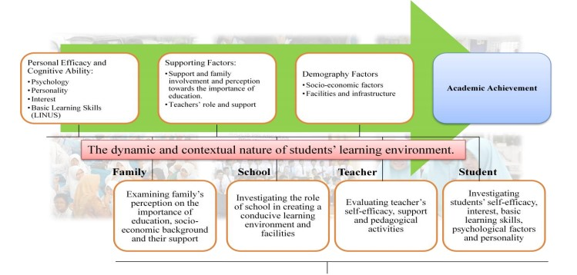

Academic performance is not achieved in vacuum neither is it purely idiosyncratic. A league of factors inter-relatedly play to determine how a given learner performs in academic assessments. These array of factors are the personal genetic ability of the learner, the school the learner attends and its teachers, the community of the learner, the educational policy obtainable in the learner’s context, the personal aspirations of the learner, and the household to which the learner belongs. If all but one is right, then, all is still not right. A single research effort will find it difficult to determine how these factors determine academic performance. As such, dedicated efforts towards discovering the impact of one factor will promise more robust result than a jumbled effort that hopes to tackle all the factors at once. This study concerns itself with how the household factors affect the learners’ academic performance. It is assumed that the socio-demographic characteristics of the learners’ parents can influence the academic performance of the learners in that household.

For this study the chart below sheds more light on the researcher’s perspective on the relationship between learners’ academic performance and their parent’s socio-demographic characteristics. The various inputs (such as teacher, school, community, family, household size, etc) undergoes the process of resource provision, teaching and support to bring the desirable outputs of moral and academic achievement in the learner. These outputs overtime translates to the outcomes evident in an egalitarian society full of problem solvers, sustainable developers and one devoid of the fuss and kerfuffle of crime, violence, intolerance and associated vices. This will also help the community to achieve goal 4, 5, and 6 of the Sustainable Development Goals (SDGs).

Parent

Pupils

Teachers

School

Community

Peers

Family

Education

Household size

Improved Literacy and Numeracy Scopes

Improved moral attainment

Happy family, teachers, pupil

Inputs

Process

Outputs

Increase in the number of problem solvers

Learned community makes sustainable development

Reduction in crime rate, violence, intolerance and other vices

Outcomes

Figure 1: Developed by the Author, 2020

**CHAPTER THREE**

**RESEARCH METHODOLOGY**

This section presents the methodology employed in this study. It discusses the research design, the study population, the sampling technique, the method for data collection and the method for data analysis.

**3.1 Research Design**

The research design used is the descriptive survey research design which is cross-sectional in approach. The rationale for using this design is because it useful in observing the sample variables and finding out the behavioural patterns of the respondents across selected schools. The study examined the influence of parents’ socio-demographic characteristics on the academic performance of their children in Literacy and Numeracy with a focus on public primary school (primary three) pupils enjoying the Home Grown School Feeding Programme.

**3.2 Population**

The target population comprises public primary school (primary three) pupils in Kaduna Metropolis of Kaduna State. Kaduna metropolis is in the Kaduna Central Senatorial District.

**3.3 Sampling and Sampling technique**

A three-stage simple random sampling approach was employed. First, 5 Public Primary Schools in Kaduna Metropolis were randomly selected. Second, two grade 3 classrooms were randomly selected from each selected school making a total of 10 classrooms. Third, 80% of all pupils in the selected classrooms were randomly selected. These pupils and their household heads constituted the sample for the study.

An average classroom in Kaduna Metropolis consists of two classes with each having about 40 pupils making an average of 80 pupils per classroom. With this information, 70% of 80 pupils is 56 pupils and therefore 10 classrooms resulted in a total sample size of about 550 pupils.

**3.4. Instrument**

Research Instrument was the self-constructed questionnaire for collection of data from respondents. The questionnaire was sectioned into two parts that is Section A, consisting of questions covering demographic information of the respondents such as name of school, sex, etc. and Section B which was further divided into two subsections. One of the sections consisted of questions on parents’ socio-demographic characteristics such as occupation, education, household size, etc while the other consisted of questions that were responded to by the pupil’s Literacy and Numeracy teachers. These questions centered on pupil’s academic performance.

**3.5 Validity and Reliability of the Instrument**

The questionnaire was given to the Project Supervisor to scrutinize to ensure the face validity as well as content validity. The corrections and the observations of the Project Supervisor were integrated into the final instrument that was used in order to ensure content validity. In order to ascertain the reliability of the instrument, the Cronbach method was adopted. Fifteen pupils from another school were used for the test phase. These pupils were not learners in the schools that were sampled. The reliability coefficient was calculated and the Cronbach Alpha was used to determine that the level of validity of the questionnaire is acceptable.

**3.6 Administration of Instrument**

The Researcher visited the schools, obtained permission from the relevant authorities, appointed research assistants to help distribute the questionnaire. The research assistants thereafter administered the questionnaire in the selected schools for a period of two weeks.

**3.7 Method of Data Analysis**

Data was analyzed using descriptive statistics (frequency count, percentage, mean and standard deviation) and inferential statistics (correlation, simple and multiple linear regressions).

It is believed that these tools are adequate for meeting the objectives of the study and that the research questions were duly answered.

**CHAPTER FOUR**

**DATA ANALYSIS, RESULTS AND DISCUSSION OF FINDINGS**

This chapter presents the data analysis, the results, and the discussion of the findings of the analysis in relation to the study objectives.

**4.1 Preliminary Analysis of Demographic Data**

This section presents the result of the analysis of the socio-demographic data collected.

Table 1: Distribution of the age of the pupils

|  |  |  |  |  |
| --- | --- | --- | --- | --- |
| Age in years | Frequency | Percentage | Cumulative Frequency | Cumulative Percentage |
| 6 | 14 | 2.55 | 14 | 2.55 |
| 7 | 113 | 20.54 | 127 | 23.09 |
| 8 | 142 | 25.82 | 269 | 48.91 |
| 9 | 43 | 7.82 | 312 | 56.73 |
| 10 | 54 | 9.82 | 366 | 66.55 |
| 11 | 11 | 2.00 | 377 | 68.55 |
| 12 | 18 | 3.27 | 395 | 71.82 |
| 13 | 45 | 8.18 | 440 | 80.00 |
| 14 | 75 | 13.64 | 515 | 93.64 |
| 15 | 35 | 6.36 | 550 | 100.00 |
| Total | 550 | 100.00 |  |  |

Source: Field Survey, 2020

From table 1, it can be seen that the age of the respondents ranges from 6 years to 15 years. Although the study captured only primary three learners, the reality in Northern Nigeria makes it possible for 15 year olds to be in primary three. 25.82 percent of the pupils are 8 years old. Cumulatively, 66.55 percent of the pupils are 10 years old or younger. The mean age is 9.88 years, with a standard deviation of 2.83.

Table 2: Distribution of Household Head age

|  |  |  |
| --- | --- | --- |
| Age group | Frequency | Percentage |
| 30-39 | 76 | 13.82 |
| 40-49 | 146 | 26.54 |
| 50-59 | 99 | 18.00 |
| 60-69 | 201 | 36.54 |
| 70-79 | 28 | 5.10 |
| Total | 550 | 100.00 |

Source: Field Survey, 2020

As shown in table 2, 26.54 percent of households (constituting the majority in this study) have household heads aged between 40 and 49 years. Only 5.10 (28 households) have household heads aged between 70 and 79 years. The mean Household head age is 52.96 years, with a standard deviation of 11.11.

Table 3: Distribution of Pupils’ Pastime

|  |  |  |
| --- | --- | --- |
| Pastime | Frequency | Percentage |
| Reading | 245 | 44.55 |
| Footballing | 135 | 24.55 |
| Singing | 74 | 13.45 |
| Movies | 60 | 10.91 |
| Dancing | 36 | 6.54 |
| Total | 550 | 100.00 |

Source: Field Survey, 2020

From table 3, it can be seen that most pupils chose reading as their pastime (hobby). 60 pupils representing 10.91 percent of the respondents watch movies during their leisure time while 74 pupils representing 13.45 percent of the respondents enjoys singing during their leisure time.

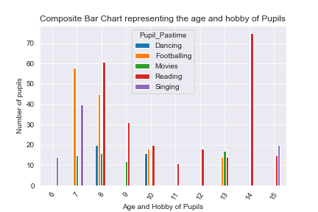

Figure 2: Composite Bar Chart Showing Age and Hobby of Pupils

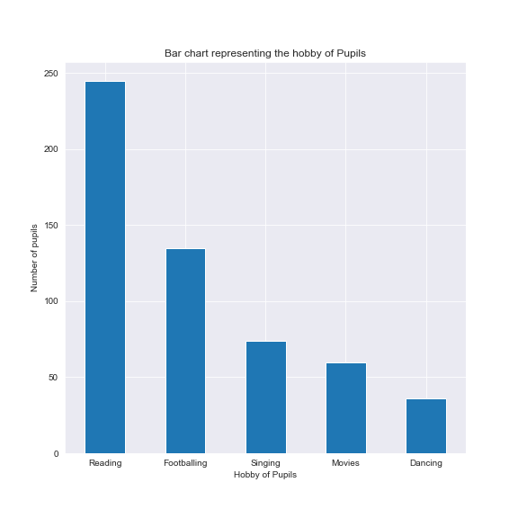

Figure 3: Bar Chart showing the Pastime of Pupils

As shown in figure 3, only few pupils dance during their free time. From figure 2 it can be seen that most pupils of age 6 and 7 prefer singing while most pupils of age 11, 12, 14 and 15 prefer reading. Moreover, majority of pupils of the age 8 and 10 enjoys dancing during their free time.

Table 4: Distribution of the Occupation of Household Head

|  |  |  |
| --- | --- | --- |
| Occupation | Frequency | Percentage |
| Artisan | 182 | 33.09 |
| Civil Servant | 158 | 28.73 |
| Petty Trader | 139 | 25.27 |
| Trader | 41 | 7.46 |
| Private Employee | 30 | 5.45 |
| Total | 550 | 100.00 |

Source: Field Survey, 2020

As shown in table 4, 33.09 percent of the household heads constituting 182 respondents are Artisans. Majority of the household heads are Artisans, Civil Servant or Petty Traders. Only 30 household heads (representing 5.45 percent of the respondents) are Private Employee.

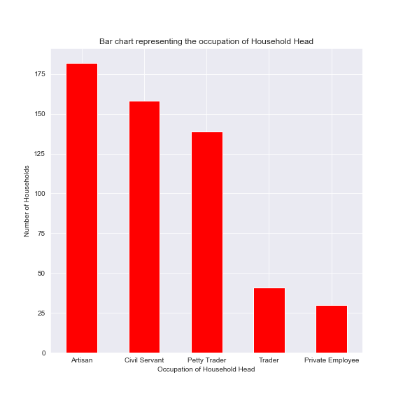

Figure 4: Bar Chart showing the occupation of household heads

Table 5: Distribution of Household head Education level

|  |  |  |
| --- | --- | --- |
| Education level | Frequency | Percentage |
| No-Formal | 104 | 18.91 |
| Primary | 185 | 33.64 |
| Secondary | 165 | 30.00 |
| Tertiary | 96 | 17.45 |
| Total | 550 | 100.00 |

Source: Field Survey, 2020

From table 5, 18.91 percent of the household heads are not lettered (meaning they do not have any form of formal education). But 33.64 percent (representing 185) respondents completed primary education. Only 96 household heads (representing 17.45 percent of the respondents) completed Tertiary education.

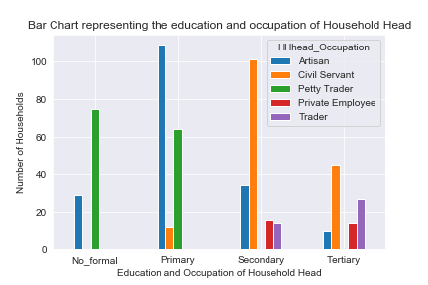

Figure 5: Bar Chart showing the education level and occupation of household heads.

From figure 5, it is glaringly clear that most artisans and petty traders either have no formal education or completed only primary education. Most Private employee and Civil Servants completed either secondary or tertiary education.

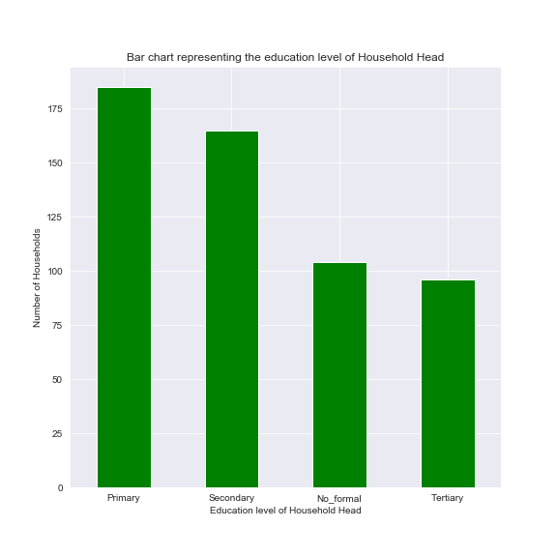

Figure 6: Bar Chart showing the education level of household heads

Table 6: Distribution of pupils based on their religion

|  |  |  |
| --- | --- | --- |
| Religion | Frequency | Percentage |
| Islam | 366 | 66.55 |
| Christianity | 184 | 33.45 |
| Total | 550 | 100.00 |

Source: Field Survey, 2020

From table 6, 66.55 percent of the respondents identified with the Islamic religion. This is not surprising since Kaduna is mainly associated with Islam.

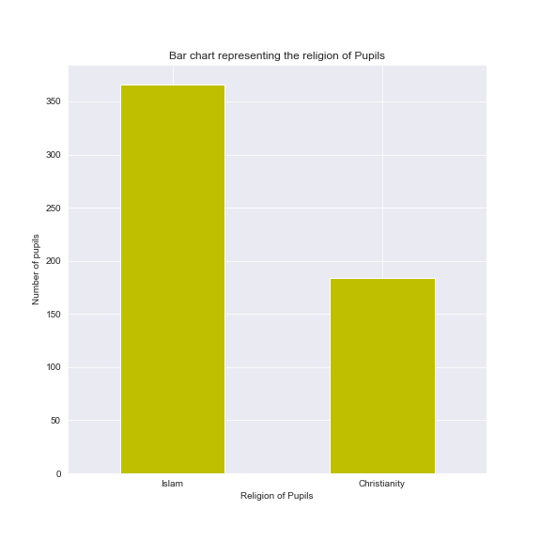

Figure 7: Bar Chart showing the religion of pupils

Table 7: Distribution of respondents based on sex

|  |  |  |
| --- | --- | --- |
| Sex | Frequency | Percentage |
| Female | 351 | 63.82 |
| Male | 199 | 36.18 |
| Total | 550 | 100.00 |

Source: Field Survey, 2020

As shown in table 7, 63.82 percent of the respondents are female while the rest are male.

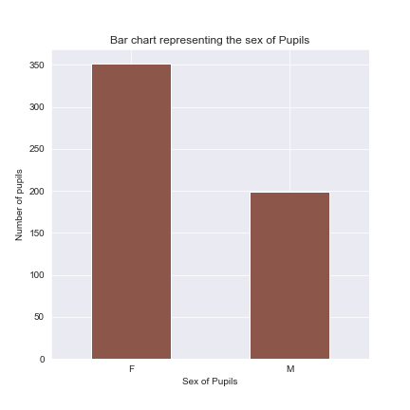

Figure 8: Bar Chart showing the sex of pupils

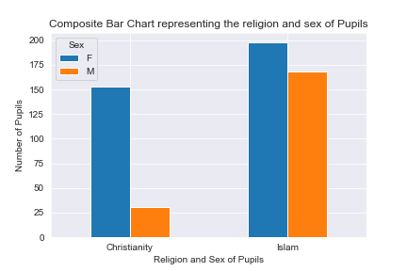

Figure 9: Bar Chart showing the religion and sex of pupils

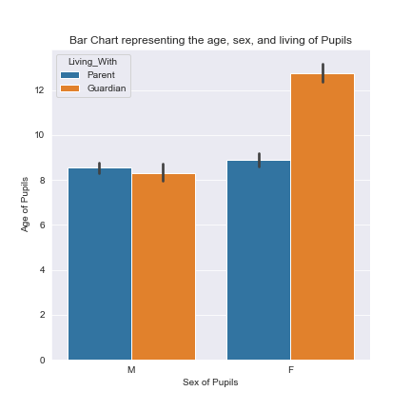

Figure 10: Bar Chart representing the age, sex, and living-with of pupils.

From figure 8 and 9, it is visible that Female pupils dominate the dataset from both religions. Moreover, the male pupils that identify with Islam are more than those that identify with Christianity. Figure 10 shows that more females live with guardians compare to girls.

Table 8: Distribution of respondents according to the size of their household

|  |  |  |  |  |
| --- | --- | --- | --- | --- |
| Household size group | Frequency | Percentage | Cumulative Frequency | Cumulative Percentage |
| 5-9 | 299 | 54.36 | 299 | 54.36 |
| 10-14 | 175 | 31.82 | 474 | 86.18 |
| 15-19 | 41 | 7.45 | 515 | 93.63 |
| 20-24 | 14 | 2.55 | 529 | 96.18 |
| 25-28 | 21 | 3.82 | 550 | 100.00 |
| Total | 550 | 100.00 |  |  |

Source: Field Survey, 2020

A table 8 show that 54.36 percent of the pupils in this study come from households whose size is not more than 9 persons. Moreover, 3.82 percent of the pupils captured by this study come from households whose size is between 25 and 28 persons. Cumulatively, 86.18 percent of the households are not larger than 14 persons. The household size has a mean of 10.61 (approximately 11) persons with a standard deviation of 5.23. This shows that there is great variance in the household size of the learners.

Table 9: Distribution of respondents according to who they live with

|  |  |  |
| --- | --- | --- |
| Living with | Frequency | Percentage |
| Parent | 277 | 50.36 |
| Guardian | 273 | 49.64 |
| Total | 550 | 100.00 |

Source: Field Survey, 2020

As shown in Table 9, 49.64 percent (representing 273 pupils out of the 550 pupils that constitute this study) live with guardians rather than their parents. Some of these pupils are maids. Most of them are also females.

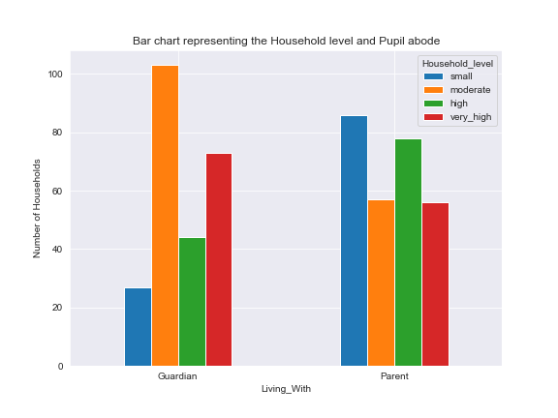

Figure 11: Composite bar chart representing Household size level and where pupils live

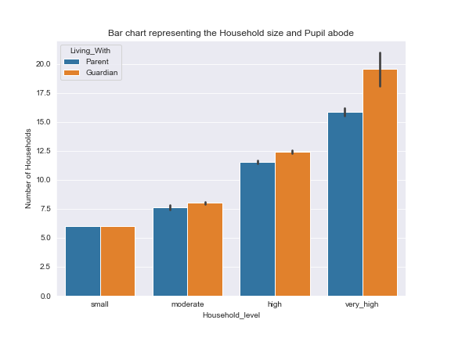

Figure 12: Composite bar chart showing relationship between household size, level and living

As shown in figure 11 and 12, the higher the number of persons in an household the higher the tendency of the learner to be living with a guardian rather than his/her biological parent. This finding may influence academic performance positively or negatively depending on the circumstances that exist in such households. Some learners may perform better with a guardian while others may perform better while living with their biological parents.

**4.2 Test of Hypothesis**

Four (4) hypotheses were tested for this study. I hereby present the results one after the other.

Hypothesis 1: There is no significant relationship between Parents’ occupation type (POT) and Pupils’ Academic Performance in Literacy and Numeracy (PAPLIN).

Table 10: Regression Literacy score on Parents’ occupation

|  |  |  |  |  |
| --- | --- | --- | --- | --- |
| VARIABLE | COEFFICIENT | STANDARD ERROR | t-SCORE | P-VALUE |
| intercept | 61.3956 | 0.959 | 63.989 | 0.000 |
| Civil Servant | 11.0981*** | 1.407 | 7.885 | 0.000 |
| Petty Trader | -19.0791*** | 1.458 | -13.085 | 0.000 |
| Trader | 15.2044*** | 2.551 | 5.961 | 0.000 |
| Private Employee | 12.2142*** | 2.238 | 5.458 | 0.000 |

Source: Field Survey, 2020

R2  = 0.476***

F-statistic = 124.0

* *Significant at 10 percent (p < 0.1)
* ** Significant at 5 percent ( p < 0.05)
* *** Significant at 1 percent (p < 0.01)

Table 11: Regression Numeracy score on Parents’ occupation

|  |  |  |  |  |
| --- | --- | --- | --- | --- |
| VARIABLE | COEFFICIENT | STANDARD ERROR | t-SCORE | P-VALUE |
| intercept | 60.0824 | 0.916 | 65.605 | 0.000 |
| Civil Servant | 19.8290*** | 1.343 | 14.760 | 0.000 |
| Petty Trader | -9.6723*** | 1.392 | -6.950 | 0.000 |
| Trader | 19.6509*** | 2.435 | 8.072 | 0.000 |
| Private Employee | 26.7225*** | 2.136 | 12.511 | 0.000 |

Source: Field Survey, 2020

R2  = 0.531***

F-statistic = 154.0

* *Significant at 10 percent (p < 0.1)
* ** Significant at 5 percent ( p < 0.05)
* *** Significant at 1 percent (p < 0.01)

Parent occupation is a dummy variable of 5 classes namely Artisan, Civil Servant, Petty Trader, Trader, and Private Employee. Artisan was used as the baseline for this regression. The significant F-statistic shows that the models are significantly different from zero. The R-squared score of 0.476 shows that the literacy model explains 47.6 percent of the variation in Literacy Score. Also, the R-squared score of 0.531 shows that the numeracy model explains 53.1 percent of the variation in Numeracy. All occupation classes are significant at an alpha level of 0.01 (1 %) in both models. This means that the calculated t-scores are greater than the tabulated t-scores at the given alpha level. As such there is sufficient evidence to reject the null hypothesis that posits that “There is no significant relationship between Parents’ occupation type (POT) and Pupils’ Academic Performance in Literacy and Numeracy (PAPLIN).”

Hypothesis 2: There is no significant relationship between pupils’ Household size and PAPLIN.

Table 12: Regression of Literacy score on pupils’ household size

|  |  |  |  |  |
| --- | --- | --- | --- | --- |
| VARIABLE | COEFFICIENT | STANDARD ERROR | t-SCORE | P-VALUE |
| intercept | 88.6028 | 1.140 | 77.731 | 0.000 |
| Household_size | -2.5549*** | 0.096 | -26.502 | 0.000 |

R2  = 0.561***

F-statistic = 702.4

* *Significant at 10 percent (p < 0.1)
* ** Significant at 5 percent ( p < 0.05)
* *** Significant at 1 percent (p < 0.01)

Table 13: Regression of Numeracy score on pupils’ household size

|  |  |  |  |  |
| --- | --- | --- | --- | --- |
| VARIABLE | COEFFICIENT | STANDARD ERROR | t-SCORE | P-VALUE |
| intercept | 95.0394 | 1.074 | 88.522 | 0.000 |
| Household_size | -2.7001*** | 0.091 | -29.737 | 0.000 |

R2  = 0.617***

F-statistic = 884.3

* *Significant at 10 percent (p < 0.1)
* ** Significant at 5 percent ( p < 0.05)
* *** Significant at 1 percent (p < 0.01)

The significant F-statistic shows that the models are significantly different from zero. The R-squared score of 0.561 shows that the literacy model explains 56.1 percent of the variation in Literacy Score. Also, the R-squared score of 0.617 shows that the numeracy model explains 61.7 percent of the variation in Numeracy. The coefficient of Household size in both models are significant at an alpha level of 0.01 (1 %). This means that the calculated t-scores are greater than the tabulated t-scores at the given alpha level. As such there is sufficient evidence to reject the null hypothesis that posits that “There is no significant relationship between pupils’ Household size and PAPLIN.”

Hypothesis 3: There is no significant relationship between parents’ educational status and PAPLIN

Table 14: Regression of literacy on parents’ education level

|  |  |  |  |  |
| --- | --- | --- | --- | --- |
| VARIABLE | COEFFICIENT | STANDARD ERROR | t-SCORE | P-VALUE |
| intercept | 72.7333 | 0.915 | 79.458 | 0.000 |
| Primary | -35.7333*** | 1.472 | -24.273 | 0.000 |
| Secondary | -13.8360*** | 1.259 | -10.989 | 0.000 |
| Tertiary | 1.0271 | 1.509 | 0.680 | 0.496 |

R2  = 0.567***

F-statistic = 238.5

* *Significant at 10 percent (p < 0.1)
* ** Significant at 5 percent ( p < 0.05)
* *** Significant at 1 percent (p < 0.01)

Table 15: Regression of Numeracy score on Parents’ education level

|  |  |  |  |  |
| --- | --- | --- | --- | --- |
| VARIABLE | COEFFICIENT | STANDARD ERROR | t-SCORE | P-VALUE |
| intercept | 76.4727 | 0.754 | 101.430 | 0.000 |
| Primary | -35.2035*** | 1.213 | -29.033 | 0.000 |
| Secondary | -15.3268*** | 1.037 | -14.780 | 0.000 |
| Tertiary | 9.9544*** | 1.243 | 8.007 | 0.000 |

R2  = 0.711***

F-statistic = 447.9

* *Significant at 10 percent (p < 0.1)
* ** Significant at 5 percent ( p < 0.05)
* *** Significant at 1 percent (p < 0.01)

Parent education level is a dummy variable of 4 classes namely No-formal, Primary, Secondary and Tertiary. No-formal was used as the baseline for this regression. The significant F-statistic shows that the models are significantly different from zero. The R-squared score of 0.567 shows that the literacy model explains 56.7 percent of the variation in Literacy Score. Also, the R-squared score of 0.711 shows that the numeracy model explains 71.1 percent of the variation in Numeracy. All education classes (except Tertiary -in the numeracy model) are significant at an alpha level of 0.01 (1 %) in both models. This means that the calculated t-scores are greater than the tabulated t-scores at the given alpha level. As such there is sufficient evidence to reject the null hypothesis that posits that “There is no significant relationship between parents’ educational status and PAPLIN.”

**Hypothesis 4**: There is no significant relationship between Pupils’ socio-educational characteristics and PAPLIN.

As shown in table 14 and 15 below, the significant F-statistic shows that the models are significantly different from zero. The R-squared score of 0.814 shows that the literacy model explains 81.4 percent of the variation in Literacy Score. Also, the R-squared score of 0.910 shows that the numeracy model explains 91.0 percent of the variation in Numeracy. Almost all the coefficients of the variables in both models are significant at an alpha level of 0.01 or 0.05 or 0.1 (1 %, 5%, and 10%). This means that the calculated t-scores are greater than the tabulated t-scores at the given alpha level. As such there is sufficient evidence to reject the null hypothesis that posits that “There is no significant relationship between Pupils’ socio-educational characteristics and PAPLIN.”

Table 16: Regression of Literacy score on Socio-educational and socio-demographic characteristics

|  |  |  |  |  |
| --- | --- | --- | --- | --- |
| VARIABLE | COEFFICIENT | STANDARD ERROR | t-SCORE | P-VALUE |
| intercept | 97.4155 | 5.572 | 17.483 | 0.000 |
| HHhead age | -0.3596*** | 0.067 | -5.364 | 0.000 |
| Age | 0.4347 | 0.280 | 1.552 | 0.121 |
| Household_size | -1.1676*** | 0.130 | -8.949 | 0.000 |
| F | -10.6595*** | 1.367 | -7.798 | 0.000 |
| Islam | -3.2166** | 1.269 | -2.535 | 0.012 |
| Guardian | -2.6230** | 1.035 | -2.534 | 0.012 |
| Footballing | -10.9005*** | 2.507 | -4.348 | 0.000 |
| Singing | -25.2984*** | 2.541 | -9.954 | 0.000 |
| Movies | -3.0724 | 2.442 | -1.258 | 0.209 |
| Dancing | -17.6540*** | 2.250 | -7.847 | 0.000 |
| Artisan | 10.3077*** | 1.225 | 8.413 | 0.000 |
| Civil Servant | 4.4273** | 2.116 | 2.093 | 0.037 |
| Trader | 0.2784 | 2.968 | 0.094 | 0.925 |
| Private Employee | -1.5993 | 2.393 | -0.668 | 0.504 |
| Secondary | 9.0951*** | 1.743 | 5.217 | 0.000 |
| Primary | -7.3062*** | 2.351 | -3.107 | 0.002 |
| Tertiary | 2.2752* | 1.241 | 1.833 | 0.067 |

R2  = 0.814***

F-statistic = 136.6

* *Significant at 10 percent (p < 0.1)
* ** Significant at 5 percent ( p < 0.05)
* *** Significant at 1 percent (p < 0.01)

Table 17: Regression of Numeracy score on Socio-educational and socio-demographic characteristics

|  |  |  |  |  |
| --- | --- | --- | --- | --- |
| VARIABLE | COEFFICIENT | STANDARD ERROR | t-SCORE | P-VALUE |
| intercept | 109.8945 | 3.892 | 28.236 | 0.000 |
| HHhead age | -0.3718*** | 0.047 | -7.939 | 0.000 |
| Age | -1.3748*** | 0.196 | -7.027 | 0.000 |
| Household_size | -1.8610*** | 0.091 | -20.421 | 0.000 |
| F | -6.3580*** | 0.955 | -6.659 | 0.000 |
| Islam | 6.8892*** | 0.886 | 7.773 | 0.000 |
| Guardian | -2.4890*** | 0.723 | -3.442 | 0.001 |
| Footballing | 8.4751*** | 1.751 | 4.840 | 0.000 |
| Singing | 11.1529*** | 1.775 | 6.283 | 0.000 |
| Movies | 22.8377*** | 1.705 | 13.391 | 0.000 |
| Dancing | 11.3573*** | 1.571 | 7.227 | 0.000 |
| Artisan | -4.5476*** | 0.856 | -5.314 | 0.000 |
| Civil Servant | -9.3479*** | 1.478 | -6.325 | 0.000 |
| Trader | -0.1773 | 2.073 | -0.085 | 0.932 |
| Private Employee | -9.2710*** | 1.672 | -5.546 | 0.000 |
| Secondary | 0.0546 | 1.218 | 0.045 | 0.964 |
| Primary | -3.1230* | 1.642 | -1.901 | 0.058 |
| Tertiary | 7.0669*** | 0.867 | 8.150 | 0.000 |

R2  = 0.910***

F-statistic = 318.3

* *Significant at 10 percent (p < 0.1)
* ** Significant at 5 percent ( p < 0.05)
* *** Significant at 1 percent (p < 0.01)

**4.3 Discussion of the Findings**

This section presents a discussion of the analysis and the findings.

From the analysis on hypothesis one, it was concluded that there is significant relationship between parent occupation and pupil academic performance in both Literacy and Numeracy. Pupils from homes whose household head is a petty trader performs significantly poorly in both literacy and numeracy. This is shown by the negative sign of the coefficient of petty trader in both models. The highest performers in literacy are children from households whose head is a trader, followed by Private Employees and finally Civil Servants. Children of artisans also performed very well in literacy. This may be due to the fact that some of those children use English language for communication at home or with their parent’s clients. Most petty traders engage in business using the local dialect and their children may also engage in hawking activities which may have contributed to their poor performance in both Literacy and Numeracy. For the numeracy model, pupils from homes whose head is a Private Employee perform much better than other categories followed by those from Civil Servant and Trader homes. This strong relationship between Pupils’ Academic Performance in Literacy and Numeracy (PAPLIN) and parent’s occupation may be influenced by other factors not covered by this study.

From the analysis on hypothesis two, the correlation between household size and academic performance in both Literacy and Numeracy is negative. The coefficients for household size in the model for both Literacy and Numeracy are significant at an alpha level of 0.01 (1%). This shows that the higher the size of the household from which a learner comes, the lesser the Literacy and Numeracy score of the learner. Household size seems to have more negative impact on Numeracy than Literacy as judged by the value of their coefficients. According to the model, a one percent (one person) increase in household size leads to a 2.55 percent decrease in Literacy score and 2.70 percent decrease in Numeracy score of learners from that household. The strong negative correlation between household size and academic performance may be due to the reason that household resources are usually allocated among its members. The more the number of persons in an household, the lesser their shares, for a given resource level. As such, resource constrained households may benefit more from lesser size.

From the analysis on hypothesis three, it was concluded that the relationship between academic performance in both Literacy and Numeracy with the education level of the parent is significant. From the literacy model shown in table 12, learners from homes whose household head has completed tertiary education generally perform better than others, although this coefficient is not significant. Pupils Academic performance in Literacy improves as household education level increases from Primary to Secondary and then to Tertiary. But the positive intercept (the intercept captures the baseline which in this case is No-Formal) of this model also suggests that learners from households whose head has no form of formal education has mixed performance. Some performed much better than those from households whose head has a secondary education level. This may be due to the reasoning that some parents without education tend to do all within their power to make sure that their children gets educated because such parents might have realized what they may be missing due to their lack of formal education. The corresponding Numeracy model also mirrors the findings from the Literacy model. Learners from households whose heads has tertiary education or no form of formal education consistently performs better than those from homes whose heads has obtained primary or secondary education.

From the analysis on hypothesis four, it was concluded that there is significant relationship between academic performance in both Literacy and Numeracy and socio-educational characteristics. The two models are significantly different from zero. While the Literacy model explains 81 percent of the variation in academic performance in Literacy, the Numeracy model explains 91 percent of the variation in academic performance in Numeracy. From the Literacy model shown in table 14, the following can be observed:

* The coefficient of household head is negative and significant at an alpha level of 0.01 (1%). This shows that the academic performance of pupils in Literacy decreases with increasing household head age. A unit (one year) increase in household head age reduces academic performance by 0.36 units. Consequently, a 10 year increase in household head age will reduce academic performance of the pupils from such households in Literacy by 3.60 percent. This is may be due to the reason that elderly household heads in the study area may be less literate than their younger counterparts and may therefore not be in touch with the current realities in the academic space.
* The coefficient of age (this is the age of the learners) is positive but not significant even at an alpha level of 0.1 (10%). This shows that the academic performance of pupils in Literacy increases with age. It should be remembered that this data is on primary three pupils only and as such the age variable has more analytical meaning compared to situations where other levels are covered. Older learners may perform much better than younger learners from the same class because they have much experience and can grasp concepts more readily than their younger counterparts. At times, keeping learners of wide age range together in a classroom may subtly tilt the teacher’s lesson delivery approach to favour the elderly learners at the expense of the younger learners. From this model, a 10 year increase in a learner’s age will increase his or her academic performance by 43.47 percent.
* The coefficient of Household size is negative and significant. This, as earlier explained, shows that the higher the household size, the lower the Literacy score of the pupil from that household provided all other factors are kept constant. This may be true because most of the learners in public primary schools are from resource-poor households. The larger such a household is, the greater the number of persons competing for these resources and consequently the lesser the resources available for each member of the household.
* In terms of sex, male was used as the base. Since the intercept of this model is positive and since the coefficient of the base dummy is by algorithm captured in the intercept, then it can be concluded that the being male has significant positive relationship with academic performance in Literacy while being female has negative significant relationship with academic performance in Literacy. This is not expected since general believe is that females perform much better than males in Literacy. This anomalous situation may have occurred because the culture in the study area places some restrictions on female interaction.
* For the living-with variable, the base class is the parent. This model shows that learners living with guardians significantly perform poorly in Literacy than those living with their parents.
* In terms of religion, the model shows that pupils who identify with the Islamic religion have lesser academic performance in Literacy than those who identify with the Christian religion.
* For the pastime (hobby) variable, reading was used as the baseline. Those learners whose hobby is reading performed significantly better than all other learners in Literacy. This is not unexpected as reading is part of the major skills in attaining excellence in Literacy and even Numeracy. Although this model shows that watching movies has a negative influence on academic performance in Literacy, it is not significant at all the three levels specified.
* In terms of parent occupation, the occupation of the household head was used. Also, Petty trading was used as the base class. Children of artisans, Civil servants and traders perform better than those from households whose head is a private employee. This conflicts slightly with the result of hypothesis one where children of private employees perform better than some other categories. This difference may be due to the addition of other variable in the model. It should also be noted that the coefficients of Trader and Private Employee are not significant at any of the specified levels.
* For the parent education level variable, the education level of the household head was also used. Households whose head have no formal education (No-formal) were used as the baseline. The model shows that secondary and tertiary education has significant influence on the academic performance of the learners in Literacy. Unexpectedly, pupils from households whose heads have no form of formal education performed much better in Literacy than those from households whose heads completed primary education.

The corresponding Numeracy model agrees with the Literacy model in all aspects except the following:

* The age variable has significant negative influence on academic performance in Numeracy. In the Literacy model it was negative but not significant.
* All the pastime types have significant positive influence on academic performance in Numeracy unlike the Literacy model where only reading has positive influence on academic performance.
* Household heads’ occupation level of Artisan, Trader, and Civil Servants have non-significant negative relationship with academic performance in Numeracy. This variable does not agree with the findings from the Literacy model. Perhaps more data will be needed to better understand the direction of the relationship between occupation level and academic performance in Numeracy.

Drawing from the discussions in this section it can be deduced that a top performing literacy and numeracy pupil will be from a household with less number of members and young household head that may have completed either secondary or tertiary education. Such pupil will probably identify with the Christian religion, be a male, loves reading and be living with his parent.

**CHAPTER FIVE**

**SUMMARY, CONCLUSON AND RECOMMENDATIONS**

This chapter presents the summary of the study, the conclusions drawn from the study findings, the recommendations and the suggestions for further studies.

**5.1 Summary**

Conventional wisdom suggests that learning occurs best in environments that are suitable for it. By environment, we mean the school, the community, and the home. But the home is the first contact of the learner. A suitable home will be one that supplies the learner with the resources and supports that are required for learning. Learners, in most cases, do not have a say on the type of home they come from. This choice is made and finalized by either their parents or other relatives. It is right to opine that the home plays a crucial part in the socialization of the learners. The home is expected to meet the physiological needs of the learners. Resource-poor homes may find these difficult to meet, hence the support of the government through various programmes such as the Home Grown School Feeding Programme and Free Education. These programmes were expected to raise the academic performance of learners to an acceptable level (grade-specific proficiencies). But that is not the observed case. Academic performances are still as bleak as it used to be. At times they are even worse. Could the answer be sought from the homes where these learners come from everyday?

This study set out to understand the relationship between the demographic characteristics of the parents of learners and the academic performance of the learners in Literacy and Numeracy. Data were collected from on 550 public school primary three learners in Kaduna Central Senatorial District. Four hypotheses were tested using regression analysis and the following findings were arrived at:

1. 66.55 percent of the respondents identify with the Islamic religion and 63.82 percent are female.
2. Only 17.45 percent of the household heads obtained formal education above secondary school level.
3. 58.36 percent of the household heads are either artisans or petty traders.
4. 41.64 percent of the household heads are not younger than 60 years.
5. 49.64 percent of the learners live with guardians rather than their biological parents
6. More female learners live with guardians than male learners.
7. The mean household size is 11 persons with a standard deviation of 5.22 suggesting that there is great variance in the size of the learners’ households.
8. As household size increases, more female learners tend to leave their biological parents to go and stay with a guardian probably working as a maid.
9. There is significant relationship between pupils’ academic performance in Literacy and Numeracy and the occupation of the household head. Learners from petty traders home perform significantly poor in both subjects.
10. There is significant relationship between pupils’ academic performance in Literacy and Numeracy and the education of the household head. Learners from homes whose head does not have any form of formal education or only completed primary education perform significantly poor in both subjects.
11. There is significant relationship between pupils’ academic performance in Literacy and Numeracy and household size. Learners from smaller households score significantly higher marks in both subjects.
12. There is significant relationship between pupils’ academic performance in Literacy and Numeracy and the overall socio-educational and demographic characteristics of the learners and their households. Male learners from Christian home whose head is younger than 60, completed at least secondary education and has small household size perform significantly better in both subjects.

It is worth noting that in all four cases of hypothesis testing, there was no sufficient evidence to accept the null. So the null hypotheses were rejected.

**5.2 Conclusion**

From the findings of this study, the following conclusions are hereby drawn:

1. Christian learners perform much better than their Muslim counterparts in both Literacy and Numeracy. This may be due to the hostile nature of Muslim adherents to western education.
2. Male learners have better Literacy and Numeracy scores than their female counterparts. This may be as a result of the heavy home chore workload that female learners working as maid have to do.
3. The larger an household is person-wise, the lower the Literacy and Numeracy score of learners from such households.
4. Households whose heads are young tend to have their children performing much better.
5. The older a learner is, the better his/her academic performance compared to younger learners from the same class.
6. The higher the level of formal education attainment of the household head (especially above primary education level), the better the academic performance of the learners from such households in both Literacy and Numeracy.
7. Learners from homes whose head is a Civil Servant or Trader tend to perform much better than those from petty trader homes.
8. The pastime (hobby) of a learner may be a pointer to how the learner will perform in both Literacy and Numeracy. While some pastimes have positive influence on PAPLIN, others have negative influence.

**5.3 Recommendations**

From the findings of this study, the following recommendations are hereby made:

1. The age range in a classroom should not be wide so as to enable the teacher to focus on all the learners. This is because in a classroom with high age variance, the older learners tend to perform better.
2. Larger households should get more resources to take care of their children. If possible, young couples or families should plan towards a small household size. This is because this study finds pupils from small households tend to perform better than those from large households.
3. For households whose heads have no form of formal education, adult education should be encouraged. This service can be rendered free 9or subsidized) to them by the government, Non Governmental Organizations, religious organizations or well meaning individuals. This recommendation is consequent on the findings that pupils from learned households tend to perform better compared to their counterparts from other homes.
4. Concerted efforts should be made to wake the interest of Islamic adherents in western education. Such efforts, if effectively applied, will help raise the performance of learners from Islamic background in Literacy and Numeracy and consequently other subjects. This recommendation is as a result of the finding that pupils from Christian homes consistently perform much better than those from Muslim homes.
5. The society should do more to encourage men to marry early. This is because learners from homes whose head is young perform better in both Literacy and Numeracy
   1. **Further Studies**

At this juncture, I will like to make some suggestions for further study. This study only examined the demographic factors that influence academic performance in Literacy and Numeracy (PAPLIN) in primary schools in Kaduna State. The study focused solely on Primary three learners in Kaduna Central Senatorial district. Further inquiries can be made into other levels of primary secondary and tertiary education. The study scope can be widened to include samples from all parts of the state. Findings from such findings will be more generalizable than those from this mini study. Also, research can be made into how to better support families in order to make their learners perform better in academics. Moreover, studies should be made into how household characteristics influence subjects like Cultural and Creative Arts, Pre-Vocational Studies, Home Economics among others. The fight against educational inequity requires sound understanding of the factors influencing education. I believe this suggested studies will contribute towards better understanding of the educational landscape in Nigeria.

**REFERENCES**

Adewale, a. ., & Ogunshola, F. (2012). *The effects of parental socio-economic status on academic performance of students in selected schools in Edu Lga of Kwara state,Nigeria. International Journal of academic research in business and social sciences.July 2012, Vol. 2, No.7ISSN; 2222-6990. www*. *2*(7), 230–239.

Bununu, Y. A., Ludin, A. N. M., & Hosni, N. (2015). City profile : Kaduna City profile : Kaduna. *CITIES*, *49*(July), 53–65. https://doi.org/10.1016/j.cities.2015.07.004

Fwacn, R., Rnt, R., Ed, M., Senior, P. D., & Ed, G. B. (2015). Influence of Family Size and Family Type on Academic Performance of Students in Government in Calabar Municipality, Cross River State, Nigeria. *International Journal of Humanities Social Sciences and Education*, *2*(11), 108–114. www.arcjournals.org

KADSG (2017). Kaduna State Government Annual School Census.

Muhammad, H., Rafiq, W., Sohail, M. M., & Saleem, M. (2013). Parental Involvement and Academic Achievement ; A Study on Secondary School Students of Lahore , Pakistan. *Parental Involvement and Academic Achievement ; A Study on Secondary School Students of Lahore , Pakistan*, *3*(8), 209–223.

Ogunsola, O., Osuolale, K., & Ojo, A. (2014). Parental and Related Factors Affecting Students’ Academic Achievement in Oyo State, Nigeria. *International Journal of Social, Behavioral, Educational, Economic, Business and Industrial Engineering*, *8*(9), 3129–3136. https://doi.org/scholar.waset.org/1999.10/10001503

Salahuddin, S., & Talukder, M. H. K. (2017). Influence of Socio-Demographic Characteristics on Academic Performance of Medical Students. *Bangladesh Journal of Medical Education*, *8*(2), 18–23. https://doi.org/10.3329/bjme.v8i2.33332

**DEPARTMENT OF EDUCATION, SCHOOL OF EDUCATION ANDHUMANITIES BABCOCK UNIVERSITY,**

**ILISHAN REMO, OGUN STATE**

**RESEARCH INSTRUMENT**

**Dear parent and pupils,**

This questionnaire is designed to collect information towards answering the research questions arising from the study: “Socio-demographic Characteristics as Determinants of Pupils’ Academic Performance: The Case of Primary Schools in Kaduna Metropolis”. Your household was chosen because your child attends one of the schools that are participating in the study.

Your response will be treated with utmost confidence. Only necessary data for answering the research questions will be asked. Collected data shall be kept anonymously and all personal identifying information shall be destroyed as soon as we are done analyzing the data. While encouraging you to respond to all the questions in this questionnaire, please note that you are at liberty to decline answer to any question that you may find offensive. And if there is need for further clarifications, please demand explanations from the research team.

We thank you for your commitment to the education of your child and believe that together we can deliver quality education to our children.

Yours sincerely,

**Amos Moses Omofaiye**

**SECTION A: To be responded to by the pupil. The subject teacher or a member of the household is encouraged to guide the learner where necessary. Please tick the appropriate boxes and write the answers where applicable.**

1. Name of school……………………………………………………………………
2. Age of the pupil……………………………………………………………………
3. Pastime (Hobby)…………………………………………………………………..
4. Sex: Male ( ) Female ( )
5. Are you currently living with your parent?: Yes ( ) No ( )
6. If you ticked “No” in question 5, are you living with your relative? Yes ( ), No ( )
7. Religion: Islam ( ) Christianity ( ) Traditional ( ) Others ( )

**SECTION B I: To be responded to by the household head of the pupil.**

1. Age of the household head…………………………………………………………..
2. Formal education attainment: No-formal education ( ) Primary education ( ) Secondary education ( ) Tertiary education ( )
3. Occupation…………………………………………………………………………..
4. Sex: Male ( ) Female ( )
5. Religion: Islam ( ) Christianity ( ) Traditional ( ) Others ( )
6. Number of persons in the household including the pupil…………………………….

**SECTION B II: To be responded to by the class teacher of the pupil.**

1. First term Literacy (English language) score of the pupil (over 100)……………………..
2. First term Numeracy (Mathematics) score of the pupil (over 100)………………………..

Thank you for taking out time to respond to this questionnaire.