ACT REPORT ON THE WERATEDOGS ARCHIVE (COMMUNICATION OF FINDINGS)

WHAT THEY DO?

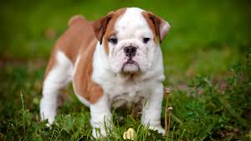

They rate dogs. They give dogs humorous ratings. Some can even get more than maximum scores.

Which dog stages rule the tweets?

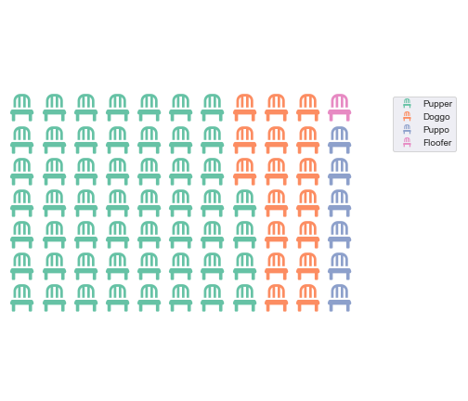

Figure 1 Most common dog stages

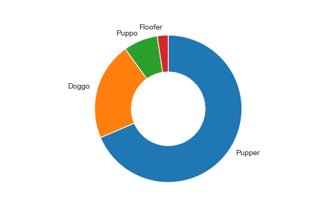

Figure 2 Donut chart showing most common dog stages

Pupper is the most popular dog stage. Then the next popular is Doggo

**Which dog names are the most common?**

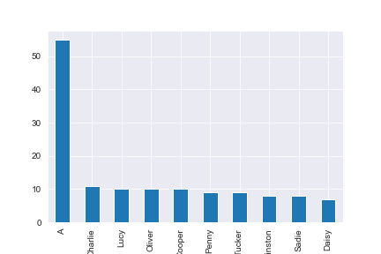

Figure 3 Count of Dog names

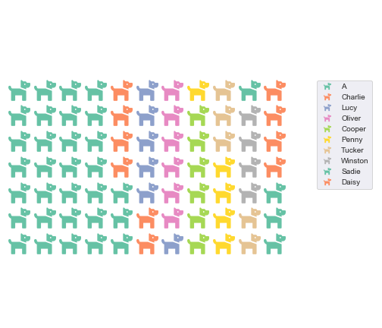

Figure 4 Most common dog names

‘A’ is the most popular dog name. Followed by the meaningful Charlie

Do tweets vary per year?

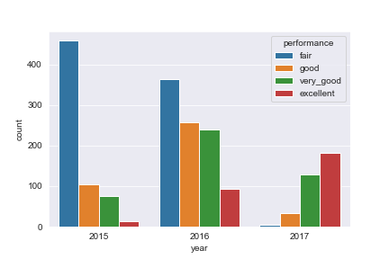

Figure 5 Rating compared to year

Dog ratings improved overtime. In 2015 most ratings were low but in 2017, most ratings were very high.

But actual tweets started decreasing after 2016.

If actual tweets decreased, how did retweets and favourites fared?

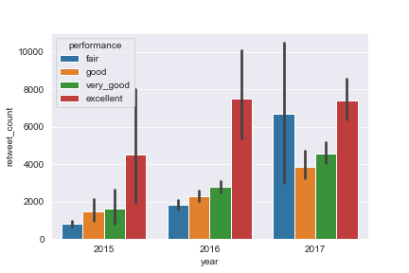

Figure 6 Ratings of retweets based on year

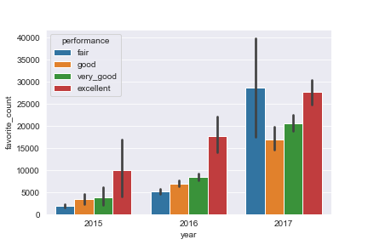

Figure 7 Ratings of favorite based on year

Both retweets and favorites count kept increasing. In fact favorites increased more than retweets.

Does tweet source affects in rating?

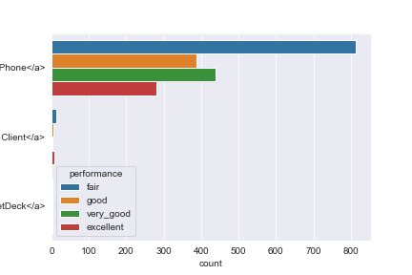

Figure 8 Tweet source and rating

Most ratings originated from Twitter for iPhone. I cannot conclude that this has any effect on rating of the dog.

Finally, were the favorited dogs those that were highly performing?

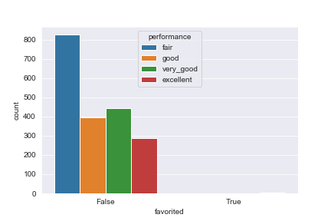

Figure 9 Ratings of favorites

The favorite dogs are so minimal. I see no evidence that can make me think that favorites are those that are highly rated.

**Conclusion**

1. Most tweets originate from Twitter for iPhone.
2. The most popular dog stage is Puupper.
3. The most popular meaningful name is Charlie.
4. Tweets peaked in 2016 and took a drastic fall.
5. Retweets and favorite counts keep increasing despite the plunge in tweets. Favorites even increased more than retweets.
6. Dog ratings improved overtime. Perhaps this is as a result of pressure from dog owners or because clients are dissatisfied with the ratings of their dogs.
7. Favorites were random not based on high rating.