
ΠΡΟΑΙΡΕΤΙΚΗ ΕΡΓΑΣΙΑ PYTHON
ΑΡΧΕΣ ΓΛΩΣΣΩΝ ΠΡΟΓΡΑΜΜΑΤΙΣΜΟΥ ΚΑΙ ΜΕΤΑΦΡΑΣΤΩΝ

Όνομα: Χαράλαμπος Γιαννέλης
ΑΜ:1093341

Contents
Κώδικας python 3
Screenshots παραδειγμάτων της εφαρμογής 15

Κώδικας python
import pandas as pd
import sqlite3
import matplotlib.pyplot as plt
import seaborn as sns
import sys
import ctypes
import numpy as np
from PyQt6.QtWidgets import QApplication, QMainWindow, QPushButton, QVBoxLayout, QWidget, QLabel, QMessageBox, \
QScrollArea
from PyQt6.QtGui import QIcon, QPixmap, QCursor
from PyQt6.QtCore import Qt
from matplotlib.backends.backend_qtagg import FigureCanvasQTAgg as FigureCanvas
# Function to load data from a CSV file
def load_data(filename):
try:
data = pd.read_csv(filename) # Load the CSV file into a DataFrame
return data
except FileNotFoundError: # Handle the case where the file is not found
QMessageBox.critical(None, "Error", "File not found. Please check the file path and try again.")
return None
# Function to create necessary tables in the SQLite database
def create_tables(db_name='hotel_bookings.db'):
conn = sqlite3.connect(db_name)
cursor = conn.cursor()
cursor.execute('''
CREATE TABLE IF NOT EXISTS average_nights (
hotel TEXT PRIMARY KEY,
average_nights REAL
)
''')
cursor.execute('''
CREATE TABLE IF NOT EXISTS cancellation_rate (
hotel TEXT PRIMARY KEY,
cancellation_rate REAL
)
''')
cursor.execute('''
CREATE TABLE IF NOT EXISTS booking_categories (
category TEXT PRIMARY KEY,
count INTEGER
)
''')
cursor.execute('''
CREATE TABLE IF NOT EXISTS booking_distribution (
arrival_date_month TEXT,
hotel TEXT,
count INTEGER,
PRIMARY KEY (arrival_date_month, hotel)
)
''')
cursor.execute('''
CREATE TABLE IF NOT EXISTS room_type_distribution (
reserved_room_type TEXT PRIMARY KEY,
count INTEGER
)
''')
cursor.execute('''
CREATE TABLE IF NOT EXISTS category_distribution (
category TEXT PRIMARY KEY,
count INTEGER
)
''')
cursor.execute('''
CREATE TABLE IF NOT EXISTS booking_trends (
date TEXT PRIMARY KEY,
count INTEGER
)
''')
conn.commit()
conn.close()
# Function to calculate statistics from the data
def calculate_statistics(data):
if data is not None:
# Calculate total nights stayed by summing weekend and week nights
data['total_nights'] = data['stays_in_weekend_nights'] + data['stays_in_week_nights']
# Calculate average nights stayed per hotel
avg_nights = data.groupby('hotel')['total_nights'].mean()
# Calculate cancellation rate per hotel
cancellation_rate = data.groupby('hotel')['is_canceled'].mean()
return avg_nights, cancellation_rate
else:
return None, None
# Function to create a plot for booking distribution by month
def create_plot(data):
plt.figure(figsize=(10, 6))
ax = sns.countplot(x='arrival_date_month', hue='hotel', data=data, palette='coolwarm')
# Annotate each bar with its height
for bar in ax.patches:
ax.annotate(format(bar.get_height(), '.2f'),
(bar.get_x() + bar.get_width() / 2,
bar.get_height()), ha='center', va='center',
size=9, xytext=(0, 5),
textcoords='offset points')
plt.title('Booking Distribution by Month')
plt.xticks(rotation=45)
plt.tight_layout()
# Extract data used in the plot
plot_data = data.groupby(['arrival_date_month', 'hotel']).size().reset_index(name='count')
return plt.gcf(), ax, plot_data # Returns the current matplotlib figure, axis, and plot data
# Function to plot room type distribution
def plot_room_type_distribution(data):
plt.figure(figsize=(10, 6))
ax = sns.countplot(x='reserved_room_type', data=data)
# Generate a color palette and set colors for each bar
palette = sns.color_palette("magma", len(data['reserved_room_type'].unique()))
for bar, color in zip(ax.patches, palette):
bar.set_facecolor(color)
for bar in ax.patches:
ax.annotate(format(bar.get_height(), '.2f'),
(bar.get_x() + bar.get_width() / 2,
bar.get_height()), ha='center', va='center',
size=9, xytext=(0, 5),
textcoords='offset points')
plt.title('Distribution of Bookings by Room Type')
plt.xlabel('Room Type')
plt.ylabel('Number of Bookings')
plt.xticks(rotation=45)
plt.tight_layout()
# Extract data used in the plot
plot_data = data['reserved_room_type'].value_counts().reset_index()
plot_data.columns = ['reserved_room_type', 'count']
return plt.gcf(), ax, plot_data # Return the figure, axis, and plot data
# Function to categorize bookings based on the number of adults, children, and babies
def categorize_bookings(data):
# Define conditions for categorizing bookings
conditions = [
(data['adults'] == 1) & (data['children'] == 0) & (data['babies'] == 0),
(data['adults'] == 2) & (data['children'] == 0) & (data['babies'] == 0),
(data['adults'] > 2) | (data['children'] > 0) | (data['babies'] > 0)
]
choices = ['Individual', 'Couple', 'Family']
data['category'] = pd.Categorical(np.select(conditions, choices, default='Other'))
category_counts = data['category'].value_counts().reset_index()
category_counts.columns = ['category', 'count']
return category_counts # Return the counts of each category as a DataFrame
# Funciont o plot booking trends over time
def plot_booking_trends(data):
plt.figure(figsize=(12, 6))
# Convert 'arrival_date_year' and 'arrival_date_month' to a datetime object.
# Specifying the format to avoid the UserWarning and ensure efficient parsing.
# The format '%Y-%B' stands for four-digit year and full month name.
# The general overview is that I convert the 'arrival_date_year' and
# 'arrival_date_month' to a datetime object.
data['date'] = pd.to_datetime(data['arrival_date_year'].astype(str) + '-' + data['arrival_date_month'],
format='%Y-%B')
# Aggregate data by new 'date' column
monthly_data = data.groupby('date').size().reset_index(name='count')
ax = monthly_data.plot(kind='line', marker='o', color='tab:blue', title='Monthly Booking Trends')
ax.set_xlabel('Month')
ax.set_ylabel('Number of Bookings')
plt.xticks(rotation=45)
plt.grid(True)
plt.tight_layout()
return plt.gcf(), ax, monthly_data # Return the figure, axis, and plot data
# Function to plot seasonality trends
def plot_seasonality(data):
month_order = [
'January', 'February', 'March', 'April', 'May', 'June',
'July', 'August', 'September', 'October', 'November', 'December'
]
plt.figure(figsize=(16, 8))
colors = {
('Resort Hotel', 'total_bookings'): 'blue',
('Resort Hotel', 'is_canceled'): 'lightblue',
('City Hotel', 'total_bookings'): 'green',
('City Hotel', 'is_canceled'): 'lightgreen'
}
data['month_key'] = pd.Categorical(data['arrival_date_month'], categories=month_order, ordered=True)
grouped = data.groupby(['hotel', 'month_key'], observed=True).agg({
'is_canceled': 'sum', # Count of cancellations
'reservation_status_date': 'count' # Count of all bookings
}).rename(columns={'reservation_status_date': 'total_bookings'}).unstack(0).fillna(0)
width = 0.2 # the width of the bars
fig, ax = plt.subplots()
positions = np.arange(len(month_order)) # positions for the groups
# Plot bars for each category and hotel
for i, ((hotel, metric), color) in enumerate(colors.items()):
offsets = {'City Hotel': -width / 2, 'Resort Hotel': width / 2}
bar_positions = positions + offsets[hotel]
ax.bar(bar_positions, grouped[metric][hotel], width, label=f"{hotel} {metric}", color=color, align='edge')
ax.set_xlabel('Month')
ax.set_ylabel('Count')
ax.set_title('Booking Trends by Hotel Type and Status')
ax.set_xticks(positions)
ax.set_xticklabels(month_order)
plt.xticks(rotation=45)
plt.legend()
# Annotate each bar with its height
for rect in ax.patches:
height = rect.get_height()
if height > 0: # Only annotate if height is greater than zero to avoid clutter
ax.annotate(f'{int(height)}',
xy=(rect.get_x() + rect.get_width() / 2, height),
xytext=(0, 3), # 3 points vertical offset
textcoords="offset points",
ha='center', va='bottom')
plt.tight_layout()
return plt.gcf()
# Function to save DataFrame to SQLite table
def save_to_sqlite(data, table_name, db_name='hotel_bookings.db'):
conn = sqlite3.connect(db_name)
data.to_sql(table_name, conn, if_exists='replace', index=False)
conn.close()
# Function to export SQLite table to CSV
def export_to_csv(table_name, db_name='hotel_bookings.db'):
conn = sqlite3.connect(db_name)
df = pd.read_sql(f"SELECT * FROM {table_name}", conn)
df.to_csv(f"{table_name}.csv", index=False)
conn.close()
# Function to insert data into SQLite table
def insert_into_table(data, table_name, db_name='hotel_bookings.db'):
conn = sqlite3.connect(db_name)
cursor = conn.cursor()
for index, row in data.iterrows():
cursor.execute(f"INSERT OR REPLACE INTO {table_name} VALUES (?, ?)", (row[0], row[1]))
conn.commit()
conn.close()
# Function to insert data into SQLite table
def insert_into_table_(data, table_name, db_name='hotel_bookings.db'):
conn = sqlite3.connect(db_name)
cursor = conn.cursor()
for index, row in data.iterrows():
cursor.execute(f"INSERT OR REPLACE INTO {table_name} VALUES (?, ?, ?)", tuple(row))
conn.commit()
conn.close()
# Function to insert data into SQLite table
def insert_into_table__(data, table_name, db_name='hotel_bookings.db'):
conn = sqlite3.connect(db_name)
cursor = conn.cursor()
if table_name == "booking_distribution":
for index, row in data.iterrows():
cursor.execute(f"INSERT OR REPLACE INTO {table_name} VALUES (?, ?, ?)", tuple(row))
elif table_name == "booking_trends":
for index, row in data.iterrows():
cursor.execute(f"INSERT OR REPLACE INTO {table_name} VALUES (?, ?)", (str(row[0]), row[1]))
else:
for index, row in data.iterrows():
cursor.execute(f"INSERT OR REPLACE INTO {table_name} VALUES (?, ?)", (row[0], row[1]))
conn.commit()
conn.close()
# Class defining the main window of the application
class MainWindow(QMainWindow):
def __init__(self):
super().__init__()
self.canvas = None # Placeholder for the canvas
self.scroll_area = None # Placeholder for the scroll area
self.setWindowTitle("Hotel Booking Analysis")
self.UPatras_icon = QIcon("Images/up_2017_logo_en.ico")
self.setWindowIcon(self.UPatras_icon)
self.setMinimumSize(800, 600) # Set the minimum size to prevent resizing below one value
# Automatically load data
self.data = load_data('hotel_booking.csv')
# Create tables in the database
create_tables()
# Layout
self.layout = QVBoxLayout()
########### Widgets ##############
self.UPatras_logo_png = QPixmap("Images/up_2017_logo_en_resized.png")
self.UPatras_logo = QLabel()
self.btn_distribution_per_month_epoch = QPushButton("Distribution per month and per epoch")
self.btn_avg_nights = QPushButton("Average Nights and Cancellation")
self.btn_room_type_distribution = QPushButton("Distribution by Room Type")
self.btn_category_distribution = QPushButton("Booking Category Distribution")
self.btn_booking_trends = QPushButton("Show Booking Trends")
self.btn_seasonality = QPushButton("Analyze Seasonality")
self.btn_export = QPushButton("Export Results to CSV")
self.btn_back = QPushButton("Back")
self.central_widget = QWidget()
self.setupUI()
def setupUI(self):
# Button Styling
button_style = """
QPushButton {
background-color: qlineargradient(spread:pad, x1:0, y1:0, x2:1, y2:1,
stop:0 rgba(105, 181, 255, 255),
stop:1 rgba(65, 131, 215, 255));
color: white;
border-radius: 10px;
padding: 10px;
font-size: 16px;
font-weight: bold;
}
QPushButton:hover {
background-color: qlineargradient(spread:pad, x1:0, y1:0, x2:1, y2:0,
stop:0 rgba(65, 131, 215, 255),
stop:1 rgba(25, 81, 165, 255));
}
QPushButton:pressed {
background-color: rgba(25, 81, 165, 255);
}
"""
# Set style
self.btn_distribution_per_month_epoch.setStyleSheet(button_style)
self.btn_avg_nights.setStyleSheet(button_style)
self.btn_back.setStyleSheet(button_style)
self.btn_room_type_distribution.setStyleSheet(button_style)
self.btn_category_distribution.setStyleSheet(button_style)
self.btn_booking_trends.setStyleSheet(button_style)
self.btn_seasonality.setStyleSheet(button_style)
self.btn_export.setStyleSheet(button_style)
# Set Cursor while hover over buttons
self.btn_distribution_per_month_epoch.setCursor(QCursor(Qt.CursorShape.PointingHandCursor))
self.btn_avg_nights.setCursor(QCursor(Qt.CursorShape.PointingHandCursor))
self.btn_back.setCursor(QCursor(Qt.CursorShape.PointingHandCursor))
self.btn_room_type_distribution.setCursor(QCursor(Qt.CursorShape.PointingHandCursor))
self.btn_category_distribution.setCursor(QCursor(Qt.CursorShape.PointingHandCursor))
self.btn_booking_trends.setCursor(QCursor(Qt.CursorShape.PointingHandCursor))
self.btn_seasonality.setCursor(QCursor(Qt.CursorShape.PointingHandCursor))
# Back Button
self.btn_back.clicked.connect(self.show_initial_ui)
self.btn_back.hide() # initially hide the back button
self.layout.addWidget(self.btn_back, alignment=Qt.AlignmentFlag.AlignLeft)
self.UPatras_logo.setPixmap(self.UPatras_logo_png)
self.layout.addWidget(self.UPatras_logo, alignment=Qt.AlignmentFlag.AlignHCenter)
# Buttons for different analyses
self.btn_distribution_per_month_epoch.clicked.connect(self.show_plot)
self.layout.addWidget(self.btn_distribution_per_month_epoch)
self.layout.addSpacing(25)
self.btn_avg_nights.clicked.connect(self.average_nights_and_cancellation)
self.layout.addWidget(self.btn_avg_nights)
self.layout.addSpacing(25)
self.btn_room_type_distribution.clicked.connect(self.show_room_type_distribution)
self.layout.addWidget(self.btn_room_type_distribution)
self.layout.addSpacing(25)
self.btn_category_distribution.clicked.connect(self.show_category_distribution)
self.layout.addWidget(self.btn_category_distribution)
self.layout.addSpacing(25)
self.btn_booking_trends.clicked.connect(self.show_booking_trends)
self.layout.addWidget(self.btn_booking_trends)
self.layout.addSpacing(25)
self.btn_seasonality.clicked.connect(self.show_seasonality)
self.layout.addWidget(self.btn_seasonality)
self.layout.addSpacing(25)
self.btn_export.clicked.connect(self.export_results)
self.layout.addWidget(self.btn_export)
# Set the central widget of the Window.
self.central_widget.setLayout(self.layout)
self.setCentralWidget(self.central_widget)
# Function to display average nights and cancellation rates
def average_nights_and_cancellation(self):
if self.data is not None:
avg_nights, cancel_rate = calculate_statistics(self.data)
avg_nights_df = avg_nights.reset_index().rename(columns={0: 'average_nights'})
cancel_rate_df = cancel_rate.reset_index().rename(columns={0: 'cancellation_rate'})
insert_into_table(avg_nights_df, 'average_nights')
insert_into_table(cancel_rate_df, 'cancellation_rate')
message = f"Average Nights:\n{avg_nights}\n\nCancellation Rate:\n{cancel_rate}"
QMessageBox.information(self, "Statistics", message)
else:
QMessageBox.warning(self, "Data Not Loaded", "Please check the data file.")
# Function to show the booking distribution plot
def show_plot(self):
fig, ax, plot_data = create_plot(self.data)
insert_into_table_(plot_data, 'booking_distribution')
if self.canvas is None:
self.canvas = FigureCanvas(fig) # Create the canvas with the figure
self.scroll_area = FigureCanvas(fig) # Create a scroll area
self.scroll_area = QScrollArea() # Create a Scroll area
self.scroll_area.setWidget(self.canvas) # Set the canvas as the widget to scroll
self.scroll_area.setWidgetResizable(True) # Allow the canvas to resize with the scroll area
self.layout.addWidget(self.scroll_area)
else:
self.canvas.figure = fig # Update the figure
self.canvas.draw()
self.hide_buttons()
self.btn_back.show()
# Function to show room type distribution plot
def show_room_type_distribution(self):
fig, ax, plot_data = plot_room_type_distribution(self.data)
insert_into_table(plot_data, 'room_type_distribution') # Save the plot data to the SQLite table
if self.canvas is None:
self.canvas = FigureCanvas(fig)
self.scroll_area = QScrollArea()
self.scroll_area.setWidget(self.canvas)
self.scroll_area.setWidgetResizable(True)
self.layout.addWidget(self.scroll_area)
else:
self.canvas.figure = fig
self.canvas.draw()
self.hide_buttons()
self.btn_back.show()
# Function to show booking category distribution
def show_category_distribution(self):
category_counts = categorize_bookings(self.data)
insert_into_table(category_counts, 'booking_categories')
message = "\n".join([f"{cat}: {count}" for cat, count in category_counts.items()])
QMessageBox.information(self, "Booking Categories", message)
# Function to show booking trends plot
def show_booking_trends(self):
fig, ax, plot_data = plot_booking_trends(self.data)
insert_into_table__(plot_data, 'booking_trends')
if self.canvas is None:
self.canvas = FigureCanvas(fig)
self.scroll_area = QScrollArea()
self.scroll_area.setWidget(self.canvas)
self.scroll_area.setWidgetResizable(True)
self.layout.addWidget(self.scroll_area)
else:
self.canvas.figure = fig
self.canvas.draw()
self.hide_buttons()
self.btn_back.show()
# Function to show seasonality analysis plot
def show_seasonality(self):
fig = plot_seasonality(self.data)
if self.canvas is None:
self.canvas = FigureCanvas(fig)
self.scroll_area = QScrollArea()
self.scroll_area.setWidget(self.canvas)
self.scroll_area.setWidgetResizable(True)
self.layout.addWidget(self.scroll_area)
else:
self.canvas.figure = fig
self.canvas.draw()
self.hide_buttons()
self.btn_back.show()
# Function to export results to CSV
def export_results(self):
export_to_csv('average_nights')
export_to_csv('cancellation_rate')
export_to_csv('booking_categories')
export_to_csv('booking_distribution')
export_to_csv('room_type_distribution')
export_to_csv('category_distribution')
export_to_csv('booking_trends ')
QMessageBox.information(self, "Export Complete", "Results have been exported to CSV files.")
# Function to show initial UI layout
def show_initial_ui(self):
if self.canvas:
self.canvas.hide()
self.canvas = None
self.scroll_area.hide()
self.scroll_area = None
self.btn_avg_nights.show()
self.btn_distribution_per_month_epoch.show()
self.btn_room_type_distribution.show()
self.btn_category_distribution.show()
self.btn_booking_trends.show()
self.btn_seasonality.show()
self.btn_export.show()
self.btn_back.hide()
# Function to hide all buttons
def hide_buttons(self):
self.btn_avg_nights.hide()
self.btn_distribution_per_month_epoch.hide()
self.btn_room_type_distribution.hide()
self.btn_category_distribution.hide()
self.btn_booking_trends.hide()
self.btn_seasonality.hide()
self.btn_export.hide()
if __name__ == '__main__':
app = QApplication(sys.argv)
app_id = 'Arxes_Glosswn'
ctypes.windll.shell32.SetCurrentProcessExplicitAppUserModelID(app_id)
window = MainWindow()
window.show()
sys.exit(app.exec())

Ο κώδικας που αναπτύχθηκε για την αναπαράσταση των συγκεκριμένων δεδομένων χησιμοποιεί διάφορες τεχνολογίες και βιβλιοθήκες για διαφορετικούς σκοπούς, συγκεκριμένα:
- Pandas: Είναι μία βιβλιοθήκη της python για τον χειρισμό και ανάλυση δεδομένων που χρησιμοποιείται για τον χειρισμό και την ανάλυση δεδομένων, ιδίως για τη φόρτωση και την επεξεργασία του συνόλου δεδομένων.
- Numpy: χρησιμοποιείτε για αριθμητικές πράξεις και χειρισμό πινάκων, στην περίπτωση μας χρειάστηκε αρκετές φορές όταν κάναμε εισαγωγή τα δεδομένα από csv και θέλαμε να τα επεξεργαστούμε τα περάσαμε σε numpy array για την ευκολότερη διαχείριση τους.
- SqLite: Χρησιμοποιείται για την αλληλεπίδραση με βάσεις δεδομένων SQLite
- Matplotlib: Χρησιμοποιείται για τη δημιουργία στατικών, κινούμενων και διαδραστικών οπτικοποιήσεων στην Python.
- Seaborn: Χτισμένο πάνω στο Matplotlib, χρησιμοποιείται για τη δημιουργία στατιστικών γραφικών στην Python.
- PyQt6: Βιβλιοθήκε για την ανάπτυξη γραφικών διεπαφών
- Sys: Παρέχει πρόσβαση σε ορισμένες μεταβλητές που χρησιμοποιούνται ή διατηρούνται από τον διερμηνέα και σε συναρτήσεις που αλληλεπιδρούν έντονα με τον διερμηνέα.
- Ctypes:
- Χρησιμοποιείται για την κλήση συναρτήσεων σε DLLs ή κοινόχρηστες βιβλιοθήκες. Συγκεκριμένα χρησιμοποιείται εδώ για τον ορισμό του αναγνωριστικού της εφαρμογής στα Windows για τη γραμμή εργασιών.

Screenshots παραδειγμάτων της εφαρμογής
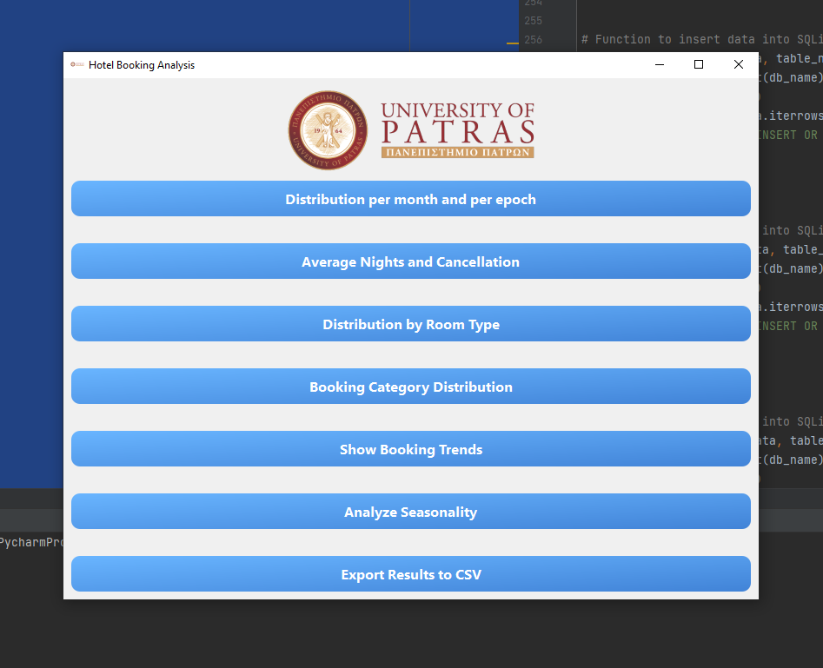
Εικόνα 1: Αρχικό UI
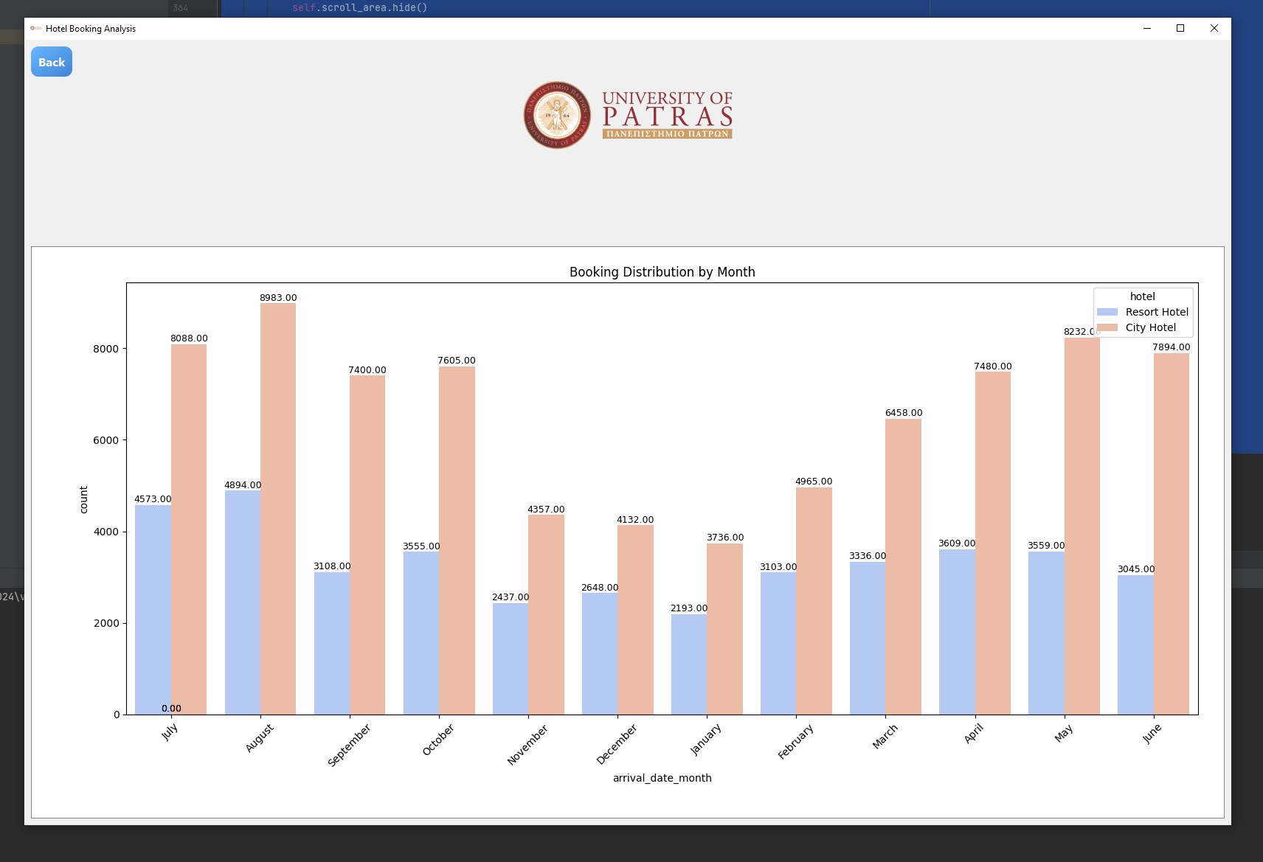
Εικόνα 2: Μέσος όρος διανυκτερεύσεων ανά μήνα
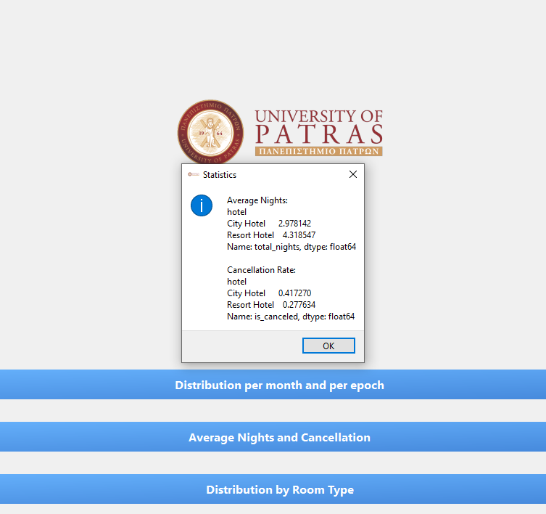
Εικόνα 3: Ποσοστό ακυρώσεων
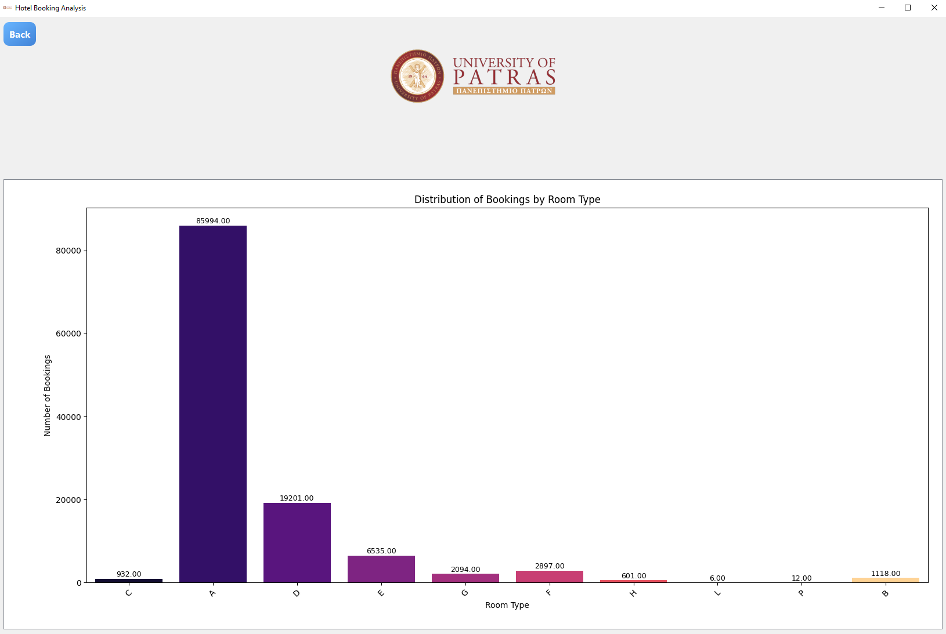
Εικόνα 4: Κατανομή κρατήσεων ανά τύπο δωματίου
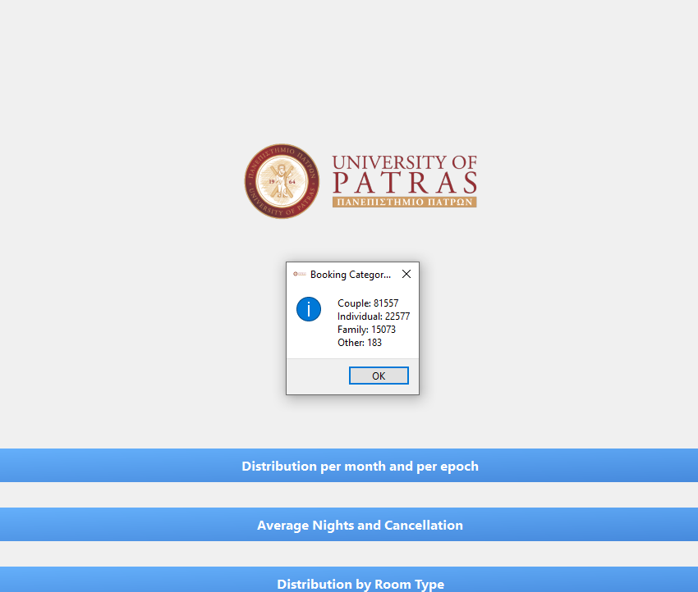
Εικόνα 5: Κατανομή κρατήσεων που αφορούν οικογένεις, ζευγάρια, ατομικές ή άλλου είδους κρατήσεις
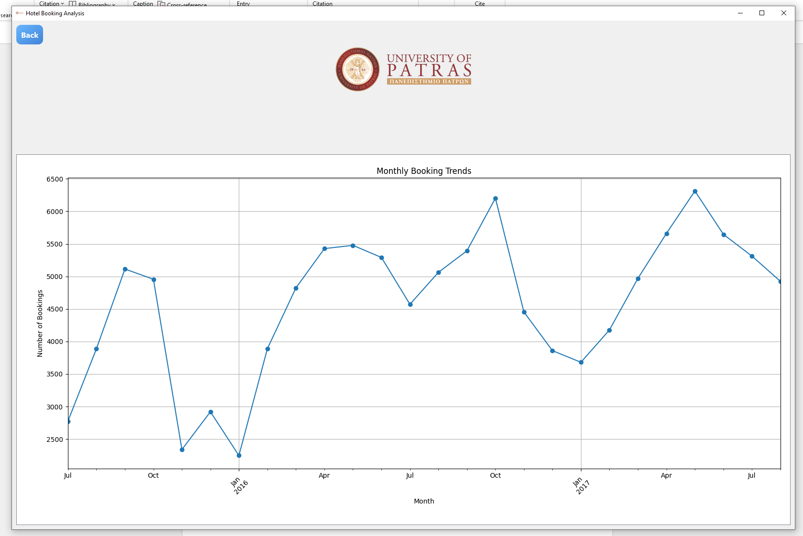
Εικόνα 6: Κατανομή τάσεων των κρατήσεων με την πάροδο του χρόνου
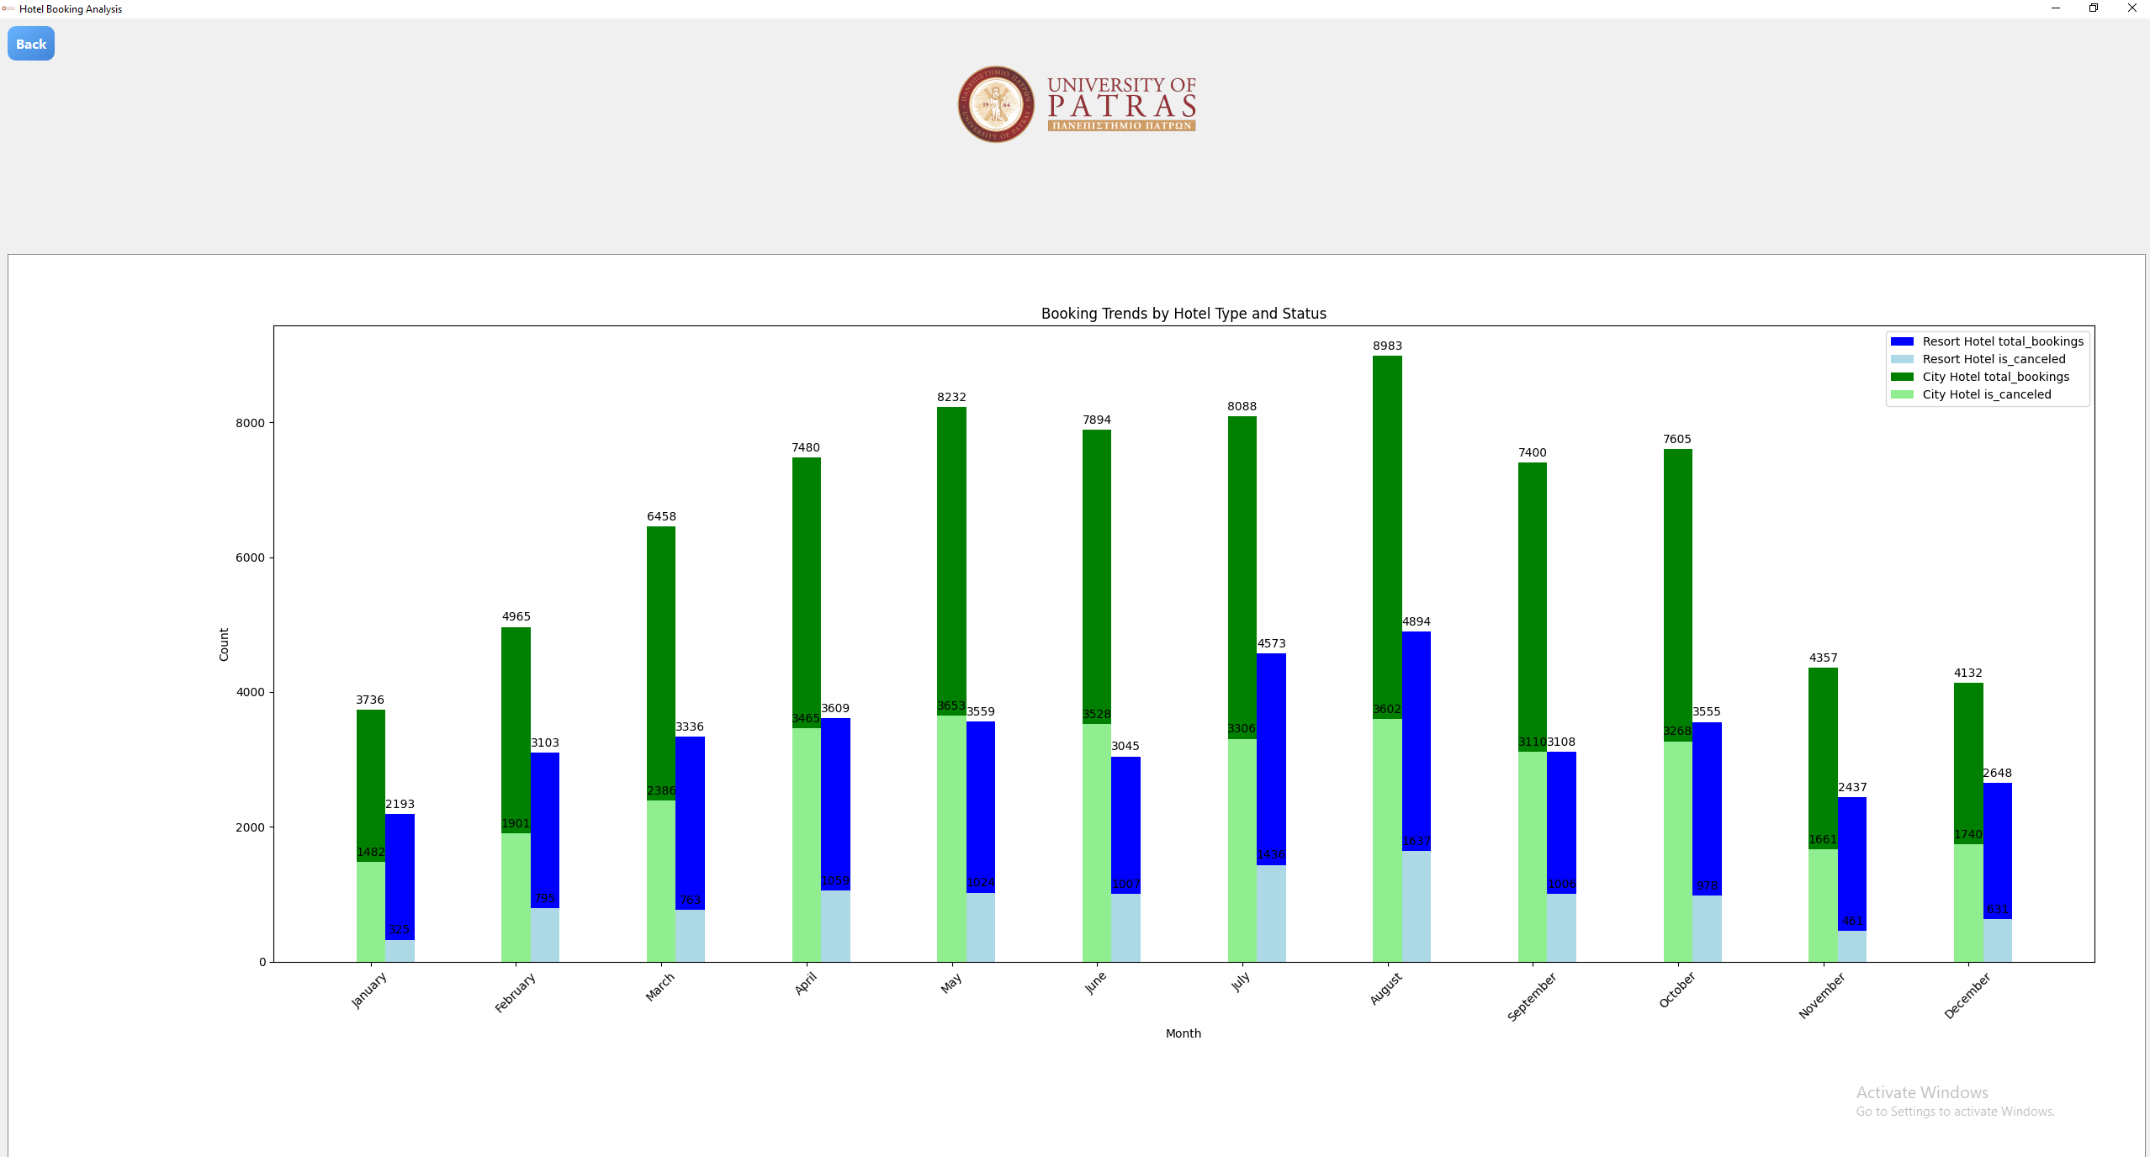
Εικόνα 7: Εποχικότητα στις κρατήσεις ή στις ακυρώσεις ανά τύπο ξενοδοχείου και ανά μήνα

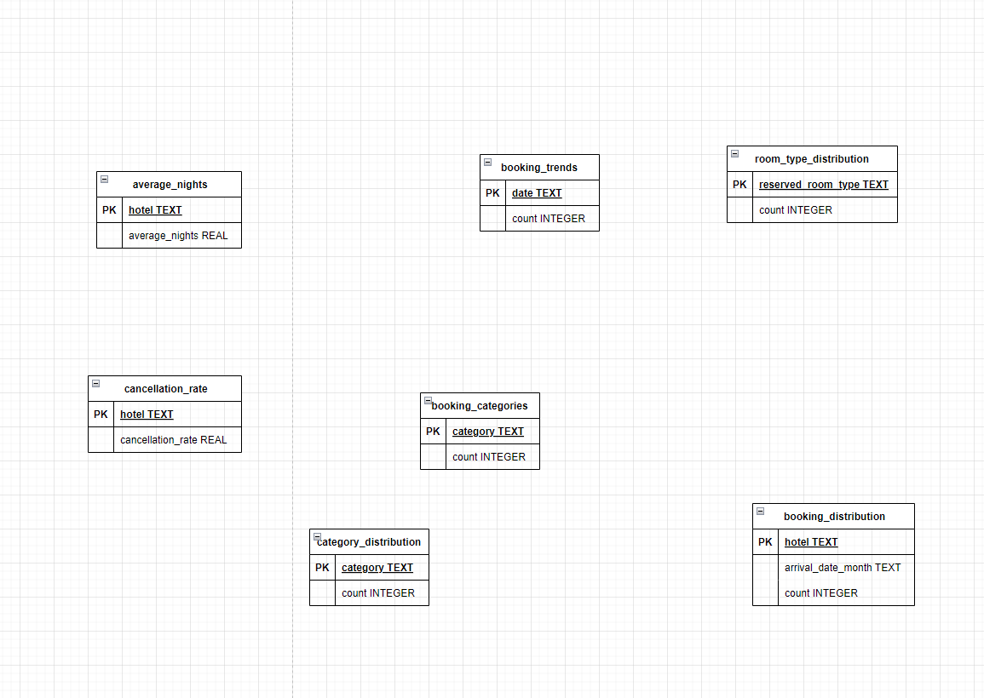
Εικόνα 8: ERD diagram

